Supporting Information
Design, synthesis, and biological activity study of novel penta-1,4-dien-3-one derivatives containining a H-phosphonate scaffold
Lijuan Chen†, Tao Guo†, Rongjiao Xia, Xu Tang, Ying Chen,
Cheng Zhang, Wei Xue*
State Key Laboratory Breeding Base of Green Pesticide and Agricultural Bioengineering, Key Laboratory of Green Pesticide and Agriculture Bioengineering, Ministry of Education,
Guizhou University, Huaxi District, Guiyang 550025, China; E-Mails: 13765645934@sina.com (L. C.); guotao9405@163.com (T. G.); xrjiao@163.com (R. X.); tx1173182020@163.com (X. T.); 15286114381@163.com (Y. C.); zhangcheng6954@163.com (C. Z.)
† These authors contributed equally to this work.
* Corresponding author: Wei Xue; e-mail: wxue@gzu.edu.cn (W.X.); Tel/Fax: 0086-851-88292090

Content
1. The physical properties of compounds 3a-3r 2
2. The data of title compounds 3a–3r 2
3. Spectrogram of title compounds 3a-3r 11

- The physical properties of compounds 3a-3r

Table 1 The physical properties of compounds 3a-3r
Compound | R₁ | R₂ | Appearance | Yield /% | M.P./ºC
3a | 4-Cl-Ph | CH₃ | Yellow solid | 66 | 90-91
3b | 4-Cl-Ph | CH₂CH₃ | Yellow solid | 69 | 68-69
3c | Ph | CH₃ | Yellow solid | 68 | 78-79
3d | Ph | CH₂CH₃ | Yellow solid | 70 | 48-49
3e | 4-F-Ph | CH₃ | Yellow solid | 69 | 73-74
3f | 4-F-Ph | CH₂CH₃ | Yellow solid | 65 | 68-69
3g | 2-OCH₃-Ph | CH₃ | Yellow solid | 70 | 52-53
3h | 2-OCH₃-Ph | CH₂CH₃ | Yellow solid | 68 | 98-99
3i | Thiophene-2-yl | CH₂CH₃ | Yellow solid | 64 | 128-129
3j | 3-NO₂-Ph | CH₂CH₃ | Yellow solid | 69 | 86-87
3k | 4-NO₂-Ph | CH₃ | Yellow oil | 65 | -
3l | 4-NO₂-Ph | CH₂CH₃ | Yellow oil | 63 | -
3m | Furan-2-yl | CH₃ | Yellow solid | 56 | 74-75
3n | Furan-2-yl | CH₂CH₃ | Yellow solid | 50 | 42-43
3o | 3-CH₃-Ph | CH₃ | Yellow solid | 42 | 71-72
3p | 3-CH₃-Ph | CH₂CH₃ | Yellow solid | 50 | 46-47
3q | 3-CF₃-Ph | CH₃ | Yellow oil | 62 | -
3r | 3-CF₃-Ph | CH₂CH₃ | Yellow oil | 58 | -

- The data of title compounds 3a–3r
Data for
4-((1E,4E)-5-(4-chlorophenyl)-3-oxopenta-1,4-dien-1-yl)phenyl dimethyl phosphate (3a) Yellow solid, m.p. 90-91 °C, yield 66%. ¹H NMR (500 MHz, CDCl₃) δ 7.68 (dd, J = 15.9, 9.4 Hz, 2H, Ar-2H), 7.60 (d, J = 8.7 Hz, 2H, Ar-2H), 7.54 (d, J = 8.4 Hz, 2H, Ar-2H), 7.38 (d, J = 8.5 Hz, 2H, Ar(4-Cl)-CH=, Ar(4-O)-CH=), 7.27 (d, J = 8.6 Hz, 2H, Ar-2H), 7.01 (dd, J = 21.4, 15.9 Hz, 2H, Ar(4-Cl)-C=CH, Ar(4-O)-C=CH), 3.88 (d, J = 11.4 Hz, 6H, 2CH₃). ¹³C NMR (126 MHz, CDCl₃) δ 188.50, 152.34, 152.29, 142.31, 142.02, 136.53, 133.33, 131.88, 131.87, 131.12, 130.06, 129.63, 129.35, 125.79, 125.44, 120.58, 120.53, 55.18, 55.13. ³¹P NMR (202 MHz, CDCl₃) δ -3.77. HRMS calcd for C₁₉H₁₉ClO₅P [M+H]⁺ 393.0653, found 393.0645.

Data for
4-((1E,4E)-5-(4-chlorophenyl)-3-oxopenta-1,4-dien-1-yl)phenyl diethyl phosphate (3b) Yellow solid, m.p.68-69 °C, yield 69%. ¹H NMR (500 MHz, CDCl₃) δ 7.68 (dd, J = 15.9, 10.4 Hz, 2H, Ar-2H), 7.59 (d, J = 8.7 Hz, 2H, Ar-2H), 7.54 (d, J = 8.5 Hz, 2H, Ar-2H), 7.38 (d, J = 8.5 Hz, 2H, Ar (4-Cl)-CH=, Ar(4-O)-CH=), 7.27 (d, J = 8.7 Hz, 2H, Ar-2H), 7.01 (dd, J = 21.7, 15.9 Hz, 2H, Ar(4-Cl)-C=CH, Ar(4-O)-C=CH), 4.27 – 4.19 (m, 4H, 2CH₂), 1.39 – 1.33 (m, 6H, 2CH₃). ¹³C NMR (126 MHz, CDCl₃) δ 188.49, 176.15, 152.58, 152.53, 142.41, 141.96, 136.52, 133.36, 131.66, 131.07, 130.00, 129.61, 129.35, 125.83, 125.32, 120.66, 120.62, 64.91, 64.86, 16.21, 16.16. ³¹P NMR (202 MHz, CDCl₃) δ -3.76. HRMS calcd for C₂₁H₂₃ClO₅P [M+H]⁺ 421.0966, found 421.0952.

Data for
dimethyl (4-((1E,4E)-3-oxo-5-phenylpenta-1,4-dien-1-yl) phenyl) phosphate (3c) Yellow solid, m.p.78-79 °C, yield 68%. ¹H NMR (500 MHz, CDCl₃) δ 7.71 (dd, J = 18.9, 16.0 Hz, 2H, Ar-2H), 7.62 – 7.58 (m, 4H, Ar-2H, Ar-CH=, Ar(4-O)-CH=), 7.43 – 7.38 (m, 3H, Ar-2H), 7.36 – 7.29 (m, 1H, Ar-H), 7.27 (d, J = 4.3 Hz, 1H, Ar-2H), 7.06 (d, J = 15.9 Hz, 1H, Ar(4-Cl)-C=CH), 7.01 (d, J = 15.9 Hz, 1H, Ar(4-O)-C=CH), 3.87 (d, J = 11.4 Hz, 6H, 2CH₃).¹³C NMR (126 MHz, CDCl₃) δ 188.79, 152.27, 152.22, 143.54, 142.05, 134.84, 131.99, 131.54, 130.02, 129.89, 129.06, 129.01, 128.49, 128.44, 125.49, 120.55, 120.51, 55.16, 55.11. ³¹P NMR (202 MHz, CDCl₃) δ -3.76. HRMS calcd for C₁₉H₂₀O₅P [M+H]⁺ 359.1042, found 359.1037.

Data for
diethyl(4-((1E,4E)-3-oxo-5-phenylpenta-1,4-dien-1-yl)phenyl) phosphate (3d) Yellow oil, m.p.48-49 °C, yield 70%. ¹H NMR (500 MHz, CDCl₃) δ 7.72 -7.63 (m, 2H, Ar-2H), 7.59 – 7.53 (m, 4H, Ar-2H, Ar-CH=, Ar(4-O)-CH=), 7.37 – 7.34 (m, 3H, Ar-3H), 7.23 (d, J = 7.9 Hz, 2H, Ar-2H), 7.03 (d, J = 16.0 Hz, 1H, Ar(4-Cl)-C=CH), 6.98 (d, J = 15.9 Hz, 1H, Ar(4-O)-C=CH), 4.24 – 4.14 (m, 4H, 2CH₂), 1.35 – 1.29 (m, 6H, 2CH₃). ¹³C NMR (126 MHz, CDCl₃) δ 188.77, 152.45, 152.39, 143.44, 142.11, 134.81, 131.75, 130.60, 129.97, 129.83, 129.03, 128.47, 128.40, 125.49, 125.36, 120.60, 120.56, 64.90, 64.85, 16.19, 16.13. ³¹P NMR (202 MHz, CDCl₃) δ -6.03. HRMS calcd for C₂₁H₂₄O₅P [M+H]⁺ 387.1355, found 387.1343.

Data for
4-((1E,4E)-5-(4-fluorophenyl)-3-oxopenta-1,4-dien-1-yl)phenyl dimethyl phosphate (3e) Yellow solid, m.p.73-74 °C, yield 69%. ¹H NMR (500 MHz, CDCl₃) δ 7.74 – 7.65 (m, 2H, Ar-2H), 7.59 (d, J = 8.5 Hz, 2H, Ar-2H), 7.50 (d, J = 8.1 Hz, 2H, Ar(4-F)-CH=, Ar(4-O)-CH), 7.27 (s, 1H, Ar-H), 7.25 (s, 1H, Ar-H), 7.21 (d, J = 8.0 Hz, 2H, Ar-2H), 7.03 (d, J = 4.3 Hz, 1H, Ar(4-F)-C=CH), 7.00 (d, J = 4.3 Hz, 1H, Ar(4-O)-C=CH), 3.87 (d, J = 11.3 Hz, 6H, 2CH₃). ¹³C NMR (126 MHz, CDCl₃) δ 188.84, 152.21, 152.15, 143.62, 141.79, 141.21, 132.08, 132.05, 129.99, 129.82, 128.71, 128.53, 125.55, 124.59, 120.53, 120.49, 55.16, 55.11, 21.63. ³¹P NMR (202 MHz, CDCl₃) δ -3.74. HRMS calcd for C₁₉H₁₉O₅P [M+H]⁺ 377.0948, found 377.2222.

Data for
diethyl(4-((1E,4E)-5-(4-fluorophenyl)-3-oxopenta-1,4-dien-1-yl)phenyl) phosphate (3f) Yellow solid, m.p.68-69 °C, yield 65%. ¹H NMR (500 MHz, CDCl₃) δ 7.74 – 7.64 (m, 2H, Ar-2H), 7.59 (d, J = 6.5 Hz, 2H, Ar-2H), 7.50 (d, J = 8.1 Hz, 2H, Ar(4-F)-CH=, Ar(4-O)-CH), 7.26 (d, J = 8.3 Hz, 2H, Ar-2H), 7.21 (d, J = 6.6 Hz, 2H, Ar-2H), 7.05 – 7.01 (m, 1H, Ar(4-F)-C=CH), 7.00 (dd, J = 4.4, 2.6 Hz, 1H, Ar(4-F)-C=CH), 4.35 – 4.10 (m, 4H, 2CH₂), 1.43 – 1.21 (m, 6H, 2CH₃). ¹³C NMR (126 MHz, CDCl₃) δ 188.86, 152.43, 152.37, 143.58, 141.90, 141.19, 132.10, 131.83, 129.94, 129.82, 128.52, 125.42, 124.61, 120.61, 120.57, 64.91, 64.86, 21.63, 21.17, 16.22, 16.17. ³¹P NMR (202 MHz, CDCl₃) δ -5.96. HRMS calcd for C₂₁H₂₃O₅FP [M+H]⁺ 405.1261, found 405.0006.

Data for
4-((1E,4E)-5-(2-methoxyphenyl)-3-oxopenta-1,4-dien-1-yl)phenyl dimethyl phosphate (3g) Yellow solid, m.p. 52-53 °C, yield 70%. ¹H NMR (500 MHz, CDCl₃) δ 8.03 (d, J = 16.1 Hz, 1H, Ar(2-OCH₃)-CH=), 7.64 (d, J = 15.9 Hz, 1H, Ar(4-O)-CH=), 7.56 (d, J = 8.8 Hz, 3H, Ar-3H), 7.36 – 7.29 (m, 1H, Ar-1H), 7.22 (d, J = 8.7 Hz, 2H, Ar-2H), 7.08 (d, J = 16.8 Hz, 1H, Ar-1H), 7.02 (d, J = 15.8 Hz, 1H, Ar-1H), 6.93 (t, J = 7.5 Hz, 1H, Ar(2-OCH₃)-C=CH), 6.89 (d, J = 8.3 Hz, 1H, Ar(4-O)-C=CH), 3.86 (s, 3H, CH₃), 3.84 (d, J = 11.4 Hz, 6H, 2CH₃). ¹³C NMR (126 MHz, CDCl₃) δ 189.31, 158.70, 152.09, 152.04, 141.56, 138.86, 132.16, 131.93, 129.97, 128.88, 126.33, 125.44, 123.73, 120.86, 120.47, 120.43, 111.31, 55.61, 55.14, 55.09. ³¹P NMR (202 MHz, CDCl₃) δ -3.80. HRMS calcd for C₂₀H₂₂O₅P [M+H]⁺ 389.1148, found 389.1139.

Data for
ethyl(4-((1E,4E)-5-(2-methoxyphenyl)-3-oxopenta-1,4-dien-1-yl)phenyl) methyl phosphate (3h) Yellow oil, m.p. 98-99 °C, yield 68%. ¹H NMR (500 MHz, CDCl₃) δ 8.00 (d, J = 16.1 Hz, 1H, Ar(4-O)-CH=), 7.61 (d, J = 15.9 Hz, 1H, Ar-1H), 7.53 (d, J = 8.8 Hz, 3H, Ar-2H, Ar(2-OCH₃)-CH=), 7.32 – 7.26 (m, 1H, Ar-1H), 7.21 (s, 1H, Ar-1H), 7.19 (s, 1H, Ar-1H), 7.06 (d, J = 16.2 Hz, 1H, Ar-1H), 6.99 (d, J = 15.9 Hz, 1H, Ar-1H), 6.90 (t, J = 7.5 Hz, 1H, Ar(2-OCH₃)-C=CH), 6.85 (d, J = 8.3 Hz, 1H, Ar(4-O)-C=CH), 4.21 – 4.12 (m, 4H, 2CH₂), 3.82 (s, 3H, CH₃), 1.29 (dd, J = 8.8, 5.3 Hz, 6H, 2CH₃). ¹³C NMR (126 MHz, CDCl₃) δ 189.28, 158.67, 152.28, 152.23, 141.64, 138.78, 131.90, 129.90, 128.84, 126.29, 125.31, 123.70, 120.83, 120.53, 120.49, 111.29, 110.56, 64.89, 64.84, 55.57, 16.16, 16.11. ³¹P NMR (202 MHz, CDCl₃) δ -6.07. HRMS calcd for C₂₂H₂₆O₅P [M+H]⁺ 417.1461, found 417.1451.

Data for
diethyl(4-((1E,4E)-3-oxo-5-(thiophen-2-yl)penta-1,4-dien-1-yl)phenyl) phosphate (3i) Yellow solid, m.p.128-129 °C, yield 64%. ¹H NMR (500 MHz, CDCl₃) δ 7.81 (d, J = 12.3 Hz, 1H, Ar-1H), 7.62 (d, J = 11.9 Hz, 1H, Ar-1H), 7.53 (d, J = 7.7 Hz, 2H, Ar-(4-O)-CH=, thiophene-H), 7.36 (d, J = 6.7 Hz, 1H, thiophene-H), 7.27 (d, J = 3.5 Hz, 1H, thiophene-CH=), 7.21 (d, J = 8.1 Hz, 2H, Ar-2H), 7.05 – 6.98 (m, 1H, thiophene-H), 6.94 – 6.85 (m, 1H, Ar(4-OH)-C=CH), 6.84 – 6.75 (m, 1H, thiophene-C=CH), 4.22 – 4.10 (m, 4H, 2CH₂), 1.45 – 1.04 (m, 6H, 2CH₃). ¹³C NMR (126 MHz, CDCl₃) δ 188.11, 152.38, 152.32, 141.85, 140.24, 135.87, 131.95, 129.95, 129.00, 128.42, 125.47, 124.28, 120.54, 120.51, 73.04, 64.86, 64.82, 16.15, 16.10. ³¹P NMR (202 MHz, CDCl₃) δ -6.09. HRMS calcd for C₁₉H₂₂O₅PS [M+H]⁺ 393.0920, found 393.0914.

Data for
diethyl(4-((1E,4E)-5-(3-nitrophenyl)-3-oxopenta-1,4-dien-1-yl)phenyl) phosphate (3j) Yellow solid, m.p. 86-87 °C, yield 69%. ¹H NMR (500 MHz, CDCl₃) δ 8.26 (dd, J = 13.0, 8.7 Hz, 2H, Ar-2H), 7.74 (dt, J = 16.0, 11.1 Hz, 4H, Ar-1H, Ar(3-NO₂)-CH=, Ar-2H), 7.60 (dd, J = 12.8, 8.5 Hz, 2H, Ar-1H, Ar(4-O)-CH=), 7.31 – 7.25 (m, 2H, Ar-2H), 7.18 (t, J = 14.5 Hz, 1H, Ar(3-NO₂)-C=CH ), 7.00 (t, J = 14.5 Hz, 1H, Ar(4-O)-C=CH ), 4.29 – 4.19 (m, 4H, 2CH₂), 1.40 – 1.33 (m, 6H, 2CH₃). ¹³C NMR (126 MHz, CDCl₃) δ 188.00, 152.80, 152.75, 148.63, 143.24, 141.08, 140.18, 133.76, 131.40, 130.13, 128.97, 128.84, 125.14, 124.29, 123.82, 120.72, 120.68, 64.94, 64.89, 16.20, 16.15. ³¹P NMR (202 MHz, CDCl₃) δ -6.02. HRMS calcd for C₂₁H₂₃O₇NP [M+H]⁺ 432.11206, found 432.1197.

Data for
dimethyl(4-((1E,4E)-5-(4-nitrophenyl)-3-oxopenta-1,4-dien-1-yl)phenyl) phosphate (3k) Yellow oil, yield 65%. ¹H NMR (500 MHz, CDCl₃) δ 8.47 (s, 1H, Ar-1H), 8.24 (d, J = 8.9 Hz, 1H, Ar-1H), 7.88 (d, J = 7.7 Hz, 1H, Ar-1H), 7.73 (dd, J = 16.6, 7.9 Hz, 2H, Ar-1H, Ar(4-NO₂)-CH=), 7.61 (d, J = 8.3 Hz, 3H, Ar-2H, Ar(4-O)-CH=), 7.28 (d, J = 7.7 Hz, 2H, Ar-2H), 7.19 (d, J = 15.9 Hz, 1H, Ar(4-NO₂)-C=CH), 6.99 (d, J = 17.8 Hz, 1H, Ar(4-OH)-C=CH), 3.88 (dt, J = 9.5, 3.9 Hz, 6H, 2CH₃).¹³C NMR (126 MHz, CDCl₃) δ 188.03, 152.54, 152.49, 148.83, 143.00, 140.36, 136.67, 134.29, 131.66, 130.17, 130.13, 127.67, 125.40, 124.71, 122.44, 120.64, 120.60, 55.18, 55.13. ³¹P NMR (202 MHz, CDCl₃) δ -3.73. HRMS calcd for C₁₉H₁₉O₇NP [M+H]⁺ 404.0893, found 404.0887.

Data for
diethyl(4-((1E,4E)-5-(4-nitrophenyl)-3-oxopenta-1,4-dien-1-yl)phenyl) phosphate (3l) Yellow oil, yield 63%. ¹H NMR (400 MHz, CDCl₃) δ 8.48 (s, 1H, Ar-1H), 8.25 (d, J = 11.3 Hz, 1H, Ar-1H), 7.90 (d, J = 7.7 Hz, 1H, Ar-1H), 7.75 (dd, J = 15.9, 5.6 Hz, 2H, Ar-1H, Ar(4-NO₂)-CH= ), 7.62 (d, J = 8.3 Hz, 3H, Ar-2H, Ar(4-O)-CH= ), 7.29 (d, J = 8.6 Hz, 2H, Ar-2H), 7.21 (d, J = 15.9 Hz, 1H, Ar(4-NO₂)-C=CH), 7.02 (d, J = 16.0 Hz, 1H, Ar(4-OH)-C=CH), 4.31 – 4.21 (m, 4H, 2CH₂), 1.37 (tt, J = 4.9, 2.5 Hz, 6H, 2CH₃). ¹³C NMR (101 MHz, CDCl₃) δ 188.00, 152.67, 152.60, 148.73, 143.01, 140.23, 136.60, 134.19, 131.38, 130.05, 129.20, 127.64, 125.19, 124.61, 122.38, 120.63, 120.58, 64.87, 64.81, 16.13, 16.06. ³¹P NMR (162 MHz, CDCl₃) δ -6.63. HRMS calcd for C₂₁H₂₃O₇NP [M+H]⁺ 432.1206, found 432.1199.

Data for
4-((1E,4E)-5-(furan-2-yl)-3-oxopenta-1,4-dien-1-yl)phenyl dimethyl phosphate (3m) Yellow oil, m.p. 74-75 °C, yield 56%. ¹H NMR (500 MHz, CDCl₃) δ 7.61 (d, J = 16.0 Hz, 1H, furan- H), 7.53 (d, J = 8.6 Hz, 2H, Ar-2H), 7.45 (d, J = 15.6 Hz, 2H, Ar(4-OH)-CH=, furan- H), 7.21 (d, J = 8.7 Hz, 2H, Ar-2H), 6.91 (dd, J = 19.9, 15.7 Hz, 2H, furan- CH=, furan- H), 6.65 (d, J = 3.4 Hz, 1H, Ar(4-OH)-C=CH), 6.50 – 6.40 (m, 1H, furan-C=CH), 3.82 (d, J = 11.3 Hz, 6H, 2CH₃).¹³C NMR (126 MHz, CDCl₃) δ 188.35, 152.35, 151.53, 145.07, 141.86, 131.77, 129.92, 129.53, 125.94, 122.58, 120.54, 116.14, 112.75, 64.88, 64.84, 16.17, 16.12. ³¹P NMR (202 MHz, CDCl₃) δ -3.82. HRMS calcd for C₁₇H₁₈O₆P [M+H]⁺ 349.0835, found 349.0823.

Data for
diethyl(4-((1E,4E)-5-(furan-2-yl)-3-oxopenta-1,4-dien-1-yl)phenyl) phosphate (3n) Yellow oil, m.p. 42-43 °C, yield 50%. ¹H NMR (500 MHz, CDCl₃) δ 7.62 (d, J = 16.0 Hz, 1H, furan- H), 7.54 (d, J = 8.6 Hz, 2H, Ar-2H), 7.45 (d, J = 15.9 Hz, 2H, Ar(4-OH)-CH=, furan- H), 7.22 (d, J = 8.7 Hz, 2H, Ar-2H), 6.92 (dd, J = 20.7, 15.8 Hz, 2H, furan- CH=, furan- H), 6.66 (d, J = 3.4 Hz, 1H, Ar(4-OH)-C=CH), 6.48 – 6.43 (m, 1H, furan-C=CH), 4.34 – 4.05 (m, 4H, 2CH₂), 1.43 – 1.19 (m, 6H, 2CH₃). ¹³C NMR (126 MHz, CDCl₃) δ 188.35, 152.40, 152.35, 151.53, 145.07, 141.86, 131.77, 129.92, 129.53, 125.94, 122.58, 120.58, 120.54, 116.14, 112.75, 64.88, 64.84, 16.17, 16.12. ³¹P NMR (202 MHz, CDCl₃) δ -6.05. HRMS calcd for C₁₉H₂₀O₆P [M+H]⁺ 377.1148, found 377.1138.

Data for
dimethyl(4-((1E,4E)-3-oxo-5-(m-tolyl)penta-1,4-dien-1-yl)phenyl) phosphate (3o) Yellow solid, m.p. 71-72 °C, yield 42%. ¹H NMR (400 MHz, CDCl₃) δ 7.72 (d, J = 6.9 Hz, 1H, Ar(4-O)-CH= ), 7.68 (d, J = 6.9 Hz, 1H, Ar-1H), 7.60 (d, J = 8.7 Hz, 2H, Ar-1H, Ar(3-CH₃)-CH=), 7.41 (d, J = 6.8 Hz, 2H, Ar-2H), 7.30 (d, J = 7.1 Hz, 1H, Ar-1H), 7.28 (s, 1H, Ar-1H), 7.21 (d, J = 7.5 Hz, 2H, Ar-2H), 7.06 (d, J = 14.2 Hz, 1H, Ar(4-OH)-C=CH), 7.02 (d, J = 14.2 Hz, 1H, Ar(3-CH₃)-C=CH), 3.89 (s, 3H, CH₃), 3.86 (s, 3H, CH₃), 2.38 (s, 3H,CH₃). ¹³C NMR (101 MHz, CDCl₃) δ 188.78, 152.13, 152.06, 143.68, 141.86, 138.62, 134.65, 131.93, 131.45, 129.96, 129.06, 128.86, 125.67, 125.43, 125.20, 120.45, 120.40, 55.11, 55.04, 21.33. ³¹P NMR (162 MHz, CDCl₃) δ -3.80. HRMS calcd for C₂₀H₂₂O₅P [M+H]⁺ 373.1199, found 373.1195.
Data for
diethyl(4-((1E,4E)-3-oxo-5-(p-tolyl)penta-1,4-dien-1-yl)phenyl) phosphate (3p) Yellow solid, m.p. 46-47 °C, yield 50%. ¹H NMR (400 MHz, CDCl₃) δ 7.72 (d, J = 5.4 Hz, 1H, Ar-1H), 7.68 (d, J = 5.4 Hz, 1H, Ar-1H), 7.60 (d, J = 8.7 Hz, 2H, Ar-2H), 7.42 (d, J = 7.2 Hz, 2H, Ar(4-O)-CH=, Ar(3-CH₃)-CH=), 7.33 – 7.27 (m, 3H, Ar-3H), 7.22 (d, J = 7.5 Hz, 1H, Ar-1H), 7.09 – 7.00 (m, 2H, Ar(4-OH)-C=CH, Ar(3-CH₃)-C=CH), 4.27 – 4.20 (m, 4H, 2CH₂), 2.39 (s, 3H, CH₃), 1.37 (td, J = 7.1, 1.0 Hz, 6H, 2CH₃). ¹³C NMR (101 MHz, CDCl₃) δ 188.79, 152.37, 152.30, 143.64, 141.98, 138.64, 134.69, 131.71, 131.43, 129.90, 129.05, 128.87, 125.67, 125.31, 125.24, 120.54, 120.49, 64.86, 64.80, 21.35, 16.14, 16.08. ³¹P NMR (162 MHz, CDCl₃) δ -6.07. HRMS calcd for C₂₂H₂₆O₅P [M+H]⁺ 401.1512, found 401.1508.

Data for
Dimethyl(4-((1E,4E)-3-oxo-5-(3-(trifluoromethyl)phenyl)penta-1,4-dien-1-yl)phenyl) phosphate (3q) Yellow oil, yield 62%. ¹H NMR (400 MHz, CDCl₃) δ 8.18 (s, 1H, Ar-1H), 8.11 (d, J = 7.8 Hz, 1H, Ar-1H), 7.86 (dd, J = 9.4, 5.6 Hz, 4H, Ar(CF₃)-CH=, Ar(4-O)-CH=, Ar-2H), 7.83 – 7.77 (m, 2H, Ar-2H), 7.71 (d, J = 7.7 Hz, 1H, Ar-1H), 7.54 (d, J = 16.1 Hz, 1H, Ar-1H), 7.34 – 7.31 (m, 2H, Ar(3-CF₃)-C=CH, Ar(4-O)-C=CH ), 3.84 (s, 3H, CH₃), 3.81 (s, 3H, CH₃). ¹³C NMR (101 MHz, CDCl₃) δ 193.70, 157.01, 156.94, 147.31, 146.17, 141.15, 137.46, 137.07, 135.60, 135.29, 132.43, 131.86, 131.73, 131.01, 130.62, 130.27, 125.71, 125.66, 60.28, 60.21. ³¹P NMR (162 MHz, CDCl₃) δ -3.74. HRMS calcd for C₂₀H₁₉F₃O₅P [M+H]⁺ 427.0916, found 427.0914.

Data for
Diethyl(4-((1E,4E)-3-oxo-5-(3-(trifluoromethyl)phenyl)penta-1,4-dien-1-yl)phenyl) phosphate (3r) Yellow oil, yield 58%. ¹H NMR (400 MHz, CDCl₃) δ 8.55 (s, 1H, Ar-1H), 8.48 (d, J = 7.8 Hz, 1H, Ar-1H), 8.28 – 8.21 (m, 3H, Ar(CF₃)-CH=, Ar(4-O)-CH=, Ar-1H), 8.17 (dd, J = 15.3, 7.5 Hz, 2H, Ar-2H), 8.07 (dd, J = 9.8, 5.7 Hz, 1H, Ar-1H), 7.94 – 7.88 (m, 1H, Ar-1H), 7.68 (dt, J = 13.2, 5.1 Hz, 3H, Ar-1H, Ar(3-CF₃)-C=CH, Ar(4-O)-C=CH), 4.56 (dq, J = 14.3, 7.1 Hz, 4H, 2CH₂), 1.68 – 1.62 (m, 6H, 2CH₃). ¹³C NMR (101 MHz, CDCl₃) δ 193.67, 157.17, 157.10, 147.32, 146.14, 141.15, 137.40, 136.88, 135.54, 135.25, 134.90, 132.46, 131.82, 130.88, 130.25, 127.90, 125.69, 125.64, 69.74, 69.68, 21.13, 21.07. ³¹P NMR (162 MHz, CDCl₃) δ -5.96. HRMS calcd for C₂₂H₂₃O₅F₃P [M+H]⁺ 455.1229, found 455.1224.

- Spectrogram of title compounds 3a-3r
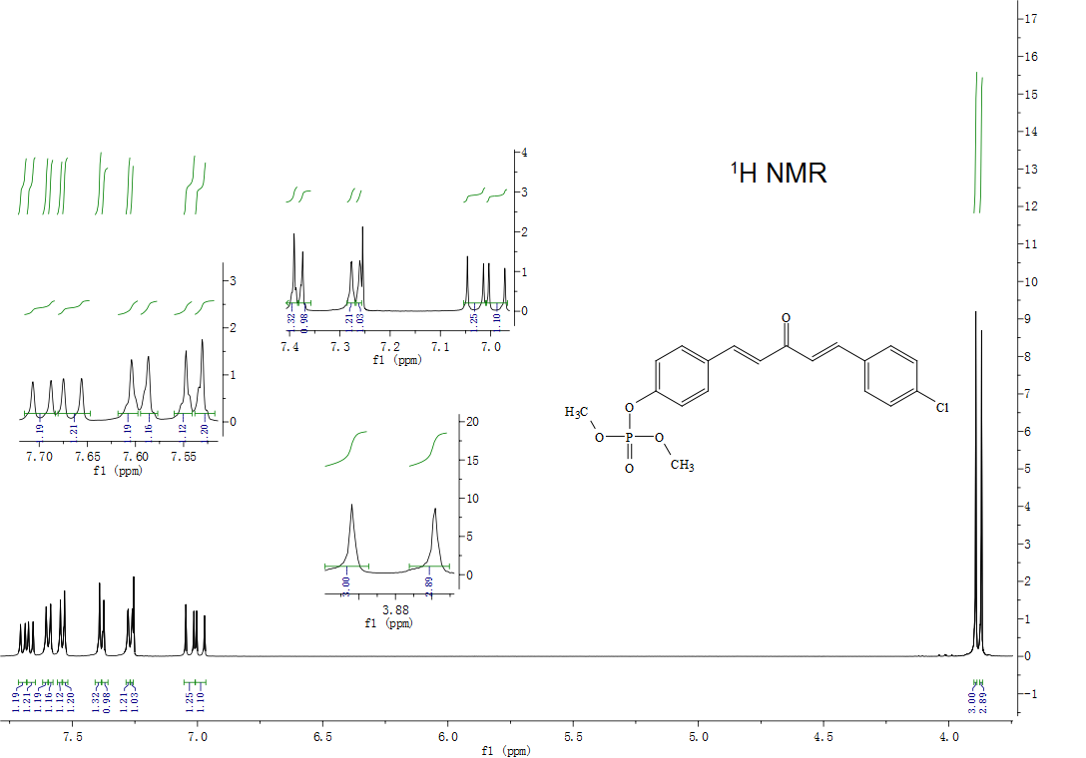
¹H NMR of compound 3a

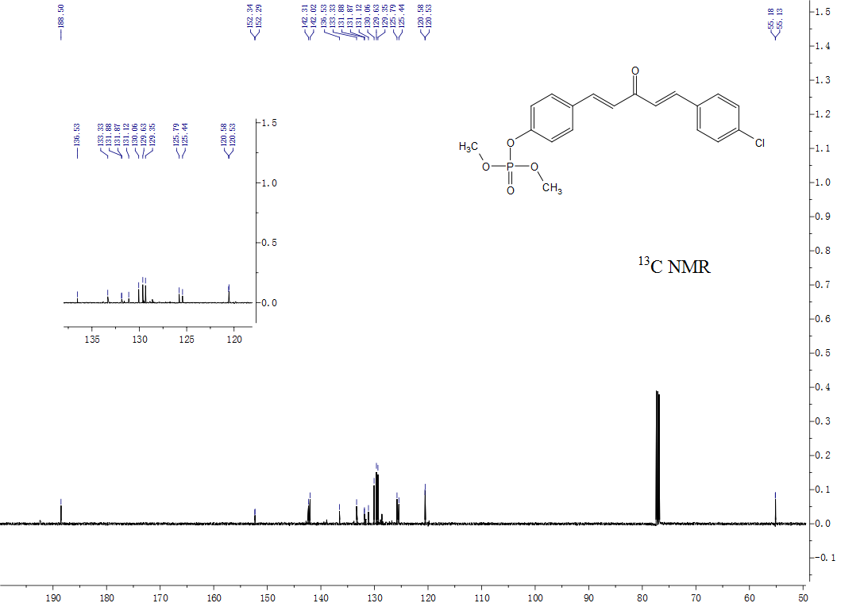
¹³C NMR of compound 3a

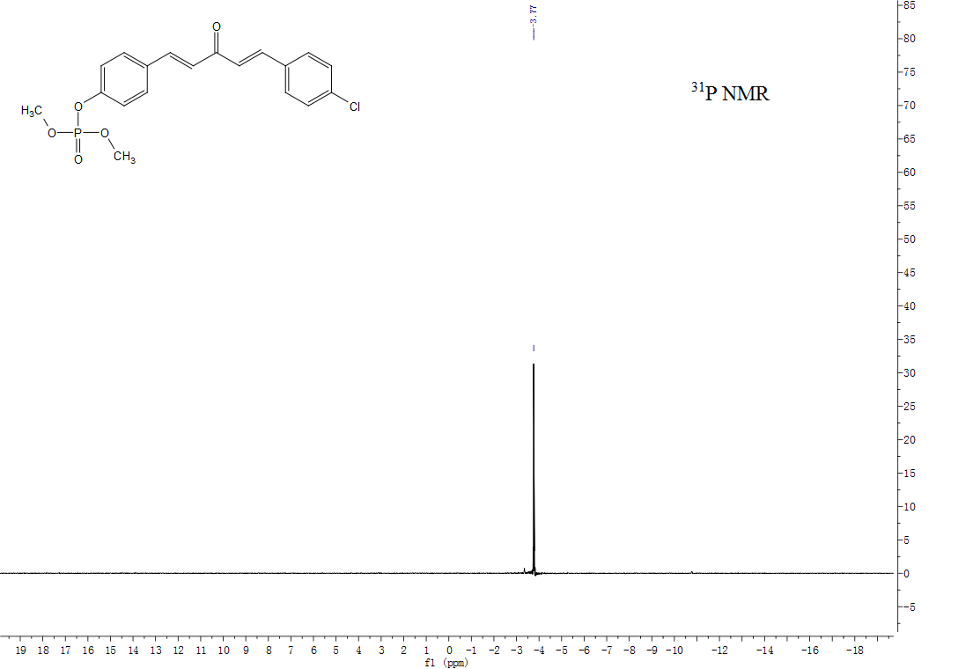
³¹P NMR of compound 3a

HRMS of compound 3a

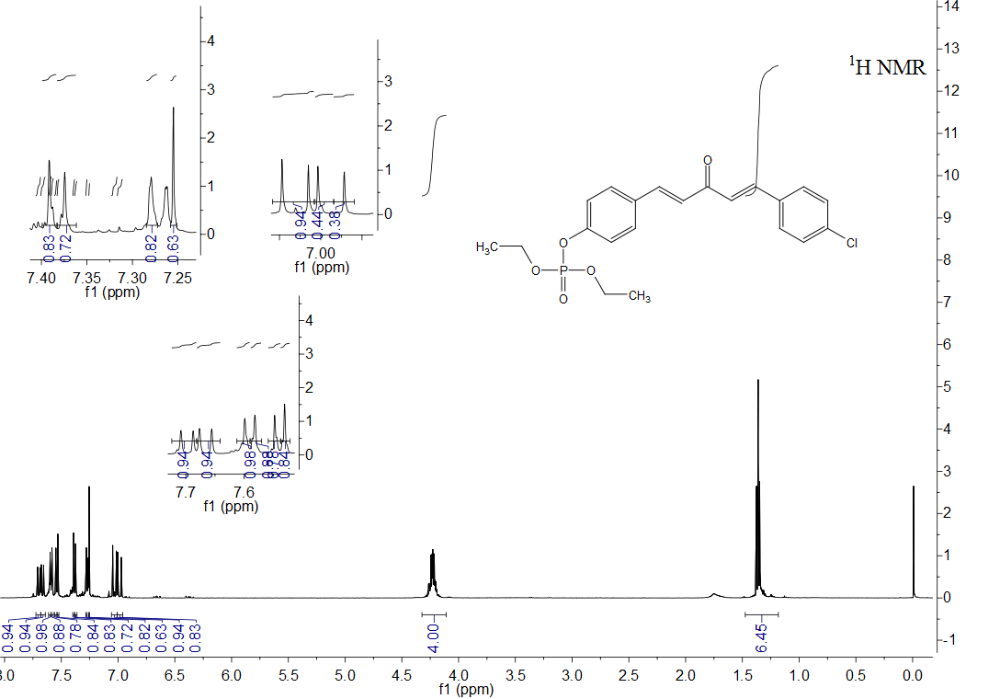
¹H NMR of compound 3b

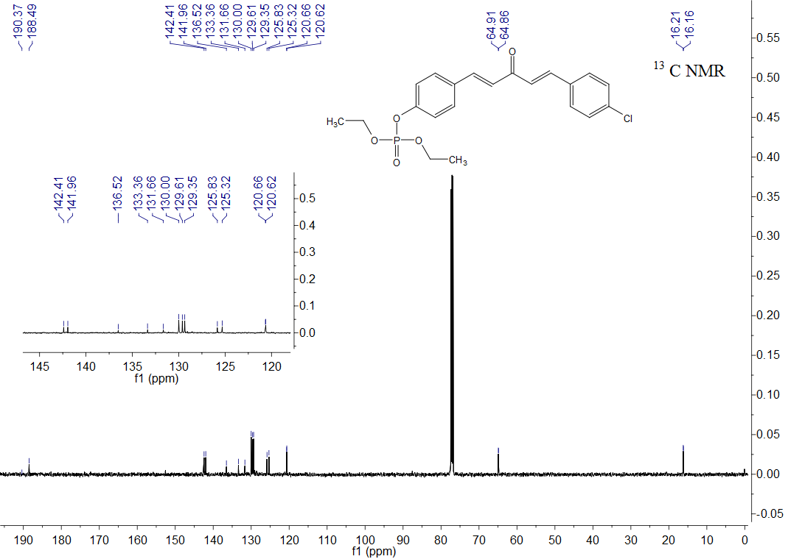
¹³C NMR of compound 3b

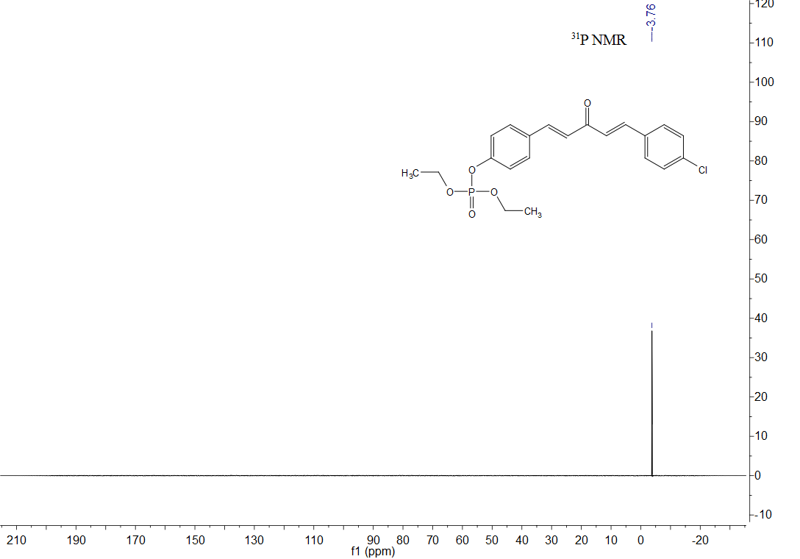
³¹P NMR of compound 3b

HRMS of compound 3b

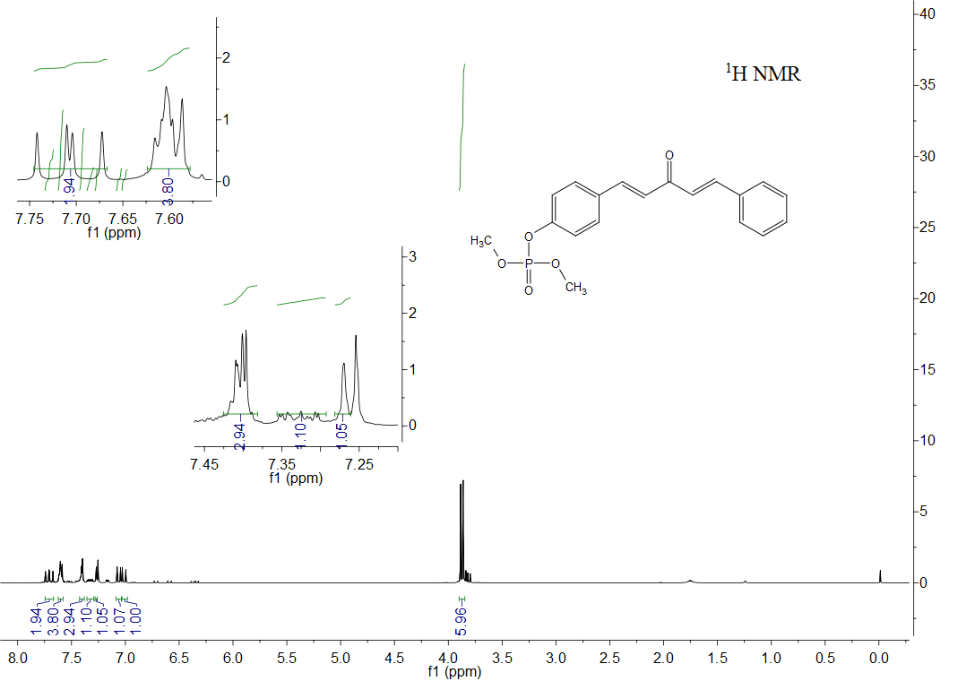
¹H NMR of compound 3c

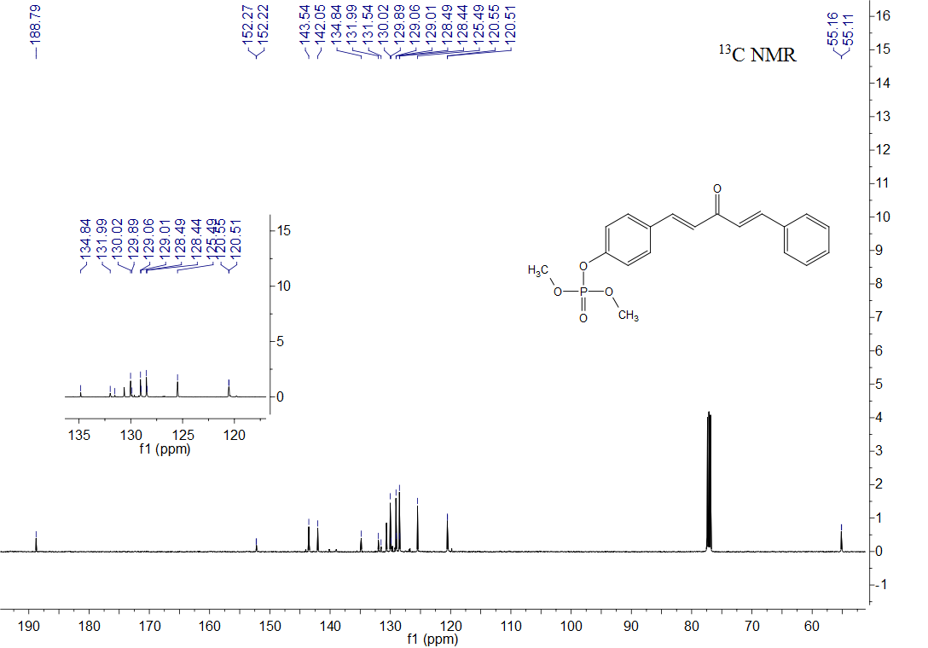
¹³C NMR of compound 3c

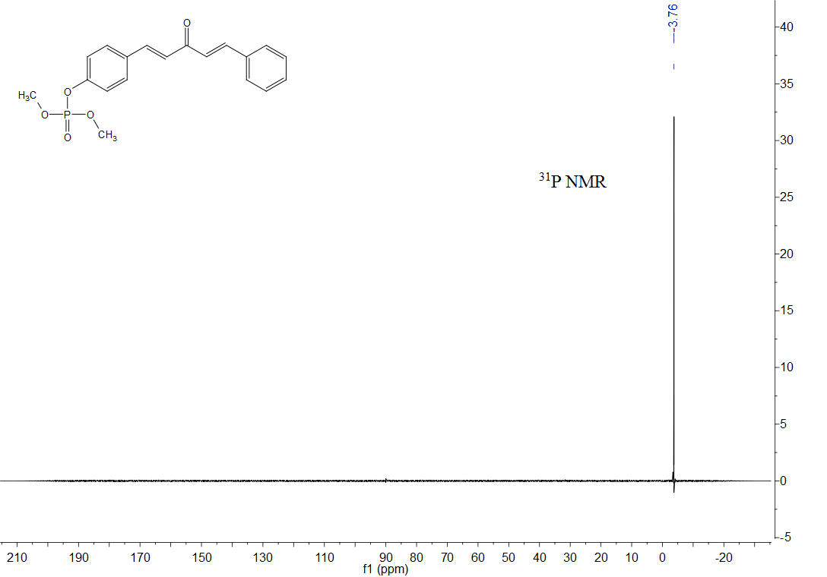
³¹P NMR of compound 3c

HRMS of compound 3c

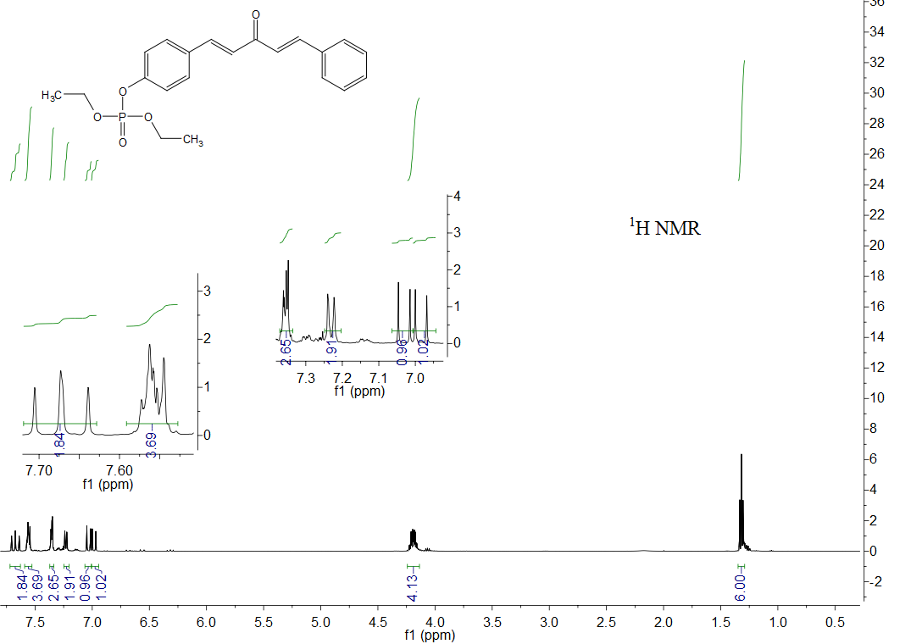
¹H NMR of compound 3d

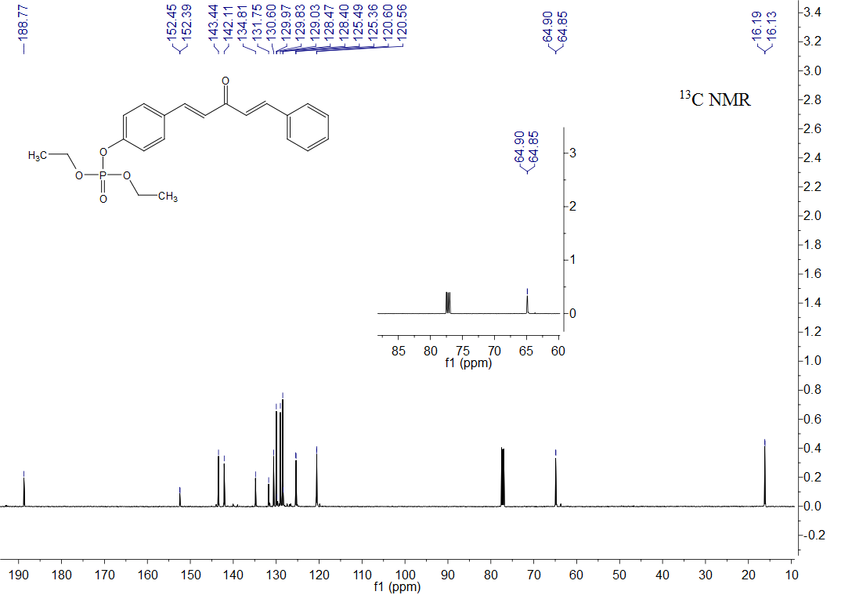
¹³C NMR of compound 3d

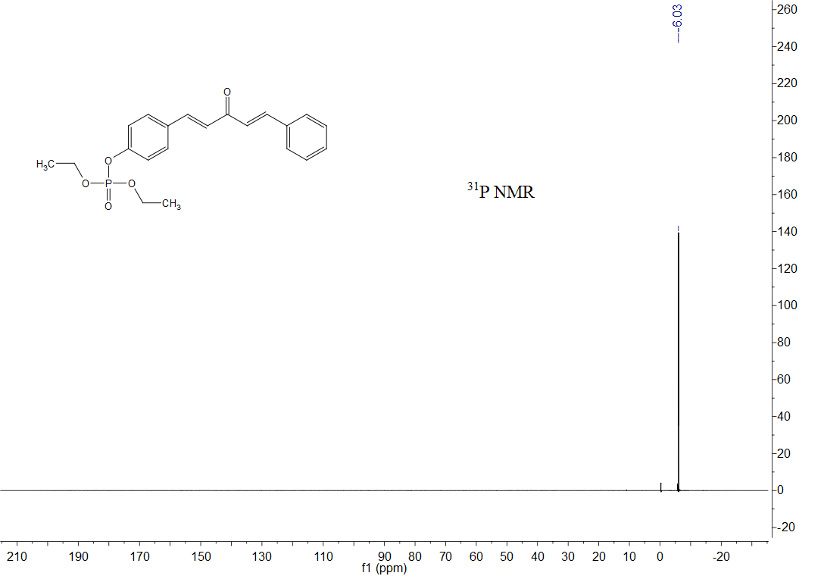
³¹P NMR of compound 3d

HRMS of compound 3d

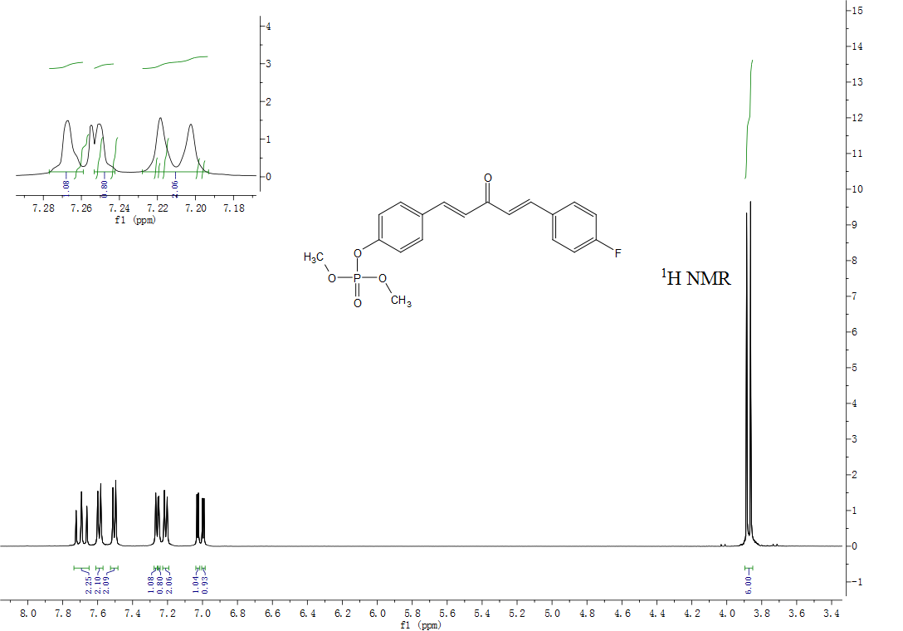
¹H NMR of compound 3e

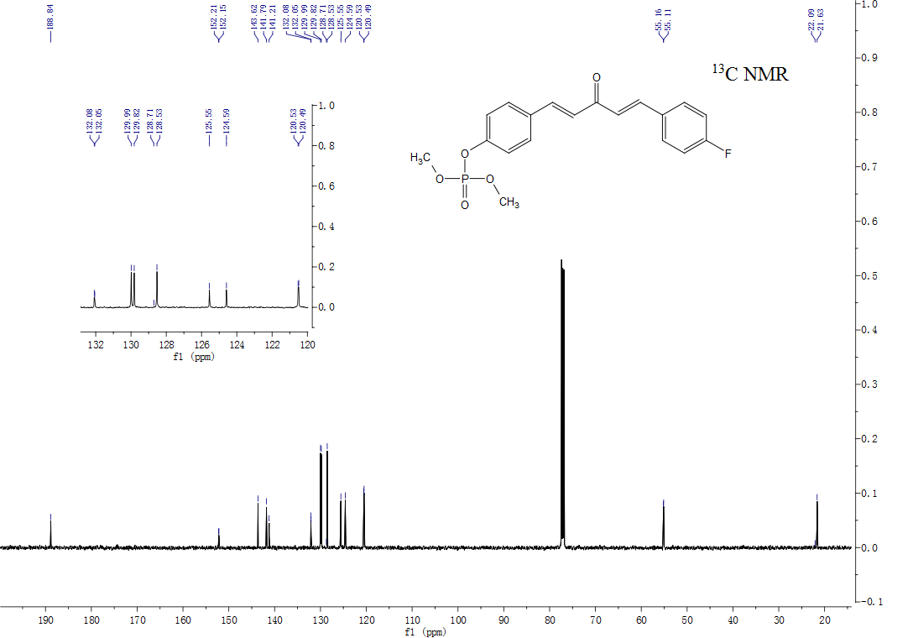
¹³C NMR of compound 3e

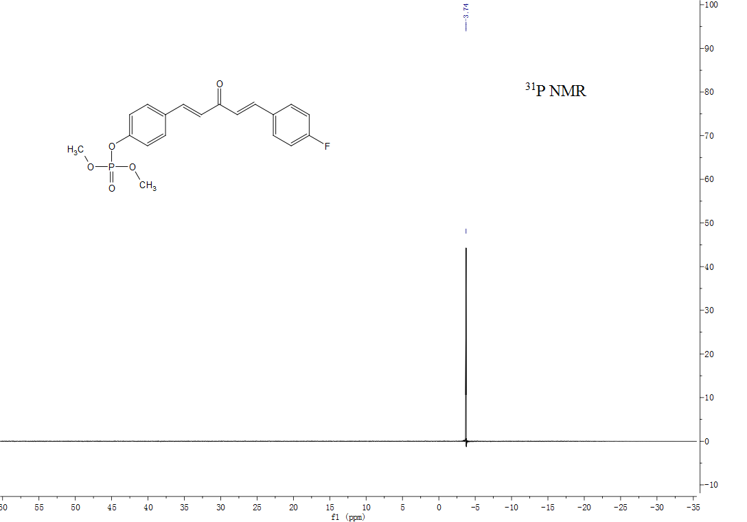
³¹P NMR of compound 3e

HRMS of compound 3e

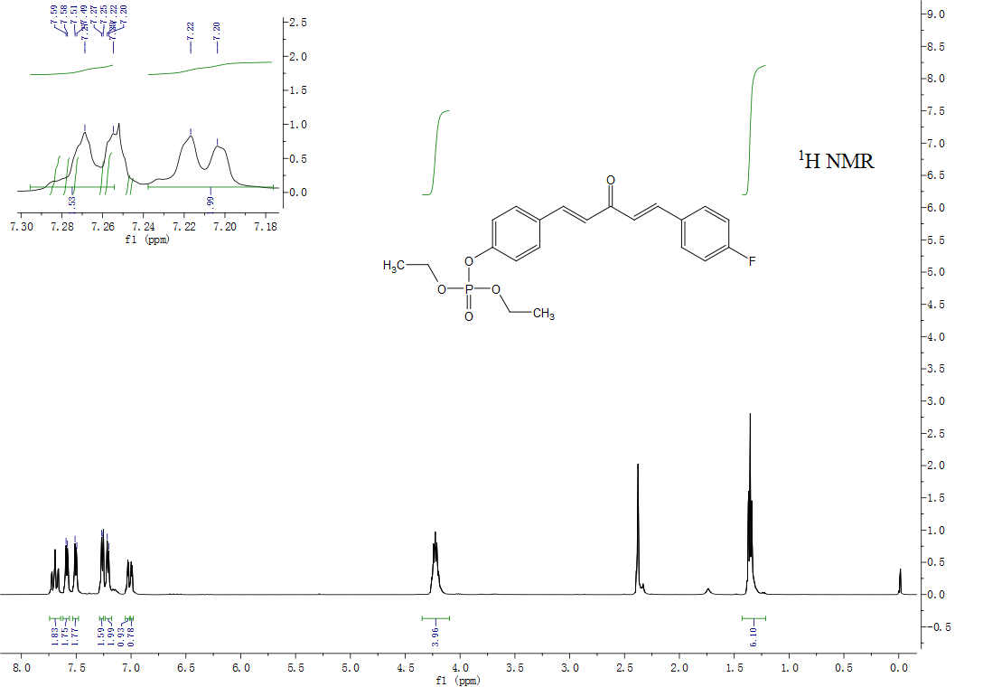
¹H NMR of compound 3f

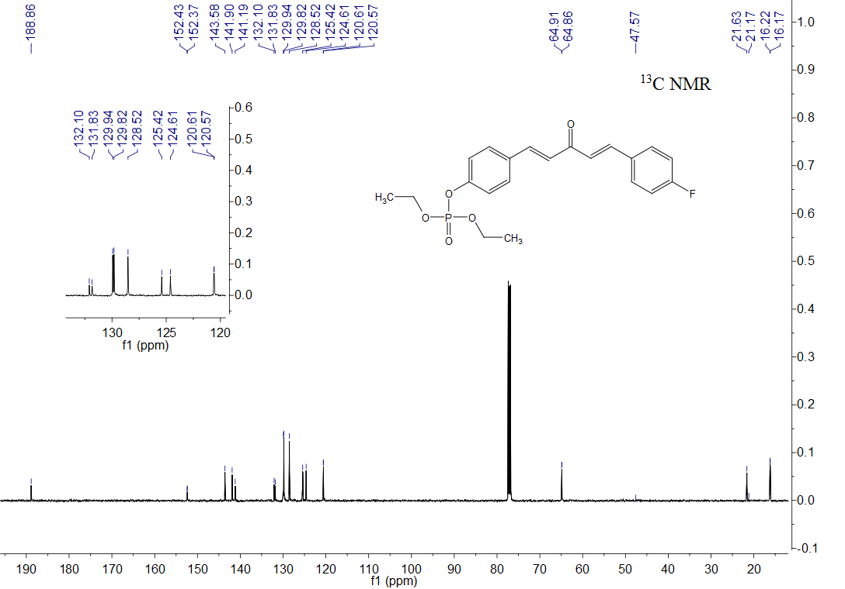
¹³C NMR of compound 3f

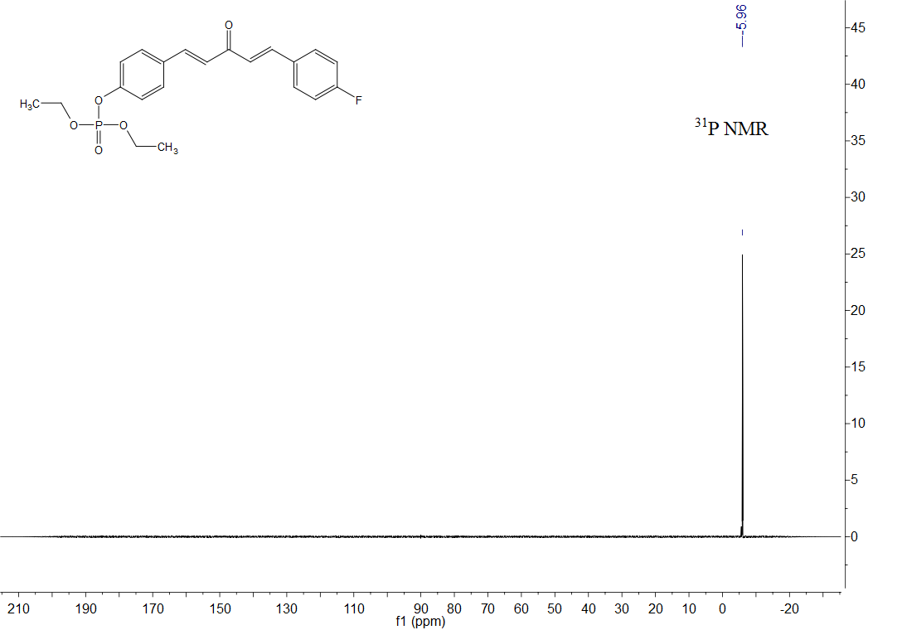
³¹P NMR of compound 3f

HRMS of compound 3f

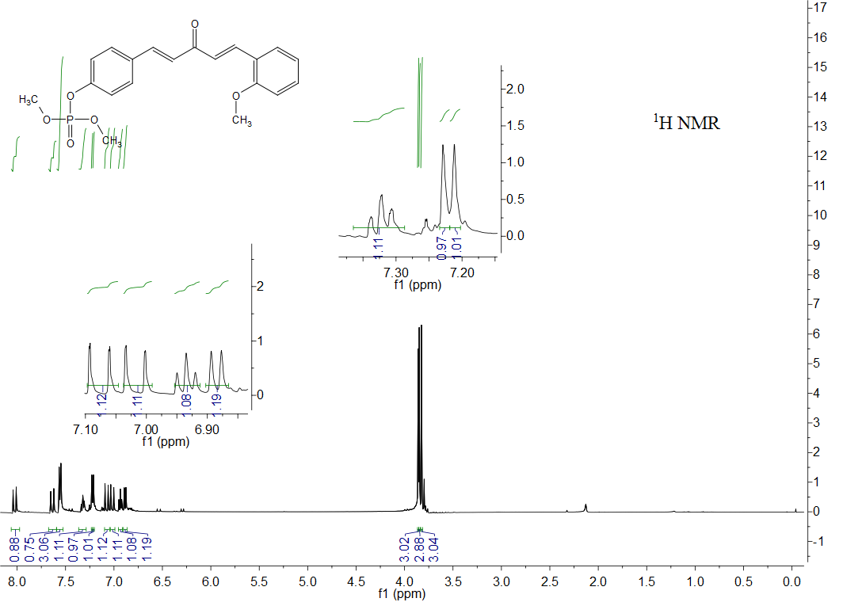
¹H NMR of compound 3g

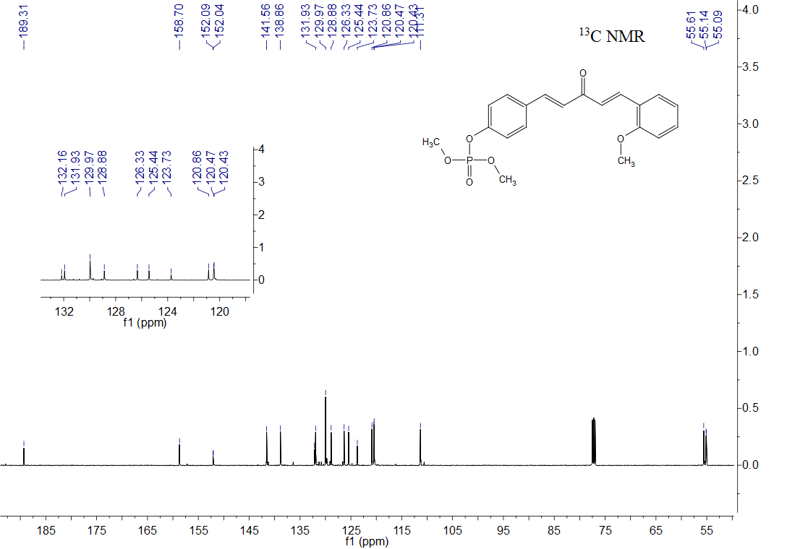
¹³C NMR of compound 3g

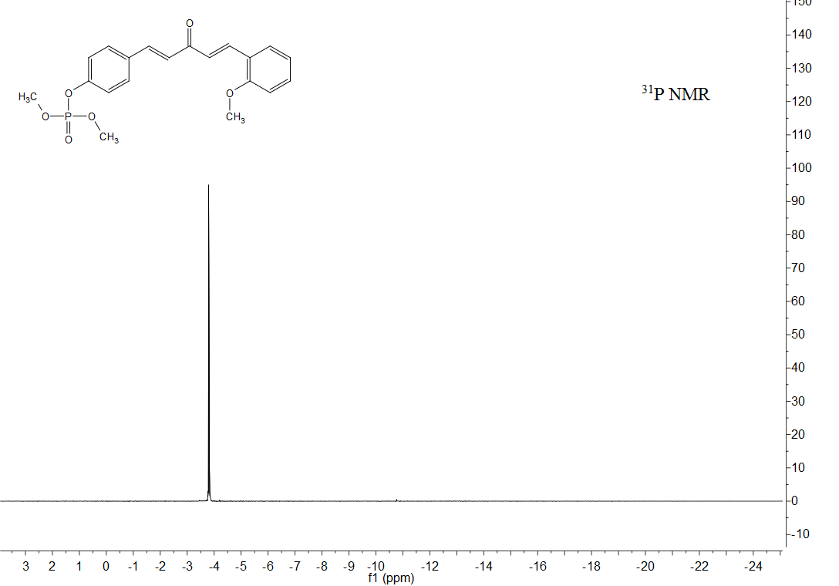
³¹P NMR of compound 3g

HRMS of compound 3g

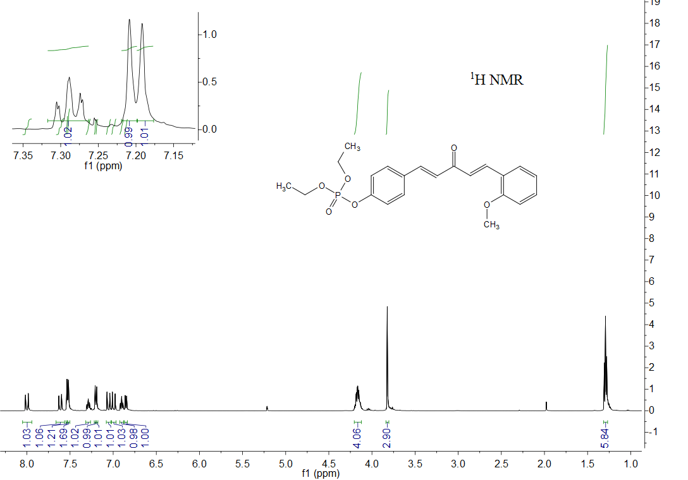
¹H NMR of compound 3h

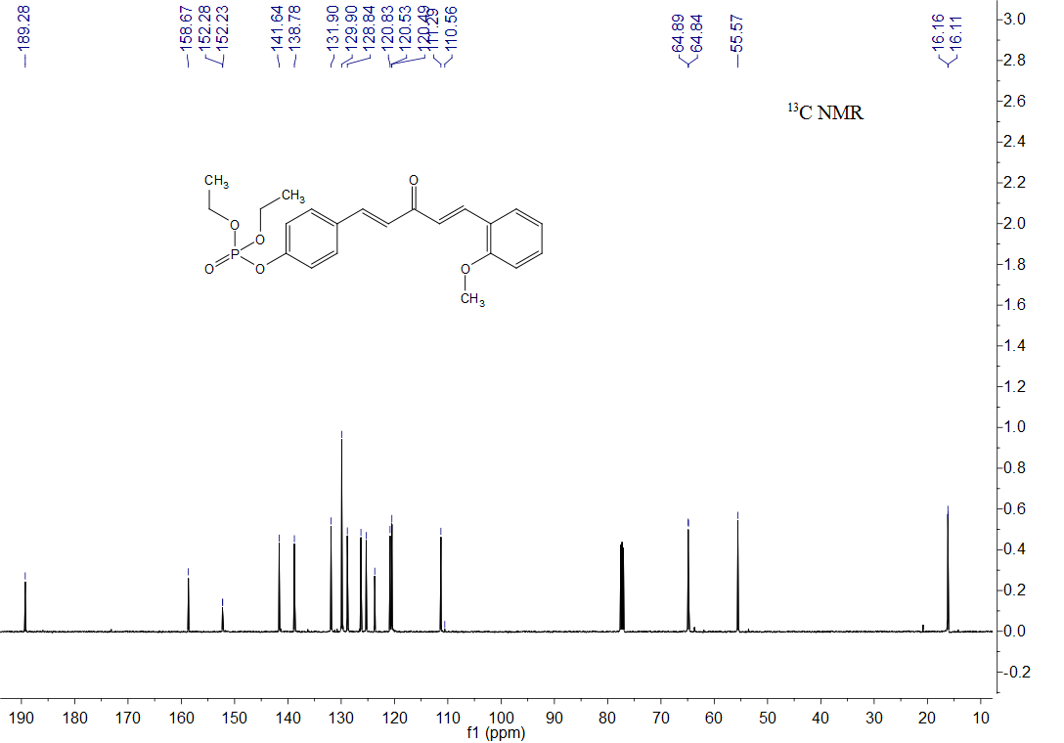
¹³C NMR of compound 3h

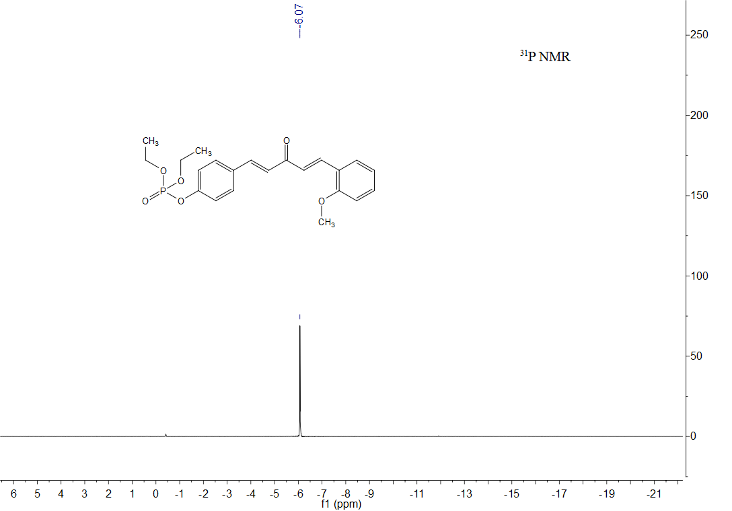
³¹P NMR of compound 3h

HRMS of compound 3h

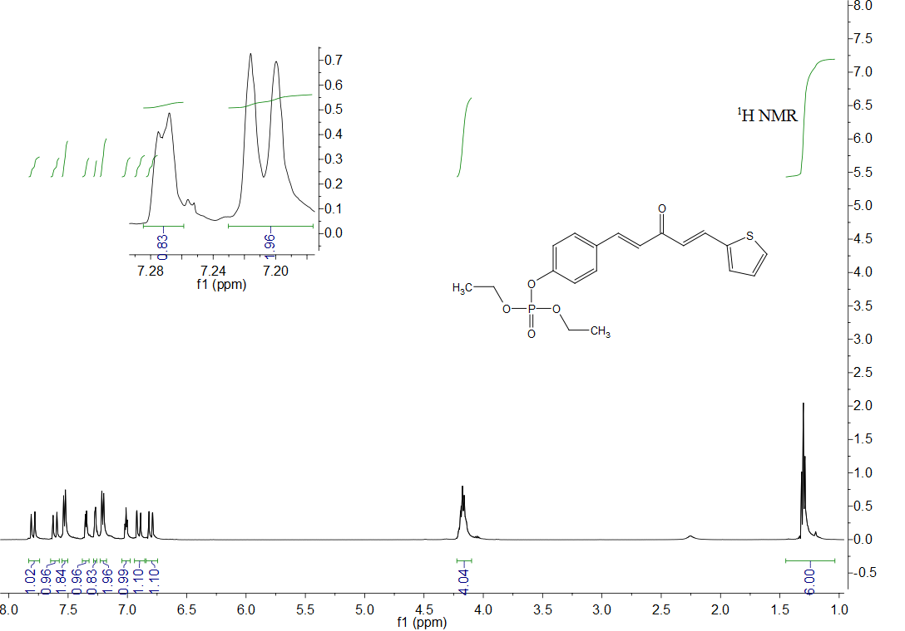
¹H NMR of compound 3i

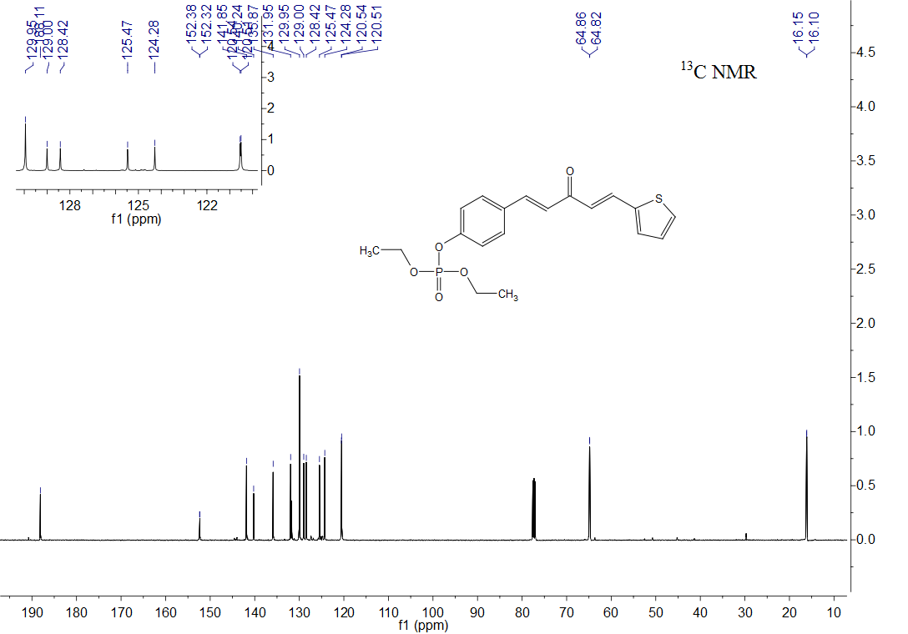
¹³C NMR of compound 3i

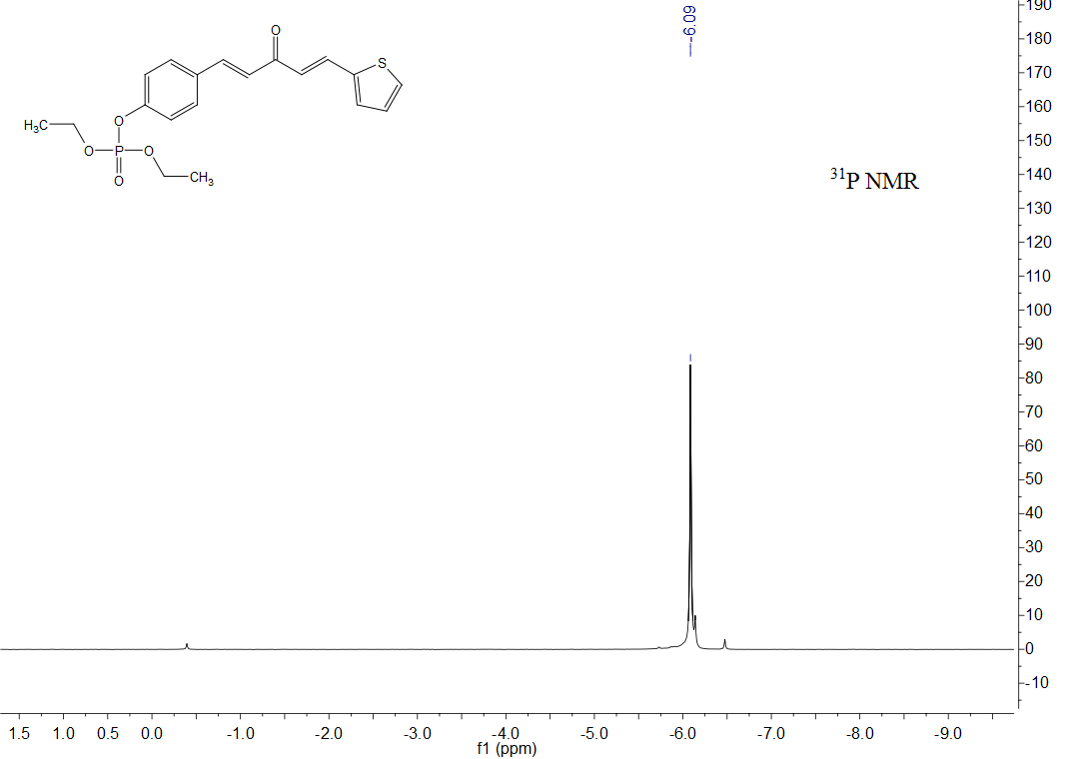
³¹P NMR of compound 3i

HRMS of compound 3i

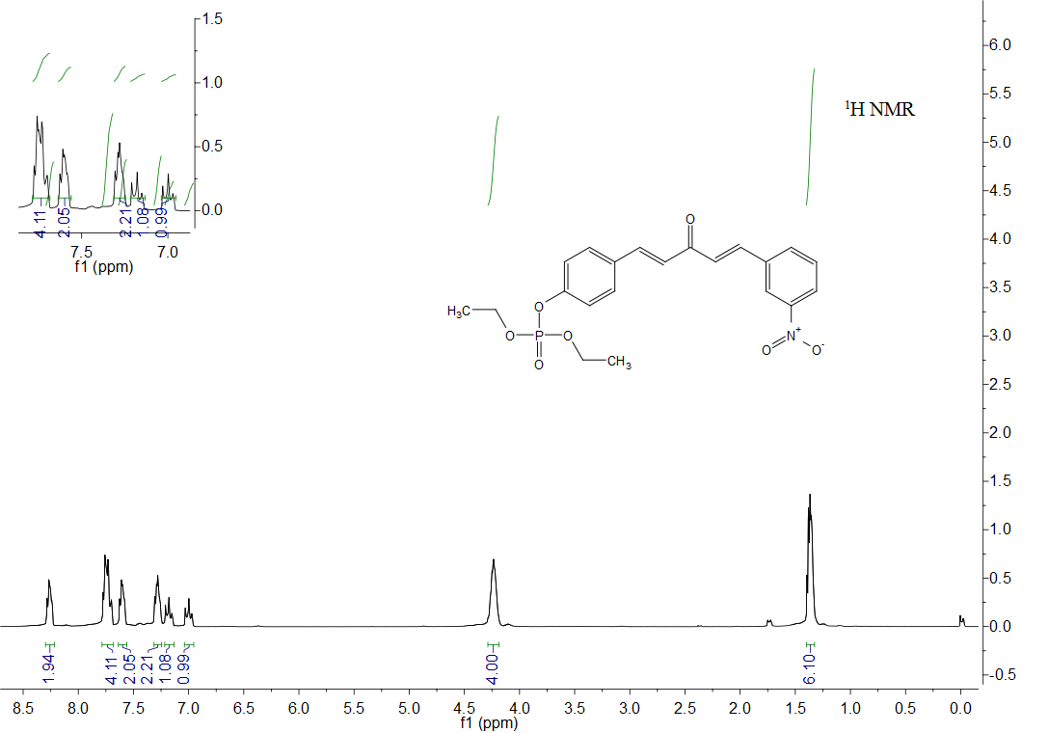
¹H NMR of compound 3j

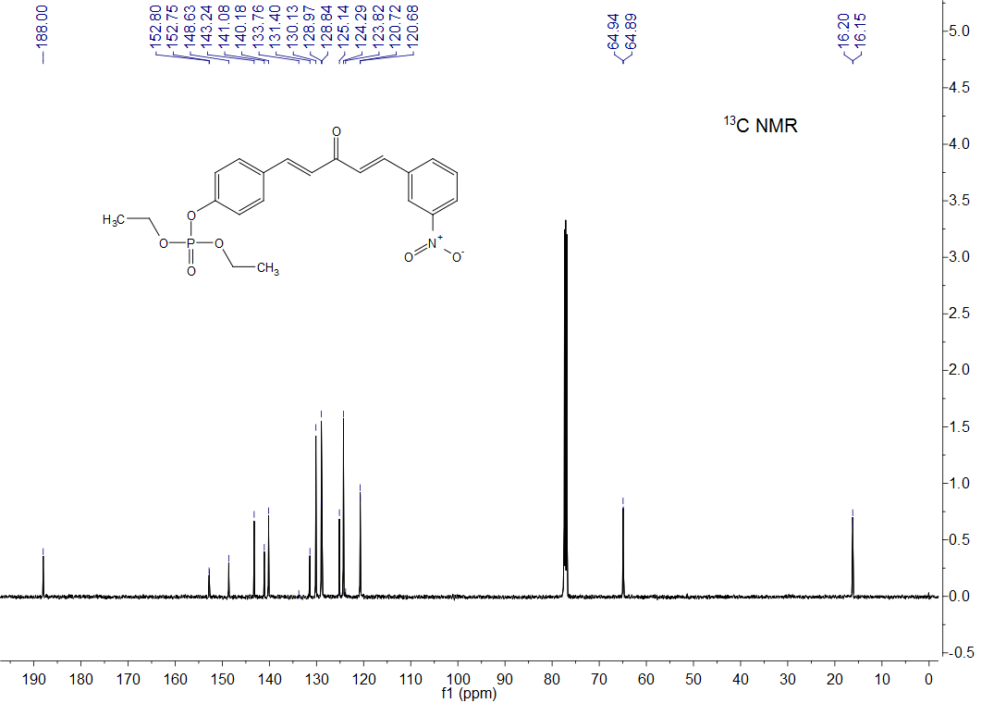
¹³C NMR of compound 3j

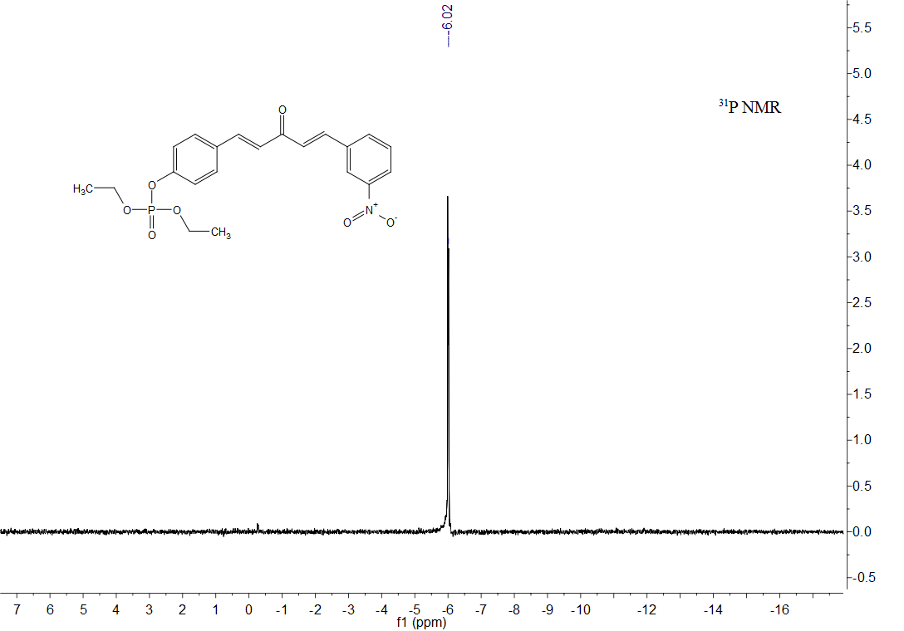
³¹P NMR of compound 3j

HRMS of compound 3j

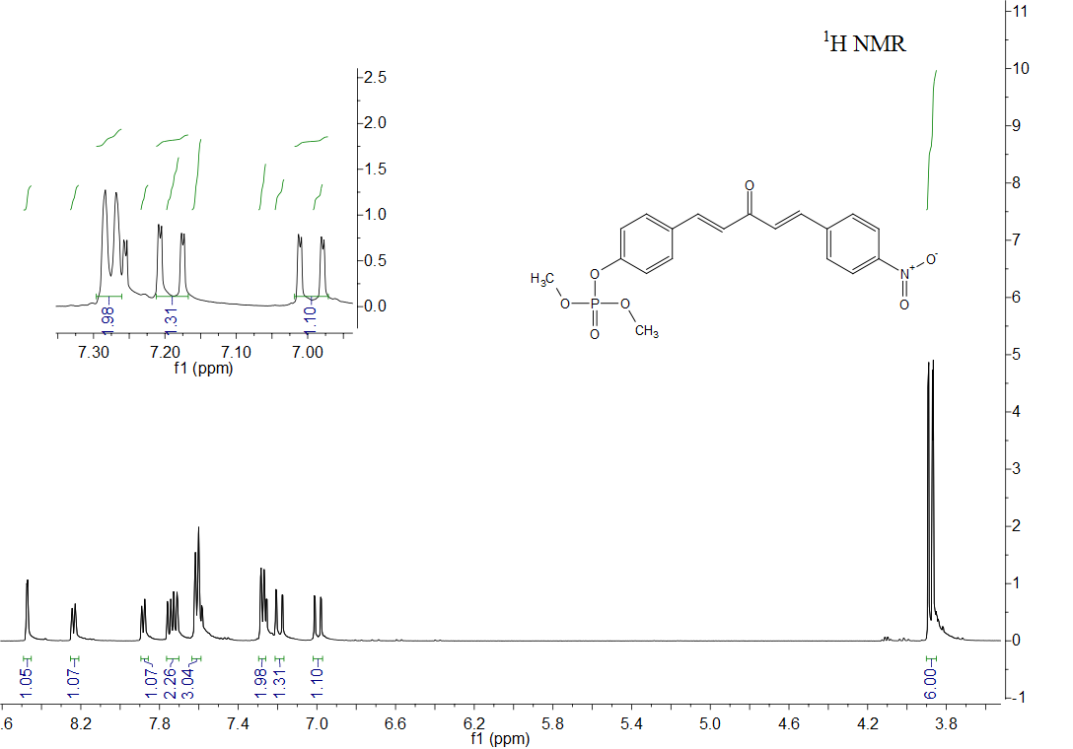
¹H NMR of compound 3k

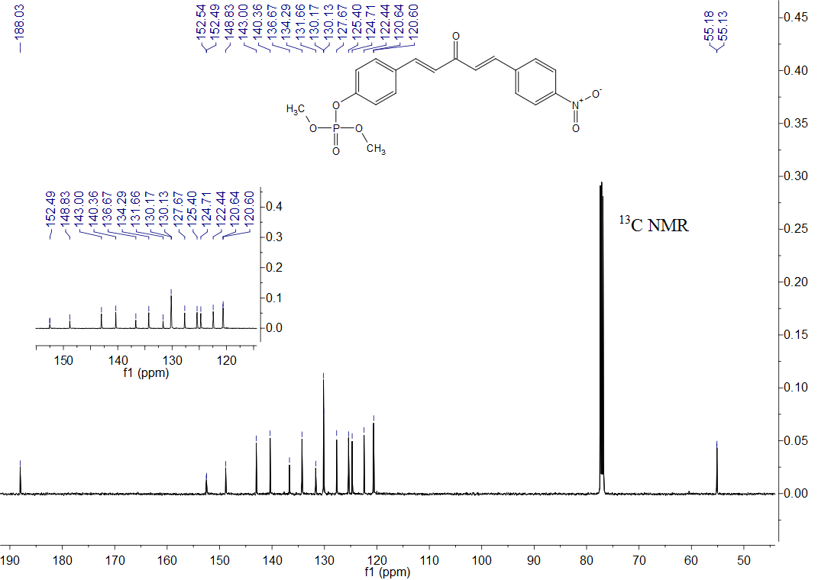
¹³C NMR of compound 3k

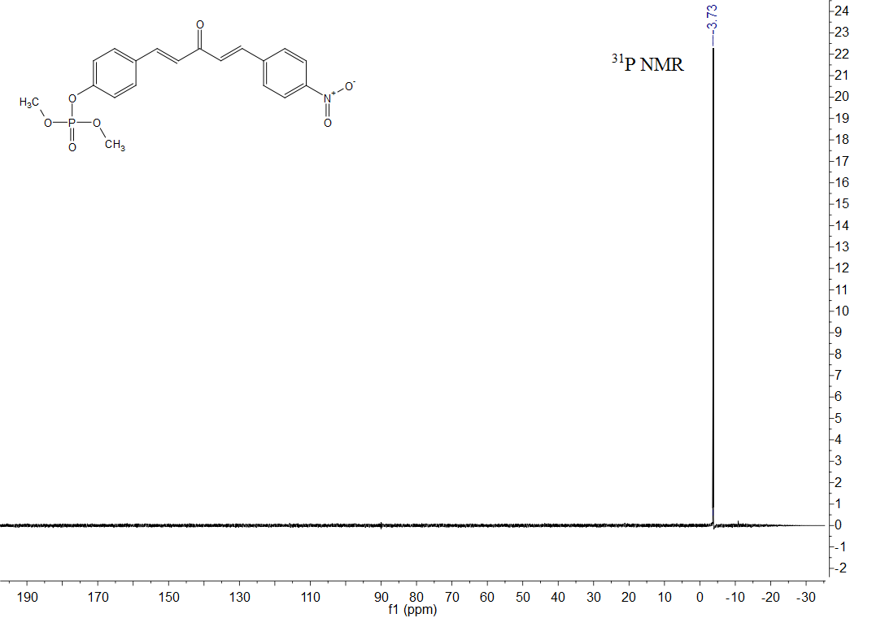
³¹P NMR of compound 3k

HRMS of compound 3k

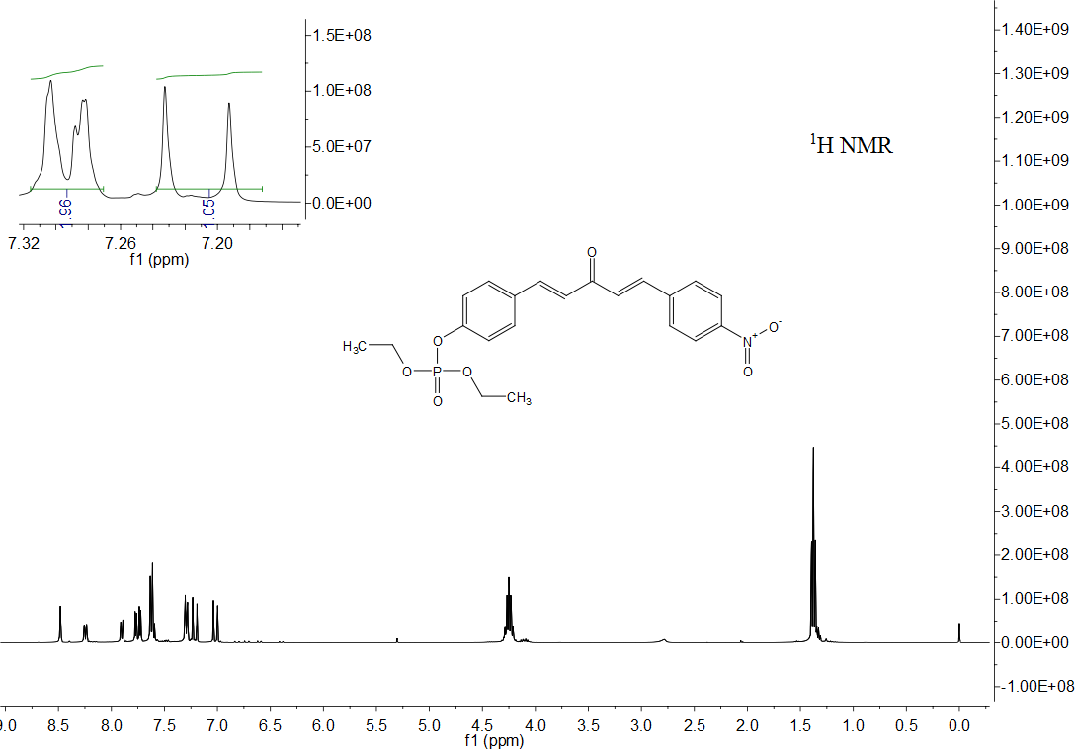
¹H NMR of compound 3l

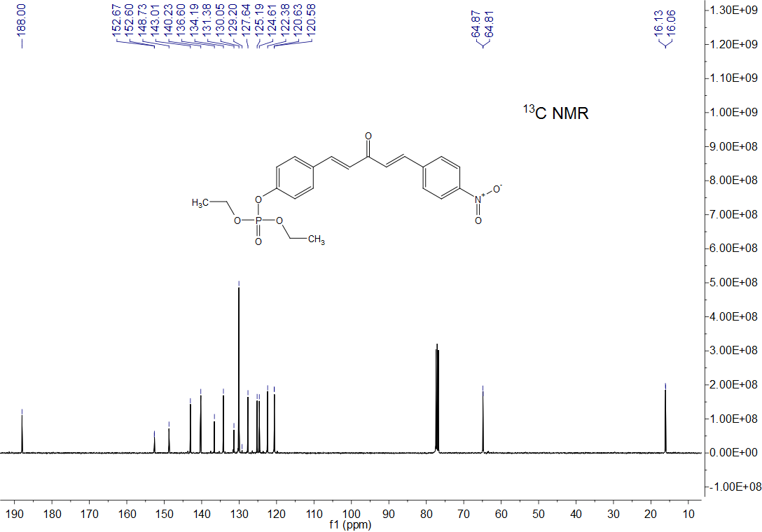
¹³C NMR of compound 3l

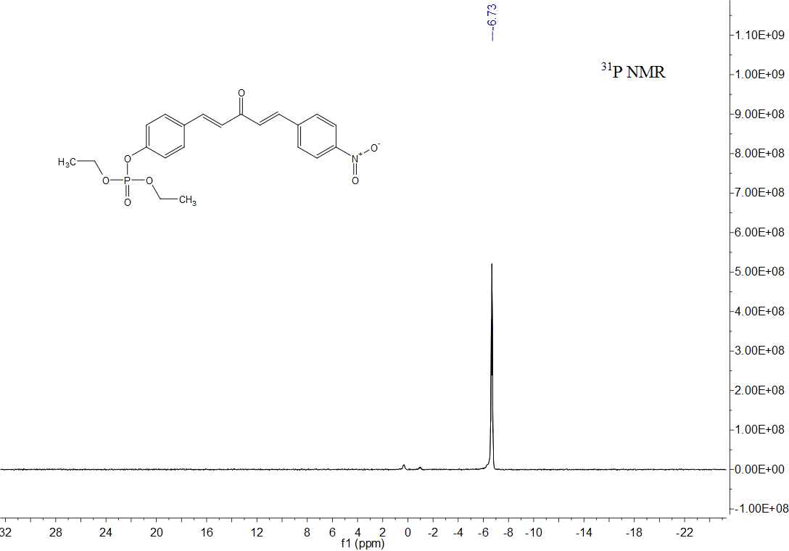
³¹P NMR of compound 3l

HRMS of compound 3l

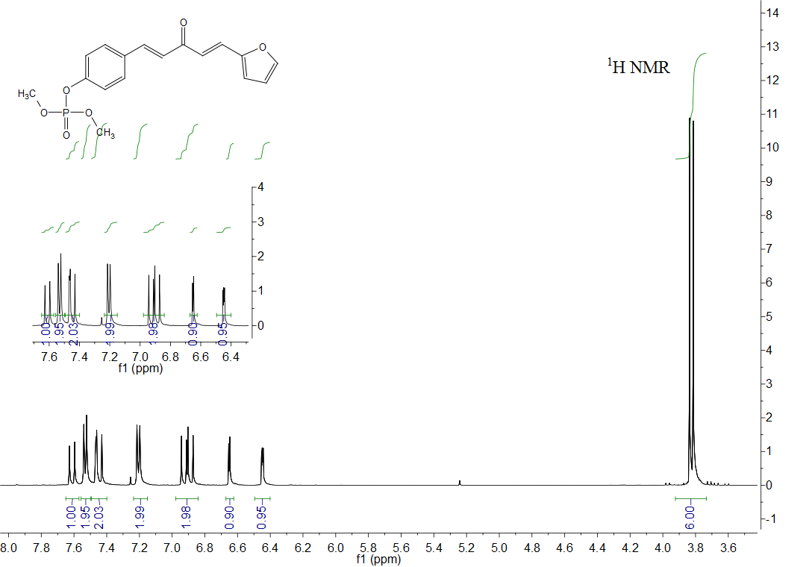
¹H NMR of compound 3m

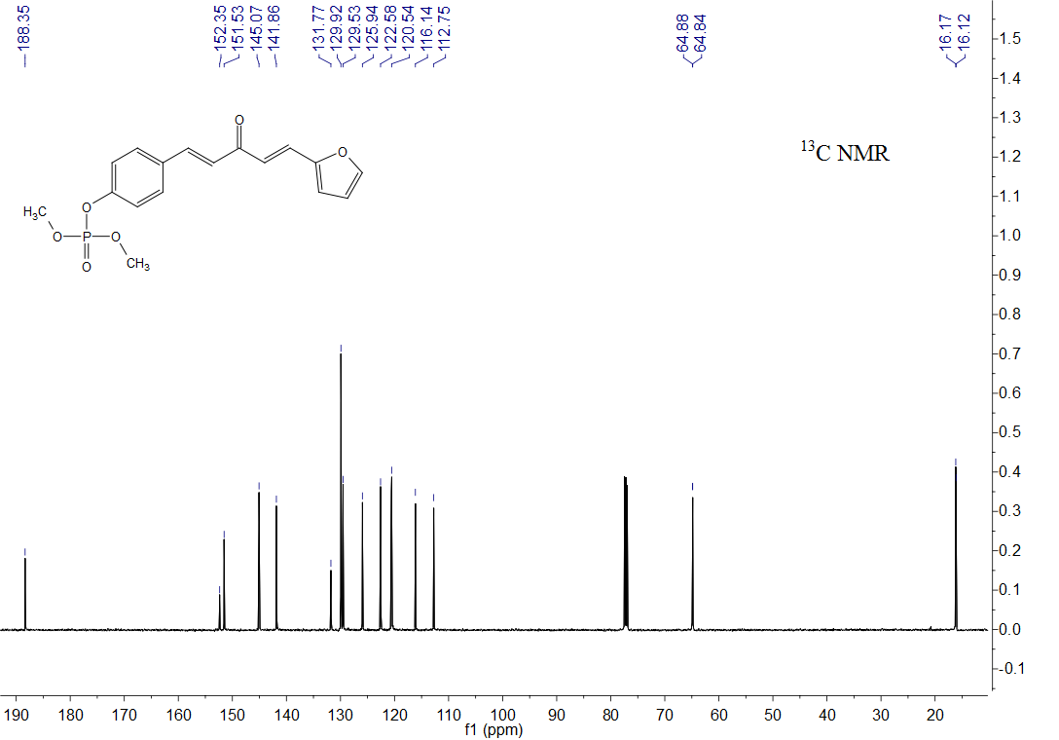
¹³C NMR of compound 3m

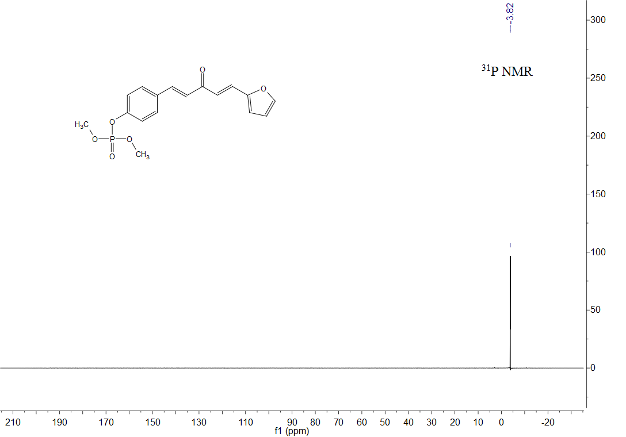
³¹P NMR of compound 3m

HRMS of compound 3m

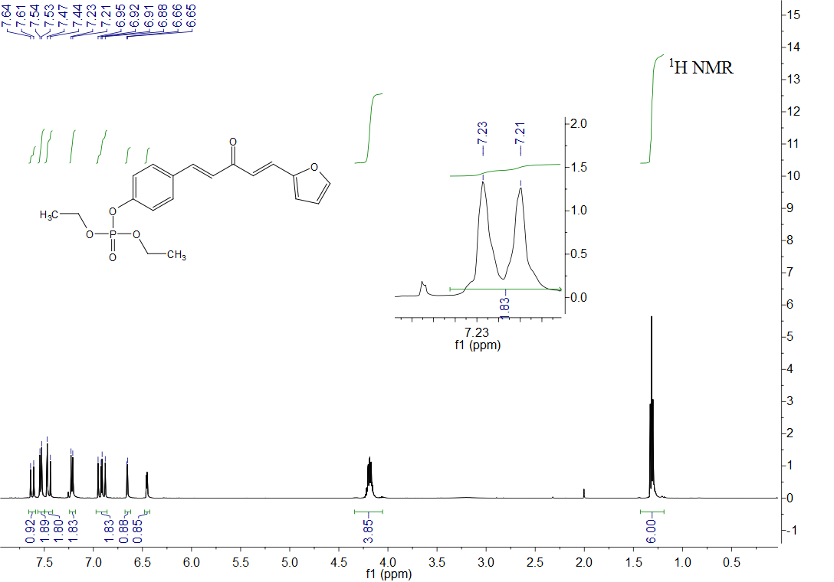
¹H NMR of compound 3n

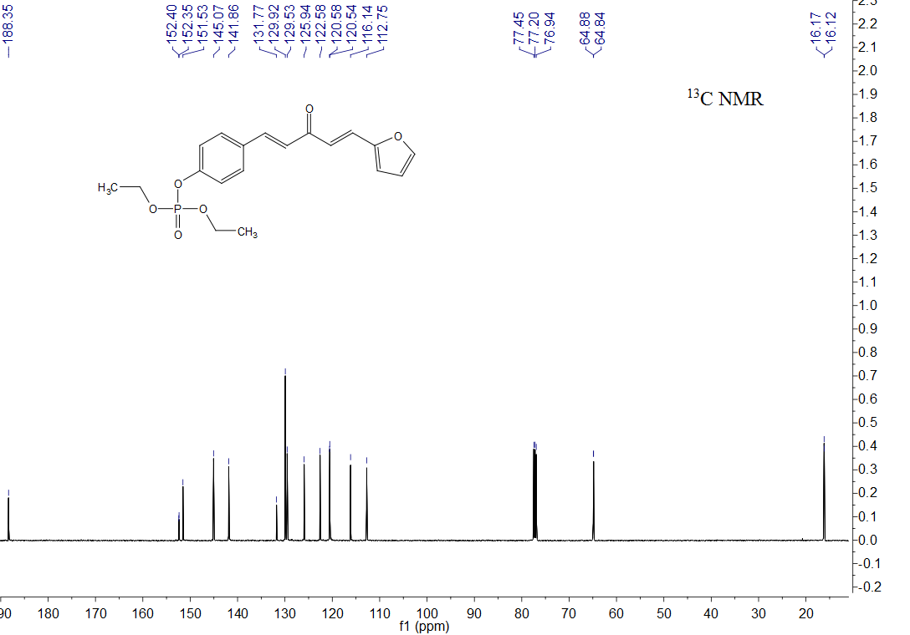
¹³C NMR of compound 3n

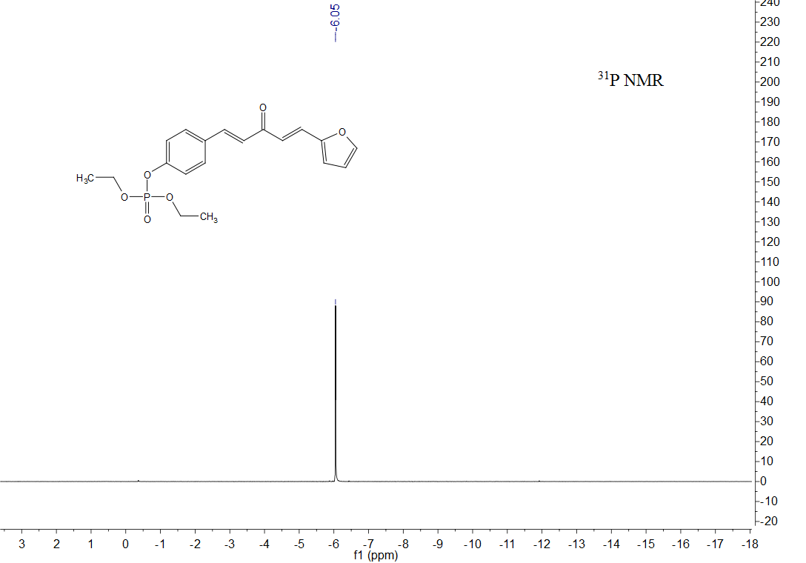
³¹P NMR of compound 3n

HRMS of compound 3n

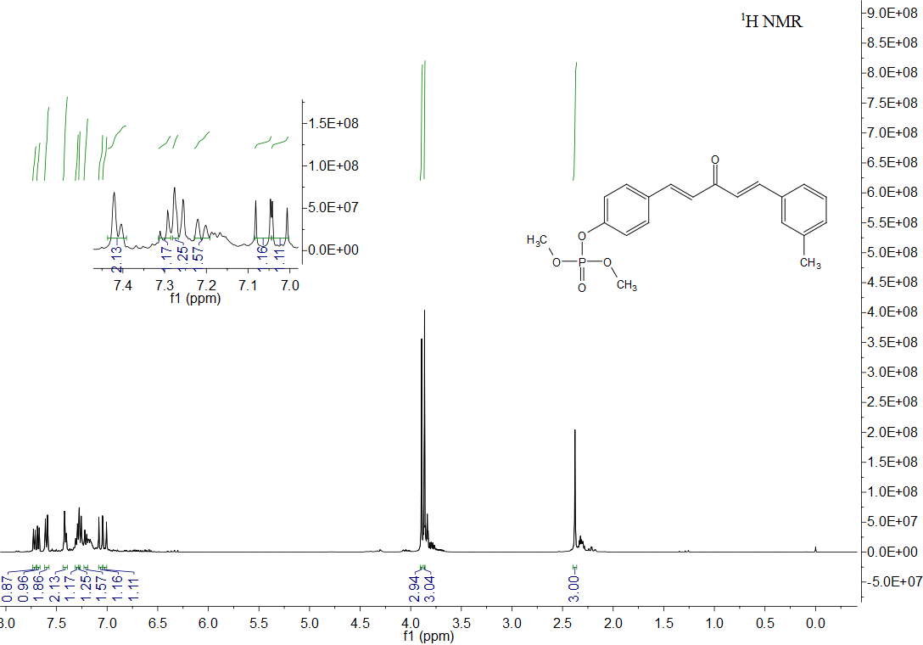
¹H NMR of compound 3o

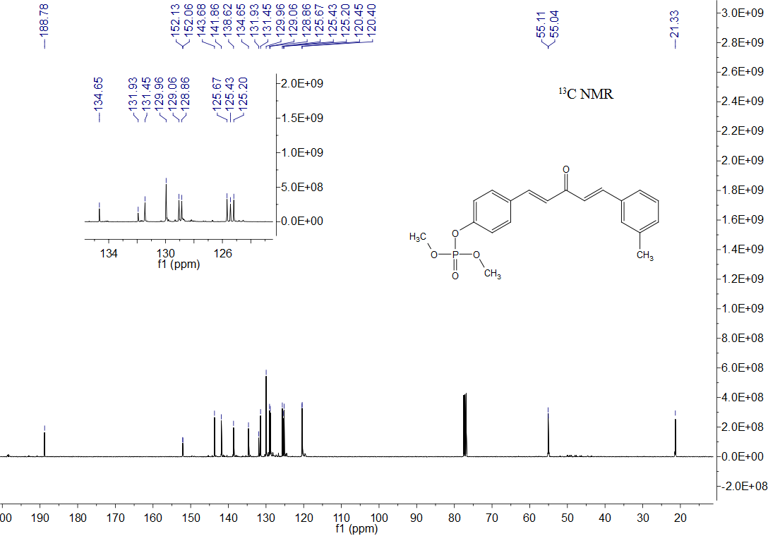
¹³C NMR of compound 3o

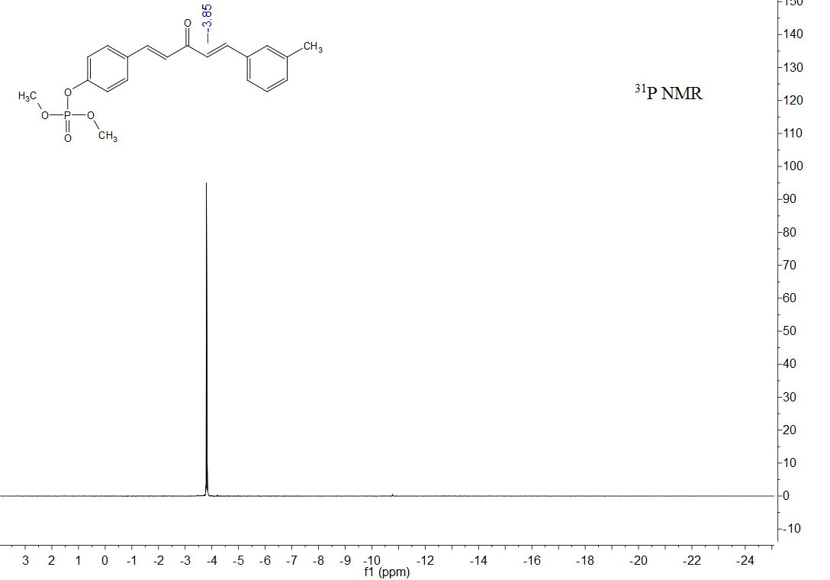
³¹P NMR of compound 3o

HRMS of compound 3o

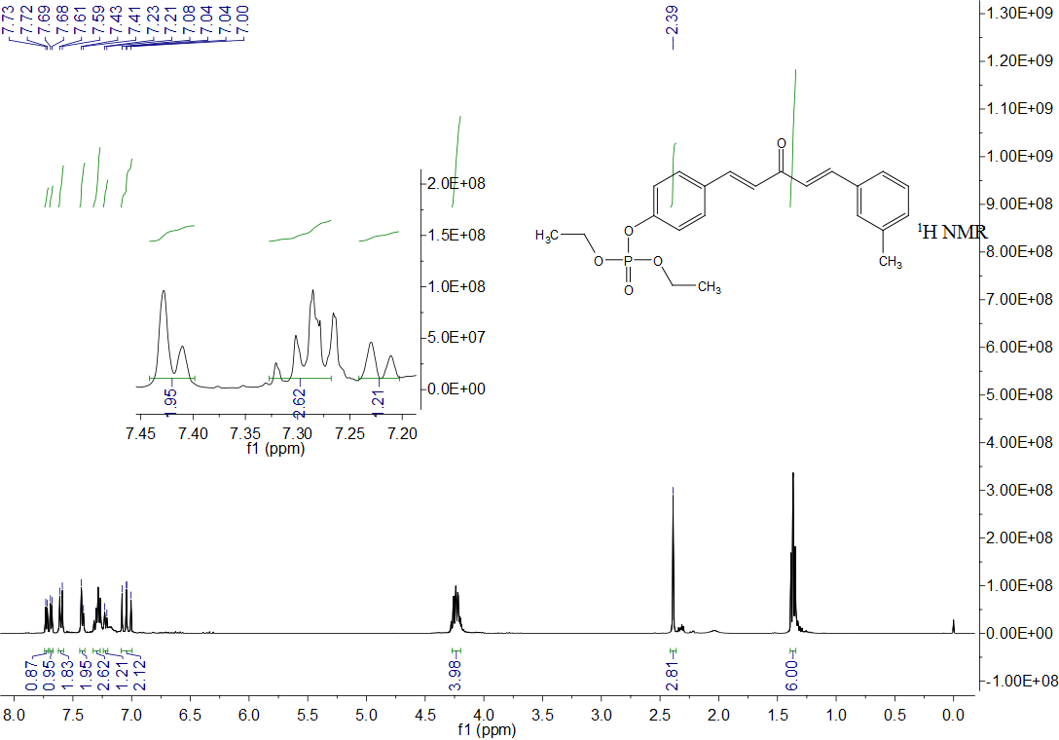
¹H NMR of compound 3p

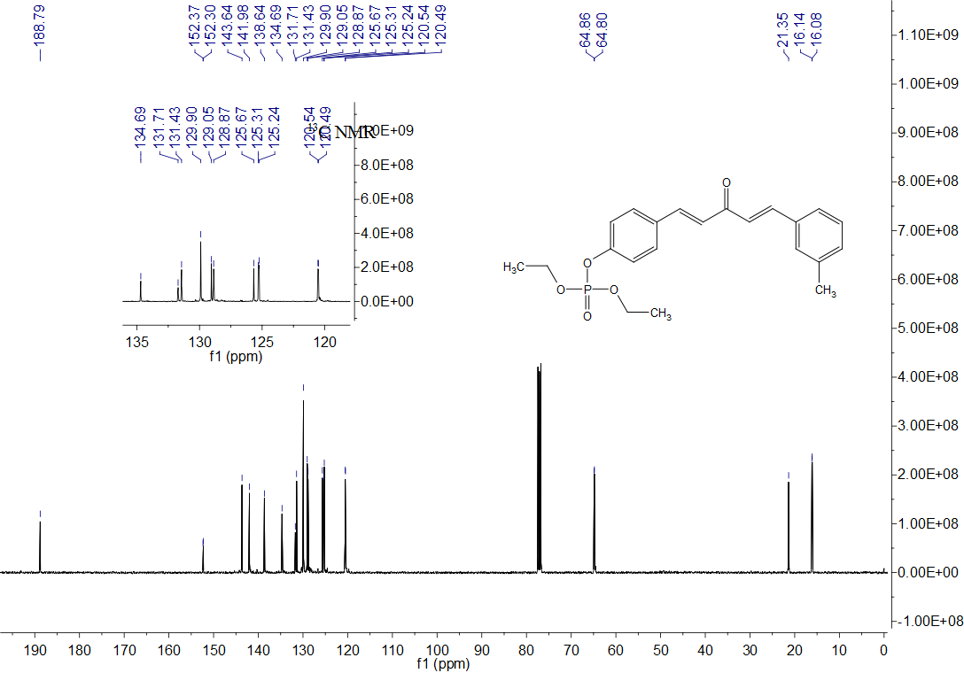
¹³C NMR of compound 3p

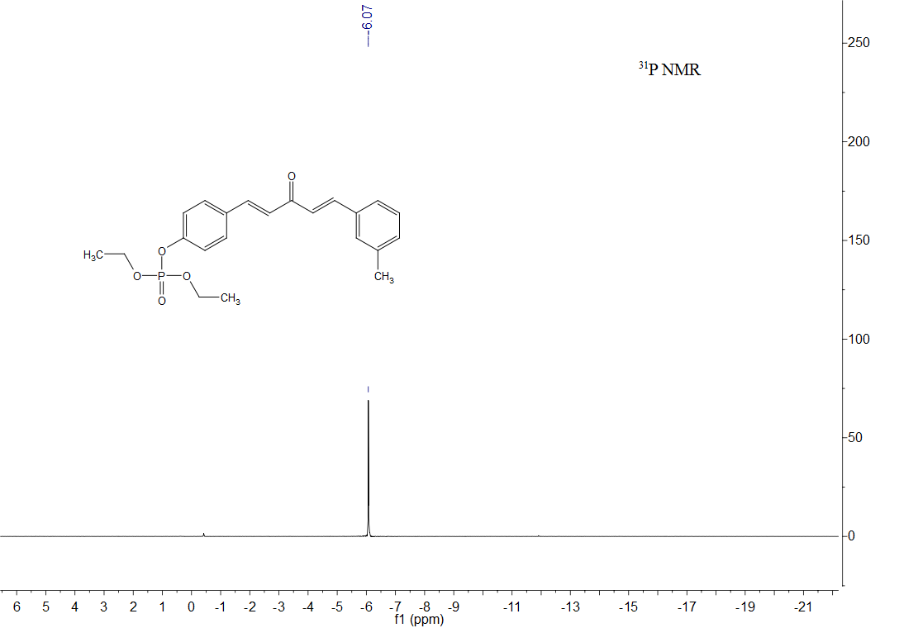
³¹P NMR of compound 3p

HRMS of compound 3p

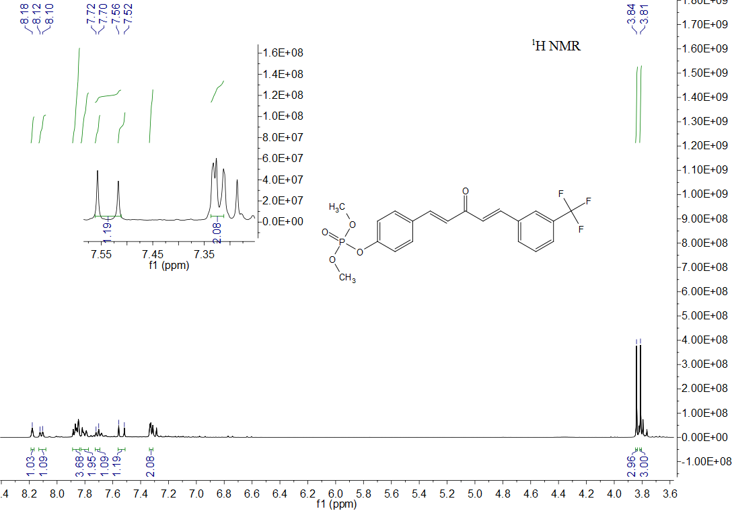
¹H NMR of compound 3q

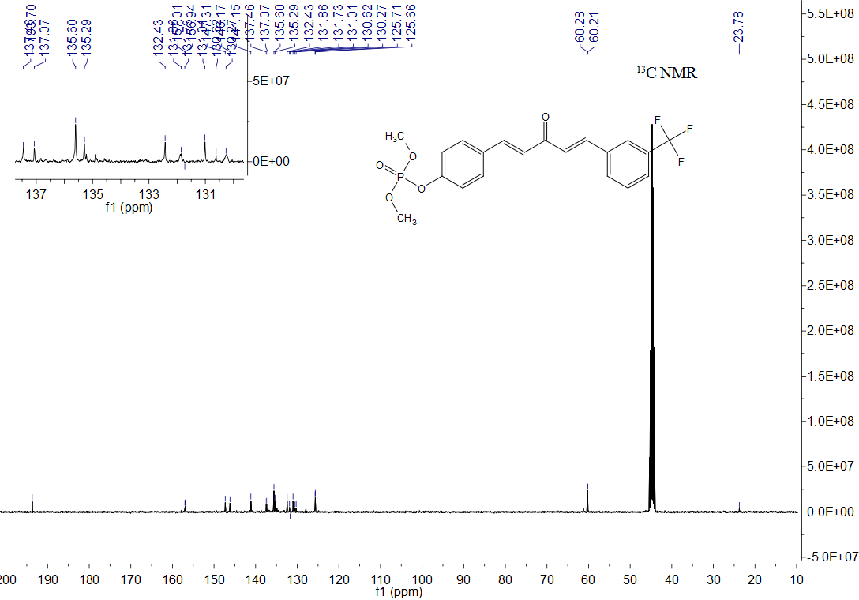
¹³C NMR of compound 3q

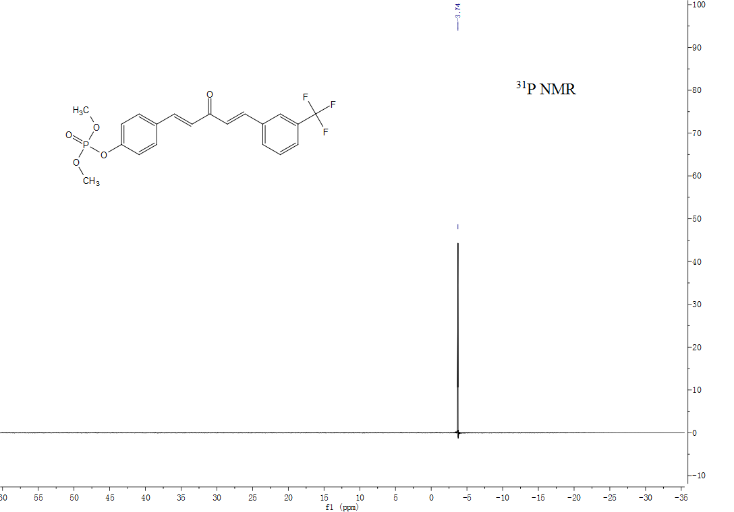
³¹P NMR of compound 3q

HRMS of compound 3q

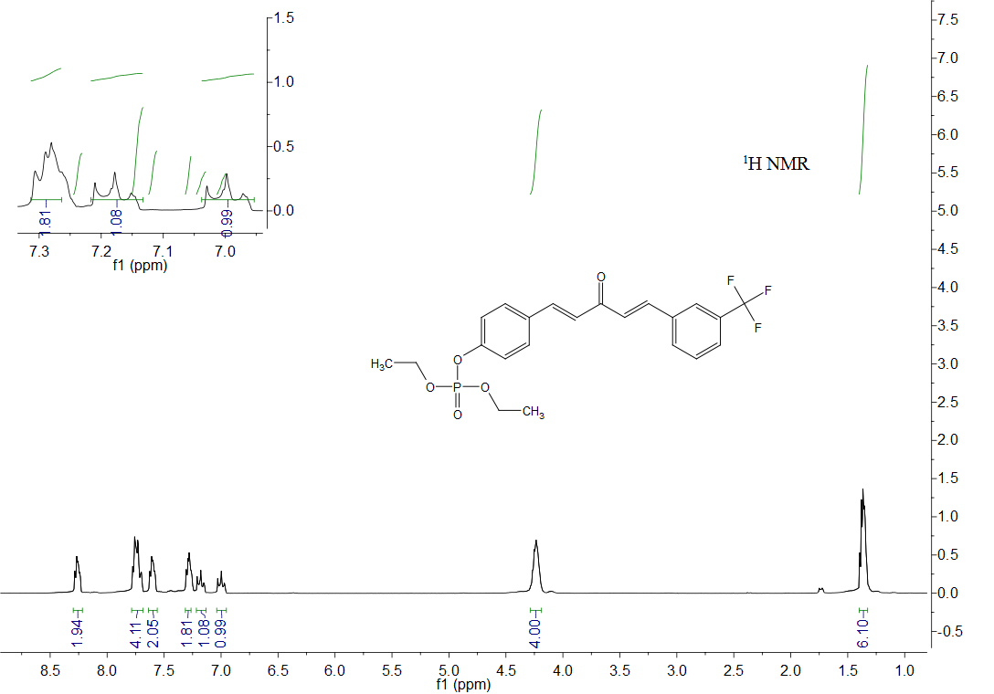
¹H NMR of compound 3r

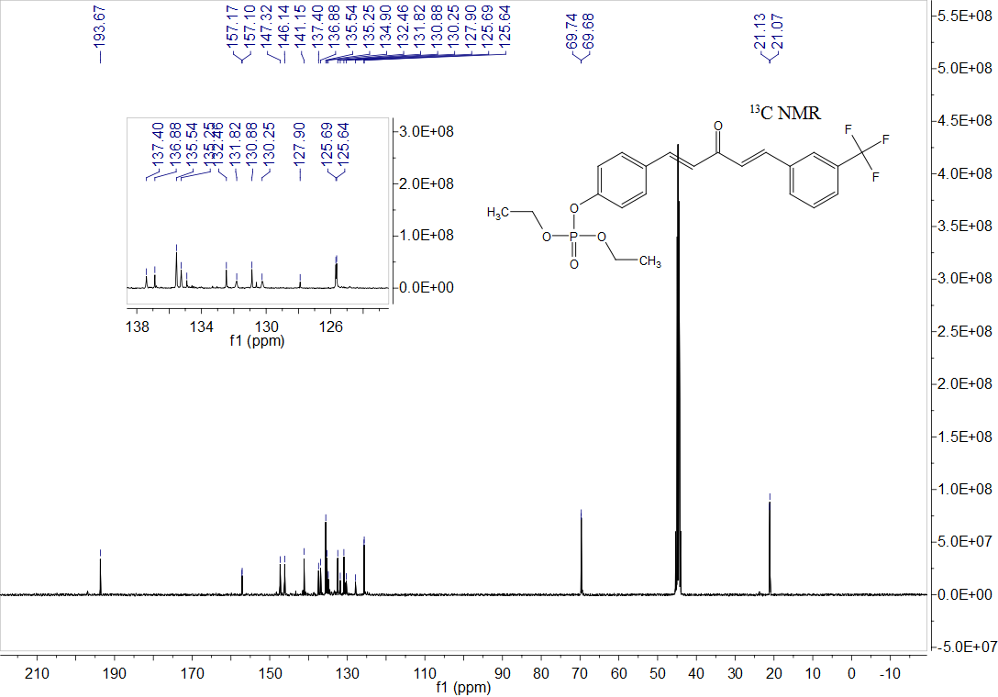
¹³C NMR of compound 3r

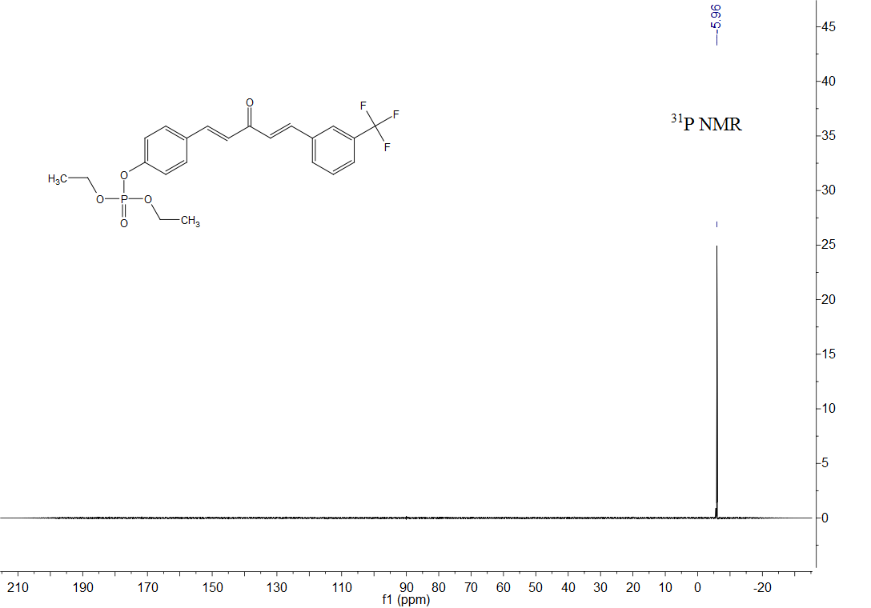
³¹P NMR of compound 3r

HRMS of compound 3r

