Diastereomeric Recognition of
5',8-cyclo-2'-deoxyadenosine Lesions by Human Poly(ADP-Ribose) Polymerase 1 in Biomimetic Model

Annalisa Masi^{1*}, Arianna Sabbia², Carla Ferreri^{1*}, Francesco Manoli¹, Yanhao Lai³, Eduardo Laverde⁴, Yuan Liu^{3,4,5}, Marios G. Krokidis⁶, Chryssostomos Chatgilialoglu¹, Maria Rosaria Faraone Mennella^{2*}

¹Istituto per la Sintesi Organica e la Fotoreattività, Consiglio Nazionale delle Ricerche, Bologna, Italy; annalisa.masi@isof.cnr.it (A.M.); carla.ferreri@isof.cnr.it (C.F.); francesco.manoli@isof.cnr.it (F.M.); chrys@isof.cnr.it (C.C.)
² Dipartimento di Biologia, Università di Napoli “Federico II”, Napoli, Italy; ar.sabbia@studenti.unina.it (A.S.); faraone@unina.it (M.R.F.M.)
³Department of Chemistry and Biochemistry, Florida International University, Miami, Florida, U.S.A; yalai@fiu.edu (Y.L.); yualiu@fiu.edu (Y.L.).
⁴Biochemistry Ph.D. Program, Florida International University, Miami, Florida, U.S.A; eduardo.laverde@fiu.edu (E.L.)
⁵Biomolecular Sciences Institute, Florida International University, Miami, Florida, U.S.A.
⁶Institute of Nanoscience and Nanotechnology, NCSR Demokritos, Athens, Greece; m.krokidis@inn.demokritos.gr (M.G.K.)
Correspondence: carla.ferreri@isof.cnr.it, annalisa.masi@isof.cnr.it, faraone@unina.it. These authors contributed equally to the work

Table of contents:
Starting materials S3 ODNs characterization: HPLC, MALDI (Figures S1 and S2) S3-S6
Melting point experiments (Figure S3) S6
Calculations of affinity (K_{a}) and dissociation (K_{d}) constants S7-S8 Circular dichroism and fluorescence analyses for PARP2 (Figure S4) S9
Full-length immunoblottings and gel mobility shift assay (Figures S5 and S6) S10-S11

Starting materials for oligonucleotide synthesis: Chemicals were purchased from Sigma Aldrich, Fluka and Link Technologies. HPLC-grade acetonitrile was obtained from Sigma Aldrich. Buffer for high performance liquid chromatography was prepared using water purified with a Mill-Q system.
MALDI-TOF mass spectrometry and analytical SAX HPLC chromatography were used to characterize the purified ODNs.

Oligonucleotides (ODNs) characterization:

Figure S1. Analytical SAX HPLC chromatograms of purified ODNs. Column and conditions: SAX DNAPac PA-100 column, 5µm, 4x250 mm; mobile phase A: TRIS.HCl 25 mM, pH 8.0, mobile phase B: TRIS.HCl 25mM, NaClO₄ 0.5M, pH 8.0. Gradient: 2-30 % B in A in 30 min. Flow rate was 1 mL/min. (A) ss-N, (B) ss-5′S, (C) ss-5′R, (D) complementary strand.

Molecular masses of the synthesized ODNs All the oligonucleotide masses were obtained by MALDI-TOF in negative mode.
ssN: GCA GAC ATA TCC TAG AGX CAT AT, X=dA; Mass calcd Da 7040.7; Mass Found Da 7038.1.

ss-5’S: GCA GAC ATA TCC TAG AGX CAT AT, X=5′S-cdA; Mass calcd Da 7038.7; Mass found Da 7037.2

ss-5’R: GCA GAC ATA TCC TAG AGX CAT AT, X=5′R-cdA; Mass calcd Da 7038.7; Mass found Da 7036.9

CS=complementary strand ATA TGT CTC TAG GAT ATG TCT GC; Mass calcd Da 7044.7; Mass found Da 7044.7

Figure S2 MALDI-TOF analyses. The analyses were performed using a Voyager DE Pro (Applied Biosystems, Foster City, CA) equipped with a pulsed N2 laser operating at 337 nm. Whole oligonucleotides negative ion spectra were acquired in linear mode over a m/z range from 3500 to 7000 using a 20000-V accelerating voltage, a 17000-V grid voltage, and a delay extraction time of 200 ns. The spectrum for each spot was obtained by averaging the result of 100 laser shots. External mass calibration was performed using peptides standard mixture (mass range: 1000-6000). The analyses were performed by spotting on the target plate 1 µL of the sample mixed with an equal volume of the matrix solution, 50 mg/mL 3-hydroxypicolinic acid/ 50 mg/mL diammonium citrate (9/1) (v/v) in water.

A: Melting Temperature of ds-N:
5′-d(GCA GAC ATA TCC TAG AGA CAT AT)-3′
5′-d(ATA TGT CTC TAG GAT ATG TCT GC)-3′

Tm = 60°C
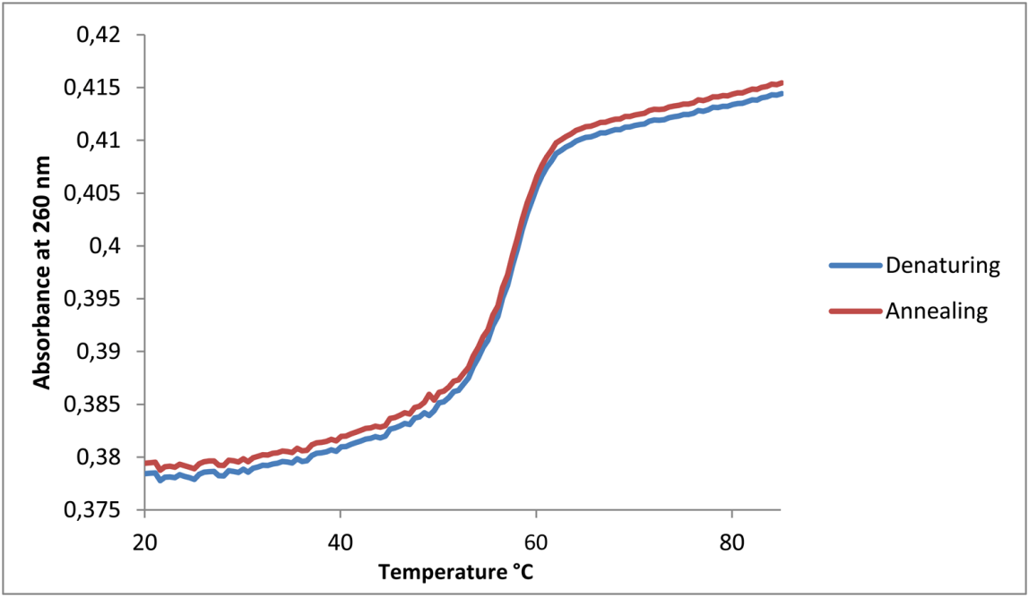
Figure S3 UV melting curves of 23-mer duplexes. Melting temperatures (Tm) of the substrates were measured with a Cary 100 UV/Vis spectrometer using a 1 mL quartz cuvette with a 1 cm pathlenght. This allowed to monitor the absorbance of the solutions at 260 nm as a function of temperature. The temperature cycles were recorded from 20 to 80 °C per each strand with a temperature controller at a heating rate of 0.3 °C/min

Calculations of affinity (K_{a}) and dissociation (K_{d}) constants of PARP1/oligonucleotide binding at saturating concentration of ligands.
Preliminary calculations
The following parameters were used for calculation:
Q = fluorescence quenching , at 369nm (max intensity of free PARP1)
$$Q=\frac{Io-I}{Io}$$
I₀ = max fluorescence intensity of free PARP1= 12630 (fluorescence intensity)
I= fluorescence intensity of free PARP1 in the presence of oligonucleotide at concentration of: 50, 100 or 200 nM
[total PARP1]=59,17·10⁻⁹M (1µg/130 µl)
$$\left[bound PARP1\right]=\left[total PARP1\right]×Q$$
$$\left[free PARP1\right]=\left[total PARP1\right]-[bound PARP1]$$

Constant calculations
The constant was calculated by McGhee & von Hippel equation at saturating concentration of ligands
Binding of PARP1 with ds-N was non cooperative (represented by a hyperbole, n=1).
Binding of PARP1 with ds-S and ds-R was cooperative (represented by sigmoids), with
the number of binding sites (n =2) as calculated by Hill equation:
$$θ=\frac{[ligand]×n}{[[ligand]×n+K_{0.5}}$$

where: K_{0.5}=[ligand] at 50% of engaged sites.
$$\frac{ν}{[free ligand]}=kd×\left(1-nν\right){\left[\frac{1-nν}{1-\left(n-1\right)ν}\right]}^{n-1}$$

Where:
$$ν=\frac{[bound ligand]}{[total protein]}$$

Figure S4. Circular dichroism and intrinsic fluorescence of mouse PARP2 in the absence and presence of ds-oligonucleotide substrates. (A-C) The CD profiles of mouse PARP2 alone (15 μg mL⁻¹,AG-40T-0012, AdipoGen, black line) and that of PARP2 along with 50 nM (A) or 100 nM (B) or 200 nM (C) ds-N (blue line), or ds-5′S (green line) or ds-5′R (red line), respectively. The profiles were measured in PBS buffer as described in Methods. (D-F) Experimental fluorescence profiles of Mouse PARP2 alone (15 μg·mL⁻¹, black line) and that from PARP2 along with 50 nM (D) or 100 nM (E) or 200 nM (F) of ds-N (blue line), or ds-5′S (green line) or ds-5′R (red line).

Figure S5. Full-length of immunoblotting analyses of Figure 3. (A, B) Full-length immunoblotting of PARP1-oligonucleotide complexes in the presence of 50 nM (A) and 200 nM (B) of double stranded oligonucleotide substrates. Each panel is a different blot. The full-length immunoblots evidence that only PARP is involved in the interaction with oligonucleotides. Immunoreactive bands start at native molecular weight of PARP and appear above, up to the top of the filter (aggregates).

Figure S6. The original gel mobility shift assay of Figure 4 in the main text.

