Supplementary Materials
Table SM-1: Carbon-14 dates for 17 dated bulk sediment samples from Schurmsee, including uncertainties and δ13C values.
lab code | depth | material | ¹⁴C age | 1 St.Dev. | δ¹³C | cal age
[-] | [cm] | [-] | [yr BP] | [yr] | [‰] | [cal yr BP]
Hd-27165 | 50 | bulk | 824 | ±20 | -28.4 | 814
Hd-28112 | 80 | bulk | 1435 | ±20 | -30.5 | 1477
Hd-28114 | 95 | bulk | 1975 | ±20 | -30.4 | 1934
Hd-28036 | 125 | bulk | 2767 | ±25 | -31.3 | 2782
Hd-28115 | 166 | bulk | 3868 | ±30 | -31.1 | 4035
Hd-28089 | 170 | bulk | 4433 | ±38 | -30.9 | 4162
Hd-28111 | 188 | bulk | 4582 | ±29 | -32.8 | 4650
Hd-27975 | 207 | bulk | 5226 | ±26 | -31.7 | 5233
Hd-28088 | 222 | bulk | 5770 | ±28 | -31.4 | 5747
Hd-28078 | 232 | bulk | 6078 | ±35 | -32.0 | 6068
Hd-27973 | 247 | bulk | 6535 | ±26 | -31.6 | 6583
Hd-28035 | 280 | bulk | 7917 | ±38 | -30.7 | 7872
Hd-28087 | 292 | bulk | 8349 | ±34 | -30.0 | 8252
Hd-27998 | 315 | bulk | 8807 | ±43 | -28.5 | 8782
Hd-27601 | 340 | bulk | 9075 | ±34 | -29.2 | 9086
Hd-27605 | 355 | bulk | 9204 | ±44 | -28.9 | 9205
Hd-28156 | 400 | bulk | 9465 | ±56 | -29.6 | 9468

Table SM-2: Carbon-14 dates for 16 dated bulk sediment samples from Glaswaldsee, including uncertainties and δ13C values. The values in parenthesis indicate one sample which was removed from the age-depth model.
lab code | depth | material | ¹⁴C age | 1 St.Dev. | δ¹³C | cal age
[-] | [cm] | [-] | [yr BP] | [yrs] | [‰] | [cal yr BP]
Hd-26951 | 8 | bulk | 586 | ±31 | -30.8 | 558
Hd-27051 | 30 | bulk | 1344 | ±30 | -32.2 | 1285
Hd-26823 | 40 | bulk | 1737 | ±25 | -33.1 | 1701
Hd-26950 | 48 | bulk | 2205 | ±33 | -32.4 | 2093
(Hd-27050) | (-55) | (bulk) | (-2273) | (±22) | (-32.7) | (-2349)
Hd-27049 | 70 | bulk | 2838 | ±26 | -32.9 | 3230
Hd-27360 | 75 | bulk | 3720 | ±34 | -33.4 | 3799
Hd-26751 | 80 | bulk | 3933 | ±58 | -31.0 | 4337
Hd-27015a | 93 | bulk | 4685 | ±25 | -21.2 | 5314
Hd-26850 | 97 | bulk | 4713 | ±30 | -33.2 | 5511
Hd-27361 | 105 | bulk | 5133 | ±30 | -32.4 | 5900
Hd-26785 | 113 | bulk | 5613 | ±31 | -32.5 | 6363
Hd-27362 | 126 | bulk | 6290 | ±29 | -32.3 | 7249
Hd-26842 | 138 | bulk | 7379 | ±29 | -32.1 | 8153
Hd-27054 | 160 | bulk | 8120 | ±44 | -30.3 | 9090
Hd-27033 | 172 | bulk | 8940 | ±61 | -29.5 | 9489

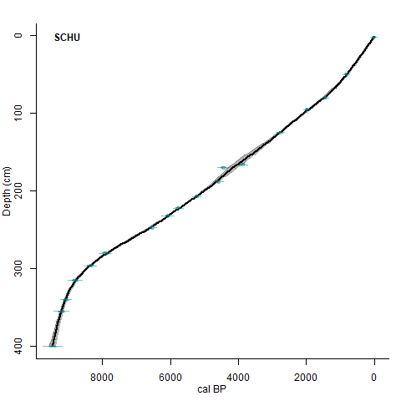
Figure SM-1: Age-depth model of Schurmsee, developed using CLAM 2.2. They grey shaded area represents the confidence interval of the model. The age calendar age distribution of each sample included in the model is marked in green.

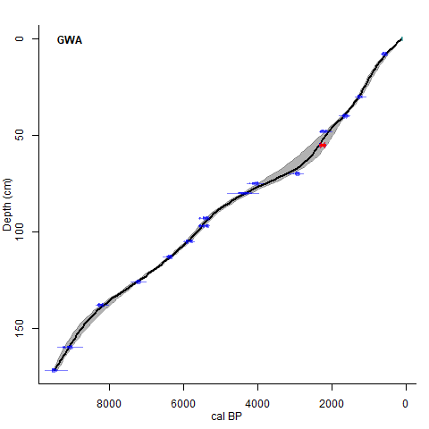
Figure SM-2: Age-depth model of Glaswaldsee, developed using CLAM 2.2. The grey shaded area represents the confidence interval of the model. The age calendar age distribution of each sample included in the model is marked in blue, while one sample that was excluded from the model is marked in red.

