Supporting Information
What characterizes the polymodal media of the mobile phone? The multiple media within the world’s most popular medium

S.1 Data description

In total we have useful data from 10,725 users from India. Each one of them committed to be monitored for one continuous month during an 11 month period (July 2011 to May 2012), without knowledge about which month their behavior would be recorded. With this randomized strategy we aimed at avoiding behavioral changes due to awareness of active monitoring. This resulted in an average daily collection of 885.5 users, with a low in July 2011 (average 734) and a high in January 2012 (928 users) (SD 61; min 656; max 948) (see Figure S.1). In this sense, our dataset can be looked at from two perspectives, one as eleven monthly samples of around 886 users, and the other one as one month-long sample of 10,725 users (collected over 11 months). As we did not find any insightful evidence of interesting behavioral changes during the year we opted to analyze the second option, giving us more statistical power to test of diversity in user characteristics. We recorded an average of 168,857 app sessions on each of the 335 days (SD 12,756; min 87,473; max 208,216), for an average of some 2,928 hours per day.
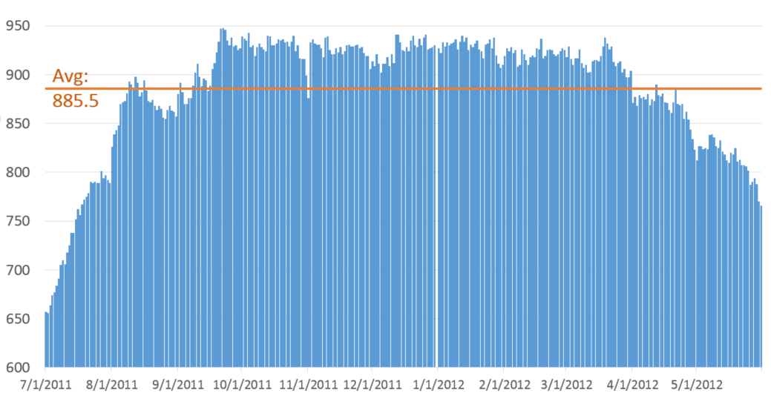
Figure S.1. Daily sample size over the 11 month period from July 2011 to May 2012.

S.1.1 Communicator characteristics
The multivariate tests in this article include seven different variables that describe users, with 28 different characteristics (see Table S.1). We are very aware that testing for all of this this at once is certainty quite ambitious, as it results in $\prod{(2*5*2*5*7*4*3)}=8,400$ possible cross-tabulated user groups (compare Table S.1). Considering this, even our considerable sample size is necessarily plagued with holes. Our sample occupies 447 of these theoretically possible user groups, with the largest group (326 users) representing single males, between 22-31 years old, with some college, who have no official employment (most likely students, but could also be housewife or temporarily unemployed), and uses a a mid-priced, small-screen Symbian-run smartphone.
Table S.1. Frequencies of user characteristics among our 10,728 user sample.
 | Male |  | Female
Gender | 10,370 |  | 358
 | 16-21 |  | 22-31 |  | 32-41 | 42-51 |  |  | 52-62
Age | 3,013 |  | 5,704 |  | 1,503 | 452 |  |  | 56
 | Single |  | Married
Marital Status | 7,578 |  | 3,150
 | Illiterate | Some School |  |  | Secondary /High School |  |  | Some College |  |  | Graduate /Postgrad.
Education | 7 | 63 |  |  | 1,714 |  |  | 2,713 |  |  | 6,231
 | D |  | C |  | B2 | B1 |  |  | A2 |  |  |  | A1 |  | Other*
Employment | 42 |  | 576 |  | 728 | 841 |  |  | 1,907 |  |  |  | 916 |  | 5,718
 | Very exp. >15K |  |  | Expensive 10-15K |  |  | Medium 6-10K |  |  |  |  | Low 4-6K
Price mobile | 1,094 |  |  | 4,428 |  |  | 3,553 |  |  |  |  | 1,653
 | < 3” |  | 3” – 3.5” |  | > 3.5”
Screen Size | 5,955 |  | 4,212 |  | 558
Note: * includes students, housewives, temporarily unemployed, unknown.
Table S.1 makes it evident that our sample might not be representative of the Indian smartphone user population as a whole. While we lack detailed statistics about the true distribution of Indian smartphone users during the years of our study, we can assume that with a mobile phone penetration of 75 % in 2012 and a smartphone penetration of some 20 %, it is unlikely that merely 3.3 % of smartphone users were women (as in our sample). These kinds of sample biases are a common problem when working with data provided by incentive-motivated sampling methods. Our best option is to judiciously control our statistical tests with multivariate techniques. This effectively means that we condition on a certain group, and then obtain relative insights (relative to the conditioned variables). We do this in form of multivariate canonical correlations, and a series of ANCOVA and MANCOVA (see Table 1 in main text). This is possible as long as the sample size of underrepresented groups is still large enough to detect significant results. Obtaining the complete one-month long app usage of 358 female smartphone users is by no means a small sample. Our statistical tests also show that most of our tests detect significant results (even for an unequal group like gender, see Table 1 in main text).

S.1.2 Normalization of ex- and intensity measurements
One of the first questions to decide on is how to normalize mobile app usage: on the total number of users or on those users that actually use a certain type of app? Not all mobile phone users use all kinds of apps. While almost all users use their mobile phone for traditional H2H communication (98.2 %), and while H2T, H2B and H2F usage is prevalent among 92.1 %, 87.1 %, and 81.6 %, respectively, the totality of H2G is concentrated among a relatively small group of users that represents merely 22.5 % of users. This means that the mean value of gaming will heavily be influenced by the vast majority that does not use their phones for gaming. As a result, Figure S.2 shows that gaming represents a lot larger share if normalization is taken only on the number of actual users. The average H2G user plays for some 27 min per day (1,644 seconds) in an average of some 10.2 sessions. However, when normalizing with the total user sample, this mean value gets cut by more than a factor of four (see Table S.2). While analyzing actual usage behavior is certainly interesting, the average of the entire sample provides a broader first look at general tendencies. This includes the fact that less popular types of apps get penalized for not being as pervasive. For the purpose of this study, we therefore calculate means not on the number of actual users, but on the total number of users in our sample.

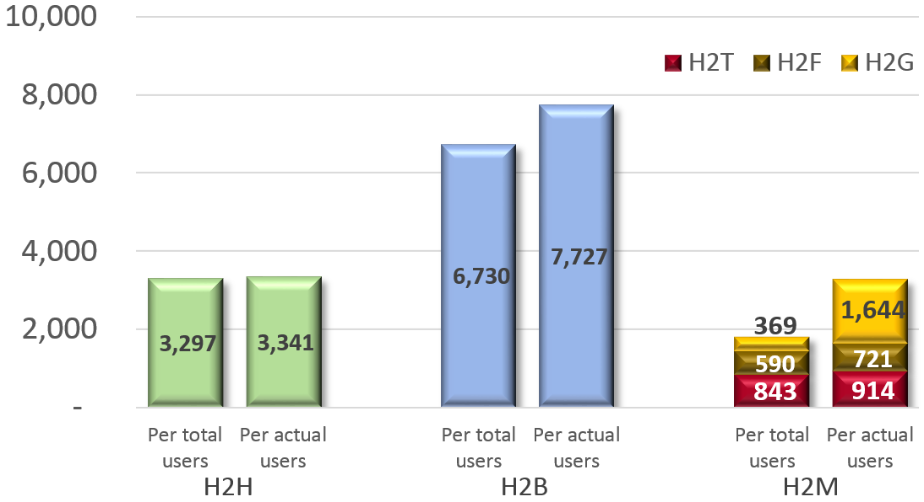
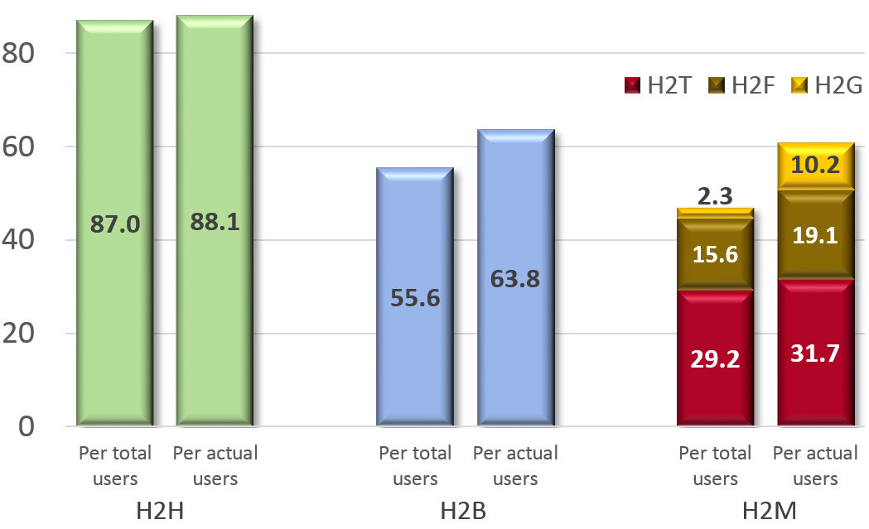
Figure S.2. Comparison of extensity of usage (upper graph, in seconds per day¹) and intensity (lower graph, in number of sessions per day) normalized on the total number of users, and normalized on those that use this H2x group of apps on a given day (actual users).

S.2 Mobile App Taxonomy
We classified mobile apps into the different categories in a two-step process. First we classified them into rather traditional rubrics, such as those used in app stores, like “Productivity”, “Utility”, “Music”, and “Games”. We consulted these existing classifications extensively. Fortunately (considering more than 16,000 apps), it was possible to partially automate this process, but with manual oversight. This resulted in 125 different rubrics. We then classified those into our different communication types. Table S. provides some examples for illustrative purposes.

Table S.2. From commercial rubrics to communication types.
H2F (Function) | H2T (Tool)
WLAN  Printer  App. Manager  File Manager  Memory Manager  Phone Management Facility  Task Manager  Anti-Virus  Phone tracker  Dictionary  Helper  Remote control  Time  Weather app …etc… | Media Editor  Recorder  Office  Calculator  Compass  Educational  GPS apps  Maps  Mobile Payment App  Portal App  Shopping  Time management  Toolbox  Travel Planner…etc…
H2B (Broadcast) | H2G (Game)
Browser  Image App  Media File Viewer App  Media player  Radio  TV  Astrologer  News app  Recipes  Religion  Sports app  Survey App …etc… | Action  Adult games  Adventure  Arcade  Card  Gambling  Puzzle  Racing  Shooting  Sports  Strategy  Treasure Hunt …etc…
H2H (Human)
Call
Chat Apps
Emails (Official)
Webmail apps
MMS
SMS
Voice mail
Content sharing apps
Blogging apps
Dating/Matrimonial apps
Social networking apps
Camera …etc…

The Table is not complete and exhaustive, since we found that existing rubrics do not always fit our purposes. For example, “adult apps” can fall into all categories. While most fall into the category of games (H2G), apps like “Erotic Stories” is akin to other broadcast apps (H2B) as it is not much different from a book or magazine; “Female Orgasm Facts app” could as well be a chapter of a medical or educational application (H2T); and “Sexy Wallpapers” is a background process (H2F). Similarly, Office Utility apps can fall in different categories, with “Adobe Reader” being rather a passive function (H2F), while the main idea behind “Google Docs” is to be an interactive tool (H2T). We therefore reviewed all apps again manually. Most religion and astrological apps are not games but simply passive broadcasting channels, as are sports or cooking recipes apps (H2B), while some of them are more interactive and are not different from games (H2G).
Several apps are certainly borderline cases, and it would have been possible to classify them into more than one category. For example, we classified music apps like “My Drums” and “DJ Mixer MP3 Player” as games (H2G), while we classified Office applications like “eNotepad” and “OpenOffice” as utilitarian tools (H2T). A professional musician might disagree with us. The same accounts for media editing tools, which we finally classified as tools (H2T), but might for some users be simply entertainment not much different from games. Following a similar logic, educational apps like “Kids shapes app” or “Test Your English” can be viewed as games, but we decided to classify them as tools (for learning). Similarly, we classified health apps, like “Body Exercise” or “BloodPressureDB” are H2T, as they aim at contributing to improve life. Similarly, word and number games, like “Andoku Sudoku” or “Crosswords” and quiz games like “Urban Slang Quiz” or “Who Wants to be a Millionaire” are not merely games we play, but meaningful workouts for the brain that teach useful skills related to math, language and facts that facilitate everyday life, similarly to other education games. Applying the same argument, one could reasonably argue that puzzle games like “Diamond Twister” or “Brain Cube” also train the brain. While these kinds of games are certainly in a grey zone between being a game and a tool, we consider puzzles as games because they are usually not considered part of education (like language learning- or math learning apps).
Time management app, like “Business Calendar” or “Birthday Scheduler” are H2T, since they are interactive tools that require proactive user input. They represent an asynchronous two-way communication exchange between the user and a digital platform. Sometimes these platforms can even have more or less rudimentary AI, such as when a scheduling apps warns the user that different events are overlapping. On the contrary, time reporting apps, like “World Clock” or “3D Digital Weather Clock” would be H2F, since they simply retrieve information that is stored somewhere. It is a one-way broadcasting of information. An anti-virus software is H2F, because even so one asks if a document has a virus, the response is much more information intensive and passive. With a weather apps one asks about the weather, and with a smart control panel one asks about the differential battery consumption of different apps (all H2F). In all of them the communication is mainly one-sided, while it is often triggered by a ‘question/command’ that solicits a response from the app. In contrast, active communication entails an iterative process of back and forth. All mobile apps have a certain degree of artificial intelligence to maintain the dialogue (even so for some this is very rudimentary). This might entail the buildup and analysis of an internal memory (ranging from preference setting functions to voice guided calendar apps that warn about overlapping events), or input from intelligence provided by an external server (such as the consideration of traffic conditions by a map). When this two-way communication is executed for utilitarian purposes we classify the app as communication with tools (H2T), otherwise as gaming (H2G).
Weather apps, like “Animated Weather app” or “Skytracker”, and static maps are considered H2F, since they simply broadcast information, while interactive travel planner apps, like “Travel Buddy” or “Metro Navigator”, “GasBuddy”, and GPS apps, like “Google Maps” or “Waze” are considered H2T. It is true that they also mainly retrieve information, but it is a more individualized back and forth communication process, where the platform responds with a tailor-made response to what is often a series of interactive questions. In the same sense, we classified dictionary apps as passive H2F, and interactive Office apps as H2T. Of course, often Office apps contain dictionaries, but in this case the use is more interactive, and not the solicitation of an answer to a question (like with a dictionary).
After much back and forth, we decided to classify web browsers as H2B, as they mainly serve as information retrieval tools. This is of course a very coarse-grained decision, as we do not not have further information what people actually do online. Browser apps might as well be used for H2T or H2G purposes.
Finally, one more fundamental question refers to the issue if H2F apps really constitute communication, or if we should have excluded them. Many aspects of H2F involve machine-to-machine sub-communications. While the treatment of M2M communication have been a very contentious field of discussion in the communication literature for decades (for a treatment se Williams, Rice and Rogers, 1988), it has become a reality in an area of the Internet of Things. The apps registered in our database are no pure M2M communications, as the human needs to trigger their usage by at least calling the app. Besides, taking one step back, sometimes we do not appreciate anymore how much communication is actually taking place, even in H2F apps. For example, not too long ago the setting up of a connection to a peripheral device or even a network of devices might have required extensive communication with a technician. It might have involved a phone book, a phone conversation, and maybe even a visit around the task of installing a network, including the personalized adjustment of security settings and preferences (“I found 5 devices in your vicinity”; “Which one do you want to be your default device?”; “I’d like to inform you that this connection is not secured, but this one is…”, etc.). Today, an app that specializes on scanning the environment and connect to peripheral devices through Bluetooth or WLAN, including their installation, might not even seem worthy of mentioning. The communication process and the installation task has been coded in algorithm, but often an explicit communication process is still taking place between the user and the app (setting up of preferences through an iterative back and forth, etc.). From this perspective, we do not distinguish between an app that responds to the question is there is a printer in the vicinity (Bluetooth app) or a rain cloud (weather app), that verifies the definition of a word (dictionary) or a pass word (security app). They are all H2F.
The focus of H2M communication (H2M = H2F + H2T + H2G) is set on definitions of communication that emphasize the extent to which the user can exert an influence on the content and form of the communication and to the extent to which communication takes place by “messages in a sequence [that] relate to each other, and especially the extent to which later messages recount the relatedness of earlier messages”. Most mobile apps have memory and are often able to intelligently string communication histories together. Apps like planning tools, social media services, shopping and trading tools, and entertainment services can respond to queries and make proactive (often context-dependent) suggestions that constitute a dialogue (which can be more active or passive). The result is a communication process not much different in degree to many exchanges between human agents.
Of course, we are aware that many of the issues of the classification process could be executed differently, but at the end every classification process is highly subjective (Bowker and Star, 2000).

S.3 Statistical Analysis

S.3.1 Assumptions of statistical tests
Table S.3 shows a considerably low level of multicollinearity among user characteristics, with the highest correlation between age and marital status (0.64) and very low correlations with screen size. Tables S.4 and S.5 also show a low level of multicollinearity among the different communication types (per user per month). All correlations significant at the 0.01 level (2-tailed). All bivariate correlations were far below the accepted threshold of multicollinearity.
Table S.3. Bivariate correlations between user characteristics.
 | Gender | Age | Marital | Education | Employ. | Price | Screen
Age | -.025** | 1
Marital | .066** | -.640** | 1
Education | -.041** | .157** | -.046** | 1
Employ. | -.094** | -.462** | .469** | .265** | 1
Price | -0.013 | .129** | -.108** | .054** | -.060** | 1
Screen | 0.006 | -.053** | .030** | 0.015 | 0.001 | .055** | 1

Table S.4. Bivariate correlations between usage extensity (length of sessions per month).
 | H2H | H2B | H2T | H2F | H2G
H2B | .030** | 1
H2T | .253** | .078** | 1
H2F | .024* | .067** | .141** | 1
H2G | 0.007 | 0.003 | .124** | .112** | 1

Table S.5. Bivariate correlations between usage intensity (number of sessions per month).
 | H2H | H2B | H2T | H2F | H2G
H2B | .266** | 1
H2T | .539** | .200** | 1
H2F | .143** | .305** | .148** | 1
H2G | 0.007 | .100** | .043** | .102** | 1

The biggest challenge in terms of statistical assumptions refers to the distribution of usage ex- and intensity, both are extremely skewed and follow a power law like distribution in their long tail (see Figure S.3). The length of sessions per user in seconds per month has mean = 327,087; median = 284,488; max = 2,001,596; min = 953; and the number of sessions per user mean = 5,247; median = 4,052; max = 74,874; min = 60. While this this kind of skewed distribution is to be expected for usage of digital media (power-users, etc.), it challenges the assumption of traditional statistical techniques.
One commonly used alternative to safeguard against non-normality is to modify the distribution and exclude ‘outliers’ in the long tail and/or to exclude less populous subgroups (such as illiterate elderly who are fully employed, etc.). However, we know that media usage is naturally skewed, so ‘outliers’ are no abnormalities, but an essential part of the analysis. Additionally, our more detailed posthoc tests may lead to interesting insights from the analysis of minority groups and one of the advantages of our extensive sample is to capture a critical mass of minority groups.
The non-normality of media usage patterns provides the largest challenge for the execution of multivariate and univariate statistical tests. The following shows several examples of the deviation from the normality assumption in the tails of our distributions. For the multivariate canonical correlation analysis, this is combined with the ambition to simultaneously test for 12 different variables. In other words, the vast combinatorial space offered by all possible intersections of our user characteristics (see Table S.1), combined with the skewed distribution of usage leads to the fact that groups with a smaller number of users (such as those above 52 years, of which we ‘only’ have 56 in our sample) tend to produce larger variances, which leads to the fact the covariance matrices amongst the dependent variables are not equal (significant Box’s M test). This leads to the preference of nonparametric tests, such as the Kruskal-Wallis test. Additionally, we test for both raw usage data and the logarithmic transformation of ex- and intensity, which is common practice when working with exponential or power law distributions.
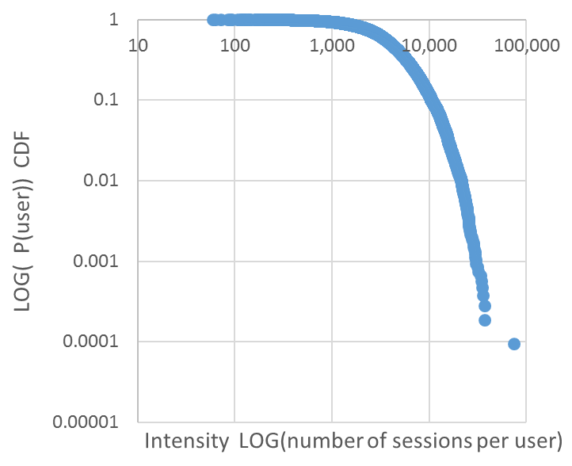
Figure S.3. Distribution of usage extensity and intensity per user (n = 10.725).
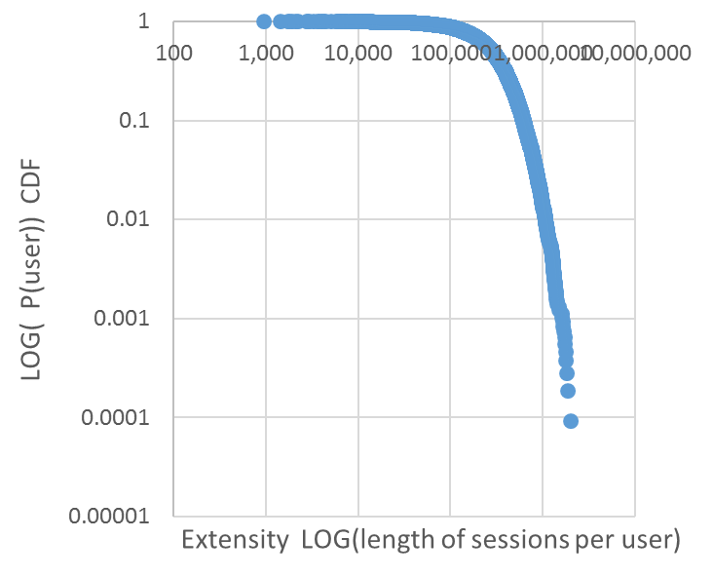

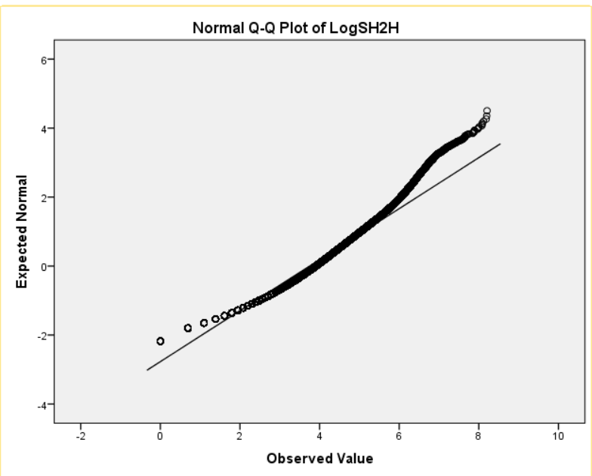
Figure S.4: Examples of deviation from normality assumption in the tails:
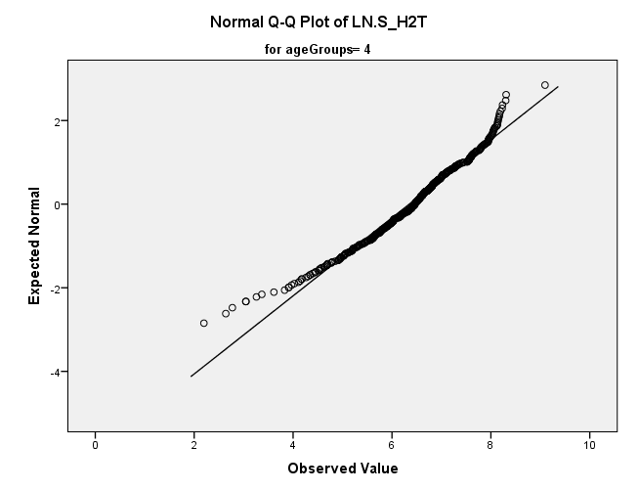

S.3.2 Details of the Multivariate Canonical Correlation Analysis

Given the five variables in of communication type, both canonical correlation analyses yielded five functions. In both cases (extensity and intensity) the dimension reduction analysis shows that the first four functions are highly significant (p < .001), while the fifth function is not.
Table S.6 presents the standardized canonical function coefficients which reflect the relative contribution of one variable given the contribution of the other variables (akin to the more familiar beta weights in regression) and the squared structure coefficients r_{s}² (the direct contribution of one variable regardless of others) for Functions 1, 2, 3 and 4. It also highlights the communalities (h²) across the three functions for each variable (which is simply the sum of the variable’s r_{s}²). Looking at the composition of the coefficients and the related squared structure coefficients for the three functions gives insight into which variables share similar tendencies. For example, for extensity Function 1 seems to mainly capture the technological characteristics (screen size and price), while for intensity Function 2 seems to capture these features (showing the highest structure coefficients). Function 2 maximally discriminates what has not been captured by Function 1 and Function 3 captures the variance not yet explained with Functions 1 and 2. With regard to communication types, Function 1 of extensity seems to capture very little of H2H, while Function 1 of intensity captures mainly variances from H2H communication, etc..

Table S.6: Extensity and Intensity of mobile app communication: canonical solution for communicator characteristics and communication types for Functions 1, 2 and 3. Coef = standardized canonical coefficients; r_{s}² = squared structure coefficient; h² = communality coefficient; R_{c}² squared canonical correlation. Coefficients greater than .45 are underlined.
Extensity (seconds) |  | Function 1 |  | Function 2 |  | Function 3 |  | Function 4
 |  | Coef | r_{s}² (%) | Coef | r_{s}² (%) | Coef | r_{s}² (%) | Coef | r_{s}² (%) | h² (%)
demogr. | Gender | -0.02 | 0.00 | 0.56 | 0.33 | -0.32 | 0.08 | 0.27 | 0.08 | 0.49
 | Age | 0.17 | 0.02 | -0.31 | 0.08 | -0.47 | 0.65 | -0.03 | 0.02 | 0.77
social | Marital Stat. | -0.08 | 0.04 | -0.36 | 0.00 | 0.34 | 0.53 | -0.04 | 0.00 | 0.57
 | Education | 0.08 | 0.02 | -0.28 | 0.13 | 0.16 | 0.00 | -0.63 | 0.42 | 0.57
 | Employment | 0.14 | 0.04 | -0.04 | 0.01 | -0.37 | 0.34 | -0.34 | 0.16 | 0.55
techno. | Price | 0.24 | 0.12 | -0.64 | 0.41 | -0.04 | 0.01 | 0.64 | 0.35 | 0.89
 | Screen Size | 0.92 | 0.82 | 0.29 | 0.07 | 0.21 | 0.10 | -0.07 | 0.00 | 0.99
 | R_{c}² |  | 6.8 |  | 2.6 |  | 2.0 |  | 0.5 | 11.9
type | H2H | -0.06 | 0.00 | -0.44 | 0.14 | 0.84 | 0.59 | -0.29 | 0.20 | 0.93
 | H2B | -0.45 | 0.18 | 0.79 | 0.67 | 0.29 | 0.09 | -0.05 | 0.00 | 0.94
 | H2T | 0.60 | 0.43 | 0.35 | 0.10 | -0.30 | 0.00 | -0.71 | 0.45 | 0.98
 | H2F | 0.32 | 0.18 | 0.23 | 0.10 | 0.51 | 0.25 | 0.31 | 0.08 | 0.61
 | H2G | 0.48 | 0.35 | 0.05 | 0.01 | 0.09 | 0.01 | 0.57 | 0.28 | 0.65
Intensity (sessions) |  | Function 1 |  | Function 2 |  | Function 3 |  | Function 4
 |  | Coef | r_{s}² (%) | Coef | r_{s}² (%) | Coef | r_{s}² (%) | Coef | r_{s}² (%) | h² (%)
demogr. | Gender | 0.12 | 0.00 | 0.12 | 0.01 | 0.61 | 0.37 | -0.20 | 0.06 | 0.44
 | Age | 0.66 | 0.77 | -0.28 | 0.07 | 0.13 | 0.01 | 0.44 | 0.09 | 0.94
social | Marital Stat. | -0.16 | 0.49 | -0.23 | 0.00 | -0.25 | 0.03 | -0.01 | 0.03 | 0.55
 | Education | -0.03 | 0.01 | 0.05 | 0.00 | -0.25 | 0.09 | 0.71 | 0.49 | 0.59
 | Employment | 0.34 | 0.34 | 0.02 | 0.00 | -0.05 | 0.00 | -0.53 | 0.10 | 0.44
techno. | Price | 0.27 | 0.14 | 0.18 | 0.06 | -0.72 | 0.47 | -0.41 | 0.09 | 0.76
 | Screen Size | 0.11 | 0.00 | 0.90 | 0.92 | 0.15 | 0.00 | 0.21 | 0.01 | 0.93
 | R_{c}² |  | 7.4 |  | 4.5 |  | 2.8 |  | 0.6 | 15.3
type | H2H | -0.68 | 0.42 | -0.31 | 0.04 | -0.82 | 0.10 | 0.31 | 0.43 | 0.99
 | H2B | -0.43 | 0.45 | -0.41 | 0.03 | 0.82 | 0.47 | -0.21 | 0.00 | 0.95
 | H2T | 0.37 | 0.01 | 0.26 | 0.02 | 0.61 | 0.10 | 0.81 | 0.83 | 0.96
 | H2F | -0.48 | 0.40 | 0.73 | 0.45 | -0.13 | 0.01 | -0.24 | 0.02 | 0.88
 | H2G | 0.11 | 0.00 | 0.57 | 0.37 | -0.01 | 0.00 | 0.13 | 0.01 | 0.38

S.3.3 Additional Figures

The following Figure conditions usage on age group and shows that older users proportionally use passive broadcasting less ex- and intensively, but more with other humans, mobile tools, and even game a bit more extensively than younger users.

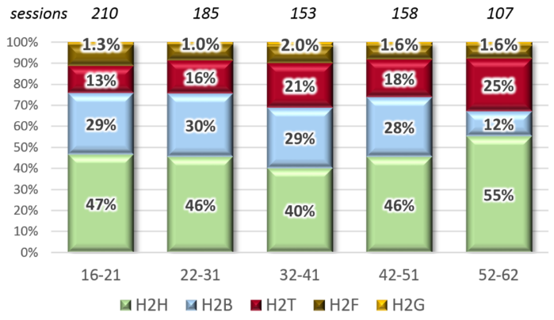
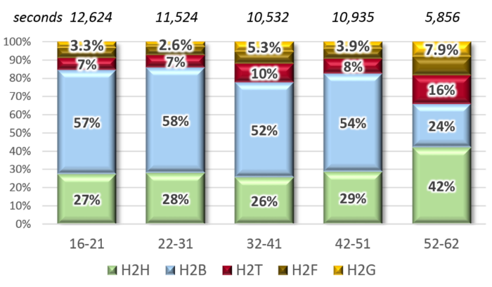
Figure 5: Age groups as fixed factor and six covariates; MANCOVA estimated marginal means of communication type per user per day: proportions for (a) extensity; (b) intensity.

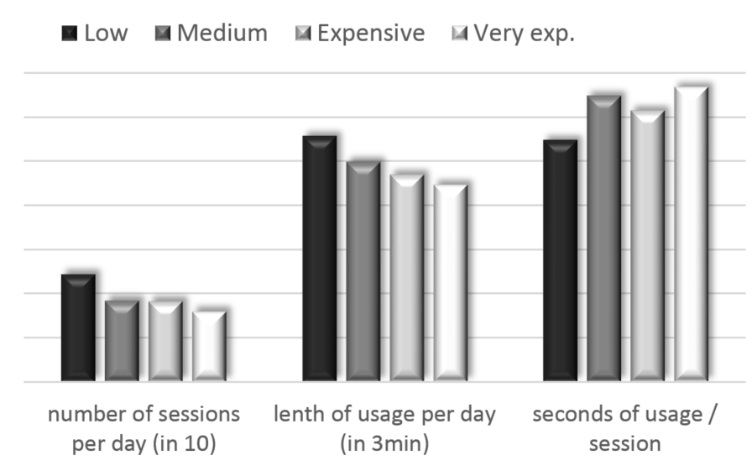
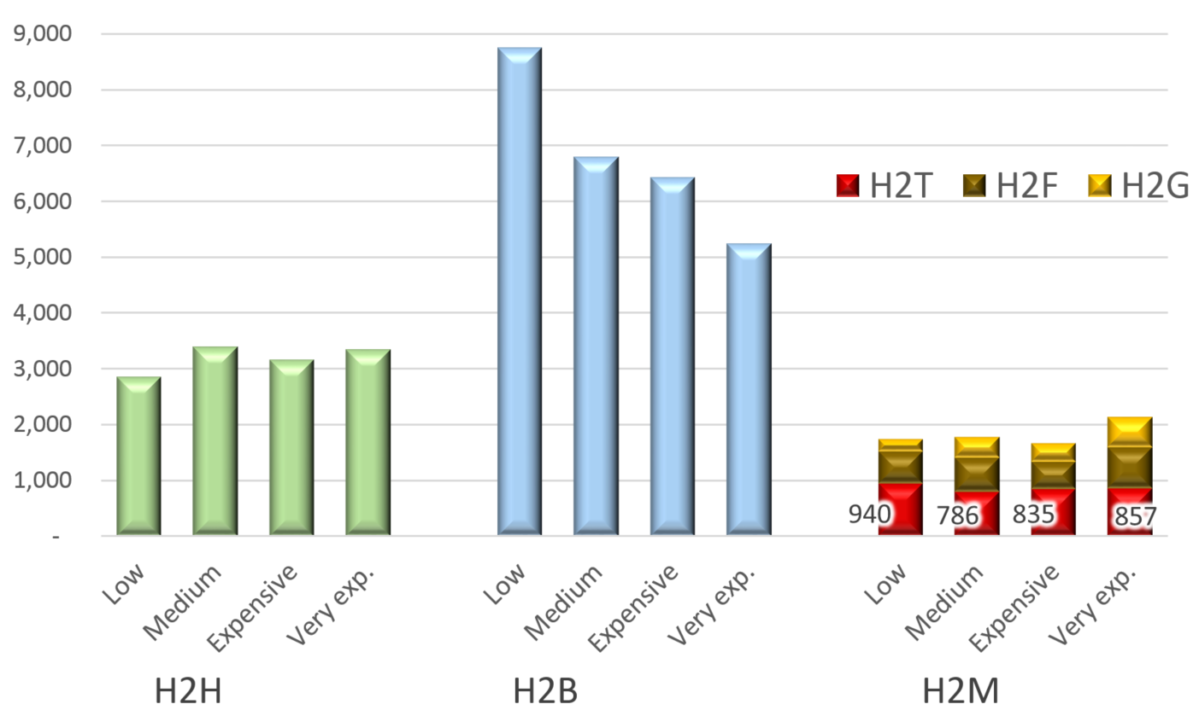
Figure S.6: Price of device and (a) communication type per user per day for extensity; (b) appropriation.

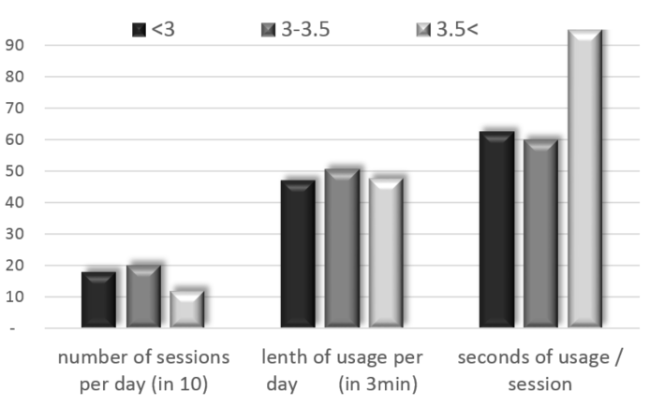
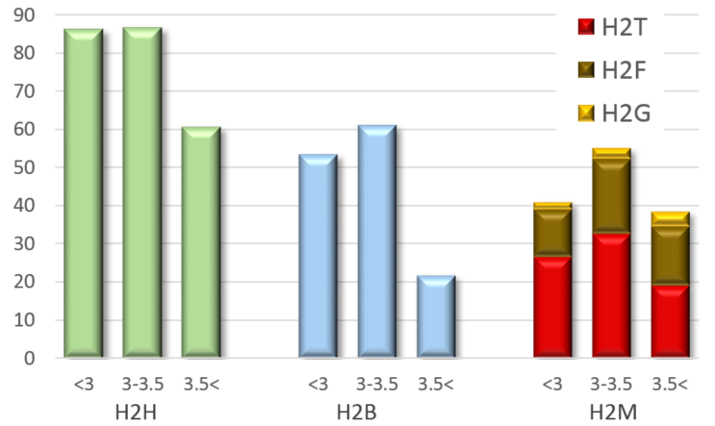
Figure S.7: Screen size of device and (a) communication type per user per day for intensity; (b) appropriation.

Last but not least, it is important to emphasize the state of technological progress during the period of data collection (May 2011 and June 2012). We worked with Symbian (8,418 in sample); BlackBerry (314 in sample); Android (1,994 in sample). We now explain this in detail in the Supporting Information. At the time of data collection, these phones were standard smart phones, as they worked on the basis of hardware independent OS, and allowed for the installation of external apps (which continues to be the definition of a smart phone, in contrast to feature phones).

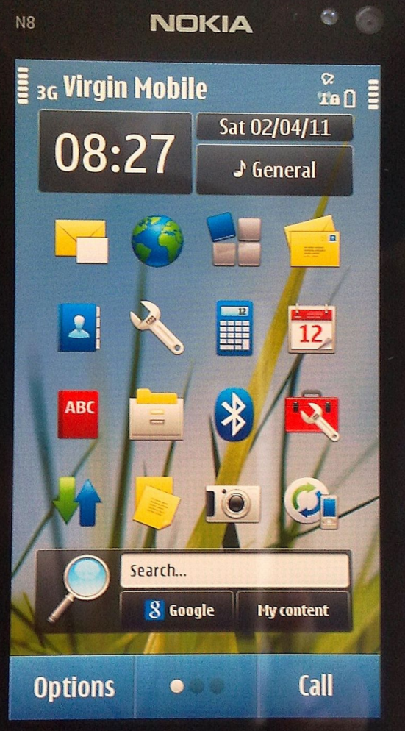
Figure S.8: Examples of operating systems from around the time of the study: (a) Symbian (8,418 in sample); (b) BlackBerry (314 in sample); (c) Android (1,994 in sample).
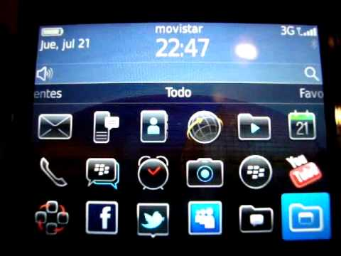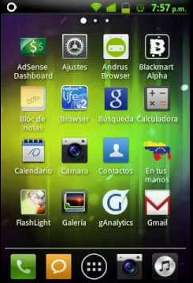
Sources: all creative commons, i.e. https://en.wikipedia.org/wiki/Nokia_N8#/media/File:Nokia_N8_%28front_view%29.jpg ; https://i.ytimg.com/vi/qqt08aw3Fdk/hqdefault.jpg ; https://i.ytimg.com/vi/xLXucYYRhnU/hqdefault.jpg

S.3.4 Weekday and daytime
Additionally to the different socio-demographic and technological characteristics, our fine-grained digital footprint also allows to test for differential usage patterns in time, which offers a bonus research question about temporal patterns. Previous research by Berg et al. (2012) found that people make less mobile call on the weekend, but send more text messages, which, they argue, stems from increased time for face-to-face interactions. This follow usage patterns of more traditional telecommunication, like fixed-line telephony, fax and email. On the contrary, it is well-known that people spend more time on the weekend for leisure entertainment purposes, especially television. The literature currently does not offer any further insights into other aspects of the polymedia mobile phone, such as H2T.
Hypothesis S1: Weekends experience less H2H communication and increased leisure communication, including H2G and H2B.
Figure S.9: Weekday: (a) extensity; (b) intensity; (c) length per session (extensity/intensity).
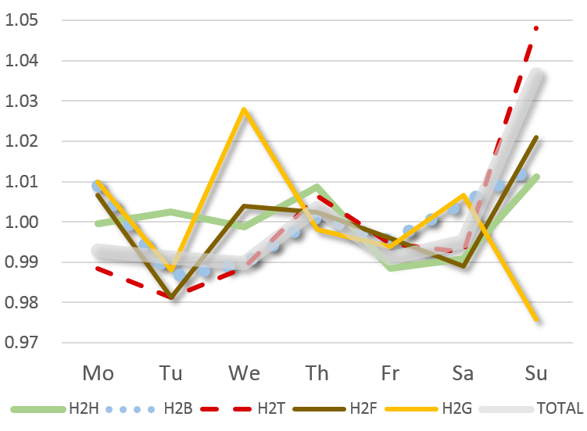
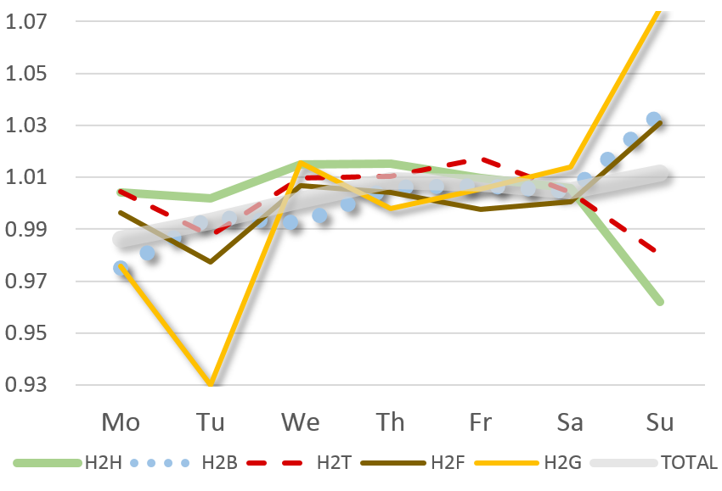
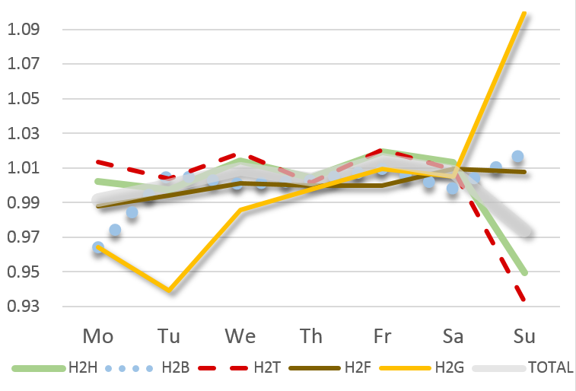

Figure S.9 represents temporal trends by normalizing on the temporal average of the particular communication type. This implies that values above 1 indicate above average usage of the specific type, and values below 1 below average usage. Figure S.9a confirms hypothesis S1. Our data provides additional interesting information. For example, the usage of gaming varies widely throughout the week, which results in the fact that the total of gaming time on Sundays are not only considerably longer, but also that the average session is considerably shorter. People game more on Sundays, but also switch much more hastily between games. The opposite accounts for H2T communication, which occupies a relatively shorter timespan on Sundays, but the average session is considerably longer. This shows that media appropriation on the mobile phone holds some more intricate patterns, which are not yet understood.
With regard to differential communication types throughout the day, it is reasonable to expect that people use their mobile phones in an increased fashion for utilitarian communication during the daytime, and more for leisure communication purposes at the evening.
Hypothesis S2: Daytime hours experience increased H2H communication and evenings increased H2G and H2B communication.
Figure S.10 confirms the hypothesis, and also adds some interesting additional details. It shows that H2T uses has two peaks during the day, one around mid-day and one during early evening. This holds for both in- and extensity. H2G communication acts countercyclical to H2T, with a high during the afternoon and later evening. This also holds for both in- and extensity. These kind of complementary uses of the mobile phone underline its essence as a polymedia with different complementary uses, all united on one single media platform.
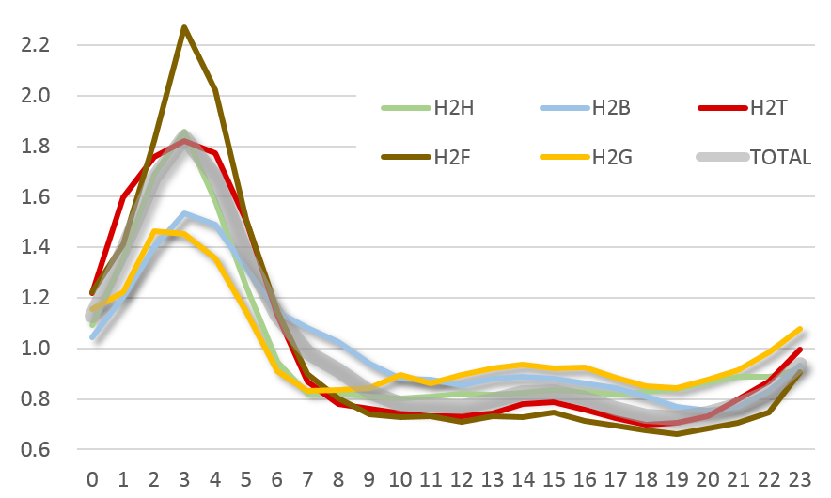
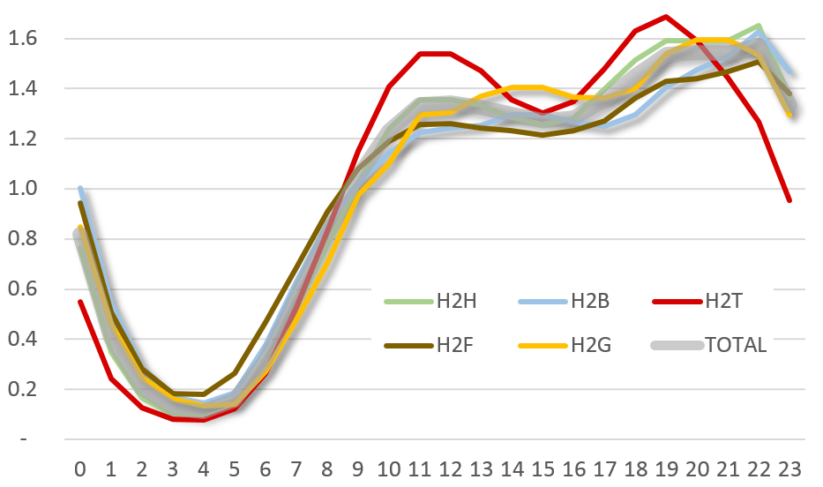
Figure S.10: Daytime: (a) extensity; (b) intensity; (c) length per session (extensity/intensity.
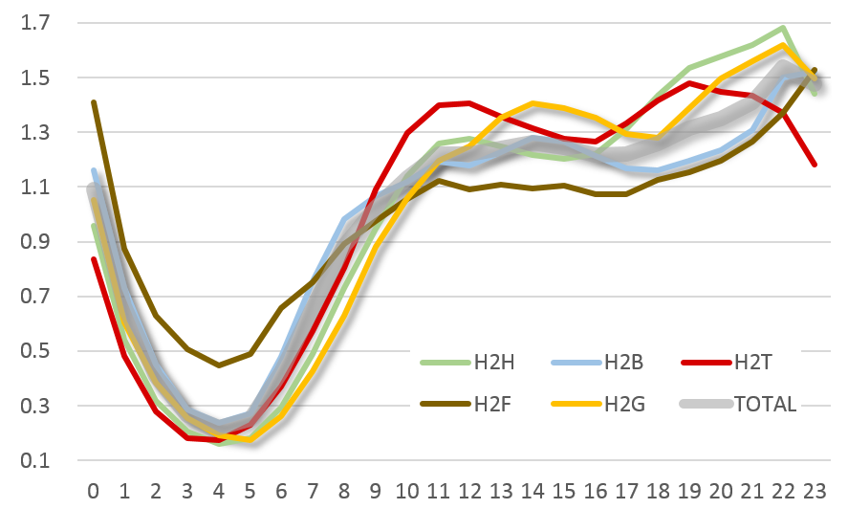

Kiousis, S. (2002). Interactivity: a concept explication. New Media & Society, 4(3), 355–383.
Rafaeli, S., & Sudweeks, F. (1997). Networked Interactivity. Journal of Computer-Mediated Communication, 2(4), 0–0; p. 0.
Bowker, G. C., & Star, S. L. (2000). Sorting Things Out: Classification and Its Consequences. The MIT Press.
Threshold r < 0.9 (Tabachnick, B. G., & Fidell, L. S. (2013). Using Multivariate Statistics. Pearson Education).
Sessions might be overlapping and occurring in parallel, such as music and surfing, etc.
For extensity: Function 1: F(35,45068)=38.5; Function 2: F(24,37378)=23.8; Function 3: F(15,29579)=18.7; Function 4(8,21432)=7.3; Function 5(3,10717)=1.52 with p = 0.207. For intensity: Function 1: F(35,45068)=49.5; Function 2: F(24,37378)=36.8; Function 3: F(15,29579)=25.7; Function 4(8,21432)=9.12; Function 5(3,10717)=1.33 with p = 0.261.
Berg, P. E. W. van den, Arentze, T. A., & Timmermans, H. J. P. (2012). New ICTs and social interaction: Modelling communication frequency and communication mode choice. New Media & Society, 14(6), 987–1003.
Mokhtarian, P. L., & Meenakshisundaram, R. (1999). Beyond tele-substitution: disaggregate longitudinal structural equations modeling of communication impacts. Transportation Research Part C: Emerging Technologies, 7(1), 33–52.
BLS, (Bureau of Labor Statistics). (2015). American Time Use Survey (ATUS) Home Page. Retrieved February 23, 2011, from http://www.bls.gov/tus/

