Supplementary Figure S1

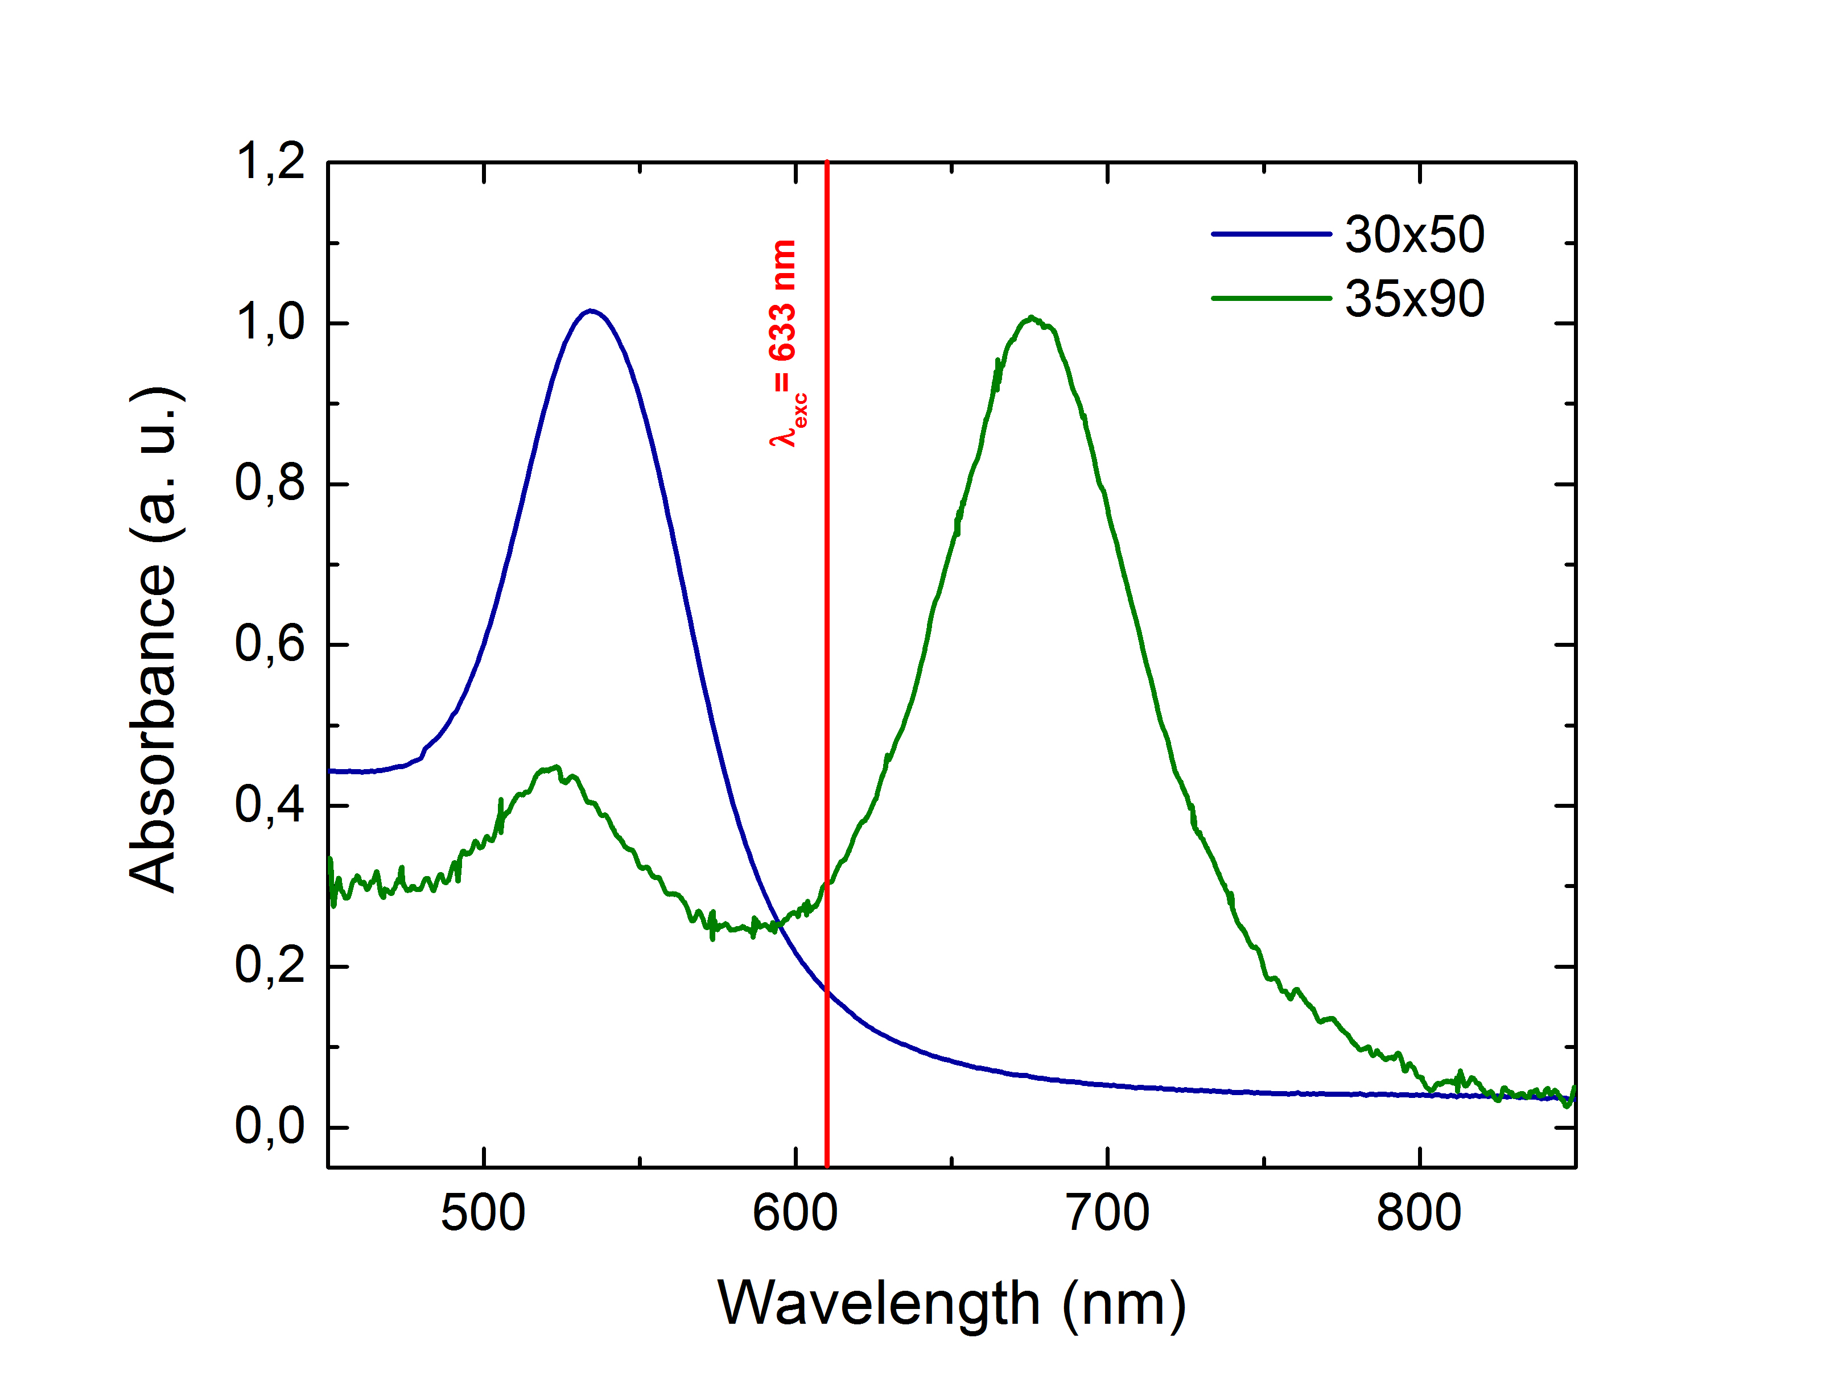

Figure S. 1 – Extinction spectra of gold NRs used for LIQUISOR experiments (green line, 35 nm diameter *×* 90 nm length – blue line 30 nm diameter $×$ 50 nm length). Red line indicates the spectral position of the laser excitation. When the incident laser interacts with 35×90 NRs we are pre-resonant with respect to the LSPR peak and therefore the gradient force is repulsive ensuring a strong optical pushing effect [[1]]. On the contrary when the laser interacts with 30×50 NR the gradient force is attractive but it is still not able to overcome the scattering force and therefore NRs are pushed along the laser beam direction also in this case. This is mostly due to the employment of low numerical aperture (~ 0.5) for our experiments.

Supplementary Figure S2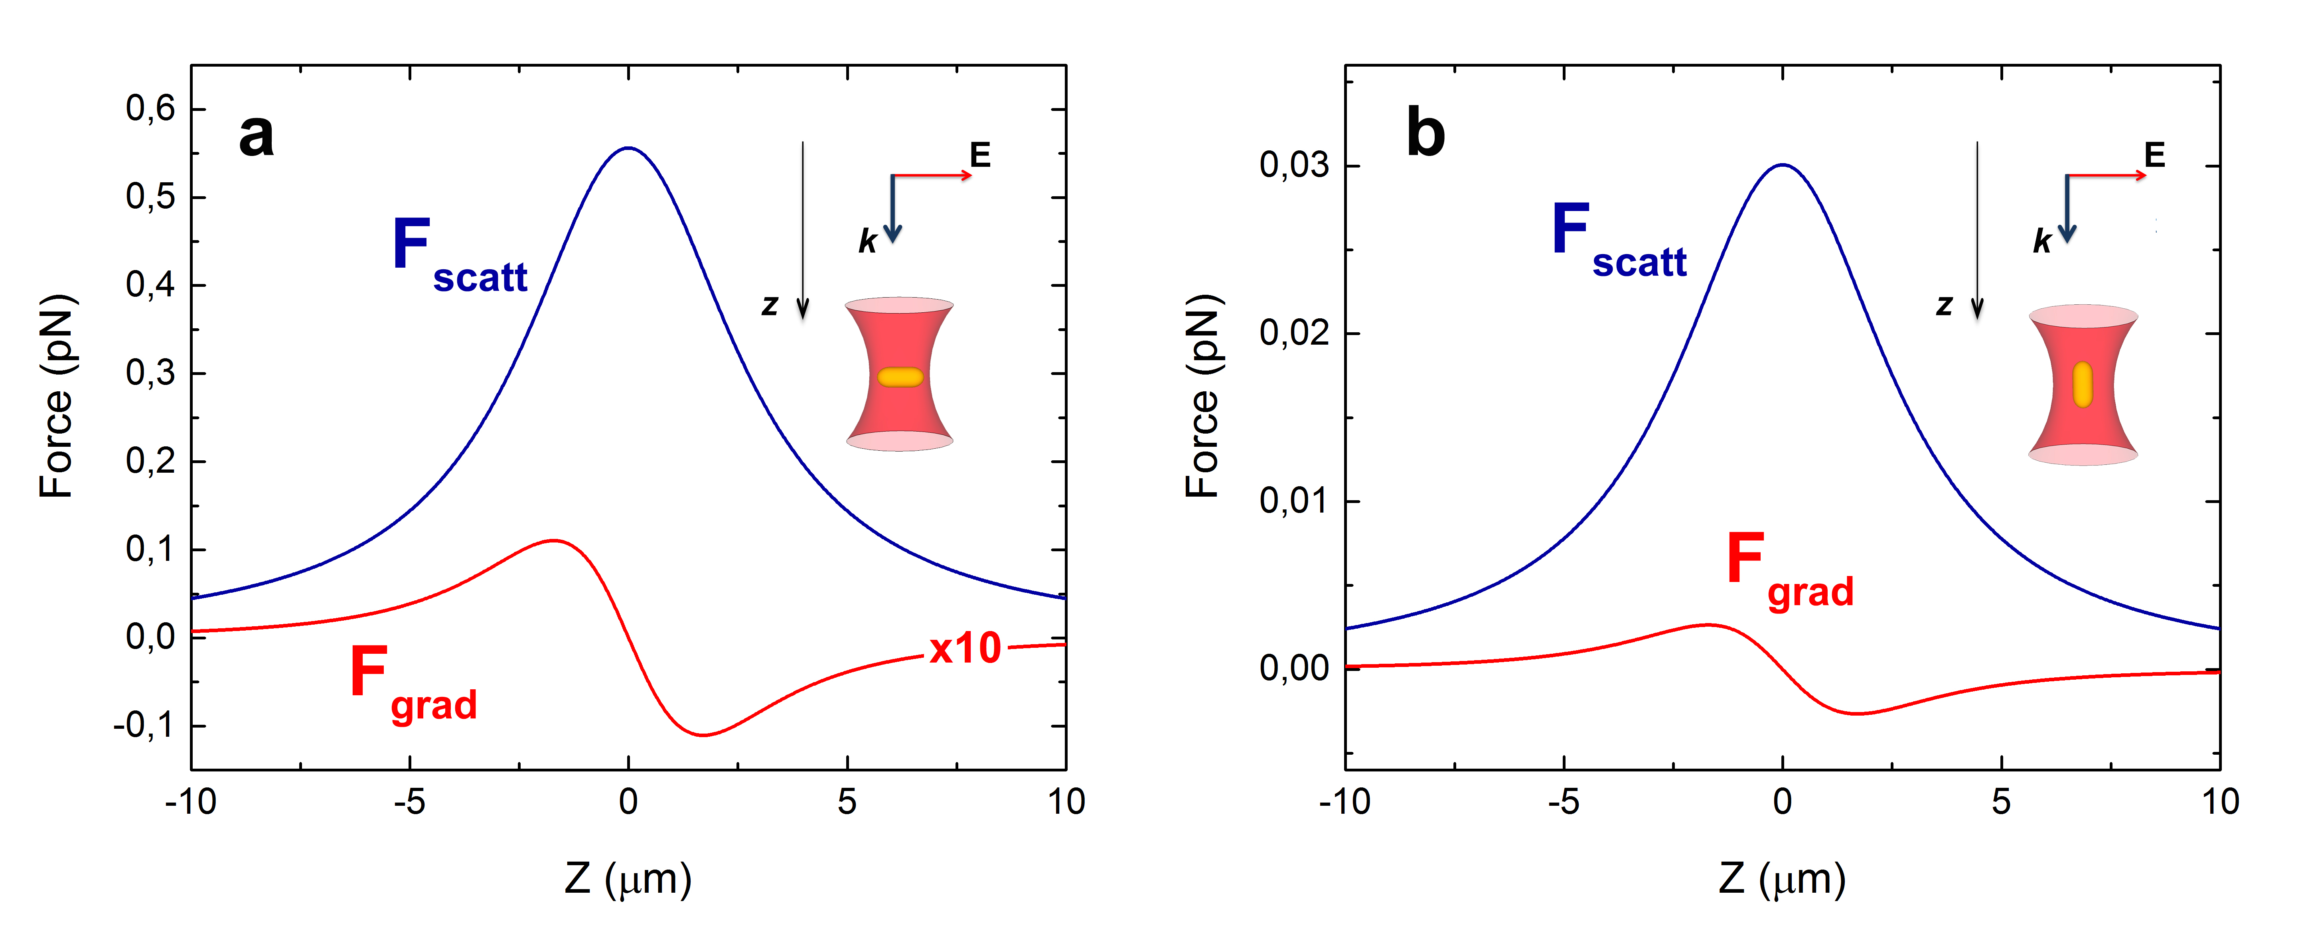

Figure S2: Radiation force ($F_{rad}$) acting on a gold nanorod is mainly composed by two principal contribution, a conservative one ($F_{grad}$) proportional to the gradient of the nanorod polarizability and a dissipative one ($F_{scatt}$) proportional to the extinction cross section [[2],[3]]. Considering a laser beam emitting 638 nm (P = 13.5 mW) irradiating gold nanorods of 30 nm in diameter $×$ 50 nm *via* a 50X long working distance objective (NA = 0.5), the dipole approximation can be considered valid. Details for the calculation of optical forces within this approximation can be found in ref [[4]]. We considered our NRs as prolate spheroids immersed in water (refractive index *nm*= 1.33) and we use optical constants derived by Johnson and Christy [[5]]. Calculations of optical forces are carried out for the two main configurations, i.e. when the field is polarized along the short (a) or the long axis (b) of the NRs. In both cases the gradient force (red lines) has an attractive nature. The scattering force (blue line) is, however, always more intense and dominates in the NRs-laser interaction, no matter how the nanorod is oriented. The predominance of the scattering force over the gradient one is at least one order of magnitude and it is insured exploiting a low numerical aperture objective. This keeps the intensity of gradient force low with respect to the scattering one, avoiding the optical trapping of the nanorods inside the laser focus region that eventually can occur when the laser wavelength is red shifted with respect to the LSPR maximum position. The net force balance acting on the rod is therefore always repulsive and leads to the pushing of the nanoparticles along the optical axis triggering the dynamic accumulation of the BIO-NRCs.

Supplementary Figure S3

figure/FigSFit.pdf

Figure S. 3 – (a) Fits (continuous lines) of the experimental absorbance profiles (dots) of the NRs (50x30) diluted in water (black) and of the NRs mixed with BSA in PBS at 10-4 M (green). (b) Absorbance (black dots) and fit (continuous red line) of the NRs mixed with BSA in PBS at 510-8 M. Measures carried out within the first 5 minutes from the mixing. The dotted lines highlight the position of the main peaks used for the fits.

Supplementary Figure S4

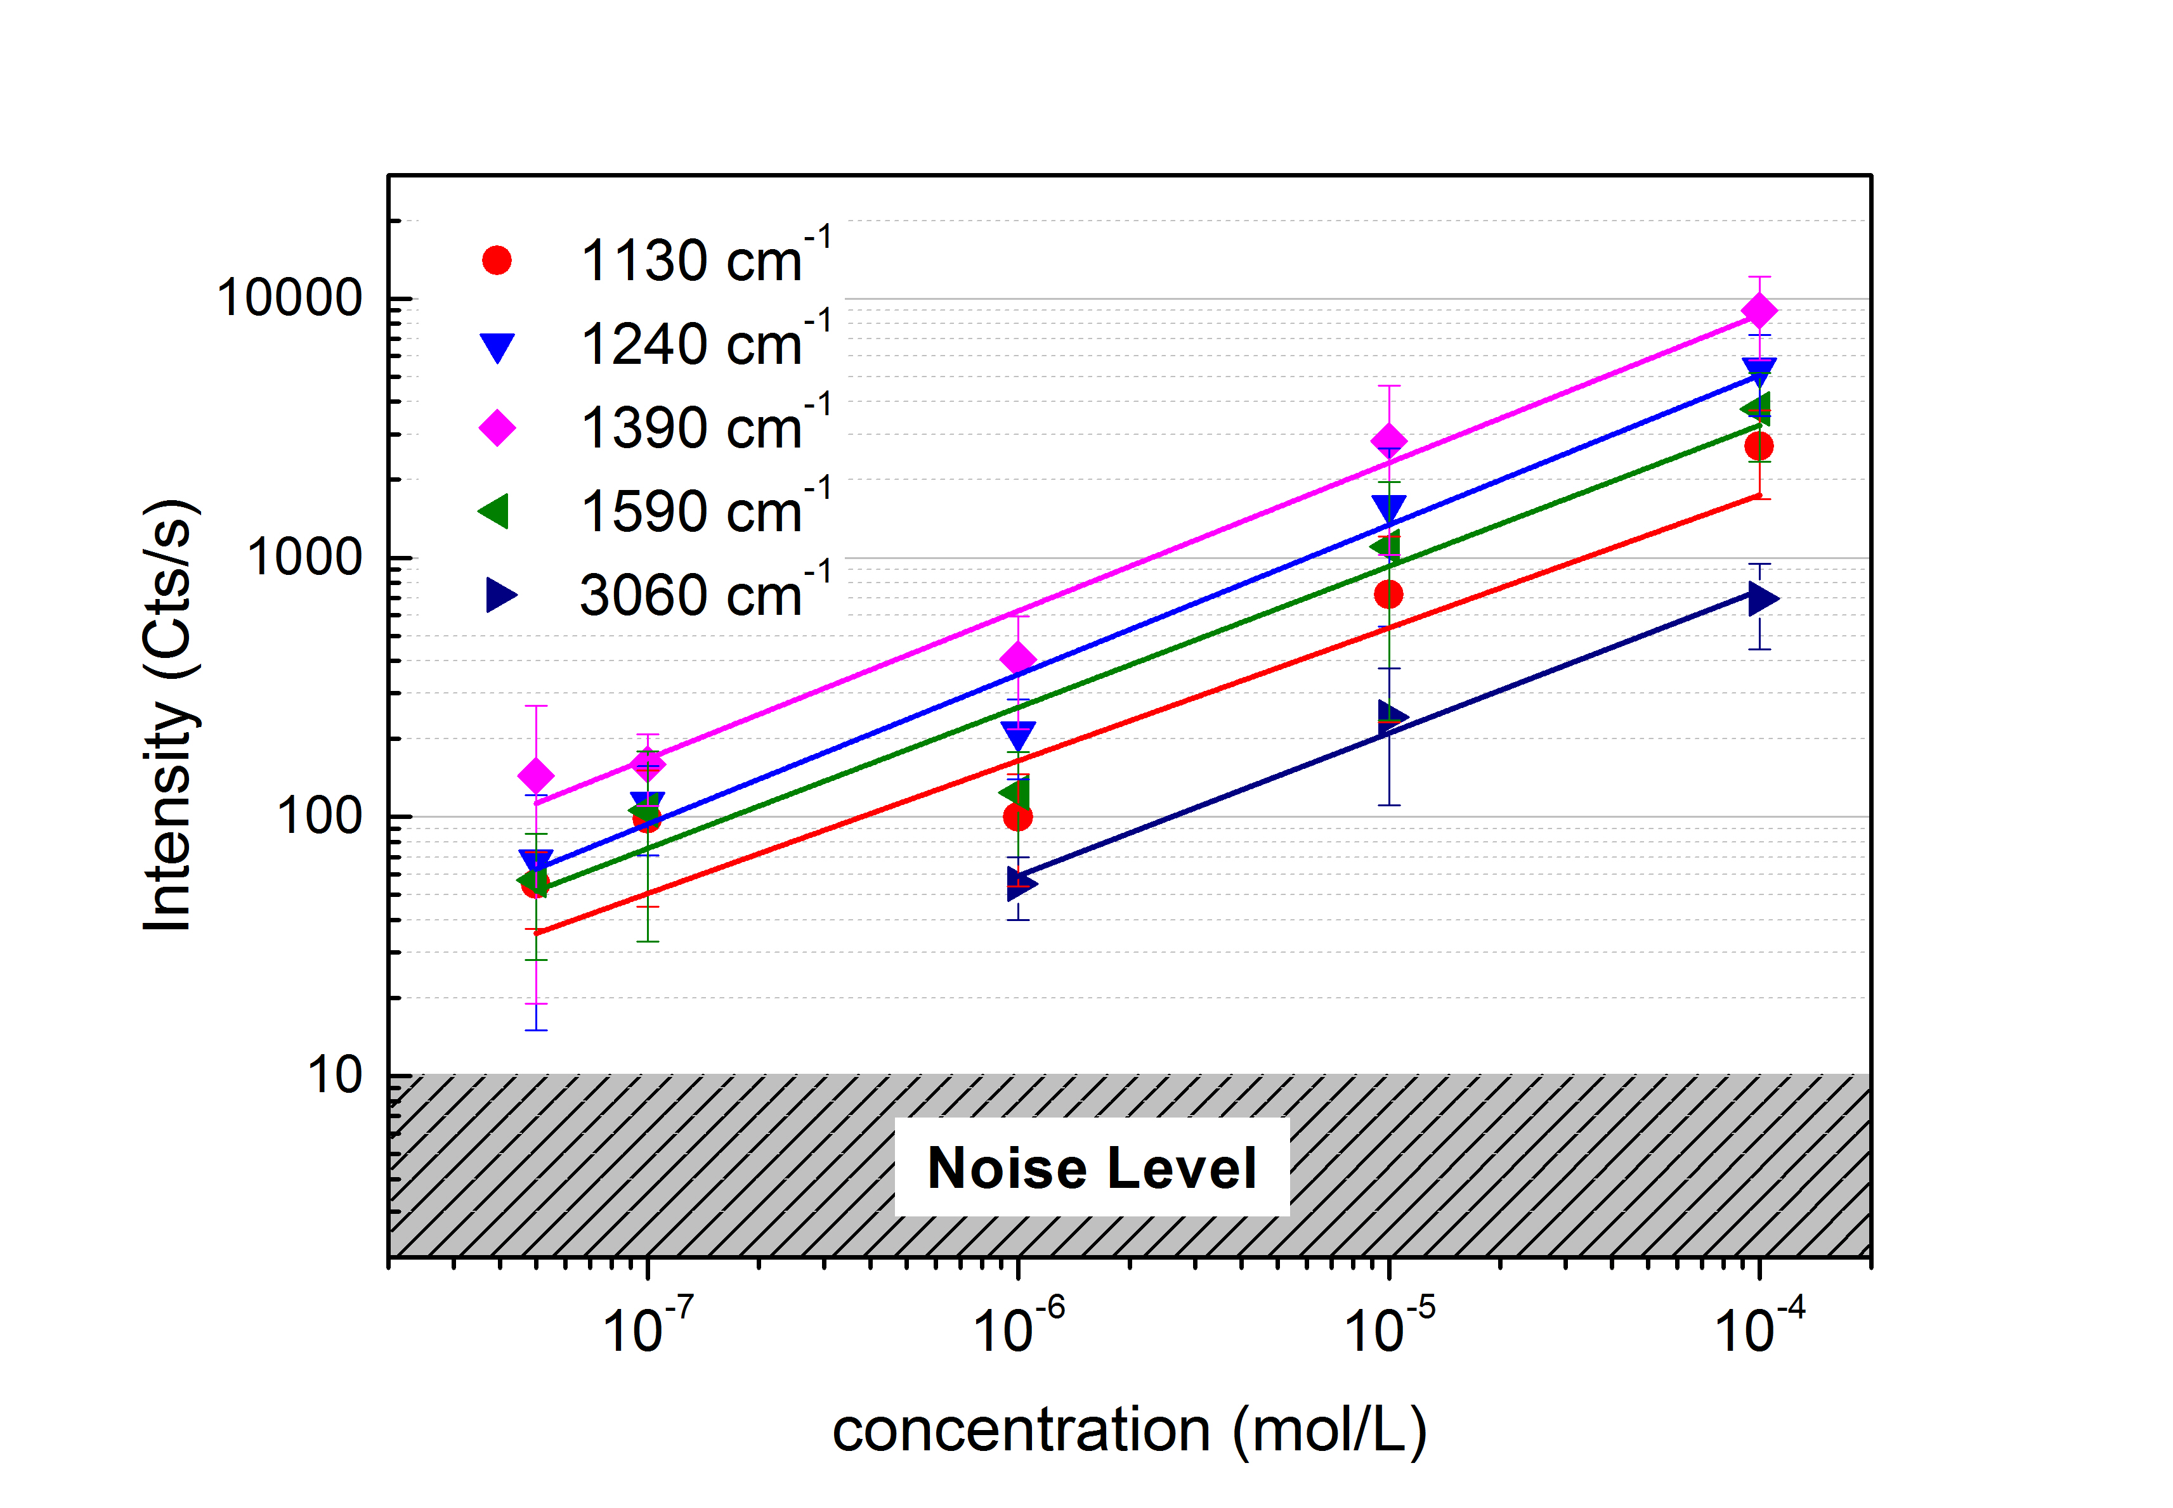

Figure S. 4 – SERS intensity at saturation for different characteristic Raman modes of BSA. Each point represents the averaged after background subtraction, from at least 4 saturated aggregates. Error bars are the standard deviation values calculated for each set of aggregates at the different concentrations. Solid lines are power law fits, whose exponents (reported in the table S1 below) are the same within the experimental fitting error to one found for Phe ring breathing mode (0.60 ± 0.04).

Supplementary Table 1

Table S1 – Best fit parameters (exponent) of the data in Figure S2.

|  |  |  |
| --- | --- | --- |
| **Raman Mode** | **Mode assignment** | **Exponent** |
| 1130 cm-1 | CN stretching [[6],[7]] | 0,5 ± 0,1 |
| 1240 cm-1 | Amide III [6,7,[8]] | 0,6 ± 0,1 |
| 1390 cm-1 | Aromatic amino acids COO- stretching [6,7,[9]] | 0,59 ± 0,05 |
| 1590 cm-1 | Phe [6,7] | 0,6 ± 0,1 |
| 3060 cm-1 | Aromatic CH stretching [[10]] | 0,55 ± 0,05 |

Supplementary Table 2

Table S2 -Vibrational modes (cm-1) of Hgb measured in PBS solution (0.1 mM), in powder state and through the LIQUISOR method (10 μM). Modes assignment is carried out following the literature.

|  |  |  |  |
| --- | --- | --- | --- |
| **Raman of Hgb in PBS (0.1 mM)** | **Raman of Hgb in powder state** | **SERS of Hgb in PBS (10 µM)** | **Tentative mode assignment of the Raman modes** |

|  |  |  |  |
| --- | --- | --- | --- |
| 664 | 663 | 668 | δ(pyr deform)sym, [[11],[12]] |
| 721 | 723 | 721 | δ(COO-) [11] |
| 750 | 750 | 750 | ν(pyr breathing), ν15 [11,12] |
| 784 | 790 | 786 | Trp:indole sym. breathe + ν(pyr breathe), ν6 [11] |
| 924 | -- | 924 | C-COO- stretch. [11] |
| -- | -- | 967 | C-C stretch. [11] |
| 997 | 999 | 994 | Phe [11] |
| 1080 | -- | 1079 | =C2vynilH + Trp [4,11] |
| 1125 | 1123 | 1125 | C-N and C-C stretch [4,11] |
| 1170 | 1173 | 1162 | ν(pyr half-ring)asym., ν30 +Tyr+Phe [4,11, 12] |
| 1214 | -- | 1214 | δ(CH) [11] |
| 1235 | -- | 1235 | Trp + Amide III [4,11] |
| 1254 | 1248 | 1263 | Amide III [4] |
| 1306 | 1309 | 1309 | CH2 wag [4,11] |
| 1340 | 1340 | -- | CH3 def. CH2 twist. CH bending [4,11] |
| -- | 1366 | 1363 | Tyr [4] |
| 1393 | 1395 | 1388 | ν (COO-) [4] |
| -- | 1445 | 1442 | δ(CH2/CH3) [4,11] |
| -- | -- | 1486 | Trp + Phe [4,11] |
| 1543 | 1546 | 1543 | Amide II + Trp [4,11,[13]] |
| -- | -- | 1564 | Trp[4,11] |
| 1582 | 1579 | 1584 | Phe + Tyr [11] |
| 1610 | 1603 | 1608 | Phe + Tyr [11] |
| -- | 1623 | 1617 | Pyr ν (C=C) [11] |
| 1655 | -- | 1655 | Amide I [4,13] |

References

1. Arias-González, J.R.; Nieto-Vesperinas M. Optical forces on small particles: attractive and repulsive nature and plasmon-resonance conditions. *J. Opt. Soc. Am. A,* **2003**, 20, 1201–1209, DOI: https://doi.org/10.1364/JOSAA.20.001201.
2. Maragò, O.M.; Jones, P.H.; Gucciardi, P.G.; Volpe, G.; Ferrari, A.C. Optical trapping and manipulation of nanostructures. *Nat. Nanotechnol.* **2013**, 8, 807–819, DOI: 10.1038/nnano.2013.208.
3. Xu, H.; Käll, M. Surface-plasmon-enhanced optical forces in silver nanoaggregates. *Phys. Rev. Lett.* **2002**, 89, 246802, DOI: https://doi.org/10.1103/PhysRevLett.89.246802.
4. Fazio, B.; D’Andrea, C.; Foti, A.; Messina, E.; Irrera, A.; Donato, M.G.; Villari, V.; Micali, N.; Maragò, O.M.; Gucciardi, P.G. SERS detection of Biomolecules at Physiological pH via aggregation of Gold Nanorods mediated by Optical Forces and Plasmonic Heating, *Sci. Rep. UK* **2016**, 6, 26952, DOI: 10.1038/srep26952.
5. Johnson, P.B.; Christy, R.W. Optical constants of the noble metals. *Phys. Rev. B* **1972**, 6, 4370–4379, DOI: https://doi.org/10.1103/PhysRevB.6.4370.
6. Chen, M.C.; Lord, R.C. Laser-Excited Raman Spectroscopy of Biomolecules. VIII. Conformational Study of Bovine Serum Albumin. *J. Am. Chem. Soc.* **1976**,98, 990-992.
7. Lin, V.J.C.; Koenig, J.L. Raman Studies of Bovine Serum Albumin. *Biopolymers* **1976**, 15, 203-218, DOI: 10.1002/bip.1976.360150114.
8. Cavalu, S.; Cinta-Pinzaru, S.; Leopold, N.; Kiefer, W. Raman and Surface Enhanced Raman Spectroscopy of 2,2,5,5-Tetramethyl-3-pyrrolin-1-yloxy-3-carboxamide Labeled Proteins: Bovine Serum Albumin and Cytochrome C. *Biopolymers* **2001**, 62, 341, DOI: 10.1002/bip.10002.
9. Navarra, G.; Tinti, A.; Leone, M.; Militello, V.; Torreggiani, A. Influence of metal ions on thermal aggregation of bovine serum albumin: Aggregation kinetics and structural changes. *J. Inorg. Biochem.* **2009**, 103, 1729–1738, DOI: https://doi.org/10.1016/j.jinorgbio.2009.09.023.
10. Socrates, G. *Infrared and Raman Characteristic Group Frequencies: Tables and Charts*, 3rd Edition. John Wiley & Sons, 2004, ISBN: 978-0-470-09307-8.
11. Drescher, D.; Büchner, T.; McNaughton, D.; Kneipp, J. SERS reveals the specific interaction of silver and gold nanoparticles with hemoglobin and red blood cell components. *Phys. Chem. Chem. Phys.* **2013**, 15, 5364, DOI: 10.1039/C3CP43883J.
12. Hu S., Smith K. M. and Spiro T.G., Assignment of protoheme resonance Raman spectrum by heme labeling in myoglobin. *J. Am. Chem. Soc.* **1996**, 118, 12638-12648, DOI: 10.1021/ja962239e.
13. Pelton, J.T.; McLean, L.R. Spectroscopic Methods for Analysis of Protein Secondary Structure. *Anal. Biochem.* **2000**, 277, 167–176, DOI: https://doi.org/10.1006/abio.1999.4320.