Supplementary Materials:
Table S1 Bajhang Sample details
SN | Lat | Long_ | Alt | Date_ | Plot_ID | Land use
1 | 29.54622 | 80.75865 | 2272.988 | 2015-07-10T08:42:35Z | B01 | Agriculture
2 | 29.54567 | 80.75808 | 2272.029 | 2015-07-10T09:04:02Z | B02 | Grassland
3 | 29.545 | 80.758 | 2278.029 | 2015-07-10T09:15:21Z | B03 | Forest land
4 | 29.5454 | 80.75867 | 2276.964 | 2015-07-10T09:29:16Z | B04 | Barren land
5 | 29.57994 | 81.23145 | 1398.593 | 2015-07-11T04:14:33Z | B05 | Agriculture
6 | 29.57995 | 81.23146 | 1399.088 | 2015-07-11T04:14:45Z | B06 | Grassland
7 | 29.58059 | 81.23061 | 1410.421 | 2015-07-11T04:48:40Z | B07 | Forest land
8 | 29.5648 | 81.22148 | 1310.675 | 2015-07-11T06:44:40Z | B08 | Agriculture
9 | 29.53617 | 81.19755 | 1254.079 | 2015-07-11T11:00:44Z | B09 | Agriculture
10 | 29.54052 | 81.19886 | 1285.37 | 2015-07-11T11:21:04Z | B10 | Grassland
11 | 29.54307 | 81.19847 | 1284.315 | 2015-07-11T11:37:01Z | B11 | Forest land
12 | 29.55039 | 81.19871 | 1276.82 | 2015-07-11T12:07:49Z | B12 | Barren land
13 | 29.50479 | 81.14772 | 1151.845 | 2015-07-12T09:22:10Z | B13 | Agriculture
14 | 29.50289 | 81.14163 | 1129.89 | 2015-07-12T09:46:43Z | B14 | Grassland
15 | 29.50192 | 81.10649 | 1106.252 | 2015-07-12T10:36:09Z | B15 | Forest land
16 | 29.50369 | 81.11094 | 1072.696 | 2015-07-12T10:59:02Z | B16 | Barren land
17 | 29.47476 | 81.01201 | 1054.585 | 2015-07-13T04:12:51Z | B17 | Forest land
18 | 29.47604 | 81.00922 | 988.1212 | 2015-07-13T04:40:50Z | B18 | Agriculture
19 | 29.46978 | 80.98428 | 1017.006 | 2015-07-13T05:10:25Z | B19 | Barren land
20 | 29.46861 | 80.9796 | 1000.968 | 2015-07-13T05:25:42Z | B20 | Grassland
21 | 29.48136 | 80.89805 | 894.0933 | 2015-07-13T07:23:35Z | B21 | Agriculture
22 | 29.47711 | 80.89748 | 915.1145 | 2015-07-13T07:38:47Z | B22 | Forest land
23 | 29.47644 | 80.89704 | 928.1861 | 2015-07-13T07:53:23Z | B23 | Barren land
24 | 29.4727 | 80.89601 | 901.1138 | 2015-07-13T08:14:33Z | B24 | Grassland
25 | 29.50218 | 80.85192 | 1633.089 | 2015-07-14T04:49:48Z | B25 | Forest land
26 | 29.5047 | 80.84784 | 1714.14 | 2015-07-14T05:33:12Z | B26 | Agriculture
27 | 29.50846 | 80.83637 | 1782.68 | 2015-07-14T05:47:55Z | B27 | Barren land
28 | 29.51423 | 80.82326 | 1899.262 | 2015-07-14T06:04:48Z | B28 | Grassland

Table S2 Mustang Sample details
SN | Lat | Long_ | Alt | Date_ | Plot_ID | Land use
1 | 28.69391 | 83.60943 | 2664 |  | M01 | Forest land
2 | 29.18105 | 83.95647 | 3813.665 | 2015-09-16T02:34:14Z | M02 | Agriculture
3 | 29.18201 | 83.94767 | 3849.577 | 2015-09-16T06:35:16Z | M03 | Grassland
4 | 29.23549 | 83.98274 | 3941.363 | 2015-09-16T09:48:04Z | M04 | Barren land
5 | 28.99076 | 83.83891 | 3776.387 | 2015-09-17T04:27:33Z | M05 | Grassland
6 | 28.97337 | 83.79956 | 3799.354 | 2015-09-17T05:42:05Z | M06 | Forest land
7 | 28.93366 | 83.81972 | 3219.814 | 2015-09-17T06:37:57Z | M07 | Barren land
8 | 28.91463 | 83.81926 | 2967.115 | 2015-09-17T07:59:24Z | M08 | Agriculture
9 | 28.81466 | 83.87006 | 3733.944 | 2015-09-18T03:16:08Z | M09 | Grassland
10 | 28.81708 | 83.86844 | 3692.822 | 2015-09-18T03:48:42Z | M10 | Barren land
11 | 28.82423 | 83.87079 | 3673.708 | 2015-09-18T05:11:18Z | M11 | Forest land
12 | 28.82391 | 83.86949 | 3655.75 | 2015-09-18T05:47:47Z | M12 | Agriculture
13 | 28.76133 | 83.71563 | 2882.442 | 2015-09-18T10:11:57Z | M13 | Forest land
14 | 28.77107 | 83.7258 | 2812.181 | 2015-09-19T03:57:17Z | M14 | Agriculture
15 | 28.78169 | 83.71838 | 2854.845 | 2015-09-19T10:14:27Z | M15 | Grassland
16 | 28.77985 | 83.7173 | 2819.213 | 2015-09-19T10:42:09Z | M16 | Barren land
17 | 28.65183 | 83.63327 | 2550.972 | 2015-09-21T06:08:59Z | M17 | Agriculture
18 | 28.6493 | 83.62261 | 2737.708 | 2015-09-21T08:34:58Z | M18 | Grassland
19 | 28.65455 | 83.6081 | 2702.999 | 2015-09-21T10:12:07Z | M19 | Forest land
20 | 28.62311 | 83.62794 | 2241.694 | 2015-09-25T03:01:14Z | M20 | Barren land
21 | 28.691 | 83.61187 | 2590.479 | 2015-09-22T04:51:50Z | M21 | Forest land
22 | 28.68543 | 83.61413 | 2547.124 | 2015-09-22T05:46:53Z | M22 | Barren land
23 | 28.6894 | 83.61512 | 2570.884 | 2015-09-22T07:19:54Z | M23 | Agriculture
24 | 28.74892 | 83.68473 | 2732.683 | 2015-09-23T07:28:03Z | M25 | Grassland
25 | 28.74852 | 83.68632 | 2691.068 | 2015-09-23T08:36:58Z | M26 | Agriculture
26 | 28.74373 | 83.68174 | 2683.668 | 2015-09-23T09:29:08Z | M27 | Forest land
27 | 28.74383 | 83.67939 | 2703.194 | 2015-09-23T10:04:42Z | M28 | Barren land
Table S3 Bajhang Correlation analysis
Correlations (Bajhang)
 |  | pH | SOC | Bulk_density_gm_cm3 | Total_N_ppm | Available_P_ppm | Available_K_ppm | CEC_me_100gm
pH | Pearson Correlation | 1 | -.403** | .161 | -.389** | .215 | -.088 | -.420**
 | Sig. (2-tailed) |  | .002 | .236 | .003 | .112 | .520 | .001
 | N | 56 | 56 | 56 | 56 | 56 | 56 | 56
SOC | Pearson Correlation | -.403** | 1 | -.492** | .869** | -.265* | .377** | .651**
 | Sig. (2-tailed) | .002 |  | .000 | .000 | .048 | .004 | .000
 | N | 56 | 56 | 56 | 56 | 56 | 56 | 56
Bulk_density_gm_cm3 | Pearson Correlation | .161 | -.492** | 1 | -.528** | .184 | -.322* | -.565**
 | Sig. (2-tailed) | .236 | .000 |  | .000 | .174 | .016 | .000
 | N | 56 | 56 | 56 | 56 | 56 | 56 | 56
Total_N_ppm | Pearson Correlation | -.389** | .869** | -.528** | 1 | -.326* | .329* | .672**
 | Sig. (2-tailed) | .003 | .000 | .000 |  | .014 | .013 | .000
 | N | 56 | 56 | 56 | 56 | 56 | 56 | 56
Available_P_ppm | Pearson Correlation | .215 | -.265* | .184 | -.326* | 1 | .063 | -.296*
 | Sig. (2-tailed) | .112 | .048 | .174 | .014 |  | .645 | .027
 | N | 56 | 56 | 56 | 56 | 56 | 56 | 56
Available_K_ppm | Pearson Correlation | -.088 | .377** | -.322* | .329* | .063 | 1 | .449**
 | Sig. (2-tailed) | .520 | .004 | .016 | .013 | .645 |  | .001
 | N | 56 | 56 | 56 | 56 | 56 | 56 | 56
CEC_me_100gm | Pearson Correlation | -.420** | .651** | -.565** | .672** | -.296* | .449** | 1
 | Sig. (2-tailed) | .001 | .000 | .000 | .000 | .027 | .001
 | N | 56 | 56 | 56 | 56 | 56 | 56 | 56
**. Correlation is significant at the 0.01 level (2-tailed).
*. Correlation is significant at the 0.05 level (2-tailed).
Table S4 Mustang Correlation analysis

Correlations (Mustang)
 |  | pH | SOC_percent | Bulk_density_gm_cm3 | Total_N_percent | Available_P_ppm | Available_K_me_100gm | CEC_me_100gm
pH | Pearson Correlation | 1 | -.494** | .383** | -.091 | -.055 | .015 | -.533**
 | Sig. (2-tailed) |  | .000 | .004 | .503 | .687 | .914 | .000
 | N | 56 | 56 | 56 | 56 | 56 | 56 | 56
SOC_percent | Pearson Correlation | -.494** | 1 | -.585** | .239 | -.002 | .100 | .678**
 | Sig. (2-tailed) | .000 |  | .000 | .077 | .991 | .464 | .000
 | N | 56 | 56 | 56 | 56 | 56 | 56 | 56
Bulk_density_gm_cm3 | Pearson Correlation | .383** | -.585** | 1 | -.401** | -.164 | -.380** | -.590**
 | Sig. (2-tailed) | .004 | .000 |  | .002 | .226 | .004 | .000
 | N | 56 | 56 | 56 | 56 | 56 | 56 | 56
Total_N_percent | Pearson Correlation | -.091 | .239 | -.401** | 1 | .297* | .435** | .203
 | Sig. (2-tailed) | .503 | .077 | .002 |  | .026 | .001 | .133
 | N | 56 | 56 | 56 | 56 | 56 | 56 | 56
Available_P_ppm | Pearson Correlation | -.055 | -.002 | -.164 | .297* | 1 | .509** | -.059
 | Sig. (2-tailed) | .687 | .991 | .226 | .026 |  | .000 | .667
 | N | 56 | 56 | 56 | 56 | 56 | 56 | 56
Available_K_me_100gm | Pearson Correlation | .015 | .100 | -.380** | .435** | .509** | 1 | .038
 | Sig. (2-tailed) | .914 | .464 | .004 | .001 | .000 |  | .779
 | N | 56 | 56 | 56 | 56 | 56 | 56 | 56
CEC_me_100gm | Pearson Correlation | -.533** | .678** | -.590** | .203 | -.059 | .038 | 1
 | Sig. (2-tailed) | .000 | .000 | .000 | .133 | .667 | .779
 | N | 56 | 56 | 56 | 56 | 56 | 56 | 56
**. Correlation is significant at the 0.01 level (2-tailed).
*. Correlation is significant at the 0.05 level (2-tailed).

Table S5: ANOVA for SOC by land use types
Bajhang
ANOVA
SOC_percent
 | Sum of Squares | df | Mean Square | F | Sig.
Between Groups | 5.229 | 3 | 1.743 | .959 | .419
Within Groups | 94.465 | 52 | 1.817
Total | 99.694 | 55

Mustang
ANOVA
SOC_percent
 | Sum of Squares | df | Mean Square | F | Sig.
Between Groups | 15.404 | 3 | 5.135 | 1.485 | .229
Within Groups | 179.772 | 52 | 3.457
Total | 195.175 | 55

Figure S1: Local participants for discussion (Bajhang)
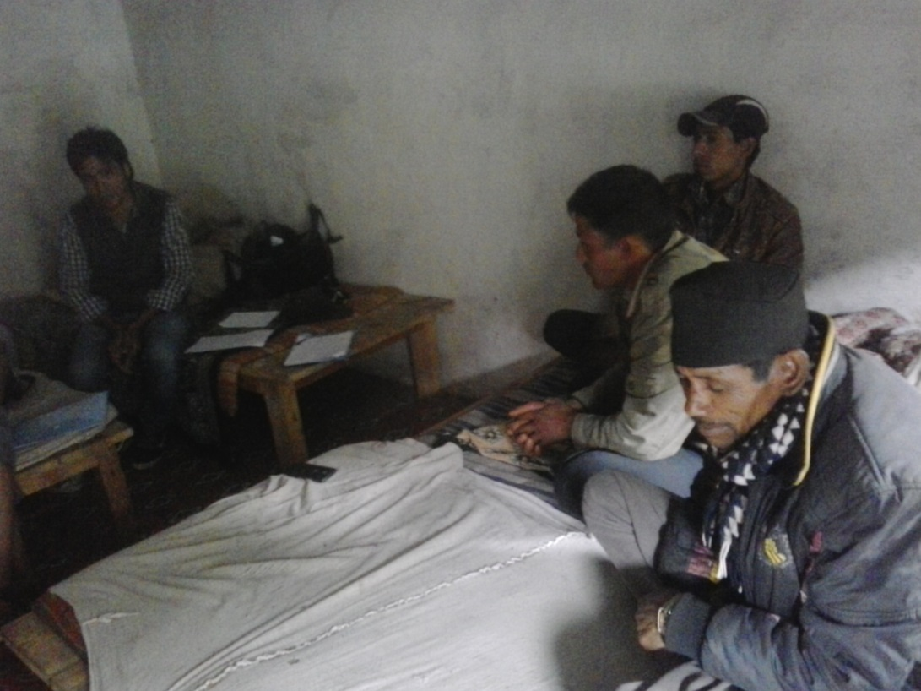
Figure S2: Soil sampling in Bajhang
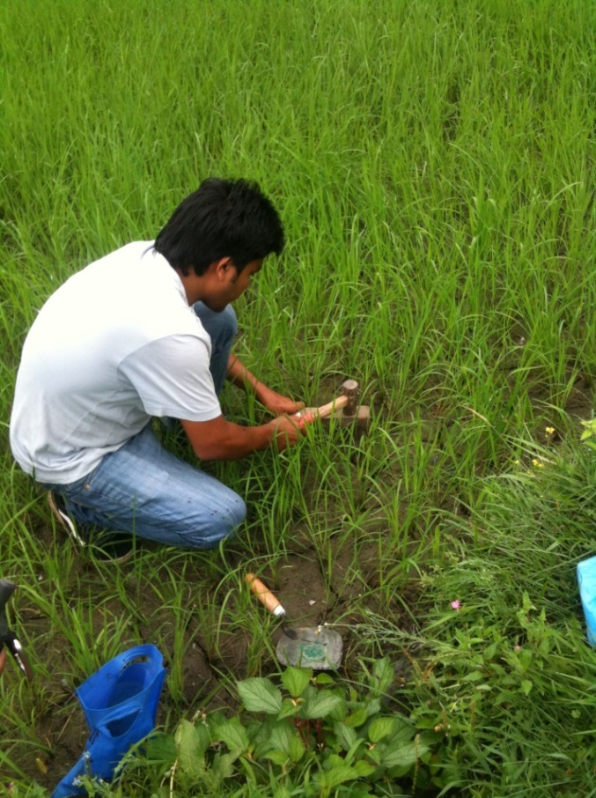
Figure S3: Sample depth measurement (Bajhang)
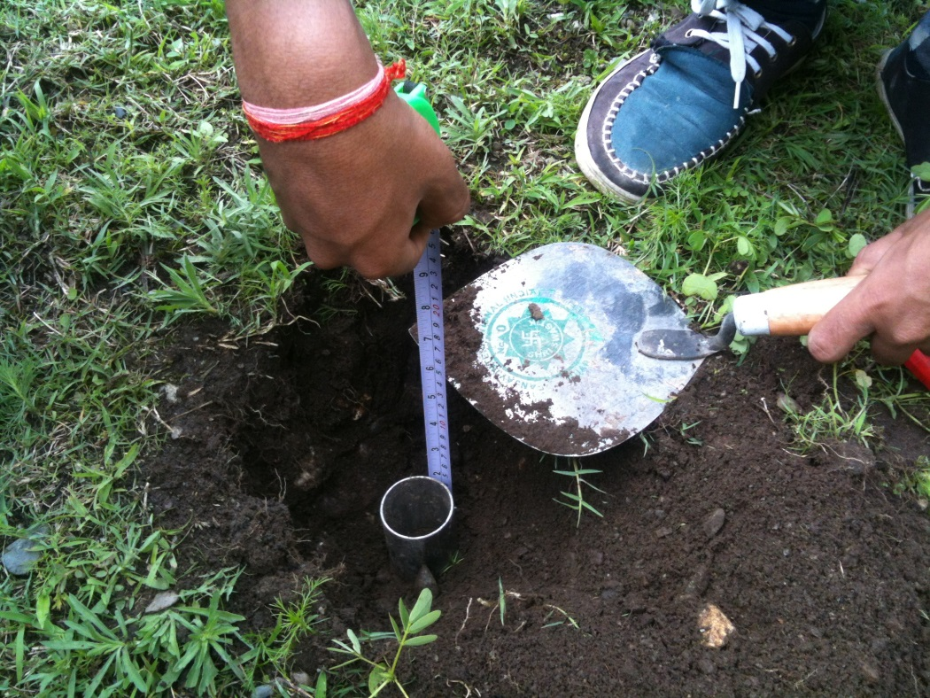
Figure S4: Questionnaire survey in Bajhang
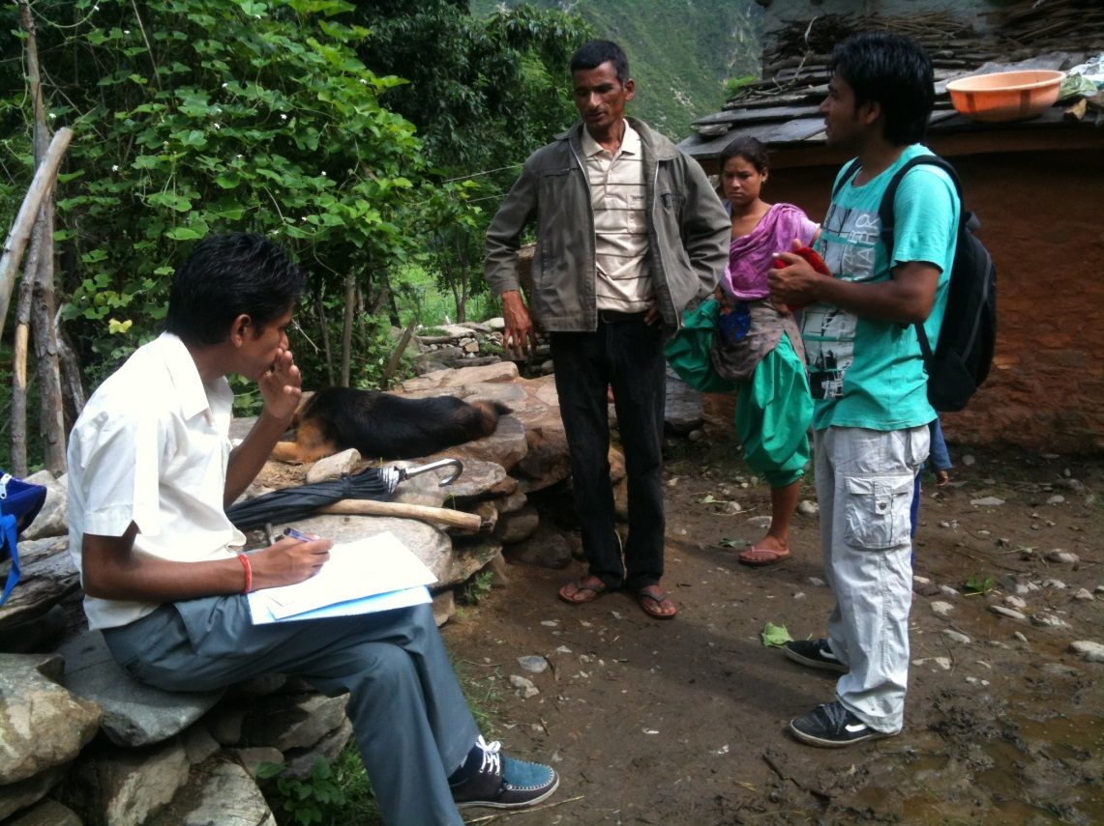
Figure S5: Land system in Mustang
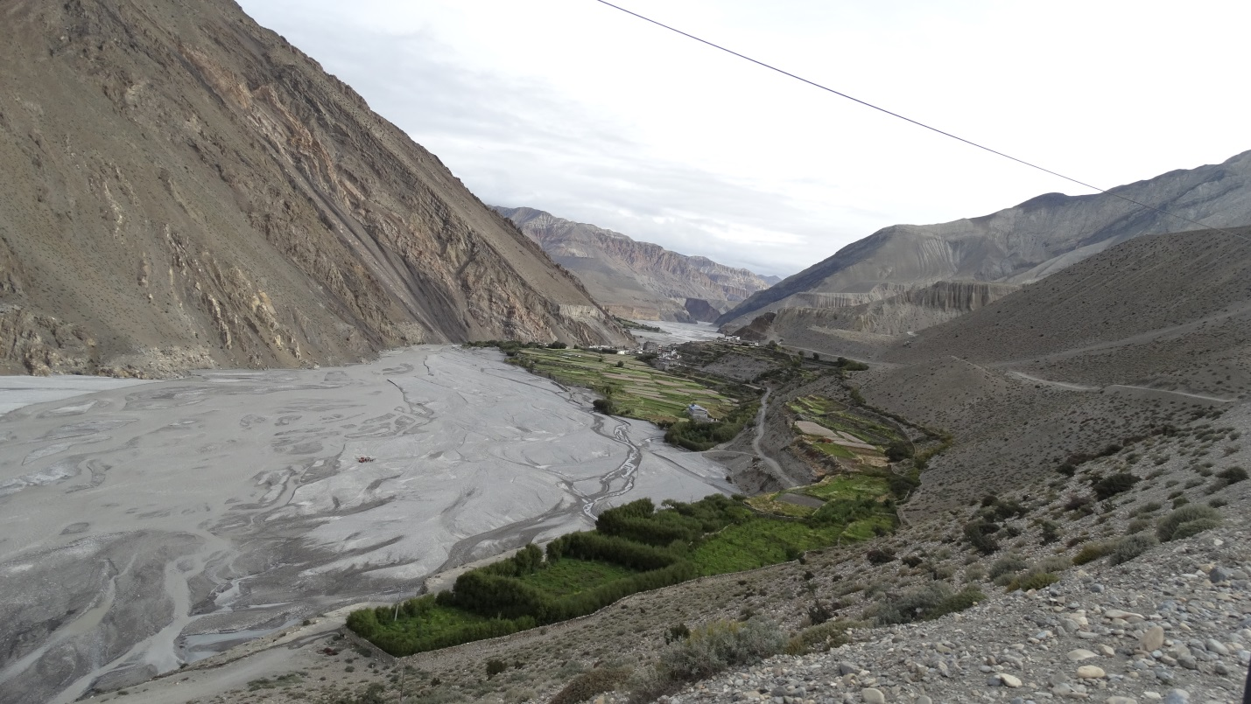
Figure S6: Focus group discussion in Mustang
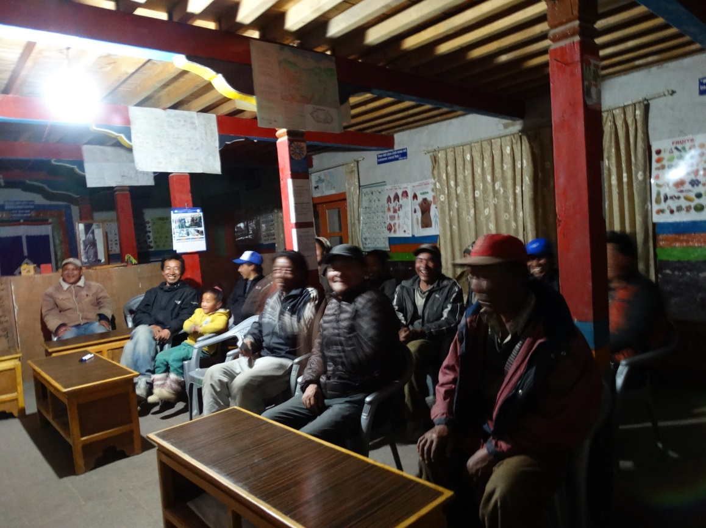
Figure S7: Sample collection
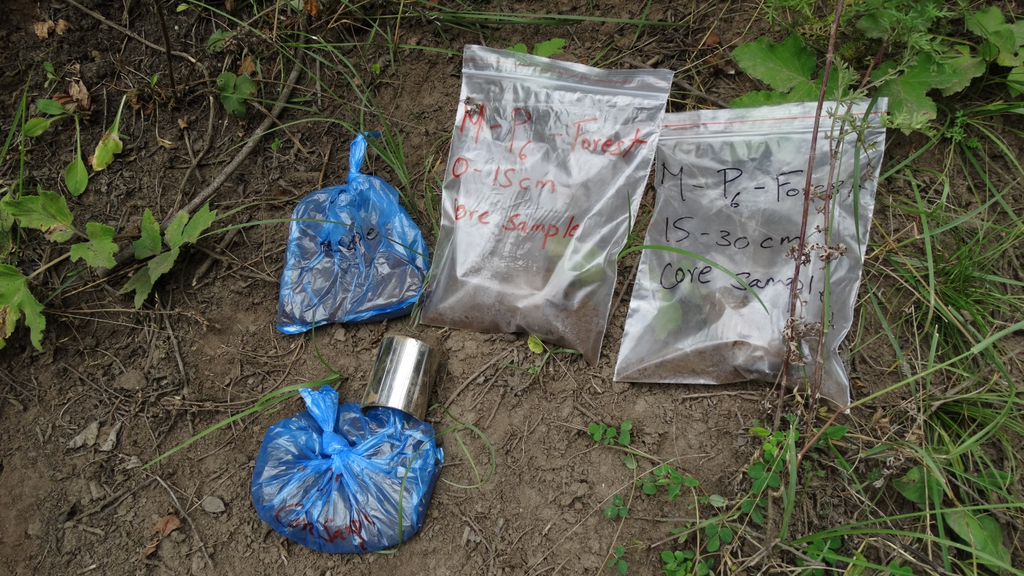
Figure S8: Soil sampling in Mustang
