Supporting Information
Li-ion Mobility and Solvation Structures in Concentrated Poly(ethylene carbonate) Electrolytes: A Molecular Dynamics Simulation Study
Wei Tan ¹, Kento Kimura ² and Yoichi Tominaga ¹*

1 Graduate School of Bio-Applications and Systems Engineering, Tokyo University of Agriculture and Technolo-gy, 2-24-16 Naka-cho, Koganei-shi, Tokyo 184-8588, Japan
2 Department of Applied Chemistry, Graduate School of Engineering, Tokyo University of Agriculture and Tech-nology, 2-24-16 Naka-cho, Koganei-shi, Tokyo 184-8588, Japan

*Corresponding author: ytominag@cc.tuat.ac.jp

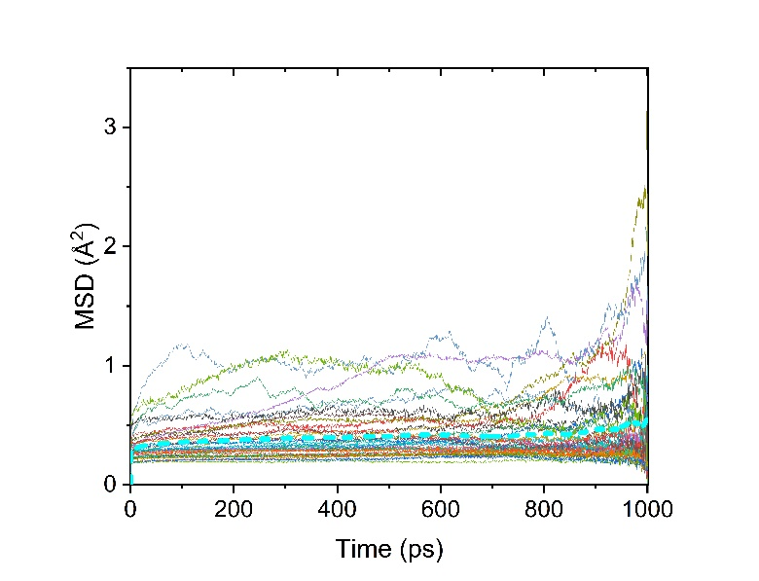 | 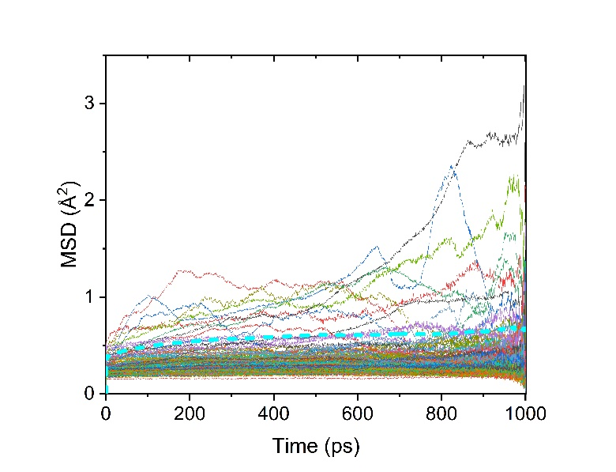
(a) | (b)
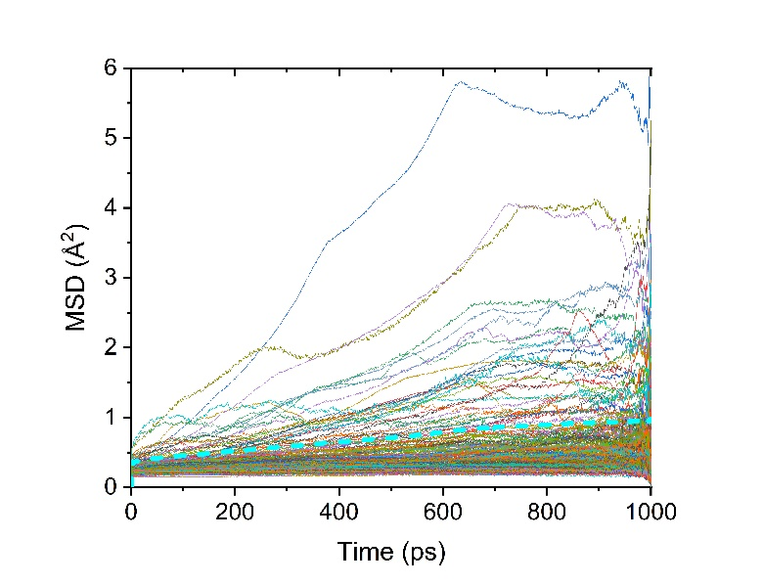
(c)

Figure S1. MSDs of each Li cations and average (marked as dashed lines) calculated in PEC/LiTFSI models, with different salt concentrations of (a) 20 mol%, (b) 80 mol% and (c) 120 mol%.

Table S1. Coordination number of Li-O(PEC).
Salt concentration (mol%) | Faster Li-ion | Slower Li-ion | Overall
5 | 2.12 | 2.77 | 2.51
10 | 1.85 | 2.28 | 2.13
20 | 1.44 | 1.55 | 1.51
40 | 1.13 | 1.03 | 1.06
60 | 0.83 | 0.88 | 0.86
80 | 0.62 | 0.69 | 0.68
100 | 0.45 | 0.73 | 0.63
120 | 0.37 | 0.58 | 0.54

Table S2. Coordination number of Li-O(TFSI).
Salt concentration (mol%) | Faster Li-ion | Slower Li-ion | Overall
5 | 1.65 | 1.75 | 1.71
10 | 1.81 | 2.21 | 2.07
20 | 2.23 | 3.08 | 2.78
40 | 2.42 | 3.21 | 2.97
60 | 2.76 | 2.97 | 2.89
80 | 2.37 | 3.01 | 2.91
100 | 2.26 | 3.43 | 3.12
120 | 1.64 | 3.70 | 3.31

Table S3. Coordination number of Li-O(All).
Salt concentration (mol%) | Faster Li-ion | Slower Li-ion | Overall
5 | 3.77 | 4.52 | 4.22
10 | 3.66 | 4.49 | 4.20
20 | 3.67 | 4.63 | 4.29
40 | 3.55 | 4.24 | 4.03
60 | 3.59 | 3.85 | 3.75
80 | 2.99 | 3.70 | 3.59
100 | 2.71 | 4.16 | 3.75
120 | 2.01 | 4.28 | 3.85

