Supporting Information

Enhanced Moisture Management in Textiles via Spray-Coated Water-Based Polyhydroxyalkanoate Dispersions

Marta A. Teixeira ¹*, Wael Almustafa ², Joana Castro ¹, Catarina Guise ¹, Helena Vilaça ¹ and Carla J. Silva ¹
Academic Editor: Firstname Lastname
Received: date
Revised: date
Accepted: date
Published: date
Citation: To be added by editorial staff during production.
Copyright: © 2025 by the authors. Submitted for possible open access publication under the terms and conditions of the Creative Commons Attribution (CC BY) license (https://creativecommons.org/licenses/by/4.0/).
¹ CITEVE-Technological Center for the Textile and Clothing Industries of Portugal, Vila Nova de Famalicão, Portugal; mteixeira@citeve.pt (M.A.T); jcastro@citeve.pt (J.C); cguise@citeve.pt (C.G); hvilaca@citeve.pt (H.V); cjsilva@citeve.pt (C.J.S)
² Department of Applied Logistics and Polymer Sciences, Kaiserslautern University of Applied Science, Schoenstr. 11, 67659 Kaiserslautern, Germany; wael.almustafa@hs-kl.de
* Correspondence: mteixeira@citeve.pt

Academic Editor: Firstname Lastname
Received: date
Revised: date
Accepted: date
Published: date
Citation: To be added by editorial staff during production.
Copyright: © 2025 by the authors. Submitted for possible open access publication under the terms and conditions of the Creative Commons Attribution (CC BY) license (https://creativecommons.org/licenses/by/4.0/).

Section S1: Thermogravimetric Analysis (TGA)
The graphs below present the thermogravimetric analysis (TGA) results and their corresponding derivative curves (DTG), providing detailed support and complementing the data presented in Table 2 of the original manuscript.

TGA analyses were conducted to investigate the thermal degradation behavior of the samples and to assess the presence and thermal contribution of the PHB.E.0 coating. A magnified image of the initial region of the TGA curves was included to clearly distinguish differences between the uncoated control fabrics and the PHB.E.0-coated counterparts, allowing for a more accurate estimation of the polymer content on the surface.
For the PES substrates (Figure S1-a), the presence of PHB.E.0 is readily identifiable as a distinct mass loss event, clearly separated from the main degradation step of the PES, indicating successful deposition of the polymer. In contrast, the TGA curves of the CO samples do not exhibit a similarly well-defined degradation step attributable to PHB.E.0, likely due to the overlapping degradation temperatures of both the CO substrate and the PHB.E.0 coating. Nonetheless, the zoomed-in profiles reveal subtle but consistent differences between the coated and uncoated CO substrates, supporting the presence of the coating. These observations are further corroborated and discussed in detail within the manuscript.

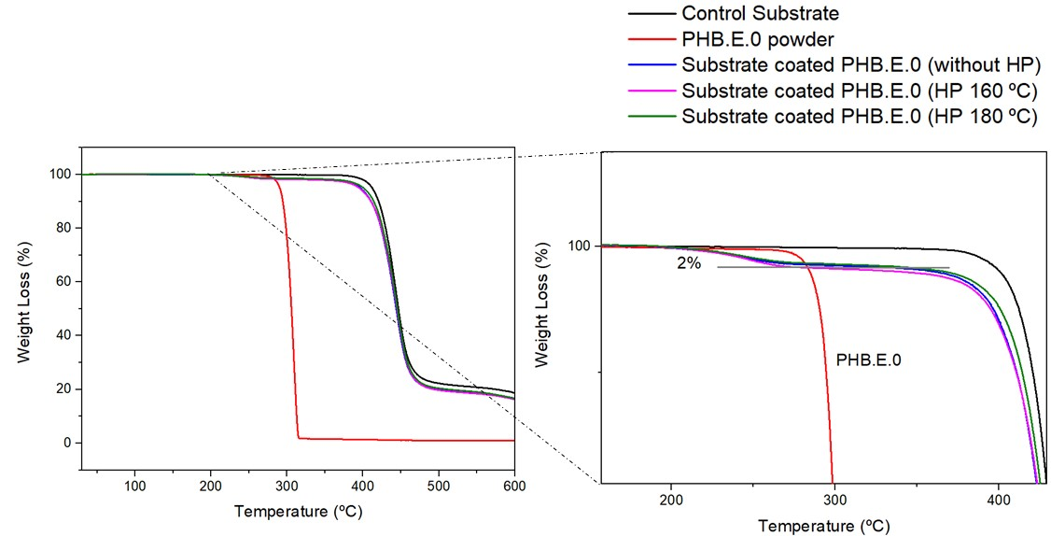
(a) (a₁)

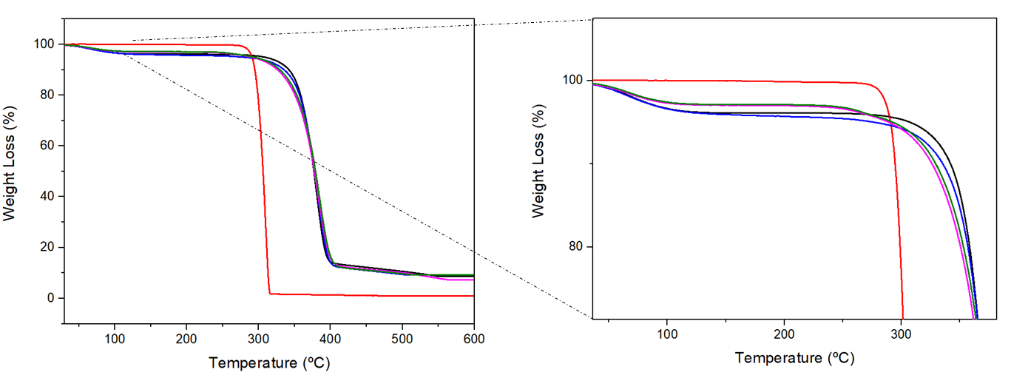
(b) ..(b₁)
Figure S1. Thermogravimetric analysis (TGA) of (a) PES substrates and PHB.E.0-coated PES; (b) CO substrates and PHB.E.0-coated CO. Images (a₁) and (b₁) present magnified views of the initial degradation regions for PES and CO substrates, respectively.

The derivative thermogravimetric (DTG) curves presented below illustrate the temperatures at which the maximum degradation rates occur for each sample. These profiles clearly indicate the temperatures at which the substrates undergo the most rapid thermal decomposition. Although PHB.E.0 is present in relatively low amounts, its thermal contribution is still noticeable. Notably, in the case of CO substrates, unlike PES, the main degradation event of the coating closely overlaps with that of the substrate, making it more challenging to distinguish. This behavior is clearly observable in Figure S2.

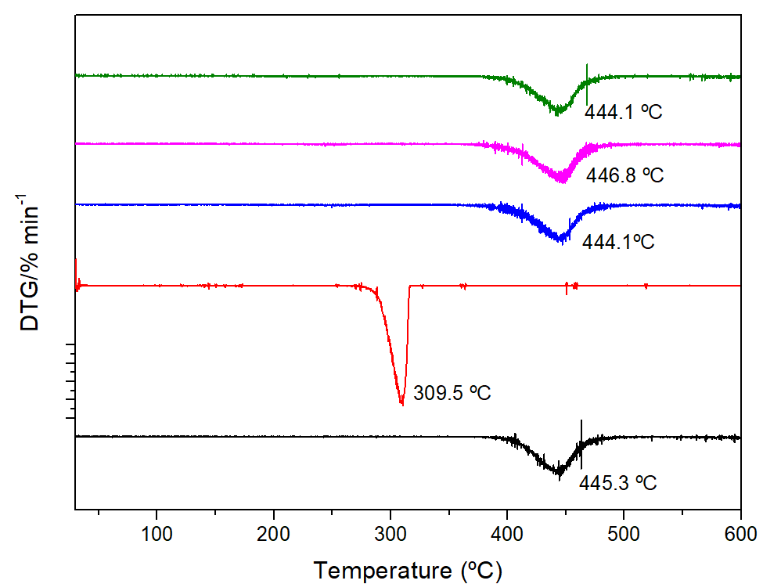 |  | 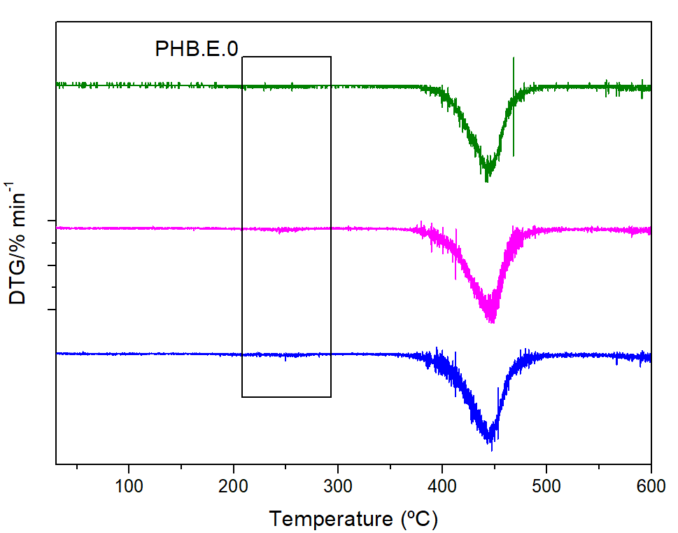
(a) |  | (a₁)
 | 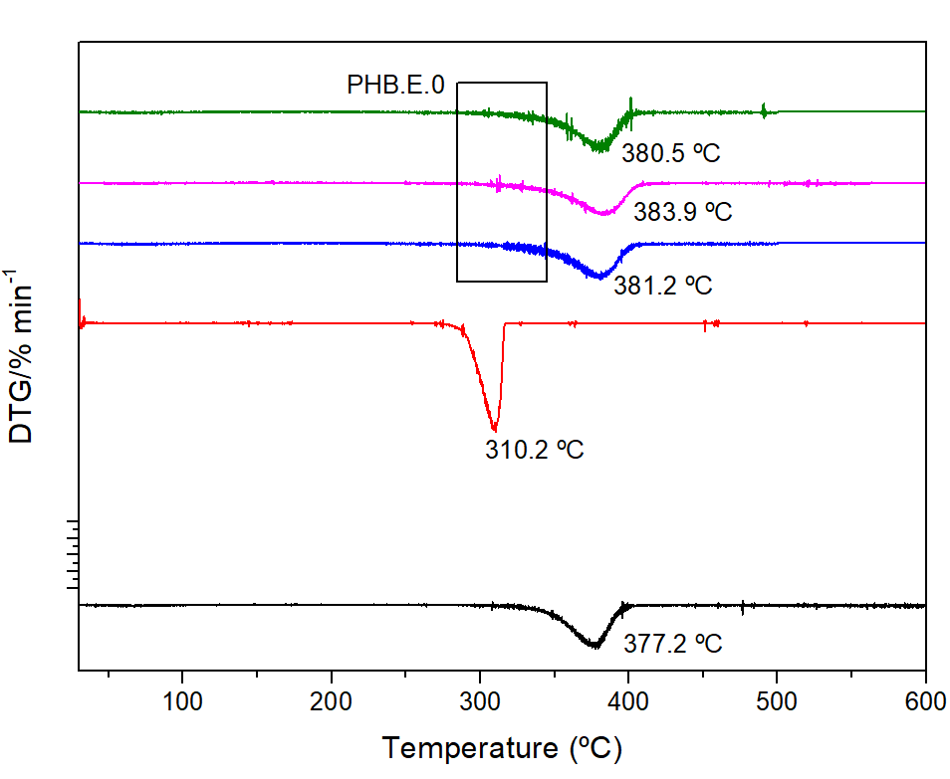
 | (b)
Figure S2. Derivative thermogravimetric analysis (DTG) of (a) PES substrates and PHB.E.0-coated PES substrates, with the corresponding magnified view shown in (a₁); and (b) CO substrates and PHB.E.0-coated CO samples.

