Appendix A: Literature Sources for Table 2

General
Pfizer. (2021). 5.3.6 Cumulative analysis of post-authorization adverse event reports of PF-07302048 (BNT162b2) received through 28-Feb-2021 (reissued). https://www.phmpt.org/wp-content/uploads/2022/04/reissue_5.3.6-postmarketing-experience.pdf

PASC
Bowe B, Xie Y, Al-Aly Z. Postacute sequelae of COVID-19 at 2 years. Nat Med. 2023;29(9):2347-2357. doi: 10.1038/s41591-023-02521-2.

Cheng KL, Yu WS, Wang YH, Ibarburu GH, Lee HL, Wei JC. Long-term Thyroid Outcomes After COVID-19 Vaccination: A Cohort Study of 2,333,496 Patients from the TriNetX Network. J Clin Endocrinol Metab. 2025: dgaf064. doi: 10.1210/clinem/dgaf064

Autoimmune
Sumantri S, Rengganis I. Immunological dysfunction and mast cell activation syndrome in long COVID. Asia Pac Allergy. 2023;13(1):50-53. doi: 10.5415/apallergy.0000000000000022.

Cardiovascular
Zhang T, Li Z, Mei Q, Walline JH, Zhang Z, Liu Y, Zhu H, Du B. Cardiovascular outcomes in long COVID-19: a systematic review and meta-analysis. Front Cardiovasc Med. 2025;12:1450470. doi: 10.3389/fcvm.2025.1450470.

Otolarygnological
Alzahrani M, Alshathri AH, Alduraibi K, Alshathri AH, Alanazi TF, Alandijani H, Almajed JA, Wajdi KA. Long-Term Outcomes of COVID-19 Otolaryngology Symptoms in Saudi Arabia. Cureus. 2023;15(1):e33461. doi: 10.7759/cureus.33461. PMID: 36751176; PMCID: PMC9899518.

Dermatology
Gambichler T, Boms S, Susok L, Dickel H, Finis C, Abu Rached N, Barras M, Stücker M, Kasakovski D. Cutaneous findings following COVID-19 vaccination: review of world literature and own experience. J Eur Acad Dermatol Venereol. 2022;36(2):172-180. doi: 10.1111/jdv.17744.

Endocrine
Kazakou P, Paschou SA, Psaltopoulou T, Gavriatopoulou M, Korompoki E, Stefanaki K, Kanouta F, Kassi GN, Dimopoulos MA, Mitrakou A. Early and late endocrine complications of COVID-19. Endocr Connect. 2021;10(9):R229-R239. doi: 10.1530/EC-21-0184

Gynecological/reproductive
Pollack B, von Saltza E, McCorkell L, Santos L, Hultman A, Cohen AK, Soares L. Female reproductive health impacts of Long COVID and associated illnesses including ME/CFS, POTS, and connective tissue disorders: a literature review. Front Rehabil Sci. 2023;4:1122673. doi: 10.3389/fresc.2023.1122673

Sandoval MN, Klawans MR, Bach MA, Mikhail J, Graviss EA, Cao T, Parchem JG, Husain J, Boerwinkle E. COVID-19 infection history as a risk factor for early pregnancy loss: results from the electronic health record-based Southeast Texas COVID and Pregnancy Cohort Study. BMC Med. 2025 May 9;23(1):274. doi: 10.1186/s12916-025-04094-y.

Manniche V, Fürst T, Schmeling M, Gilthorpe JD, Hansen PR. Rates of successful conceptions according to COVID-19 vaccination status: Data from the Czech Republic. Int J Risk Saf Med. 2025 Jun 19:9246479251353384. doi: 10.1177/09246479251353384

Thorp JA, Rogers C, Deskevich MP, Tankersley S, Benavides A, Redshaw MD, McCullough PA. COVID-19 vaccines: The impact on pregnancy outcomes and menstrual function. J Am Phys Surg. 2023; 28(1). https://www.jpands.org/vol28no1/thorp.pdf

Madaan S, Talwar D, Jaiswal A, Kumar S, Acharya N, Acharya S, Dewani D. Post-COVID-19 menstrual abnormalities and infertility: Repercussions of the pandemic. J Educ Health Promot. 2022;11:170. doi: 10.4103/jehp.jehp_1200_21

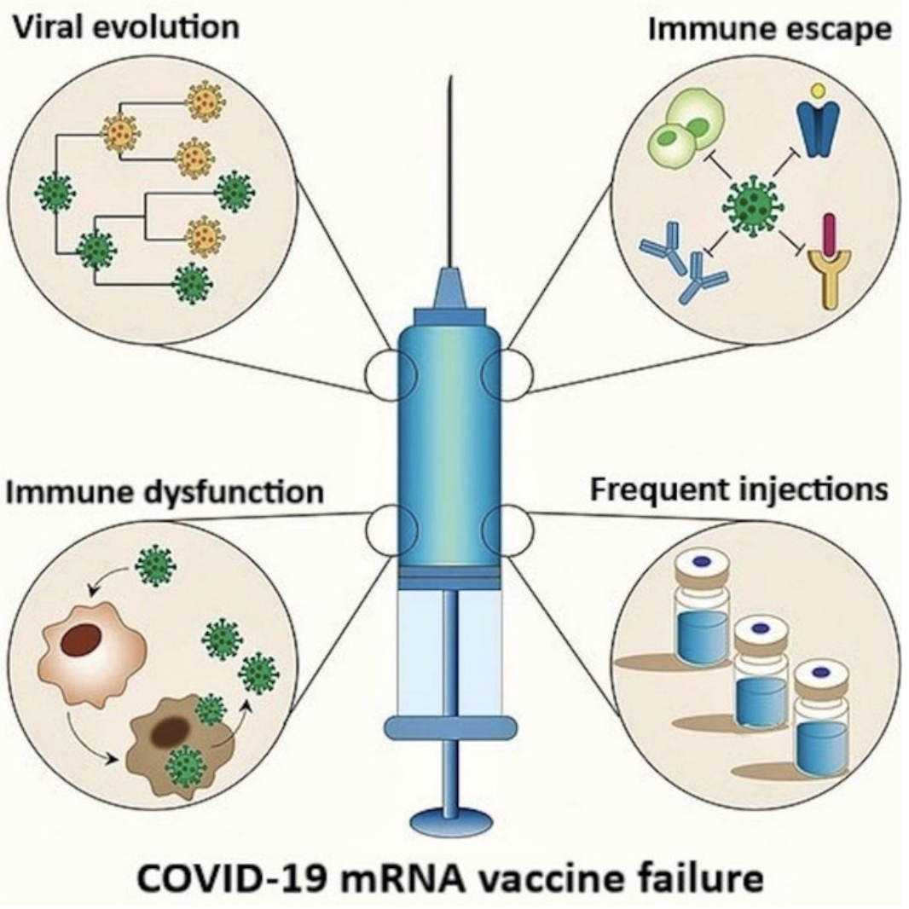
Appendix B, Figure 4. The basis for the failure of COVID-19 mRNA vaccinations has been elucidated. The SARS-CoV-2 spike (S) protein interacts with ACE2 receptor on host cells, creating conditions that exert significant selective pressure on the S gene, driving mutations that facilitate viral immune escape. Most of these mRNA products were developed using the S protein sequence from the original Wuhan strain, rendering them less effective against these escape variants, as the mutants can circumvent the immune responses elicited by these vaccines. This results in diminished vaccine efficacy for formulations based on the original S protein sequence. Furthermore, repeated mRNA vaccinations may alter viral dynamics, potentially promoting the emergence of immune-evasive variants, which could further reduce the effectiveness of these biologics. Additionally, frequent booster doses may contribute to excessive spike-related toxicities as well as immune dysregulation, potentially compromising antiviral and antimicrobial immunity while increasing the risk of autoimmune conditions and accelerated oncogenesis.

