Appendices A
A1. Taxonomy, scientific and vernacular names of Ophiocordyceps sinensis and Cordyceps militaris
Ophiocordyceps sinensis is a species of ascomycete fungi in the family Ophiocordycipitaceae.
Cordyceps militaris is a species of ascomycete fungi in the family Cordycipitaceae.

Table A1. Scientific and vernacular names of Ophiocordyceps sinensis and Cordyceps militaris
Accepted scientific name | Ophiocordyceps sinensis (Berk.) G.H. Sung, J.M. Sung, Hywel-Jones & Spatafora, 2007 | Cordyceps militaris (L.) Fr., 1818
Synonims | Cordyceps sinensis (Berk.) Sacc. (1878),  Sphaeria sinensis Berk. (1843) | Clavaria militaris L., 1753
Language | Vernacular names
Sanskrit | Yarsagumba
Tibetan | Yarsa gumba, Yarcha gumba (དབྱར་རྩ་དུད་འབྱུར་)
Nepali | Keera jhar, Jeevan buti, Keeda ghass, Chyou kira, Sanjeevani bhooti (यार्सागुम्बा)
Chinise (Mandarin) | Dong chong xi cao (冬蟲夏草, or 冬虫夏草, meaning “winter worm, summer grass”) | Běi chóng cǎo (北虫草) Northern Cordyceps
Japanase | Tocheikasa, Tochyuka-sou | 冬虫夏草 (Tōchūkasō)
Korean | 동충하초 (Dong Chung Ha Cho) | 북충초 (Buk chung cho)
Vietnamese | Đông trùng hạ thảo | Đông trùng hạ thảo quân đội
Thai | ถั่งเช่า (Thungchao) | ถั่งเช่าเหนือ (Thungchao nuea)
French | cordyceps, champignon chenille
German | Cordyceps, Chinesischer Raupenpilz, Tibetischer, Raupenpilz, Tibetischer Raupenkeulenpilz
Italian | cordyceps, fungo del bruco
Spanish | cordyceps
English | Caterpillar fungus, Cordyceps mushroom  Winter Worm - Summer Grass | Scarlet Caterpillar Club, Orange Cordyceps

Etymology: Ophiocordyceps = from Greek ophio- (“snake-like”) + cordyle (“club”) + ceps (“head”).
Refers to the slender, serpentine fruiting body; sinensis = Latin for “from China,” where the species was first described (Berkeley, 1843). The traditional phrase “冬虫夏草” (Dōng chóng xià cǎo) encapsulates its dual nature as both animal (insect larva) and plant-like (fungal fruiting body). Cordyceps = from Greek kordyle (club) + ceps (head), militaris = Latin for “military” — a reference to its upright, orange, “soldier-like” appearance.

Table A2. Taxonomy of Ophiocordyceps sinensis and Cordyceps militaris
Scientific name | Ophiocordyceps sinensis (Berk.) G.H. Sung, J.M. Sung, Hywel-Jones & Spatafora, 2007 | Cordyceps militaris (L.) Fr., 1818
Domain | Eukaryota (eukaryotes) | Eukaryota (eukaryotes)
Kingdom | Fungi | Fungi
Phylum | Ascomycota (ascomycete fungi) | Ascomycota (ascomycete fungi)
Class | Class: Sordariomycetes | Sordariomycetes
Order | Hypocreales | Hypocreales
Family | Ophiocordycipitaceae | Cordycipitaceae
Genus | Ophiocordyceps | Cordyceps
Species | Ophiocordyceps sinensis | Cordyceps militaris

A2. Chemical composition, bioactive compounds, and pharmacological activity of Ophiocordyceps sinensis and Cordyceps militaris species
Overall, 110 primary and secondary metabolites of O. sinensis and C. militaris fungi were identified in several comprehensive reviews of their traditional uses, chemical composition, and pharmacological activity [16,18,19,69,70,71]. Figures A1 – A5 and Tables A3 – A6.

Table A3: Chemical bioactive constituents of O. sinensis [21,29,65] and C. militaris [23,66,67]
C. sinensis | C. militaris
- Cordycepic acid,  - glutamic acid, amino acids (phenylalnine, praline, histidine, valine, oxyvaline, arginine):  - polyamines (1,3-diamino propane, cadaverine, spermidine, spermine, homospermidine, and purtescine): cyclic dipeptides (cyclo-(gly-pro), cyclo-(leu-pro), cyclo-(val-pro), cyclo-(ala-leu), cyclo-(alaval), and cyclo-(thr-leu),  - saccharides and sugar derivatives (d-mannitol, oligosaccharides, and polysaccharides);  - sterols (ergosterol, delta-3 ergosterol, ergosterol peroxide, 3-sistosterol, daucosterol and campesterol);  - nucleotides, and nucleosides, including adenine, adenosine, inosine, cytidine, cytosine, guanine, uridine, thymidine, uracil, hypoxanthine, guanosine, uracil, uridine, guanosine, and deoxyuridine and cordycepia;  - saturated and unsaturated fatty acids, their derivatives and other organic acids (oleic, linoleic, palmitic and stearic acids);  - vitamins (B1, B2, B12, E, and K); and  - inorganic elements (K, Na, Ca, Mg, Fe, Ca, Mn, Zn, Pi, Se, Al, Si, Ni, Si, Ti, Cr, Ga, V, and Zr). | - cordycepin,  - cordycepic acid,  - pentostatin,  - carotenoids (lutein, zeaxanthin, cordyxanthins),  - L-ergothioneine,  - ergosterol,  - polysaccharides,  - glycoproteins,  - 5-Methyltryptamine  - Lovastatin  - 5-Hydroxy-L-tryptophan  - L-Tryptophan  - Serotonine  - L-Phenylalanine

Table A4. The pharmacological activity of bioactive compounds of O. sinensis and C. militaris*⁾

Classification | Compound, the pharmacological activity, and the reference
Nucleoside and bases | Adenosine: Neuroprotection, immunomodulatory [270,271]  Cordycepin: Neuroprotection, anti-metastatic, anti-platelet aggregation, anti-inflammatory activity, anticancer [62, 130,272]  Dimethylguanosine: Antioxidant and HIV-1 protease [273]  Guanosine: Immunomodulatory [270,271]  Cordysinin B: Anti-inflammatory activity [71]
Sterols | Ergosteryl-3-O-β-D-glucopyranoside: Anti-inflammatory, antioxidant [71, 81]  5α,8α-epidioxy-22E-ergosta-6,9-(11)-22-trien-33β-ol: Cytotoxic against HL-60 cell line [274]  5α,6α-epoxy-5α-ergosta-7,22-dien-3β-ol: Cytotoxic against HL-60 cell line [274]  5α,8α-epidioxy-24(R)-methylcholesta-6,22-dien-3β-Dglucopyranoside: Antitumor [81]  Ergosta-4,6,8(14),22-tetraen-3-one: Antitumor [81]  22-dihydro-ergosteryl-3-O-β-D-glucopyranoside: Antitumor [81]
Cyclodipeptides | Cordyceamide A: Cytotoxicity against L929, A375 and Hela cell lines [275]  Cordyceamide B: Cytotoxicity against L929, A375 and Hela cell lines [275]  Cycloaspeptide A: Cytotoxicity against HeLa and MCF7 cell lines [276]  Cycloaspeptide C: Cytotoxicity against HeLa and MCF7 cell lines [276]  Cycloaspeptide F: Cytotoxicity against HeLa and MCF7 cell lines [276]  Cycloaspeptide G: Cytotoxicity against HeLa and MCF7 cell lines [276]  Cyclo(L-Pro-L-Val): Antioxidant, anti-inflammatory [71]  Cyclo(L-Phe-L-Pro): Antioxidant, anti-inflammatory [71]  Cyclo(L-Pro-L-Tyr): Antioxidant, anti-inflammatory [71]
Alkaloids | Cordysinin A: Anti-inflammatory, antioxidant [19,277]  Cordysinin C: anticancer [277, 278]  Cordysinin D: anticancer [277, 278]  Flazin: Antioxidant, anti-inflammatory [278]  Perlolyrine (100) Antioxidant, anti-inflammatory, anticancer [278]  α-methoxy-α-trifluoro-methylphenylacetyl chlorides: Anti-inflammatory [71]  1-acetyl-β-carboline: Anticancer [71, 278]  gliocladicillins A: antitumor cell proliferation inhibitors and apoptosis inducers [16, 69]  gliocladicillin B: antitumor cell proliferation inhibitors and apoptosis inducers [16, 69]  11,11’-dideoxyverticillin: antitumor cell proliferation inhibitors and apoptosis inducers [16, 69]
Flavonoids | 3′,4′,7-trihydroxyisoflavone: Antioxidant [71]  Diadzein: Antioxidant, anti-inflammatory [71]  6,7,2′,4′,5′-pentamethoxyflavone: Antioxidant activity, anti-HIV-1 protease [273]  Glycitein-7-O-β-D-glucoside-4’-O-methylate: Anti-inflammatory [279]  Iso-sinensetin (120) Antioxidant activity, anti-HIV-1 protease [273]
Miscellaneous | Ophicordin: Antifungal [280]  2-Furancarboxylic acid: Anti-inflammatory, antioxidant [71]  3-hydroxy-2-methyl-4-pyrone: Anti-inflammatory, antioxidant [71]  Cordycerebroside A: Anti-inflammatory [281]  Soyacerebroside I: Anti-inflammatory [281]  Glucocerebroside: Anti-inflammatory [281]
*) – Data extracted from the review Olatunji et al., 2018 [19]

Table A5: Summary of biomarkers and pharmacological activity used for quality control of Cordyceps [18]

Nucleosides
Anti-tumor activities; Ca2+ antagonist; depresses the excitability of CNS neurons, inhibits
release of various neurotransmitters presynaptically and anticonvulsant activity [[72-74]
stimulate axon growth in vitro and in the adult central nervous system [75]
Polysaccharides
Anti-oxidation, immuno-potentiation, anti-tumor, and hypoglycemic activity [76-79]; anti-inflammatory activity and suppresses the humoral immunity in mice [80]
Ergosterol and its analogs
Cytotoxic activity, anti-viral activity, and anti-arrhythmia effect [81,82]; suppress the activated human mesangial cells and alleviate immunoglobulin A nephropathy (Berger’s disease) [83]
Mannitol
Diuretic, anti-tussive, and anti-free radical activities [18]
Peptides
Anti-tumor and immuno-potentiation activities [18]

Table A6. Pharmacological activity of total extracts of Ophiocordyceps sinensis and Cordyceps militaris in experimental study models [19,97]

O. sinensis | C. militaris
Anti-arteriosclerosis: Rats | Acetylcholinesterase inhibition
Anticancer Mice | Anti-allergic Mice
Anti-diabetic Rats | Anticancer A 4T1, SMMC-7721, BGC-823,MCF-7 cells
Anti-fatigue Rats | Anti-HCV
Anti-fibrotic HK-2, HLFS cells | Anti-HCV
Anti-hypertensive Rats | Antihyperglycemic Mice
Anti-inflammatory HM cells | Antihyperlipidemic Mice
Antioxidant | Anti-inflammatory human ADMSC cells
Anti-thrombotic Humans | Antimicrobial
Antitumor S-180 cells | Anti-obesity C58BL/6 J mice
Hepatoprotective HepG2 cells | Antioxidant
Immunomodulatory RAW 264.7 cells | Antitumor J6/JFH1-huh 7.5 cells
Radio-protective Mice | Hepatoprotective Mice
Renoprotective Rats | HIV-1 protease inhibiting
 | HuH-7-derived OR6, AH1R cells
 | Hypouricemic Mice
 | Immunomodulatory Sea Cucumbers

Table A7. Dietary uses of O. sinensis in medicinal dishes

Dishes | Indications for use
Cooked with an old duck | For patients with cancer, asthenia, or after severe illness
Cooked with hen | For hyposexuality (especially emission)
Cooked with black-bone hen | For asthenia (especially Qi-Yin asthenia)
Cooked with lean pork | For fatigue, male impotence, and "kidney" asthenia
Cooked with sparrow | For antiaging/senescence
Cooked with quail | For fatigue, poor appetite, "kidney" asthenia, and tuberculosis
Cooked with steamed turtle | For male/female hyposexuality
Cooked with baked abalone | For chronic bronchitis, COPD, tuberculosis, arteriosclerosis, cataracts, and for healthy individuals in any season
Data adapted from Jiang (1994) and Zhu et al. (1998) [13].

A3. Clinical studies
Table A8. Summary of Randomized Placebo-Controlled Clinical Trials of O.sinensis and C.militaris
Species | Botanical Material / Product | Comparator | Daily Dose | Duration | Population / Condition | Sample Size | Study Design (GCP) | Primary Endpoints | Outcome Measures | Key Clinical Results | Effect Size (reported / calculable) | Risk of Bias (Cochrane) | Citation
O. sinensis | Cs-4 mycelium (Paecilomyces hepiali) | Placebo | 999 mg/day (333 mg TID) | 12 weeks | Healthy elderly (50–75 y) | n=20 | DB-PC RCT | Exercise performance | VO₂max, ventilatory threshold, VT, MT | ↑ ventilatory & metabolic thresholds; no VO₂max change | VO₂max SMD ≈ 0 | Low | Chen et al., 2010 [151]
O. sinensis | Mycelium extract | Placebo | 2 g/day | 12 weeks | Amateur marathoners | n=12 | DB-PC RCT | Aerobic performance | CPET, HR | ↓ HR at submax load; ↑ aerobic performance | SMD small–moderate | Moderate | Savioli et al., 2022 [160]
O. sinensis | Cs-4 | Placebo | 3 g/day | 12 weeks | Healthy elderly | n=37 | Randomized DB-PC | Aerobic capacity | VO₂max, FEV₁ | Significant ↑ VO₂max | SMD ≈ 0.54 | Moderate | Yi et al., 2004 [162]
O. sinensis | Cs-4 (CordyMax) | Placebo | 3 g/day | 5 weeks | Trained cyclists | n=25 | Randomized DB-PC | Endurance | Time-to-exhaustion | No difference | SMD ≈ 0.00 | Low | Parcell et al., 2004 [156]
O. sinensis | Herbal formulation | Standard asthma care | NR | 3 months | Moderate–severe asthma | n=120 | RCT | QoL | AQLQ, FEV₁ | Significant QoL improvement | MD (AQLQ) +0.8 | Moderate | Wang et al., 2016 [167]
O. sinensis | Cs-4 mycelium, capsule | Placebo “Wait-list group.” | 1.6 g (4 caps 0.4 g/caps daily) | 12 weeks, follow-up at week 24 | Long COVID | n=110 (55/55} | Waitlist-controlled RCT | Change in the symptom severity, COVID-19 Yorkshire Rehabilitation Scale (C19-YRSm**) at 12 weeks | Long Covid symptoms severity (C19-YRSm), Fatigue, sleep, QoL, depression, anxiety, | Significant multi-domain improvement. Improved Long COVID severity symptoms, fatigue & QoL | Moderate, Significant change from baseline between-group difference (adjusted for duration and vaccine doses) | Low  Some concerns | Chen et al., 2025 [165]
O. sinensis | Mycelium extract | Standard care | NR | ≥8 weeks | Diabetic kidney disease | >13,000 (meta-analysis) | Systematic review of RCTs | Renal surrogates | Proteinuria, Cr | ↓ proteinuria, ↓ Cr | Pooled MD significant | High | Xue et al., 2024 [141]
O. sinensis | Mycelium extract | Standard care | NR | NR | Dialysis patients | n=2,914 | Meta-analysis | Inflammation, anemia | CRP, Hb, Alb | Improvements in surrogates | Low certainty | High | Liu et al., 2024 [137]
O. sinensis | Mycelium extract | Placebo | NR | Peri-procedure | CA-AKI risk | n=1,271 | Systematic review | AKI incidence | Serum Cr | ↓ CA-AKI incidence | RR <1 | Moderate | Pu et al., 2024 [139]
O. sinensis | Mycelium | Placebo | 1 g (3.5 mg of adenosine and 40 mg polysaccharide) | Single dose | Healthy young adults | n=14 | DB crossover RCT | Muscle recovery | CD34⁺/Pax7⁺ cells | Accelerated stem-cell recruitment | Not pooled | Low | Dewi et al., 2024 [282]
O. sinensis | Cordyceps capsules | Placebo | 1.5 g (3x500 mg) | 15 days | Mild-moderate COVID-19 | 65 (32/33) | Double-blind RCT | Recovery time | Viral load days at hospital; Serum biomarkers | Faster recovery vs placebo | Moderate | Some concerns | ANM Health (2023) [166]
O. sinensis | Cordyceps sinensis | Chemo alone |  | 6 months | NSCLC | 60 | RCT |  | Survival, QoL | Improved survival, QoL | Moderate | Some concerns | Hao et al. (2008) [283]
O. sinensis | Cordyceps + NP regimen | NP regimen |  | 6 months | Advanced NSCLC | 80 | RCT |  | Tumour response | Improved response rate | Moderate | Some concerns | Hao et al. (2007) [284]
O. sinensis | CBG-CS-2 mycelium | Placebo |  | 8 weeks | Healthy adults | 80 | Double-blind RCT |  | Immune markers | ↑ immune markers | Moderate | Low | Jung et al. (2019) [285]
O. sinensis | Cordyceps + anthocyanin | Placebo |  | 8 weeks | Middle-aged adults | 40 | Double-blind RCT |  | Mental condition | Improved mood | Small | Some concerns | Morikubo et al. (2005) [286]
O. sinensis | Cordyceps extract | Placebo |  | 6 weeks | Asthma | 120 | Double-blind RCT |  | HRQoL | Improved HRQoL | Moderate | Some concerns | Wang et al. (2016) [167]
O. sinensis | C. sinensis capsules | Placebo | 2400 mg in 6 capsules | 8 weeks | Healthy young adults | 30 | Double-blind RCT |  | Testosterone, strength | No effect | None | Low | Hsu et al. (2011) [155]
O. sinensis | Extract powder | Placebo | 0.5 g | 2 weeks | Exhaustive running exercise | 36 | Double- blind RCT | Recovery time | Respiratory variables, heart rate, and lactate, | ↓ fatigue ↓ recovery time | Significant difference vs placebo | Some concerns | Nagata et al., 2006 [153]
C. militaris | C. militaris | Placebo |  | 3 weeks | Healthy adults | 28 | Double-blind RCT |  | Exercise tolerance | ↑ tolerance | Small | Low | Hirsch et al. (2017)[154]
C. militaris | Fruiting body extract (standardised) | Placebo | NR | 8 weeks | Healthy adults | n=40 | DB-PC RCT | Immune response | NK activity | Significant ↑ NK activity | SMD moderate | Low | Ontawong et al., 2024 [164]
C. militaris | Mycelium extract | Placebo | 1.5 g/day | 8 weeks | Mild liver dysfunction | n=57 | Randomized DB-PC | Liver enzymes | ALT, AST | Significant ↓ ALT & AST vs placebo | MD −12 U/L Moderate | Low | Heo et al., 2015 [168]
C. militaris (dominant) | PeakO₂ mushroom blend | Placebo | 1.0 - 2.0 g/day) and 12 g/day | 28 days | Healthy adults | n=40+43 | DB-PC RCT | Endurance | VO₂peak, Time-to-fatigue | ↑ VO₂peak in subgroups: Improved tolerance vs baseline | ES not calculable (no control SD), Heterogeneous | Moderate | Dudgeon et al., 2018 [163]
C. militaris | Fruiting body extract | Placebo | 1.8 g/day | 16 weeks | Endurance athletes | n=11 | DB-PC RCT | Hematology | Hb, CK | ↑ Hb, ↓ muscle damage | MD clinically relevant | Low | Nakamura et al., 2024 [155]
C. militaris | Mycelium capsules+ duloxetine | Placebo + duloxetine | 4 g/day | 6 weeks | Depression with insomnia | n=59 | Double-blind RCT | Changes in the Athens Insomnia Scale (AIS) score Sleep quality | Sleep quality PSQI, ISI | C. militaris did not improve sleep symptoms in patients with depression; no superiority over placebo. | 0.6 | Low–Moderate | Zhou et al., 2021 [169]
*- DB-PC = double-blind placebo-controlled, RCT = randomized controlled trial, ES = effect size, RoB = Risk of Bias (Cochrane domains, summary judgment); ** - C19-YRSm - modified COVID-19 Yorkshire Rehabilitation Scale including the following symptoms in the symptom severity subscale: breathlessness; cough/throat sensitivity/voice change; fatigue; smell/taste; pain/discomfort; cognition; palpitations/dizziness; post-exertional malaise; anxiety/mood; and sleep. Each item was scored on a scale from 0–3 to indicate severity.

Table A9. Clinical trials evaluating O.sinensis for fatigue and related outcomes in COVID-19 and Long COVID
Study, year | Preparation/ Dose | Population | Study design | Duration | Fatigue-related outcomes | Meta-analysis results | Main findings | Key limitations | GRADE-style certainty*
Chen et al., 2025 | O.sinensis Cs-4® (fermented mycelium) | Long COVID patients | Randomized, waitlist-controlled clinical trial | 12 weeks | Fatigue severity scales, exercise tolerance, HRQoL | No meta-analysis available (single RCT); aligns with pooled post-viral fatigue effects of adaptogens | Significant reduction in fatigue severity and improvement in functional capacity and QoL compared with usual care | Single-region study; short follow-up; patient-reported outcomes | Moderate (exploratory) ⬤⬤⬤◯
ANM Health, 2023 | O.sinensis Capsules (add-on therapy) | Mild–moderate COVID-19 patients | Randomized, double-blind, placebo-controlled | 14–28 days | Fatigue, recovery time, QoL | Not pooled; excluded from formal meta-analyses due to reporting limitations | Faster symptom resolution and reduced fatigue compared with placebo | Industry-sponsored; non–peer-reviewed; limited methodological transparency | Low ⬤⬤◯◯
*Level of evidence reflects EMA/HMPC-oriented qualitative grading, not formal regulatory classification. Abbreviations: HRQoL, health-related quality of life.DB-RCT, double-blind randomized controlled trial

GRADE-style certainty explanation (adapted for Frontiers)
- ⬤⬤⬤⬤ High: Very unlikely to change confidence
- ⬤⬤⬤◯ Moderate: Likely to have an important impact on confidence
- ⬤⬤◯◯ Low: Further research is very likely to change the estimate
- ⬤◯◯◯ Very low: Evidence uncertainty

A4. network pharmacology/systems pharmacology

The 22 studies in which network pharmacology/systems pharmacology was combined with wet-lab or clinical validation (animal models, cell experiments, or RCTs) are listed in Table A10.

Table A10. Overview of network-pharmacology studies of O. sinensis, C. militaris preparations, and cordycepin, supported by experimental validation
Study (year) | Dose/concentration  Main bioactive compounds | Disease or  physiological function | Key targets/nodes validated | Signaling Pathways | Type of validation & main mechanistic outcome
Jiang et al.,2023  [177] | O. sinensis ;  arachidonic acid, lysergol, glycitein; stigmasterol, sitosterol, linoleic acetate, karanjin, aurantiamide acetate, and berberine.  1000 mg/kg in rats, | Ischemic stroke | CASP3, PTGS2, and PPARG, AR, NOS2, PTGS2, PTGS1, CYP17A1, ADRB2, CHRM2, ESR1, RXRA, and SCN5A | IL-17, AGE-RAGE, and TNF signaling pathways | The mechanism of action of O. sinensis is related to the regulation of blood lipids, anti-apoptotic effects, and anti-inflammatory effects. The results of the docking analysis suggest that sitosterol, lysergol, and stigmasterol have high affinities to some core proteins (CASP3, PTGS2, PPARG, JUN, and ESR1.
Wang et al., 2017  [179] | O. sinensis ,  Cordycepin.  0.2, 1 or 2 mg/kg  In mice | Hepatitis B vaccine adjuvant | Immune-response targets related to B- and T-cell activation and cytokine signaling | Immune & vaccine-response pathways  (e.g. T-cell receptor, cytokine signaling) | Systems pharmacology predicted cordycepin as an adjuvant; BALB/c mouse vaccination showed enhanced humoral and cellular HBV responses without apparent toxicity. Effects of cordycepin (C) on serum HBV antibodies, lymphocyte proliferation and cytokine levels in spleen cell supernatants.
Zhang X et al., 2023  [180] | O. sinensis extract  A total of 54 active ingredients which are not specified for their name and chemical structure.  300, 600, 1200 mg/kg in mice | Lung adenocarcinoma | Breast cancer type 1 susceptibility protein (BRCA1 ) and G1/S-specific cyclin-E1 (CCNE1) and oxidative-stress regulators | PI3K–Akt, HIF-1 signaling, apoptosis pathways | Bioinformatics + network analysis predicted anti-Lung adenocarcinoma targets; in vivo validation showed O. sinensis inhibits tumor growth and modulates these pathways.
Ma and Jin, 2024  [145] | O. sinensis  121 bioactive compounds, including cordycepin | Chronic obstructive pulmonary disease (COPD) | CXCR4, PDGFRB, PARP1, SRC, HIF1A, NFKB1, HDAC 2, and PKACA | Chemokine signaling | The target analysis of the Bailing capsule's effects revealed interactions with multiple targets. The study suggested that the mechanism might involve interactions with chemokines, tyrosine kinase receptors, and other related molecular signaling pathways.
Zhou et al., 2025  [176] | C. sinensis  Sphingolipid.  0.405 g/kg/day (L-CS), 0.81 g/kg/day (M-CS), and 1.62 g/kg/day (H-CS); in rats | Chronic obstructive pulmonary disease (COPD) | PLA2G4E and B4GALT4 proteins  AKT1, ESR1, TLR4, and MMP9; TNF-α, IL-8, and multiple metabolic proteins | PI3K-AKT signaling pathway  Inflammatory and metabolic pathways | O. sinensis alleviated lung injury, cytokine profiles, and inflammation in the COPD model of rats; Proteomics + metabolomics + network analysis connected altered proteins/metabolites to COPD-relevant pathways including PI3K-AKT signaling pathway in COPD rats, potentially affecting glycerophospholipid metabolism and sphingolipid metabolism by targeting PLA2G4E and B4GALT4 proteins, thereby alleviating the inflammatory response and mitigating lung tissue damage caused by COPD.
Zhang Y et al.,2023  [180] | O. sinensis ;  arachidonic acid, linoleyl acetate, cerevisterol,beta-sitosterol, peroxyergosterol, cholesterol, and cholesteryl palmitate.  50 μg/mL fermented O. sinensis (in vitro a proximal tubular HK-2 cell line derived from normal human kidney) | diabetic kidney disease | RELA, JNK1, PTEN, VEGFA, EGF, ERK2, CASP3, AKT1, MMP9. O.synensis downregulated the expressions of Bax, Caspase-3, VEGFA, P-AKT, and P-ERK, and upregulated the expression of PTEN | AKT and ERK signaling pathway | O.synensis has nephroprotective effects, which functions via promoting proliferation and inhibiting apoptosis of renal proximal tubular cells, likely by targeting Caspase-3, Bax, VEGFA and PTEN.
Li et al., 2024  [182] | O. sinensis  adenosine; 2’deoxyadenosine; cordycepin; adenine; uracil; hypoxanthine; uridine; guanosine hydrate; thymidine.  CS extract (150 mg/kg in mice;  2’-deoxyadenosine  The dose is Not specified | acute kidney injury (AKI) | STING, Irf3, Perforin, IFN-γ, GAPDH | STING/IRF3 pathway | 2’-deoxyadenosine treatment significantly alleviated FA-induced renal damage in vivo and alleviated the renal injury in NK cells by activating the STING/IRF3 pathway to inhibit perforin release in vitro. 2’-deoxyadenosine could mitigate AKI by downregulating NK cell activity (by decreasing perforin and IFN-γ expression) and inhibiting the stimulator of interferon genes and phosphorylated IFN regulatory factor 3.
Tao et al., 2024  [141] | O. sinensis mycelial preparation (Bailing capsules ), including arachidonic acid, linoleoyl acetate, cerevisterol, beta-sitosterol, peroxyergosterol, cholesteryl palmitate, and cholesterol  0.8 – 5 g/day in humans | Chronic kidney disease (CKD), human RCT | Inflammatory & metabolic renal function markers including: PTPN1, HSD11B1, HSD11B2, HMGCR, AR, NR1H3, NR3C1, CNR2, CYP19A1, CYP17A1, and DRD2 | Neuroactive ligand-receptor interaction, Chemical carcinogenesis receptor activation, Diabetic cardio-myopathy, cAMP signaling, Inflammatory mediator regulation of TRP channels, Insulin resistance,Proteoglycans, Serotonergic synapse, AGE-RAGE signaling, EGFR tyrosine kinase inhibitor resistance, Prolactin signaling, Endocrine resistance, C-type lectin receptor, ErbB, VEGF, Arachidonic acid metabolism, and Adipocytokine signaling pathways. | Network pharmacology analysis identified 190 common targets of O.synensis (Bailing Capsule) and chronic kidney disease associated with immune response, inflammatory response, vascular endothelial damage, cell proliferation, and fibrosis .  Clinical trials showed improved renal indices and reduced inflammation when the Bailing capsule was added to standard CKD therapy. Mechanistic validation is indirect but consistent.
He et al., 2020  [183] | O.sinensis  Adenosine  exopolysaccharide, amino acid, mannitol  human keratinocyte line HaCaT  (50, 250, and 500 μg/  mL extract | UVB-induced damage in human keratinocytes | Aquaporin 3 (AQP3) | PPAR signaling pathway, cholesterol metabolism, and ovarian steroidogenesis. | Cordyceps significantly decreased intracellular UVB-induced oxidative stress, including ROS production and intracellular H2O2 content. Besides, AQP3, which mediates intracellular signaling and transports H2O2 into cells, was significantly increased in the presence of Cordyceps extract under UVB irradiation. In addition, the DNA repair effect of Cordyceps extract after UV irradiation was proven to be effective by the comet assay.
Pei et al., 2023  [184] | C. militaris polysaccharides | Immune modulation  (non-specific, innate/adaptive immunity) | TNF, MAPK3, CASP3, VEGFA, STAT3; TLR4 | Toll-like receptor (TLR4), TNF-α signaling; macrophage M1↔M2 polarization and immune activation, apoptosis, cytokine pathways | Network analysis identified immune targets enriched in TLR pathways; in vitro macrophage assays showed altered polarization, and in vivo mouse experiments confirmed TLR4/TNF-α activation by C. militaris polysaccharides consistent with predictions.
Kim et al., 2025  [185] | C. militaris extracts (cordycepin, adenosine)  Lung cancer cell lines (LLC1, H460, H1299 | Lung cancer | p53, EGFR, apoptosis-related targets | PI3K–Akt, p53, apoptosis | Network pharmacology/docking indicated cordycepin and adenosine as key ligands targeting EGFR/p53-related networks; cell experiments showed enhanced apoptosis and anticancer activity, particularly after optimizing extraction/drying procedures to enrich key actives.
Wang et al., 2025  [186] | C. militaris fruiting body; nucleosides (uridine, guanosine, adenosine, cordycepin, N⁶-(2-hydroxyethyl)adenosine); | Chronic obstructive pulmonary disease (COPD) | IDH1, CYP19A1, lipid-metabolism targets | Linoleic acid metabolism, inflammatory and oxidative pathways | HPLC fingerprinting + metabolomics + network pharmacology; COPD mouse model demonstrated improved lung function and pathology; docking supported strong binding of CM components to IDH1/CYP19A1.
Zhou et al., 2024  [187] | C. militaris (cordycepin, ergosterol)  100 and 200 mg/kg/d C. militaris extract; | Gouty nephropathy/hyperuricemia | cyclooxygenase-2 (COX-2); renal transport proteins ABCG2, GLUT9, and URAT1; Xanthine oxidase (XO), | Inflammation (PTGS2, NLRP3, etc.) signaling pathway and uric acid metabolic pathway (XDH, ADA, UMOD). | Network pharmacology suggested cordycepin + ergosterol as core ligands; in vivo data show anti-hyperuricemic effect via XO inhibition and modulation of renal urate transporters.
Gandhale et al.,2024  [188] | C. militaris  adenosine, cinnamic acid, citric acid, cordycepin, dipicolinic acid, ergosterol, fumaric acid, hypoxanthine, N-acetylgalactosamine, p-hydroxybenzoic acid, β-sitosterol, and δ-tocopherol  Vero E6 cells (25, 50, 75, 100 μg/mL) C. militaris aqueous extract in-vitro | SARS-CoV-2 | Multiple targets | Numerous interactions | Cordycepin, Cicadapeptin-I, Cicadapeptin-II, Cordycerebroside-B, and N-Acetyl galactosamine were found to be top scorers To assess the anti-SARS-CoV-2 activity of the C. militaris aqueous extract in-vitro, at 80% confluency, Vero E6 cells were infected in triplicate with SARS-CoV-2
Lee et al., 2019  [189] | Cordycepin and C. militaris extract constituents  MCF-7 human breast cancer cell line, treatment with C. militaris (100 µg/mL) and cordycepin (25, 50 µM). | Breast cancer (MCF-7 cells) | Apoptosis-related proteins: CASP3, BAX, BCL2, X-linked inhibitor of apoptosis protein (XIAP) Caspases; p53, Hedgehog signaling components | Apoptosis, p53, Hedgehog, estrogen, PI3K–Akt, pathways | Cordycepin exhibited the ability to induce apoptotic cell death by increasing the cleavage of caspase-7 -8, and -9, increasing the Bax/Bcl-2 protein expression ratio, and decreasing the protein expression of X-linked inhibitor of apoptosis protein (XIAP) in MCF-7 cells. Consequently, the C. militaris concentrate and cordycepin exhibited significant anticancer effects through their ability to induce apoptosis in breast cancer cells.
Chen et al., 2024  [57] | Cordycepin  (10 μM, 20 μM, 50 μM, 100 μM, or 200 μM) in The human breast cancer cell lines MCF7 and MDA-MB-231, as well as the human monocyte cell line THP-1. | breast cancer | Alumin gene ALB | protein tetramerization, regulation of protein complex disassembly, and somatic diversification of immunoglobulin signaling | Cordycepin regulates immune suppression of tumors by upregulating down-regulated ALB to play an anti-tumor role (Chen et al., 2024)
Qui et al., 2025  [190] | Cordycepin | Fibrosarcoma | AKT1 | Akt1 (protein kinase B) and disruption of protein phosphorylation pathways | Cordycepin significantly inhibited cell activity at an effective concentration of 100 μmol/L. Key observations included changes in cell morphology, reduced migration, inhibited proliferation, cell cycle arrest at the G0/G1 and G2/M phases, and induction of apoptosis. Western blot analysis further confirmed that cordycepin simultaneously downregulated both the expression and phosphorylation levels of Akt in a dose-dependent manner.
Zhong et al., 2025  [191] | Cordycepin  50 mg/kg/d, 100 mg/kg/d, 200 mg/kg/d of cordycepin in mice | Cancer  immunosuppression | EGFR, upregulated the protein expression of Nrf2, NQO1 and HO-1 in the spleens | metabolic and immune pathways | Cordycepin ameliorated cyclophosphamide-induced immunosuppression of mice by reversing metabolic dysfunction and activating the Nrf2 pathway through regulating EGFR, indicating its potential as a therapeutic agent for immunosuppression.
Chen et al., 2022 [192] | Cordycepin (alone and in combination)  80 mM of cordycepin in Human glioblastoma cells (LN-229, U251, T98G) | Glioblastoma (GBM) | Multiple tumor and apoptosis targets (predicted network) | PI3K-Akt, apoptosis, cell proliferation pathways | Network pharmacology predicted synergy; in vitro assays supported enhanced cytotoxicity when cordycepin combined with doxorubicin; docking suggested binding to targets involved in GBM survival.
Wang et al., 2025  [103] | Cordycepin  20 mg/kg and 40 mg/kg  In rats | Chronic unpredictable mild stress (CUMS) induced depression | Cordycepin increased protein levels of p-GSK3β, β-catenin, and nuclear β-catenin, and enhanced transcription of downstream genes PKM, LDHA, Cyclin D1 and C-myc in brains of CUMS-induced rats | GSK3β/β-catenin signaling | Cordycepin exerted an antidepressant effect by modulating the GSK3β/β-catenin pathway. Western blot and Real-time PCR were applied to validate the signaling pathway.
Lin et al., 2024  [193] | Cordycepin | Pulmonary arterial hypertension  (PAH) | TP53, AKT1, CASP3, BAX, BCL2L1 | Apoptosis, PI3K–Akt, vascular remodeling pathways | Network analysis and docking identified PAH-core genes; in MCT-induced PAH rats, cordycepin reduced RVSP and vascular remodeling and modulated PASMC proliferation/apoptosis,
Liao et al., 2025  [194] | Cordycepin (± 5′-monophosphate)  40 mg/kg in mice. | Western-diet–induced obesity | CPS1, HRAS, MAPK14, AKT1, GSK3B, EGFR, CASP3, APOA1/2/3, APOM, etc. | Metabolic pathways, insulin signaling, HIF-1, FOXO, lipid & atherosclerosis, TNF, IL-17, Toll-like receptor signaling, inflammatory pathways | Integrated network pharmacology, transcriptomics, and docking analysis identified 244 potential targets and core hubs; cordycepin improved obesity and metabolic parameters in animal experiments: core targets and pathways involved in obesity were validated by gene expression and phenotypic changes. The authors uncover a potential mechanism of action of cordycepin against obesity through network pharmacology and quantitative transcriptomics, providing evidence for obesity pathogenesis and suggesting that cordycepin is a potential lead compound for anti-obesity treatment.

The 15 in-silico prediction studies by network pharmacology analysis.

Table A11. Overview of network-pharmacology studies on Ophiocordyceps sinensis, Cordyceps militaris, and cordycepin, in-silico predictions without experimental validation
Study (year) | Main bioactive compounds | Disease or  physiological function | Key targets/nodes validated | Signaling Pathways | Type of validation & main mechanistic outcome
Li J. et al., 2021b  [195] | O. sinensis,  6 main active ingredients, including  adenosine, ergosterol, | Liver cirrhosis, | MAPK1, CASP8, TNF, VEGFA | Hepatitis B, cancer, apoptosis, and inflammation signaling | Modulation of inflammatory and apoptotic pathways.
Mu et al., 2023  [196] | O. sinensis ;  arachidonic acid, sitosterol, berberine, Higenamine, Cordycepin, Uralene. Crachidonic aci Caffeine | Liver cancer | TNF, CASP3, BCL2, IL6, VEGF-A,  NF, Caspase 3 (CASP3), B-Cell Lymphoma 2 (BCL2), Interleukin-6 (IL-6), Vascular Endothelial Growth Factor-A (VEGF-A), and Prostaglandin-endoperoxide Synthase 2 (PTGS2) | hepatitis B, cancer, Advanced Glycation Endproducts-Receptor for Advanced Glycation Endproducts (AGE-RAGE) signaling pathway, non-alcoholic fatty liver disease, hepatitis C, alcoholic liver disease, and IL-17 signaling pathway, Nucleotide-binding Oligomerization Domain (NOD)-like receptor signaling pathway, and TNF signaling pathway | The authors suggest that the antitumor effect of O. sinensis primarily in hepatocellular carcinoma originates from its intricate influence on the target proteins through a complex interplay of its constituents.
Gonzalez-Llerena et al., 2025  [197] | 129 compounds, including cordycepsidone A, jiangxienone, and flazin, exhibiting binding affinity comparable or superior to clinically used inhibitors across the Cordyceps genus (including C. militaris, O. sinensis) | Cancer (broad anticancer potential) | Hub proteins such as TYMS, AURKA, and CDK1 were identified as primary targets,  Multi-target lists across cancer biology (eg. EGFR, AKT, CASP families) | PI3K-Akt, MAPK, apoptosis, cell cycle, immune pathways; Oncogenic pathways, including cell cycle regulation, DNA replication, and apoptosis. | Systematic identification of putative multitarget anticancer agents in Cordyceps genus; suggests prioritized compounds for further testing.
Ma et al., 2022  [60] | O. sinensis ,  adenosine, ergosterol, nucleosides | Oral lichen planus (OLP) | TNF, IL6, CD4, EGFR, IL1B | PI3K–Akt, MAPK, apoptosis, T-cell activation | Predicted multi-target action; docking supported ligand-target interactions; authors propose anti-inflammatory/immunomodulatory mechanism.
Long et al., 2021  [204] | O. sinensis  Including daucosterol, vitamin A, inosine, peroxyergosterol, vitamin B1, cerevisterol, linoleic acid, alpha-trehalose, and galactomannan | Hypoxia | O. cordyceps inctrease the expression of MAPK1,MAPK3, VEGFA, and decrease the expression of AKT1, PIK3CA, and RAC1 under hypoxic conditions | VEGF signaling pathway | O. sinensis promotes angiogenesis by regulating the VEGF signaling pathway, which might be one of the mechanisms of hypoxia adaptation. And improve the survival rate of H9C2 cells.
Zhang et al., 2022 [198] | O. sinensis,  7 main active ingredients: arachidonic acid, linoleyl acetate, beta-sitosterol, peroxyergosterol, cerevisterol, cholesteryl palmitate, and cholesterol | Depression  Antidepressant, serotonergic, Anti-neuroinflammatory | Catalase (CAT), CREB binding protein (CREBBP), epidermal growth factor (EGF), and E1A binding protein P300. | The FOXO, the hypoxia-inducible factor 1 (HIF-1), and Huntington's disease signaling pathways, oxidative stress response, and neurotrophic signaling | Authors propose antioxidant and epigenetic (CREB/EP300) modulation as potential antidepressant mechanisms; docking supports several compound–target interactions.
Zhou et al.,2023  [200] | O. sinensis  D-glutamine  2,3-dihydroxypropyl hexadecanoate  4-(2-aminopropyl) − 2-methoxyphenol  Caffeine | Influenza infection | SRC, RHOA, HSP90AA1, VEGFA, EGFR | PI3K-Akt, HIF-1, Influenza A, COVID-19  Innate immunity, cytokine signaling, and antiviral response. Butanoate, thiamine, amino-acid metabolism, TCA, arginine biosynthesis | Predicted immunomodulatory and antiviral host-target modulation and maintain respiratory immune balance via NF κB/IL-17 signaling and PI3K–AKT–linked survival pathways.; docking supported interactions with immune signaling proteins. UPLC-MS metabolomics + network pharmacology + molecular pharmacology; differential metabolites mapped to antiviral pathways, and pharmacological assays supported the anti-influenza effects of selected components by network mapping and glutamine docking to SRC and EGFR, targeting viral/airway targets.
Li Y. et al., 2021a  [201] | O. sinensis,  Seven  active ingredients including  arachidonic acid, linoleyl acetate, cerevisterol, beta-sitosterol, peroxyergosterol, cholesterol, and cholesteryl palmitate | Diabetic nephropathy (DN) | TNF, MAPK1, EGFR, ACE, CASP3 | AGE-RAGE signaling pathway in diabetic complications, TNF signaling pathway, PI3K-Akt signaling pathway, and IL-17 signaling pathway | The mechanism of multicomponent, multitarget, and multichannel action of O. sinensis in treating diabetic nephropathy is due to targeting TNF, MAPK1, EGFR, ACE, and CASP3 signaling pathways, which are involved in the inflammatory response, apoptosis, oxidative stress, and insulin resistance.
Xi et al., 2024  [202] | Bailing capsules (O. sinensis preparations), various metabolites | Diabetic nephropathy | TNF, IL6, TGF-β–related nodes, oxidative stress targets | AGE-RAGE, PI3K–Akt, inflammatory and fibrotic signaling | Network-pharmacology synthesis suggests Bailing capsules act via anti-inflammatory, anti-oxidative and anti-fibrotic multi-target effects in DN.
Guan et al.,2023  [203] | O. sinensis ;  106 compounds including linoleyl acetate, cholesteryl palmitate, arachidonic acid, and | Polycystic ovary syndrome | JAK2, PPARG, PI3K, and AKT1 were upregulated, whereas those of ESR1 and IRS1 were downregulated in PCOS model mice. | JAK-STAT and PI3K-Akt signaling pathways | qPCR findings indicated that BL exerted anti-PCOS effects via PIK3CA, ESR1, AKT, PPARG, and IRS1 targets affecting PI3K-Akt signaling pathways
Singh et al., 2024  [204] | 16 steroids including beta-sitosterol, cholest-5-en-3β-ol, 3β, and 7α-Dihydroxycholest-5-ene Cholest-4-en-3-one | SARS-CoV-2 | Glucocorticoid receptor (NR3C1).  thrombin (F2), | 17 inflammatory pathways | Cordyceps militaris as an add-on therapy that may reduce the progression of inflammatory co-morbidities among patients infected with SARS-CoV-
Chen et al., 2025 [205] | Cordycepin | Colorectal Cancer | 24 drug targets | activates the p53 signaling | Cordycepin inhibits the proliferation of SW480 cells and suppresses tumor growth by modulating the apoptotic pathway.
Li et al., 2025  [206] | Cordycepin | Cancer | A3 adenosine receptor (A3AR), | MAPK, AMPK, mTOR, and Wnt/𝛽-catenin
Khan and Tania, 2023  [207] | Cordycepin | Cancer | JNK, MAPK, AMPK, PI3K/Akt, ERK, mTOR, GSK-3b, FAK kinases | the c-Jun N-terminal kinase (JNK), mitogen-activated protein kinase (MAPK), AMP kinase (AMPK), phosphoinositide 3-kinase (PI3K)/Akt, extracellular signal-regulated kinase (ERK), mammalian target of rapamycin (mTOR), glycogen synthase kinase (GSK)-3b, and focal adhesion kinase (FAK) pathways | kinase inhibitors can have crucial roles in cancer treatment, targeting tyrosine kinases might be one of the molecular mechanisms involved in the anticancer potential of cordycepin (Khan and Tania, 2023)
Ma X. et al., 2022 [208] | Cordycepin | Alzheimer's disease | AKT1, MAPK8, BCL2L1, FOXO3, and CTNNB1 associated with pathogenic genes APP, MAPT, and PSEN2 and with longevity in Alzheimer's Disease | PI3K-Akt, MAPK, apoptosis, neuroinflammation pathways. Lipid and atherosclerosis, | Network/docking predicted cordycepin interacts with AD-relevant targets and signaling pathways targeting MAPK8, FOXO3, and CTNNB1, which may have significant clinical and treatment implications. The authors present cordycepin as a multi-target candidate for neurodegeneration (with in silico support).

Table A12. Abbreviations of proteins

Abbreviations Full Name, and Description
AKT1 Protein Kinase B – regulates survival and metabolism
AMPK AMP-activated protein kinase (PRKAA1/2/PRKAG1) – cellular energy sensor
BECN1 Beclin-1 – core autophagy regulator
CASP1 Caspase 1 – cleaves IL-1b/IL-18 and activates pyroptosis
FOXO3 Forkhead Box O3 – transcription factor promoting stress resistance
GSDMD Gasdermin D – effector of pyroptosis
HIF1A Hypoxia-Inducible Factor 1 Alpha – transcription factor for hypoxia response
HMOX1 Heme Oxygenase 1 – cytoprotective enzyme against oxidative stress
KEAP1 Kelch-Like ECH-Associated Protein 1 – NRF2 inhibitor
LC3B Microtubule-Associated Protein 1 Light Chain 3 Beta – autophagosome marker
MAPK1/3 Mitogen-Activated Protein Kinase 1/3 – cell proliferation & stress signaling
MAPK14/p38 Mitogen-Activated Protein Kinase 14 – controls cytokine response
MAPK8/JNK1 Mitogen-Activated Protein Kinase 8 – stress-activated kinase
mTOR Mechanistic Target of Rapamycin – regulator of growth and autophagy
MYD88 Myeloid Differentiation Primary Response 88 – adaptor protein for TLR signaling
NF-kB Nuclear Factor kappa-light-chain-enhancer of activated B cells – inflammation regulator
NLRP3 NOD-Like Receptor Family Pyrin Domain Containing 3 – inflammasome component
NQO1 NAD(P)H Quinone Dehydrogenase 1 – detoxification enzyme
NRF2 Nuclear Factor Erythroid 2–Related Factor 2 – antioxidant transcription factor
PDK1 Pyruvate Dehydrogenase Kinase 1 – reduces oxygen consumption by blocking PDH
PGC-1-α Peroxisome proliferator-activated receptor gamma coactivator 1-alpha - transcriptional coactivator that regulates the genes involved in energy metabolism.
PI3K Phosphatidylinositol 3-Kinase – upstream activator of AKT
SIRT1 Sirtuin 1 – NAD-dependent deacetylase regulating metabolism and aging
SLC2A1 Glucose Transporter 1 – mediates glucose uptake under hypoxia
TLR4 Toll-Like Receptor 4 – innate immune sensor for LPS
ULK1 Unc-51 Like Autophagy Activating Kinase 1 – initiates autophagy
VEGFA Vascular Endothelial Growth Factor A – angiogenesis mediator

Table A13. Cordycepin-induced adaptive stress Response Network signaling pathways and biological functions.

PI3K–AKT / FOXO–SIRT Metabolic Survival Axis
Abbreviation | Full Name | Primary Function
PIK3CA / PIK3CB | Phosphatidylinositol-4,5-Bisphosphate 3-Kinase Catalytic Subunits | Generate PIP3 for AKT activation.
AKT1 | Serine/Threonine Kinase 1 | Promotes cell survival and metabolism.
FOXO3 | Forkhead Box O3 | Transcription factor inducing stress resistance and repair genes.
SIRT1 | NAD-Dependent Deacetylase Sirtuin 1 | Regulates metabolism, stress resistance, and longevity.
TP53 (p53) | Tumor Protein p53 | DNA damage response and apoptosis regulator.

AMPK–mTOR–Autophagy Axis
Abbreviation | Full Name | Primary Function
AMPK | AMP-activated protein kinase (subunits PRKAA1, PRKAA2, PRKAG1) | Cellular energy sensor; activates catabolic pathways to restore ATP.
mTOR | Mechanistic Target of Rapamycin | Regulates growth, protein synthesis, and autophagy.
ULK1 | Unc-51 Like Autophagy Activating Kinase 1 | Initiates autophagy signaling downstream of AMPK.
BECN1 | Beclin-1 | Core autophagy regulator; nucleates autophagosome formation.
LC3B (MAP1LC3B) | Microtubule-Associated Proteins 1A/1B Light Chain 3B | Marker of autophagosome membrane formation.
SQSTM1/p62 | Sequestosome 1 | Cargo receptor linking ubiquitinated proteins to autophagy machinery.
ATG5, ATG7 | Autophagy Related 5 and 7 | Essential enzymes for autophagosome membrane elongation.

NRF2–KEAP1 Antioxidant Axis
Abbreviation | Full Name | Primary Function
NRF2 (NFE2L2) | Nuclear Factor Erythroid 2–Related Factor 2 | Transcription factor controlling antioxidant and detoxification genes.
KEAP1 | Kelch-Like ECH-Associated Protein 1 | Cytoplasmic inhibitor of NRF2; targets it for degradation.
HMOX1 (HO-1) | Heme Oxygenase 1 | Degrades heme; produces cytoprotective metabolites.
NQO1 | NAD(P)H Quinone Dehydrogenase 1 | Detoxifies quinones and prevents redox cycling.
SOD2 | Superoxide Dismutase 2, mitochondrial | Converts superoxide radicals to hydrogen peroxide.
CAT | Catalase | Converts hydrogen peroxide to water and oxygen.
GPX1 | Glutathione Peroxidase 1 | Reduces lipid and hydrogen peroxides using glutathione.

TLR4–MyD88–NF-κB / MAPK Inflammatory Axis
Abbreviation | Full Name | Primary Function
TLR4 | Toll-Like Receptor 4 | Pattern-recognition receptor sensing bacterial LPS.
MYD88 | Myeloid Differentiation Primary Response 88 | Adaptor protein mediating TLR/IL-1 receptor signaling.
IKBKB | Inhibitor of NF-κB Kinase Subunit Beta | Phosphorylates IκB, enabling NF-κB nuclear translocation.
NFKB1 / RELA (p50/p65) | Nuclear Factor κB Subunits | Master regulators of inflammation, immunity, and apoptosis.
MAPK1/3 (ERK1/2) | Mitogen-Activated Protein Kinases 1/3 | Regulate cell proliferation, inflammation, and stress responses.
MAPK8 (JNK1) | c-Jun N-terminal Kinase 1 | Mediates apoptosis and stress signaling.
MAPK14 (p38 MAPK) | Mitogen-Activated Protein Kinase 14 | Controls cytokine production and inflammatory response.
TNF | Tumor Necrosis Factor Alpha | Proinflammatory cytokine.
IL6 | Interleukin 6 | Cytokine linking inflammation to metabolism and stress.
PTGS2 (COX-2) | Prostaglandin-Endoperoxide Synthase 2 | Catalyzes prostaglandin synthesis in inflammation.
NOS2 (iNOS) | Inducible Nitric Oxide Synthase | Produces nitric oxide in immune defense and inflammation.

NLRP3 Inflammasome / Pyroptosis
Abbreviation | Full Name | Primary Function
NLRP3 | NOD-Like Receptor Family Pyrin Domain Containing 3 | Sensor forming inflammasome complexes in response to stress.
CASP1 | Caspase 1 | Cleaves pro–IL-1β/IL-18 and activates pyroptosis.
GSDMD | Gasdermin D | Executes pyroptotic cell death upon cleavage.
IL1B | Interleukin 1 Beta | Proinflammatory cytokine processed by inflammasome.
IL18 | Interleukin 18 | Enhances immune and inflammatory responses.

HIF-1 Hypoxia Response
Abbreviation | Full Name | Primary Function
HIF1A | Hypoxia-Inducible Factor 1 Alpha | Master regulator of hypoxia responses and metabolic adaptation.
VEGFA | Vascular Endothelial Growth Factor A | Promotes angiogenesis and oxygen delivery.

A5. Food and Drug Regulation of Cordyceps Mushroom

Table A14. Regulatory status of O. sinensis and C.militaris worldwide.
Region / Jurisdiction | O. sinensis | C. militaris | Notes/caveats/references
China (as food / health-food regulation) | O. sinensis is historically used as a medicinal fungus; in China, the wild form is not a regular food, but specific cultivated strains/preparations may have food or “medicine-food homologous” (药食同源) status in some local jurisdictions | C. militaris is approved in China as a “new resource food” (新资源食品) (i.e., allowed for food/health food use) since 2009 | The Chinese “new resource food” system permits certain traditionally medicinal fungi and their derivatives for official consumption under controlled conditions.
Japan / Korea / East Asia | Often regulated under traditional medicine/health food frameworks, not as general food | C. militaris is regarded as an edible and medicinal fungus; considered safe and edible in many Asian settings (used in cuisine and supplements) | In Asian countries, the cultural and historical use supports a more permissive edible status for C. militaris.
United States | O. sinensis per se is not Generally Recognized As Safe (GRAS) / food-approved; typical marketplace status is as a dietary supplement (mycelium cultures, etc). | C. militaris is generally sold as a dietary supplement; the FDA has issued warning letters when Cordyceps products are marketed as treatment for diseases (i.e., considered new drugs) [236]. | The U.S. classifies many mushroom extracts as dietary supplements. If a product claims to treat a disease, the FDA may treat it as a drug.
European Union (Novel Food Regulation) | Mycelium and fruiting body of O. sinensis “not novel in food supplements” per updated Novel Food Catalogue (i.e., recognized in supplement use) | C. militaris (mycelium and fruiting body) remains classified as unauthorized/novel food in supplements (i.e. not yet accepted) | A February 2025 update clarified that O. sinensis mycelium and fruiting bodies are not novel (for supplements), but C. militaris is still subject to novel food approval.
EU Food Use beyond supplements | Use of O. sinensis outside of supplements (e.g., in foods, beverages) may be treated as Novel and require pre-market authorization under Regulation (EU) 2015/2283 | For C. militaris, any use (mycelium, fruiting body) in foods or supplements is under novel food control until approved | The non-novel status currently applies only to “food supplements” of O. sinensis; other forms may still be novel.

Data derived from peer-reviewed studies (Chen 2013 [16]; Hu 2024 [228]), official food and drug regulatory websites, and Rapid Alert System for Food and Feed(RASFF) notifications [229-238]. The RASFF page shows the alert and the product name. This is robust evidence that C. militaris is being flagged by EU member authorities as unauthorized in supplements.

Tables A15-A-19 were generated by artificial intelligence (AI) technology (ChatGPT for IOS, version 1,202, model, 2025 OpenAI, L.L.C.)

Table A15. Characteristic feature of Ophiocordyceps sinensis and Cordyceps militaris across key pharmacopoeias and regulatory frameworks
O.sinensis | C.militaris
- Chinese Pharmacopoeia (ChP)  - ✅ Official monograph for wild O. sinensis.  - Quality markers include adenosine, polysaccharides, and mannitol. Adenosine is considered a key quality indicator .  - Cordycepin is present only in trace amounts in wild specimens (~0.006–0.075 mg/g), so not a standard assay marker .  - Korean Pharmacopoeia (KP)  - ✅ Official monograph for C. sinensis.  - Standards emphasize adenosine and, likely, polysaccharide content.  - Vietnamese & Thai Pharmacopoeias  - ✅ Often include C. sinensis (limited detail available).  - Typically regulated as herbal supplements or medicinal fungi.  - European Union  - ✅ Recognized as a novel food/dietary supplement.  - No formal inclusion in the European Pharmacopoeia, but officially permitted under EC/EFSA frameworks .  - USA  - ✅ Included in American Herbal Pharmacopoeia (AHP).  - ⚠️ Not yet in the USP–NF official drug compendium. Regulated as a dietary supplement. | - Chinese & Korean Pharmacopoeias  - Historically focused on C. sinensis, but C. militaris is increasingly recognized in herbal/pharma spheres, especially cultivated strains.  - Thai & Vietnamese Pharmacopoeias  - ✅ Often include C. militaris, especially for research and supplement use; however, formal monograph details are sparse.  - European Union  - ⚠️ Not yet listed as a novel food or in Pharm Eur. Products containing C. militaris typically require novel-food approval or fall under THMPD (traditional herbal medicinal products) regulations .  - USA  - ✅ Included in AHP.  - ⚠️ Not yet in the USP–NF official compendia, but prevalent in supplement market.

Table A16. Health Claims (Supplements & Traditional Use)*
Claim Category | O. sinensis | C. militaris
Energy and stamina | Traditional use for fatigue, high-altitude sickness | Claimed for fatigue and endurance, supported by more experimental data
Lung health / Respiratory health | Strong traditional use (asthma, COPD, bronchitis) | Similar claims; modern support based on anti-inflammatory effects
Kidney health / Tonic | Major use in Traditional Chinese Medicine (TCM) | Less emphasized traditionally, but included in general tonic claims
Libido / Sexual function | Used as an aphrodisiac and reproductive tonic | Also claimed, with more cordycepin-driven studies
Improving respiratory health | Broad claims in both systems | Often marketed more actively for immune health due to extract standardization
Anti-aging / Longevity | Central to its traditional appeal | Also marketed for longevity, supported by antioxidant research

* - Common Health Claims. Both species are marketed for: Acting as adaptogens to reduce fatigue and stress, enhancing energy and stamina, supporting immune function, and improving respiratory health.

Table A17. Use as Traditional Medicine and as Modern Dietary Supplements
Category | O. sinensis | C. militaris
Traditional Chinese Medicine (TCM) | Used for chronic kidney disease, lung weakness, impotence, wasting diseases | Used in similar contexts, but less prestigious historically
Modern Supplements / Functional Foods | Rare, expensive; used in elite or luxury wellness products | Widely available; found in capsules, powders, drinks, etc.
Availability | Wild harvesting leads to scarcity and high prices; may contain contaminants or adulterants | Cultivated industrially; standardized extracts available; more sustainable
Research Base | Historically revered, but limited due to cost/availability | Extensive modern pharmacological studies due to ease of cultivation
Regulatory approval | Limited due to sourcing and consistency | More amenable to standardization and functional food use worldwide

Table A18. Indications for Use as medicines

Indication O.sinensis C. militaris
Athletic performance Traditional use Supported by modern studies
Anti-aging & vitality Strong cultural use
Respiratory conditions Common in TCM Supported by modern studies
Cancer adjunct therapy Limited evidence Supported by modern studies
Immune modulation Traditional use Supported by modern studies
Chronic kidney disease Traditional use Supported by modern studies
lung weakness, Traditional use
impotence, Traditional use
Other chronic wasting diseases Traditional use

Table A19. Essential features

Feature | O. sinensis | C. militaris
Cordycepin content | Minimal | High
Tradition (TCM) | Considered a superior tonic | Less traditional prestige
Cost | Extremely high | Affordable
Sustainability | Not sustainable | Fully cultivable
Main health focus | Lung, kidney, and general tonic | Immunity, energy, anti-cancer

Table A20. Definitions and Description of Essential Terms

Term Definitions and Description
Stress. Stress is a systemic neuroendocrine response to perceived or actual challenges that threaten homeostasis. Stress is triggered by physical, psychological, metabolic, or social stressors, and mediated primarily by: (i) - Hypothalamic–pituitary–adrenal (HPA) axis (cortisol) and (ii) - Sympathetic nervous system (adrenaline, noradrenaline). The physiological role of stress is to mobilize energy, enhance alertness, and prioritize survival functions. Resolution: Stress hormones return to baseline after the threat passes and require intact feedback mechanisms.
Inflammation. Inflammation is a localized, innate immune response to tissue injury, infection, or danger signals. Inflammation is triggered by pathogens, tissue damage, or toxins, mediated by immune cells, cytokines, and prostaglandins, and produces classic signs: redness, heat, swelling, pain, and loss of function. The physiological role of inflammation is to eliminate the cause of injury, remove damaged tissue, and initiate tissue repair. Resolution: inflammation is actively terminated by pro-resolving mediators (lipoxins, resolvins), returning tissue to baseline or near-baseline function.
The adaptive stress response. The adaptive stress response is the organism’s capacity to respond to stressors efficiently and recover without damage. Adaptive stress response is characterised by: (i) - flexible activation and deactivation of stress pathways, (ii) - Involves cellular stress responses (heat shock proteins, antioxidant enzymes, autophagy), and (iii) - Maintains allostasis (stability through change). Physiological role: (i) - improves resilience, (ii)- enhances tolerance to future stressors, (iii) - prevents progression to pathology.
Pleiotropic activity. In medicine, pleiotropic activity refers to a drug's ability to produce multiple effects beyond its primary therapeutic purpose. This phenomenon, known as pleiotropy, can manifest as both additional therapeutic benefits and unwanted side effects. Understanding pleiotropic activity is crucial for drug repurposing, in which an existing drug is used to treat a new, distinct condition. It also influences the development of targeted therapies, as a treatment designed to address the root genetic cause of a condition could potentially alleviate several symptoms simultaneously. This approach offers a holistic method for managing complex genetic disorders, addressing the underlying biological defect rather than just symptoms.

Figures A1-A5 below show the chemical structures of primary and secondary metabolites of O.sinensis and C.militaris.

Primary metabolites of O.sinensis and C.militaris

Nucleosides and nucleotides

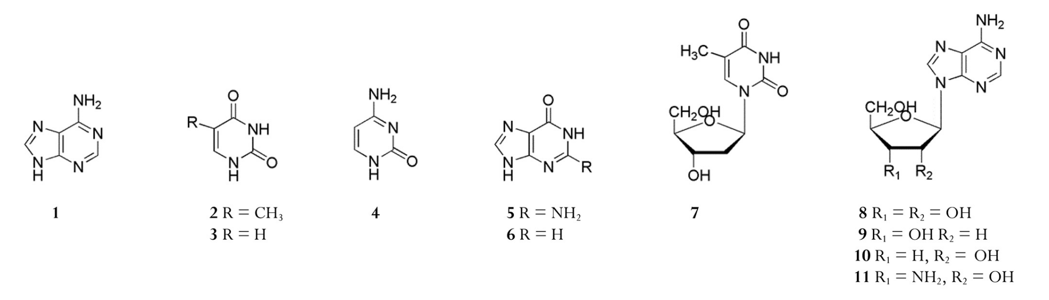
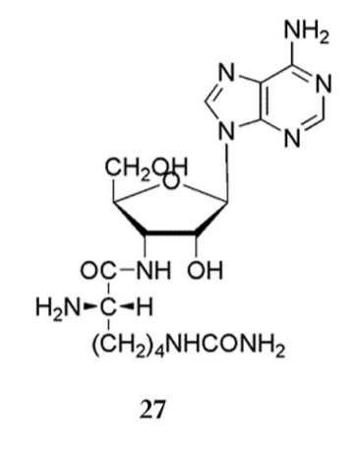
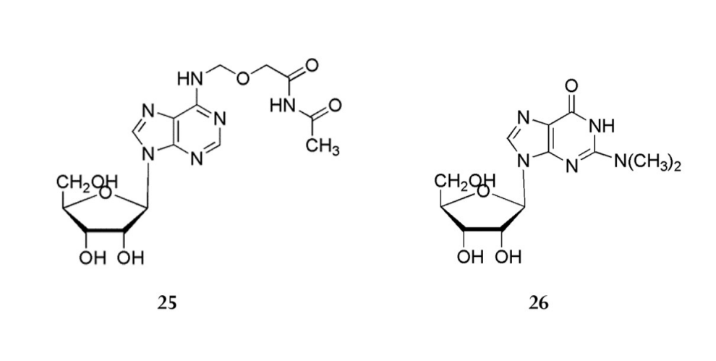
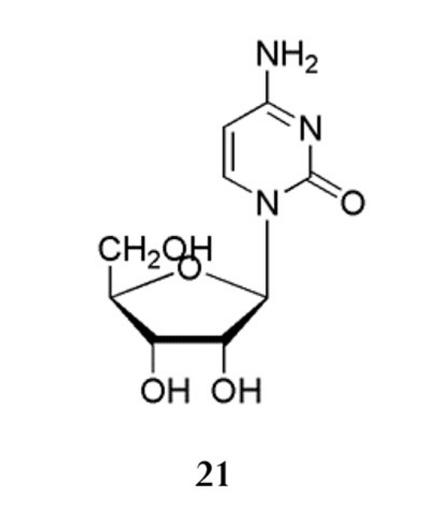
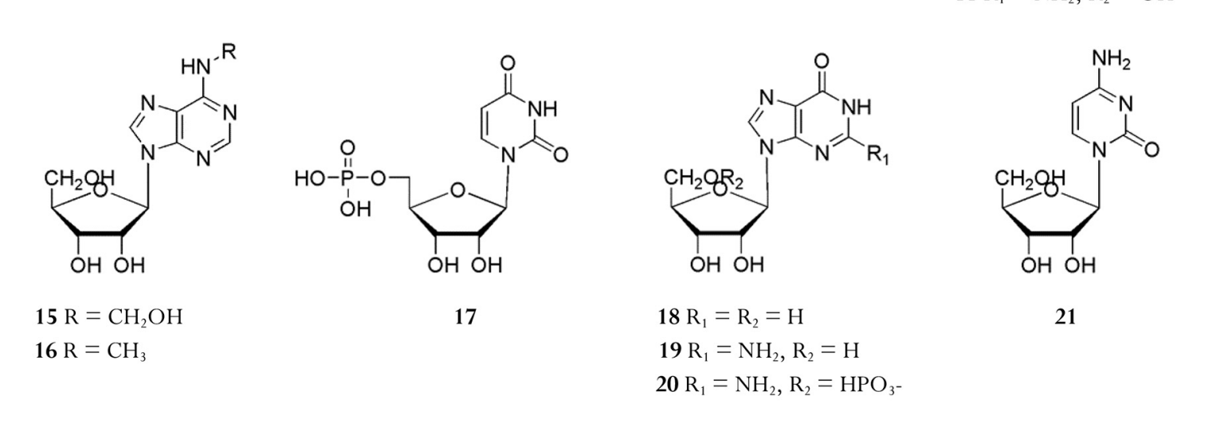
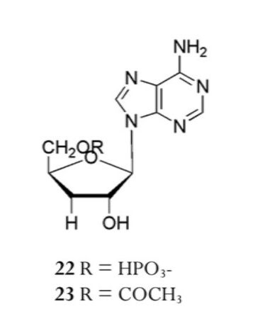
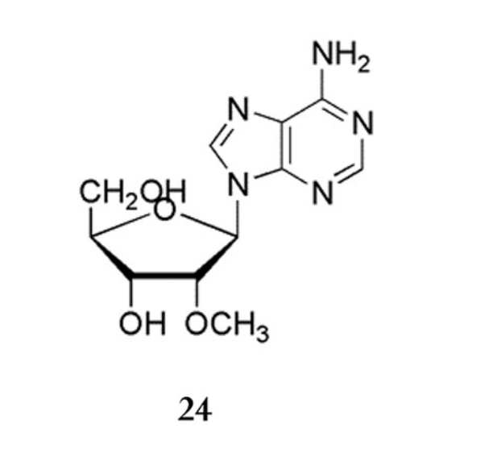
Adenosine R₁=R₂=OH
2’-deoxyadenosine R₁=OH, R₂=H
Cordycepin R₁=H, R₂=OH
3’-amino-2’-deoxyadenosine R₁= NH₂, R₂=OH

Guanine R=NH₂
Hypoxanthine R=H

Tiamine R=CH₃
Uracil R=H

Adenine

Cytosine

Thymidine

Tiamine
Uracil

N6-[β-(acetycarbamoyloxy)ethyl]-adenosine

Cytidine

Homocitrullylaminoadenosine

N⁶-methyladenosine R=CH₃

Uridine-5’-monophospate

Adenosine-5’-mono-
phosphate R=HPO₄₋
O5’-acetylcordycepin R=COCH₃

Cytidine

Cordysinin B
Inosine R₁=R₂=H
Guanosine R₁=NH₂, R₂=H
Guanosine R₁=NH₂, R₂=HPO₄-

Figure A1. Primary metabolites: nucleosides and nucleotides

Primary metabolites of O.sinensis and C.militaris

Sterols
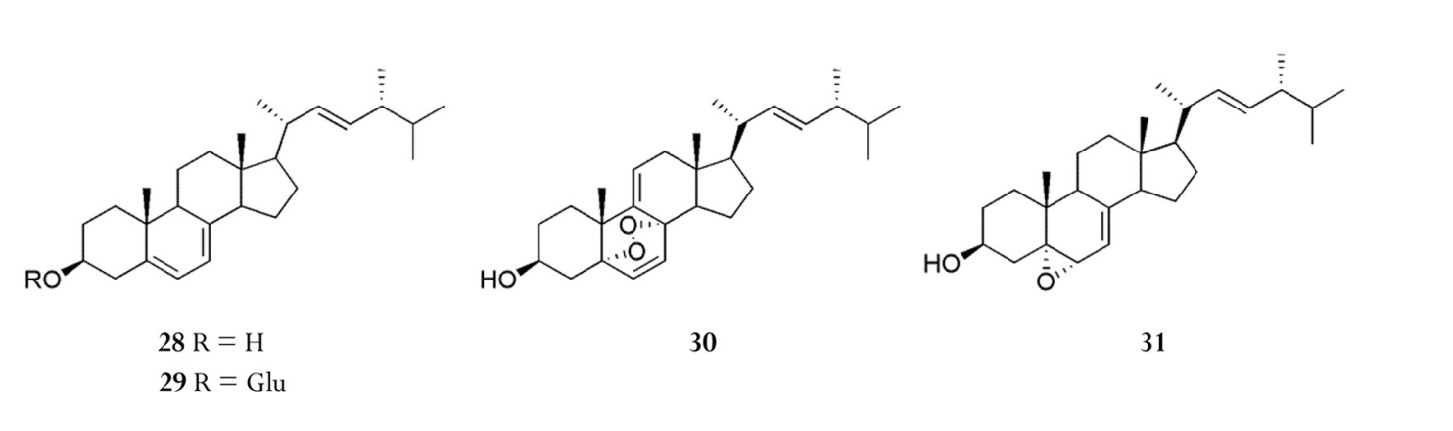
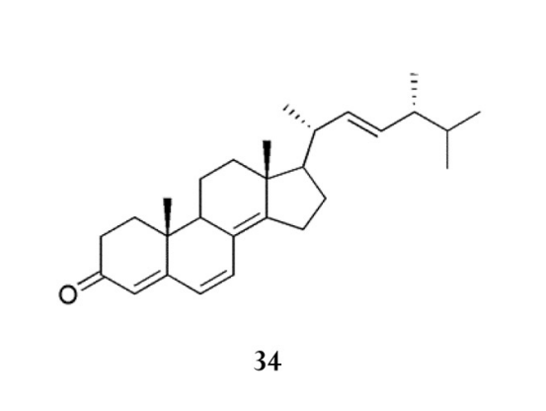
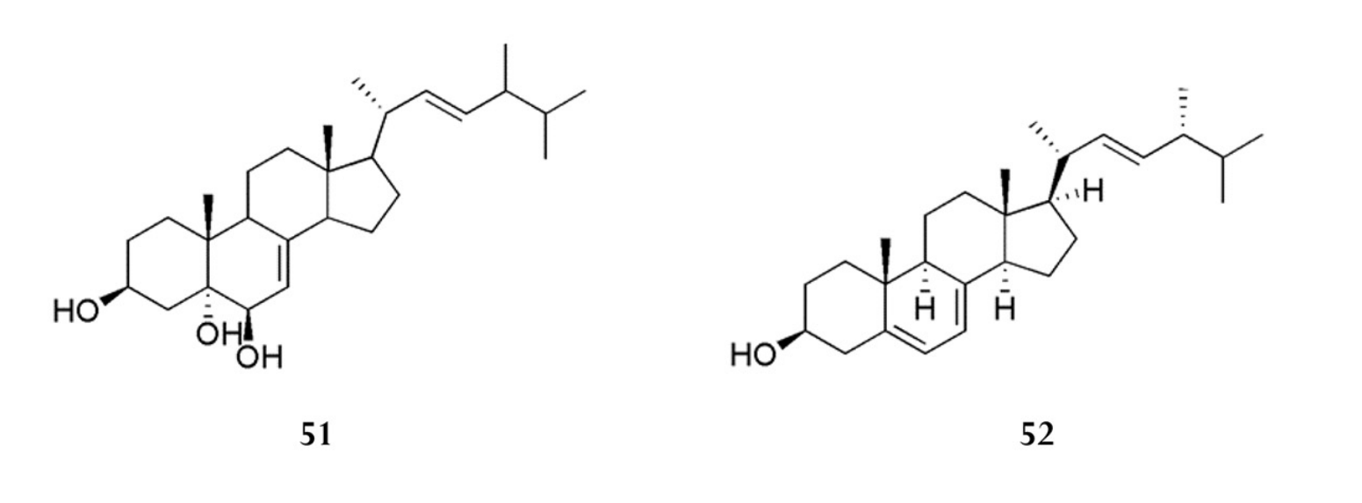
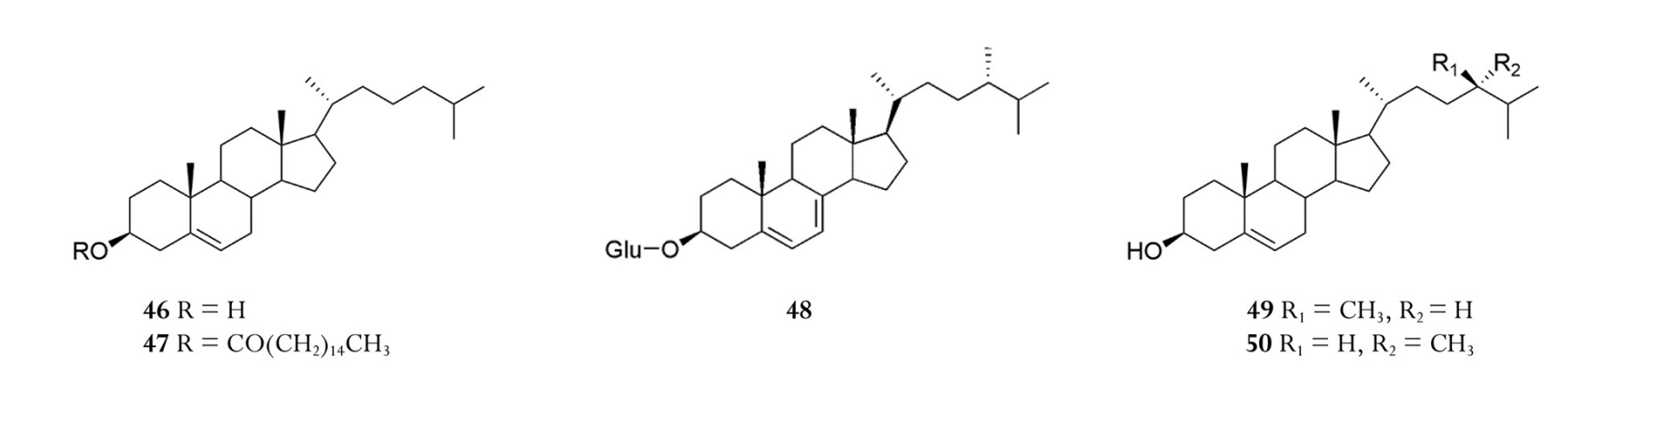
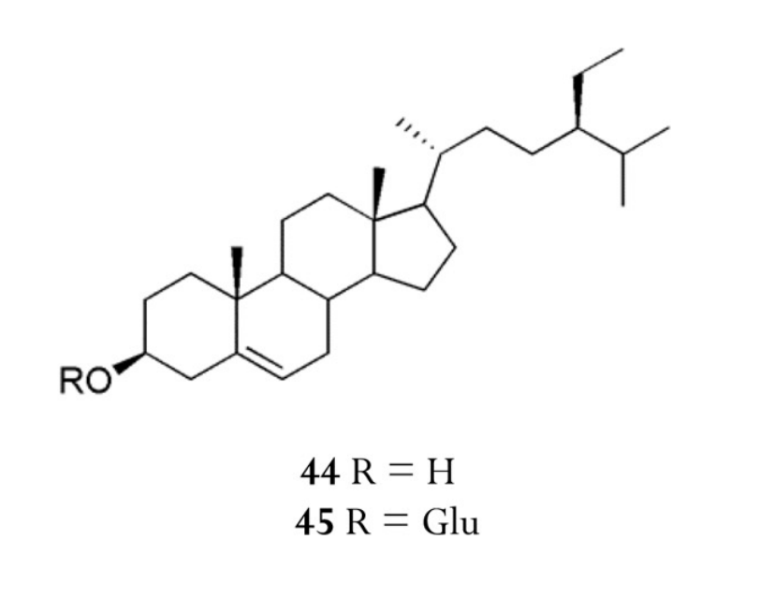
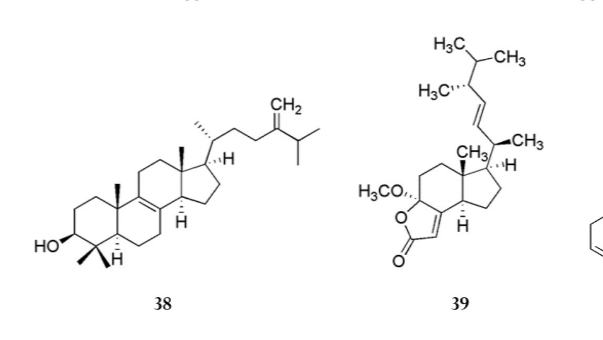
5α,8α-epidioxy-22E-ergosta-6,9-(11)-22-trien-33β-ol

Ergosterol R=H
Ergosteryl-3-O-β-D-glucopyranoside R=Glu

Ergosta-4,6,8(14),22-tetraen-3-one

5α,6α-epoxy-5α-ergosta-7,22-dien-3β-ol

Ergosta-7,22-diene-3,5,6-triol

δ-3-Ergosterol

Cholesterol R=H
Cholesteryl palmitate
R=CO(CH₂)₁₄CH₃

Campesterol R₁=CH₃, R₂=H
Dihydrobrassicasterol R₁=H, R₂=CH₃

β-sitosterol R=H
Daucosterol R=Glu

22-dihydro-ergosteryl-3-O-β-D-glucopyranoside

Fungisterol

β-sitosterol-3-O-acetate

Stigmasterol-3-O-acetate

17(R)-17-methyl-lincisterol

4,4-dimethyl-5α-ergosta-8,24(28)-dien-3β-ol

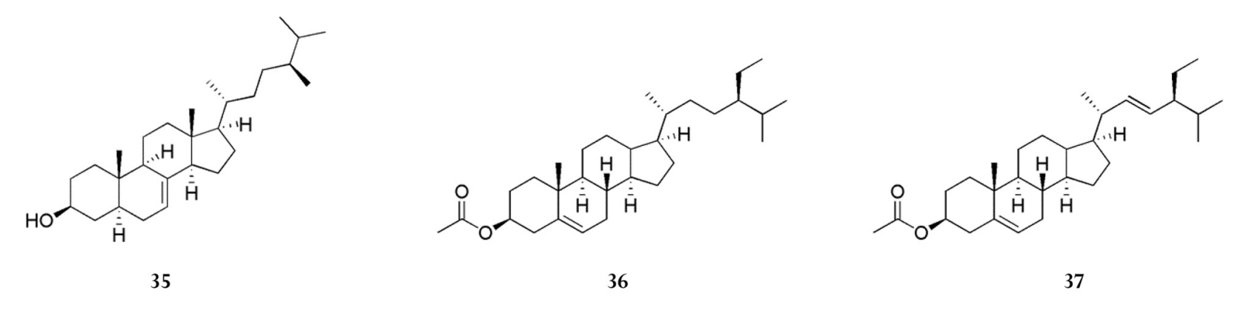

Figure A2. Primary metabolites: sterols

Secondary metabolites of O.sinensis

Alkaloids
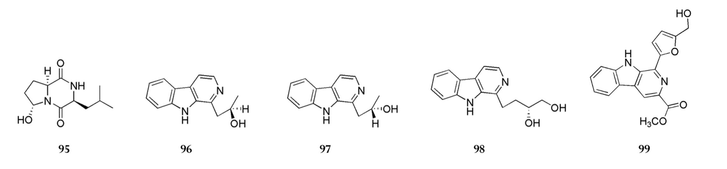
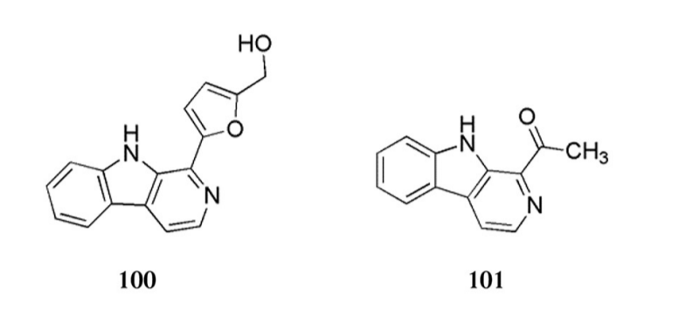
Cordysinin A Cordysinin C Cordysinins D Cordysinins E Flazin
Perlolyrine 1-acetyl-β-carboline

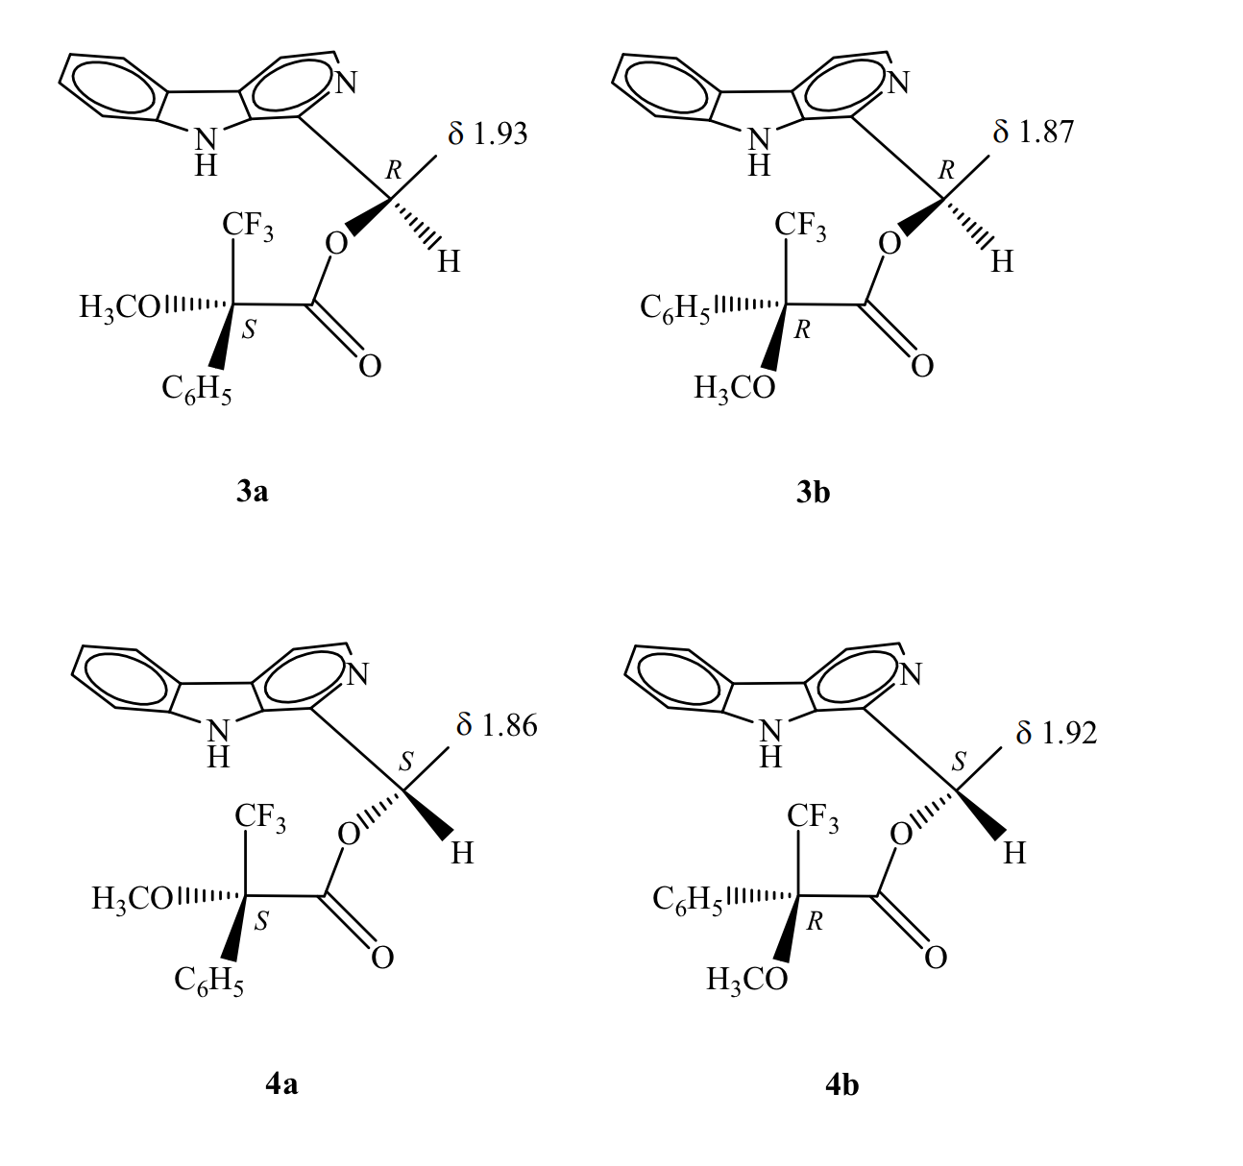
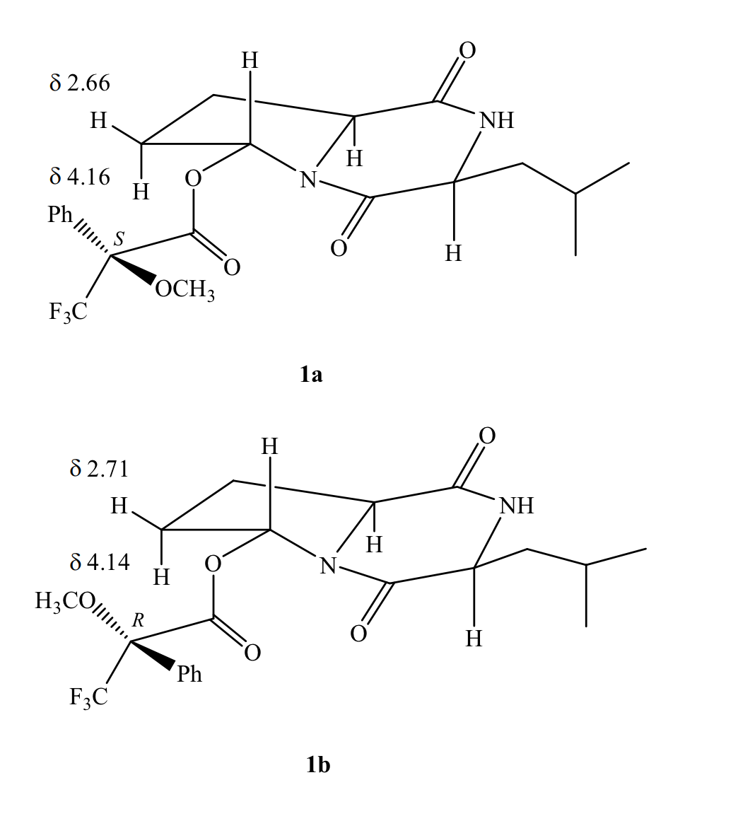
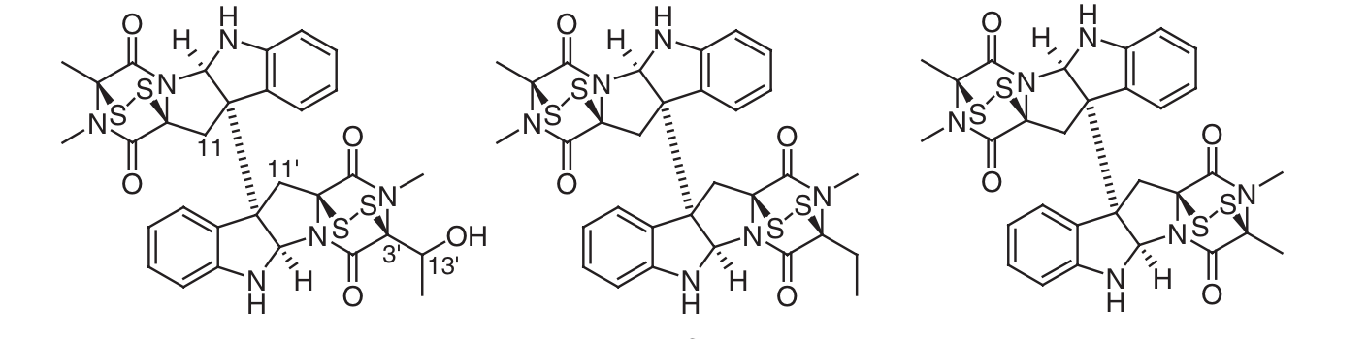
α-methoxy-α-trifluoro-methylphenylacetyl (MTPA) chlorides
gliocladicillin A , gliocladicillin B 11,11’- dideoxyverticillin

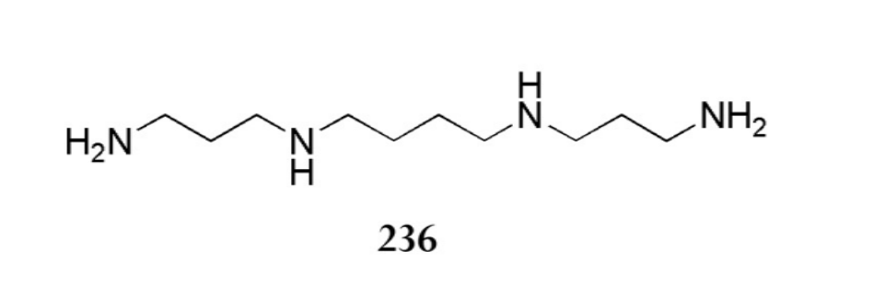
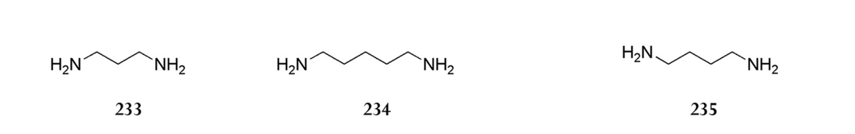
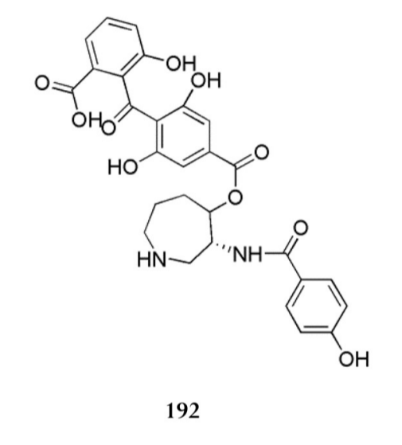
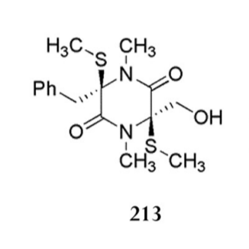
Spermine

Putrescine

Cadaverine

1,3-diaminopropane

Ophicordin
Bisdethiodimethylthio-hyalodendrin

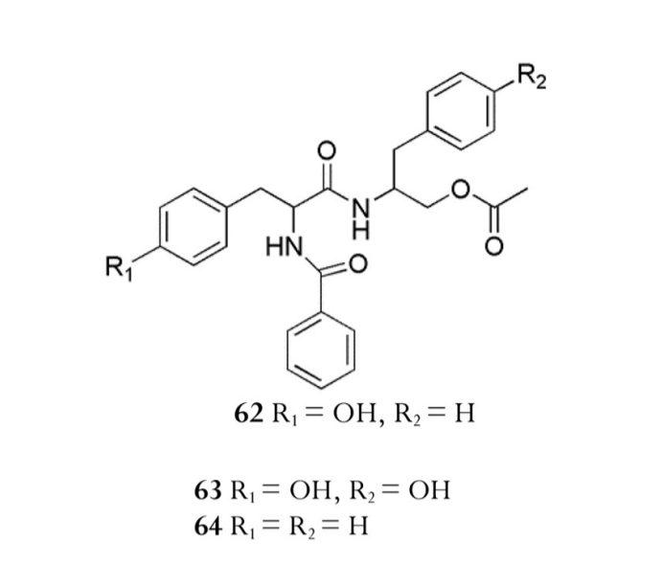
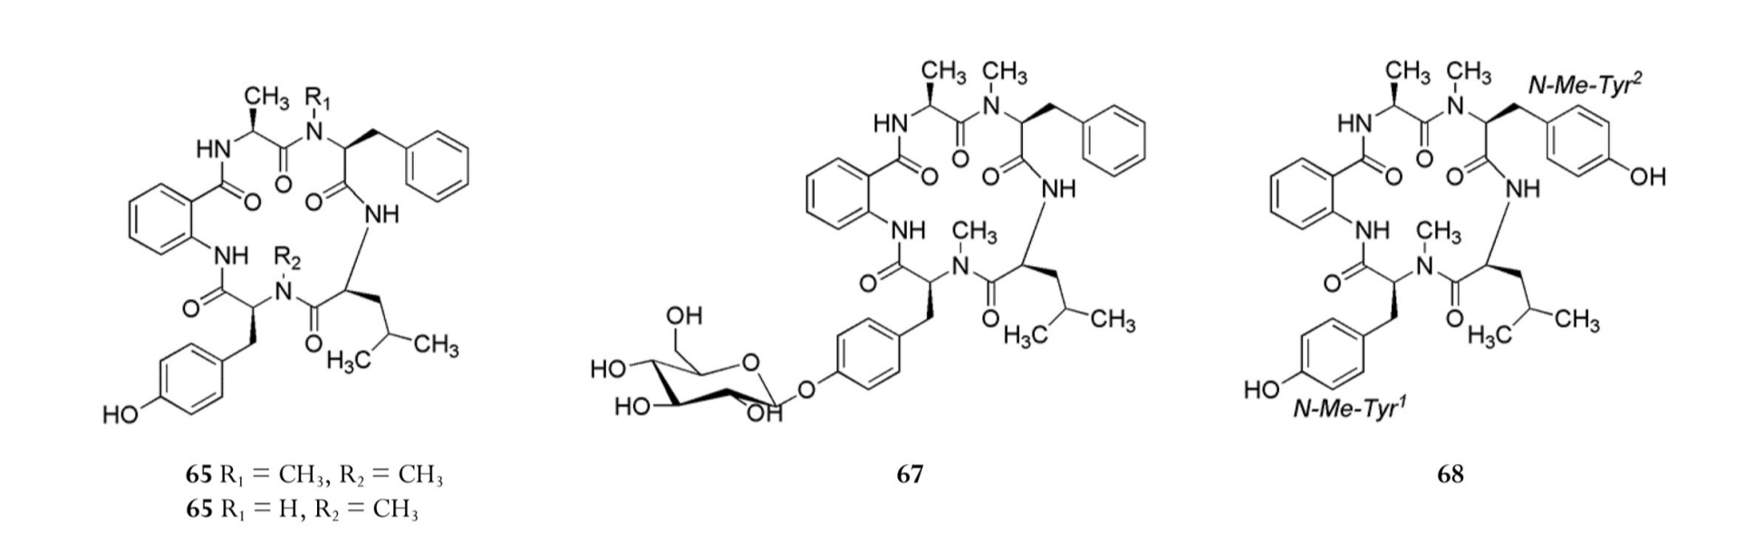
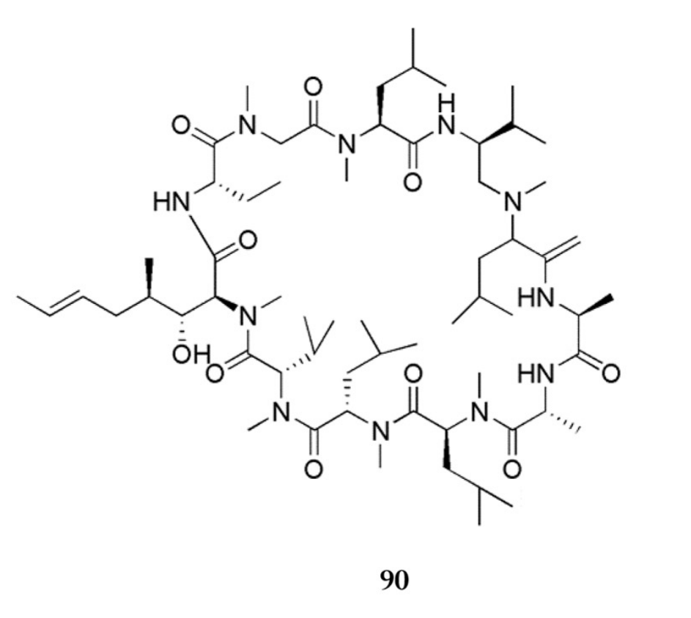
Alkaloid cyclopeptides
Cordyceamide A R₁=OH, R₂=H
Cordyceamide B R₁=OH, R₂=OH
Aurantamide acetate R₁= R₂=H

Cycloaspeptide A R₁=CH₃, R₂=CH3
Cycloaspeptide C R₁=H, R₂=CH₃

Cycloaspeptide G

Cycloaspeptide F

Cyclosporin

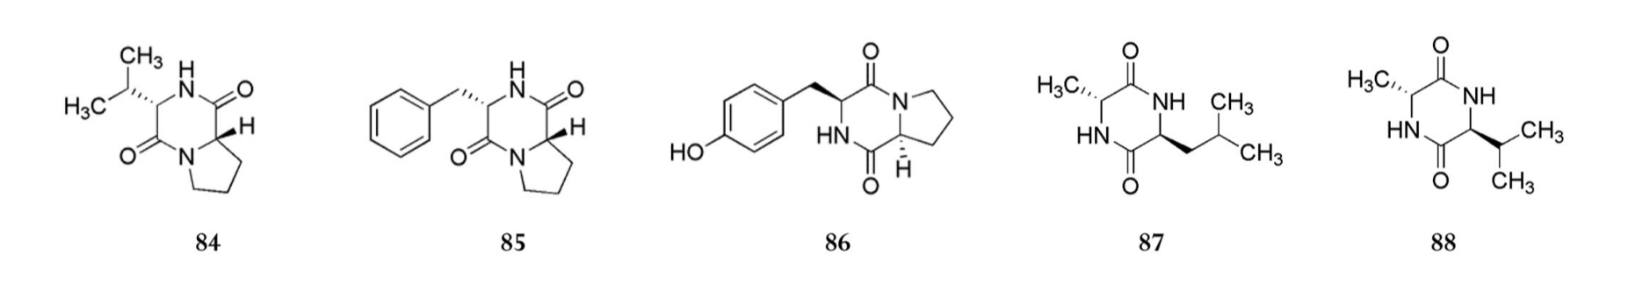
Cyclo(L-Pro-L-Val) Cyclo(L-Phe-L-Pro) Cyclo(L-Pro-L-Tyr) Cyclo(L-Ala-L-Leu) Cyclo(L-Ala-L-Val)

Figure A3. Secondary metabolites of O.sinensis

Secondary metabolites of O.sinensis

Flavonoids
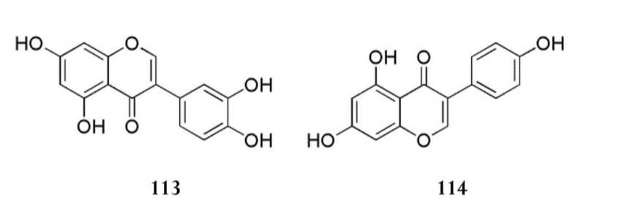
6,7,2′,4′,5′-pentamethoxyflavone

3′,4′,7-trihydroxyisoflavone

Glycitein

Genistein

Diadzein

Orobol

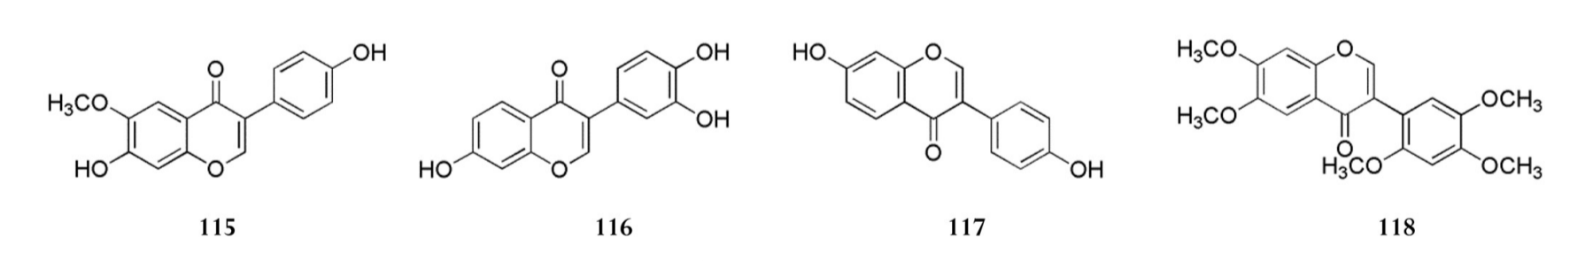

Phenolics

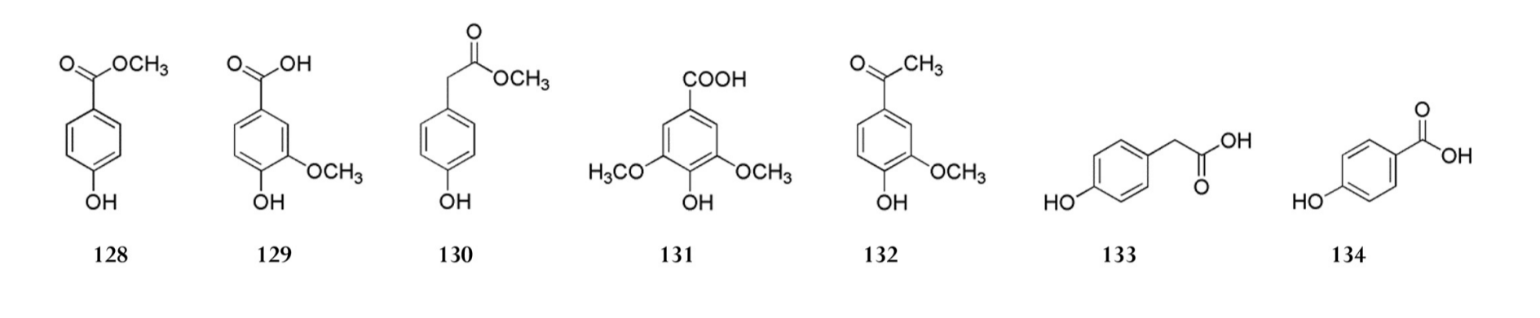
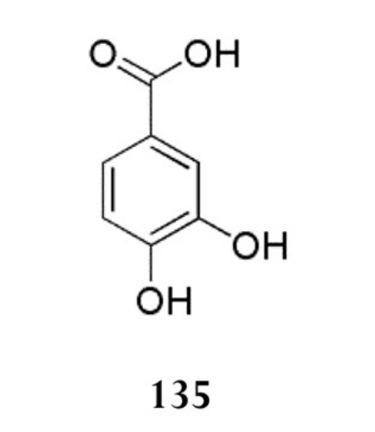
Vanillic acid

4-Hydroxy-acetophenone

Methyl-p-hydroxy phenylacetate

Syringic acid
p-hydroxy-phenylacetic acid
p-hydroxy-benzoic acid
Acetovanillone

Protocatechuic acid

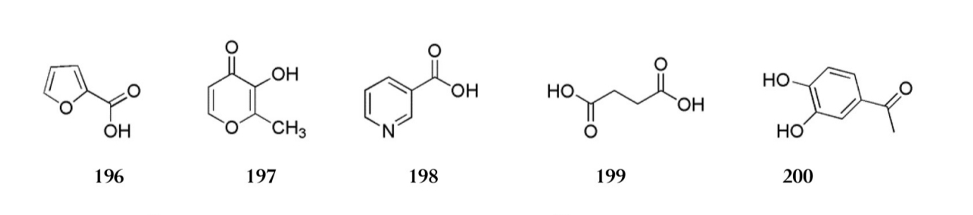
Miscellaneous
3,4 -dihydroxy-acetophenone
Nicotinic acid
2-Deoxy-D-ribono-1,4-lactone
Succinic acid
3-hydroxy-2-methyl-4-pyrone
2-Furan-carboxylic acid

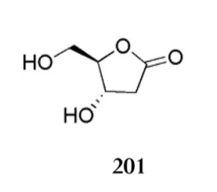

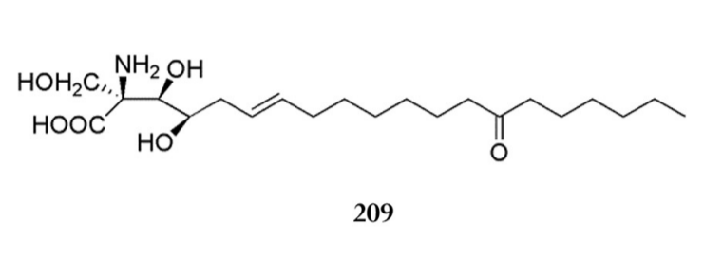
1-Methylpyrimidine-2,4-dione

Figure A4. Secondary metabolites of O.sinensis (continued)

Secondary metabolites of C.militaris

Alkaloids
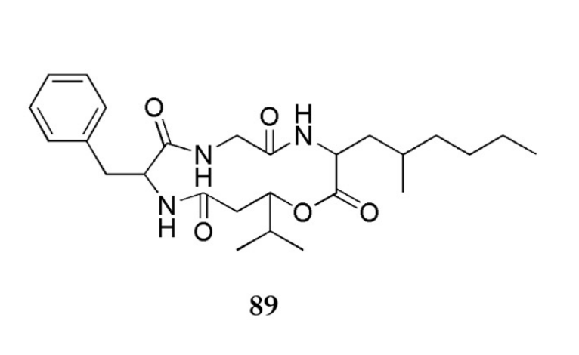
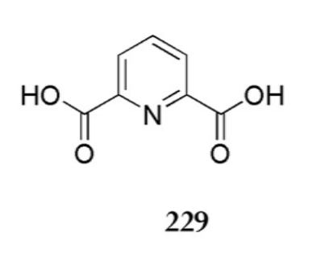
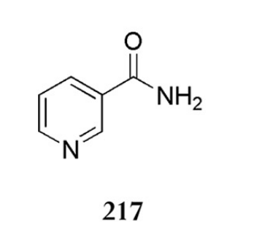
Pyridine-2,6-dicarboxylic acid

Nicotinic amide

Cordyceptide A

Macrolides
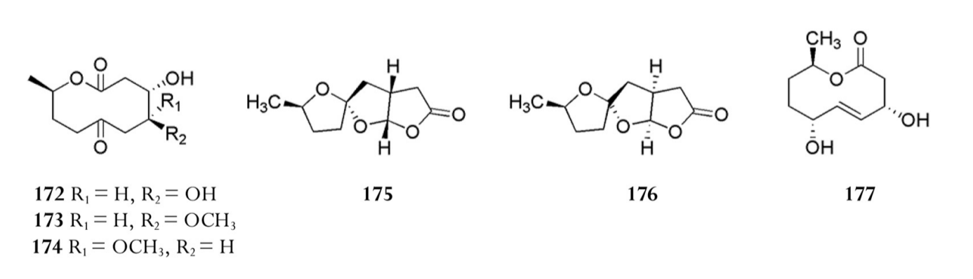
Cepharosporolides C R₁=H, R₂=OH
Inactive Compound R₁=H, R₂=OCH₃
Inactive Compound R₁=OCH₃, R₂=H

Cepharosporolide E

Cepharosporolide E

Inactive Compound

Miscellaneous
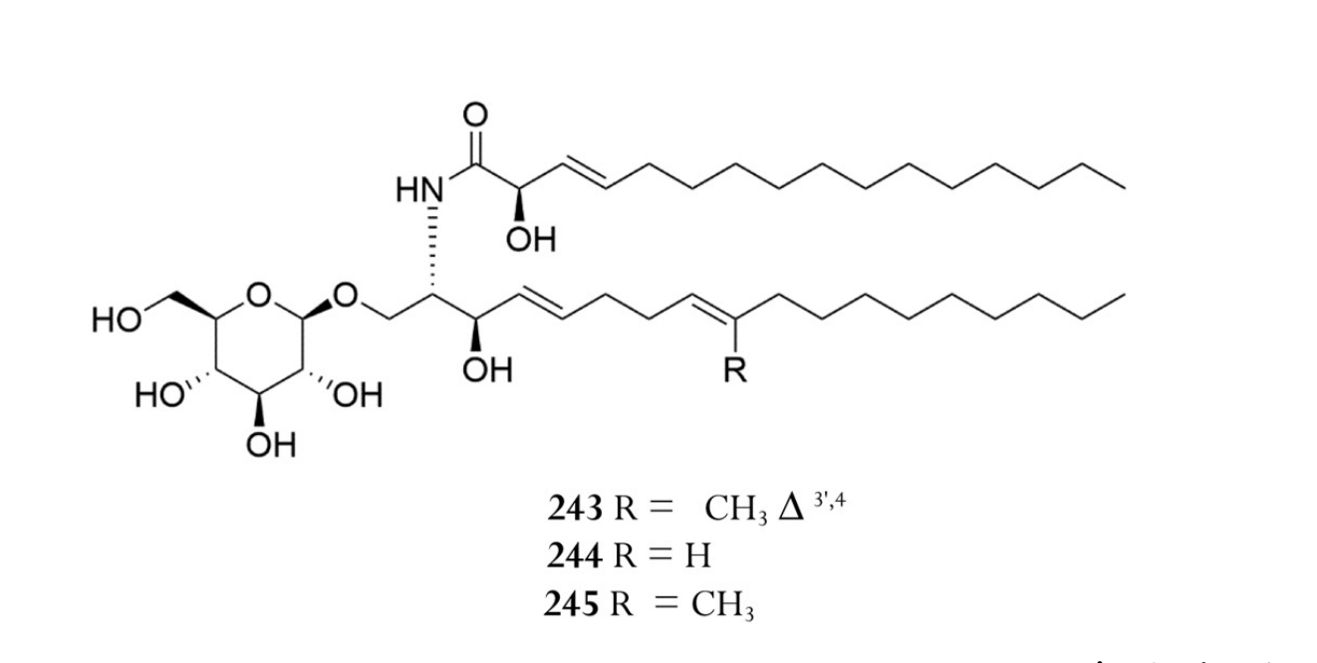
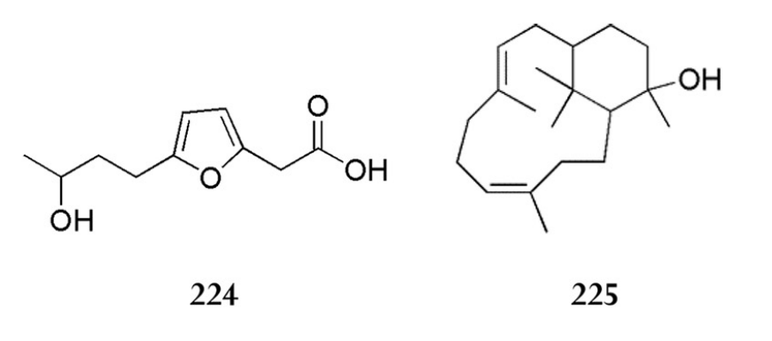
Cordycerebroside A R=CH₃
Soyacerebroside I R=H
Glucocerebroside R=CH₃

2-Carboxymethyl-4-(3′-hydroxybutyl)furan

Verticiol

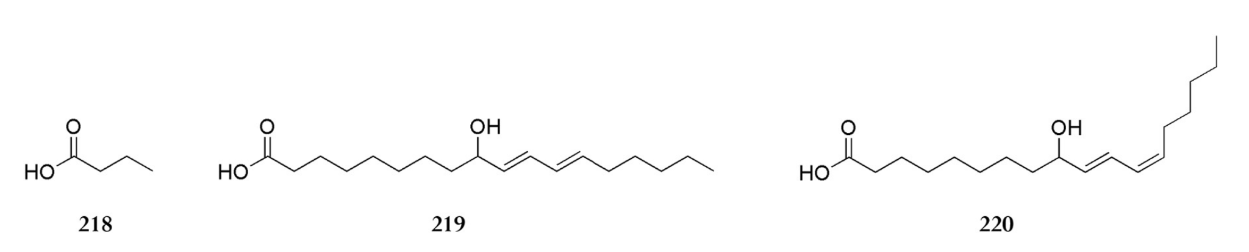
α-Dimorphecolic acid

β-Dimorphecolic acid

Butyric acid

Figure A5. Secondary metabolites of C.militaris

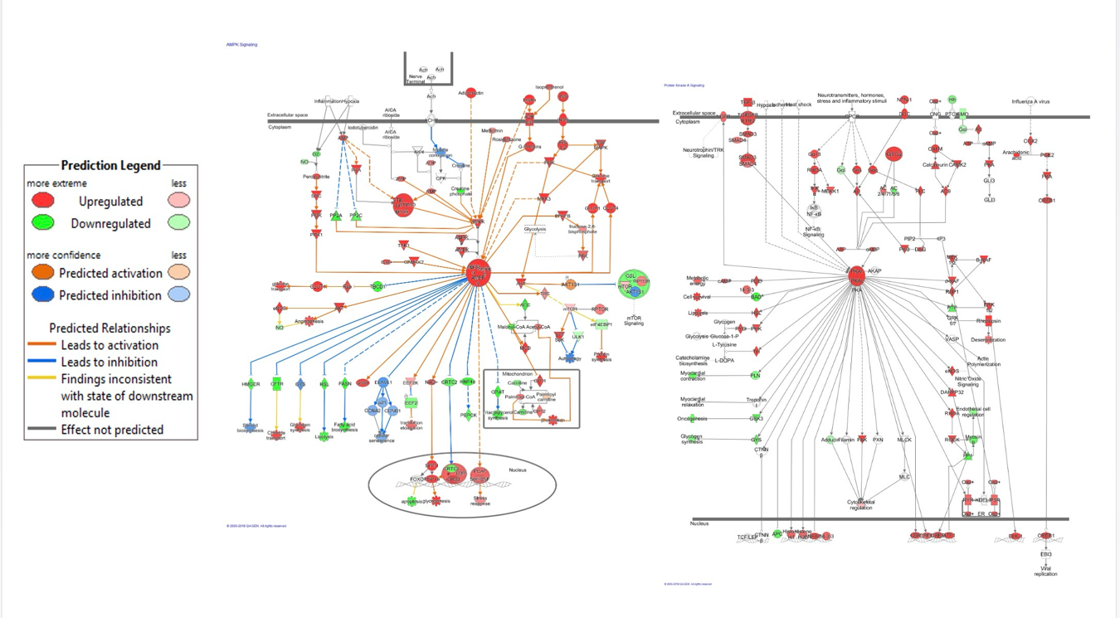

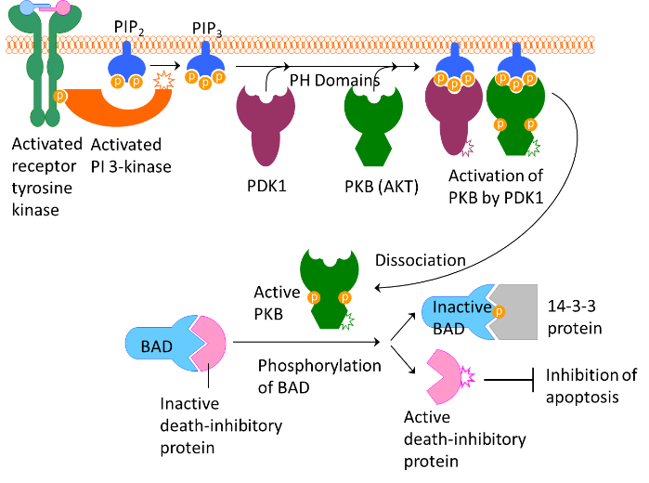
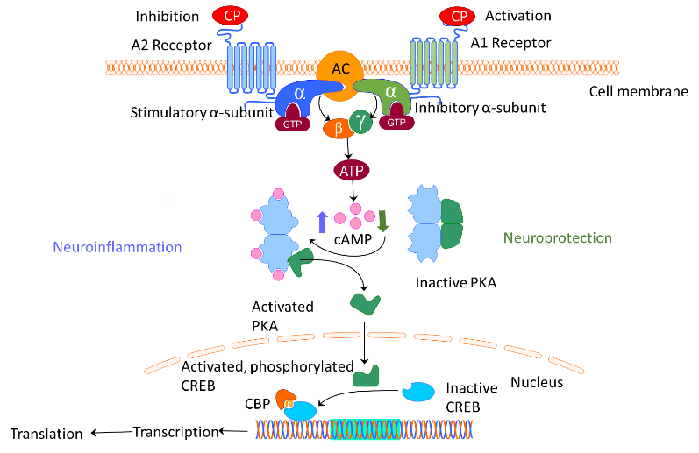

Figure A6. (a) - Activation of the AMPK and protein kinase A (PKA) signaling pathways and multiple effects on stress response, cellular senescence, apoptosis, autophagy, angiogenesis, protein and glycogen synthesis, steroids biosynthesis, mTOR signaling, and other canonical adaptive signaling pathways [249], (b) - neuroprotective effects of cordycepin on activation of cAMP, PKA and cAMP-response element binding protein (CREB) in neuroinflammation [59, 251], and (c) - PI3-kinase and PKB (AKT) signaling of inhibition of apoptosis that promotes cell survival.

