Supplementary Materials
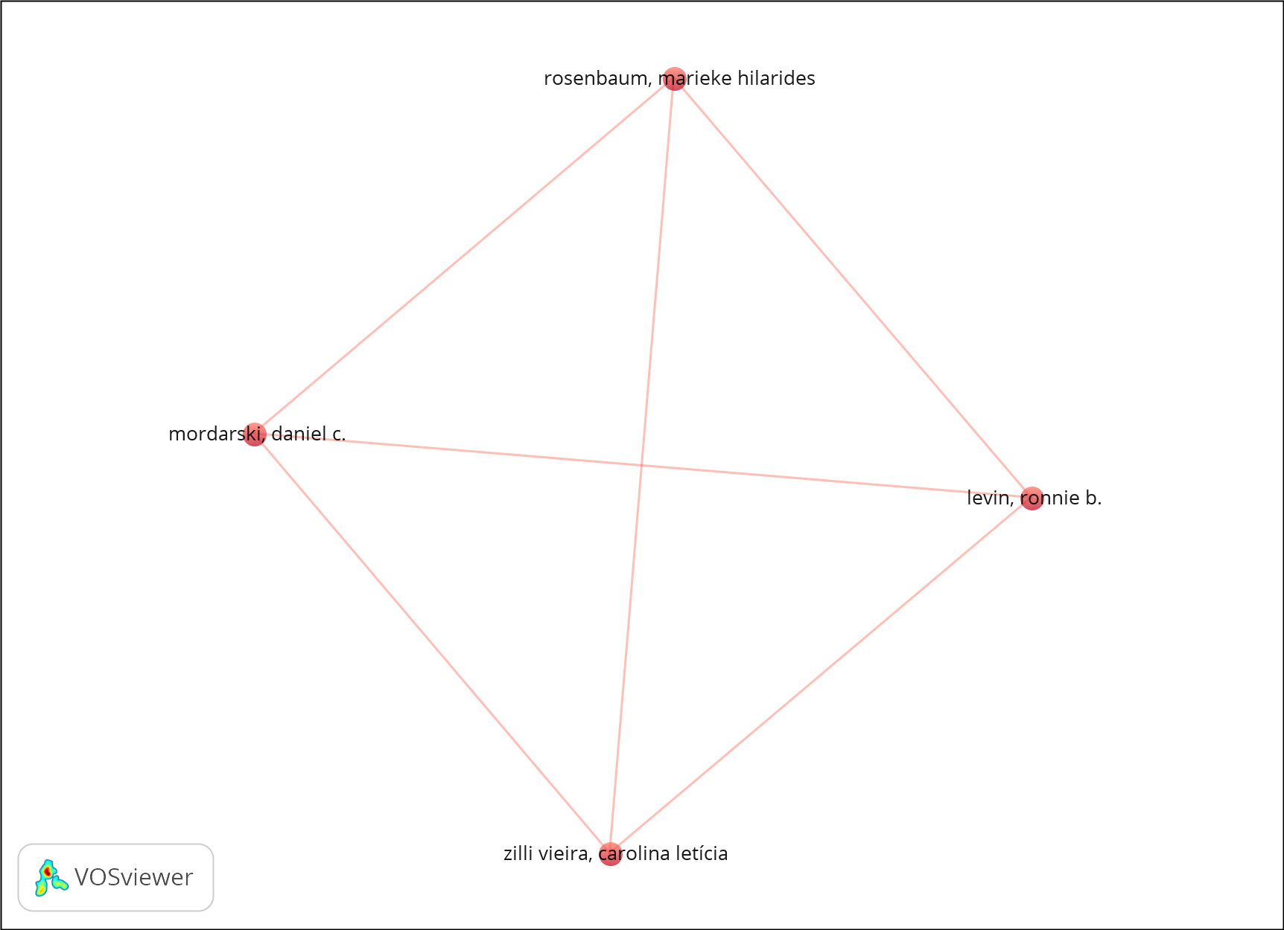
Figure S1. Author co-authorship network based on the Scopus database. The Scopus dataset comprised 135 authors; four met the minimum publication threshold and formed a single cluster (six links; total link strength = 12). The consistency with Web of Science results reinforces the finding of low author continuity and limited interdisciplinary collaboration. The sparse structure suggests episodic research activity rather than sustained, institutionalized collaboration within the climate–lead–health research domain.
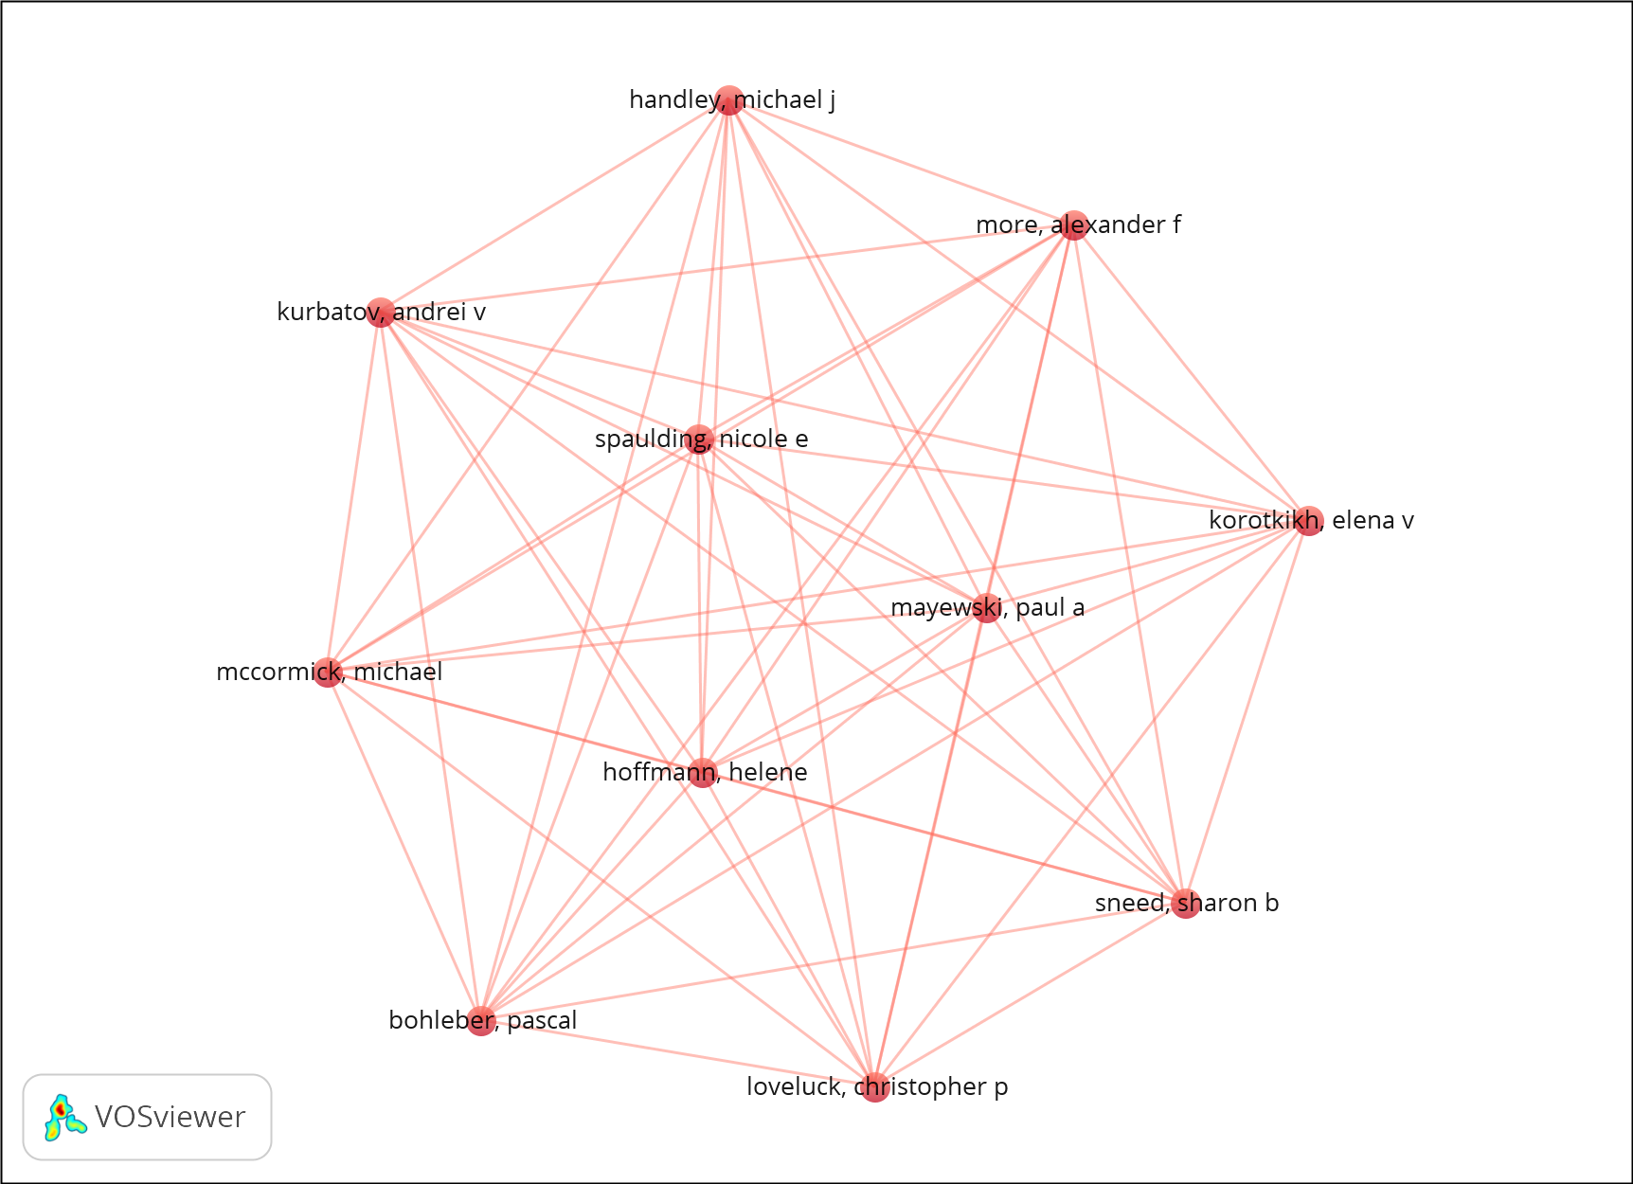
Figure S2. Author co-authorship network based on the PubMed database. The PubMed-based network included 44 authors, all meeting the minimum threshold, forming a single dense cluster (55 links). This pattern reflects strong collaboration within a biomedical-focused group but limited integration with environmental and climate science communities. Despite this internal cohesion, the network remains largely disconnected from environmental and climate science author groups, reinforcing the presence of disciplinary silos within the broader climate–lead–health literature.

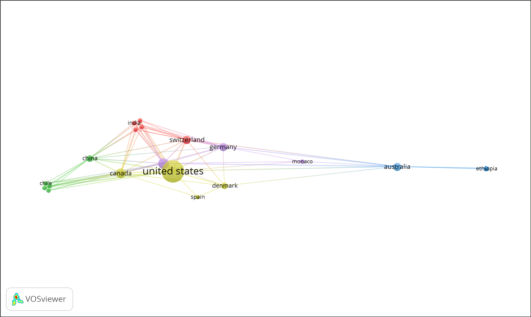
Figure S3. International co-authorship network by country based on Scopus records. The Scopus country-level analysis identified a weakly connected international collaboration structure, with a small number of countries acting as central hubs. The network highlights limited cross-national integration beyond dominant research centers.
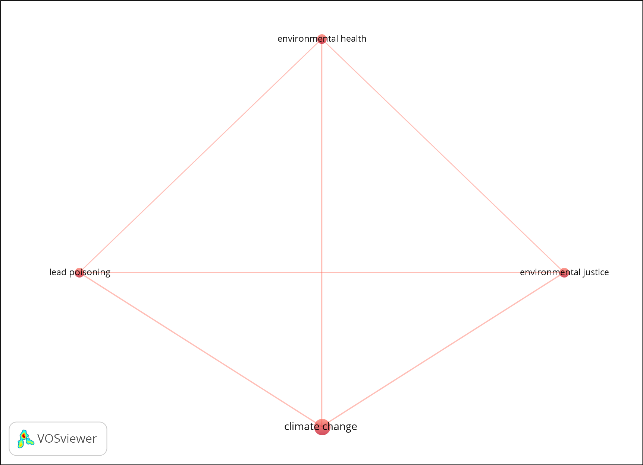
Figure S4. Author keyword co-occurrence network based on PubMed records. The PubMed-based keyword co-occurrence network includes 53 keywords, with four meeting the minimum occurrence threshold. The PubMed analysis identified four highly connected keywords forming a single cluster, indicating thematic concentration within biomedical and public health research domains.
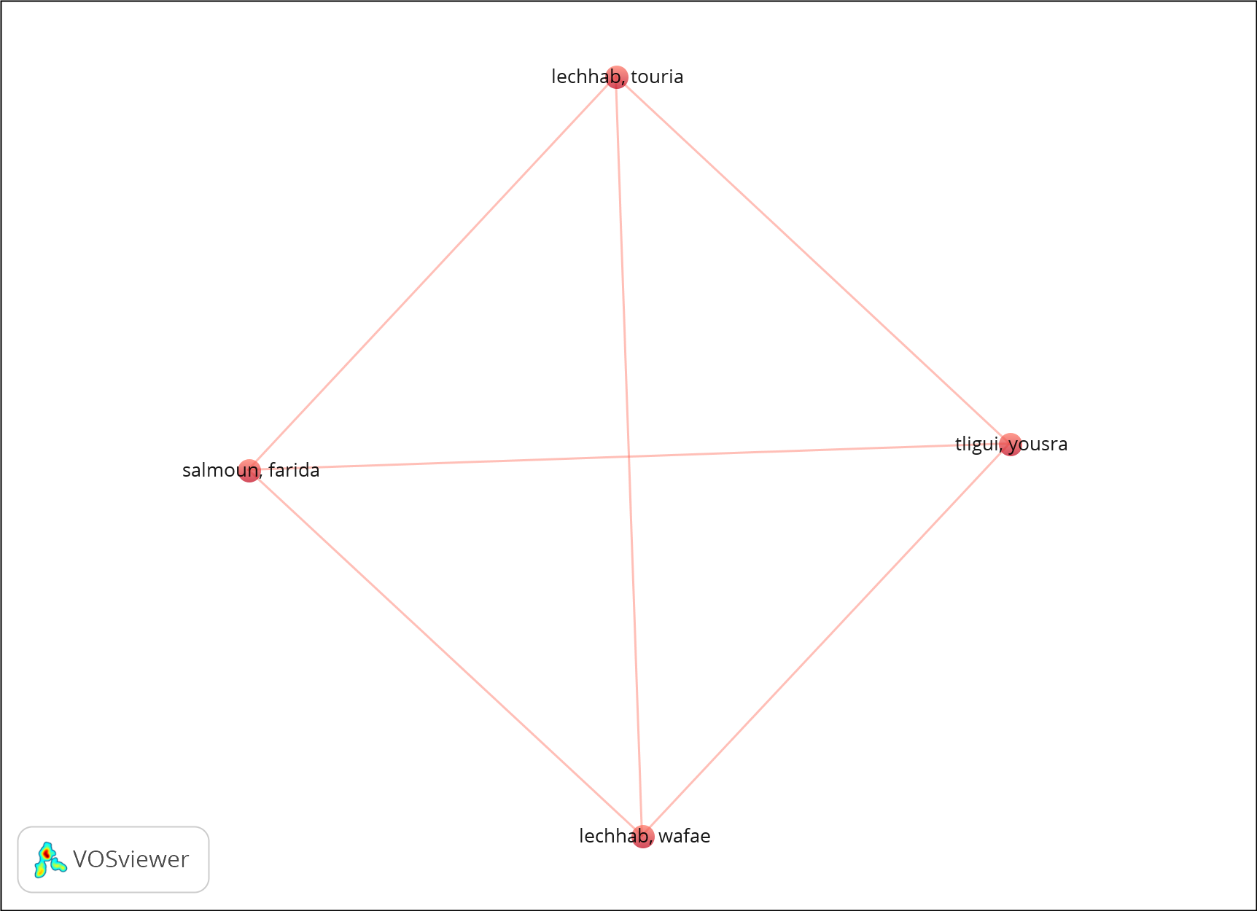
Figure S5. Author citation network based on the Web of Science database. The citation analysis includes 105 authors, with four meeting the minimum citation threshold. The resulting network forms a single cluster with six citation links and a total link strength of 12. This pattern indicates a small group of frequently cited authors shaping the field, suggesting concentration of scholarly influence and limited diversification of authoritative voices within the climate–lead–health literature.
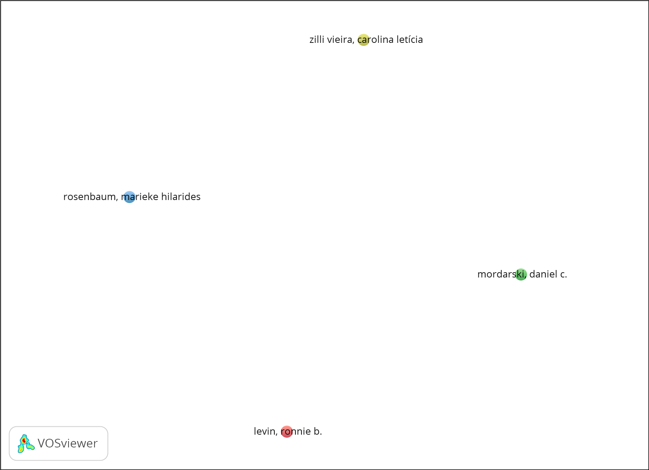
Figure S6. Author citation network based on the Scopus database. Author citation network based on the Scopus revealed among 135 authors, four met the threshold but no citation links were observed, indicating minimal author-level citation cohesion in that database.

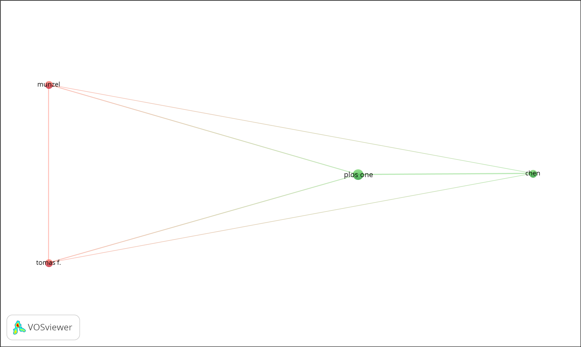
Figure S7. Author co-citation network based on the Scopus database. The Scopus co-citation analysis included 181 cited authors, of whom 10 met the minimum threshold, forming two clusters (six links; total link strength = 25), reflecting limited intellectual integration compared to Web of Science and reinforcing disciplinary separation.
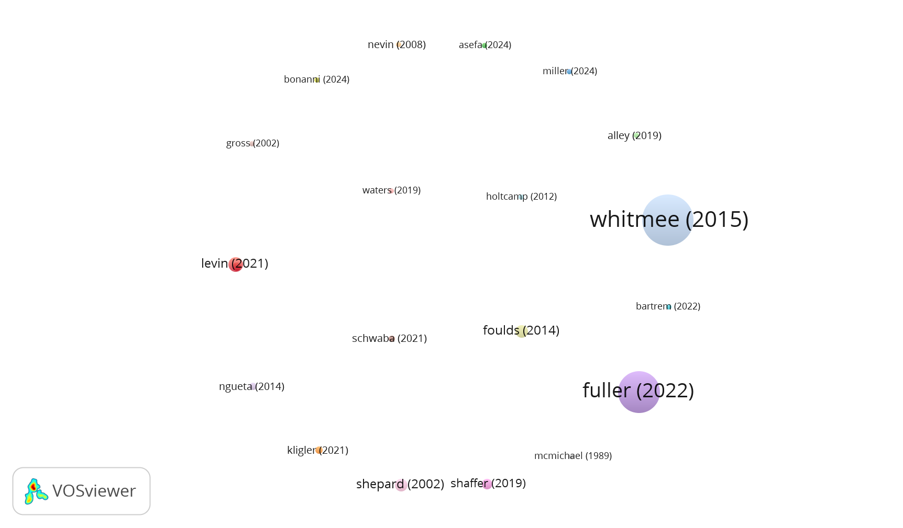
Figure S8. Bibliographic coupling network of documents based on the Scopus database. Bibliographic coupling analysis identified 20 documents meeting the minimum threshold, forming 19 small clusters. The absence of strong coupling links indicates thematic diversity and limited shared reference bases, reinforcing the fragmented knowledge structure of the field.
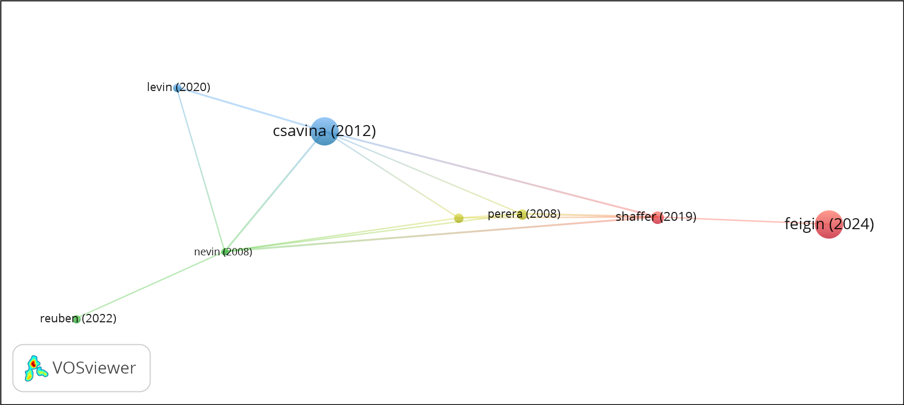
Figure S9. Bibliographic coupling network of authors (Web of Science). The high total link strength reflects substantial overlap in cited references among a small core of authors, consistent with methodological alignment in an otherwise fragmented field.
References S1: Complete list of 89 references included in the bibliometric dataset.
Note: References [1–45] are cited in the main text. References [46–89] are included for bibliometric completeness.
- Sun Z, Das PK, editores. 10th International Conference on Energy Engineering and Environmental Engineering, ICEEEE 2023. Environmental Science and Engineering [Internet]. 2024 [citado 5 ene 2026]. Disponible en: https://www.scopus.com/inward/record.uri?eid=2-s2.0-85185817151&partnerID=40&md5=e6697465564fcecb4140d5337dd9da35
- Alley MR, Gartrell BD. Wildlife diseases in New Zealand: recent findings and future challenges. N Z Vet J. 2019;67(1):1–11.
- Miller MR, Landrigan PJ, Arora M, Newby DE, Münzel T, Kovacic JC. Water, Soil, Noise, and Light Pollution: JACC Focus Seminar, Part 2. J Am Coll Cardiol [Internet]. 2024 [citado 5 ene 2026];83(23):2308–23. Disponible en: https://doi.org/10.1016/j.jacc.2024.03.421
- Fabolude G. Unveiling Urban Lead Exposure Dynamics Through System Modeling. [Tesis/Reporte]. 2025.
- Béziat P, Kunzmann A. Under pressure: Cassiopea andromeda jellyfish exposed to increasing water temperature or lead, cadmium and anthropogenic gadolinium contamination. Mar Biol Res [Internet]. 2022 [citado 5 ene 2026];18(1–2):48–63. Disponible en: https://doi.org/10.1080/17451000.2022.2066132
- Alvarado-Calvo A, Alvarado-Rodríguez Y, Cruz-Mora K, Mora-Jiménez J, Arguedas-Chacón S, Zavaleta-Monestel E. Trends and Association of Environmental Exposure and Climate Change with Non-Communicable Diseases in Latin America. Healthcare (Basel). 1 jul 2025;13(14).
- Özden Ö, Can Tunçelli İ, Mammadova A, Erkan N, Karakulak FS. Toxic metal accumulation in Flexopecten glaber from the Black Sea: Risk assessment for food safety and marine environmental health. Mar Pollut Bull [Internet]. 2025 [citado 5 ene 2026];219. Disponible en: https://doi.org/10.1016/j.marpolbul.2025.118275
- Steingraeber LF, Knolle F, Kierdorf H, Ludolphy C, Kierdorf U. Toxic Legacy-Environmental Impacts of Historic Metal Mining and Metallurgy in the Harz Region (Germany) at Local, Regional and Supra-Regional Levels. Environments. 2025;12(7).
- Levin R, Zilli Vieira CL, Rosenbaum MH, Bischoff K, Mordarski DC, Brown MJ. The urban lead (Pb) burden in humans, animals and the natural environment. Environ Res. 2021;193:110599.
- More AF, Spaulding NE, Bohleber P, Handley MJ, Hoffmann H, Korotkikh E v, et al. The Role of Historical Context in Understanding Past Climate, Pollution and Health Data in Trans-disciplinary Studies: Reply to Comments on More et al., 2017. Geohealth. 2018;2(5):162–70.
- Brunekreef B. The relationship between environmental lead and blood lead in children: a study in environmental epidemiology. [Tesis]. 1985.
- Goodman S. THE LONG HAUL: Three Decades of Teaching Student Documentary Action Research for Environmental and Climate Justice. En: Taylor & Francis, editores. 2023. p. 213–33.
- Reuben A, Manczak EM, Cabrera LY, Alegria M, Bucher ML, Freeman EC, et al. The Interplay of Environmental Exposures and Mental Health: Setting an Agenda. Environ Health Perspect. 2022;130(2):25001.
- Kligler B, Pinto Zipp G, Rocchetti C, Secic M, Ihde ES. The impact of integrating environmental health into medical school curricula: a survey-based study. BMC Med Educ. 1 dic 2021;21(1):298.
- Schwaba T, Bleidorn W, Hopwood CJ, Gebauer JE, Rentfrow PJ, Potter J, et al. The impact of childhood lead exposure on adult personality: Evidence from the United States, Europe, and a large-scale natural experiment. Proc Natl Acad Sci U S A [Internet]. 2021 [citado 5 ene 2026];118(29). Disponible en: https://doi.org/10.1073/pnas.2020104118
- Kadro JM, Hagfeldt A. The End-of-Life of Perovskite PV. Joule. 2017;1(1):29–46.
- Zhang W, Xu M, Feng Y, Mao Z, Yan Z. The Effect of Procrastination on Physical Exercise among College Students—The Chain Effect of Exercise Commitment and Action Control. Int J Ment Health Promot. 2024;26(8):611–22.
- Waters H. The biopower of ignorance: Individualizing blame for lead poisoning in Kabwe, Zambia. Environ Plan E Nat Space. 2019;2(2):390–408.
- Kumar N, Krishnani KK, Brahmane MP, Gupta SK, Kumar P, Singh NP. Temperature induces lead toxicity in Pangasius hypophthalmus: an acute test, antioxidative status and cellular metabolic stress. Int J Environ Sci Technol. 2018;15(1):57–68.
- Dineva S. Seawater Physico-chemical Parameters in Varna Bay (Bulgaria). En: Ksibi M, et al., editores. Advances in Science, Technology and Innovation [Internet]. Springer Nature; 2024. p. 607–11.
- Whitmee S, Haines A, Beyrer C, Boltz F, Capon AG, de Souza Dias BF, et al. Safeguarding human health in the Anthropocene epoch: report of The Rockefeller Foundation-Lancet Commission on planetary health. Lancet. 2015;386(10007):1973–2028.
- Neutra RR. Reflections on the origins of the international society for environmental epidemiology after its first 25 years. Epidemiology. 2014;25(5):622–4.
- Laraque-Arena D. Racism, environmental injustice, and child health. En: Oxford University Press; 2024. p. 130–43.
- McMichael AJ. Public health, the environment and the 21st century: A wider field of vision. Eur J Public Health. 2008;18(2):101.
- Kumar N, Thorat ST, Patole PB, Gite A, Reddy KS. Protective role of selenium and selenium-nanoparticles against multiple stresses in Pangasianodon hypophthalmus. Fish Physiol Biochem. 2024;50(1):239–58.
- Howard AJ, Kincey M, Carey C. Preserving the Legacy of Historic Metal-Mining Industries in Light of the Water Framework Directive and Future Environmental Change in Mainland Britain: Challenges for the Heritage Community. Hist Environ Policy Pract. 2015;6(1):3–15.
- Shepard PM, Northridge ME, Prakash S, Stover G. Preface: Advancing environmental justice through community-based participatory research. Environ Health Perspect. 2002;110(Suppl 2):139–40.
- Xi JY, Chen LC, Li XQ, Hu J, Hu W, Bai JJ, et al. Potential links between the progress in environmental governance and the prevalence of mental disorder burden: New insight from a dynamic panel-data analysis for 197 countries. Sustain Cities Soc. 15 may 2025;126:106295.
- Fuller R, Landrigan PJ, Balakrishnan K, Bathan G, Bose-O’Reilly S, Brauer M, et al. Pollution and health: a progress update. Lancet Planet Health. 2022;6(6):e535–47.
- Hossain A, Elahi SF. Phenomena Leading to Food Chain Contamination to Intensify Climate Change Effects and Adaptation in Bangladesh. En: Lal R, et al., editores. Climate Change and Food Security in South Asia. Springer; 2011. p. 527–48.
- Laskey AB, Stanley E, Islam K, Schwetschenau S, Sobeck J, Smith RJ, et al. Perspectives and Propositions on Resilience as Interdisciplinary, Multilevel, and Interdependent. Nat Hazards Rev. 2023;24(3).
- Bonanni LJ, Newman JD. Personal Strategies to Reduce the Cardiovascular Impacts of Environmental Exposures. Circ Res. 2024;134(9):1197–217.
- Mcconnell JR, Chellman NJ, Plach A, Wensman SM, Plunkett G, Stohl A, et al. Pan-European atmospheric lead pollution, enhanced blood lead levels, and cognitive decline from Roman-era mining and smelting. Proc Natl Acad Sci U S A. 2025;122(3).
- More AF, Spaulding NE, Bohleber P, Handley MJ, Hoffmann H, Korotkikh E v, et al. Next-generation ice core technology reveals true minimum natural levels of lead (Pb) in the atmosphere: Insights from the Black Death. Geohealth. 1 jun 2017;1(4):211–9.
- Znidi F, Morsy M, Uddin MN. Navigating challenges and solutions for metal-halide and carbon-based electrodes in perovskite solar cells (NCS-MCEPSC): An environmental approach. Heliyon. 2024;10(2).
- Nevin R, Jacobs DE, Berg M, Cohen J. Monetary benefits of preventing childhood lead poisoning with lead-safe window replacement. Environ Res. 2008;106(3):410–9.
- Ordóñez-Iriarte JM. Mental health and environmental health. A prospective view. SESPAS Report 2020. Gac Sanit. 2020;34(Supl 1):68–75.
- DuBay S, Weeks BC, Davis-Kean PE, Fuldner C, Harris NC, Hughes S, et al. Measuring historical pollution: Natural history collections as tools for public health and environmental justice research. Proc Natl Acad Sci U S A. 2025;122(24).
- Maruf Hossain AMM, Rahman H, Park K. Manifestations of climate change impacts affecting socio-economy in Bangladesh: Looking through the framework of sustainable development. Int J Clim Chang Strateg Manag. 18 may 2010;2(2):180–90.
- Rector J. LESSONS FOR A GREEN NEW DEAL: Race, the New Deal legacy, and environmental justice in Detroit. En: Taylor & Francis; 2022. p. 157–72.
- Levin R, Zilli Vieira CL, Mordarski DC, Rosenbaum MH. Lead seasonality in humans, animals, and the natural environment. Environ Res. 2020;180:108797.
- Dotaniya ML, Dotaniya CK, Solanki P, Meena VD, Doutaniya RK. Lead Contamination and Its Dynamics in Soil-Plant System. En: Gupta DK, et al., editores. Lead in Plants and the Environment. Springer; 2020. p. 83–98.
- Kemmerling LR, Darst AL, Adabag M, Koch NM, Snell-Rood EC. Lead (Pb) concentrations across 22 species of butterflies correlate with soil and air lead and decreased wing size in an urban field study. Sci Total Environ. 15 mar 2025;969:173210.
- Ezquerro L, Coimbra R, Bauluz B, Núñez-Lahuerta C, Román-Berdiel T, Moreno-Azanza M. Large dinosaur egg accumulations and their significance for understanding nesting behaviour. Geosci Front. 1 sep 2024;15(5).
- McMichael AJ. Issues in environmental epidemiological research: the example of environmental lead and health. Asia Pac J Public Health. 1989;3(2):150–5.
- Lu J, Li A, Fang H, Zhang J. Interannual variation in the distribution of Yangtze River-derived sediments in the Yellow Sea: Evidence from the suspended sediments. Mar Environ Res. 1 ago 2025;209.
- Tligui Y, Cherif EK, Lechhab W, Lechhab T, Laghzal A, Nouayti N, et al. Integrated Multivariate and Spatial Assessment of Groundwater Quality for Sustainable Human Consumption in Arid Moroccan Regions. Water. 2025;17(16).
- Shaffer RM, Sellers SP, Baker MG, Kalman RD, Frostad J, Suter MK, et al. Improving and Expanding Estimates of the Global Burden of Disease Due to Environmental Health Risk Factors. Environ Health Perspect. 2019;127(10):105001.
- Bolan S, Padhye LP, Jasemizad T, Govarthanan M, Karmegam N, Wijesekara H, et al. Impacts of climate change on the fate of contaminants through extreme weather events. Sci Total Environ. 2024;909:168244.
- Singh Sankhla M, Kumar R, Prasad L. Impact of Variation in Climatic Changes in Concentration of Lead & Nickel in Yamuna River Water, Delhi, India. Mater Today Proc. 2022;57(4):1540–7.
- Martin KMZHR. Human health and environmental sustainability: the 21st century's grand challenges. [Reporte]. 2016.
- Baars C, Barbir J, Paulino Pires Eustachio JH. How Can Climate Change Impact Human Health via Food Security? A Bibliometric Analysis. Environments. 1 nov 2023;10(11).
- Asefa EM, Damtew YT, Mengistu DA, Tolera ST, Dugasa FF, Berhanu A, et al. Heavy metals in Ethiopian drinking water and public health risks: Insights from nationwide and regional analysis. Sci Total Environ. 2024;947:174527.
- Smith KR. Health effects of indoor air pollution: The global picture. Pollut Atmos. 2005;(188):29–34.
- Collaborators GBD 2021 SRF, Feigin VL, et al. Global, regional, and national burden of stroke and its risk factors, 1990-2021: a systematic analysis for the Global Burden of Disease Study 2021. Lancet Neurol. 2024;23(10):973–1003.
- Catalan J, Pla-Rabés S, Wolfe AP, Smol JP, Rühland KM, Anderson NJ, et al. Global change revealed by palaeolimnological records from remote lakes: a review. J Paleolimnol. 2013;49(3):513–35.
- Petkovsek SA. Forest biomonitoring of the largest Slovene thermal power plant with respect to reduction of air pollution. Environ Monit Assess. 2013;185(2):1809–23.
- Foulds SA, Brewer PA, Macklin MG, Haresign W, Betson RE, Rassner SME. Flood-related contamination in catchments affected by historical metal mining: An unexpected and emerging hazard of climate change. Sci Total Environ. 2014;476–477:165–80.
- Holtcamp W. Flavors of uncertainty: the difference between denial and debate. Environ Health Perspect. 2012;120(8):A315–9.
- Ngueta G, Prévost M, Deshommes E, Abdous B, Gauvin D, Levallois P. Exposure of young children to household water lead in the Montreal area (Canada): The potential influence of winter-to-summer changes in water lead levels on children’s blood lead concentration. Environ Int. 2014;73:57–65.
- Expert elicitation. En: Cambridge University Press; 2017. p. 244–73.
- Maróti P, Kis M. Environmental protection via biomonitoring lead exposure by photosynthetic purple bacteria. Plant Physiol Rep. 2022;27(4):590–5.
- Environmental problems and developing countries. Finance Dev. 1992;29(2):22–3.
- Chen M. Environmental lead risk in the 21st century. [Reporte]. 2025.
- Etzel RA. Environmental hazards that matter for children’s health. Hong Kong J Paediatr. 2015;20(2):86–94.
- Bell W. Environmental effects on human health. Can Fam Physician. 2005;51:620.
- del Rio M, Gibson J. Environmental Determinants of Health. En: Springer International Publishing; 2023. p. 547–65.
- Manisalidis I. Environmental and Health impacts of air pollution: a review. Front Public Health. 2020;8:14.
- Michaelides EE. Environmental and Ecological Effects of Energy Production and Consumption. Green Energy Technol. 2012;20:33–63.
- Njoku AU, Sampson NR. Environment Injustice and Public Health. En: Springer International Publishing; 2023. p. 1987–2006.
- Holdren J, Tao S, Carpenter DO. Environment and Health in the Twenty-First Century: Challenges and Solutions. Ann N Y Acad Sci. 2008;1140:1–21.
- Demorest S. Emerging Leaders Tackling the Challenges of Environmental Health. Creat Nurs. 2019;25(4):270–4.
- Lee J, Hu M. Effect of Environmental and Socioeconomic Factors on Increased Early Childhood Blood Lead Levels: A Case Study in Chicago. Int J Environ Res Public Health. 1 abr 2024;21(4).
- Jassey VEJ, Gilbert D, Binet P, Toussaint ML, Chiapusio G. Effect of a temperature gradient on Sphagnum fallax and its associated living microbial communities: a study under controlled conditions. Can J Microbiol. 2011;57(3):226–35.
- Turner TE, Swindles GT. Ecology of Testate Amoebae in Moorland with a Complex Fire History: Implications for Ecosystem Monitoring and Sustainable Land Management. Protist. 2012;163(6):844–55.
- Fayaz F, Pottoo FH, Shafi S, Wani MA, Wakode S, Sharma A. Denouement of Chemicals on Amyotrophic Lateral Sclerosis: Is Green Chemistry the Answer. Med Chem (Los Angeles). 2020;16(8):1058–68.
- Macdonald RW. Contaminants, global change and cold regions. En: Springer; 2007. p. 305–27.
- Bartrem C, von Lindern I, von Braun M, Tirima S. Climate Change, Conflict, and Resource Extraction: Analyses of Nigerian Artisanal Mining Communities and Ominous Global Trends. Ann Glob Health. 2022;88(1):54.
- Abdul-Nabi SS, al Karaki V, Khalil A, el Zahran T. Climate change and its environmental and health effects from 2015 to 2022: A scoping review. Heliyon. 2025;11(1).
- Rylander C, Odland JO, Sandanger TM. Climate change and environmental impacts on maternal and newborn health with focus on Arctic populations. Glob Health Action. 2011;4:8434.
- Perera FP. Children are likely to suffer most from our fossil fuel addiction. Environ Health Perspect. 2008;116(8):987–90.
- Thacker SB, Sencer DJ. Centers for disease control. En: Elsevier Inc.; 2008. p. 549–55.
- Serio-Silva JC, Olguín EJ, Garcia-Feria L, Tapia-Fierro K, Chapman CA. Cascading impacts of anthropogenically driven habitat loss: deforestation, flooding, and possible lead poisoning in howler monkeys (Alouatta pigra). [Reporte]. 2014.
- Gross R. Beyond food and nutrition: how can cities be made healthy? [Reporte]. 2002.
- Lechhab W, Lechhab T, Tligui Y, Lanjri AF, Allah RF, Cacciola F, et al. Assessing hydrogeochemical characteristics, pollution sources, water quality, and health risks in Northwest Moroccan springs using statistical analysis. Sustain Water Resour Manag. 2024;10(5).
- Shahzad MF, Xu S, Lim WM, Yang X, Khan QR. Artificial intelligence and social media on academic performance and mental well-being: Student perceptions of positive impact in the age of smart learning. Heliyon. 30 abr 2024;10(8).
- Taghvaie M, Shaykh-Baygloo R, Es’hagh Davatgar L. Analysis of pollutions resulted from jobs in Isfahan. J Environ Stud. 2011;36(56):111–22.
- Ji JS, Dominici F, Gouveia N, Kelly FJ, Neira M. Air pollution interventions for health. Nat Med. 2025;31(9):2888–900.
- Csavina J, Field J, Taylor MP, Gao S, Landázuri A, Betterton EA, et al. A review on the importance of metals and metalloids in atmospheric dust and aerosol from mining operations. Sci Total Environ. 2012;433:58–73.

