Pair Bonding is Associated with Sexually Dimorphic Microglia Morphology in Prairie Voles (Microtus ochrogaster)
Supplementary Material

SUPPLEMENTARY TABLES S1-S10
SUPPLEMENTARY FIGURES S1-S6
SUPPLEMENTARY METHODS

TABLES AND FIGURES

Table S1
Descriptive Statistics of Distributions of Microglia Soma Areas
Sex | Pairing Status | Brain Region | n | Skewness (s) | Excess Kurtosis (k) | p | chi²
Male
 | Unpaired
 |  | ACC | 2,166 | 0.88 | 0.03 | ***2.46 x 10⁻⁴⁶ | 231.43
 |  | PFC | 654 | 1.06 | 0.35 | ***6.01 x 10⁻²⁴ | 122.06
 |  | Both | 2,820 | 0.92 | 0.09 | ***1.97 x 10⁻⁷⁰ | 344.38
 | Paired
 |  | ACC | 2,119 | 1.24 | 1.23 | ***1.71 x 10⁻⁹² | 442.83
 |  | PFC | 1,302 | 1.06 | 0.53 | ***1.37 x 10⁻³⁸ | 191.26
 |  | Both | 3,421 | 1.17 | 0.94 | ***3.26 x 10⁻¹²⁹ | 613.23
Female
 | Unpaired
 |  | ACC | 1,632 | 1.28 | 1.37 | ***1.93 x 10⁻⁵⁴ | 261.44
 |  | PFC | 1,598 | 1.35 | 1.72 | ***1.58 x 10⁻⁵⁷ | 275.81
 |  | Both | 3,230 | 1.31 | 1.54 | ***4.79 x 10⁻¹⁶⁹ | 797.72
 | Paired
 |  | ACC | 1,945 | 1.15 | 0.84 | ***1.22 x 10⁻⁶⁴ | 313.19
 |  | PFC | 1,123 | 1.02 | 0.47 | ***1.23 x 10⁻³² | 163.22
 |  | Both | 3,068 | 1.11 | 0.71 | ***1.29 x 10⁻¹²⁰ | 578.06
Note. Positive skewness indicates moderate non-normality at values between +1 and +2, and significant non-normality at values greater than +2. Excess kurtosis was calculated assuming the kurtosis of a normal distribution to be 3. Excess kurtosis indicates significant non-normality at values greater than +2. The reported p value is from a chi-squared test of normality. The chi-squared statistic is abbreviated chi2stat. ***p < .001. *s > +2. *k > +2

PARAMETRIC TESTING

Table S2
Independent Samples T-Tests: Microglia Soma Size in Vole Anterior Cingulate Cortex (ACC)
 | n | Mean | SD | t | p | df | Cohen’s d
Baseline (Unpaired) Sex Differences: ACC
Unpaired Male | 2,166 | 31.84 | 11.91 | 10.54 | *** 1.29 x 10⁻²⁴ | 3756.3 | 0.34
Unpaired Female | 1,632 | 28.09 | 9.95
Unpaired Male vs. Paired Male: ACC
Unpaired Male | 2,166 | 31.84 | 11.91 | 8.35 | ***8.94 x 10⁻¹⁷ | 4237.6 | 0.25
Paired Male | 2,119 | 28.97 | 10.50
Unpaired Female vs. Paired Female: ACC
Unpaired Female | 1,632 | 28.09 | 9.95 | -4.71 | ***2.61 x 10⁻⁶ | 3560.4 | -0.16
Paired Female | 1,945 | 29.75 | 11.12
Paired Sex Differences: ACC
Paired Male | 2,119 | 28.97 | 10.51 | -2.29 | *0.02 | 3981.2 | -0.07
Paired Female | 1,945 | 29.75 | 11.13
Unpaired vs. Paired: ACC
Unpaired | 3,798 | 30.23 | 11.27 | 3.54 | ***4.02 x 10⁻⁴ | 7768.1 | 0.08
Paired | 4,064 | 29.35 | 10.81
Note. SD = standard deviation. Cohen’s d is considered significant at | d | > 0.2. Each subgroup of microglia (e.g. Unpaired Male) contains data combined from two subjects, with n indicating the sum of the total microglia identified in the ACC of those subjects. Mean soma area was measured in square microns and is shown for each subgroup of microglia. All t-tests assume unequal variance as indicated by Q-Q plots in Figures 1-2. *p < .05. ***p < .001.

Table S3
Independent Samples T-Tests: Microglia Soma Size in Vole Prefrontal Cortex (PFC)
 | n | Mean | SD | t | p | df | Cohen’s d
Baseline (Unpaired) Sex Differences: PFC
Unpaired Male | 654 | 30.93 | 11.95 | 5.13 | ***3.44 x 10⁻⁷ | 1021.6 | 0.25
Unpaired Female | 1,598 | 28.23 | 9.69
Unpaired Male vs. Paired Male: PFC
Unpaired Male | 654 | 30.93 | 11.95 | 1.57 | 0.1157 | 1241.0 | 0.08
Paired Male | 1,302 | 30.04 | 11.26
Unpaired Female vs. Paired Female: PFC
Unpaired Female | 1,598 | 28.23 | 9.69 | -4.63 | ***3.87 x 10⁻⁶ | 2240.3 | -0.18
Paired Female | 1,123 | 30.10 | 10.84
Paired Sex Differences: PFC
Paired Male | 1,302 | 30.04 | 11.26 | -0.12 | 0.90 | 2393.9 | -0.005
Paired Female | 1,123 | 30.10 | 10.84
Unpaired vs. Paired: PFC
Unpaired | 2,252 | 29.01 | 10.47 | -3.36 | ***7.87 x 10⁻⁴ | 4673.3 | -0.10
Paired | 2,425 | 30.07 | 11.06
Note. SD = standard deviation. Cohen’s d is considered significant at | d | > 0.2. Each subgroup of microglia (e.g. Unpaired Male) contains data combined from two subjects, with n indicating the sum of the total microglia identified in the PFC (Infralimbic and Prelimbic Areas) of those subjects. Mean soma area was measured in square microns and is shown for each subgroup of microglia. All t-tests assume unequal variance as indicated by Q-Q plots in Figures 3-4. *p < .05. ***p < .001.

Table S4
Independent Samples T-Tests: Microglia Soma Size in Combined Regions
 | n | Mean | SD | t | p | df | Cohen’s d
Baseline (Unpaired) Sex Differences: Combined Regions
Unpaired Male | 2,820 | 31.63 | 11.93 | 12.24 | ***5.60 x 10⁻³⁴ | 5470.3 | 0.32
Unpaired Female | 3,230 | 28.16 | 9.82
Unpaired Male vs. Paired Male: Combined Regions
Unpaired Male | 2,820 | 31.63 | 11.93 | 9.60 | ***1.23 x 10⁻²¹ | 5504.3 | 0.24
Paired Male | 3,421 | 28.97 | 10.51
Unpaired Female vs. Paired Female: Combined Regions
Unpaired Female | 3,230 | 28.16 | 9.82 | -6.53 | ***7.27 x 10⁻¹¹ | 6127.8 | -0.16
Paired Female | 3,068 | 29.88 | 11.02
Paired Sex Differences: Combined Regions
Paired Male | 3,421 | 28.97 | 10.51 | -3.54 | ***4.05x 10⁻⁴ | 6419.5 | -0.08
Paired Female | 3,068 | 29.88 | 11.02
Unpaired vs. Paired: Combined Regions
Unpaired | 6,050 | 29.78 | 10.99 | 0.81 | 0.42 | 12462 | 0.01
Paired | 6,489 | 29.62 | 10.91
Note. SD = standard deviation. Cohen’s d is considered significant at | d | > 0.2. Each subgroup of microglia (e.g. Unpaired Male) contains data combined from two subjects, with n indicating the sum of the total microglia identified in the PFC (Infralimbic and Prelimbic Areas) and ACC combined of those subjects. Mean soma area was measured in square microns and is shown for each subgroup of microglia. All t-tests assume unequal variance as indicated by Q-Q plots in Figures 5-6. *p < .05. ***p < .001.

Table S5
One-way ANOVA Summary Table for Microglia Soma Area
Source | df | MS | F | p
ACC Groups | 3 | 5057.41 | 42.20 | ***4.80 x 10²⁷
Within ACC Groups | 7858 | 120.08
ACC Total | 7861
PFC Groups | 3 | 1565.32 | 13.54 | ***8.50 x 10⁹
Within PFC Groups | 4673 | 115.70
PFC Total | 4676
Combined ACC and PFC Groups | 3 | 6197.18 | 52.31 | ***1.37 x 10³³
Within Combined Groups | 12535 | 118.48
ACC and PFC Combined Total | 12538
Note. MS = Mean squares. *p < .05. ***p < .001. The four variable groups for each brain region are the same: Unpaired Male, Unpaired Female, Paired Male, Paired Female.

NONPARAMETRIC TESTING

Table S6
Mann-Whitney U tests: Microglia Soma Size in Vole Anterior Cingulate Cortex (ACC)
 | n | Median | U | p | Effect Size
Baseline (Unpaired) Sex Differences: ACC
Unpaired Male | 2,820 | 28.93 | 4,440,160 | ***2.03 x 10⁻²² | 3.57
Unpaired Female | 3,230 | 25.36
Unpaired Male vs. Paired Male: ACC
Unpaired Male | 2,820 | 28.93 | 4,959,936 | ***3.87 x 10⁻¹⁵ | 2.75
Paired Male | 3,421 | 26.18
Unpaired Female vs. Paired Female: ACC
Unpaired Female | 3,230 | 25.36 | 2,792,961 | ***3.82 x 10⁻⁵ | -1.41
Paired Female | 3,068 | 26.78
Paired Sex Differences: ACC
Paired Male | 3,421 | 26.18 | 4,238,700 | 0.07 | -0.60
Paired Female | 3,068 | 26.7778
Unpaired vs. Paired: ACC
Unpaired | 3,798 | 27.30 | 15,262,000 | **0.001 | 0.81
Paired | 4,064 | 26.48
Note. U = Mann-Whitney U-test statistic, the number of times a y precedes an x in an ordered arrangement of the elements in the two independent samples X and Y. U is reported for X only since Nₓ ≠ N_{y}. Effect Size = Median(X) - Median(Y). Each subgroup of microglia (e.g. Unpaired Male) contains data combined from two subjects, with n indicating the sum of the total microglia identified in the ACC of those subjects. Median soma area was measured in square microns and is shown for each subgroup of microglia. *p < .05. **p< .01. ***p < .001.

Table S7
Mann-Whitney U tests: Microglia Soma Size in Vole Prefrontal Cortex (PFC)
 | n | Median | U | p | Effect Size
Baseline (Unpaired) Sex ^{Differences}: PFC
Unpaired Male | 654 | 27.48 | 794,790 | ***3.40 x 10⁻⁵ | 1.56
Unpaired Female | 1,598 | 25.92
Unpaired Male vs. Paired Male: PFC
Unpaired Male | 654 | 27.48 | 656,022 | 0.17 | 0.41
Paired Male | 1,302 | 27.07
Unpaired Female vs. Paired Female: PFC
Unpaired Female | 1,598 | 25.92 | 2,092,164 | ***4.14 x 10⁻⁵ | -1.15
Paired Female | 1,123 | 27.07
Paired Sex Differences: PFC
Paired Male | 1,302 | 27.07 | 1,567,450 | 0.49 | 0
Paired Female | 1,123 | 27.07
Unpaired vs. Paired: PFC
Unpaired | 2,252 | 26.256 | 5,132,700 | **0.003 | -0.81
Paired | 2,425 | 27.074
Note. U = Mann-Whitney U-test statistic, the number of times a y precedes an x in an ordered arrangement of the elements in the two independent samples X and Y. U is reported for X only since Nₓ ≠ N_{y}. Effect Size = Median(X) - Median(Y). Each subgroup of microglia (e.g. Unpaired Male) contains data combined from two subjects, with n indicating the sum of the total microglia identified in the PFC (Infralimbic and Prelimbic Areas) of those subjects. Median soma area was measured in square microns and is shown for each subgroup of microglia. *p < .05. **p< .01. ***p < .001.

Table S8
Mann-Whitney U tests: Microglia Soma Size in Combined Regions
 | n | Median | U | p | Effect Size
Baseline (Unpaired) Sex Differences: Combined Regions
Unpaired Male | 2,820 | 28.64 | 9,277,410 | ***3.81 x 10⁻²⁸ | 2.98
Unpaired Female | 3,230 | 25.66
Unpaired Male vs. Paired Male: Combined Regions
Unpaired Male | 2,820 | 28.64 | 9,321,200 | ***2.13 x 10⁻¹³ | 2.16
Paired Male | 3,421 | 26.48
Unpaired Female vs. Paired Female: Combined Regions
Unpaired Female | 3,230 | 25.66 | 9,768,900 | ***2.12 x 10⁻⁸ | -1.26
Paired Female | 3,068 | 26.93
Paired Sex Differences: Combined Regions
Paired Male | 3,421 | 26.48 | 10,962,332 | 0.07 | -0.45
Paired Female | 3,068 | 26.93
Unpaired vs. Paired: Combined Regions
Unpaired | 6,050 | 26.78 | 38,103,366 | 0.40 | 0.074
Paired | 6,489 | 26.70
Note. U = Mann-Whitney U-test statistic, the number of times a y precedes an x in an ordered arrangement of the elements in the two independent samples X and Y. U is reported for X only since Nₓ ≠ N_{y}. Effect Size = Median(X) - Median(Y). Each subgroup of microglia (e.g. Unpaired Male) contains data combined from two subjects, with n indicating the sum of the total microglia identified in the PFC (Infralimbic and Prelimbic Areas) and ACC combined of those subjects. Median soma area was measured in square microns and is shown for each subgroup of microglia. *p < .05. **p< .01. ***p < .001.

Table S9
Kruskal-Wallis Test of One-way Variance Summary Table for Microglia Soma Area
Source | df | MS | chi-sq | p
ACC Groups | 3 | 1.88 x 10⁸ | 109.50 | ***1.40 x 10⁻²³
Within ACC Groups | 7858 | 5.08 x 10⁶
ACC Total | 7861
PFC Groups | 3 | 1.61 x 10⁷ | 26.45 | ***7.66 x 10⁻⁶
Within PFC Groups | 4673 | 1.81 x 10⁶
PFC Total | 4676
Combined ACC and PFC Groups | 3 | 5.44 x 10⁸ | 124.47 | ***8.40 x 10⁻²⁷
Within Combined Groups | 12535 | 1.30 x 10⁷
ACC and PFC Combined Total | 12538
Note. MS = Mean squares. *p < .05. ***p < .001. The four variable groups for each brain region are the same: Unpaired Male, Unpaired Female, Paired Male, Paired Female

INTERACTION EFFECTS

Table S10
Three-way ANOVA Summary Table for Microglia Soma Area
Source | df | MS | F | p
Sex | 1 | 1,017,000.6 | 47.51 | ***0.00
Pairing Status | 1 | 8,307.3 | 0.39 | ***0.53
Brain Region | 1 | 26,402.3 | 1.23 | ***0.27
Sex x Pairing Status | 1 | 2,060,294.6 | 96.24 | ***0.00
Sex x Brain Region | 1 | 622.6 | 0.03 | ***0.86
Pairing Status x Brain Region | 1 | 126,351.9 | 5.90 | ***0.02
Within Groups | 12532 | 21,406.8
Total | 12538
Note. MS = Mean squares. *p < .05. ***p < .001.

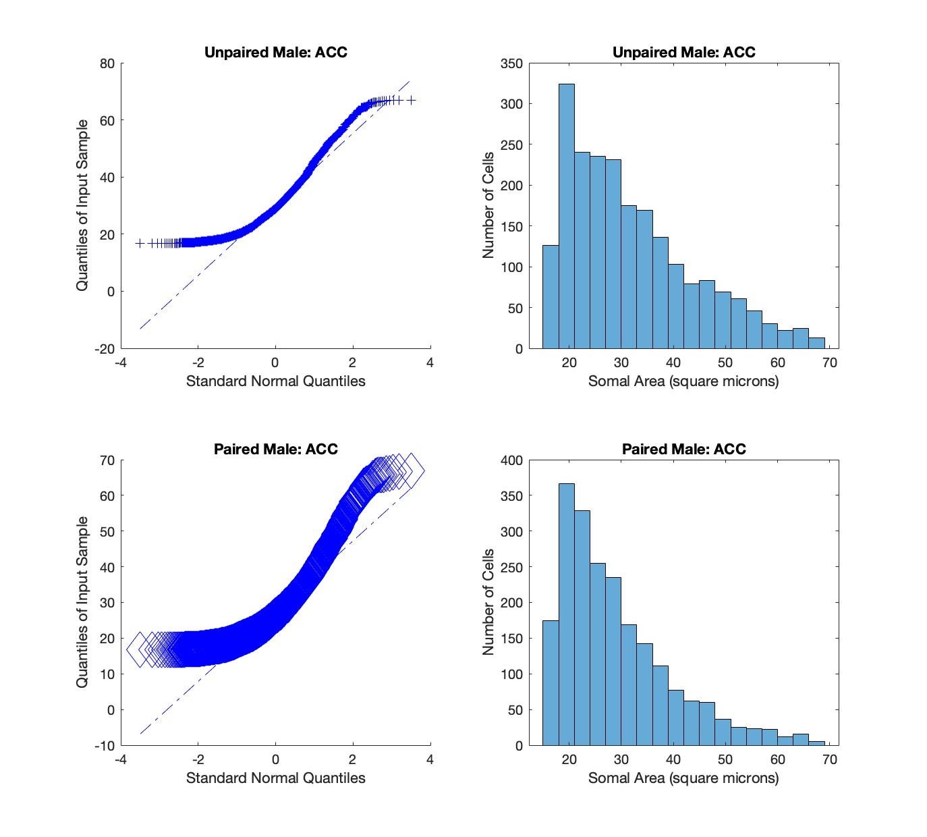
Figure S1. Male ACC distribution visualizations. Q-Q Plots (Left) and Histograms (Right) produced as visualizations of the distributions of microglia soma areas in the anterior cingulate cortex (ACC). Q-Q Plots depict the unequal variance of each distribution compared to a normal distribution as indicated by the diagonal dashed line. The color blue indicates male microglia. A small cross indicates unpaired microglia. A large diamond indicates paired microglia.

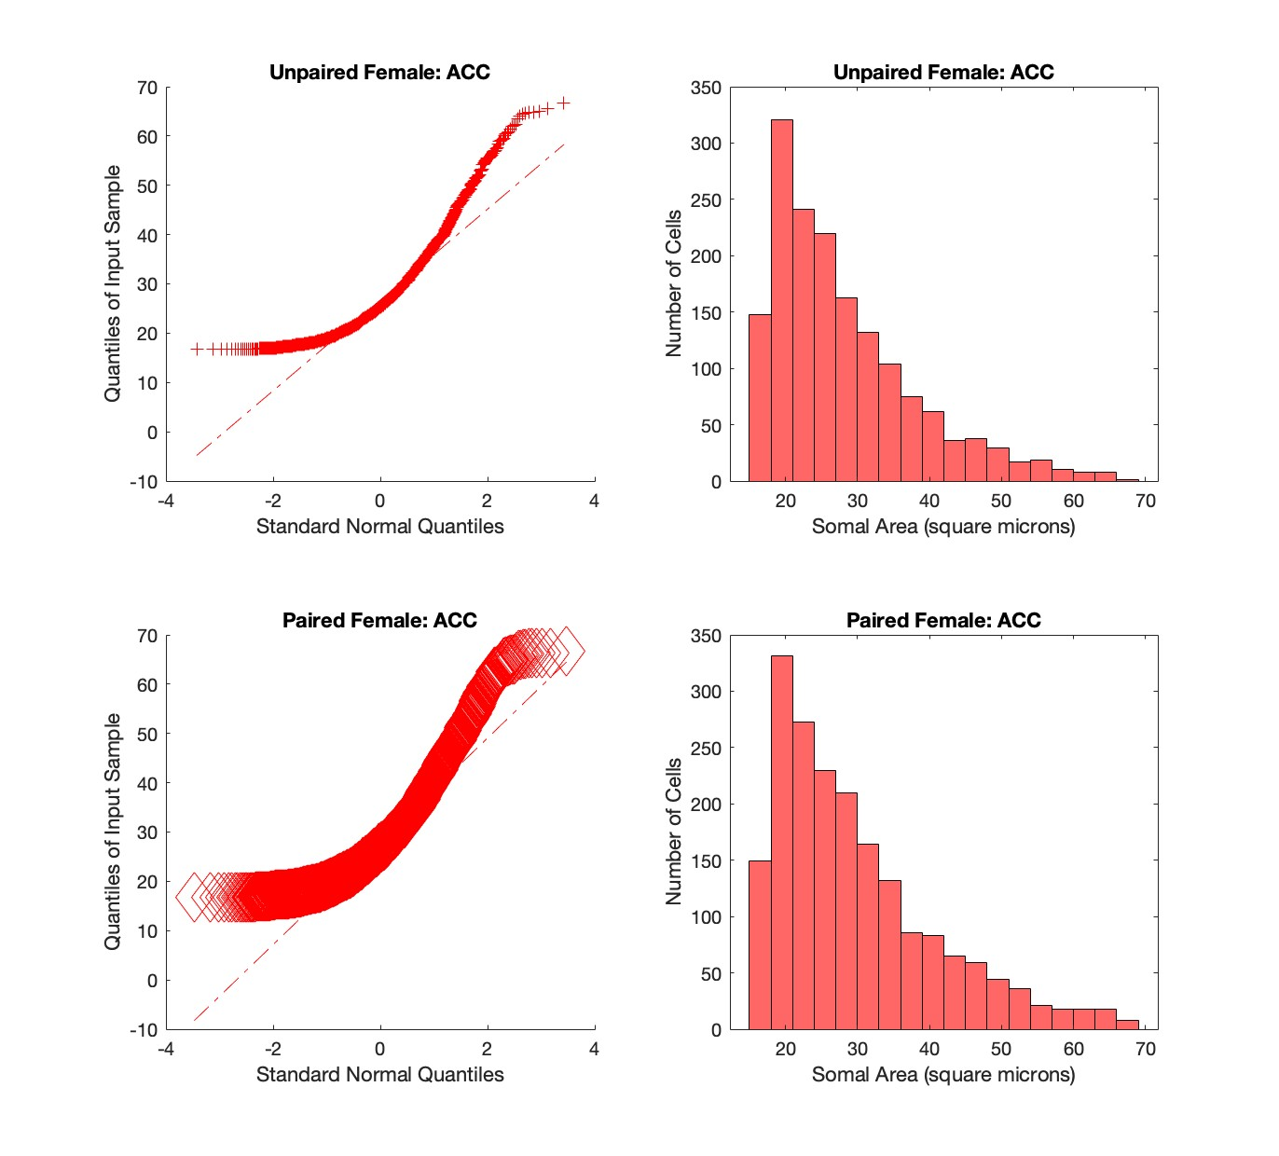
Figure S2. Female ACC distribution visualizations. Q-Q Plots (Left) and Histograms (Right) produced as visualizations of the distributions of microglia soma areas in the anterior cingulate cortex (ACC). Q-Q Plots depict the unequal variance of each distribution compared to a normal distribution as indicated by the diagonal dashed line. The color red indicates female microglia. A small cross indicates unpaired microglia. A large diamond indicates paired microglia.

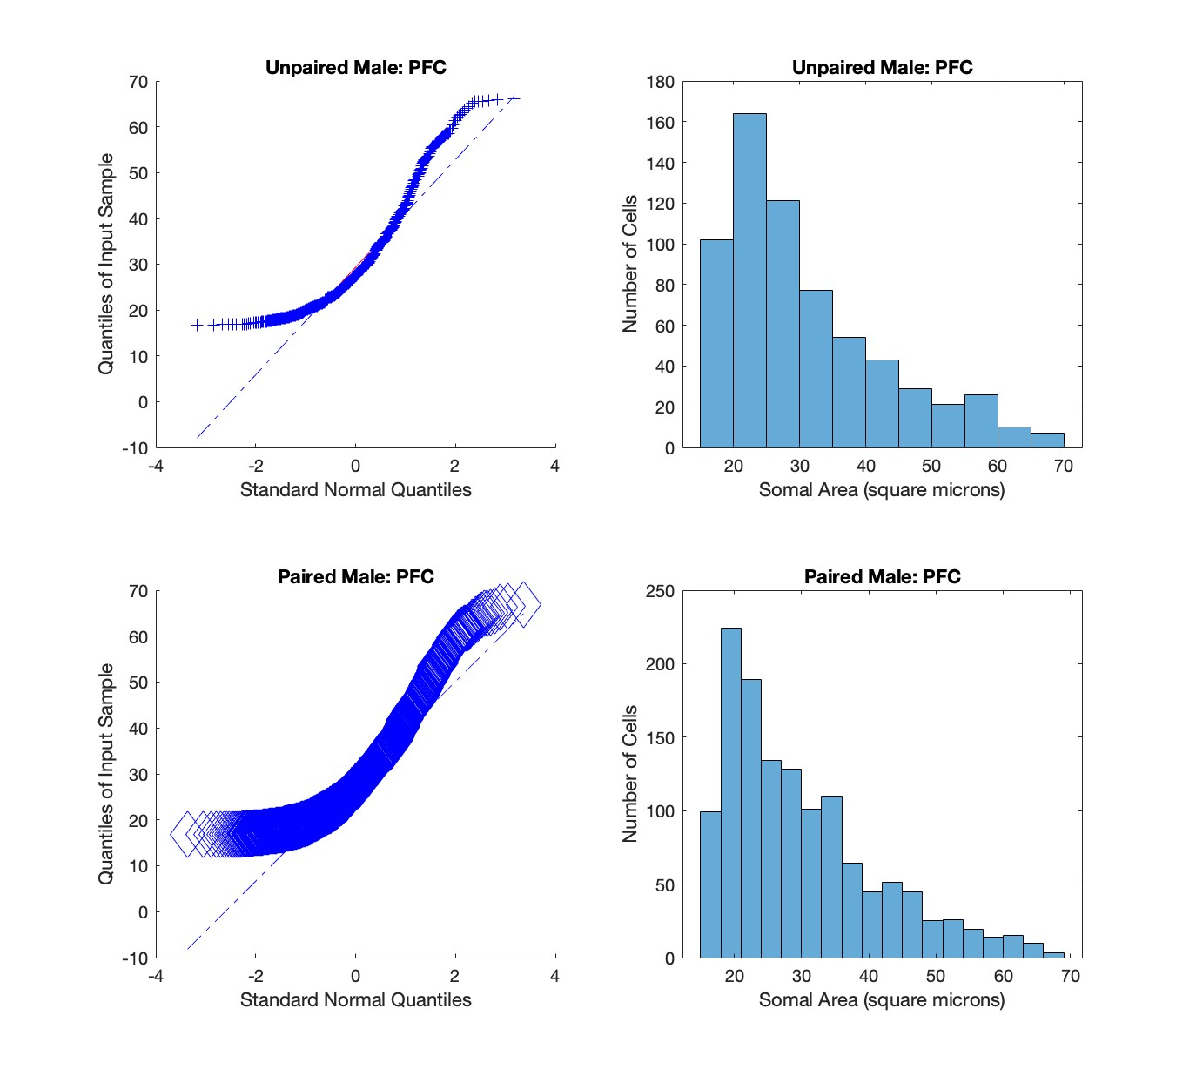
Figure S3. Male PFC distribution visualizations. Q-Q Plots (Left) and Histograms (Right) produced as visualizations of the distributions of microglia soma areas in the prefrontal cortex (PFC). Q-Q Plots depict the unequal variance of each distribution compared to a normal distribution as indicated by the diagonal dashed line. The color blue indicates male microglia. A small cross indicates unpaired microglia. A large diamond indicates paired microglia.

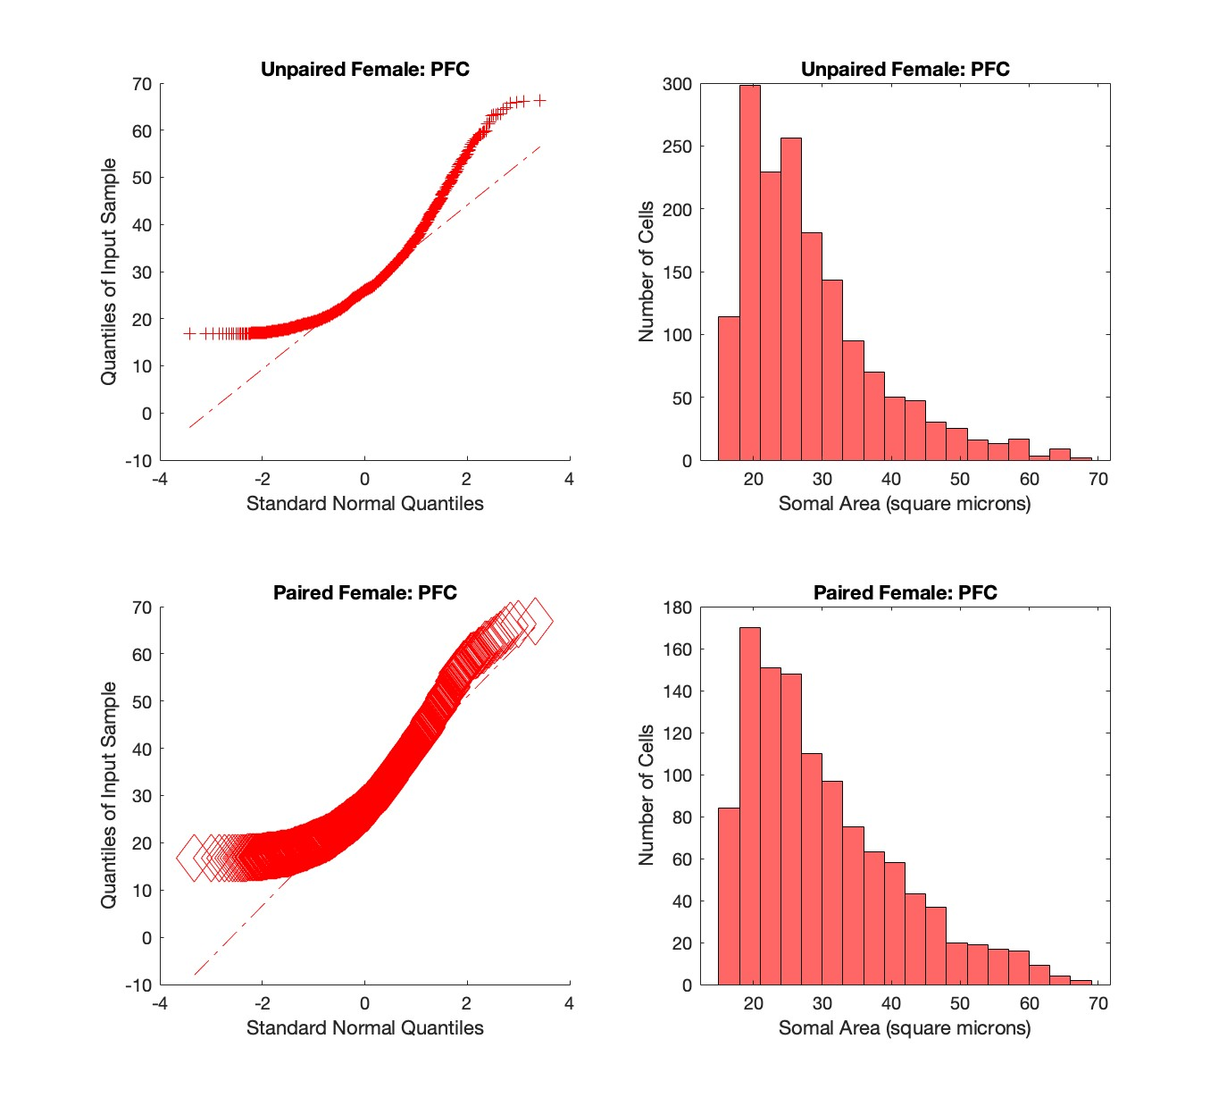
Figure S4. Female PFC distribution visualizations. Q-Q Plots (Left) and Histograms (Right) produced as visualizations of the distributions of microglia soma areas in the prefrontal cortex (PFC). Q-Q Plots depict the unequal variance of each distribution compared to a normal distribution as indicated by the diagonal dashed line. The color red indicates female microglia. A small cross indicates unpaired microglia. A large diamond indicates paired microglia.
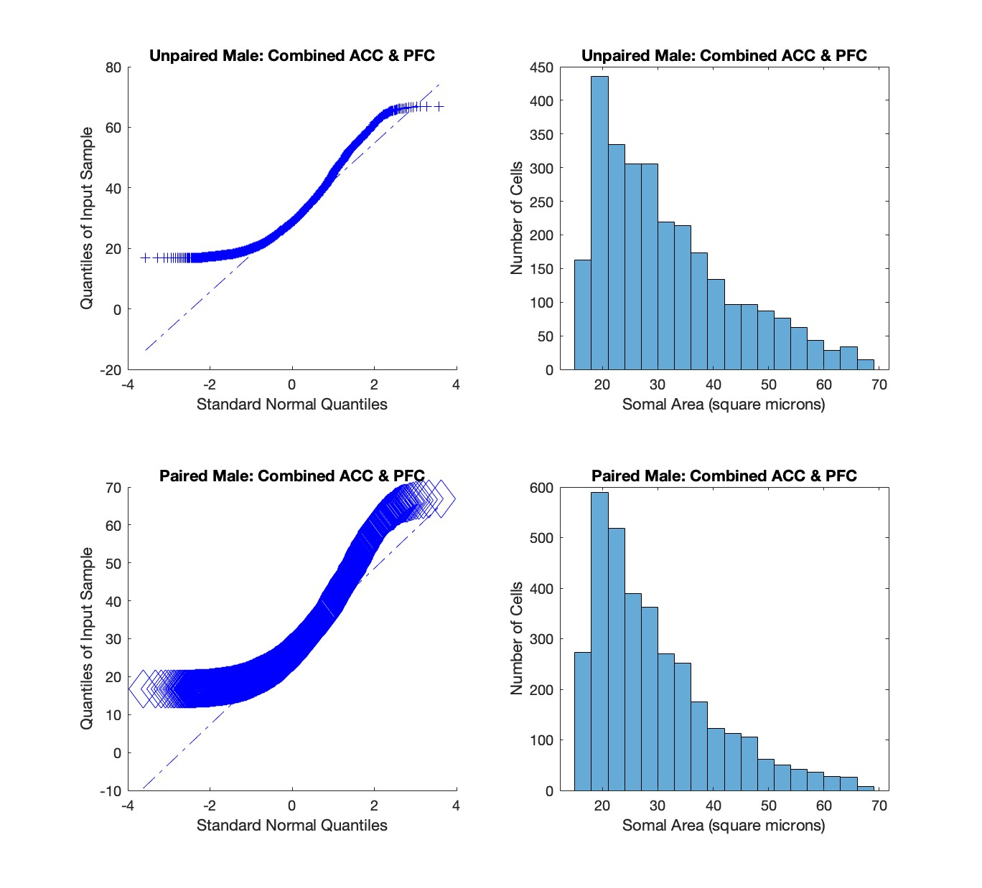
Figure S5. Male combined regions distribution visualizations. Q-Q Plots (Left) and Histograms (Right) produced as visualizations of the distributions of microglia soma areas in the anterior cingulate cortex (ACC) and prefrontal cortex (PFC) combined. Q-Q Plots depict the unequal variance of each distribution compared to a normal distribution as indicated by the diagonal dashed line. The color blue indicates male microglia. A small cross indicates unpaired microglia. A large diamond indicates paired microglia.

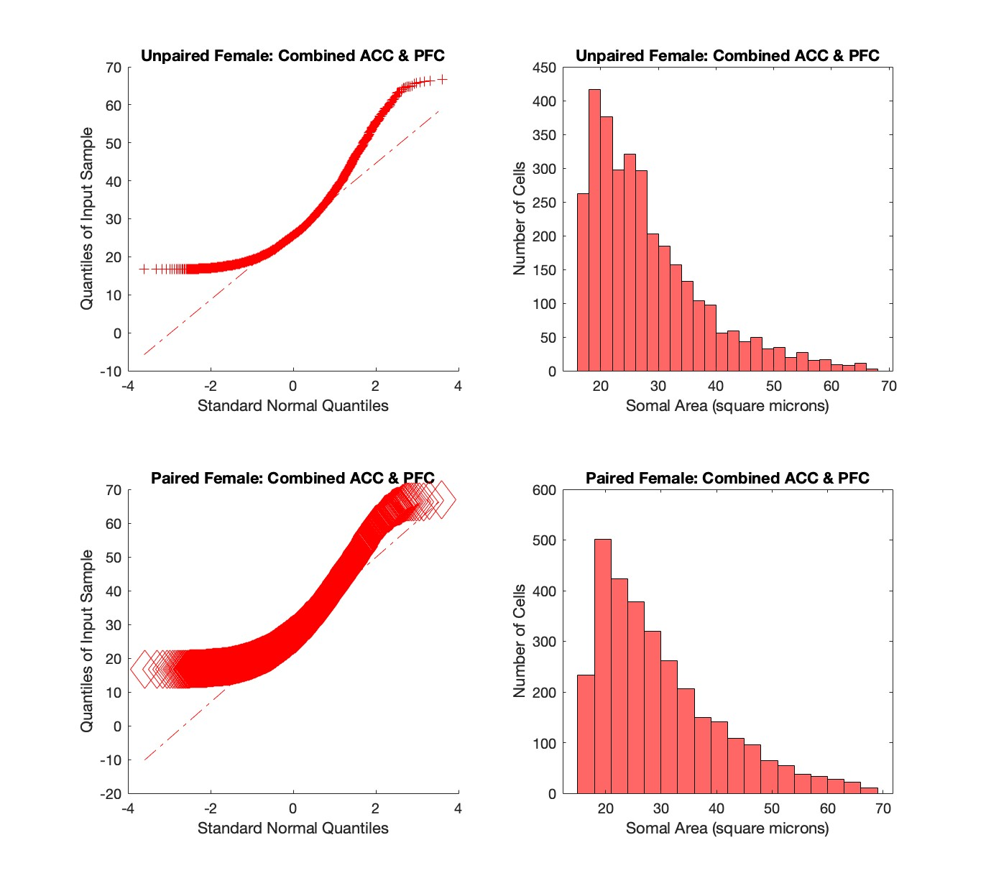
Figure S6. Female combined regions distribution visualizations. Q-Q Plots (Left) and Histograms (Right) produced as visualizations of the distributions of microglia soma areas in the anterior cingulate cortex (ACC) and prefrontal cortex (PFC) combined. Q-Q Plots depict the unequal variance of each distribution compared to a normal distribution as indicated by the diagonal dashed line. The color red indicates female microglia. A small cross indicates unpaired microglia. A large diamond indicates paired microglia.

SUPPLEMENTARY METHODS

Sectioning and Tissue Preparation
Prairie vole brains arrived at the lab having been perfused with 1x Phosphate Buffered Saline (PBS) followed by 4% Paraformaldehyde (PFA) for short-term storage. Upon receiving, brains were stored at 4 degrees Celsius until sectioning. Each subject was sectioned coronally at 30 microns using a freezing microtome, with sections passed into six different rostral-caudal samples per subject. Sections were stored in a six well plate containing 5mL of PBS with 0.05% sodium azide as a preservative per well for long-term storage.
After sectioning, 8 samples (one per subject) were selected for immunohistochemistry (IHC). Samples were placed in tissue carriers (Corning NetWell CLS3479, 24mm diameter, 74μm mesh) using a paintbrush to allow for ease of transferring tissue between reagents. Only in-tact sections anterior to the hippocampal formation were selected for staining. Sections were placed unfolded and flat in the tissue carrier, one at a time, while the carrier was submerged in 5mL of PBS in order to minimize twisting. After tissue loading, each subject was placed in a new six well plate containing 5mL PBS per well to begin rinsing.

Antigen Retrieval
Due to prolonged storage in 4% paraformaldehyde during shipping and storage, antigen retrieval was deemed necessary to remove cross-linked formalins and performed on samples prior to staining. Samples were incubated in 1x Tris-EDTA (TE) Buffer (Fisher BioReagents BP2477-500, pH 7.4) in a water bath at 95-100 degrees Celsius for 40 minutes. Samples were returned to room temperature while submerged in the TE Buffer before being moved to PBS for rinsing.

Free-Floating Immunohistochemistry
The staining protein of interest was the Ionized calcium binding adaptor molecule 1 (Iba-1). Iba-1 is a molecule specific to macrophages and microglia that is involved in the phagocytic and pruning functions of all types of brain-derived macrophages. It is present uniformly throughout the cytoplasm of the cell (Korzhevskii & Kirik, 2016), and has been shown to increase its immunoreactivity following glial cytokine expression/release, meaning it is found in increasing concentrations as microglia reactivity increases (Norden et al., 2016). While not commercially validated in prairie voles, the antibody has been used previously in successful vole studies (Pohl et al., 2021; Donovan et al. 2022).
The tissue underwent Free-Floating Immunohistochemistry (IHC) and a Diaminobenzidine (DAB) reaction according to the reagents specified in the Abcam Rabbit specific HRP/DAB (ABC) Detection IHC Kit (ab64261). Approximately 100-200 microliters of each prepared reagent was diluted in PBS to a total volume of 5mL for each well. 0.3% Triton-X 100 was also added to all blocking steps, the primary incubation, and the secondary incubation for permeabilization. All incubation times were optimized in order to lower costs of additional reagents, and according to the dilutions and number of sections per well as described below.
Endogenous peroxidase activity was blocked with the hydrogen peroxide block in 0.3% Triton X-100 and PBS for 15 min at room temperature on the rocker. This was followed by blocking nonspecific antibody binding with the Protein Block in 0.1% Triton-X 100 and PBS for 30 min at room temperature on the rocker. For primary incubation, tissue was moved to a primary buffer containing Iba-1 polyclonal antibody (Thermo Fisher Invitrogen PA5-27436 Rabbit IgG) (1:500) and left to incubate for 48 hours at 4 degrees Celsius on the rocker. For secondary incubation, tissue was moved to a secondary buffer containing biotinylated goat anti-rabbit IgG (H+L) (1:25) and left to incubate for 90 minutes at room temperature on the rocker. All antibodies were diluted in 0.3% Triton-X 100 and PBS to a total volume of 5mL per well. All samples were rinsed three to four times in PBS for 15-32 minutes between incubations.
At the conclusion of the secondary incubation and rinsing, tissue was placed in the stock streptavidin peroxidase diluted in PBS to incubate for one hour at room temperature on the shaker. To prepare for the DAB reaction, tissue was rinsed several times in PBS followed by a final rinse in sterile deionized water before being moved to a solution of sterile deionized water containing a 1:25 dilution of 50x DAB Chromogen in DAB Substrate. Well plates were placed on top of a white background while on the rocker to monitor the intensity of brown precipitate. Tissue was left to react with DAB for 10 minutes before being moved to a final rinse in PBS. Sections were then stored in PBS at four degrees Celsius until mounting.

Mounting and Imaging
Sections were mounted out of deionized water onto gel coated slides at a ratio of eight sections per slide using aqueous mounting techniques. Slides were coverslipped using aqueous mounting medium designed for brightfield IHC (Abcam AB64230) and glass coverslips. Images of the ACC and PFC were captured on an LED microscope using a 10x Leica Objective, Basler camera (acA3088-57uc), and Basler imaging software. Regions of Interest (ROIs) were determined using the Allen Mouse Brain Atlas to approximate vole brain regions. Microglia in the anterior cingulate cortex (ACC) and prefrontal cortex (PFC) were counted and traced using the “Analyze Particles” feature in Fiji/ImageJ. PFC was considered as a composite region including the subjects’ Prelimbic Areas and Infralimbic Areas as is standard in rodent literature (Carlén, 2017). Care was taken to exclude meningeal and perivascular macrophages, which also appear as Iba-1 positive cells, from the ROIs. Particle threshold was determined to be 10-80 square microns by measuring the soma diameter of 15 random cells, determining the minimum and maximum diameter values, and taking the square of each. Data containing soma area and ROI area for each image were exported and analyzed.

Statistical Analyses
All statistical analyses were completed using MATLAB R2023a. Independent samples t-tests, one-way analyses of variance (ANOVA), and two-way ANOVAs were completed to test for statistically significant differences in soma size between microglia in males and females and between microglia in paired and unpaired voles.

