Steady forest sink of 10% of carbon emissions resulting from a tenfold increase in biomass stock over 150 years in France

Supporting Information

Jean-Daniel Bontemps¹, Anaïs Denardou¹, Jean-Luc Dupouey²

¹IGN, ENSG, Laboratoire d’Inventaire Forestier, 14 rue Girardet, 54000 Nancy, France

²INRAE, AgroParisTech, Université de Lorraine, route d’Amance, 54280 Champenoux, France

*Corresponding author, jean-daniel.bontemps@ign.fr

Content:

- Supporting text

- Figures S1 to S3

- Tables S1 to S3

- Supporting datasets: (i) reference to open datasets, (ii) legend for Dataset S1

- Dataset S1

Supporting Information Text

S1 Forest GS densification equations
GSD (Growing Stock Density, m³/ha), hereafter denoted D for the sake of simplicity, is represented as a function of forest age, measured since the origin of a unit forest area, that can be either the total forest area of 1850, or any annual flux of new forest area after this date. A same seed D_{ini} (initial condition) was assumed for each new unit of forest area. Because ancient statistics are assumed conservative as regards forest definition (tree-populated forests) this seed was assumed low but positive, and expressed on a logarithmic scale, namely D_{ini} (1, 2, 5, 10, or 20 m³/ha), encompassed in the following integrated equation forms (see S2 for other parameter ranges)

M1 – monomolecular model (2 parameters in the differential form), with the following integrated form:
$$\text{D}\left(\text{t}\right) \text{=} {\text{D}}_{\text{max}} -\left({\text{D}}_{\text{max}} {- \text{D}}_{\text{ini}}\right)\text{exp}\left(\text{-c }\text{t}\right)$$
M1 was parameterized with t_{max} being the time at which 99% of D_{max} is reached, leading to:
$\text{D}\left(\text{t}\right) \text{= }{\text{D}}_{\text{max} }- \left({\text{D}}_{\text{max}} {-\text{ D}}_{\text{ini}}\right)\text{exp}\left(\frac{\text{t}}{{\text{t}}_{\text{max}}} \text{log}\left(\frac{\text{0.01 }{\text{D}}_{\text{max}}}{{\text{D}}_{\text{max}} {\text{- D}}_{\text{ini}}}\right)\right)$ [1]

M2 – linear model (1 parameter):
$$\text{D}\left(\text{t}\right) \text{=} \text{c }\text{t}{ + \text{D}}_{\text{ini}}$$
M2 was parameterized to allow the identification of D_{max} at t_{max}, leading to:
$\text{D}\left(\text{t}\right)\text{ = }\left({\text{D}}_{\text{max}} {- \text{D}}_{\text{ini}}\right) \frac{t}{{\text{t}}_{\text{max}}}{ + \text{D}}_{\text{ini}}$ [2]
Note that D can exceed D_{max} in this model, and parameter name is used for the sake of homogeneity with other models.

M3 – exponential model (1 parameter):
$$\text{D}\left(\text{t}\right)\text{ = }\text{exp} \left(\text{c} \text{t} {\text{+ }\text{log}{\text{D}}}_{\text{ini}}\right)$$
Constraining the model to reach D_{max} at t_{max} yielded:
$\text{D}\left(\text{t}\right)\text{ = }\text{exp} \left(\frac{\text{t}}{{\text{t}}_{\text{max}}} \text{log}\left(\frac{{\text{D}}_{\text{max}}}{{\text{D}}_{\text{ini}}}\right){\text{+ }\text{log}{\text{D}}}_{\text{ini}}\right)$ [3]
D_{max} can also be exceeded in this model.

M4 – Hossfeld sigmoid asymptotic model (3 parameters). This model was selected among classical 3-parameter sigmoid growth equations (1) for its slow convergence toward an upper asymptote. The differential form of Hossfeld model is:

$$\frac{\text{d}\text{D}\left(\text{t}\right)}{\text{dt}}\text{ = r }{\text{D(}\text{t}\text{)}}^{\text{1-m}}{\left(\text{1} \text{-} \frac{\text{D(t)}}{{\text{D}}_{\text{max}}}\right)}^{\text{1+m}}$$
After integration, it was parameterized with the asymptote D_{max}, the GS density at the inflection point, D_{inf}, and its associated time of occurrence, t_{inf}, and D_{ini} the density at the origin of forest, yielding:
$\text{D}\left(\text{t}\right)\text{ = }\frac{{\text{D}}_{\text{max}}}{\left(\text{1} \text{+} {\text{D}}_{\text{max}}{\left(\left({\left(\frac{{\text{D}}_{\text{max}} \text{-} {\text{D}}_{\text{inf}}}{{\text{D}}_{\text{max}}\text{ .} {\text{D}}_{\text{inf}}}\right)}^{\text{2}{\text{D}}_{\text{inf}}\text{/}{\text{D}}_{\text{max}}\text{ - 1}}\text{-} \text{C}\right)\frac{\text{t}}{{\text{t}}_{\text{inf}}} \text{+} \text{C}\right)}^{{\text{D}}_{\text{max}}\text{/2}{\text{D}}_{\text{inf}}\text{ - 1}}\right)}$ [4]
With the constant C being defined as follows:
$$\text{C} \text{=}\left(\frac{\text{1}}{{\text{D}}_{\text{ini}}} \text{-} \frac{\text{1}}{{\text{D}}_{\text{max}}}\right)\left(\frac{\text{2 }{\text{D}}_{\text{inf}}}{{\text{D}}_{\text{max}}} \text{-} \text{1}\right)$$

These trajectories are illustrated in Figure S1.

For preexisting forests in 1850, equivalent ages for initial conditions of D₁₈₅₀ different from D_{ini} needed be computed that are given by:
M1:
age₁₈₅₀ = log ((D_{max} – D₁₈₅₀) / (D_{max} – D_{ini})) / log (0.01 D_{max} / (D_{max} – D_{ini})) t_{max},
M2:
age₁₈₅₀ = (D₁₈₅₀ – D_{ini}) / (D_{max} – D_{ini}) / t_{max}
M3:
age₁₈₅₀ = (log D₁₈₅₀ – log D_{ini}) / (log D_{max} – log D_{ini}) . t_{max}
M4:
$${\text{age}}_{\text{1850}} \text{=} \frac{\left({\left(\frac{{\text{D}}_{\text{max}} \text{-} {\text{D}}_{\text{1850}}}{{\text{D}}_{\text{max}}{\text{ . D}}_{\text{1850}}}\right)}^{\text{2}{\text{D}}_{\text{inf}}\text{/}{\text{D}}_{\text{max}}\text{ - 1}}\text{- C}\right)}{\left({\left(\frac{{\text{D}}_{\text{max}} \text{-} {\text{D}}_{\text{inf}}}{{\text{D}}_{\text{max}}{\text{ . D}}_{\text{inf}}}\right)}^{\text{2}{\text{D}}_{\text{inf}}\text{/}{\text{D}}_{\text{max}}\text{ - 1}} \text{- C}\right)}{\text{t}}_{\text{inf}}$$

Note that age₁₈₅₀ is identified as y₀ in the main manuscript.

S2 Forest area data
Contemporary statistics stemmed from national forest inventory estimates at department administrative unit (dau, NUTS-3 units of the European Union, ca. 5000 km² on average) geographical scale, linearly interpolated across successive inventories and aggregated over all dau to estimate the course of country’s forest area between 1976 and 2010 (2). Ancient estimations available prior to the NFI program have been reviewed and synthesized in (3) and (4). Statistics are considered poorly reliable before the completion of the imperial land register (1830), a baseline for the mid-19th century reaching 9.2 million ha. These authors assume the existence a systematic negative bias in ancient statistics, for technical (access to private land), and political (support forest protection) reasons. Ancient statistics selected for GS estimation aimed at providing a centennial estimate of GS changes. They included the agricultural statistics of 1892 (5, termed “S1”) and 1929 (6, termed “S3”), and the Daubree forest statistics of 1908 (7, termed “S2”), all digitized, presented and analyzed in (8), and open access (see Supporting datasets section). Between 1871 and 1919, primary statistics did not encompass a part of France (Alsace-Moselle) annexed by Germany, a gap corrected for by using two complementary statistics (Ministerium für Elsaß-Lothringen, 1907; (9)). Moreover, data from 1882 and 1892 described reforestation perimeters intended for mountain protection by afforestation, but not necessarily afforested at these dates. These estimates were replaced by statistics on effective afforestation (10). Last, contemporary quantitative definitions of forests used in national forest inventory (11) are more inclusive than in the past (a minimum 10% of tree cover over an area of a minimum 0.5 ha and trees able to grow taller than 5m high at their maximum), leading to the assumption that ancient statistics may remain negatively biased in this respect. This aspect was handled in the uncertainty analysis.

S3 Fitting process and uncertainty analysis
Models were fitted to the GS chronology established from the French NFI over 1976-2010 (2, Dataset S1). In view of the close-to-linear pattern of GS progression, five GS estimates equidistant in time were extracted from this chronology, in 1978, 1986, 1994, 2002 and 2010 (indexed GS (j)). Goodness-of-fit indicators included:
- the root mean square error of prediction (RMSEP):
$$\text{RMSEP } \text{=} {\left(\frac{\text{1}}{\text{5}}\sum_{\text{j} \text{=} \text{1}}^{\text{5}}{\left({\text{GS}}_{\text{M}}\left(\text{j}\right)\text{ - GS(}\text{j}\text{)}\right)\text{²}}\right)}^{\text{0.5}}$$
- the bias of prediction:
$\text{Bias = }\frac{\text{1}}{\text{5}}\sum_{\text{j}\text{ = 1}}^{\text{5}}{\left(\text{GS}\left(\text{j}\right)\text{ - }{\text{GS}}_{\text{M}}\text{(}\text{j}\text{)}\right)}$
- the relative RMSEP and bias:
$${\text{Relative RMSEP =} \left(\frac{\text{1}}{\text{5}}\sum_{\text{j}\text{ = 1}}^{\text{5}}{{\left(\left({\text{GS}}_{\text{M}}\left(\text{j}\right)\text{ - GS(}\text{j}\text{)}\right)\text{/GS}\text{(}\text{j}\text{)}\right)}^{\text{2}}}\right)}^{\text{0.5}}$$
$$\text{Relative Bias = }\frac{\text{1}}{\text{5}}\sum_{\text{j}\text{ = 1}}^{\text{5}}{\left(\text{GS}\left(\text{j}\right)\text{ - }{\text{GS}}_{\text{M}}\text{(}\text{j}\text{)}\right)}\text{/GS(}\text{j}\text{)}$$
- and the R²:
$${\text{R}}^{\text{2}}\text{ = 1 - }\frac{\sum_{\text{j=1}}^{\text{5}}{\text{(GS}\text{M}\text{(}\text{j}\text{) – GS(}\text{j}\text{))²}} }{\sum_{\text{j=1}}^{\text{5}}{\left(\text{GS (}\text{j}\text{) – mean (GS(}\text{j}\text{)}\right)\text{²}} }$$

The parameter space was explored to minimize the RMSEP. In models M2 and M3 (one parameter to fit: GSD_{max}, see S1), age_{max} was fixed at a level providing sensitivity on the fit of GSD_{max}. Parameter age_{max} was explored at a 25-year resolution in model M1, and at a 50-year resolution in model M4. Parameter GSD_{max} was explored at resolutions of 25, 5, 10, and 10 m³/ha in models M1 to M4, as well as parameter GSD_{inf} in model M4. The uncertainty analysis encompassed the GSD of preexisting forests (GSD₁₈₅₀: 5, 10, 25, 50 and 100 m³/ha), the initial GSD of new forests on a discrete logarithmic scale (GSD_{ini}: 1, 2, 5, 10, and 20 m³/ha), and a positive shift on forest area estimates prior to contemporary statistics by +1 million ha (see S1 for the justification).

S4 GS estimation for historical forest area statistics S1 to S3
GS estimates can be produced at a country level only through a systematic probabilistic sampling of forests, at the basis of modern forest inventories (12), the oldest ones having been initiated in the 1920s in Nordic European countries (13). In addition, the relascope stereologic concept of Bitterlich allowing the estimate of basal area and volume per hectare in forest plots was made operational in the 1940s (14). These reasons account for why no GS estimation is found in forest statistics of the 19th century and before. These forest statistics split the forest area according to: (i) department administrative units (dau), corresponding to the NUTS-3 geographic level of the European Union, with an order of magnitude of 5000 km² in area, (ii) ownership categories (private or public, often distinguished in state forests and forests of the municipalities), (iii) forest vertical structure (coppice forests, high forests, coppice-with-standard forests). GSD was estimated for all combinations of these partitioning factors, forming so-called analogues, and transported to ancient statistics of 1892, 1908 and 1929 (S1 to S3, Supporting datasets and S2).
Both present-day mean GSD, and a standard range of lower quantiles of GSD were computed over these analogues. In view of the position of the country average of GSD mean (between quantiles 0.55 and 0.6 for both ancient statistics), quantiles ranging from 0.1 to 0.6 (step 0.05) were estimated. The French NFI survey has been conducted periodically between 1961 and 2005, with a >10-year rotation across department administrative units (dau). It was turned annual and systematic over the territory in 2005. Two reference periods were therefore defined: (i) a first reference period corresponding to the oldest inventory available in databases for each dau (mean year 1983, period NFI#1), and (ii) a second reference period using 9 years of annual inventories between 2006 and 2014, centered on the median year 2010 (NFI#2).
Mean GSDs for the different categories of forest vertical structure were: (NFI#1) – high forest: 166 m³/ha, coppice-with-standard forest: 127 m³/ha, coppice forest: 60 m³/ha, (NFI#2) – high forest: 202 m³/ha, coppice-with-standard forest: 148 m³/ha, coppice forest: 66 m³/ha. They highlighted the pace of forest densification. The estimates of mean GSD and total GS for the three ancient statistics based on the reference period NFI #1 are provided in Table S1 for the standard range of GSD (mean and quantiles 0.1 to 0.6) from forest analogues defined by the three factors including dau, ownership category and vertical forest structure.

S5 Historical conversions of coppice and coppice-with-standard forests
Broadleaved forests of Europe have been managed for long as simple coppice or coppice-with-standard (CWS) forests, as regeneration based on natural tree sprouting from stumps is more efficient and cheaper than regeneration from seeds, and trees are cut regularly (every 10 to 30 years) to deliver small-sized products with a main use as fuelwood (15). There is growing evidence that this traditional forest management system may date back from the Neolithic times and after in Europe ((16) in Germany, (17) in France, see also (18)). In France, the conversion of public coppice/CWS forests into high forests has been decided with the enforcement of the Forestry Code in 1827, with a view to produce roundwood (19) in the context of increasing fuelwood substitution by coal (20). The process was first initiated in State forests, and was then extended to forests of the municipalities (21), with a substantial intensification in the 1860s (20, 22). The process has however met serious budget- driven disruptions along time (23). The process of coppice/CWS conversion following the introduction of fossil fuels has also been described in different regions of Europe (e. g. (24) in Germany, (25) in Italy, (26) in Spain, (27) in Austria). Its degree of generality in Europe (28) makes it one likely driver of wood accumulation in European forests.

S6 Conversion of stemwood GS into total aerial carbon mass
The conversion of stemwood volume to aerial carbon mass can be directly operated by using biomass expansion factors, with existing references for European temperate forests (e. g. 29). We however here made profit from a much more accurate reference, specifically established for the French forests in different published projects that separately target: (i) the conversion of stemwood volume into total aerial volume, (ii) the estimation of wood infradensity (WID, dry mass over green volume, intended for such conversions, (30)).
We further assumed that the GS proportion of broadleaf and conifer trees has remained constant over the study period, which is supported, for forest area (1908 – 2015) by (8), and for forest GS (1987 – 2010) by (2). Indeed, the areal proportion of broadleaved tree species in 1908 (statistics S2, Daubée, 8) was 0.724 while this proportion was 0.710 in official NFI statistics at the end of the period in 2010. Similarly, the GS proportion of broadleaved tree species was 0.621 in 1987 (first available NFI statistics) and 0.641 in 2010.
Carbon stocks being related to GS volume, we therefore considered the constant fractions of 0.359/0.641 (NFI data at the period end) for conifer/broadleaved forest GS fractions, respectively over the period, and operated the conversion according to these two botanical classes.
Total aerial volume of GS
Volume expansion factors (VEF) have been specifically derived for converting stemwood at a final stem diameter of 7 cm as measured in NFI plots into total aerial volume. We used the VEF average values for broadleaf and conifer tree species (31), as this reference was established from mensuration of both stemwood and tree aerial volume on samples of the French National Forest Inventory, systematic across space and tree species, and therefore reliable for the present estimation. The reference provided VEFs of 1.335/1.611 for conifers/broadleaves, respectively. Total aerial volume of GS was therefore obtained from GS simulations and historical reconstitutions at any date t by:

Total volume (t, m³) = GS (t, m³) × (F_{C} × VEF_{C} + (1 – F_{C}) × VEF_{B})

where B and C designate broadleaves and conifers, and F_{C} stands for the conifer areal fraction (0.359)
Total aerial carbon mass
In view of the lack of information on wood density and its variation across European tree species, a collection of +100’000 tree cores sampled at breast height (1,30 m) over all leaving trees sampled by the national inventory over 4 years has been collected and measured by X-ray tomography (32, 33). One major property of this dataset is that trees have been sampled using the spatially systematic gridded design of the national forest inventory, implying that the number of tree cores collected by species is immediately proportional to their importance in the volume of GS of the country. Therefore, simple wood density averaging of these measurements by botanical class immediately weights these means according to the importance of species. The following wood infra-densities were obtained: 443.3/600.8 kg/m³ for conifer/broadleaf wood, respectively. Total aerial carbon mass was obtained by using 0.5 as the mass fraction of carbon-to-wood, and expressed in the conventional unit of Pg C (10¹⁵ g):

Total C mass (t, Pg C) = Total volume (t, m³) × (F_{C} × WID_{C} + (1 – F_{C}) × WID_{B}) × 0.5 × 10⁻¹²

where WID stands for wood infra-density, in kg/m³.

S7 GS estimation for actively afforested forests since 1850
This estimation is based on French annual NFI statistics (http://ocre.ign.fr) for the period 2007-2012 corresponding to the median year 2010. It includes the GS of all exotic tree species encountered in France, and the GS of semi-exotic species, native of some regions, and introduced in other ones, most essentially in plains. Broadleaved trees represent a minor fraction of this GS. The oldest significant afforestation programs correspond to Maritime pine in Aquitaine and Scots pine in Central inland France (mid-19th century), and to European larch, transplanted from Italy in the inner Alps to initiate the mountain terrain restoration programs at the end 19th century. Norway spruce is considered natural in the Vosges, Alps and Jura mountains. Scots pine is considered natural in the same regions plus the Central Mountain range. In total, GS of areas afforested since the mid-19th century represent around 514 million cubic meters. Of note, this estimation does not comprehend the GS of forests that have been extending naturally over abandoned lands, whose process has not been described nor quantified and whose tree species cannot be detected (indigenous species). This estimate therefore constitutes a lower bound for the GS of forests that have extended after the forest minimum. The breakdown of GS of planted forests since 1850 by tree species/region is provided in Table S2.

S8 Simulations for historical environmental growth changes and site recovery effects on the convexity of forest densification trajectory
The effect of documented environmental growth changes on GS densification (GSD) convexity was evaluated by making GSD rate variable over time instead of constant in the densification models (see S1), to explore how it may affect the GSD trajectory. Two scenarios were considered:
- Scenario E₁, a base linear scenario from 1900 onward, figuring out a +100% GS accumulation rate over one century (1900-2000), based on the centennial growth change quantifications accumulated in the literature regarding French and European forests (see main text),
- Scenario E₂, a convex quadratic scenario, assuming a recovery phase in the second mid-19th, and of a twice as high final magnitude over 1850-2000 (+200%). Assumptions for this formulation were to also account for site fertility enhancement due to management release (34), and some qualitative interaction over time with exogenous environmental drivers. Despite historical recovery of site fertility remains undocumented to date, we thus assumed a fairly neutral balance of environmental and site drivers of densification improvement, leading to this 200%.
An increase in dimensional growth (here GS) is dynamically equivalent to a time contraction to reach a given density (35), or said differently, an acceleration of time. For instance, a constant difference of +50% in the GS densification rate between two theoretical area units would yield a time contraction of one third for the fastest accumulating one.
These scenarios were thus translated into equivalent time series for easier use in the model simulations. Assuming a densification response: GSD (t, t₀, P) with P the parameter vector of densification equations, an acceleration term f (t) is introduced (parameterized for E₁/E₂) that modifies that response (P’), and leads to the alternative model to be fitted:

GSD (t, t₀, P) → GSD (f(t), t₀, P’)
With f(t) > t
Since the tested change occurred gradually, this yielded the continuous model:

dt’ = dt . chg (t)

where chg (t) stands for the environmental change with condition chg (t) > 1.
Thus, t was replaced in the GS densification model (section S2) by:

t' = $\int_{{\text{t}}_{\text{0}}}^{\text{t}}{\text{chg} \text{(}\text{u}\text{)} \text{d}\text{u}}$ + t₀

The scenarios were formulated as follows and applied to model M4 in the areal parameterization of + 1000 kha:
Scenario E1: a linear change occurring since 1900 and of a centennial magnitude of +100% as estimated in the literature (hence chg (t ≤ 1900 = 1 and chg (2000) = 2), namely:

chg (t) = 1 + 0.01 (t – 1900) if t ≥ 1900
Leading to:
t' = t + 0.005 (t – 1900)²

Scenario E2: an accelerated change occurring since 1850, represented by a quadratic function, and of a centennial magnitude of +200% at after 150 years (thus chg (t ≤ 1850) = 1, and chg (2000) = 3), namely:

chg (t) = 1 + (t – 1850)/300 + (t – 1850)² / 15000 if t ≥ 1850

Leading to:
t' = t + (t – 1850)² / 600 + (t – 1850)³ / 45000

Systematic exploration of the parameter space was conducted for model M4 under the assumption of a +1000 kha area (Table 1), with a step of 50 m³/ha for GSD_{max}, 5 years for t_{inf}, and at a unit resolution for GSD_{inf}.
Associated model fits are described in Table S3, and changes in the GSD trajectories are figured out in Figure S3.

S9 Changes in the historical delivery of forest products over the study period.
The three ancient statistics of 1892, 1908 and 1929 (see S2) provide statistics of “forest production” that must be understood as harvested commercialized volume (available online, see Supporting datasets. Conversions from specific volume units found in the statistics of 1929 to m³ roundwood equivalents were performed from (36).
Contemporary NFI statistics also allowed estimating volumes of wood fellings, with however two major differences: (i) tree census and fluxes are not operated below a diameter threshold of 7.5 cm at breast height, (ii) only volume of the main tree stem up to a final 7 cm diameter threshold is accounted for. Therefore, contemporary NFI-based fluxes are bound to be underestimated with respect to those of ancient statistics.
One first estimate (37) was produced from two successive and remote decennial national forest inventories operated at NUTS-3 geographic level of the EU (mean years 1982 and 1995, median year 1990) by the inventory comparison method, where (denoting t₁ and t₂ the two inventory occasions):
GS(t₂) – GS(t₁) = GS_{R} + G – GS_{H}
with G, GS_{R}, and GS_{H}, being total production, volume of recruitment and harvested/dead volume, respectively, leading to annual:
GS_{H} = {(GS_{R} + G + GS(t₁) – GS(t₂)} / (t₂ – t₁).
One second estimate was obtained from the new annual systematic national forest inventory initiated in 2005 with direct measurement of harvests by a semi-permanent plot design, over the period 2005-2009, leading to an estimate of wood harvest for the median year 2007.
Last, we made profit from the agricultural statistics of 1962 (38) that introduced a new section dedicated to forest and wood production, in absence of a statistical inventory (launched in 1961, see Supporting datasets). This data source showed a particular interest as (i) wood harvest accounting is based on commercialized wood products, in a way similar to ancient statistics, (ii) it is closer in time to contemporary inventory estimates and allows an evaluation of the robustness/biasedness of any comparison between contemporary and ancient periods. Wood harvests were quantified in absolute terms, and by unit area (m³/ha). Data compiled are presented in Table 4 of the main manuscript.

Supporting Figures and Tables

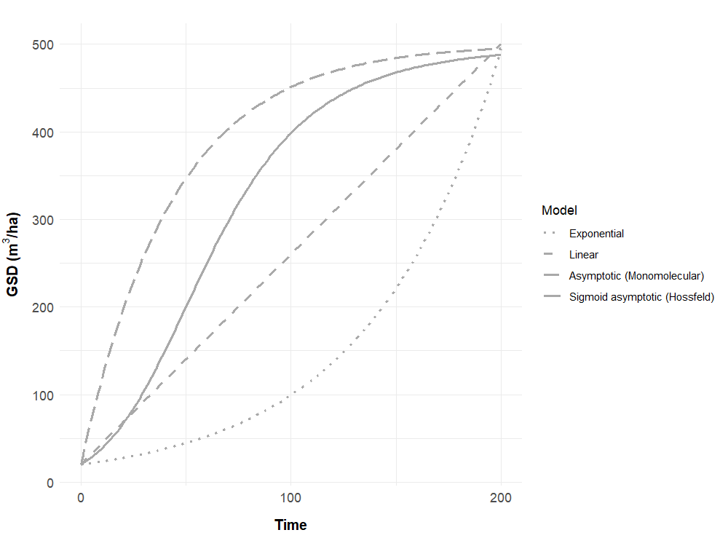

Fig. S1. GSD trajectories (m³/ha) generated by the four models tested in the study (see section S1). Parameterizations are theoretical ones intended for GSD to approach 500 m³/ha over 200 years.

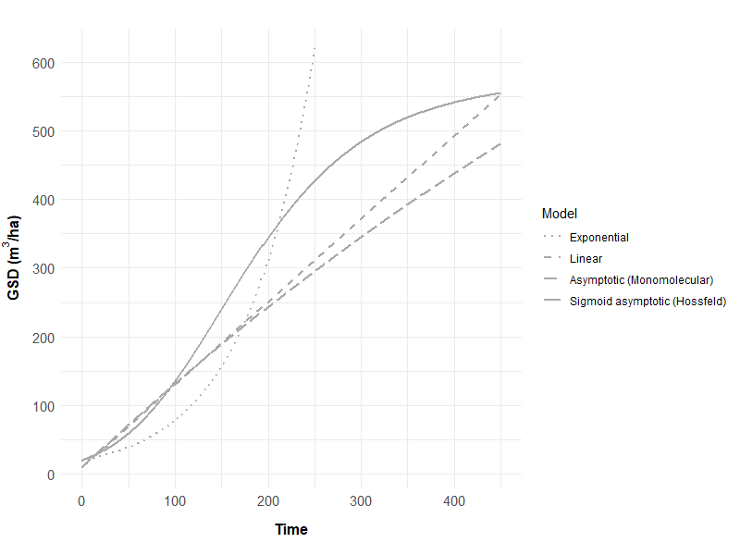

Fig. S2. GSD trajectories (m³/ha) generated by the four models tested in the study (see section S1). Parameterizations are those obtained from fits reported in Table 1 of the article.

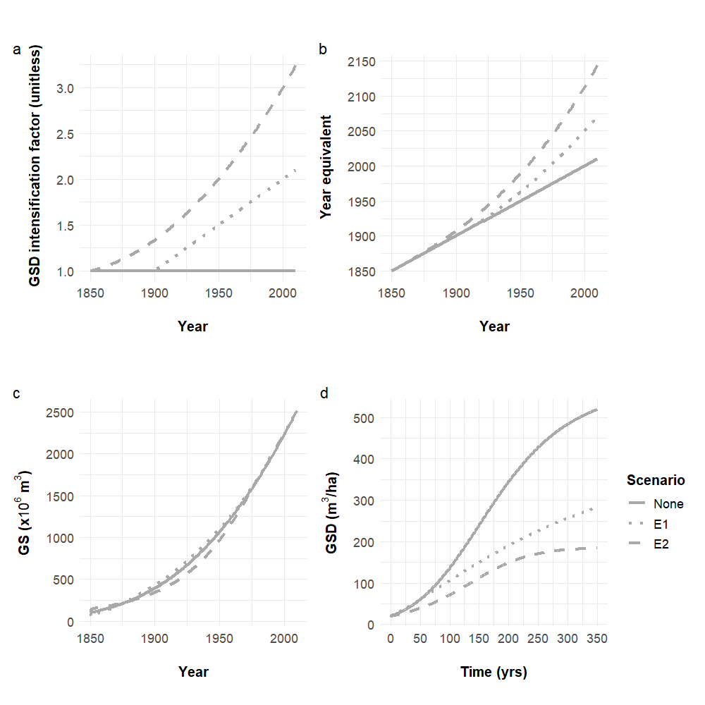

Fig. S3. Scenarios of historical environmental growth changes and their effects of GS densification under the sigmoid densification assumption (see Materials and Methods and SI appendix, section 8). Intensification in the GSD rate is interpreted as an equivalent time acceleration and a change in the time referential, whereby dt’ = dt chg (t), leading to substitution of t for t’ = t₀ + ∫_{(t0, t)} chg (u) du in GSD equations. a: scenarios for chg (t), E1 is a linear intensification of +100% in 2000, E2 is an accelerated intensification of +200% in 2000, b: equivalent time referential for GSD under S1 and S2, c: simulation control of total GS trajectories showing their convergence over the recent period covered by NFI estimates for GS, d: intrinsic trajectories of GSD (m³/ha) under the different scenarios (parameterizations of model M4 in Table 1 and Table S3), showing a negative displacement of the time occurrence of maximum GSD,

Table S1. Country averages of growing stock density (GSD) and total GS as estimated for three ancient forest statistics (1892, 1908 and 1929) for mean- and quantile-based conditional imputation of contemporary NFI data using geographic, ownership and forest structure partitioning factors. Data for the reference period NFI#1. See SI appendix, section 4 for additional information.

Forest statistic | 1892 |  | 1908 |  | 1929
Quantiles of present-day GSD | GSD  (m³/ha) | GS  (x 10⁶ m³) | GSD | GS | GSD | GS
Q10 | 20.9 | 199 | 23.7 | 234 | 20.3 | 217
Q15 | 31.9 | 304 | 35.6 | 352 | 31.3 | 334
Q20 | 43.8 | 417 | 48.0 | 475 | 43.2 | 461
Q25 | 55.3 | 526 | 59.9 | 592 | 54.6 | 583
Q30 | 66.7 | 635 | 71.4 | 706 | 65.8 | 702
Q35 | 77.6 | 739 | 82.6 | 817 | 76.8 | 819
Q40 | 88.8 | 845 | 93.7 | 927 | 87.8 | 937
Q45 | 100.1 | 953 | 105.1 | 1039 | 99.1 | 1057
Q50 | 111.1 | 1058 | 116.2 | 1149 | 109.9 | 1173
Q55 | 122.8 | 1169 | 127.8 | 1264 | 121.5 | 1296
Mean | 128.0 | 1219 | 132.1 | 1306 | 126.1 | 1346
Q60 | 134.9 | 1284 | 139.7 | 1382 | 133.3 | 1422
Table S2. GS estimates of forests planted since the mid-19th century across inland France obtained from statistics of year 2010 of the National Forest Inventory. Ranked by decreasing order of GS. Confer and grand totals rounded to the nearest 1000 m³.

Tree species | Botanical class | Region |  | GS (m³) | Origin
Maritime pine | C | All regions |  | 123 651 589 | Semi-exotic, since mid-19th
Douglas fir | C | All regions |  | 106 535 369 | Exotic, after WWII
Norway spruce | C | All regions but Vosges, Jura and Alps (native range) |  | 75 150 977 | Semi-exotic, 20th century
Scots pine | C | All plains, Jura (native range in other regions) |  | 46 966 140 | Semi-exotic, since mid-19th
Cultivated poplar | B | All regions |  | 32 004 228 | Exotic, after WWII
Black locust | B | All regions |  | 26 436 803 | Exotic, after end 19th century
Austrian black pine | C | All regions |  | 26 018 339 | Exotic, after WWII
Corsican pine | C | All regions but Corsica |  | 25 318 030 | Exotic in inland France, after WWII
European larch | C | Northern plains, all mountain ranges |  | 20 813 161 | Semi-exotic, since mid-19th
Sitka spruce | C | All regions |  | 13 731 350 | Exotic, after WWII
Northern red oak | B | Plains, Central mountain range, Vosges, Pyrénées |  | 5 470 258 | Exotic, after WWII
Grand fir | C | Plains, Central Mountain range and Alps |  | 4 512 411 | Exotic, 20th century
Exotic larch | C | Northern plains, Central Mountain range |  | 3 061 766 | Exotic, after WWII
Other exotic conifers | C | All regions |  | 1 426 053 | Exotic
Weymouth pine | C | Plains, Central Mountain range and Jura |  | 1 133 032 | Exotic, 20th century
Atlas cedar | C | All regions |  | 997 988 | Exotic, after WWII
Other exotic broadleafs | B | All regions |  | 565 915 | Exotic
Eucalyptus | B | Southern inland France, Corsica |  | 422 372 | Exotic, after WWII
American tulip tree | B | Pyrénées and Southern inland France |  | 109 993 | Exotic, after WWII
Caucasian fir | C | Northern plains |  | 107 268 | Exotic, 20th century
Conifer forests  TOTAL |  |  |  | 449 423 000  514 433 000 | (87.3 %)

Table S3. Summary statistics and parameter estimates for the sigmoid asymptotic forest densification assumption (model M4) under environmental change scenarios (section S8). The first two fits are those presented in Table 1 for the sake of comparison with these additional scenarios. In the latter two simulations, initial conditions were maintained identical to those of best fit with model M4. See SI appendix, sections S1, S2, S3 for details, and section S8 for environmental growth change scenarios E1 and E2.

Densification assumption | Sigmoid (M4)
Uncertainty analysis
Forest area | Initial | +1000 kha | +1000 kha | +1000 kha
GSD_{ini} (m³/ha) | 20 | 20 | 20 | 20
GSD₁₈₅₀ (m³/ha)  Environmental scenario | 25  - | 10  - | 10  E1 | 10  E2
Parameter estimates
t_{inf} (year) | 250 | 150 | 85 | 135
GSD_{inf} (m³/ha) | 480 | 240 | 92 | 100
age_{max} (years) | - | - | - | -
GSD_{max} (m³/ha) | 1000 | 580 | 490 | 185
Summary statistics
RMSEP (hm³) | 23.5 | 18.0 | 24.1 | 5.9
Relative RMSEP (%) | 1.3 | 0.9 | 1.2 | 0.3
Bias (hm³) | 2.0 | –0.7 | 5.3 | 2.4
Relative bias (%) | 0.2 | 0.0 | 0.3 | 0.1
R2 | 0.996 | 0.998 | 0.996 | 0.999

Supporting Datasets

Pre-existing open datasets:

- Historical forest statistics S1 (1892, Agricultural Statistics), S2 (1908, “Daubrée” forest statistics), and S3 (1929, Agricultural statistics), reference (8):

DOI: 10.5281/zenodo.3739458

- INSEE statistics of 1962 on forest fellings:

https://www.bnsp.insee.fr/ark:/12148/bc6p06z4f6p/f1.pdf

- French national wood density record (XyloDensMap), reference (33):

DOI: 10.6084/m9.figshare.c.7515396

- Historical CO2 emissions in France (gaz: CO2, accounting: territorial, fuel or land use change: all fossil emissions, country: France)

https://ourworldindata.org/co2-and-greenhouse-gas-emissions

Dataset S1 (separate file). Historical course of forest area (1850-2010) and volume of the stem growing stock (GS) at final 7cm diameter (1971-2010) in France. For the sake of easy re-use, the dataset also contains additional material including: (i) volume expansion factors for broadleaf/conifer tree species groups in France GS (31), (ii) average density of broadleaf/conifer woods in France, weighted by the relative abundance of the tree species in the GS (33), (iii) broadleaf/conifer GS fractions in France. MS Excel format (.xlsx), 4 pages.

DOI: 10.5281/zenodo.17141796

References
- B. Zeide, Analysis of growth equations, Forest Science 39, 594-616 (1993).
- J.-D. Bontemps, A. Denardou, J.-C. Hervé, J. Bir, J.-L. Dupouey, Unprecedented pluri-decennial increase in the growing stock of French forests is persistent and dominated by private broadleaved forests, Annals of Forest Science 77, 98 (2020).
- L. Brenac, Connaissance des forêts françaises avant l’inventaire forestier national, Revue Forestière Française 36, 77-90 (1984).
- B. Cinotti, Évolution des surfaces boisées en France : proposition de reconstitution depuis le début du XIXe siècle, Revue forestière française 48, 547-562 (1996).
- Ministère de l’Agriculture, “Statistique Agricole de la France. Résultats généraux de l’enquête décennale de 1892” (Imprimerie Nationale, 1897), 357 p.
- Ministère de l’Agriculture, “Statistique Agricole de la France. Résultats généraux de l’enquête décennale de 1929” (Imprimerie Nationale, 1936), 803 p.
- L. Daubrée, “Statistique et atlas des forêts de France” (Imprimerie Nationale, 1912), published in two parts, 387 p. / 337 p.
- T. Audinot, H. Wernsdörfer, J.-D. Bontemps, Ancient forest statistics provide centennial perspective over the status and dynamics of forest area in France, Annals of Forest Science 77, 77 (2020).
- G. Hüffel, Statistique des forêts de l’Alsace-Lorraine, Revue des Eaux et Forêts 7, 185-188 (1920)
- Ministère de l’Agriculture, “Exposition universelle international de 1900 à Paris. Restauration et conservation des terrains en montagne” (Imprimerie Nationale 1900), 33 p.
- FAO. On definitions of forest and forest change. FRA Working Paper 33 (FAO, 2000).

- E. Tomppo, T. Gschwantner, M. Lawrence, et al, “National forest inventories. Pathways for Common Reporting”, (Springer, European Science Foundation, 2010), 541-553.

- J. Breidenbach, R. E. McRoberts, I. Alberdi, et al., A century of national forest inventories – informing past, present and future decisions, Forest Ecosystems 8, 36 (2021).
- W. Bitterlich, Die Winkelzählprobe, Allgemeine Forst- und Holzwirtschafte Zeitung 59, 4–5 (1948). A. F. Hawes, Conversion of coppice under standards to high forests in eastern France, Journal of Forestry 6, 151–157 (1908).
- A. F. Hawes, Conversion of coppice under standards to high forests in eastern France, Journal of Forestry 6, 151–157 (1908).
- B. Muigg, G. Skiadaresis, W. Tegel, et al., Tree rings reveal signs of Europe’s sustainable forest management long before the first historical evidence, Scientific Report 10, 21832 (2020).
- V. Bernard, "L'Homme, le Bois et la Forêt dans la France du nord entre le Mésolithique et le haut Moyen-Âge", British Archaeological Reports 733, (Oxford, 1988), 190 p.
- P. Buckley, J. Mills, "Coppice silviculture from the Mesolithic to the 21st century", In Europe's changing woods and forests: from wildwood to managed landscapes, K. J Kirby, C. Watkins, eds. (CABI publishing, 2015), 77-92.
- G. Hüffel, "Les méthodes de l’aménagement forestier en France", (Berger-Levrault, 1926).
- A. S. Mather, J. Fairbairn, C.L. Needle, The course and drivers of the forest transition: The case of France, Journal of Rural Studies 15, 65-90 (1999).
- L. Schaefer, Le pour et le contre dans les conversions, Revue Forestière Française 9-10, 413-420 (1949).
- R. Degron, La Conversion des forêts domaniales feuillues françaises (1860-1888): une grande vague brisée, Revue forestière française 50, 71-84 (1998).

J.-P. Husson, R. Degron, L'aménagement forestier entre conjoncture et temps long, rupture et continuité, Annales de Géographie 609-610, 595-602 (1999).

J. Kamp, Coppice loss and persistence in Germany, Trees, Forests and People 8, 100227 (2022).
- W. Mattioli, B. Ferrari, D. Giuliarelli, et al., Conversion of mountain beech coppices into high forest: an example for ecological intensification. Environmental Management 56, 1159–1169 (2015).
- R. Salomón, J. Rodríguez-Calcerrada, I. González-Doncel et al., On the general failure of coppice conversion into high forest in Quercus pyrenaica stands: a genetic and physiological approach. Folia Geobotanica 52, 101–112 (2017).
- E. Johann, Coppice forests in Austria: the re-introduction of traditional management systems in coppice forests in response to the decline of species and landscape and under the aspect of climate change, Forest Ecology and Management 490, 119-129 (2021).
- A. Unrau, G. Becker, R. Spinelli, et al., Coppice forests in Europe. COST action FP1301 (Albert Ludwig University Freiburg, 2020), 388 p.
- M. Teobaldelli, Z. Somogyi, M. Migliavacca, V. A. Usoltsev, Generalized functions of biomass expansion factors for conifers and broadleaved by stand age, growing stock and site index, Forest Ecology and Management 257, 1004-1013 (2009).
- G. B. Williamson, M. C. Wiemann, Measuring wood specific gravity...Correctly. Am J Bot. 97, 519-524 (2010).
- Dupouey, J.-L., Pignard, G., Hamza, N., Dhôte, J.-F., “Estimating carbon stocks and fluxes in forest biomass: 2. Application to the French case based upon National Forest Inventory data” in Forests, Carbon Cycle and Climate Change, (Quae, France, 2010), pp. 101–129.
- P. Jacquin, F. Mothe, F. Longuetaud, A. Billard, B. Kerfriden, J.-M. Leban, CarDen; a software or fast measurement of wood density on increment cores by CT scanning, Computer and Electronics in Agriculture 156, 606-617 (2019).
- H. Cuny, J.-M. Leban, J.-C. Hervé, et al., XyloDensMap: a georeferenced dataset for the wood density of 110,000 trees from 156 European species in France, Scientific Data 12, 380 (2025).
- Kurz, D., Alveteg, M., Sverdrup, H., “Acidification of Swiss forest soils. Development of a regional dynamic assessment” (Swiss Agency for the Environment, Forests and Landscape (SAEFL), 1998).
- J.-D. Bontemps, J.-C. Hervé, J.-F. Dhôte, Long-term changes in forest productivity: a consistent assessment in even-aged stands, Forest Science 55, 549-564 (2009).
- A. Mathey, “Traîté d’exploitation commerciale des bois” (Laveur, 1908), t. II, 835 p.
- A. Denardou, “Changements du stock de bois sur pied des forêts françaises: description, analyse et simulation sur des horizons temporels pluri-décennal (1975-2015) et séculaire à partir des données de l’inventaire forestier national et de statistiques anciennes”, PhD dissertation (Université de Lorraine, 2019), 487 p.
- Ministère de l’Agriculture, “Statistique Agricole 1962” (Imprimerie Nationale, 1963), 652 p.

