Supporting Information

Numerical Modeling of CO₂ Reduction Reaction in a Batch-Cell with Different Working Electrodes
Ahmad Ijaz^{a,*}, SeyedSepehr Mostafayiª, Mohammadreza Esmaeilirad^{c}, Mohammad Asadi^{b}, Javad Abbasianª, Hamid Arastoopourª

ª Wanger Institute for Sustainable Energy Research (WISER) and Department of Chemical and Biological Engineering Illinois Institute of Technology, Chicago, IL, 60616, USA.
^{b} Department of Chemical and Biological Engineering, Illinois institute of technology, Chicago, IL, 60616, USA.
^{c} Mojave Energy Systems, Sunnyvale, Ca, 94085, USA.

* Corresponding author: aijaz@hawk.iit.edu

Keywords: CO₂ reduction, electrode kinetics, Copper kinetics, electrode-electrolyte microenvironment, batch cell/electrolyzer, numerical modeling

Experimental Setup

Catalyst Synthesis
Copper (II) nitrate trihydrate [Cu(NO₃)₂.3H₂O], Silver nitrate [AgNO₃], Cerium nitrate hexahydrate [Ce(NO₃)₃.6H₂O] (Sigma Aldrich, ACS reagent), carbon black (Fuel Cell store), and sodium hydroxide [NaOH] (Sigma Aldrich) were utilized in the heterogeneous deposition-precipitation (DP) method for catalyst synthesis [1]. A solution containing copper (Cu), silver (Ag), and cerium (Ce) nitrates, with a molar ratio of 1:0.5:0.2 Cu:Ag:Ce, was prepared by dissolving appropriate amounts of metal nitrates in 50 ml of deionized water. The DP process was conducted for 12 hours on a magnetic hotplate at 90°C. Metal ions were precipitated onto 1.1 grams of carbon black by incremental addition of a 6 wt.% NaOH solution, maintaining the solution's pH around 11. The resulting CuAg_{0.5}Ce_{0.2} nanoparticles were washed with deionized water, filtered, and dried in a vacuum oven at 110 °C overnight. The dried powders were subsequently ground using a mortar and pestle, followed by functionalization in a tubular furnace under a mixed hydrogen/argon (H₂/Ar) flow (volume ratio H₂:Ar - 1:10) at 550 °C and a pressure of 100 torr for 4 hours.

Electrochemical Cell
A custom-designed three electrodes electrochemical cell was used for electrochemical CO₂ reduction reaction (eCO₂RR) [2]. The synthesized CuAg_{0.5}Ce_{0.2} catalyst was applied onto a customized glassy carbon electrode (used as the working electrode) via the drop-casting method. The catalyst loading on the electrode was precisely set to 0.1 mg on a 1 cm² glassy carbon electrode surface. All experiments were performed under identical conditions using a 1 M KOH electrolyte saturated with CO₂ (UHP 99.99%, Airgas). Platinum (Pt) gauze 52 mesh (Alfa Aesar) and Ag/AgCl (BASi) electrodes served as counter and reference electrodes, respectively.

Electrochemical Analysis
The catalytic performance of CuAg_{0.5}Ce_{0.2} nanoparticles in electrocatalytic CO₂ reduction was studied using the custom-designed sealed three-electrode electrochemical cell. To analyze the selectivity of the catalyst. Chronoamperometry (CA) experiments were conducted at different potentials over 30 minutes with a flame ionization detector and a thermal conductivity detector [3], [4]. Ultra-high purity helium and nitrogen gases (UHP 99.99%, Airgas) served as the carrier gases. Selectivity was measured by calibrating the signal response of detectors to known standard gas mixtures before the experiments.
Figure S1 and Figure S2 (refer to supplementary information) presents the faradaic efficiency (FE) and partial current density (PCD) results of CuAg_{0.5}Ce_{0.2} nanoparticles, respectively. At a potential of −1.0 V vs RHE, the CuAg_{0.5}Ce_{0.2} nanoparticles exhibit C₃H₇OH and C₂H₅OH formation FEs of 35.3% and 20.6%, respectively. Additionally, at −1.0 V vs RHE, the CuAg_{0.5}Ce_{0.2} nanoparticles show C₂H₄, CH₄, and CO FEs of 14.1%, 15.4%, and 8.7%, respectively. Notably, CuAg_{0.5}Ce_{0.2} nanoparticles primarily favor C₂₊ alcohols formation within the potential range of −0.8 to −1 V vs RHE, with C₂H₄, CH₄, CO, and H₂ as other byproducts during this process.

Experimental Results
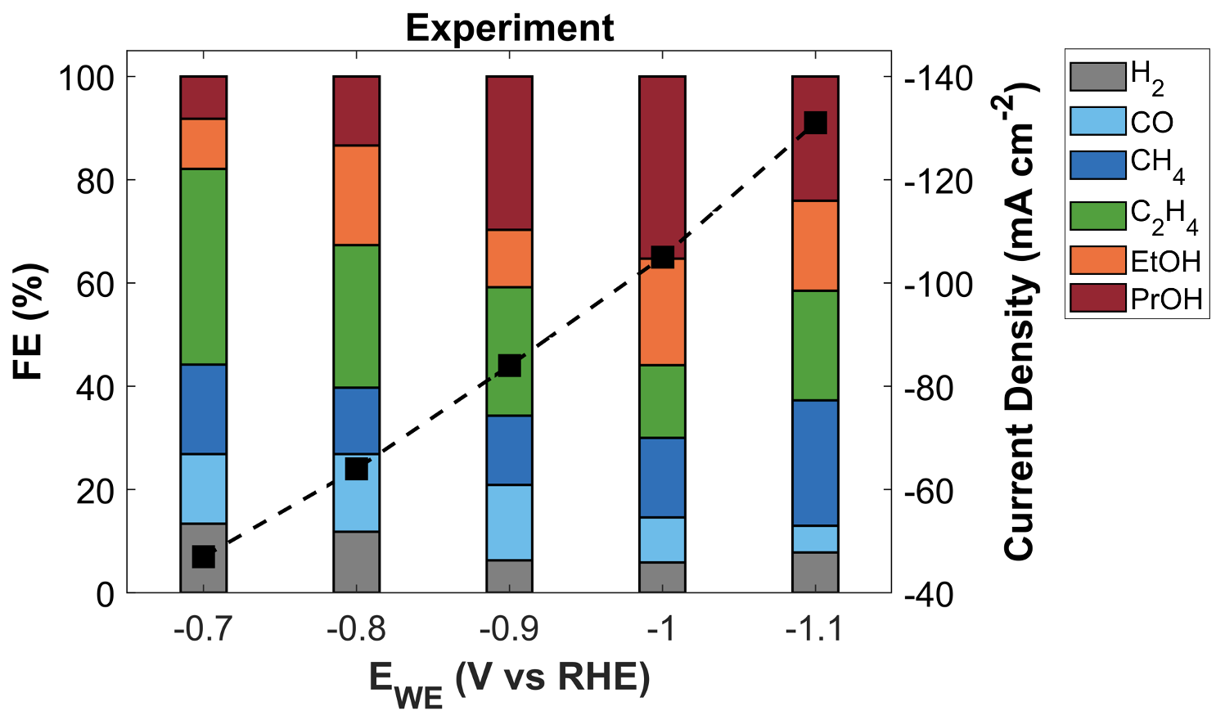
Figure S1 – Experimental faradic efficiency plot of CuAg_{0.5}Ce_{0.2} catalyst in a batch-cell with three-electrodes configuration.
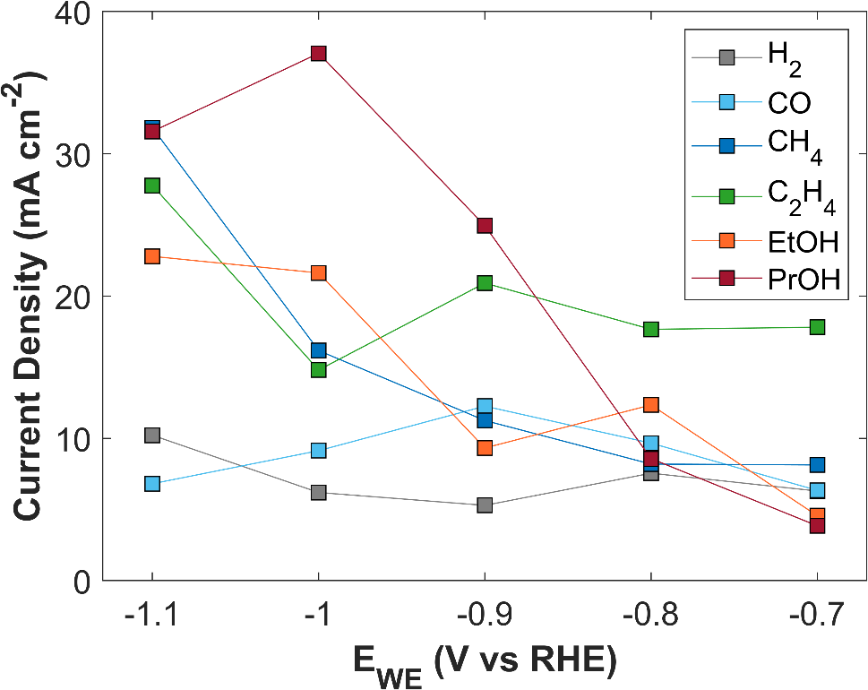
Figure S2 – Experimental partial current density plots of CuAg_{0.5}Ce_{0.2} catalyst in a batch-cell with three-electrodes configuration.

Table S1 – Experimental data of CuAg_{0.5}Ce_{0.2} catalyst in a three-electrode batch-cell.
TCD | E_{WE} | Faradic Efficiency (%)
(mA cm⁻²) | (V vs RHE) | H₂ | CO | CH₄ | C₂H₄ | EtOH | PrOH
-47 | -0.7 | 13.4 | 13.5 | 17.3 | 37.9 | 9.7 | 8.2
-64 | -0.8 | 11.8 | 15.1 | 12.8 | 27.6 | 19.3 | 13.4
-84 | -0.9 | 6.3 | 14.6 | 13.4 | 24.9 | 11.1 | 29.7
-105 | -1 | 5.9 | 8.7 | 15.4 | 14.1 | 20.6 | 35.3
-131 | -1.1 | 7.8 | 5.2 | 24.3 | 21.2 | 17.4 | 24.1

Electrode kinetics
The electrode kinetics or electrochemical reaction kinetics are modeled using concentration dependent Butler-Volmer (BV) equation. The BV equation used in this study is adopted from [5]. The BV equation describes both anodic half reaction, and cathodic half reaction.
 | $$i_{k}=A_{a,k}\exp\left(\frac{α_{a,k}F}{RT}η_{k}\right)-A_{c,k}\exp\left(-\frac{α_{c,k}F}{RT}η_{k}\right)$$ | S1
Since CO₂ is being reduced, and reduction reaction happens at cathode (working electrode), therefore, the second term in BV equation is considered.
 | $$i_{k}=-A_{c,k}\exp\left(-\frac{α_{c,k}F}{RT}η_{k}\right)$$ | S2
The BV equation reduces to Tafel equation that describes the conversion of dissolved CO₂ into products at a certain applied voltage. $α_{c,k}$ is the transfer coefficient, R is the universal gas constant, and T is the temperature of batch-cell. The pre-factor $A_{c,k}$ is defined as;
 | $$A_{c,k}=i_{0,k}{\left(\frac{c_{CO_{2}}}{c_{ref}}\right)}^{γ_{CO_{2},k}}\exp\left(-γ_{pH,k,RHE} pH\right)$$ | S3
$i_{0,k}$ is the exchange current density. $c_{CO_{2}}$ is the local CO₂ concentration, while $c_{ref}$ is the reference concentration of CO₂ in the bulk of an electrolyte. $γ_{CO_{2}}$ is the CO₂ reaction order parameter for each reaction/product. It is obtained through rigorous microkinetic modeling approach [5]. $γ_{pH,k,RHE}$ is the pH rate ordering parameter. It describes local pH relation with current density. The substitution of pre-factor in Tafel kinetic equation gives;
 | $$i_{k}=-i_{0,k}{\left(\frac{c_{CO_{2}}}{c_{ref}}\right)}^{γ_{CO_{2},k}}\exp\left(-γ_{pH,k,RHE} pH\right)\exp\left(-\frac{α_{c,k}F}{RT}η_{k}\right)$$ | S4
$η_{k}$ is the reaction overpotential term and it is defined as;
 | $$η_{k}=ϕ_{s}-ϕ_{l}-\left(E_{0,k}-\frac{2.303RT}{F}pH\right)$$ | S5
$ϕ_{s}$ is the potential applied to the working electrode, reported against RHE reference. $ϕ_{l}$ is the electrolyte potential at the surface of electrode. $E_{0,k}$ is the thermodynamic potential of reaction k measured against RHE reference. The last term converts the thermodynamic potential from RHE to the SHE scale. All potentials in this model are in SHE scale. SHE reference scale is pH dependent, and it has been observed in previous studies that product selectivity is sensitive to local pH [6], [7], [8], [9], [10]. The substitution of overpotential equation into Tafel kinetic provides;
$$i_{k}=-i_{0,k}{\left(\frac{c_{CO_{2}}}{c_{ref}}\right)}^{γ_{CO_{2},k}}\exp\left(-γ_{pH,k,RHE} pH\right)\exp\left[-\frac{α_{c,k}F}{RT}\left(ϕ_{s}-ϕ_{l}-\left(E_{0,k}-\frac{2.303RT}{F}pH\right)\right)\right]$$ | S6
This equation is further simplified by pulling out the last term in the exponent.
$$i_{k}=-i_{0,k}{\left(\frac{c_{CO_{2}}}{c_{ref}}\right)}^{γ_{CO_{2},k}}\exp\left(-γ_{pH,k,RHE} pH-α_{c,k}2.303pH\right)\exp\left[-\frac{α_{c,k}F}{RT}\left(ϕ_{s}-ϕ_{l}-E_{0,k}\right)\right]$$ | S7
Since all potentials are in SHE scale; therefore, it is indispensable to convert pH rate ordering parameter to SHE scale, as well.
 | $$γ_{pH,k,SHE}=γ_{pH,k,RHE}+α_{c}2.303$$ | S8
The final form of the Tafel kinetic equation used in the model is;
$$i_{k}=-i_{0,k}{\left(\frac{c_{CO_{2}}}{c_{ref}}\right)}^{γ_{CO_{2},k}}\exp\left(-γ_{pH,k,SHE} pH\right)\exp\left[-\frac{α_{c,k}F}{RT}\left(ϕ_{s}-ϕ_{l}-E_{0,k}\right)\right]$$ | S9

Kinetic parameters from experimental data
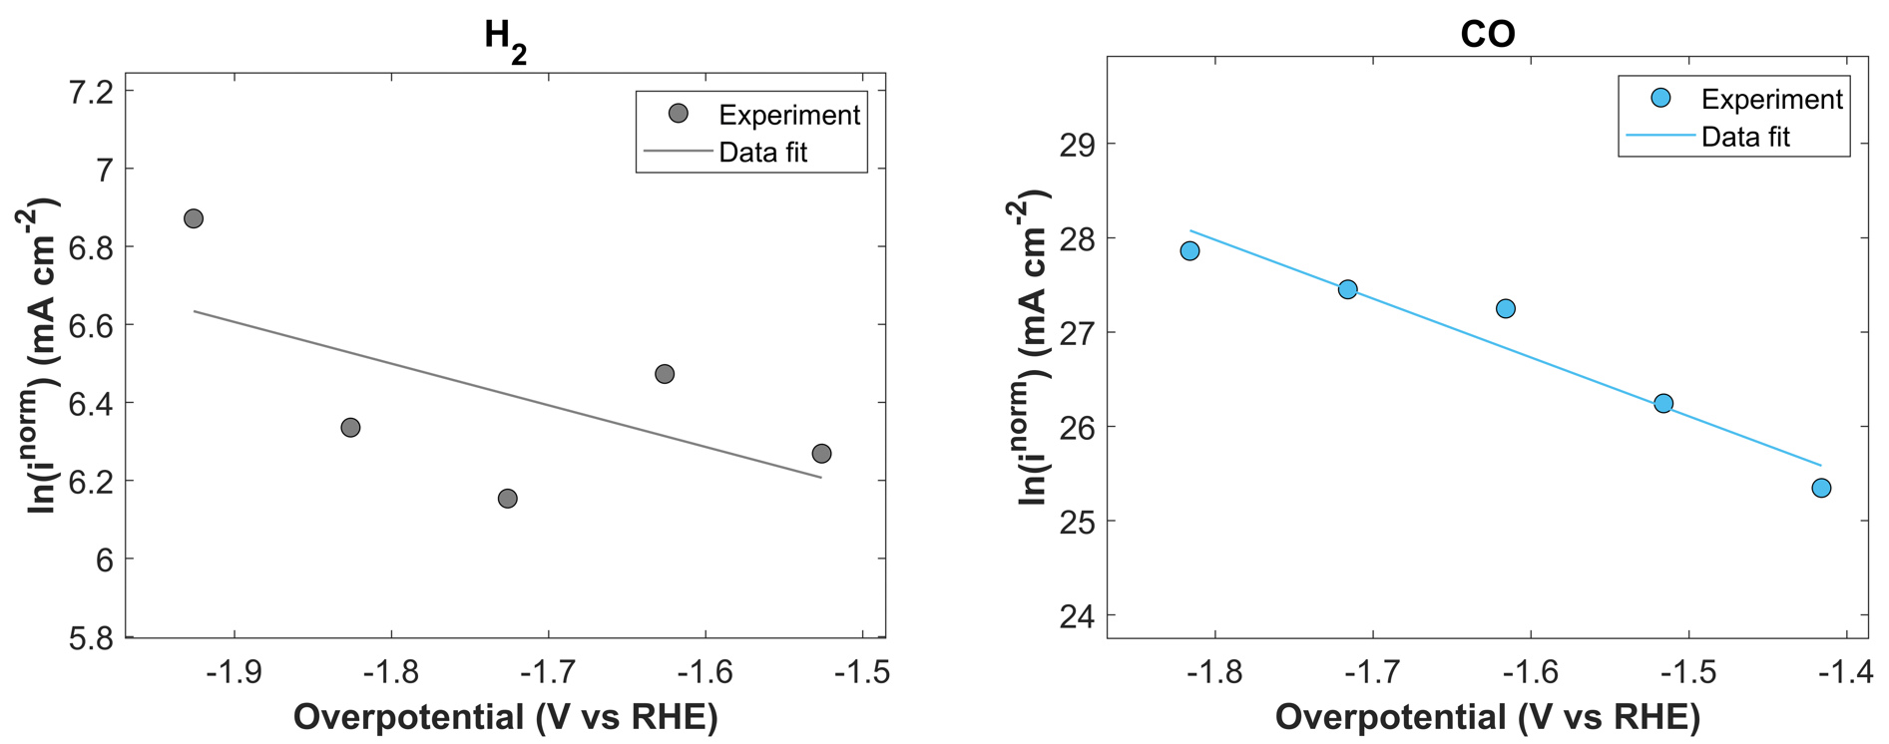
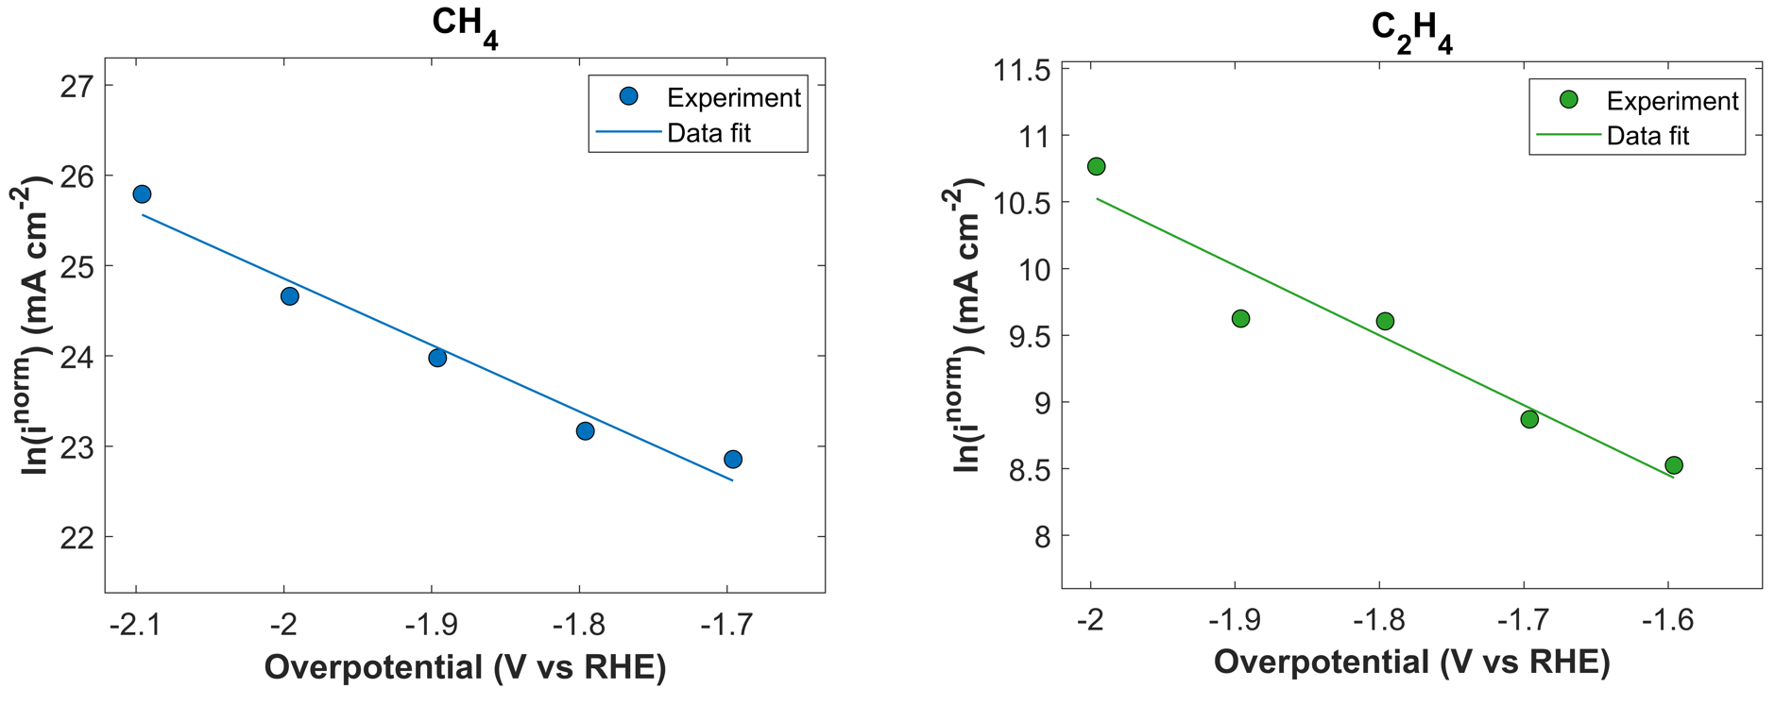
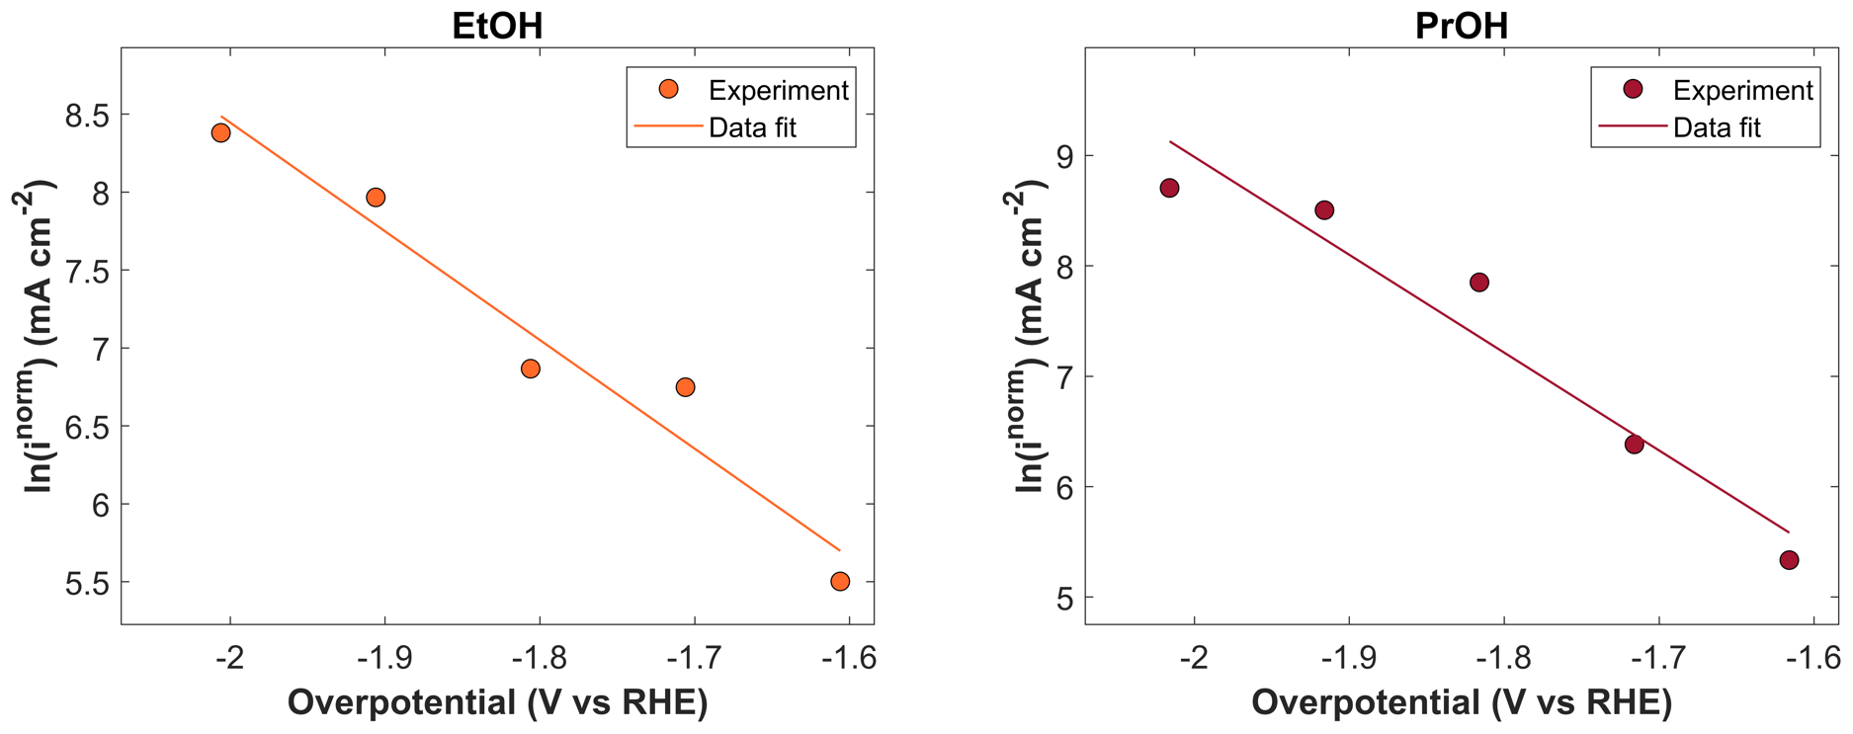
Figure S3 – CuAg_{0.5}Ce_{0.2} catalyst data fit plots for CO₂ reduction products

Kinetic model validation
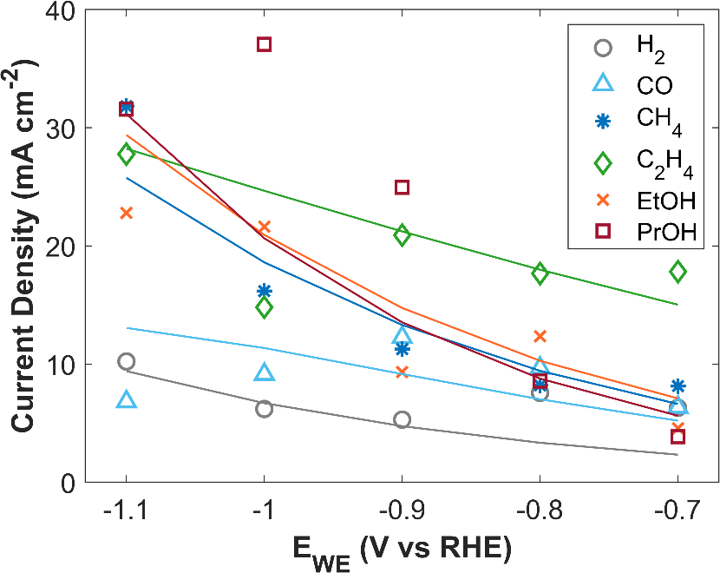
Figure S4 – Simulated partial current densities vs experimental partial current densities as a function of applied cathodic potential for CuAg_{0.5}Ce_{0.2} catalyst. Markers show the experimental data. Solid lines represent the simulation.
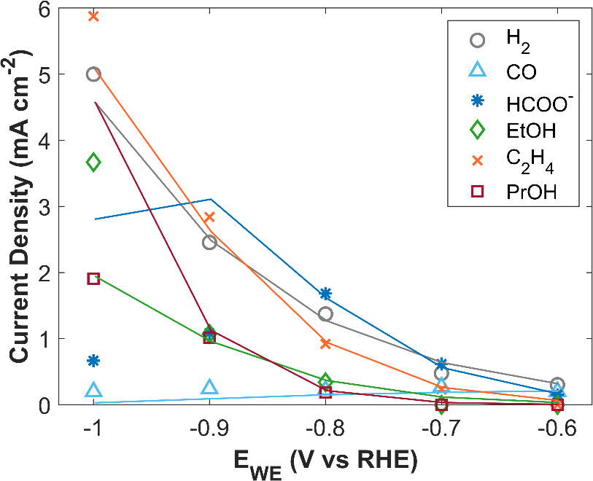
Figure S5 – Partial current density comparison as a function of applied cathodic potential for metallic Cu catalyst. Markers show the experimental data. Solid lines represent the simulation.

Table S2 – Electrochemical kinetic rate parameters for metallic Cu catalyst.
$$i_{0,h2}$$ | 9.76 $×$ 10⁻⁴ | mA cm⁻² | Fitted
$$i_{0,CO}$$ | 2.03 $×$ 10⁴ | mA cm⁻² | Fitted
$$i_{0,HCOO^{-}}$$ | 1.36 $×$ 10³ | mA cm⁻² | Fitted
$$i_{0,EtOH}$$ | 7.31 $×$ 10⁻⁷ | mA cm⁻² | Fitted
$$i_{0,C_{2}H_{4}}$$ | 2.31 $×$ 10⁻⁵ | mA cm⁻² | Fitted
$$i_{0,PrOH}$$ | 6.31 $×$ 10⁻⁷ | mA cm⁻² | Fitted
$$α_{H_{2}}$$ | 0.234 |  | Fitted
$$α_{CO}$$ | 0.207 |  | Fitted
$$α_{HCOO^{-}}$$ | 0.311 |  | Fitted
$$α_{EtOH}$$ | 0.329 |  | Fitted
$$α_{C_{2}H_{4}}$$ | 0.308 |  | Fitted
$$α_{PrOH}$$ | 0.321 |  | Fitted

References
[1] M. Esmaeilirad et al., “Oxygen Functionalized Copper Nanoparticles for Solar-Driven Conversion of Carbon Dioxide to Methane,” ACS Nano, vol. 14, no. 2, pp. 2099–2108, Feb. 2020, doi: 10.1021/acsnano.9b08792.
[2] M. Esmaeilirad et al., “Gold-like activity copper-like selectivity of heteroatomic transition metal carbides for electrocatalytic carbon dioxide reduction reaction,” Nat Commun, vol. 12, no. 1, p. 5067, Aug. 2021, doi: 10.1038/s41467-021-25295-y.
[3] M. Esmaeilirad et al., “Imidazolium-functionalized Mo3P nanoparticles with an ionomer coating for electrocatalytic reduction of CO2 to propane,” Nat Energy, vol. 8, no. 8, pp. 891–900, Aug. 2023, doi: 10.1038/s41560-023-01314-8.
[4] M. Esmaeilirad et al., “Efficient electrocatalytic conversion of CO2 to ethanol enabled by imidazolium-functionalized ionomer confined molybdenum phosphide,” Appl Catal B, vol. 317, p. 121681, Nov. 2022, doi: 10.1016/j.apcatb.2022.121681.
[5] J. C. Bui, C. Kim, A. Z. Weber, and A. T. Bell, “Dynamic Boundary Layer Simulation of Pulsed CO2Electrolysis on a Copper Catalyst,” ACS Energy Lett, vol. 6, no. 4, pp. 1181–1188, Apr. 2021, doi: 10.1021/ACSENERGYLETT.1C00364/ASSET/IMAGES/LARGE/NZ1C00364_0004.JPEG.
[6] Z. Zhang, L. Melo, R. P. Jansonius, F. Habibzadeh, E. R. Grant, and C. P. Berlinguette, “pH Matters When Reducing CO2in an Electrochemical Flow Cell,” ACS Energy Lett, vol. 5, no. 10, pp. 3101–3107, Oct. 2020, doi: 10.1021/ACSENERGYLETT.0C01606/ASSET/IMAGES/LARGE/NZ0C01606_0005.JPEG.
[7] A. Böhme et al., “Direct observation of the local microenvironment in inhomogeneous CO2 reduction gas diffusion electrodes via versatile pOH imaging,” Energy Environ Sci, vol. 16, no. 4, pp. 1783–1795, Apr. 2023, doi: 10.1039/D2EE02607D.
[8] M. Schatz, J. F. Kochs, S. Jovanovic, R.-A. Eichel, and J. Granwehr, “Interplay of Local pH and Cation Hydrolysis during Electrochemical CO2 Reduction Visualized by In Operando Chemical Shift-Resolved Magnetic Resonance Imaging,” The Journal of Physical Chemistry C, pp. 127–18986, Sep. 2023, doi: 10.1021/ACS.JPCC.3C03563.
[9] D. T. Whipple, E. C. Finke, and P. J. A. Kenis, “Microfluidic reactor for the electrochemical reduction of carbon dioxide: The effect of pH,” Electrochemical and Solid-State Letters, vol. 13, no. 9, p. B109, Jun. 2010, doi: 10.1149/1.3456590/XML.
[10] D. A. Henckel et al., “Potential Dependence of the Local pH in a CO2 Reduction Electrolyzer,” ACS Catal, vol. 11, no. 1, pp. 255–263, Jan. 2021, doi: 10.1021/ACSCATAL.0C04297/SUPPL_FILE/CS0C04297_SI_001.PDF.

