Deep learning-assisted mapping of wetland dynamics in the Niger Delta using open-access multi-sensor remote sensing data
Alex O. Onojeghuo ^{1, *}, Christopher E. Ndehedehe ^{2,3} and Ajoke R. Onojeghuo ¹
¹ Jolexy Environmental Research, Edmonton, Alberta, Canada; alex.onojeghuo@jolexyenviro.com
² School of Environment & Science, Griffith University, Nathan, QLD 4111, Australia.
³ Australian Rivers Institute, Griffith University, Nathan, QLD 4111, Australia.

Supplementary Information
Graphical Abstract
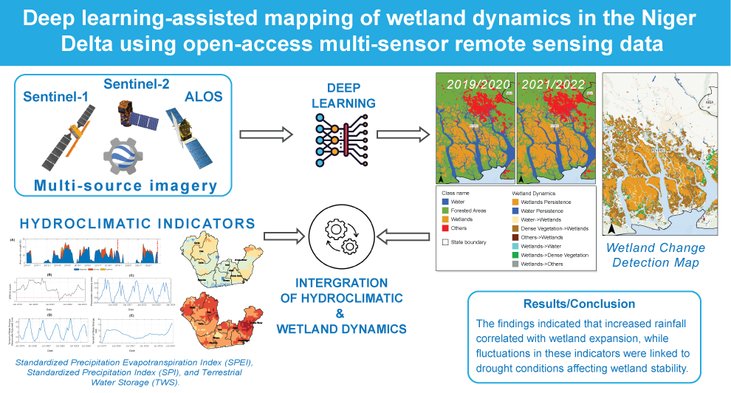

Appendix S.1

A list of Google Earth engine codes was generated in the study.
Sentinel-1 multi-date image collection:
- 2019/2020: https://code.earthengine.google.com/1f1ea84aaf0692b2f486a994b1a1b3e0
- 2021/2022: https://code.earthengine.google.com/0de3ed427f08015b4b05262f83678c74

Sentinel-2 multi-date image collection:
- 2019/2020: https://code.earthengine.google.com/a928f73ad2c99a80ceca8fe4298080b4
- 2021/2022: https://code.earthengine.google.com/6418b969ecc3d3efb98c44a0a48db576

Global Precipitation Measurements precipitation data:
- https://code.earthengine.google.com/efa4bf25beb39f40aff2d9161a18b2ae

Figure S1. Map showing the spatial distribution of reference data points used to perform the random forest classifications with the Google Earth Engine classification algorithm.
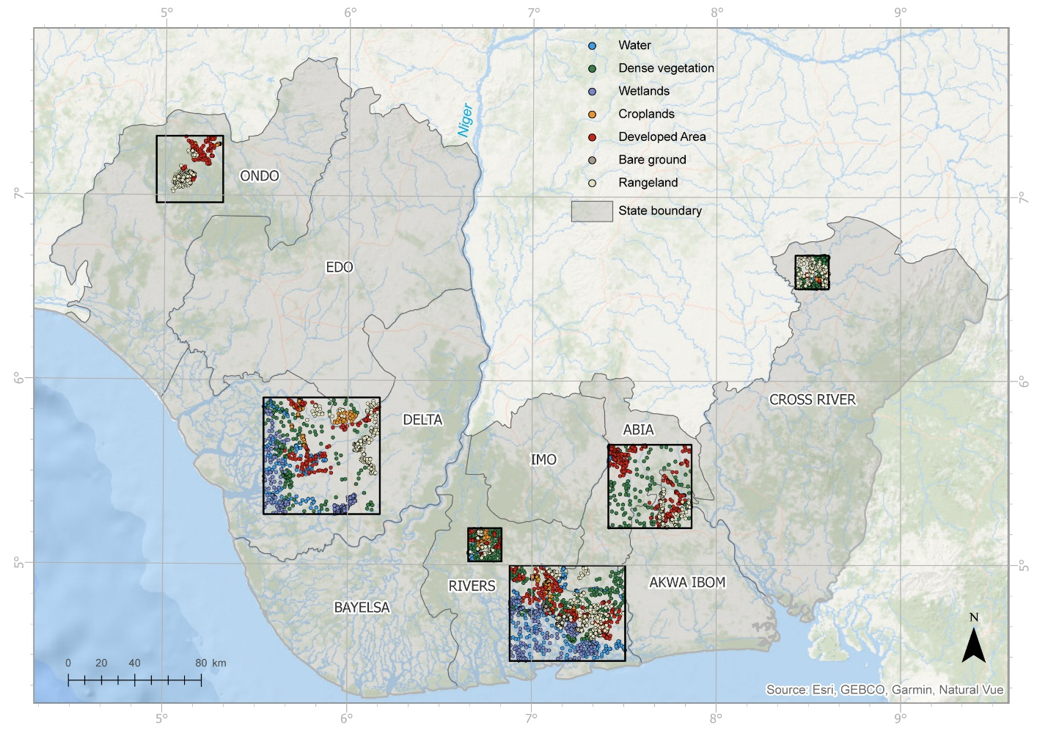

Figure S2. Map showing the spatial distribution of reference data extent used to perform the Res-UNet and DeepLabV3 segmentation models for 2019/2020
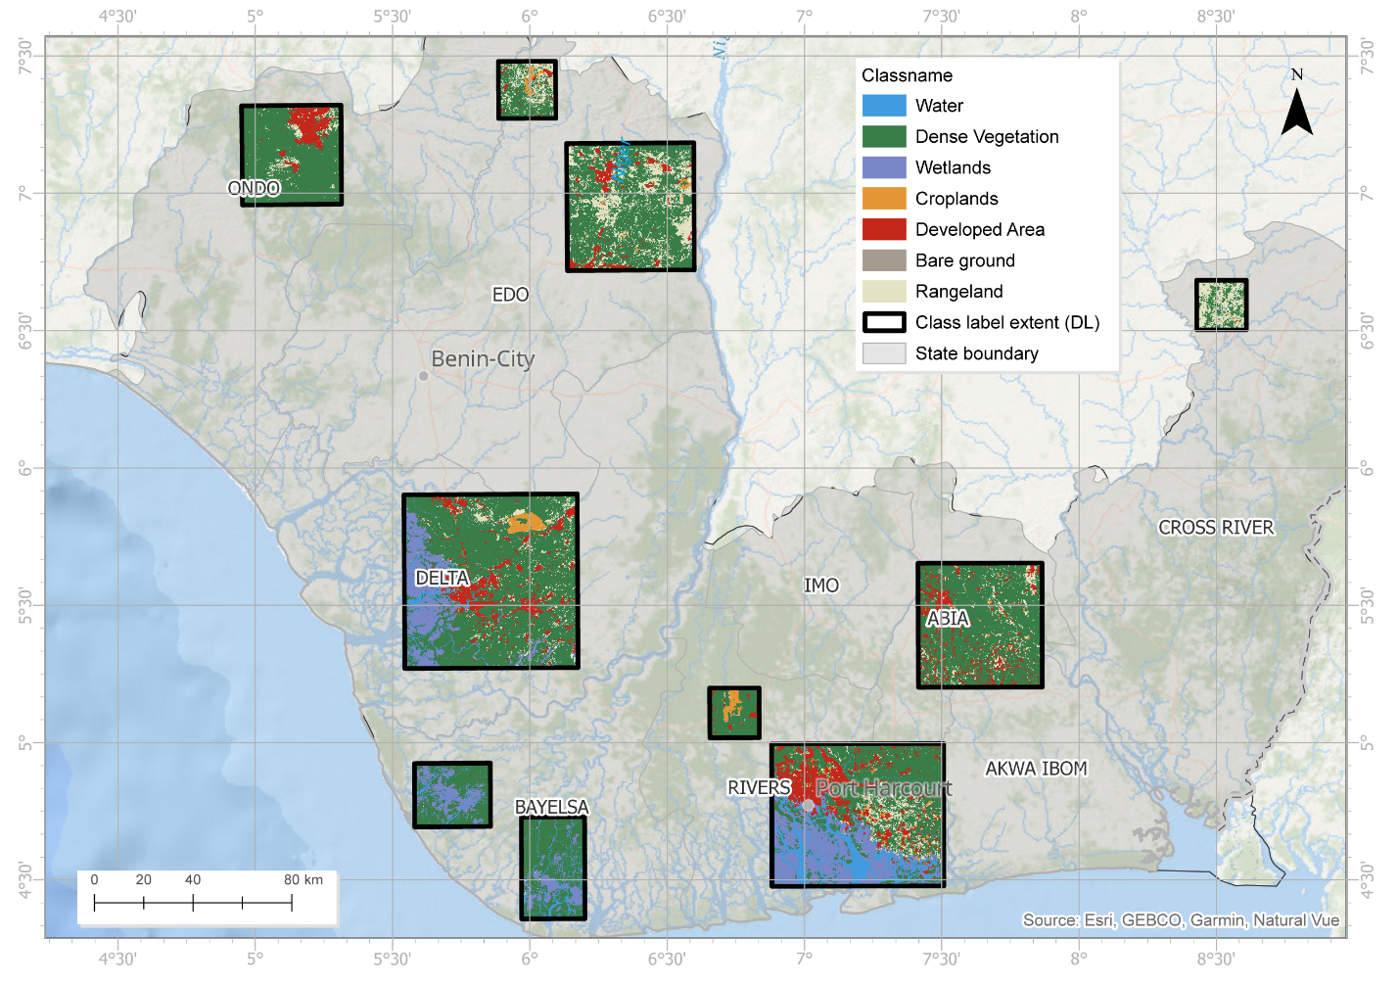
Figure S3. Map showing the spatial distribution of reference data extent used to perform the Res-UNet and DeepLabV3 segmentation models for 2021/2022
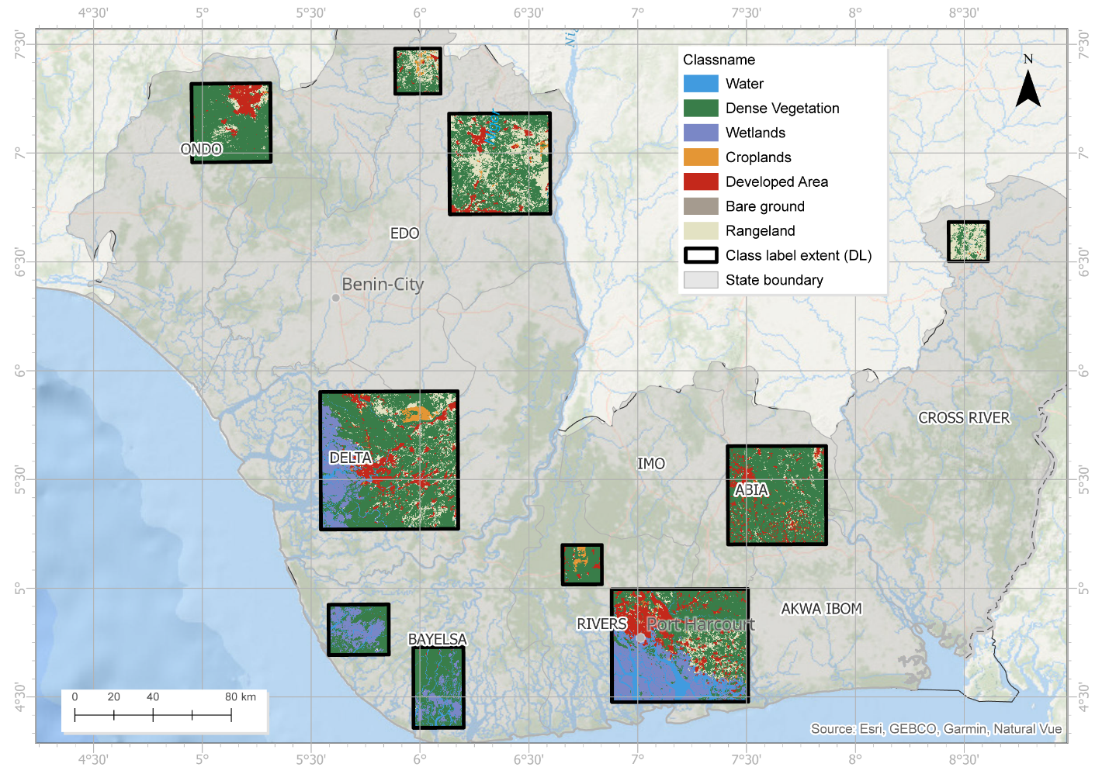
Table S1.
Summary statistics of exported training data used in Res-UNet and DeepLabV3 segmentation models simulations for 2019/2020 and 2021/2022.
Class name | Class value | Images # | Features # | Min size  (m²) | Mean size  (m²) | Max size  (m²)
Water | 1 | 4,445 | 21,607 | 13 | 143,607 | 6,553,600
Dense Vegetation | 2 | 9,954 | 143,101 | 13 | 303,034 | 6,553,600
Wetlands | 3 | 3,330 | 78,601 | 13 | 86,736 | 6,553,045
Croplands | 4 | 3,665 | 43,404 | 13 | 25,887 | 6,553,600
Developed Area | 5 | 6,194 | 28,313 | 13 | 240,221 | 6,553,600
Bare ground | 6 | 870 | 2,651 | 33 | 10,639 | 1,152,800
Rangeland | 7 | 8,259 | 168,736 | 13 | 38,856 | 6,553,561
 | Total: | 36,717 | 486,413
Period = 2019/2020
Images = 10090 *10*256*256 (Total no. of images * Pixel size * Tile X * Tile Y)
Class feature statistics:
Features = 486413
Features per image = [min = 1, mean = 48.21, max = 311]

Class name | Class value | Images # | Features # | Min size  (m²) | Mean size  (m²) | Max size  (m²)
Water | 1 | 4,332 | 21,970 | 13 | 140,308 | 6,553,600
Dense Vegetation | 2 | 9,862 | 159,874 | 13 | 254,213 | 6,553,600
Wetlands | 3 | 3,079 | 71,594 | 13 | 105,426 | 6,553,539
Croplands | 4 | 3,637 | 47,280 | 13 | 20,793 | 6,553,600
Developed Area | 5 | 6,239 | 31,405 | 13 | 230,945 | 6,553,600
Bare ground | 6 | 2,264 | 16,154 | 13 | 4,071 | 1,298,800
Rangeland | 7 | 8,315 | 180,181 | 13 | 46,219 | 6,553,600
 | Total: | 36,717 | 486,413
Period = 2021/2022
Images = 10090 *10*256*256 (Total no. of images * Pixel size * Tile X * Tile Y)
Class feature statistics:
Features = 528458
Features per image = [min = 1, mean = 52.37, max = 348]

Figure S4. Training and validation loss graph for deep learning simulations applied to the 2019/2020 multi-date and multi-source image dataset.
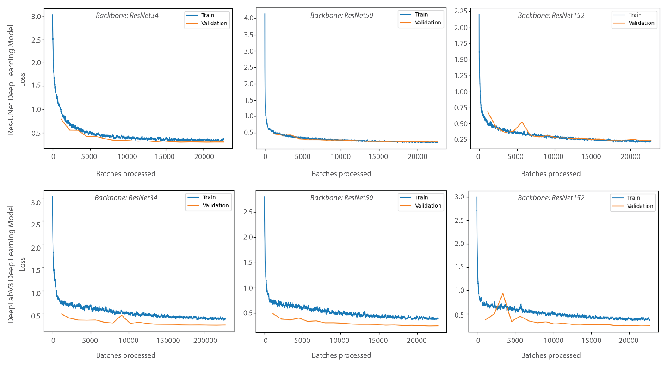

Figure S5. Training and validation loss graph for deep learning simulations applied to the 2021/2022 multi-date and multi-source image dataset.
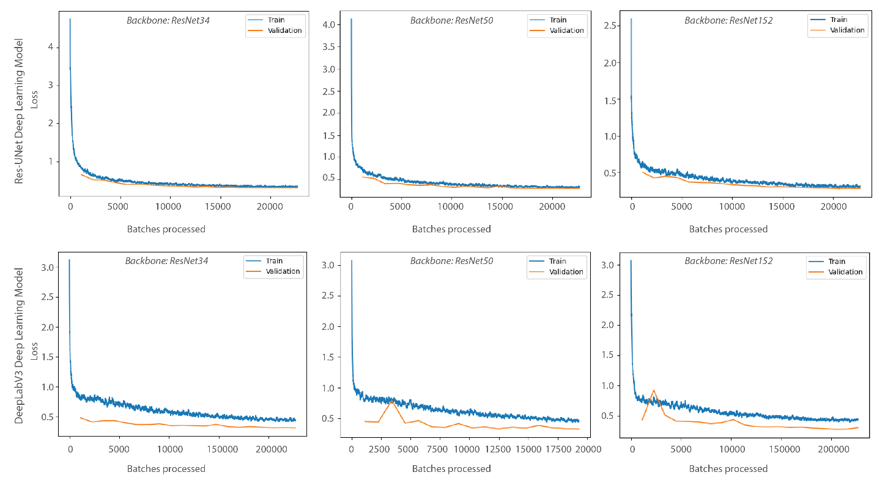

Table S.2. Per-class metrics results of Res-UNet and DeepLabV3 models for 2019/2020. Where WA=Water, DV=Dense vegetation, WT=Wetland, CR=Croplands, DA=Developed Area, BG=Bare ground, and RAN=Rangeland
Model: Res-UNet (ResNet34 backbone) | 2019/2020 |  |  |  |  |  |  |  |  | Model: DeepLabV3 (ResNet34 backbone) | 2019/2020
Class name | WA | DV | WT | CR | DA | BG | RAN |  | Class name | WA | DV | WT | CR | DA | BG | RAN
Precision | 0.929 | 0.899 | 0.876 | 0.798 | 0.884 | 0.849 | 0.752 |  | Precision | 0.929 | 0.911 | 0.873 | 0.802 | 0.928 | 0.612 | 0.786
Recall | 0.925 | 0.949 | 0.743 | 0.525 | 0.932 | 0.388 | 0.598 |  | Recall | 0.915 | 0.960 | 0.821 | 0.553 | 0.914 | 0.608 | 0.623
F1 | 0.927 | 0.924 | 0.804 | 0.634 | 0.908 | 0.533 | 0.666 |  | F1 | 0.922 | 0.935 | 0.846 | 0.655 | 0.921 | 0.610 | 0.695
F1 Mean | 0.771 |  |  |  |  |  |  |  | F1 Mean | 0.798
IoU | 0.876 |  |  |  |  |  |  |  | IoU | 0.899
Model: Res-UNet (ResNet50 backbone) | 2019/2020 |  |  |  |  |  |  |  |  | Model: DeepLabV3 (ResNet50 backbone) | 2019/2020
Class name | WA | DV | WT | CR | DA | BG | RAN |  | Class name | WA | DV | WT | CR | DA | BG | RAN
Precision | 0.955 | 0.927 | 0.873 | 0.816 | 0.936 | 0.769 | 0.768 |  | Precision | 0.931 | 0.915 | 0.883 | 0.858 | 0.932 | 0.750 | 0.779
Recall | 0.939 | 0.954 | 0.856 | 0.604 | 0.928 | 0.679 | 0.688 |  | Recall | 0.925 | 0.959 | 0.816 | 0.564 | 0.921 | 0.548 | 0.652
F1 | 0.947 | 0.941 | 0.864 | 0.694 | 0.932 | 0.722 | 0.726 |  | F1 | 0.928 | 0.937 | 0.848 | 0.680 | 0.927 | 0.633 | 0.710
F1 Mean | 0.832 |  |  |  |  |  |  |  | F1 Mean | 0.809
IoU | 0.909 |  |  |  |  |  |  |  | IoU | 0.902
Model: Res-UNet (ResNet152 backbone) | 2019/2020 |  |  |  |  |  |  |  |  | Model: DeepLabV3 (ResNet152 backbone) | 2019/2020
Class name | WA | DV | WT | CR | DA | BG | RAN |  | Class name | WA | DV | WT | CR | DA | BG | RAN
Precision | 0.958 | 0.926 | 0.867 | 0.788 | 0.935 | 0.790 | 0.773 |  | Precision | 0.933 | 0.918 | 0.879 | 0.802 | 0.926 | 0.698 | 0.774
Recall | 0.941 | 0.954 | 0.863 | 0.608 | 0.929 | 0.672 | 0.675 |  | Recall | 0.924 | 0.957 | 0.839 | 0.534 | 0.918 | 0.595 | 0.655
F1 | 0.949 | 0.940 | 0.865 | 0.687 | 0.932 | 0.726 | 0.721 |  | F1 | 0.928 | 0.937 | 0.859 | 0.642 | 0.922 | 0.642 | 0.710
F1 Mean | 0.831 |  |  |  |  |  |  |  | F1 Mean | 0.806
IoU | 0.908 |  |  |  |  |  |  |  | IoU | 0.908

Table S.3.
Per class metrics results of Res-UNet and DeepLabV3 models for 2021/2022. Where WA=Water, DV=Dense vegetation, WT=Wetland, CR=Croplands, DA=Developed Area, BG=Bare ground, and RAN=Rangeland
Model: Res-UNet (ResNet34 backbone) | 2021/2022 |  |  |  |  |  |  |  |  | Model: DeepLabV3 (ResNet34 backbone) | 2021/2022
Class name | WA | FA | WT | CR | DA | BG | RAN |  | Class name | WA | FA | WT | CR | DA | BG | RAN
Precision | 0.920 | 0.889 | 0.872 | 0.684 | 0.902 | 0.751 | 0.768 |  | Precision | 0.933 | 0.900 | 0.868 | 0.514 | 0.922 | 0.760 | 0.772
Recall | 0.923 | 0.936 | 0.831 | 0.540 | 0.912 | 0.173 | 0.616 |  | Recall | 0.900 | 0.933 | 0.876 | 0.597 | 0.895 | 0.215 | 0.649
F1 | 0.922 | 0.912 | 0.851 | 0.603 | 0.907 | 0.281 | 0.684 |  | F1 | 0.916 | 0.916 | 0.872 | 0.553 | 0.908 | 0.335 | 0.705
F1 Mean | 0.737 |  |  |  |  |  |  |  | F1 Mean | 0.744
IoU | 0.896 |  |  |  |  |  |  |  | IoU | 0.881
Model: Res-UNet (ResNet50 backbone) | 2021/2022 |  |  |  |  |  |  |  |  | Model: DeepLabV3 (ResNet50 backbone) | 2021/2022
Class name | WA | DV | WT | CR | DA | BG | RAN |  | Class name | WA | DV | WT | CR | DA | BG | RAN
Precision | 0.938 | 0.899 | 0.846 | 0.721 | 0.937 | 0.741 | 0.758 |  | Precision | 0.923 | 0.880 | 0.891 | 0.633 | 0.915 | 1.000 | 0.794
Recall | 0.921 | 0.933 | 0.890 | 0.554 | 0.892 | 0.245 | 0.648 |  | Recall | 0.898 | 0.948 | 0.813 | 0.549 | 0.890 | 0.003 | 0.597
F1 | 0.929 | 0.916 | 0.867 | 0.626 | 0.914 | 0.369 | 0.699 |  | F1 | 0.910 | 0.913 | 0.850 | 0.588 | 0.902 | 0.006 | 0.682
F1 Mean | 0.760 |  |  |  |  |  |  |  | F1 Mean | 0.693
IoU | 0.882 |  |  |  |  |  |  |  | IoU | 0.878
Model: Res-UNet (ResNet152 backbone) | 2021/2022 |  |  |  |  |  |  |  |  | Model: DeepLabV3 (ResNet152 backbone) | 2019/2020
Class name | WA | DV | WT | CR | DA | BG | RAN |  | Class name | WA | DV | WT | CR | DA | BG | RAN
Precision | 0.944 | 0.905 | 0.868 | 0.749 | 0.913 | 0.750 | 0.764 |  | Precision | 0.928 | 0.898 | 0.874 | 0.701 | 0.921 | 0.667 | 0.808
Recall | 0.917 | 0.935 | 0.872 | 0.525 | 0.928 | 0.256 | 0.665 |  | Recall | 0.912 | 0.946 | 0.881 | 0.586 | 0.912 | 0.259 | 0.627
F1 | 0.931 | 0.920 | 0.870 | 0.617 | 0.920 | 0.382 | 0.711 |  | F1 | 0.920 | 0.921 | 0.878 | 0.638 | 0.916 | 0.373 | 0.706
F1 Mean | 0.764 |  |  |  |  |  |  |  | F1 Mean | 0.765
IoU | 0.886 |  |  |  |  |  |  |  | IoU | 0.888

Figure S7. Spatial distribution of sample points used to evaluate the accuracy of the optimal Res-UNet152 DL model and Random Forest prediction for both years (2019/20 and 2021/22).
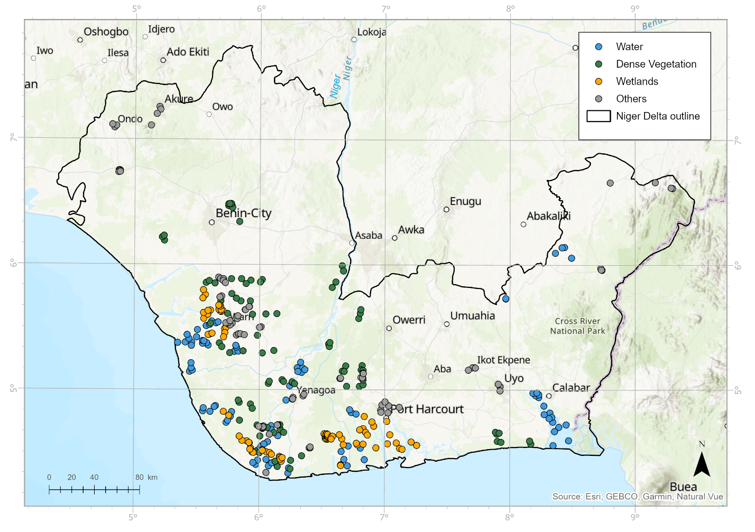
Figure S8. Res-UNet segmentation maps for 2019/2020 and 2021/2022 generated using the backbones: ResNet34 (a and b), ResNet50 (c and d), and ResNet152 (e and f).
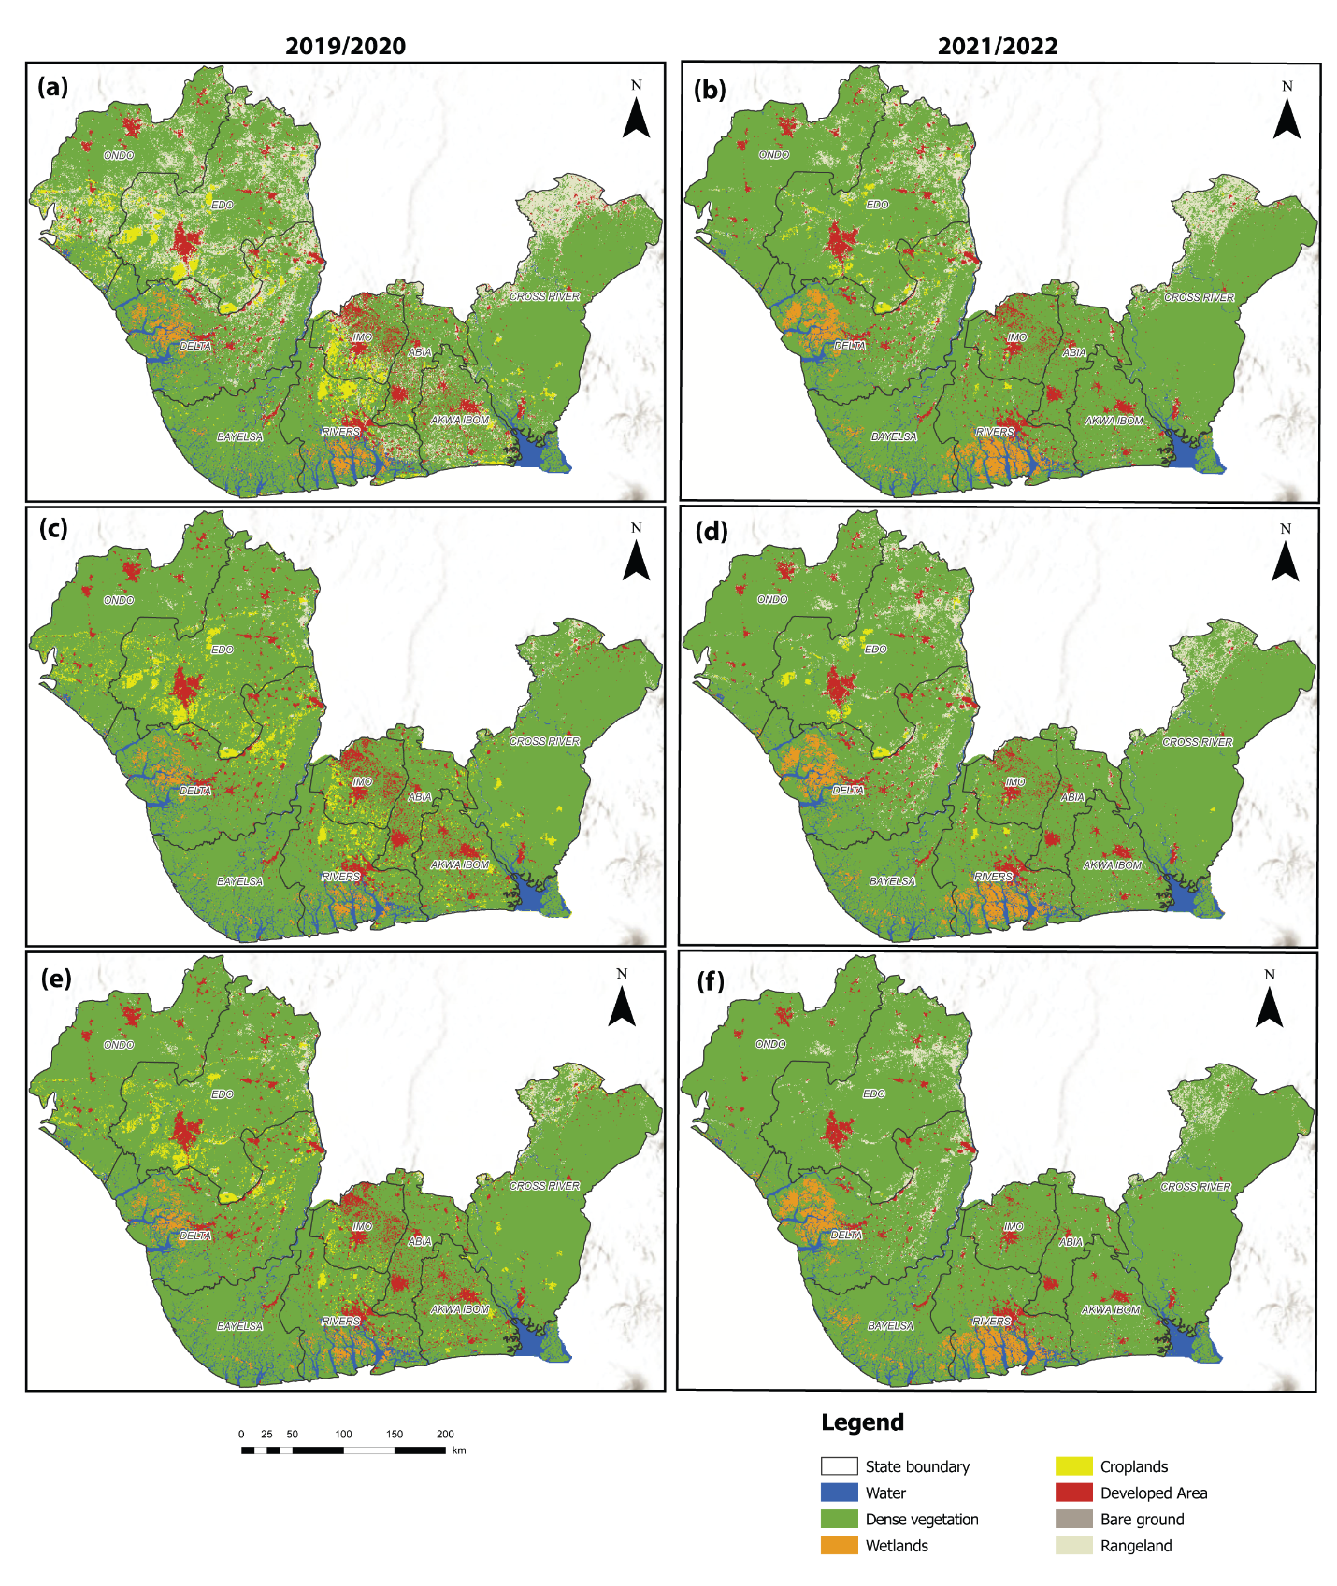

Figure S9. DeepLabV3 segmentation maps for 2019/2020 and 2021/2022 generated using the backbones: ResNet34 (a and b), ResNet50 (c and d), and ResNet152 (e and f).
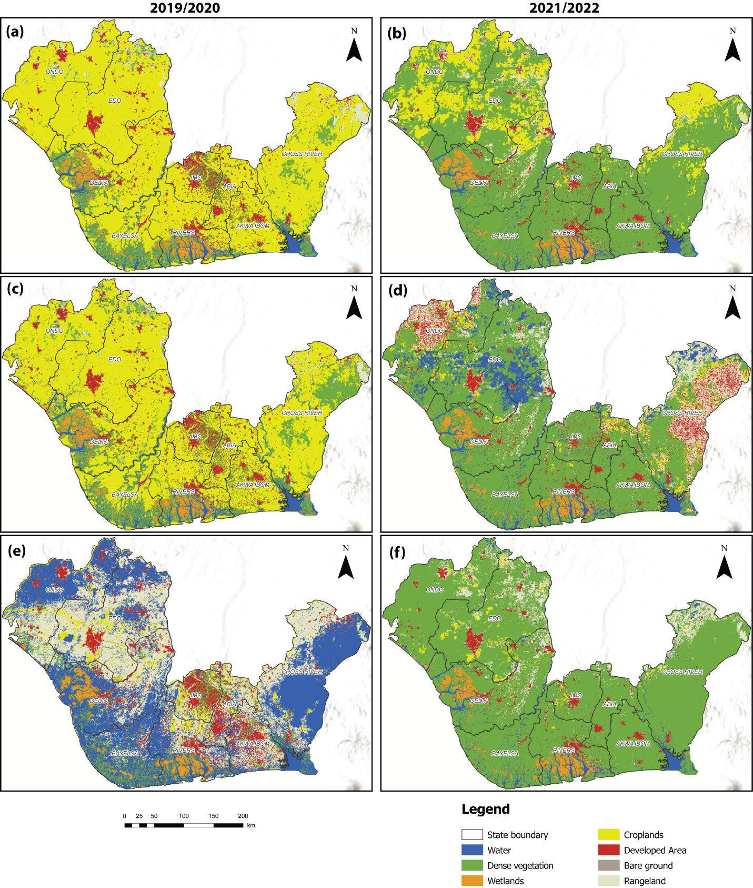

Figure S10. Map showing the random forest land use and land cover maps generated using the Google Earth Engine classification algorithm for 2019/2020 and 2021/2022.
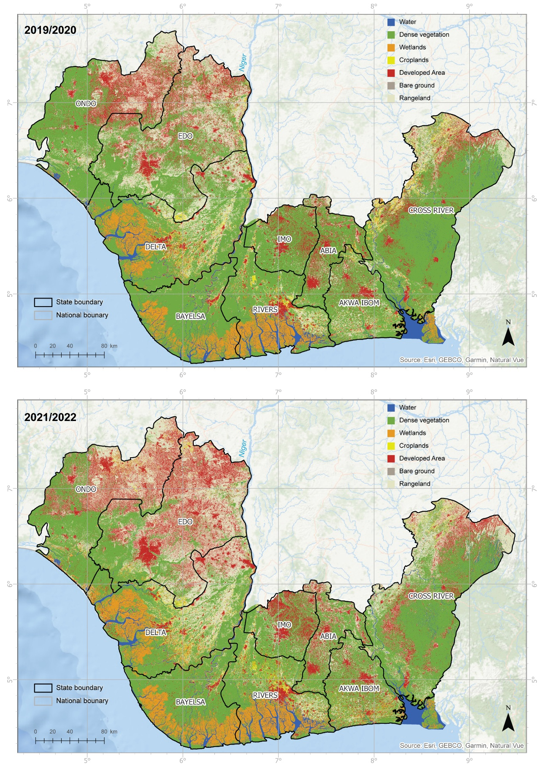

Table S4. Error matrix used to calculate accuracy measures for the optimal deep learning model (Res-UNet154) and random forest for 2019/20 and 2021/22. Where UA=User’s Accuracy, PA=Producer’s Accuracy, OA=Overall Accuracy, OK=Overall Kappa, WA=Water, DV=Dense vegetation Areas, WT=Wetland, and OC=Other classes (i.e. croplands, developed area, bare ground and rangeland).
Random Forest - 2019/2020 |  |  |  |  |  |  |  | Res-UNet152 - 2019/2020
 | Training Set Data |  |  |  |  |  |  |  | Training Set Data
Class | WA | DV | WT | OC | Row Total | UA (%) |  | Class | WA | DV | WT | OC | Row Total | UA (%)
WA | 200 | 0 | 27 | 0 | 227 | 88.1 |  | WA | 200 | 0 | 1 | 0 | 201 | 99.5
DV | 0 | 173 | 4 | 0 | 177 | 97.7 |  | DV | 0 | 200 | 2 | 21 | 223 | 89.7
WT | 0 | 18 | 169 | 0 | 187 | 90.4 |  | WT | 0 | 0 | 197 | 2 | 199 | 99
OC | 0 | 9 | 0 | 200 | 209 | 95.7 |  | OC | 0 | 0 | 0 | 177 | 177 | 100
Column  Total | 200 | 200 | 200 | 200 | 800 |  |  | Column  Total | 200 | 200 | 200 | 200 | 800
PA (%) | 100 | 87 | 85 | 100 |  |  |  | PA (%) | 100 | 100 | 99 | 89
F1-Score | 0.94 | 0.92 | 0.87 | 0.98 |  |  |  | F1-Score | 1 | 0.95 | 0.99 | 0.94
OA (%) | 90.3 |  |  |  |  |  |  | OA (%) | 97
OK | 0.90 |  |  |  |  |  |  | OK | 0.96
Random Forest - 2021/2022 |  |  |  |  |  |  |  | Res-UNet152 - 2021/2022
 | Training Set Data |  |  |  |  |  |  |  | Training Set Data
Class | WA | DV | WT | OC | Row Total | UA (%) |  | Class | WA | DV | WT | OC | Row Total | UA (%)
WA | 200 | 0 | 27 | 4 | 231 | 86.6 |  | WA | 200 | 0 | 0 | 0 | 200 | 100
DV | 0 | 165 | 5 | 1 | 171 | 96.5 |  | DV | 0 | 200 | 6 | 12 | 218 | 91.7
WT | 0 | 20 | 168 | 2 | 190 | 88.4 |  | WT | 0 | 0 | 194 | 0 | 194 | 100
OC | 0 | 15 | 0 | 193 | 208 | 92.8 |  | OC | 0 | 0 | 0 | 188 | 188 | 100
Column  Total | 200 | 200 | 200 | 200 | 800 |  |  | Column  Total | 200 | 200 | 200 | 200 | 800
PA (%) | 93 | 89 | 86 | 97 |  |  |  | PA (%) | 100 | 100 | 97 | 94
F1-Score | 0.93 | 0.89 | 0.86 | 0.95 |  |  |  | F1-Score | 1.00 | 0.96 | 0.98 | 0.97
OA (%) | 91 |  |  |  |  |  |  | OA (%) | 98
OK | 0.88 |  |  |  |  |  |  | OK | 0.97

