Supplemental data

Table S1: Elemental composition of the surface of C-D and Cu-D samples upon analysis with EDS, ICP-OES. ∅ indicates that the element was not detected.
 |  | EDS |  | ICP-OES
 | Element | Atomic concentration (%) | Weight concentration (%) | Concentration (mg/ml)
C-D | O | 58.8 | 35.7 | ∅
C-D | Al | 4.8 | 4.9 | 0.61
C-D | Si | 9.2 | 9.8 | 1.51
C-D | Ti | 25.7 | 47.0 | 9.97
C-D | V | 1.3 | 2.6 | 0.71
C-D | Cu | ∅ | ∅ | ∅
C-D | Fe | ∅ | ∅ | 0.091
C-D | Ca | ∅ | ∅ | 0.0047
C-D | Na | ∅ | ∅ | 0.10
Cu-D | O | 51.2 | 27.4 | ∅
Cu-D | Al | 4.0 | 3.6 | 0.50
Cu-D | Si | 13.3 | 12.5 | 1.70
Cu-D | Ti | 19.5 | 31.2 | 8.18
Cu-D | V | 0.9 | 1.6 | 0.73
Cu-D | Cu | 10.9 | 23.1 | 12.64
Cu-D | Fe | ∅ | ∅ | 0.11
Cu-D | Ca | ∅ | ∅ | 0.085
Cu-D | Na | ∅ | ∅ | 0.16

Table S2: Elemental composition of C-D and Cu-D obtained with XPS analysis. ∅ indicates that the element was not detected.
 | Elements | O 1s | C 1s | Na 1s | Ti 2p | Si 2p | Cu 2p | Al 2p
Atomic conc. (%) | C-D | 50.5±0.5 | 22.5±0.2 | 1.5±0.1 | 5.5±0.2 | 19.9±0.3 | ∅ | ∅
Atomic conc. (%) | Cu-D | 32.9±0.5 | 31.5±1.5 | 1.0±0.1 | 1.5±0.1 | 12.5±0.2 | 1.1±0.2 | 1.9±1.1

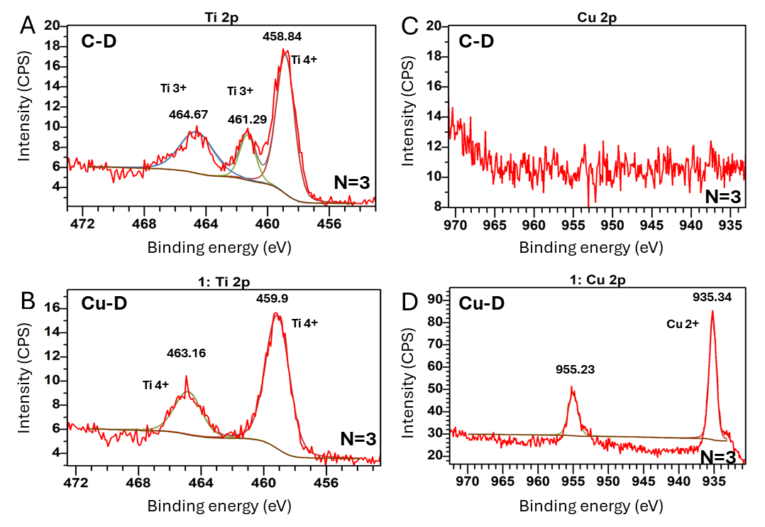
Figure S1: Detailed XPS results including: (A) High resolution spectrum of Ti 2p for C-D group, (B) High resolution spectrum of Cu 2p for C-D group, (C) High resolution spectrum of Ti 2p for Cu-D group, (D) High resolution spectrum of Cu 2p for Cu-D group.

