Complementary characterization and selective synthesis of cyclic and dimeric analogues of the antimicrobial peptide Cm-p5.
Fidel E. Morales-Vicente, ¹ Luis A. Espinosa,² Erbio Díaz-Pico,¹ Ernesto M. Martell,³ Melaine Gonzalez,³ Gerardo Ojeda,¹ Luis Javier González,² ArmandoRodríguez,⁴ Hilda E. Garay,¹ Anselmo J. Otero-González^{3,} * Frank Rosenau,^{4,} * and Ludger Staendker^{6,}*
¹ Synthetic Peptide Group, Physics and Chemistry Department, Center for Genetic Engineering and Biotechnology, P.O. Box 6162, 10600 La Habana, Cuba.
² Mass Spectrometry Laboratory, Systems Biology Department, Center for Genetic Engineering and Biotechnology, P.O. Box 6162, 10600 La Habana, Cuba.
³ Center for Protein Studies, Faculty of Biology, University of Havana, 25 Str. and I Str., 10400, La Habana, Cuba.
⁴ Core Facility for Functional Peptidomics, Faculty of Medicine, Ulm University, 89081 Ulm, Germany
⁵ Core Facility for Functional Peptidomimetics, Ulm Peptide Pharmaceuticals (U-PEP), University Ulm, Faculty of Medicine, Ulm University 89081 Ulm, Germany.
* Correspondence: ludger.staendker@uni-ulm.de; Tel.: +49 (0)731-500 65171 (L.S.)
Table of Contents:
SD1. Differentiating cyclic parallel and antiparallel dimers of Cm-p5 by ESI-MSMS. 1
SD2. Independent synthesis of the cyclic monomer and dimers of CysCysCm-p5. 2
2.1 General protocol for solid-phase peptide synthesis 2
2.2 Independent synthesis of the cyclic monomer of CysCysCm-p5. 3
2.3 Independent synthesis of the parallel dimer of CysCysCm-p5. 5
References 5

Additional Figures and Tables

SD1. Differentiating cyclic parallel and antiparallel dimers of Cm-p5 by ESI-MSMS.
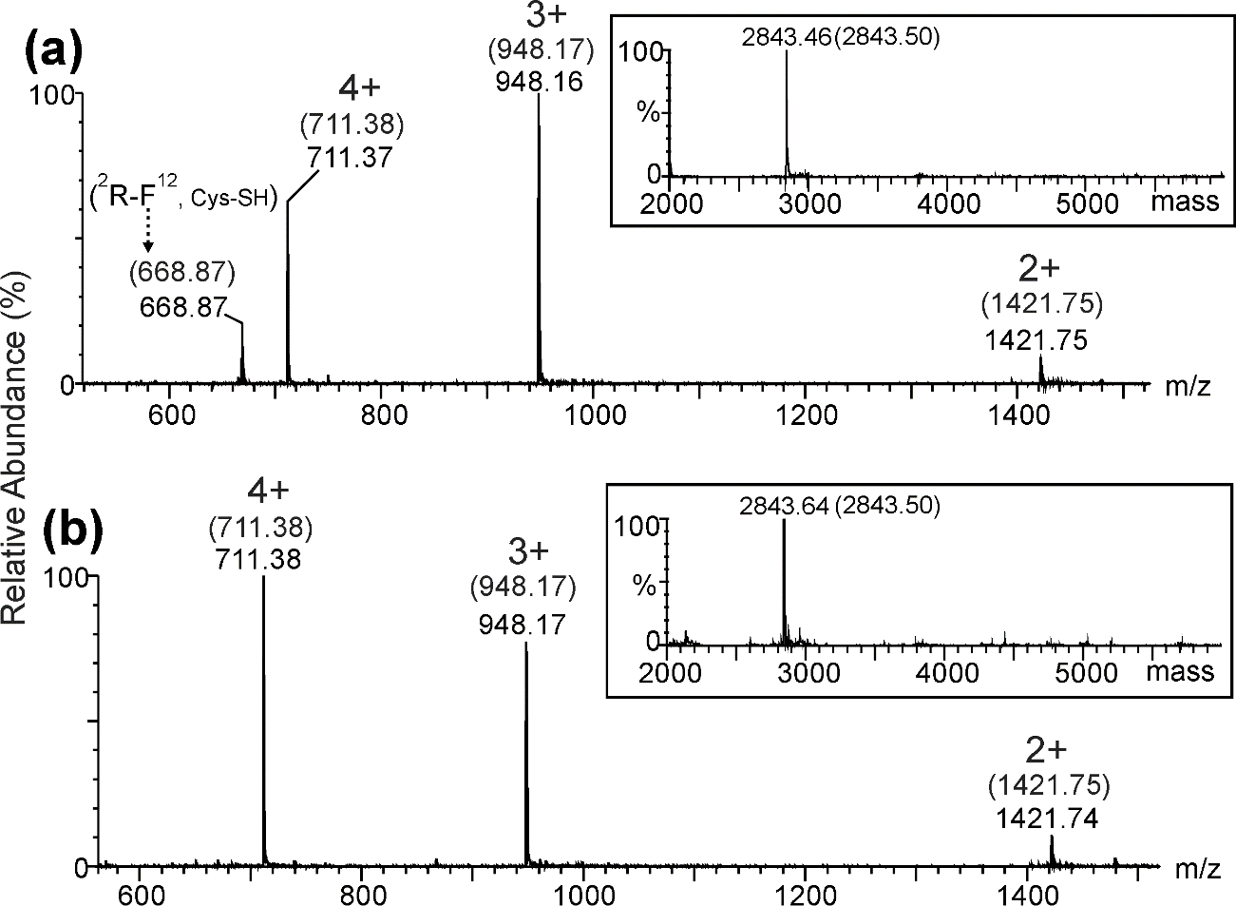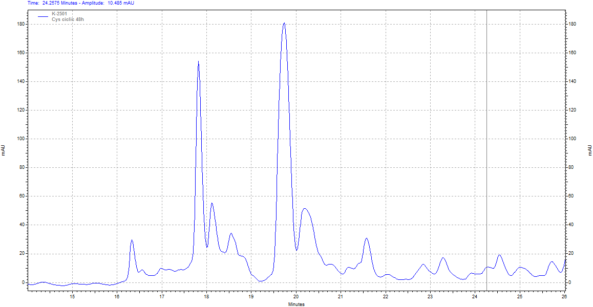
(c)

Figure S1: (a) (b) ESI-MS spectra of dimers of CysCysCm-p5. Theoretical monoisotopic species marked in a box and (c) RP-HPLC (oxidation conditions: 0.5mg/ml in water/ACN, pH=8) [1].
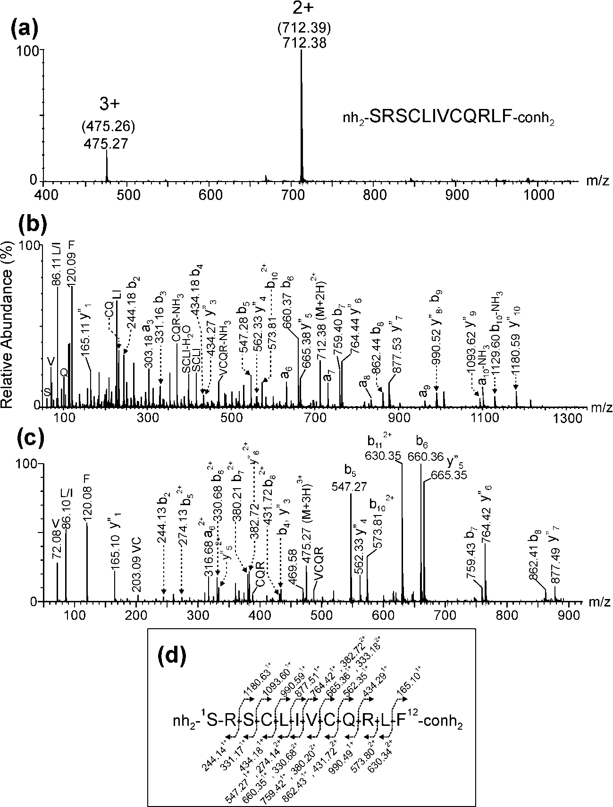
Figure S2: (a) Electrospray ionization mass spectrometry (ESI‐MS) analysis of the lineal monomer of Cys-Cmp5. (b-c) ESI‐MS/MS analysis of the (M+2H)²⁺ and (M+3H)³⁺ ions detected at m/z 712.38 and 475.27, respectively. (d) Fragmentation scheme of peptide and summary of the assignment for fragment ions observed in the ESI‐MS/MS spectra shown in (b) and (c). The expected monoisotopic m/z values are indicated in (a)(inside parentheses) and (d).

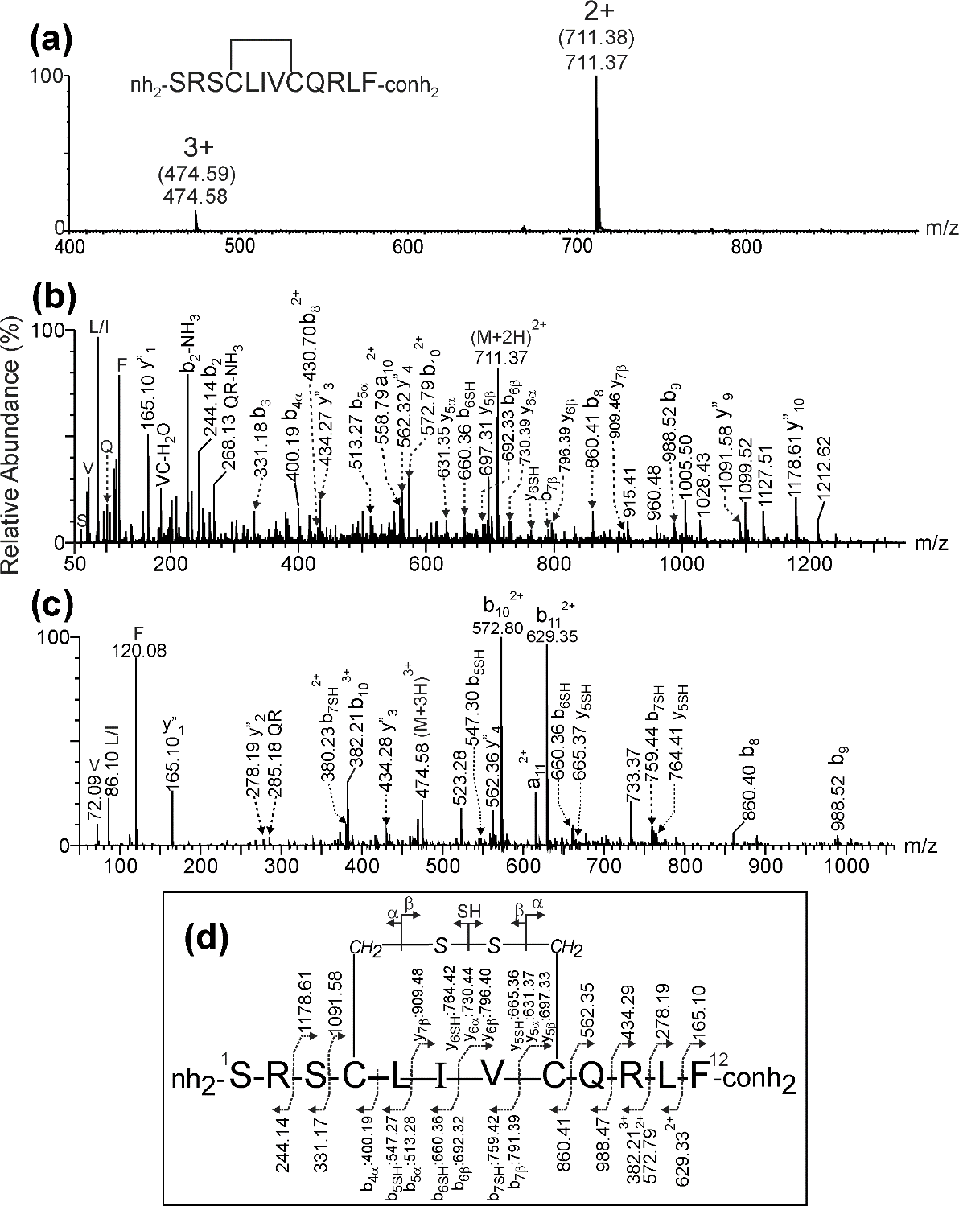
Figure S3: (a) Electrospray ionization mass spectrometry (ESI‐MS) analysis of the cyclic monomer of Cys-Cmp5. (b-c) ESI‐MS/MS analysis of the (M+2H)²⁺ and (M+3H)³⁺ ions detected at m/z 711.37 and 474.58, respectively. (d) Fragmentation scheme of peptide and summary of the assignment for fragment ions observed in the ESI‐MS/MS spectra shown in (b) and (c). The expected monoisotopic m/z values are indicated in (a)(inside parentheses) and (d). The nomenclature for the asymmetric fragmentation of the intramolecular disulfide bond (α and β ions) corresponds to a previous paper [2].
The ESI-MS analysis of the lineal (Figure S2) and cyclic (Figure S3) monomer species showed a good agreement between the experimental and expected m/z values for the multiply charged ions (2+ and 3+) of CysCys-Cmp5 considering the peptide with two free thiols or an intramolecular disulfide bond linking Cys4-Cys8, and an amidation at the C-terminal. The mass difference of the backbone ions (bn and y”n) observed in the MS/MS spectra (Figure S2 b-c) of the (M+2H)²⁺ and (M+3H)³⁺ ions (m/z 712.38 and 475.27) confirmed the presence of two free cysteine residues corresponding to the lineal monomer (Figure S2 d) amidated in the C-terminal. Figure S3 b-c shows the MS/MS spectra of the precursor ions at m/z 711.37 (2+) and 474.58 (3+) and a summary of the cyclic monomer assignment is presented in Figure S3 d. The backbone ions corresponding to yn (y1-y4, y9-y10) and bn ions (b2-b3, b8-b11) considering an intramolecular disulfide bond between Cys4-Cys8 were detected. A symmetric cleavage of the disulfide bond and further backbone fragmentation generates several signals assigned to y5SH-y6SH and b5SH-b7SH containing Cys8 and Cys4 residues as a free thiol group. Additionally, an asymmetric cleavage were detected according to Mormann and coworkers generating α(b4α, b5α,y5α,y6α) and β(b6β, b7β, y5β, y6β, y7β) fragment ions with the two Cys residues transformed in dehydroalanine and disulfohydryl cysteine residue, respectively. The nomenclature for the asymmetric fragmentation of the intermolecular disulfide bond ( and  ions) corresponds to a previous paper [2].

SD2. Independent synthesis of the cyclic monomer and dimers of CysCysCm-p5.
2.1 General protocol for solid-phase peptide synthesis
Coupling reactions were performed manually on Knorr-MBHA resin by a stepwise Fmoc/tBu strategy. Aminoacids were coupled using DIC/Oxyma activation, and completion of the coupling reaction was monitored by the ninhydrin test. Fmoc-deprotection was carried out using 20% piperidine solution in DMF. All final product were cleaved from the resin with the cocktail TFA/TIS/water (95:2.5:2.5), or TFA/TIS/EDT/water (94:1:2.5:2.5) for cysteine containing peptides, precipitated from diethyl ether at -70ºC, then taken up in 1:2 acetonitrile/water and lyophilized. All Cm-p5 analogues were analyzed by RP-HPLC, C18 column (Vydac, 4.6 × 150 mm, 5μm) (λ= 226 nm) (linear gradient of 5 to 60 % of solvent B for 35 min, at 0.8 mL/min flow) (solvent A: H₂O, 0.1 % TFA; solvent B: CH₃CN, 0.05 % TFA) to determine purity and realize the ESI-MS characterization. In All cases, final products were dissolved in DMSO and purified by preparative RP-HPLC, C18 column (Vydac, 25 × 250 mm, 25μm) (λ= 226 nm) (with a linear gradient of 15 to 80 % of B for 60 min, at 5mL/min flow).
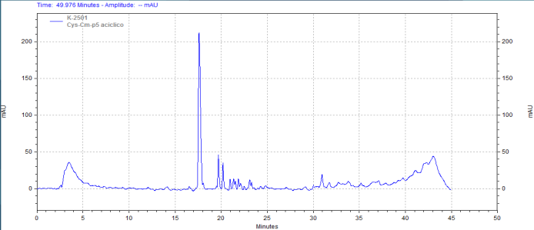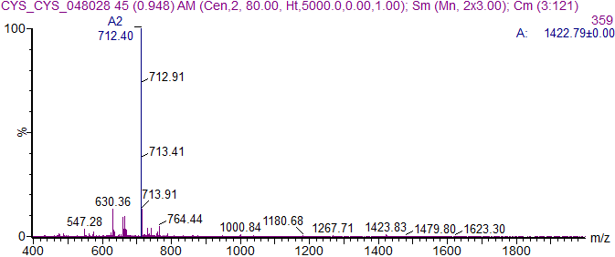
Figure S4: RP-HPLC and ESI-MS of crude CysCysCm-p5 peptide.
2.2 Independent synthesis of the cyclic monomer of CysCysCm-p5.
Scheme S1: Ionization of CysCysCm-p5 at pH=8.
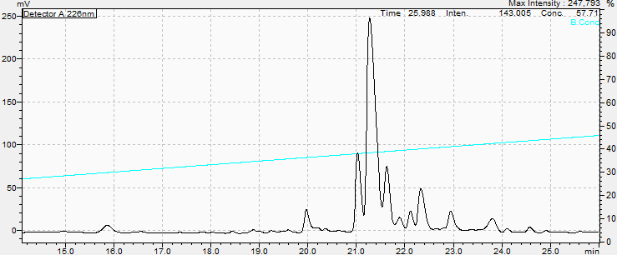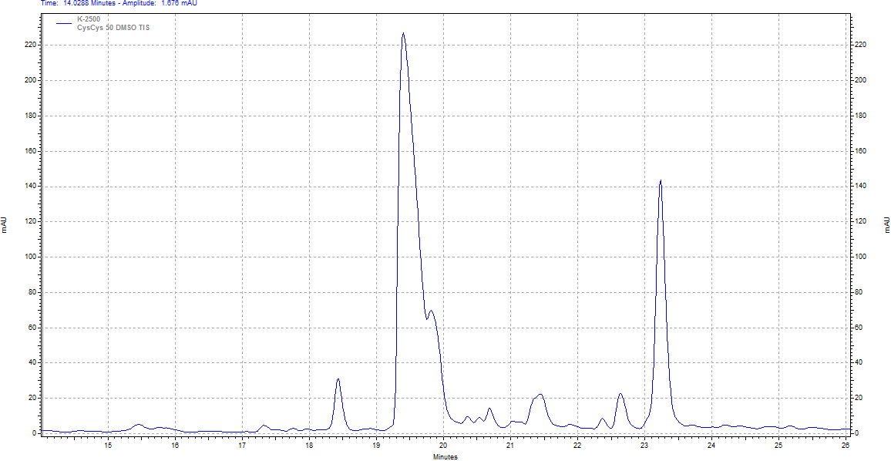
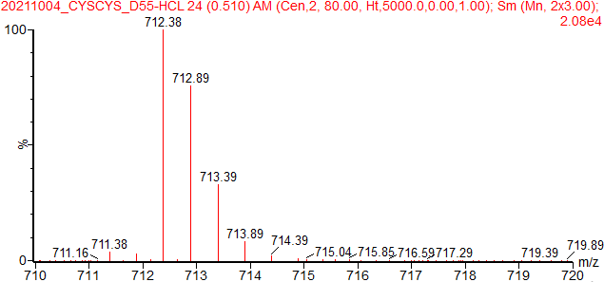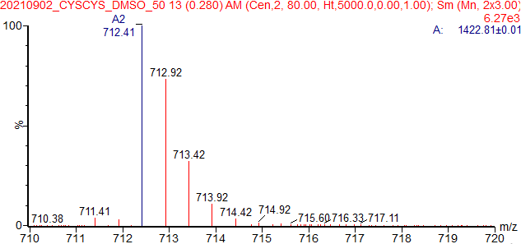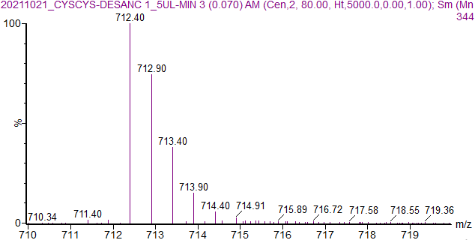
Figure S5: Analytical RP‐HPLC profile and ESI-MS of the crude peptide CysCysCm-p5 after the on resin cyclization with DMSO (40%), pH=3, 6h (left panel, Shimatsu RP-HPLC), DMSO 50%, pH=5, 12h (Knauer RP-HPLC) and DMSO 60%, pH=3, 3h (Knorr-MBHA, 1.11mmol/g, 0.17g).
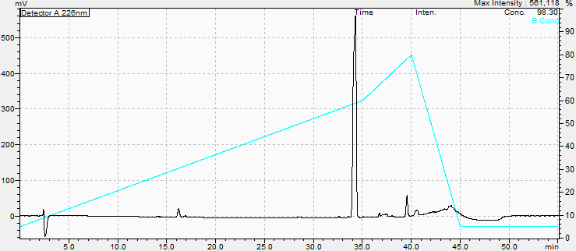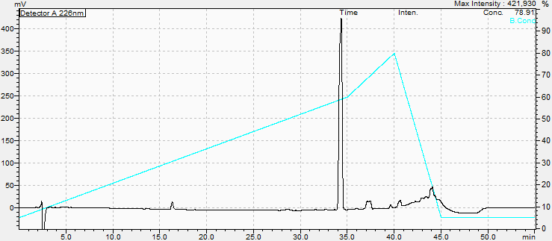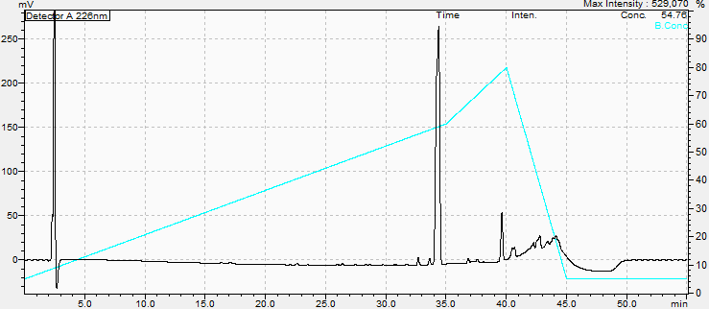
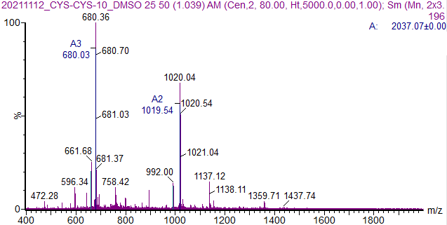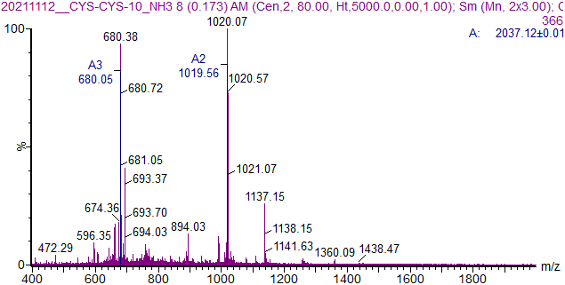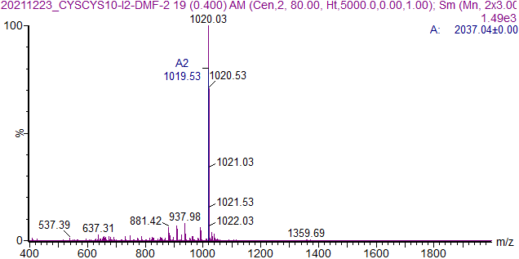
Figure S6: Analytical RP‐HPLC (upper panel)profiles and ESI-MS (lower panel) of the protected cyclic peptide CysCysCm-p5 after the on resin (Chemmatrix) cyclization with DMSO 35%, O₂/NH₃ in THF/H₂O (2:1), I₂/DMF.
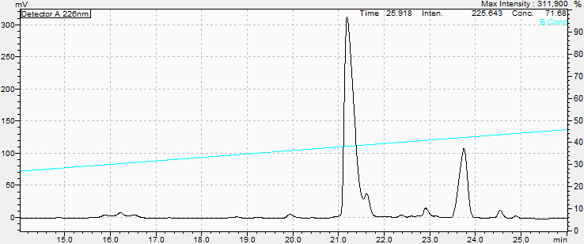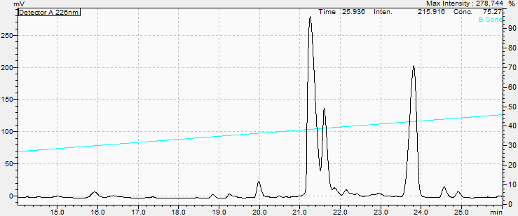
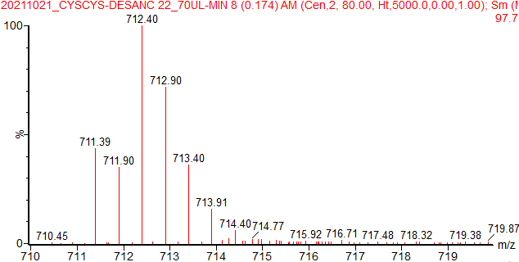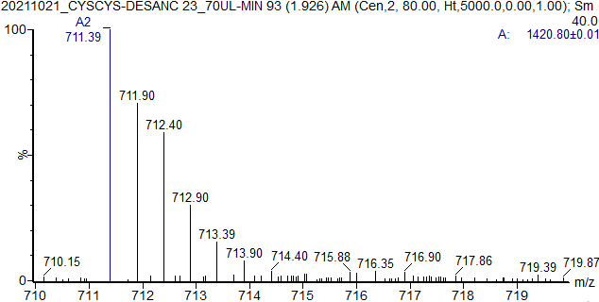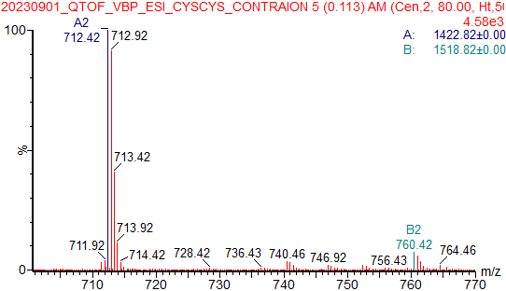
Figure S7: Analytical RP‐HPLC profiles and ESI-MS of the crude peptide CysCysCm-p5 after the on resin cyclization with DMSO and cleavage with 1% TIS, 3.5% H₂O (left panel) or 1%TIS, 1% H₂O (right panel).
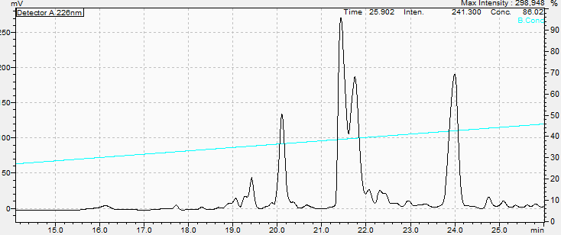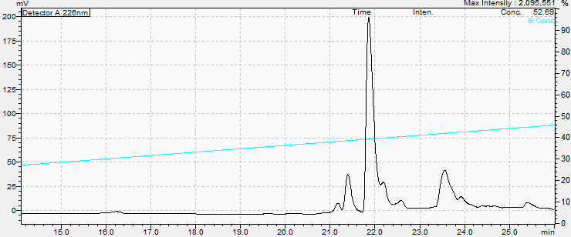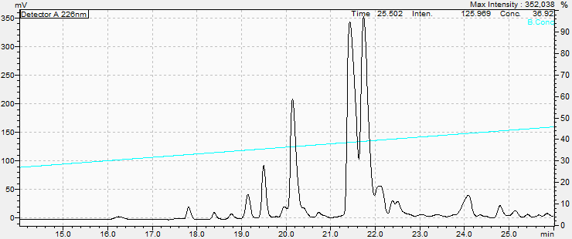
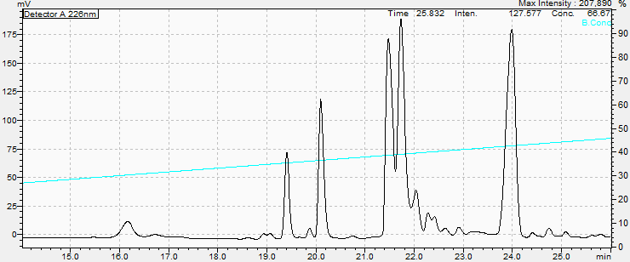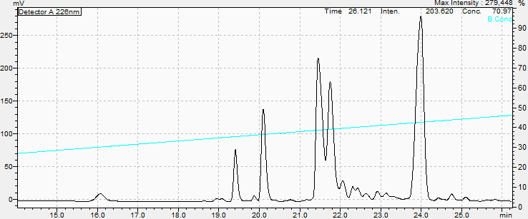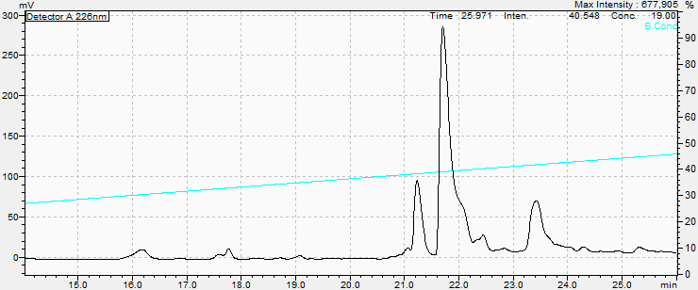
Figure S8: Analytical RP‐HPLC profiles of the crude peptide CysCysCm-p5 after the treatment with different cleavage cocktails. Chemmatrix resin of 0.2mmol/g (upper panels): on resin cyclization with DMSO or I₂/DMF and cleavage (1.5h) with 1% TIS (1% of PhSiH₃ upper righ panel). Chemmatrix resin of 0.41mmol/g (lower panels): on resin cyclization with DMSO 35%, O₂/NH₃ (THF/H₂O 2:1), I₂/DMF-Trt.
Scheme S2: a,b) Modes of carbocation capping, c,d) effect of water in TFA autoprotolysis and e) impurities generated by Pbf.
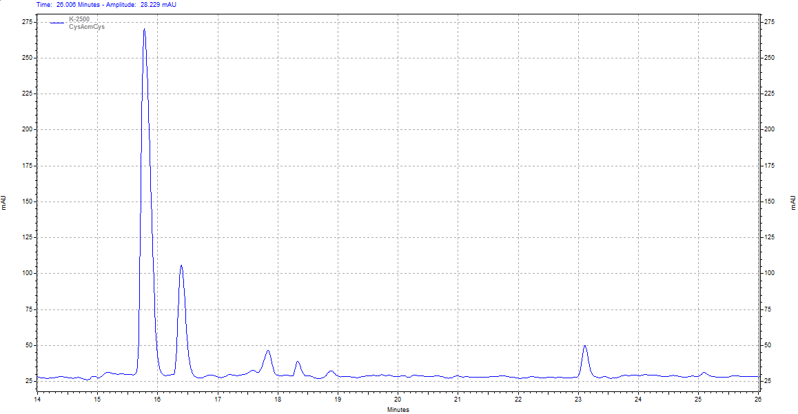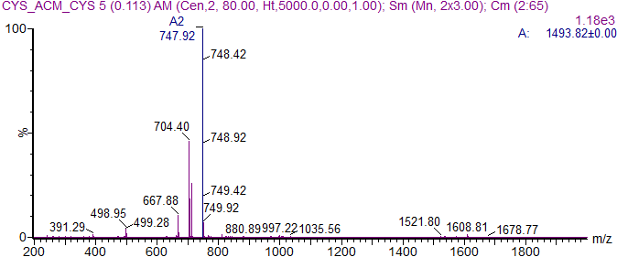
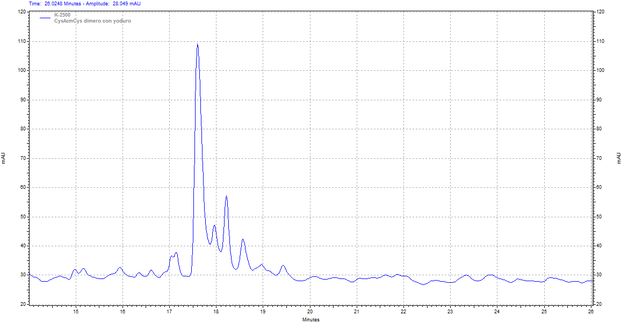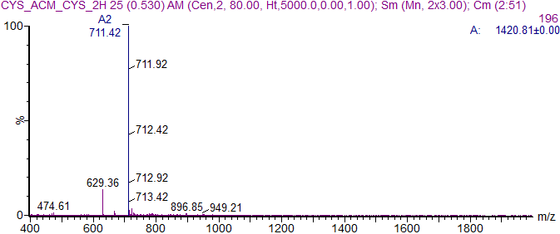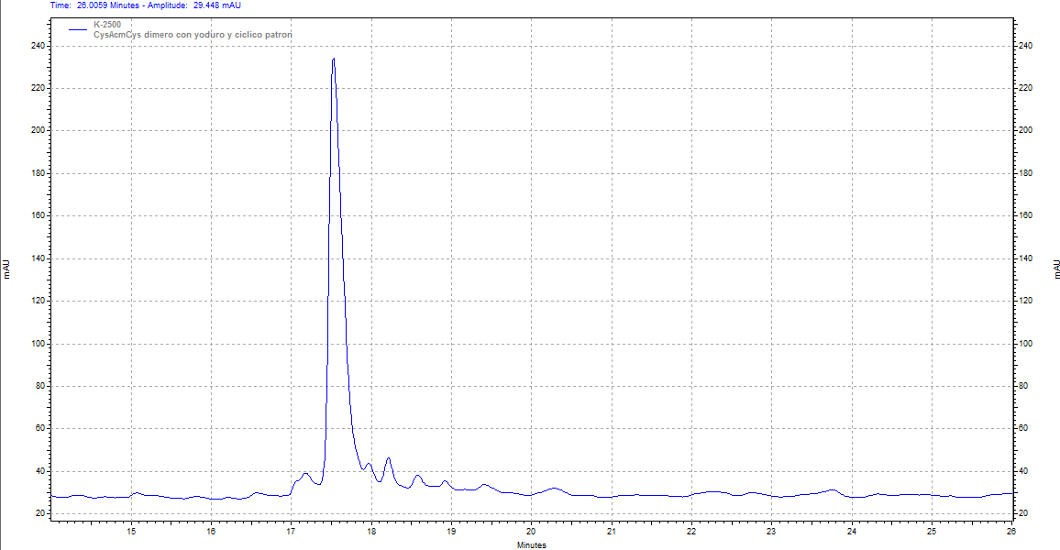
Figure S9: Analytical RP‐HPLC profile and ESI-MS of crude peptide CysAcmCysCm-p5 (upper panel) and after the liquid phase cyclization (5mg/ml) with I₂ (lower panel) in HAc or THF.
Scheme S3: Liquid phase synthesis of the cyclic CysCysCm-p5ss by iodine oxidation of CysAcmCysCm-p5 peptide in HAc or THF.
2.3 Independent synthesis of the parallel dimer of CysCysCm-p5.
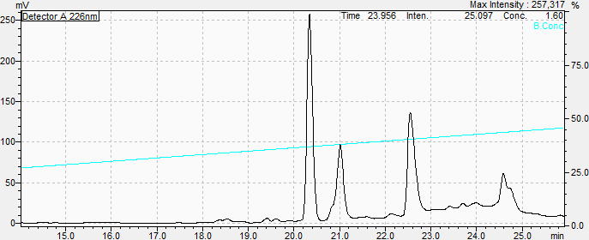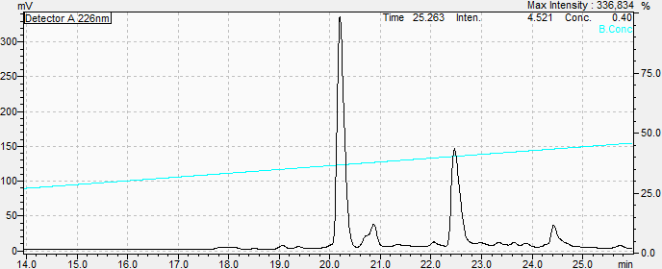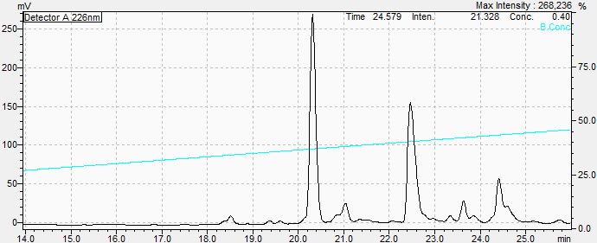
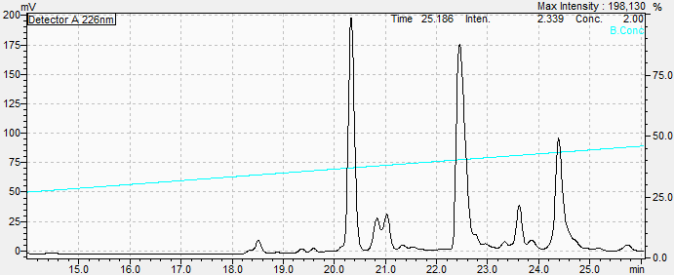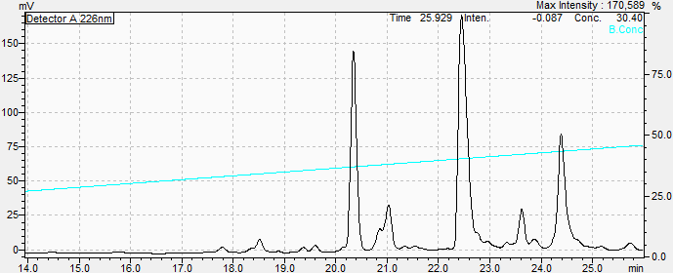
Figure S10: Analytical RP‐HPLC profile of the cyclization of CysCysCm-p5 at different EtOH concentration: EtOH 5%, EtOH 25%, EtOH 50%, EtOH 75%, EtOH 90%, pH=8, 12-24h, 0.5mg/ml.
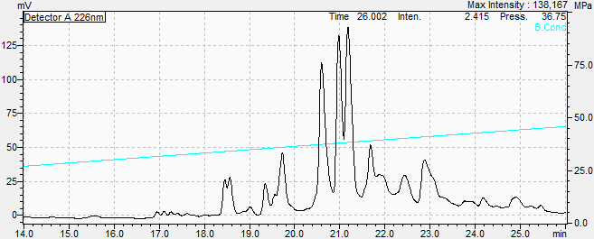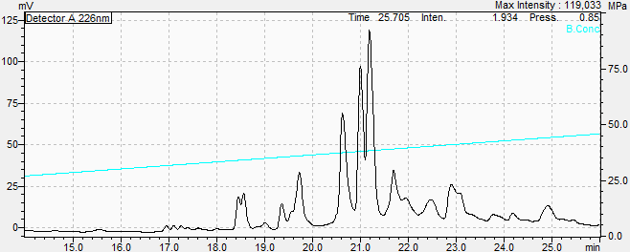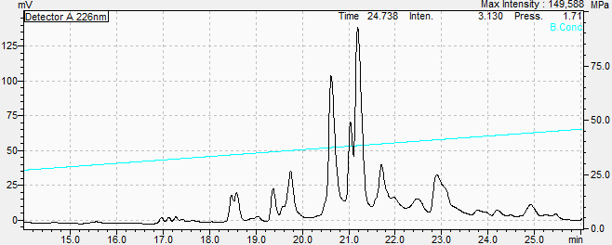

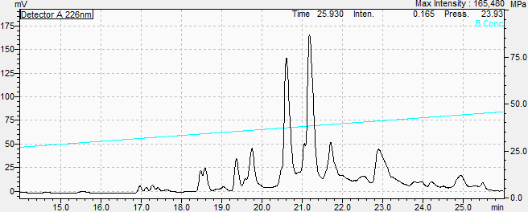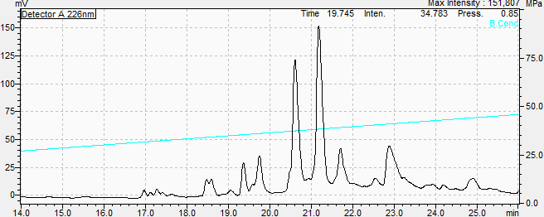

Figure S11: Analytical RP‐HPLC profile of the cyclization of CysCysCm-p5 in different EtOH concentrations, 0.5mg/ml (dissolved first in EtOh absolute and sonicated during 1min).

References
1. Morales-Vicente, F.E.; González-García, M.; Díaz Pico, E.; Moreno-Castillo, E.; Garay, H.E.; Rosi, P.E.; Jimenez, A.M.; Campos-Delgado, J.A.; Rivera, D.G.; Chinea, G.; Pietro, R.C.L.R.; Stenger, S.; Spellerberg, B.; Kubiczek, D.; Bodenberger, N.; Dietz, S.; Rosenau, F.; Paixao, M.E.; Standker, L.; Otero-González, A.J. Design of a Helical-Stabilized, Cyclic, and Nontoxic Analogue of the Peptide Cm-p5 with Improved Antifungal Activity. ACS Omega 2019, 4, 19081-19095.
2. Mormann, M.; Eble, J.; Schwoppe, C.; Mesters, R.M.; Berdel, W.E.; Peter-Katalinic, J.; Pohlentz, G. Fragmentation of intra-peptide disulfide bonds of proteolytic peptides by nano ESI collision induced dissociation. Anal Bioanal Chem 2008, 392, 831-838.

