Supplementary Material
Cobalt Coordination Networks Based on the Linker (Phenazine-5,10-diyl)di- and tetrabenzoate
Annette Vollrath, Xiang Liu, Nikolas Jansen, Philipp Seiffert, David Geller and Christoph Janiak *
Institut für Anorganische Chemie und Strukturchemie, Heinrich-Heine-Universität 40204 Düsseldorf, Germany
* Correspondence: janiak@uni-duesseldorf.de
Emails: annette.vollrath@hhu.de, xiang.liu@hhu.de, nijan113@hhu.de, philipp.seiffert@uni-duesseldorf.de, david.geller@hhu.de, janiak@uni-duesseldorf.de

Content
Section S1 Chemicals used 2
Section S2 Reaction schemes for ligand syntheses (Scheme S1-S5) 3
Section S3 NMR spectra 5
Section S4 IR spectra 14
Section S5 Crystal photographs and crystal structure images 16
Section S6 PXRD 18
Section S7 Thermogravimetric analyses 20

Section S1 Chemicals used

Table S1. List of chemicals used.
Chemical | Purity [%] | Supplier
Cobalt(II) nitrate hexahydrate | ≥ 98 | Carl Roth
Dimethyl-5-Iodoisophthalate | 98.45 | BLDpharm
Hydrochloric acid | 37 | VWR Chemicals
Lithium hydroxide monohydrate | p.a. | AppliChem
Magnesium sulfate | 99.0 | VWR Chemicals
Methyl-3-bromobenzoate | 97 | BLDpharm
Palladium(II) acetate | 99.9 | BLDpharm
Phenazine | 99.87 | BLDpharm
Potassium carbonate | 99.5 | Grüssing
Sodium dithionite | 85 | Acros Organics
Tri-tert-butyl-phosphine | 98 | Merck
1,4-Dioxane | ≥ 99.8 | Fisher Chemical
Chloroform | ≥ 99 | Fisher Chemical
Dichlormethane (DCM) | 99.8 | Fisher Chemical
Ethanol | ≥ 99.8 | Honeywell
n-Hexane | ≥ 95 | Sigma Aldrich
N,N-Dimethylformamide (DMF) | ≥ 99.5 | Fisher Chemical
Xylene (isomer mixture) | 98.7 | VWR Chemicals

Section S2 Reaction schemes for ligand syntheses (Scheme S1-S5)
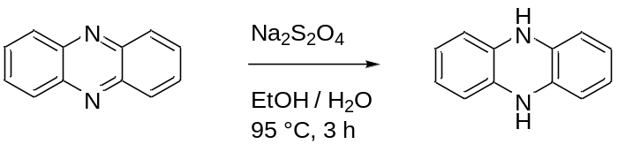
Scheme S1. Synthesis of 5,10-dihydrophenazine.

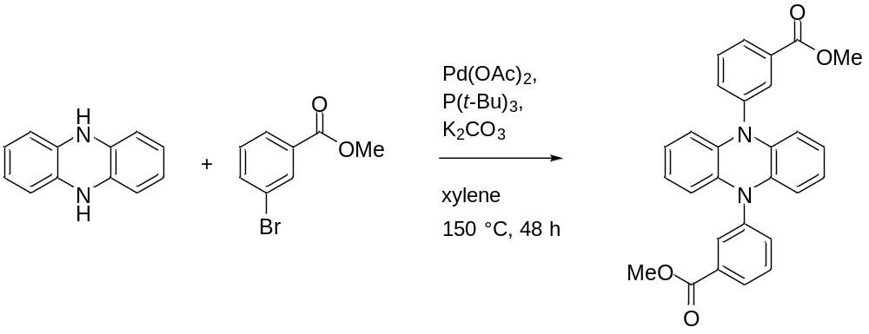
Scheme S2. Synthesis of dimethyl 3,3'-(phenazine-5,10-diyl)dibenzoate.

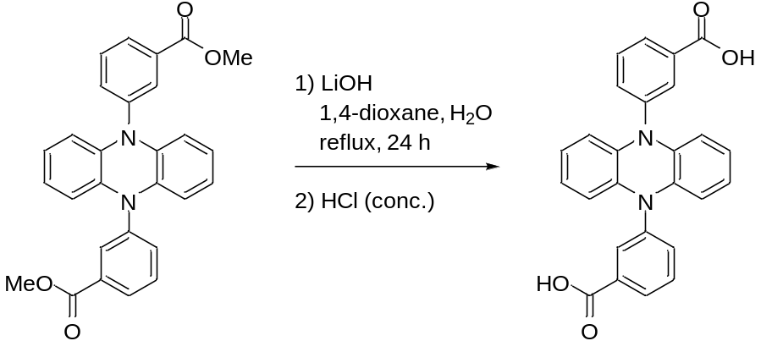
Scheme S3. Synthesis of 3,3'-(phenazine-5,10-diyl)dibenzoic acid (H₂pdb).

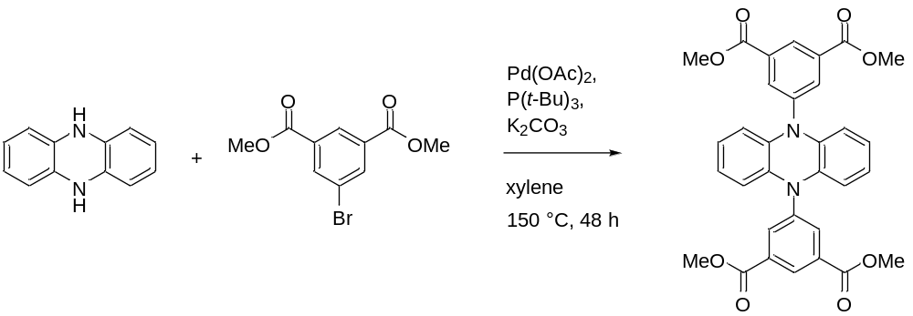
Scheme S4. Synthesis of tetramethyl 5,5'-(phenazine-5,10-diyl)diisophthalate.

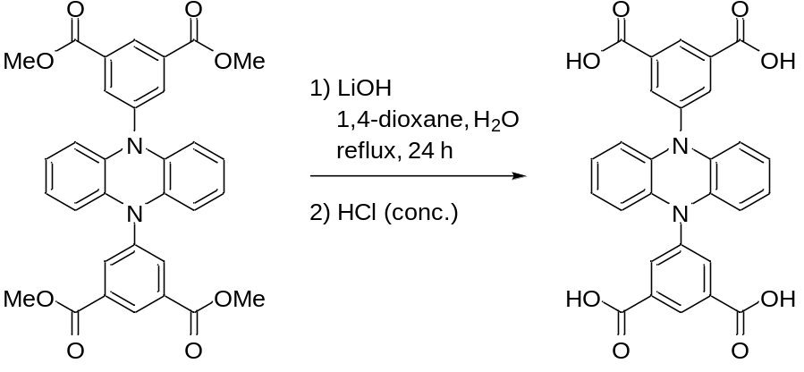
Scheme S5. Synthesis of 5,5'-(phenazine-5,10-diyl)diisophthalic acid (H₄pdi).

Section S3 NMR spectra

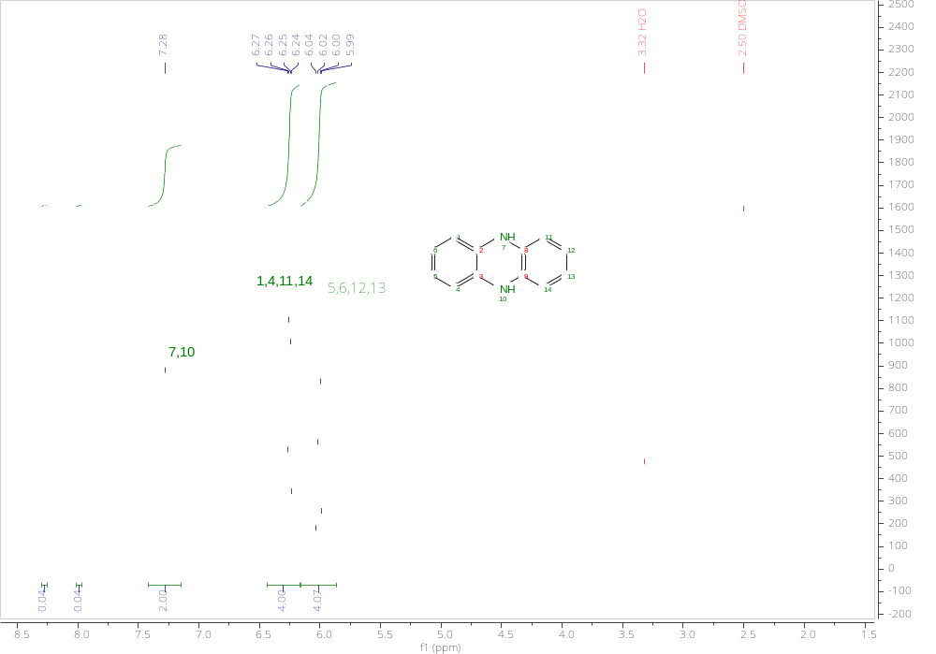
Figure S1. ¹H-NMR-spectrum of 5,10-dihydrophenazin (300 MHz, DMSO-d₆).
The two doublets at 6.01 ppm and 6.26 ppm can be attributed to the two benzene rings in 5,10-dihydrophenazine, while the singlet at 7.29 ppm can be assigned to the NH protons. At 8.00 ppm and 8.30 ppm, there are two further signals that can be assigned to the remaining or re-oxidized phenazine starting material. The percentage content of phenazine in the sample can be calculated from the ratios of the signals of the reactant to the product as 1%.

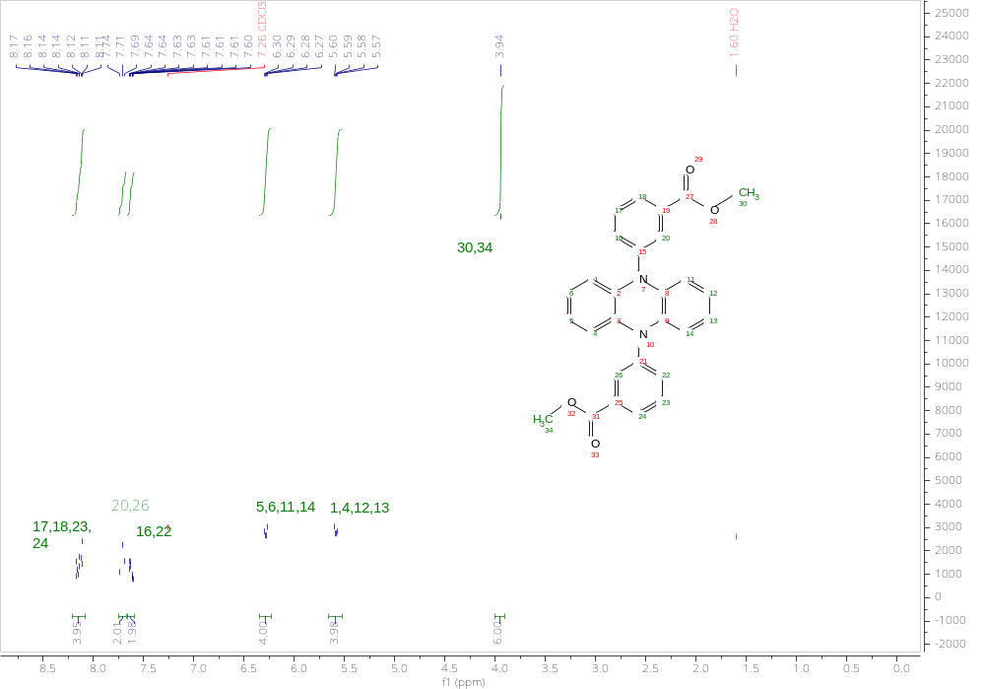
Figure S2. ¹H-NMR-spectrum of dimethyl 3,3'-(phenazine-5,10-diyl)dibenzoate (H₂pdb) (300 MHz, CDCl₃).
In the ¹H NMR spectrum, the singlet at 3.94 ppm can be assigned to the two methyl groups in dimethyl 3,3'-(phenazine-5,10-diyl)dibenzoate, while the doublet at 5.58 ppm and 6.28 ppm can be assigned to the protons in the 5,10-dihydrophenazine core. The multiplet from 7.59 ppm to 7.65 ppm can be assigned to the protons at positions 20 and 25 of the benzenoate ring and the triplet at 7.71 ppm belongs to the protons at positions 21 and 26. The multiplet from 8.08 ppm to 8.20 ppm can be assigned to the other four protons on the benzoate ring. In addition, a small water signal at 1.60 ppm is observed, which may originate from the water in the sample and the water contained in the solvent.

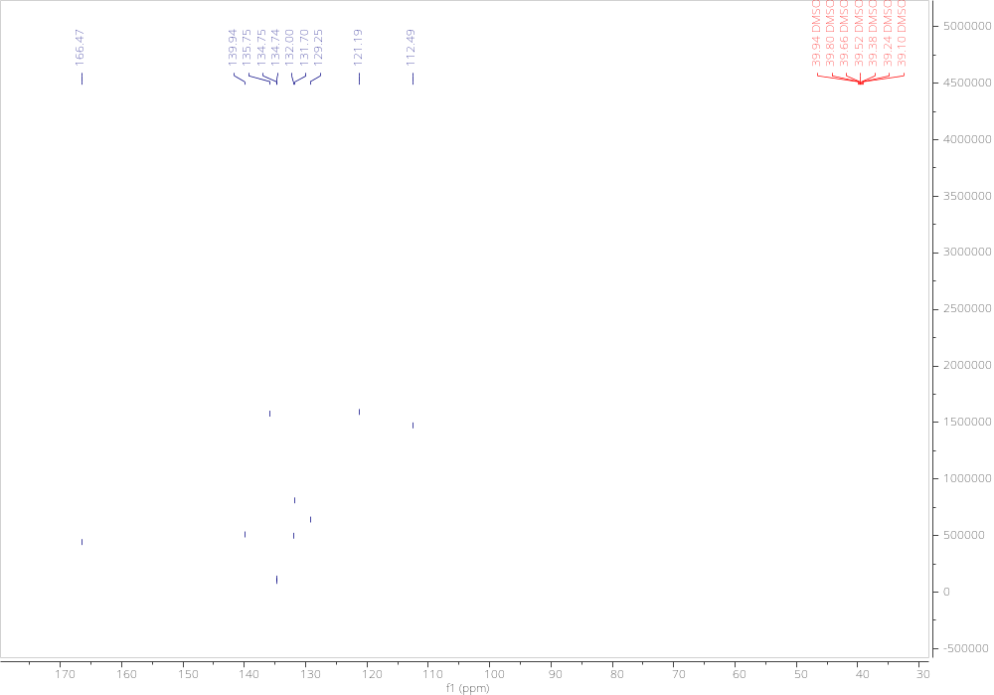
Figure S3. ¹³C{1H}-NMR-spectrum of dimethyl 3,3'-(phenazine-5,10-diyl)dibenzoate (600 MHz, CDCl₃).

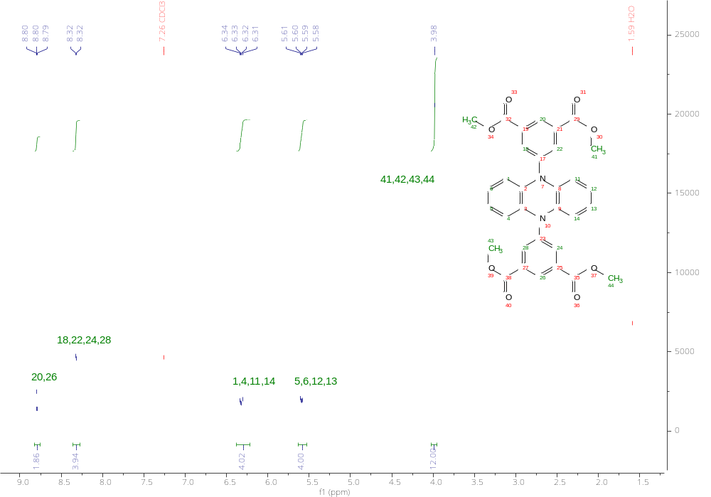
Figure S4. ¹H-NMR-spectrum von tetramethyl-5,5'-(phenazine-5,10-diyl)diisophthalate (300MHz, CDCl₃).
All five chemically different signals were observed in the ¹H NMR spectrum. The singlet located at 3.98 ppm can be assigned to the four methyl groups, while the two doublets of doublets at 5.59 and 6.32 ppm can be assigned to the protons of the 5,10-dihydrophenazine core of this molecule. The two signals between 8.0 ppm and 9.0 ppm belong to the three protons of the isophthalate benzene rings.

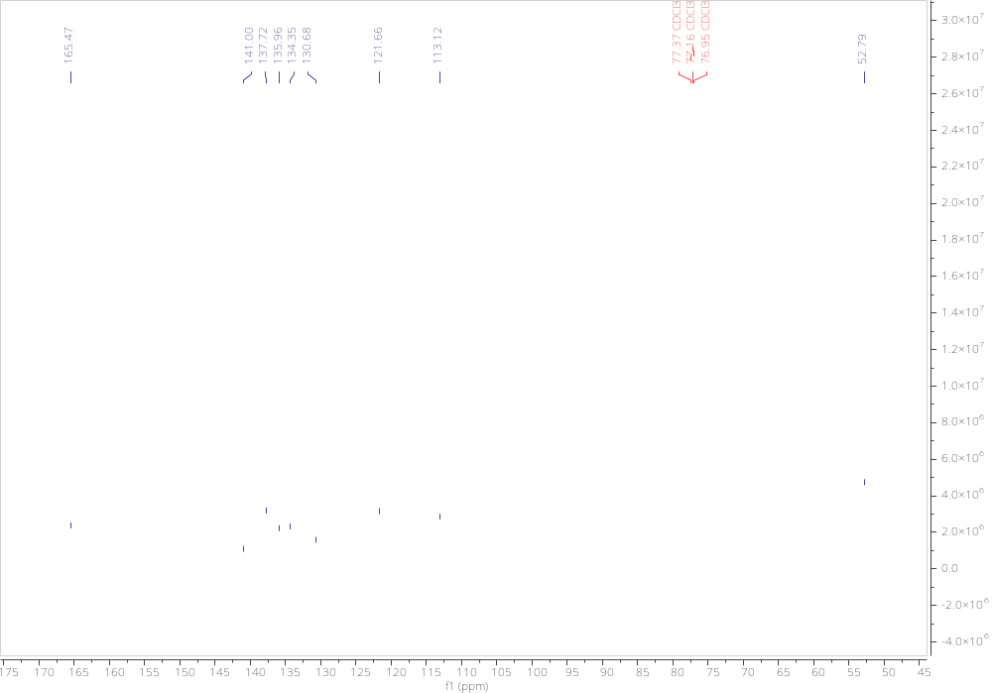
Figure S5. ¹³C{1H}-NMR-spectrum von tetramethyl-5,5'-(phenazine-5,10-diyl)diisophthalate (600MHz, CDCl₃).
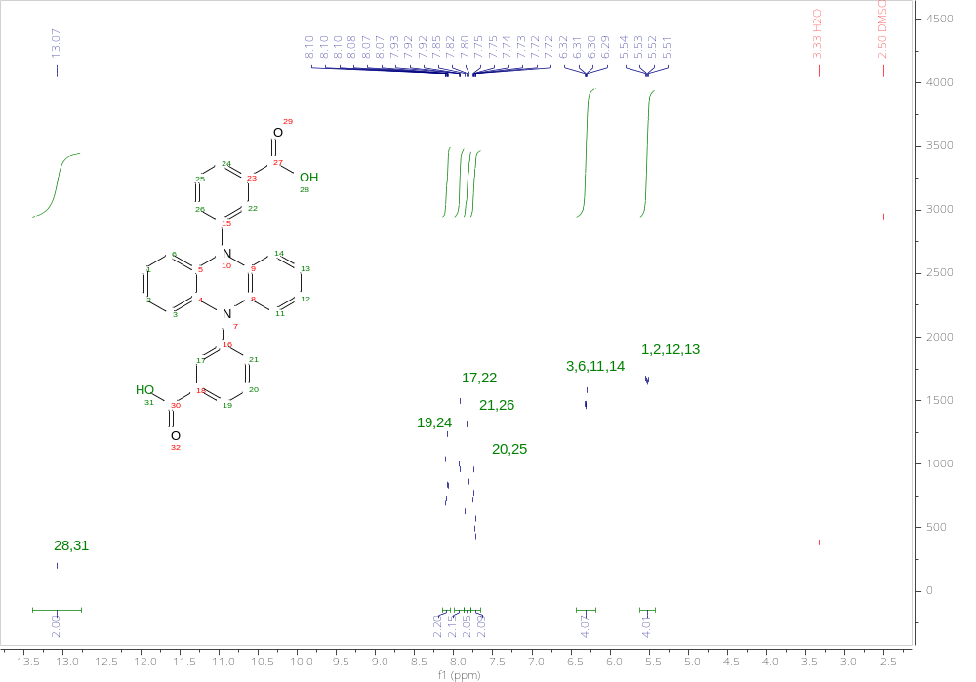
Figure S6. ¹H-NMR-spectrum of 3,3'-(phenazine-5,10-diyl)dibenzoic acid (H₂pdb) (300 MHz, DMSO-d₆).
The two doublets at 5.52 ppm and 6.30 ppm can be assigned to the protons on the two anellated benzene rings of the 5,10-dihydrophenazine core. The four signals between 7.60 ppm and 8.20 ppm can be assigned to the protons on the two benzoate rings. The integrals in the spectrum correspond exactly to the expected number of hydrogen atoms.
Figure S7. ¹³C{¹H}-NMR-spectrum of 3,3'-(phenazine-5,10-diyl)dibenzoic acid (H₂pdb) (600 MHz, DMSO-d₆).

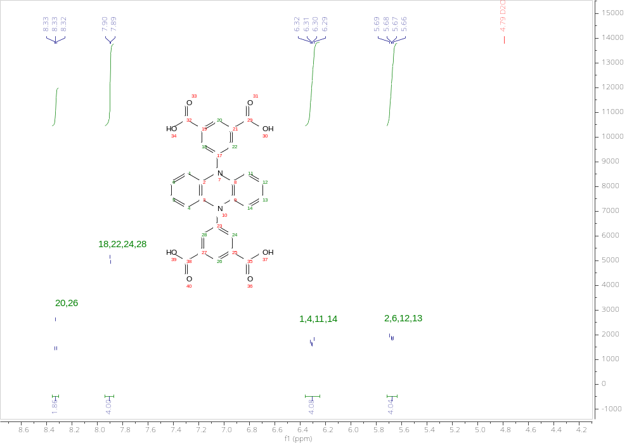
Figure S8. ¹H-NMR-Spectrum of 5,5'-(phenazine-5,10-diyl)diisophthalic acid (H₄pdi) (300 MHz, D₂O). The two doublets at 5.81 ppm and 6.44 ppm can be assigned to the 5.10-dihydrophenazine core, the two signals between 8.0 ppm and 8.5 ppm to the protons on the two isophthalate rings. The integrals correspond to the number of protons in the molecule.
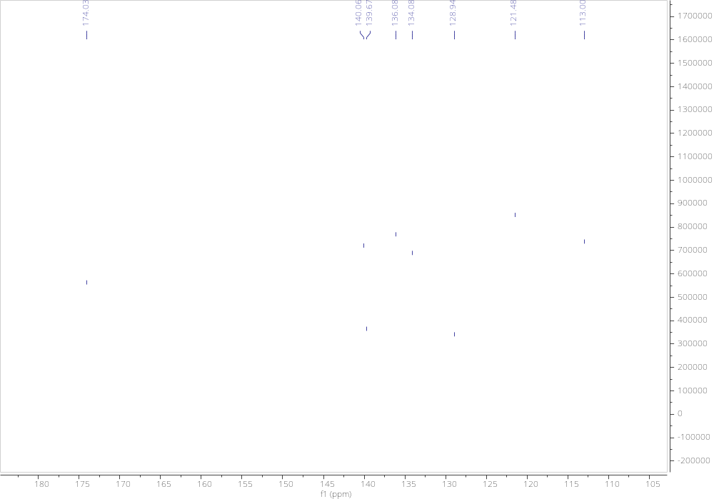
Figure S9. ¹³C{¹H}-NMR-Spectrum of 5,5'-(phenazine-5,10-diyl)diisophthalic acid (H₄pdi) (600 MHz, D₂O).

Section S4 IR spectra

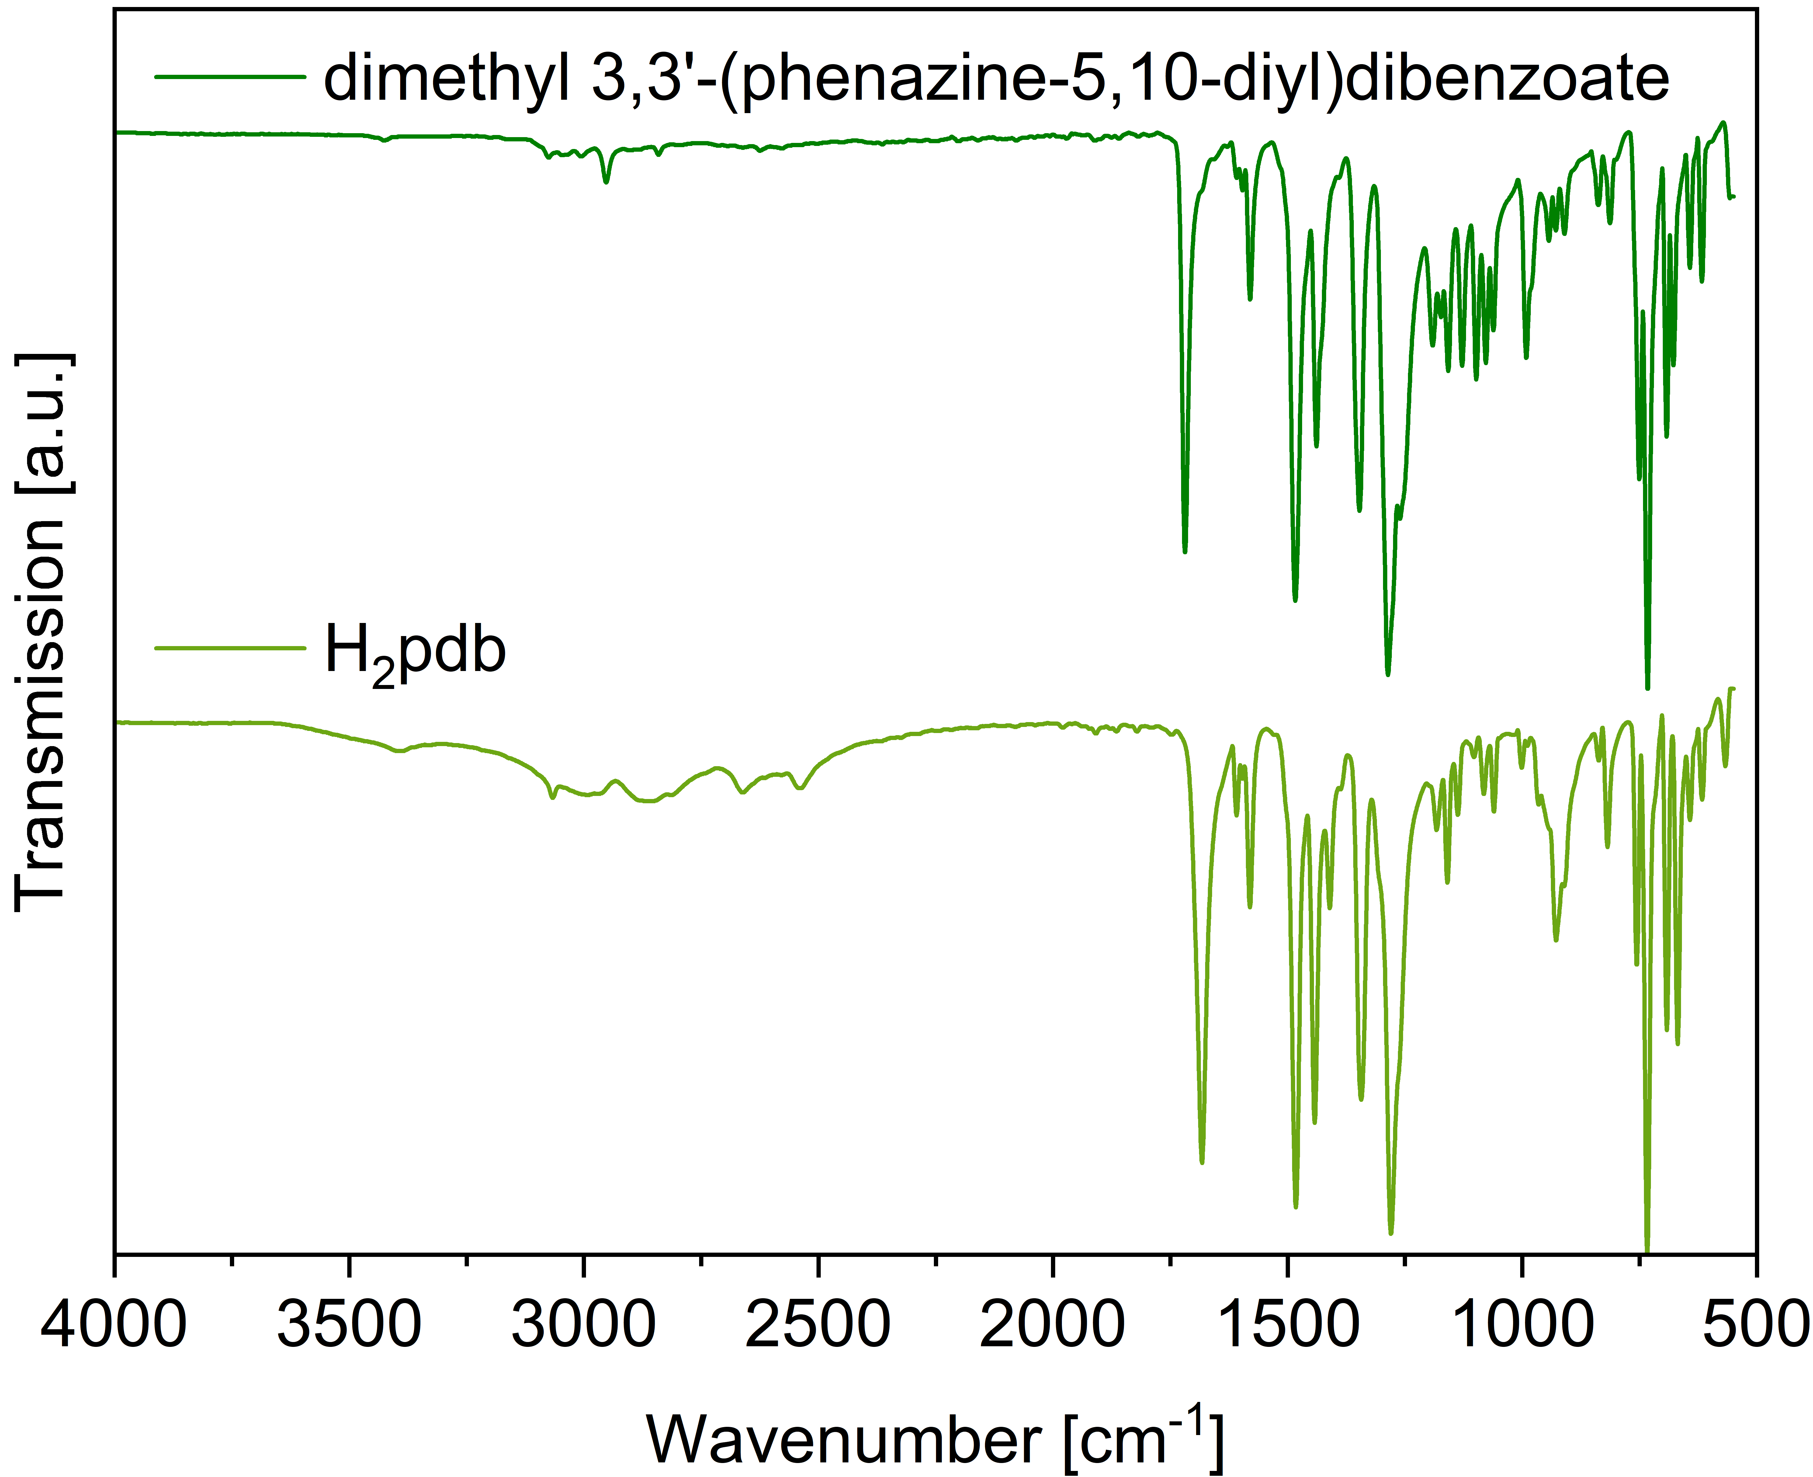
Figure S10. IR-spectra of 3,3'-(phenazine-5,10-diyl)dibenzoic acid (H₂pdb, light green) and dimethyl 3,3'-(phenazine-5,10-diyl)dibenzoate (dark green).
The strong band around 1700 cm⁻¹ in both spectra can be attributed to the stretching vibration of the C=O bond, the band at approximately 1483 cm⁻¹ to the stretching vibration of the C=C bond on the benzene ring, the band at approximately 1345 cm⁻¹ to the stretching vibration of the C-N bond, the strong band at approximately 1280 cm⁻¹ to the stretching vibration of the C-O bond, the band at 734 cm⁻¹ to the out-of-plane bending vibration of the carbon-hydrogen bond in the benzene ring.
Bands between 3000 cm⁻¹ and 3100 cm⁻¹ are attributable to the C-H stretching vibration of the benzene rings. Unlike in the spectrum of dimethyl 3,3'-(phenazine-5,10-diyl)dibenzoate, a very broad band between 2500 cm⁻¹ and 3100 cm⁻¹ can be observed in the spectrum of H₂pdb, which belongs to the stretching vibration of the O-H bond in the carboxyl group. At the same time, the band at 928 cm⁻¹ in the diacid spectrum can be attributed to the out-of-plane deformation vibration of the hydrogen bond in the dimer. In the infrared spectrum of the diester, a band at 2953 cm⁻¹ can also be observed, which corresponds to the stretching vibration of the methyl C-H bond. The band at 1260 cm⁻¹ in the diester spectrum can also be attributed to the stretching vibration of the C-O bond.
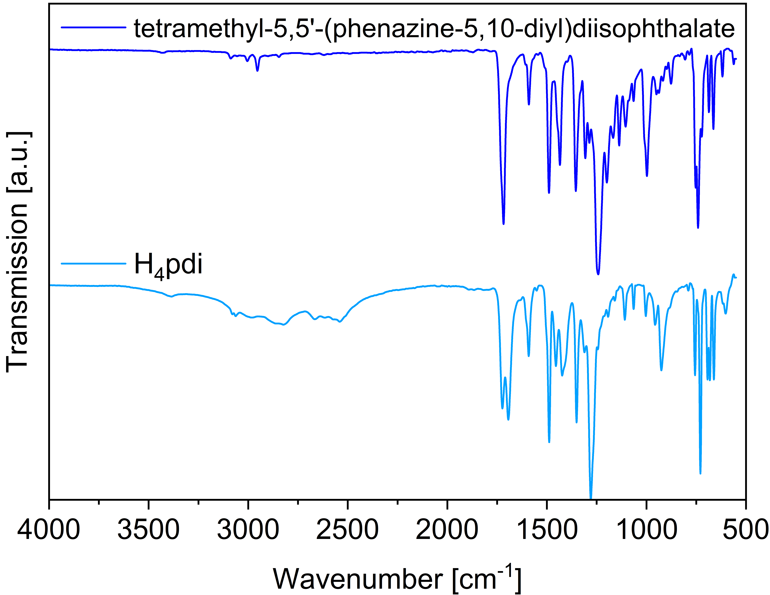
Figure S11. IR-spectra of 5,5'-(phenazine-5,10-diyl)diisophthalic acid (H₄pdi, light blue) and tetramethyl-5,5'-(phenazine-5,10-diyl)diisophthalate (dark blue).
Similar to the IR spectra in Figure S10, bands between 3000 cm⁻¹ and 3100 cm⁻¹ are attributable to the C-H stretching vibration of the benzene rings. The band at a wavenumber of approximately 1700 cm⁻¹ in both spectra can be attributed to the stretching vibration of the C=O bond, and this band is split in the IR spectrum of the tetraacid H₄pdi. The two bands between 1600 cm⁻¹ and 1450 cm⁻¹ in both spectra can be attributed to the stretching vibration of C=C on the benzene ring, the bands near 1350 cm⁻¹ and 1260 cm⁻¹ to the stretching vibration of the C-N bond and the stretching vibration of the C-O bond, respectively. Due to the overlap of the antisymmetric C-O-C stretching band and the C-O stretching band in the ester group, the band at 1242 cm⁻¹ in the IR spectrum of the tetraester is broad and strong. The band at approximately 740 cm⁻¹ in both spectra originated from the out-of-plane bending vibration of the C-H bond on the benzene ring.
In the spectrum of H₄pdi, the very broad band between 2400 cm⁻¹ and 3300 cm⁻¹ corresponds to the stretching vibration of the O-H bond on the carboxyl group. The band located at a wavenumber of 925 cm⁻¹ can be attributed to the deformation vibration of hydrogen bonds in the carboxylic acid dimer.
In the IR spectrum of the tetraester, the band at 2954 cm⁻¹ is due to the C H stretching vibration of the methyl group.

Section S5 Crystal photographs and crystal structure images

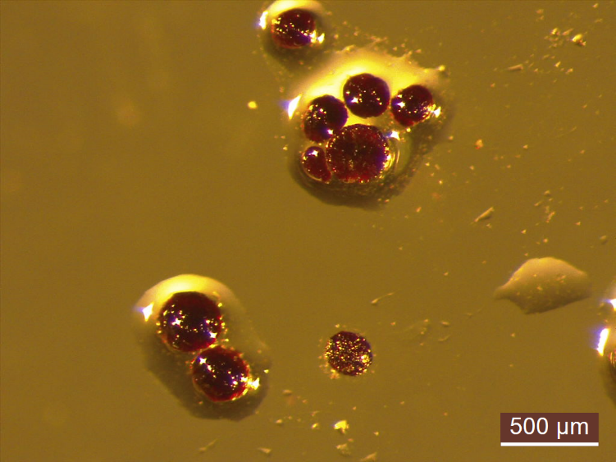
Figure S12. Light microscope photograph of [Co(pdb)(DMF)].
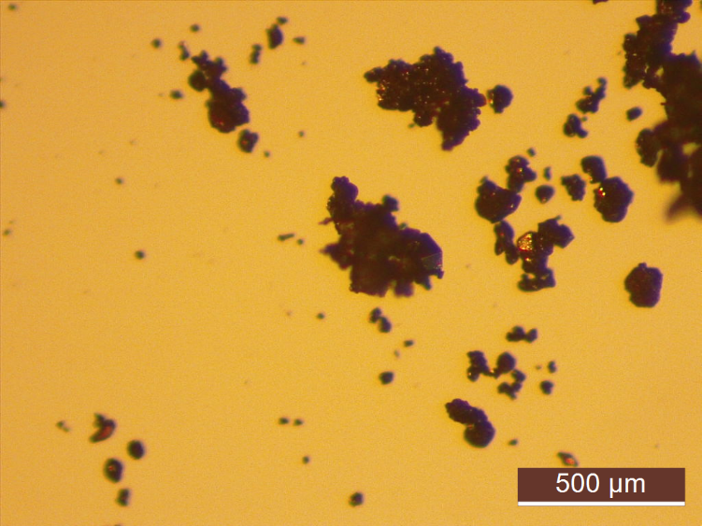
Figure S13. Light microscope photograph of [Co₂(pdi)(DMF)₃]·2(DMF)·H₂O.

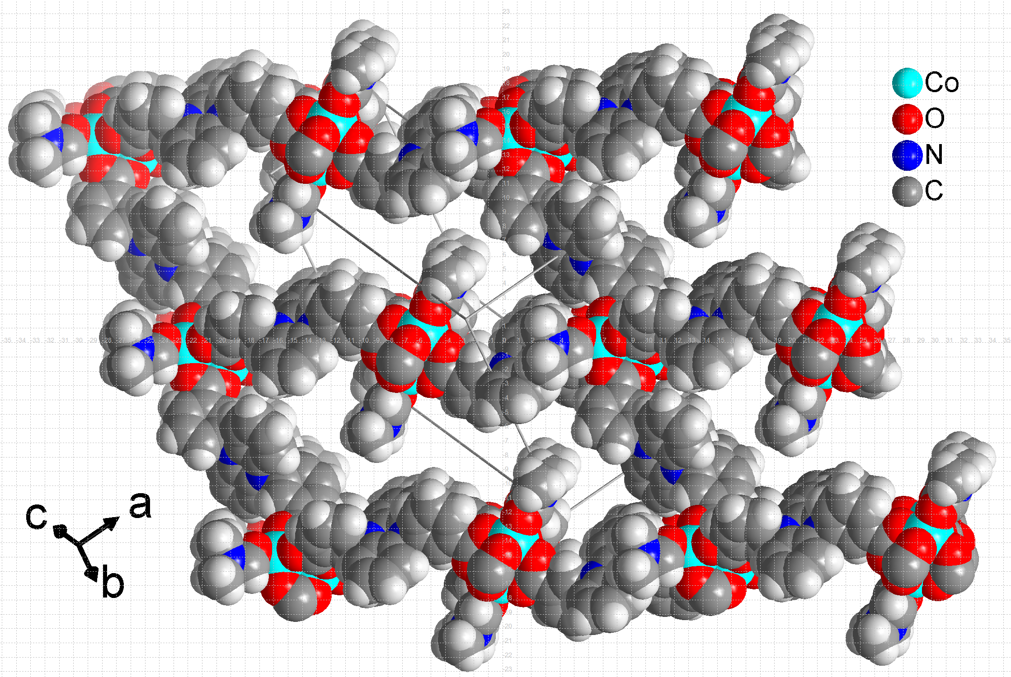
Figure S14. Space-filling view of the [Co(pdb)(DMF)] network with hydrogen atoms included. The edges of the square in the underyling grid are 1 Å.

Section S6 PXRD

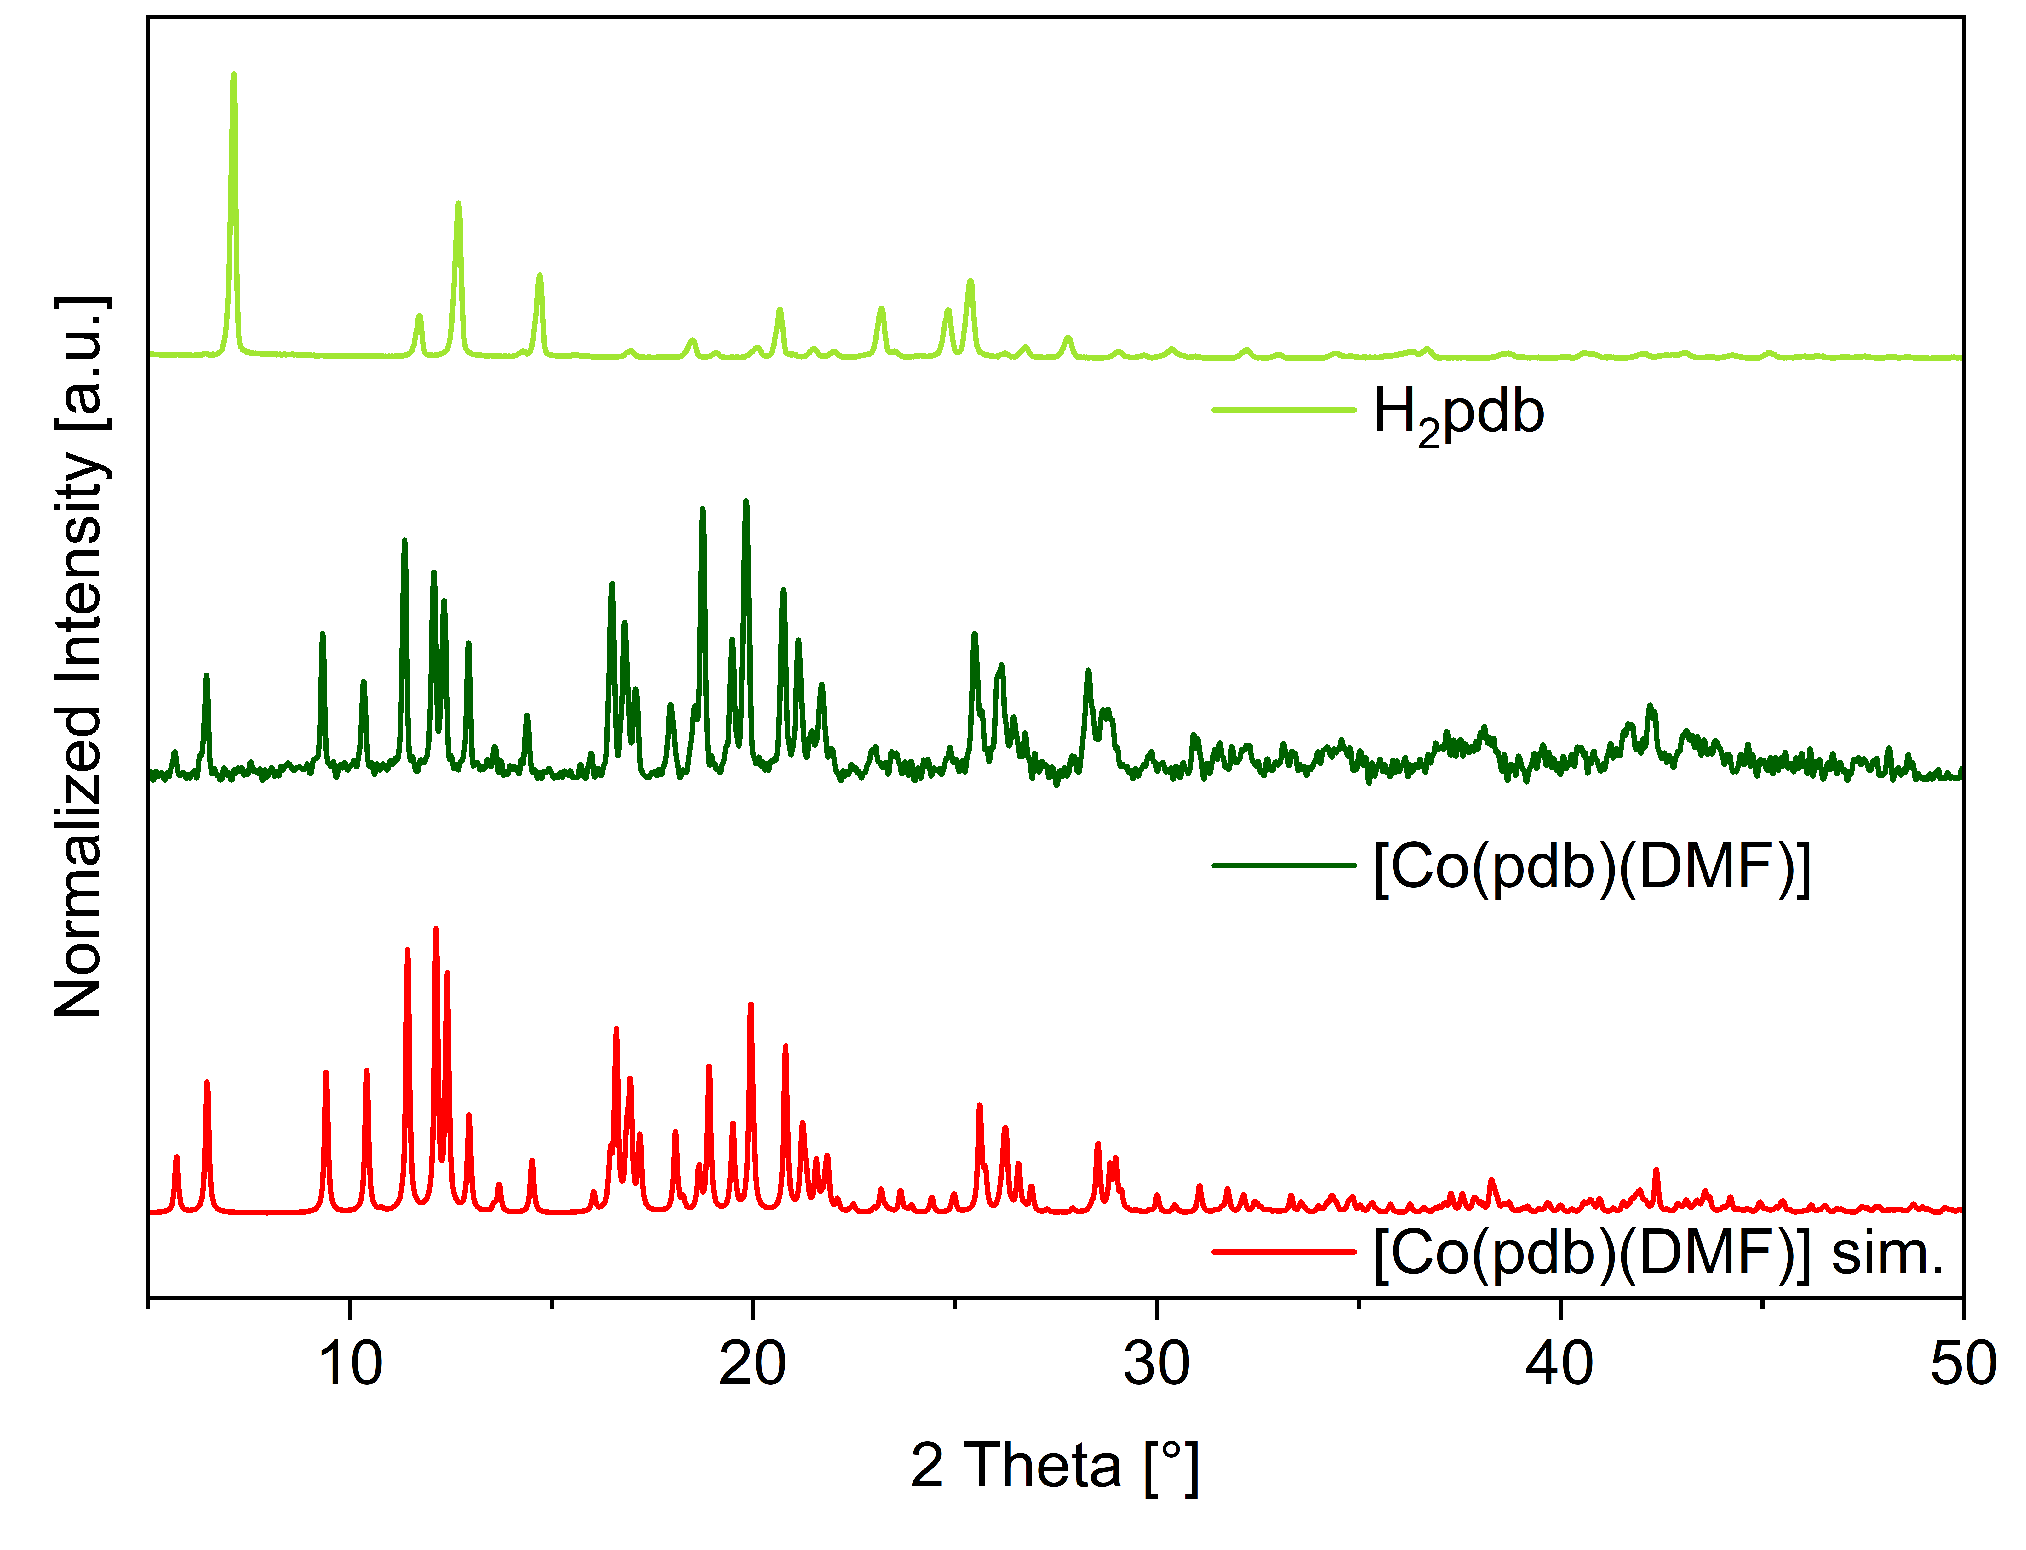
Figure S15. Powder X-ray diffraction patters of dimethyl 3,3'-(phenazine-5,10-diyl)dibenzoate (H₂pdb) (light green), Simulated (sim.) (red) and experimental powder X-ray diffraction patterns of [Co(pdb)(DMF)] (dark green).
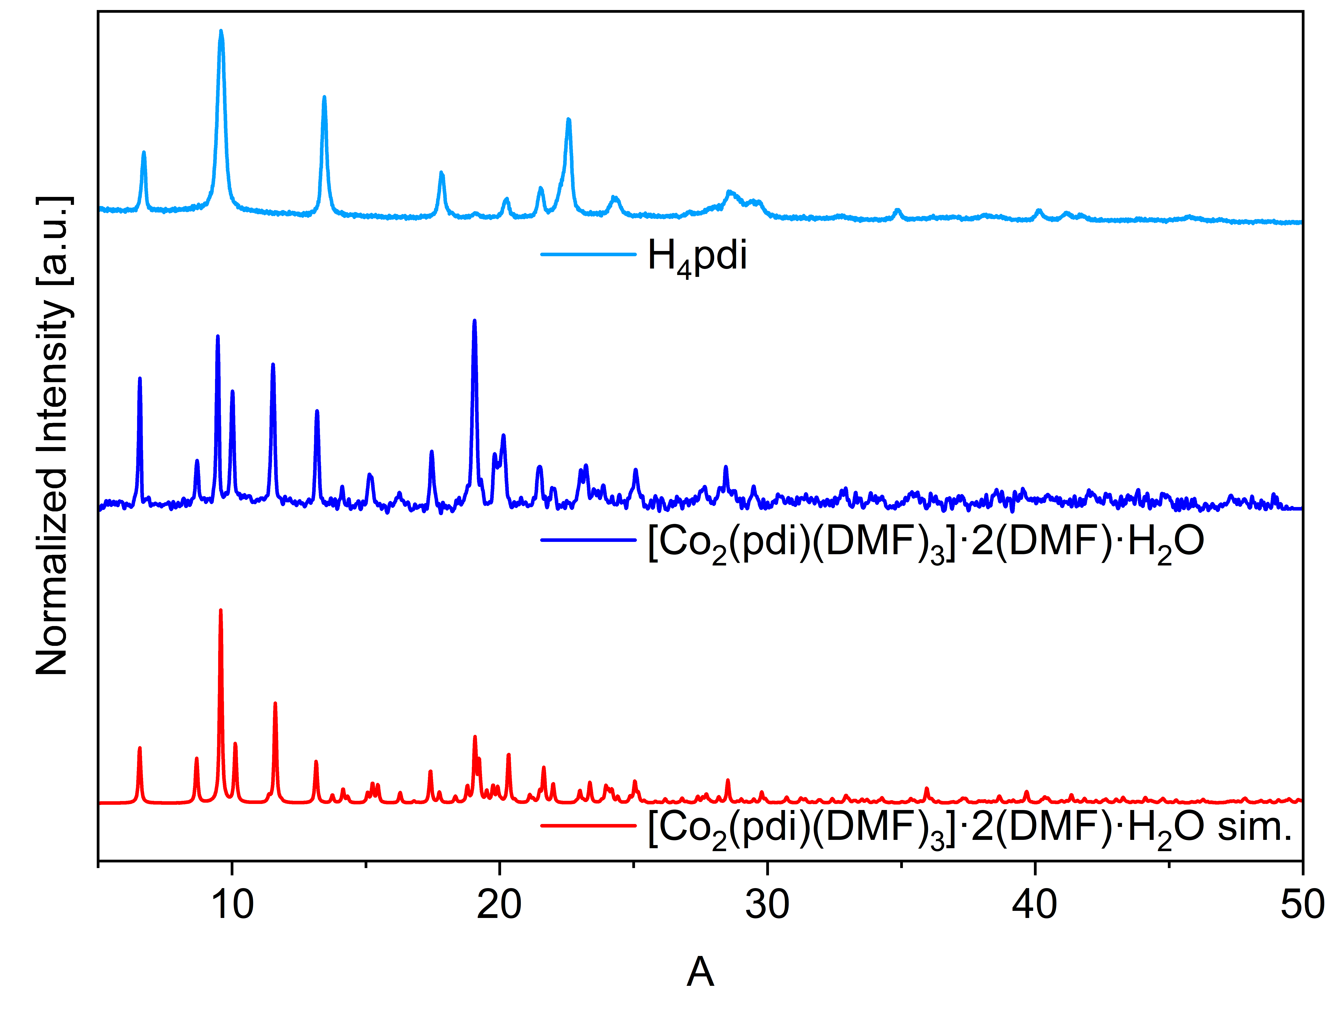
Figure S16. Powder X-ray diffraction patters of 5,5'-(phenazine-5,10-diyl)diisophthalic acid (H₄pdi) (light blue), simulated (sim.) (red) and experimental powder X-ray diffraction patterns of [Co₂(pdi)(DMF)₃]·2(DMF)·H₂O (dark blue).

Section S7 Thermogravimetric analyses

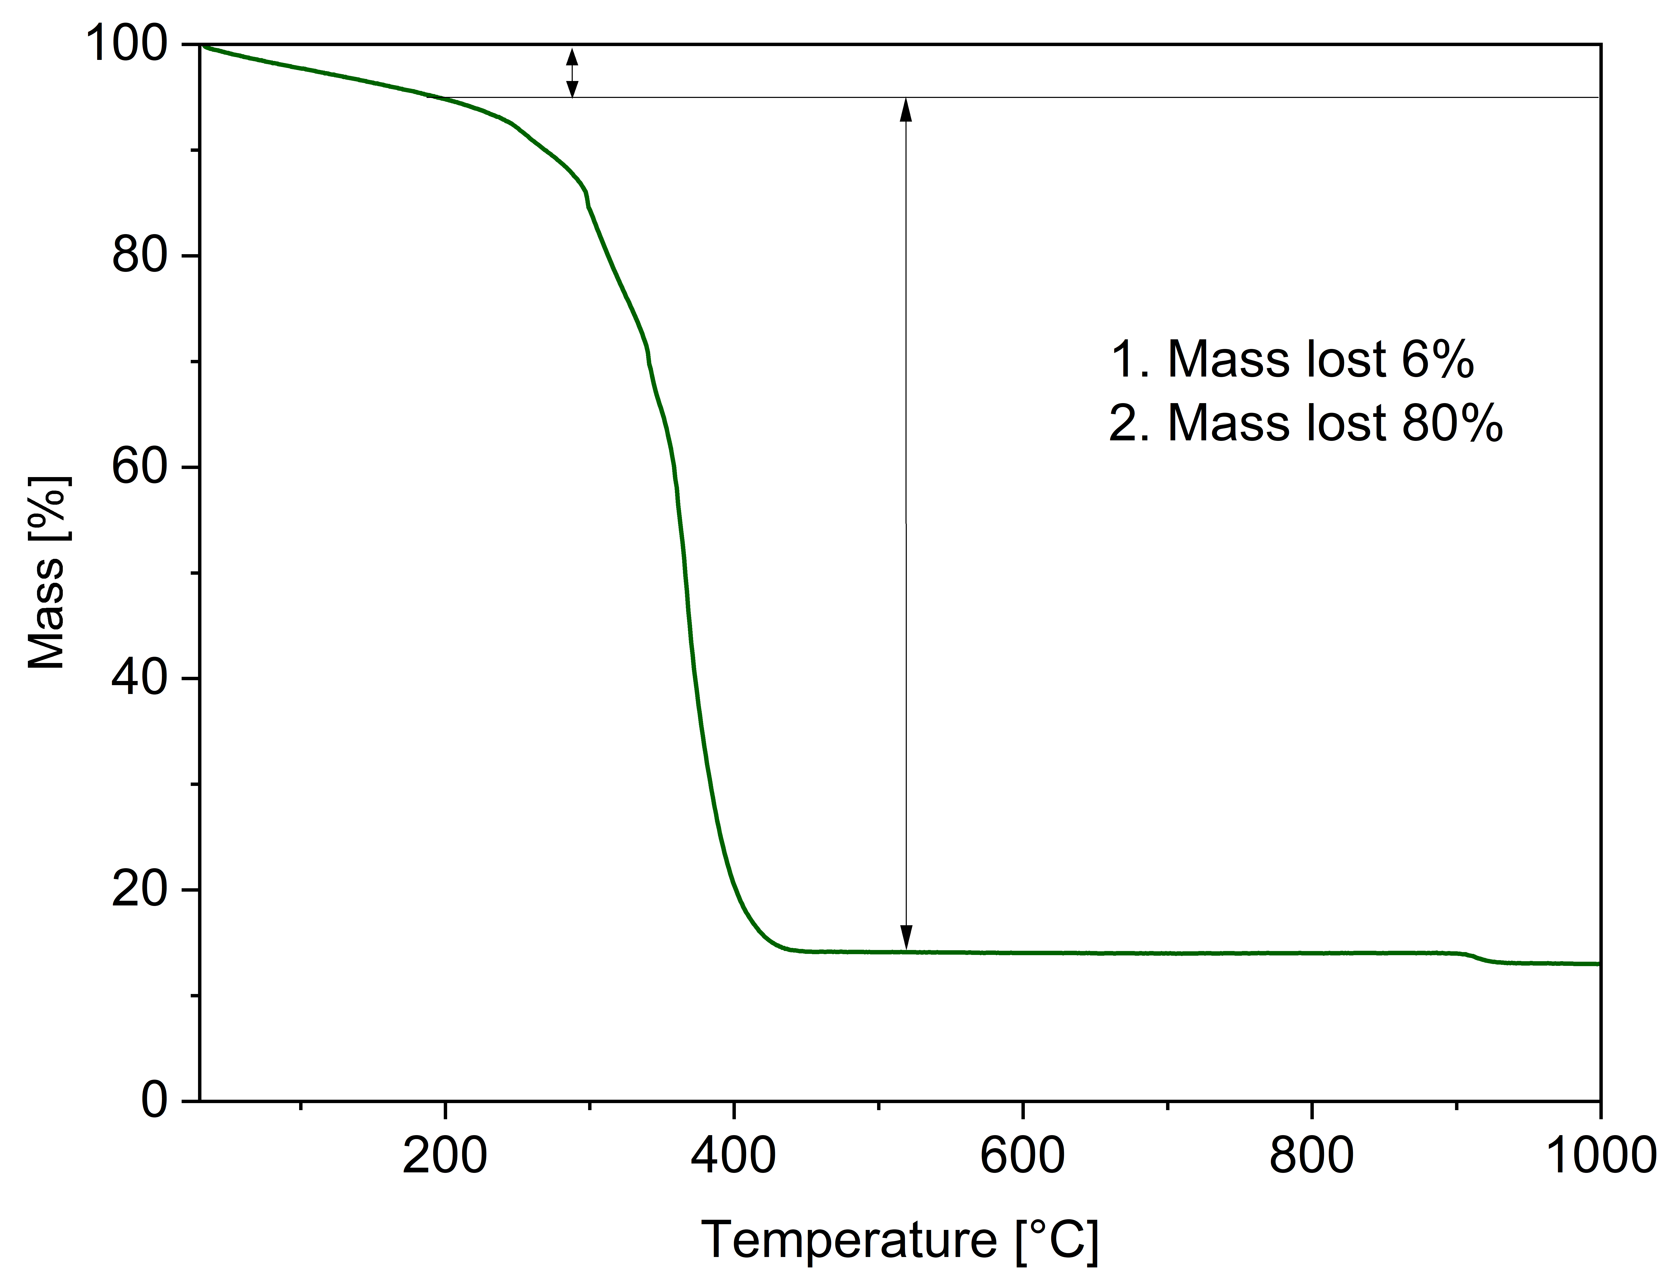
Figure S17. TGA of [Co(pdb)(DMF)] (carried out under synthetic air, heating rate 10 K min⁻¹).
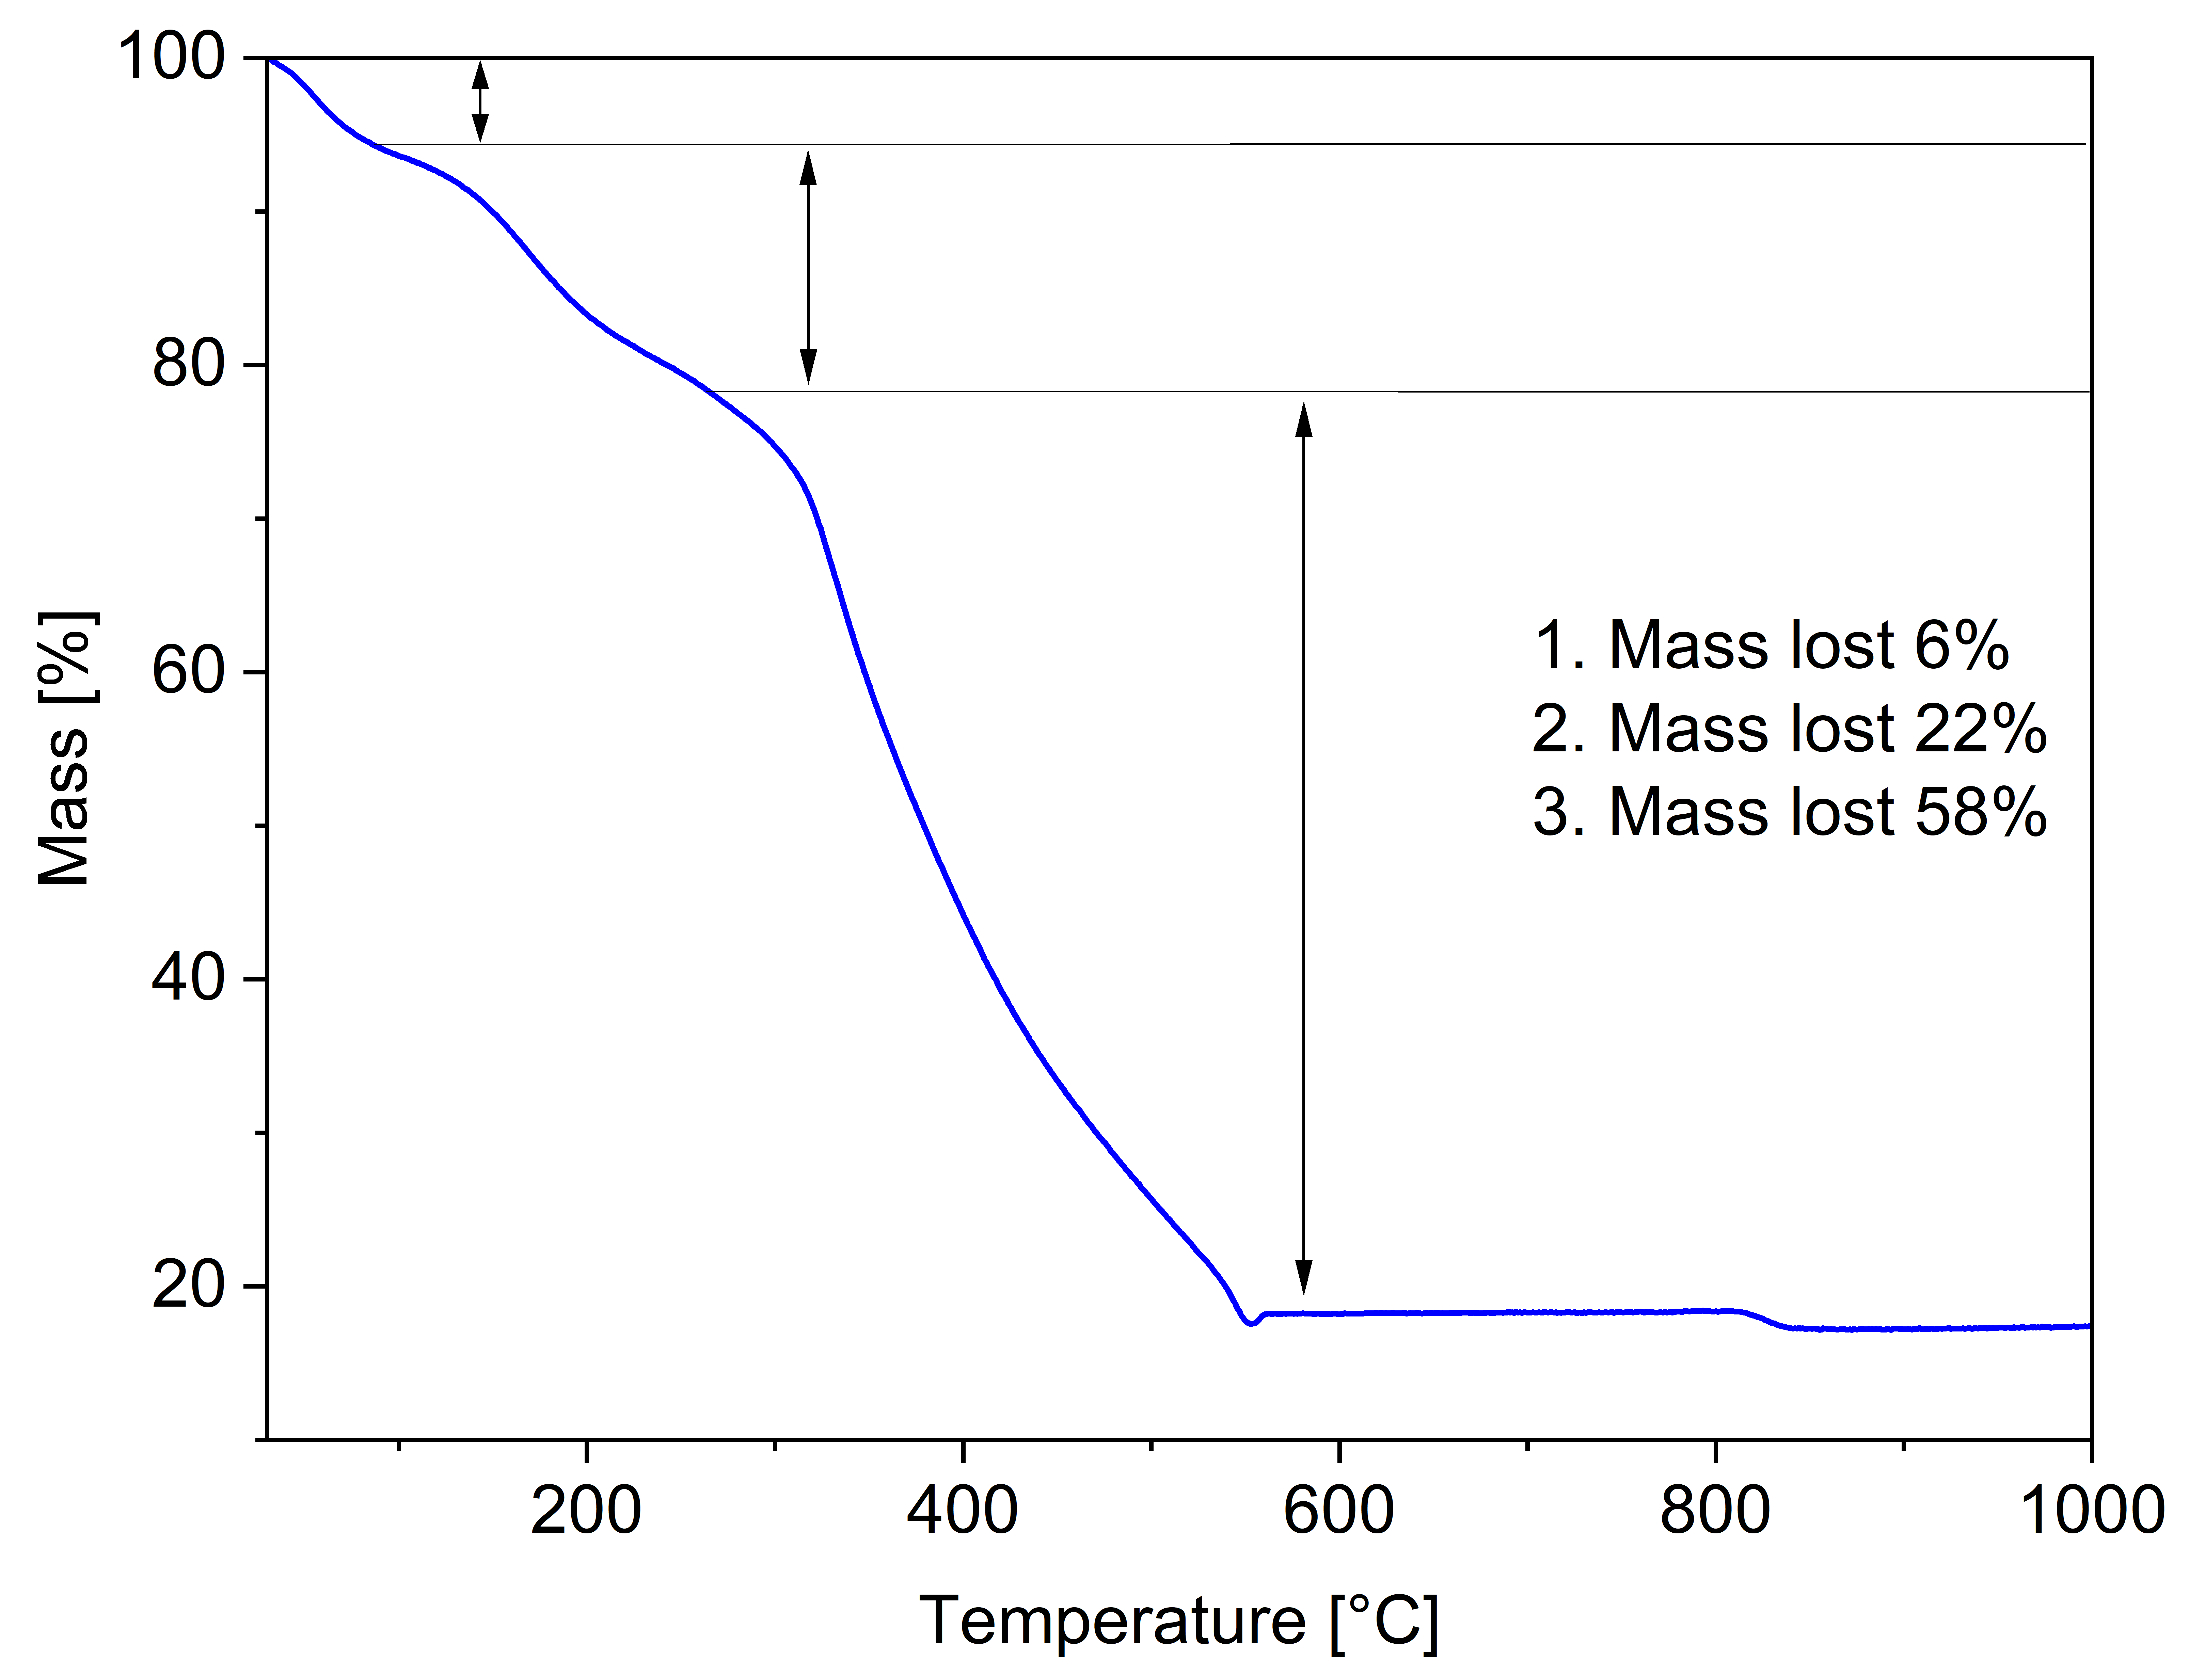
Figure S18. TGA of [Co₂(pdi)(DMF)₃]·2(DMF)·H₂O (carried out under nitrogen, heating rate 10 K min⁻¹). The mass loss percentage value are assigned somewhat arbitrarily in the absence of distinct plateaus. Especially between the second and third mass loss there is a rather continuous degradation, hence, the values of 22% and 58% are rather approximative.

