Supplementary Materials

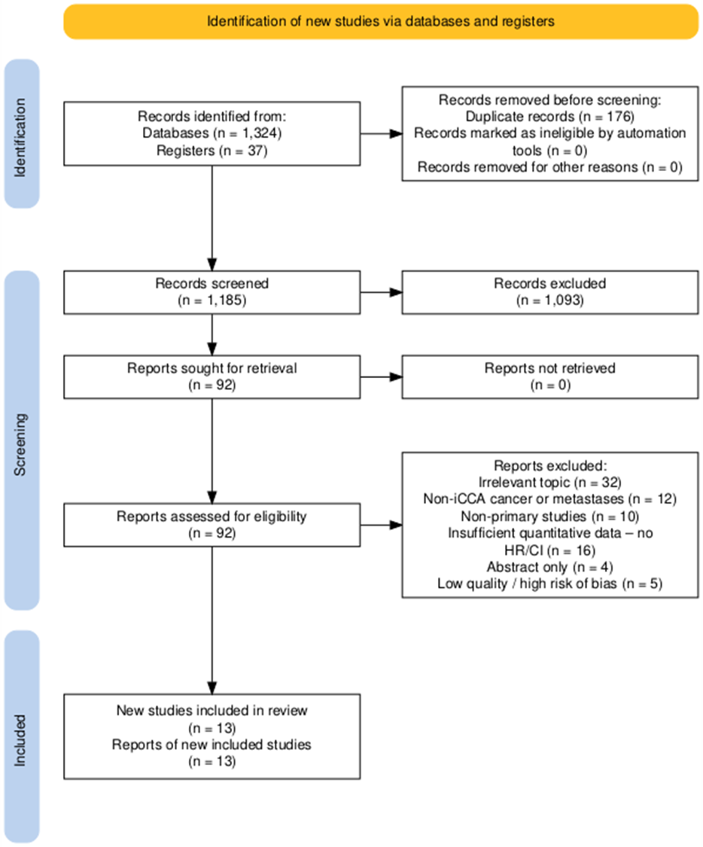
Figure 1. PRISMA 2020 flow diagram for study selection.

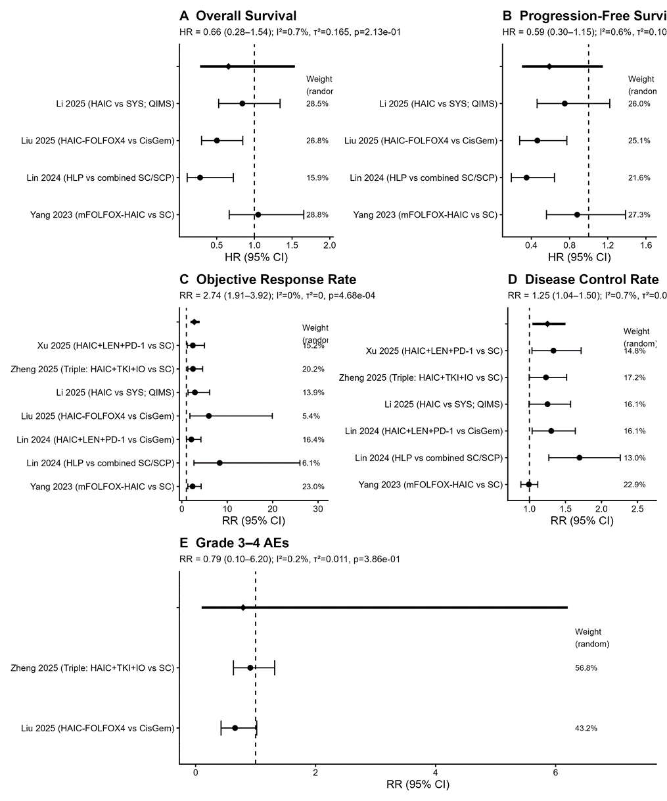
Figure 2. Forest plot — Overall survival (HR).

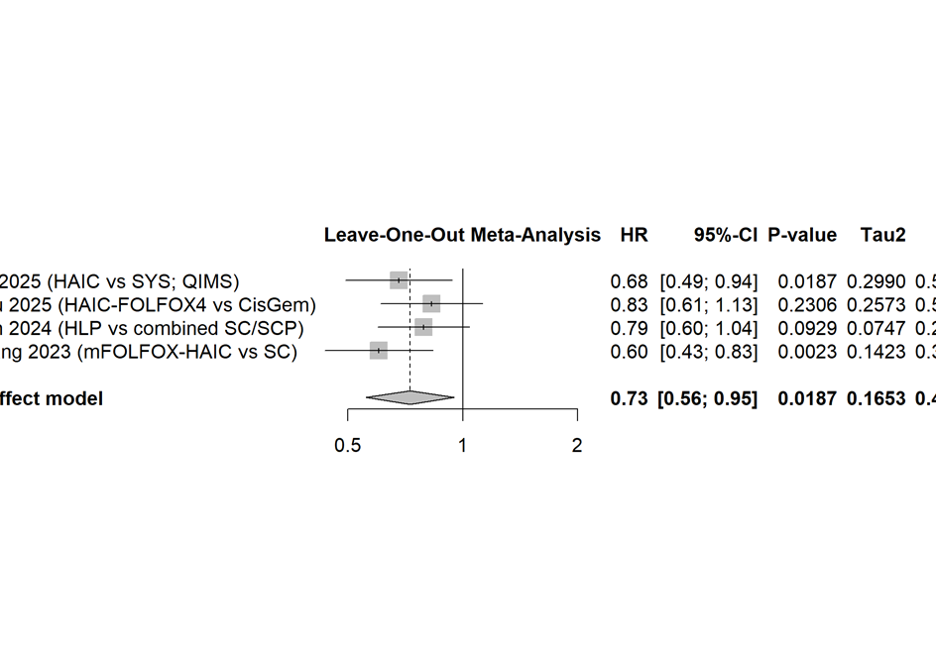
Figure 3. Forest plot — Progression-free survival (HR).
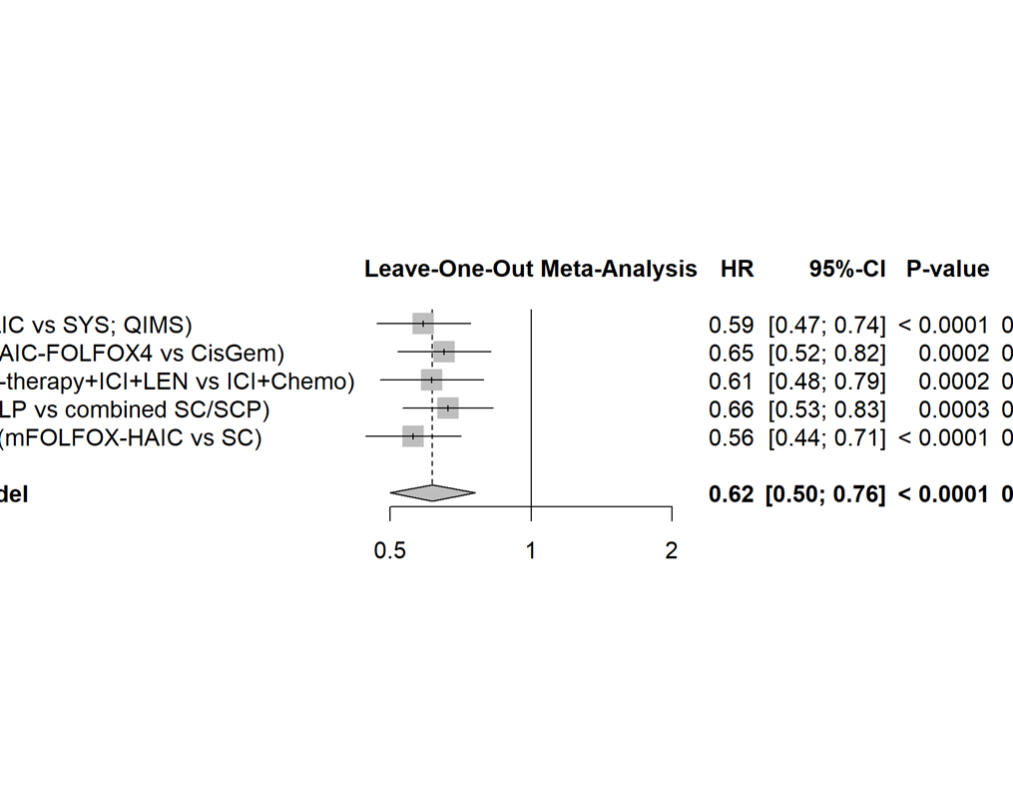
Figure 4. Forest plot — Objective response rate (RR).

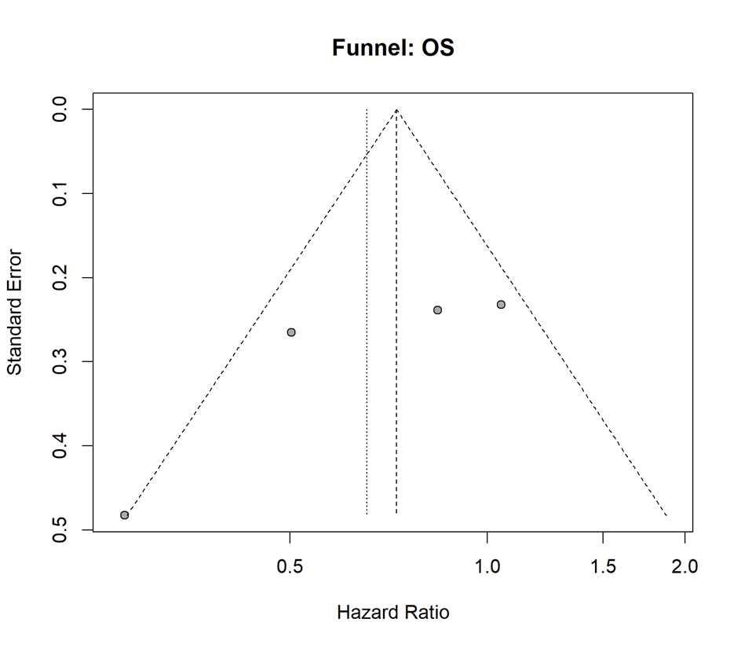
Figure 5. Forest plot — Disease control rate (RR).
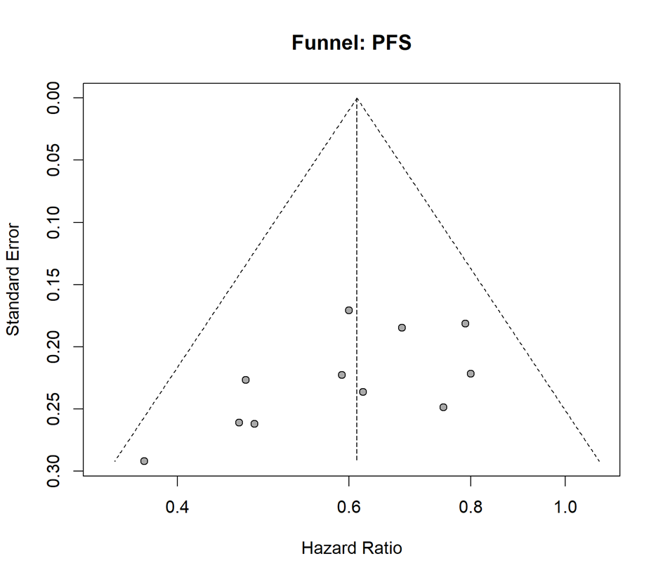
Figure 6. Forest plot — Grade 3–4 adverse events (RR).
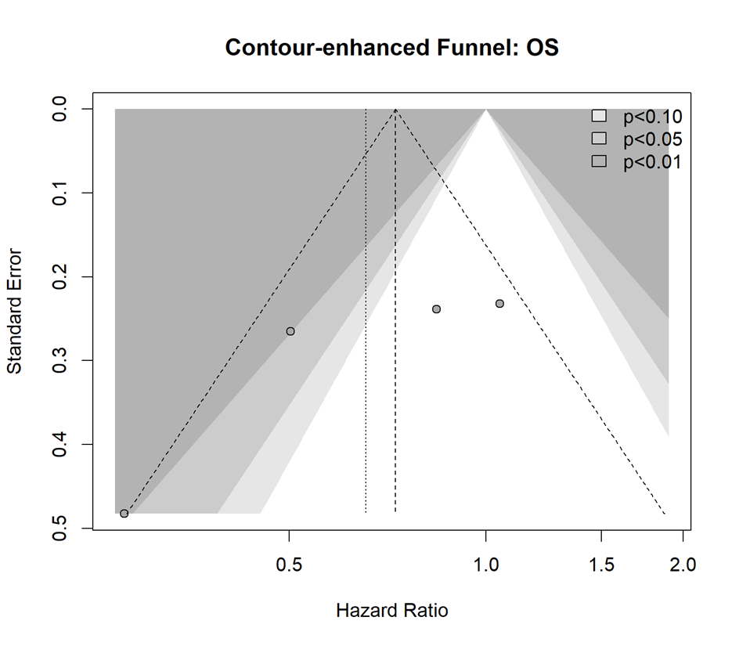
Figure 7. Funnel plot — Overall survival.
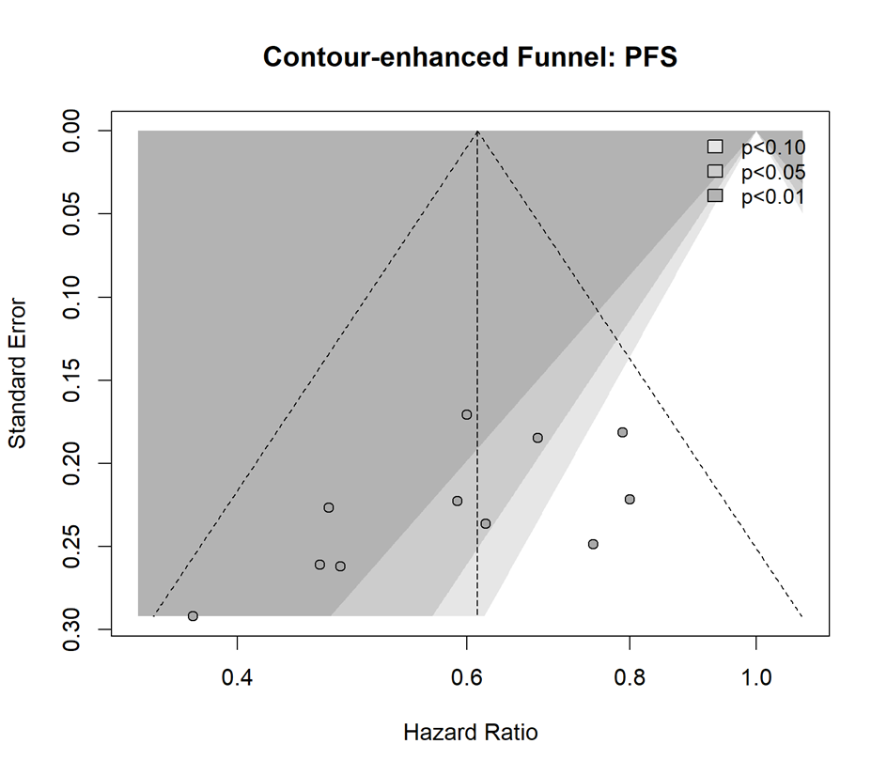
Figure 8. Funnel plot — Progression-free survival.
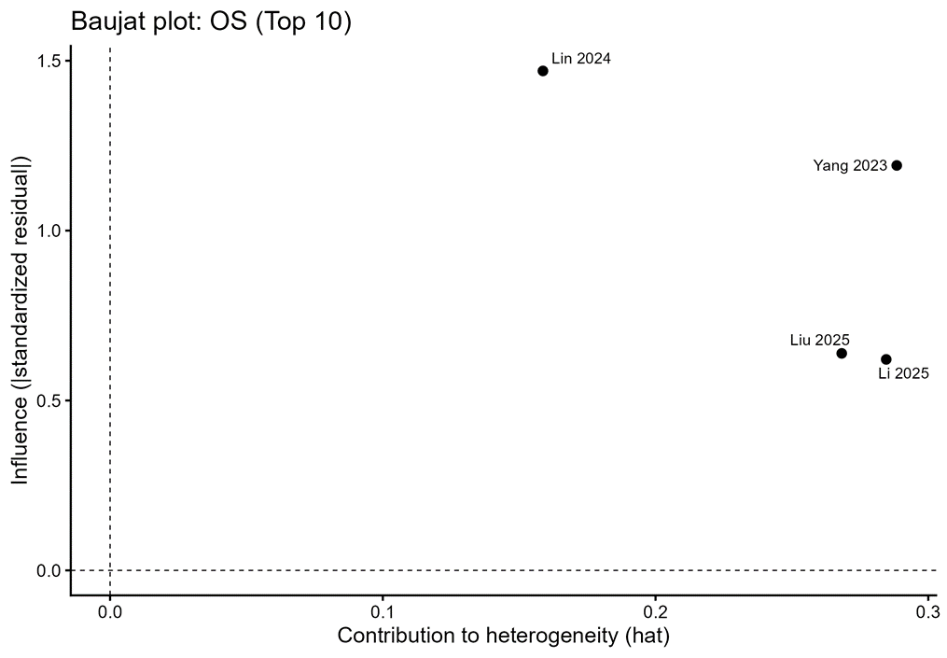
Figure 9. Baujat plot — Overall survival (top contributors).

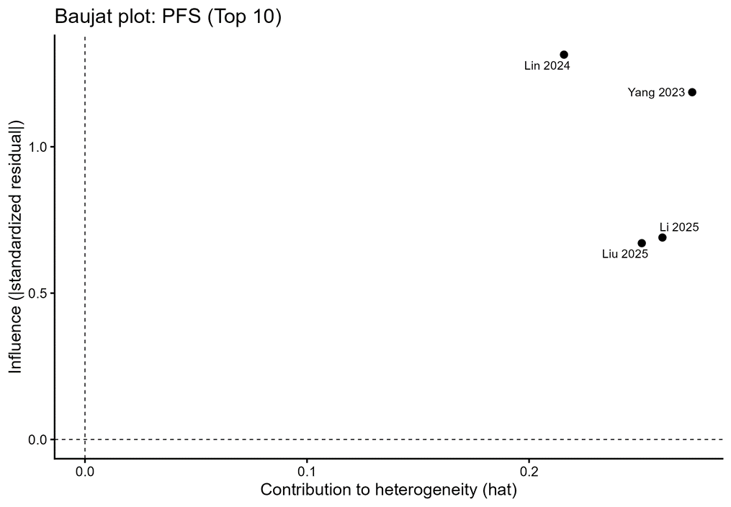
Figure 10. Baujat plot — Progression-free survival (top contributors).

