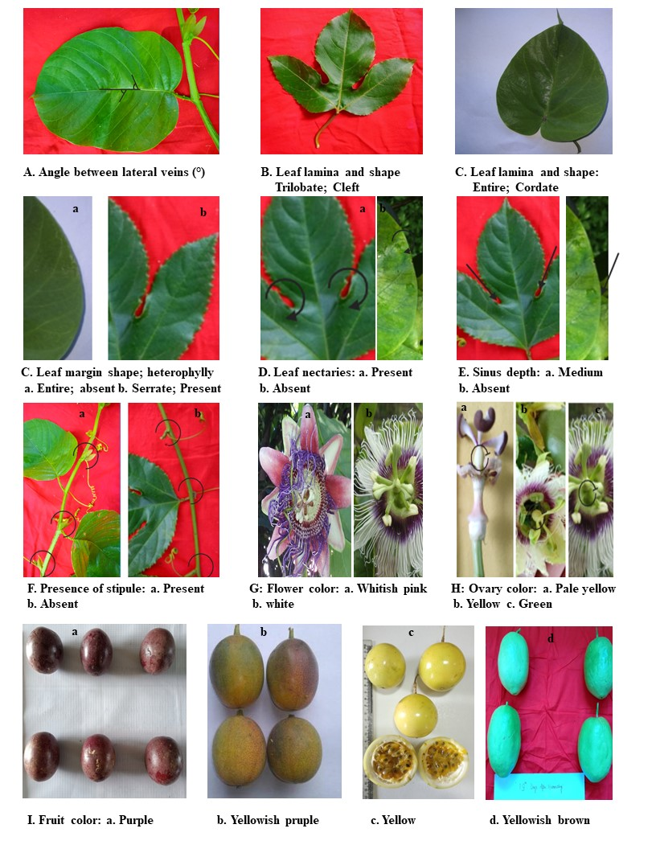
Figure 7. Morphological parameters recorded as per the descriptor suggested by De Jesus et al. (2017)

Table 4A Morphological characters of fifteen genotypes of Passiflora edulis f. flavicarpa Deg, Passiflora edulis Sim, Passiflora ligularis A. Juss and Passiflora quadrangularis L.
Species | code | Leaf shape | Leaf size | Leaf base size | Leaf color | Leaf margin shape | Division of leaf lamina | Presence of Leaf nectaries | Sinus depth | Presence  of heterophylly | Presence of  stipule
P. edulis f. flavicarpa Deg | P1 | Cleft | Medium | Hastate | Dark-green | Serrate | Trilobate | Present | Medium | Present | Absent
P. edulis f. flavicarpa Deg | P2 | Cleft | Medium | Hastate | Green | Serrate | Trilobate | Present | Medium | Present | Absent
P. edulis f. flavicarpa Deg | P3 | Cleft | Medium | Hastate | Green | Serrate | Trilobate | Present | Medium | Present | Absent
P. edulis f. flavicarpa Deg | P4 | Cleft | Medium | Hastate | Green | Serrate | Trilobate | Present | Medium | Present | Absent
P. edulis f. flavicarpa Deg | P5 | Cleft | Medium | Hastate | Green | Serrate | Trilobate | Present | Medium | Present | Absent
P. edulis f. flavicarpa Deg | P6 | Cleft | Medium | Hastate | Green | Serrate | Trilobate | Present | Medium | Present | Absent
Passiflora edulis Sim | P7 | Cleft | Medium | Hastate | Green | Serrate | Trilobate | Present | Medium | Present | Absent
Passiflora edulis Sim | P8 | Cleft | Medium | Hastate | Green | Serrate | Trilobate | Present | Medium | Present | Absent
Passiflora edulis Sim | P9 | Cleft | Medium | Hastate | Green | Serrate | Trilobate | Present | Medium | Present | Absent
Passiflora edulis Sim | P10 | Cleft | Medium | Hastate | Dark-green | Serrate | Trilobate | Present | Medium | Present | Absent
Passiflora edulis Sim | P11 | Cleft | Medium | Hastate | Green | Serrate | Trilobate | Present | Medium | Present | Absent
Passiflora edulis Sim | P12 | Cleft | Medium | Hastate | Dark-green | Serrate | Trilobate | Present | Medium | Present | Absent
Passiflora ligularis Juss | P13 | Cordate | Large | Cordate | Light-green | Entire | Entire | Absent | Absent | Absent | Present
Passiflora ligularis Juss | P14 | Cordate | Large | Cordate | Light-green | Entire | Entire | Absent | Absent | Absent | Present
Passiflora quadrangularis L. | P15 | Cordate | Large | Subcordate | Green | Entire | Entire | Absent | Absent | Absent | Present

Table 4B Morphological characters of fifteen genotypes of Passiflora edulis f. flavicarpa Deg, Passiflora edulis Sim, Passiflora ligularis A. Juss and Passiflora quadrangularis L.
Species | Code | Stem color | Flower color | Petal color | Ovary color | Fruit color | Fruit shape | Seed color
P. edulis f. flavicarpa Deg | P1 | Light green | White | White | Green | Yellow | Oblate | Black
P. edulis f. flavicarpa Deg | P2 | Light green | White | White | Green | Yellow | Oblate | Black
P. edulis f. flavicarpa Deg | P3 | Purplish-green | White | White | Green | Yellow | Oblate | Black
P. edulis f. flavicarpa Deg | P4 | Light green | White | White | Green | Yellow | Oblate | Black
P. edulis f. flavicarpa Deg | P5 | Light green | White | White | Green | Yellow | Ellipsoid | Black
P. edulis f. flavicarpa Deg | P6 | Purplish green | White | White | Green | Yellow | Oblate | Black
P. edulis Sim | P7 | Light green | White | White | Yellow | Purple | Oblate | Black
P. edulis Sim | P8 | Light green | White | White | Yellow | Purple | Oblate | Black
P. edulis Sim | P9 | Light green | White | White | Yellow | Purple | Oblate | Black
P. edulis Sim | P10 | Light green | White | White | Yellow | Reddish orange | Oblate | Black
P. edulis Sim | P11 | Light green | White | White | Yellow | Purple | Oblate | Black
P. edulis Sim | P12 | Light green | White | White | Yellow | Purple | Obate | Black
P. ligularis Juss | P13 | Light green | White | White | Greenish yellow | Yellowish purple | Ellipsoid | Black
P. ligularis Juss | P14 | Light green | White | White | Greenish yellow | Yellowish purple | Ellipsoid | Black
P. quadrangularis L. | P15 | Light green | whitish Pink | Light Red | Pale yellow | Yellowish brown | Oblong | Dark Brown

