Supplementary Information

The study of Raman scattering on S-DNTT-10 thin films

Modeled the molecular structure
The molecular formula derived from Ref [1] and the structure was modeled on the website named Molview (https://molview.org/) as Figure S1 shown. It was a free website with easily operational interface. It stored kinds of conventional molecular information in the database such as pentacene, DNTT. It supported the structure files which can be input into relevant calculated engineering software such as Gaussian 09W.
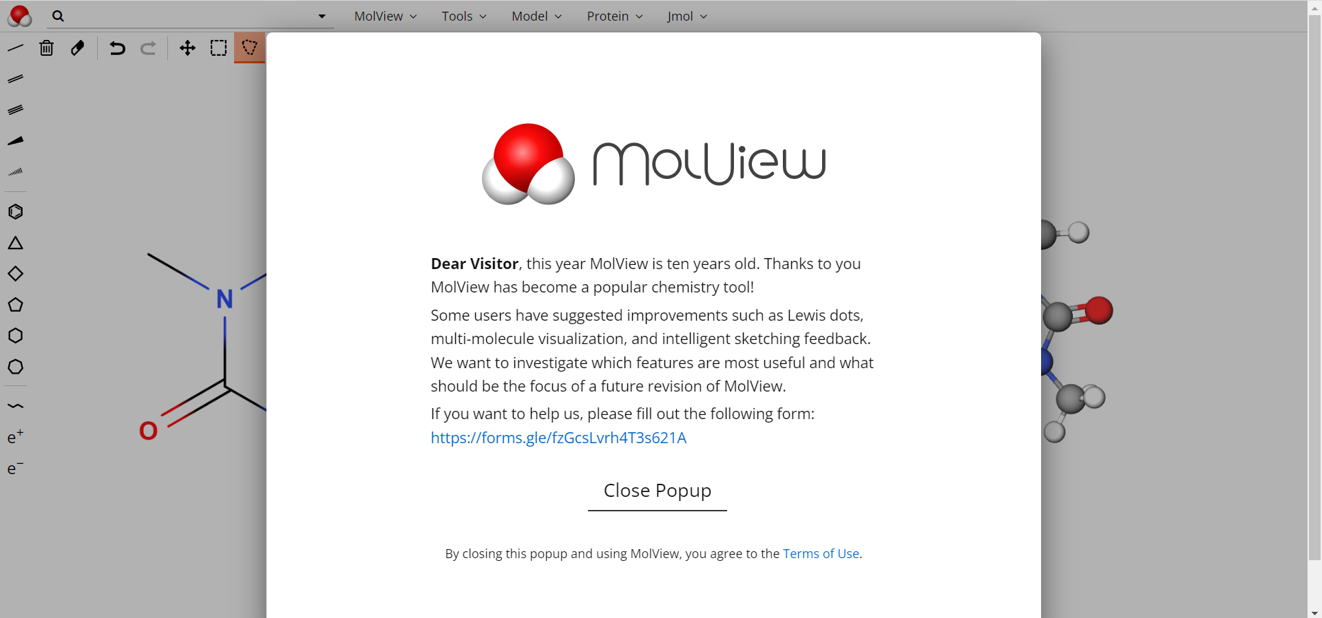
(a)
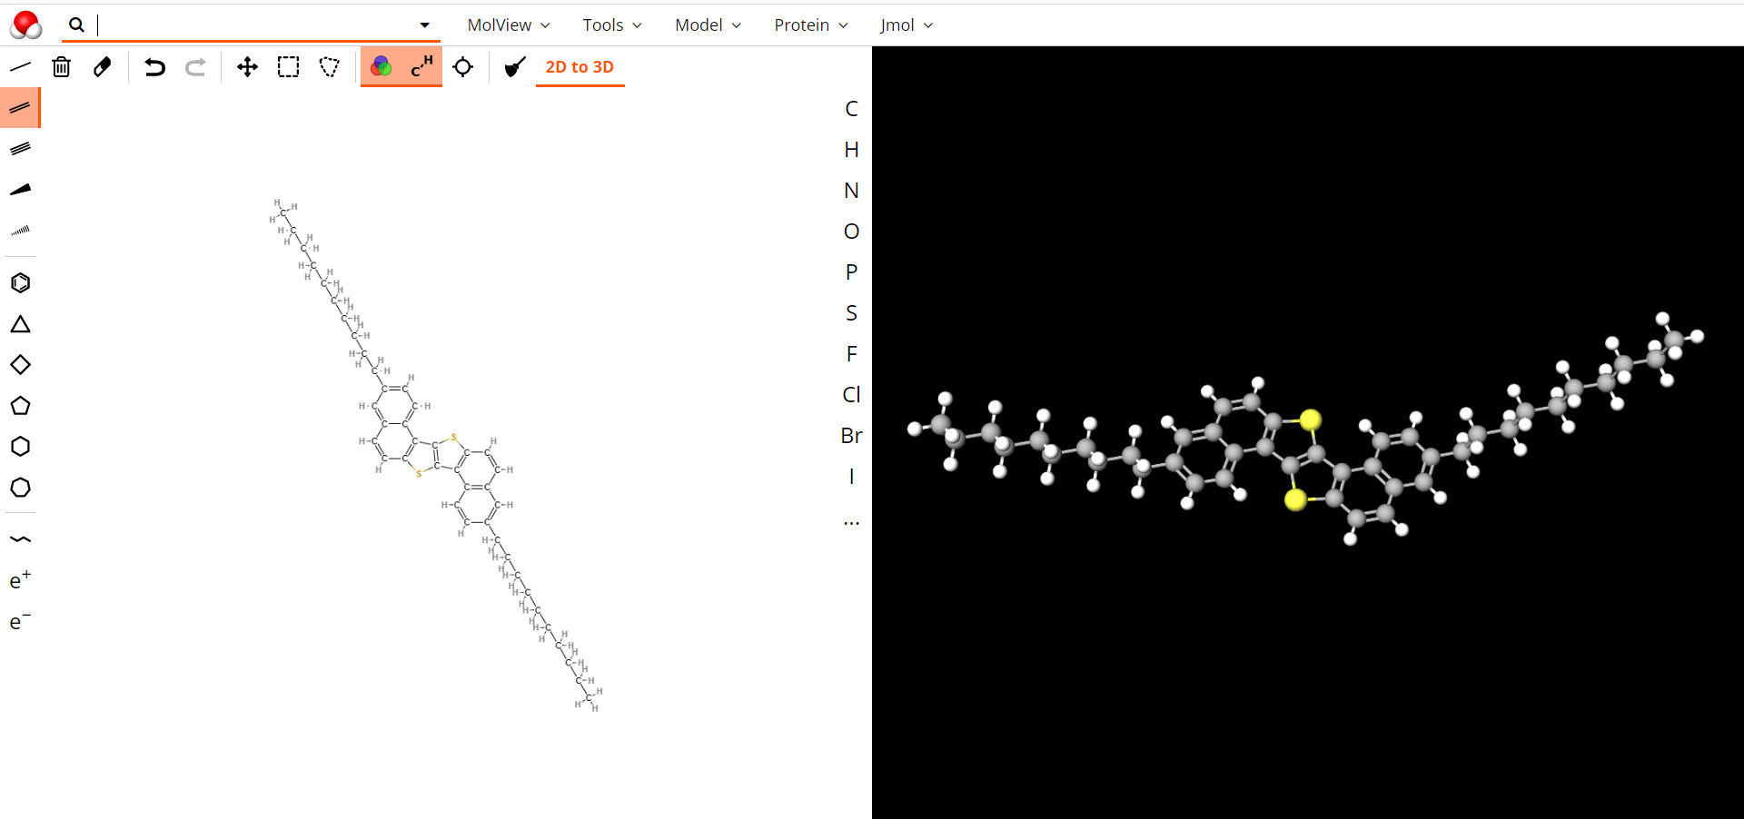
(b)
Figure S1. (a) The illustration of interface of Molview website. (b)The model of S-DNTT-10 molecule was established in the interface. The left part suggested the 2D structure and the right part represented the 3D structure.

DFT calculation
The DFT (Density Functional Theory) was one common method of quantum chemical calculation and meanwhile it was essential to Gaussian calculated software. It can assist to obtain the theoretical Raman spectrum and supply the details of vibrational modes. The proved standard of results was the value of imaginary frequency was zero. And it exhibited the whole Raman vibrational spectrum of one single S-DNTT-10 molecule.

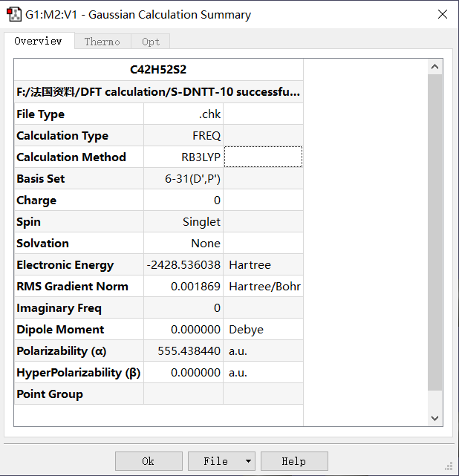
(a)
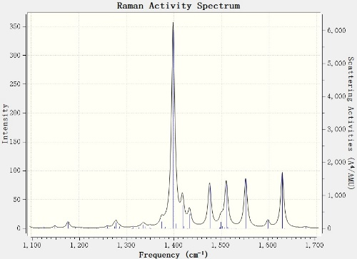
(b)
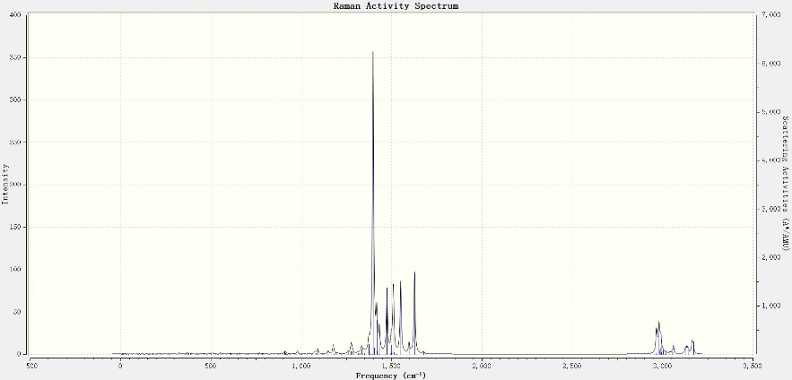
(c)
Figure S2. (a) The value of imaginary frequency in the Gaussian Calculation Summary. (b) The partial spectrum ranging from 1100cm⁻¹ to 1700cm⁻¹. (c) The entire Raman vibrational spectrum of one single S-DNTT-10 molecule.

The raw data of Raman map
Figure S3. The raw data of Raman spectrums on S-DNTT-10/Au thin-films under 785 nm excitation source.

Reference
[1] Yamaguchi, Y. et al. Solution-Processable Organic Semiconductors Featuring S-Shaped Dinaphthothienothiophene (S-DNTT): Effects of Alkyl Chain Length on Self-Organization and Carrier Transport Properties. Chem. Mater. 32, 5350–5360 (2020).

