Supplementary Material for Article
Advanced Efficient Feature Selection Integrating Augmented Extreme Learning Machine and Particle Swarm Optimization for Predicting Nitrogen Use Efficiency and Yield in Corn
Josselin Bontemps ^{1,}*, Isa Ebtehaj ¹, Gabriel Deslauriers ², Alain N. Rousseau ³, Hossein Bonakdari ⁴, and Jacynthe Dessureault-Rompré ¹
¹ Department of Soils and Agri-Food Engineering, Université Laval, Québec, QC G1V 0A6, Canada
² PleineTerre Inc., 169 Rue St-Jacques, Napierville, Québec, QC J0J 1L0, Canada
³ Institut National de la Recherche Scientifique–Centre Eau Terre Environnement, Québec, Canada
⁴ Department of Civil Engineering, University of Ottawa, Ottawa, ON K1N 6N5, Canada
* Correspondence: josselin.bontemps.1@ulaval.ca

Supplementary Table S1. Descriptive statistics of the inputs and outputs
Variable | Minimum | Mean | Maximum | Standard Deviation | Kurtosis | Skewness
Yield | 1772.38 | 11419.32 | 17277.46 | 2460.29 | 0.44 | -0.80
NHI | 0.06 | 0.53 | 0.91 | 0.19 | -1.00 | -0.60
ANUE | -80.96 | 23.18 | 145.83 | 22.09 | 3.87 | 0.82
N_Rate | 0.00 | 100.08 | 200.00 | 70.71 | -1.30 | 0.00
Texture | 1.00 | 1.60 | 3.00 | 0.74 | -0.75 | 0.81
Tillage | 1.00 | 2.13 | 3.00 | 0.55 | 0.09 | 0.06
pH | 4.97 | 6.08 | 7.43 | 0.53 | -0.70 | 0.18
OrgMat | 1.18 | 3.55 | 7.99 | 1.30 | 0.12 | 0.66
P_M3 | 7.09 | 82.23 | 513.54 | 81.09 | 10.18 | 2.86
K_M3 | 12.86 | 222.69 | 849.53 | 158.93 | 1.11 | 1.20
Ca_M3 | 751.79 | 3622.96 | 11593.74 | 2331.04 | 1.01 | 1.23
Mg_M3 | 17.57 | 547.75 | 2514.16 | 505.77 | 2.32 | 1.59
Al_M3 | 393.50 | 883.32 | 1639.50 | 234.42 | -0.03 | 0.36
Init_NO3 | 1.92 | 10.50 | 37.77 | 5.35 | 4.22 | 1.69
Tassel_NO3 | 0.00 | 33.44 | 380.72 | 46.29 | 12.64 | 3.04
Harvest_NO3 | 0.00 | 20.59 | 254.98 | 27.97 | 16.06 | 3.25
BD_0_15 | 0.69 | 1.33 | 1.74 | 0.15 | 0.61 | -0.38
BD_15_30 | 0.98 | 1.43 | 1.83 | 0.14 | -0.14 | -0.10
BD_30_45 | 0.64 | 1.46 | 1.82 | 0.16 | 1.94 | -0.47
BG | 0.35 | 18.46 | 121.93 | 16.04 | 5.37 | 2.07
Init_BG | 1.88 | 20.08 | 113.86 | 16.26 | 5.12 | 1.78
NAG | 0.14 | 15.31 | 90.41 | 15.80 | 0.65 | 1.25
Init_NAG | 0.72 | 11.31 | 40.15 | 11.85 | -0.98 | 0.84
FDA | 0.00 | 13839.02 | 112064.54 | 14269.95 | 8.19 | 2.42
Init_FDA | 361.49 | 20659.75 | 79348.00 | 14690.79 | 1.40 | 1.23
RM | 0.11 | 3.70 | 8.95 | 1.29 | 0.32 | 0.68
Init_RM | 1.56 | 3.91 | 7.89 | 1.13 | 0.17 | 0.45
PRT | 0.89 | 4.01 | 17.40 | 1.83 | 7.33 | 2.04
Init_PRT | 1.02 | 3.67 | 9.70 | 1.68 | 1.75 | 1.33
CHU_May | 261.88 | 379.29 | 480.87 | 45.69 | -0.44 | -0.25
CHU_June | 517.91 | 703.94 | 828.53 | 84.96 | -1.07 | -0.58
CHU_July | 661.86 | 782.91 | 934.31 | 74.10 | -0.99 | 0.30
CHU_August | 608.06 | 693.96 | 792.61 | 42.76 | -0.72 | 0.20
CHU_September | 571.39 | 690.57 | 808.78 | 54.18 | -0.56 | -0.47
CHU_October | 0.00 | 260.76 | 412.54 | 116.91 | 0.61 | -1.39
Rain_May | 21.30 | 50.19 | 110.60 | 16.72 | 2.30 | 1.24
Rain_June | 25.20 | 109.57 | 248.70 | 59.19 | -0.45 | 0.68
Rain_July | 55.20 | 134.52 | 277.80 | 61.77 | -0.31 | 0.79
Rain_August | 7.30 | 72.43 | 125.60 | 31.00 | -1.01 | -0.26
Rain_September | 43.80 | 108.40 | 202.80 | 39.81 | -0.57 | 0.64
Rain_October | 0.00 | 68.61 | 176.30 | 46.05 | -0.60 | 0.29

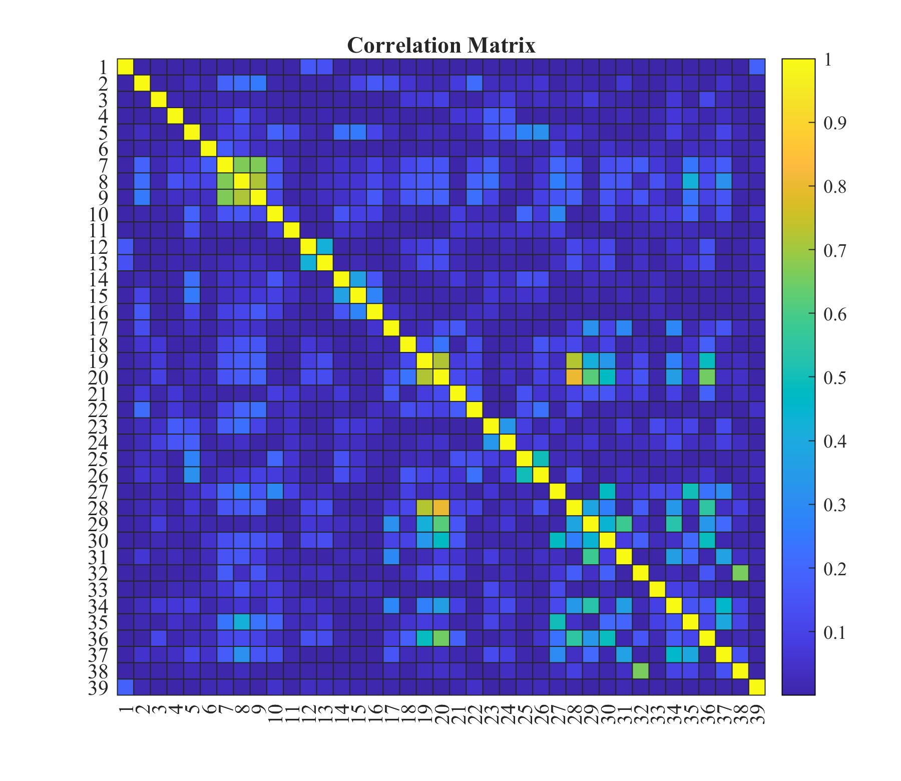
(a) Correlations for Yield (1 to 38 are the inputs N_Rate to Rain_October, respectively, and the 39 is the ouput Yield)
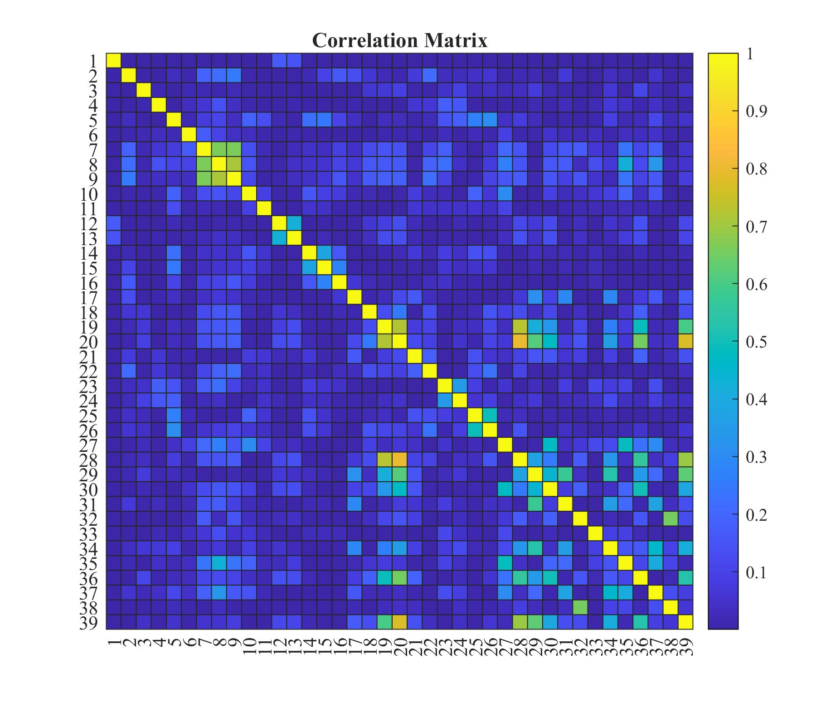
(b) Correlations for NHI (1 to 38 are the inputs N_Rate to Rain_October, respectively, and the 39 is the ouput NHI)
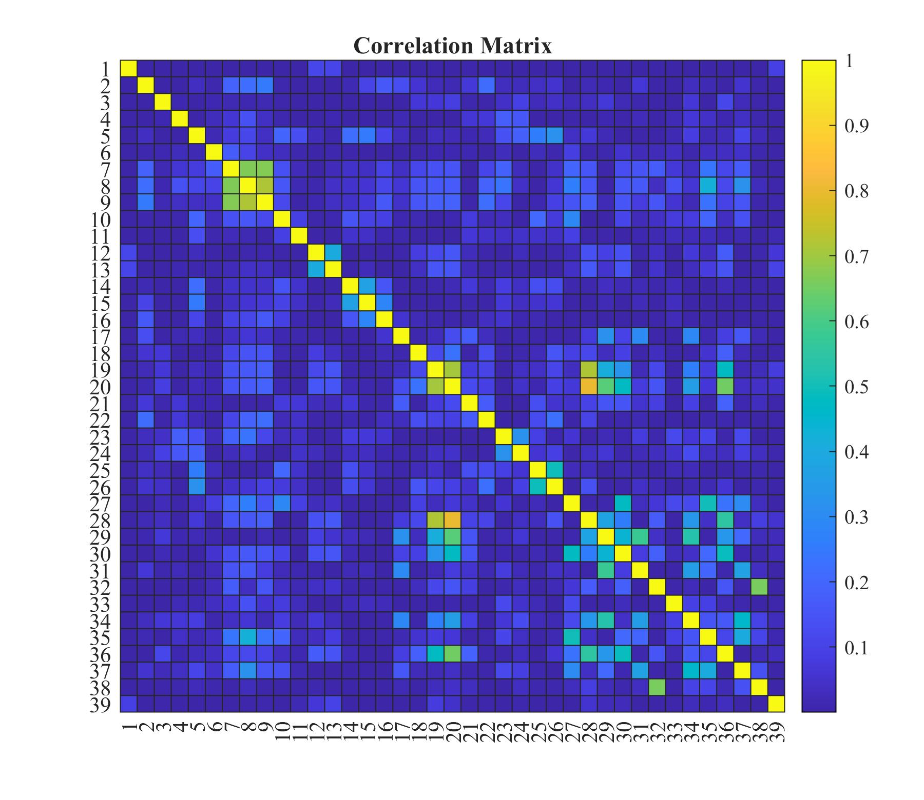
(c) Correlations for ANUE (1 to 38 are the inputs N_Rate to Rain_October, respectively, and the 39 is the ouput ANUE)
Supplementary Figure S1. Heatmap of Correlation Between Inputs and Outputs

