Supplementary file
Coordinated cpSRP43 and cpSRP54 abundance is essential for tetrapyrrole biosynthesis while cpSRP43 is independent of retrograde signaling
Shuiling Ji^{1,2,*} , Bernhard Grimm^{2,*}

¹ Key Laboratory of Pesticide & Chemical Biology of Ministry of Education, Hubei Key Laboratory of Genetic Regulation and Integrative Biology, School of Life Sciences, Central China Normal University, Wuhan, China
² Institute of Biology/Plant Physiology, Humboldt-Universität zu Berlin, Philippstr.13, Building 12, 10099, Berlin, Germany
* Correspondence:
Shuiling Ji - shuiling.ji@ccnu.edu.cn
Bernhard Grimm - bernhard.grimm@rz.hu-berlin.de

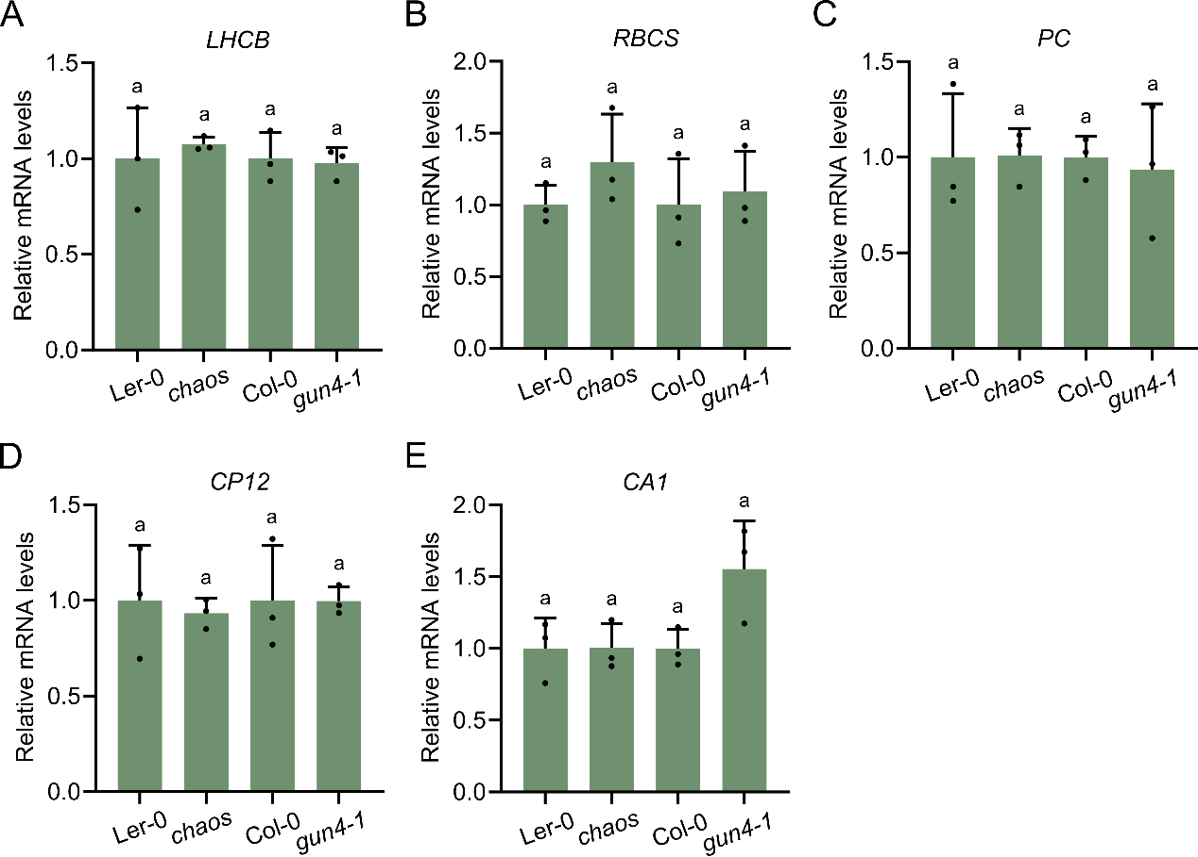
Figure S1. Expression of nuclear-encoded photosynthesis-associated genes (PhANGs) in chaos and gun4-1 mutants under standard conditions (without NF). (A–E) Relative mRNA levels of (A) LHCB, (B) RBCS, (C) PC, (D) CP12, and (E) CA1 in Ler-0, the chaos (cpSRP43-deficient) mutant, Col-0, and the gun4-1 mutant. All data are presented as the mean ± SD from three biological replicates, with individual data points shown as small black dots. Letters above the bars indicate statistically significant differences (P < 0.05) determined by one-way ANOVA followed by Tukey’s multiple comparisons test.

Table S1. Genotypes used and analyzed in this study
Line | Gene ID | Description | Source
Col-0 | - | Arabidopsis Columbia wild type (WT) | -
Ler-0 | - |  | -
  Arabidopsis Landsberg erecta wild type (WT)
chaos | AT2G47450 | cpSRP43 knock-out mutant | [1]
cpSRP43-OX | AT2G47450 | chaos complementation line expressing cpSRP43 | [2]
ffc | AT1G15310 | cpSRP54 knock-out mutant | [3]
cpSRP54-OX | AT1G15310 | ffc complementation line expressing cpSRP43 | [4]
ffc/chaos | AT2G47450  AT1G15310 | cpSRP43 and cpSRP54 double knock-out mutant | [3]
cpSRP54-OX/chaos | AT1G15310  AT2G47450 | Overexpressing cpSRP54 in chaos | This study
cpSRP43-OX/ffc | AT2G47450  AT1G15310 | Overexpressing cpSRP43 in ffc | This study
gun4-1 | AT3G59400 | Leu88->Phe8 mutation in GUN4 | [5]
gun4-3 | AT3G59400 | T-DNA within the coding region of the C terminus in GUN4 | [5]
gun5-1 | AT5G13630 | Ala990->Val990 mutation in CHLH/GUN5 | [6]
gun4-1/chaos | AT3G59400  AT2G47450 | gun4-1 and chaos double mutant | This study
gun4-3/chaos | AT3G59400  AT2G47450 | gun4-3 and chaos double mutant | This study
gun5-1/chaos | AT5G13630  AT2G47450 | gun5-1 and chaos double mutant | This study

Table S2. List of primers used in this study
Name | Sequences (5’->3’) | Reference | Purpose
Actin2- Fw | CTTCCCTCAGCACATTCCAG | [7] | qPCR
Actin2- Rev | GACCTGCCTCATCATACTCG | [7] | qPCR
LHCB- Fw | GGACTTGCTTTACCCCGGTG | [7] | qPCR
LHCB- Rev | TCGGTAGCAAGACCCAATGG | [7] | qPCR
CA1- Fw | TGTGTCCATCACACGTTCTGG | [7] | qPCR
CA1- Rev | GGACCACGAAGGCATCTCCT | [7] | qPCR
RBCS- Fw | GCAACGGCGGAAGAGTTAAC | [7] | qPCR
RBCS- Rev | TCTTTCCAATCGGAGGCCA | [7] | qPCR
PC- Fw | TGGTGTTCGACGAAGACGAG | [7] | qPCR
pc- Rev | AGATCTTGCTTGCGTCCACA | [7] | qPCR
CP12- Fw | CGGACCCTTTGGAGGAATACTG | [7] | qPCR
CP12- Rev | GGCACTCGTTGGTCTCAGGA | [7] | qPCR

References:
1. Klimyuk, V.I.; Persello-Cartieaux, F.; Havaux, M.; Contard-David, P.; Schuenemann, D.; Meiherhoff, K.; Gouet, P.; Jones, J.D.; Hoffman, N.E.; Nussaume, L. A chromodomain protein encoded by the Arabidopsis CAO gene is a plant-specific component of the chloroplast signal recognition particle pathway that is involved in LHCP targeting. The Plant cell 1999, 11, 87-99.
2. Wang, P.; Liang, F.C.; Wittmann, D.; Siegel, A.; Shan, S.O.; Grimm, B. Chloroplast SRP43 acts as a chaperone for glutamyl-tRNA reductase, the rate-limiting enzyme in tetrapyrrole biosynthesis. Proceedings of the National Academy of Sciences of the United States of America 2018, 115, E3588-E3596, doi:10.1073/pnas.1719645115.
3. Amin, P.; Sy, D.A.; Pilgrim, M.L.; Parry, D.H.; Nussaume, L.; Hoffman, N.E. Arabidopsis mutants lacking the 43-and 54-kilodalton subunits of the chloroplast signal recognition particle have distinct phenotypes. Plant physiology 1999, 121, 61-70.
4. Ji, S.; Grimm, B.; Wang, P. Chloroplast SRP43 and SRP54 independently promote thermostability and membrane binding of light‐dependent protochlorophyllide oxidoreductases. The Plant Journal 2023, 115, 1583-1598.
5. Larkin, R.M.; Alonso, J.M.; Ecker, J.R.; Chory, J. GUN4, a regulator of chlorophyll synthesis and intracellular signaling. Science 2003, 299, 902-906.
6. Mochizuki, N.; Brusslan, J.A.; Larkin, R.; Nagatani, A.; Chory, J. Arabidopsis genomes uncoupled 5 (GUN5) mutant reveals the involvement of Mg-chelatase H subunit in plastid-to-nucleus signal transduction. Proceedings of the National Academy of sciences 2001, 98, 2053-2058.
7. Woodson, J.D.; Perez-Ruiz, J.M.; Chory, J. Heme synthesis by plastid ferrochelatase I regulates nuclear gene expression in plants. Current Biology 2011, 21, 897-903.

