Journal: Biology
Appendix A Supplementary data
Contrasting Assembly and Network Roles of Abundant and Rare Bacteria in Reservoir and Soil Habitats

Cuixia Zhang ^{1,2,3,4}, Haiming Li ^{1,2,3,4}*, Mengdi Li ^{1,2,4}, Sihui Su ^{1,3,4}, Han Xiao ⁵, Xiaodong Zhang ^{1,4} and Qian Zhang ⁴

1 School of Ocean and Environment, Tianjin University of Science and Technology, Tianjin 300457, China; zhangcuixia@tust.edu.cn (C.Z.); limengdi@tust.edu.cn (M.L.); susihui@tust.edu.cn (S.S.); xiao-dongzhang521@tust.edu.cn (X.Z.)
2 Key Laboratory of Marine Resource Chemistry and Food Technology, Ministry of Education, Tianjin 300457, China
3 Tianjin Key Laboratory of Marine Resources and Chemistry, Tianjin 300457, China
4 Binhai Laboratory of Groundwater utilization and Protection, Tianjin University of Science and Technology, Tianjin 300457, China; zq15536363317@163.com
5 Chinese Research Academy of Environmental Sciences, Beijing 100012, China; hxiao0716@163.com
* Correspondence: lhm@tust.edu.cn
----------------------------------
* Corresponding author: Haiming Li (lhm@tust.edu.cn);
Tel.: +86 022 60600359; Fax. +86 022 60600359
First author: Cuixia Zhang (zhangcuixia@tust.edu.cn)
Address: Tianjin University of Science & Technology, No 9,13th Avenue, TEDA, Tianjin, P.R. China, 300457
This document includes:
FIGURE S1 to S5; Table S1 to S9

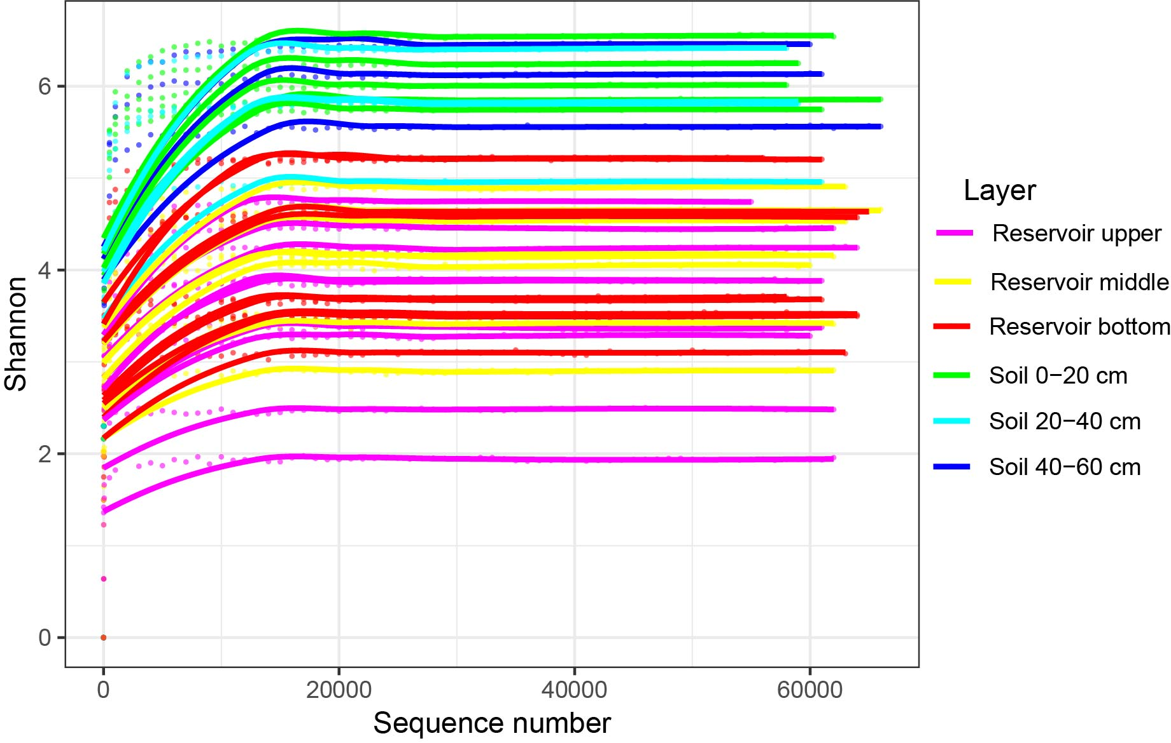

Figure S1. Rarefaction curve of bacterial community Shannon index reaches saturation stage with increasing sequencing depth.

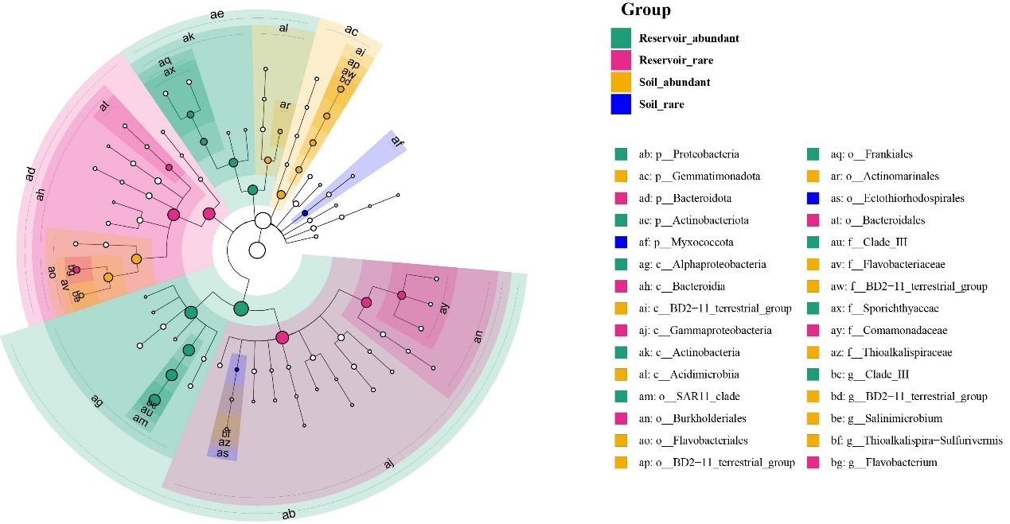
Figure S2. Taxonomic cladogram from Linear discriminant analysis Effect Size (LEfSe) analysis identifying significant biomarker taxa in bacterial communities across four groups: reservoir-abundant, reservoir-rare, soil-abundant, and soil-rare.

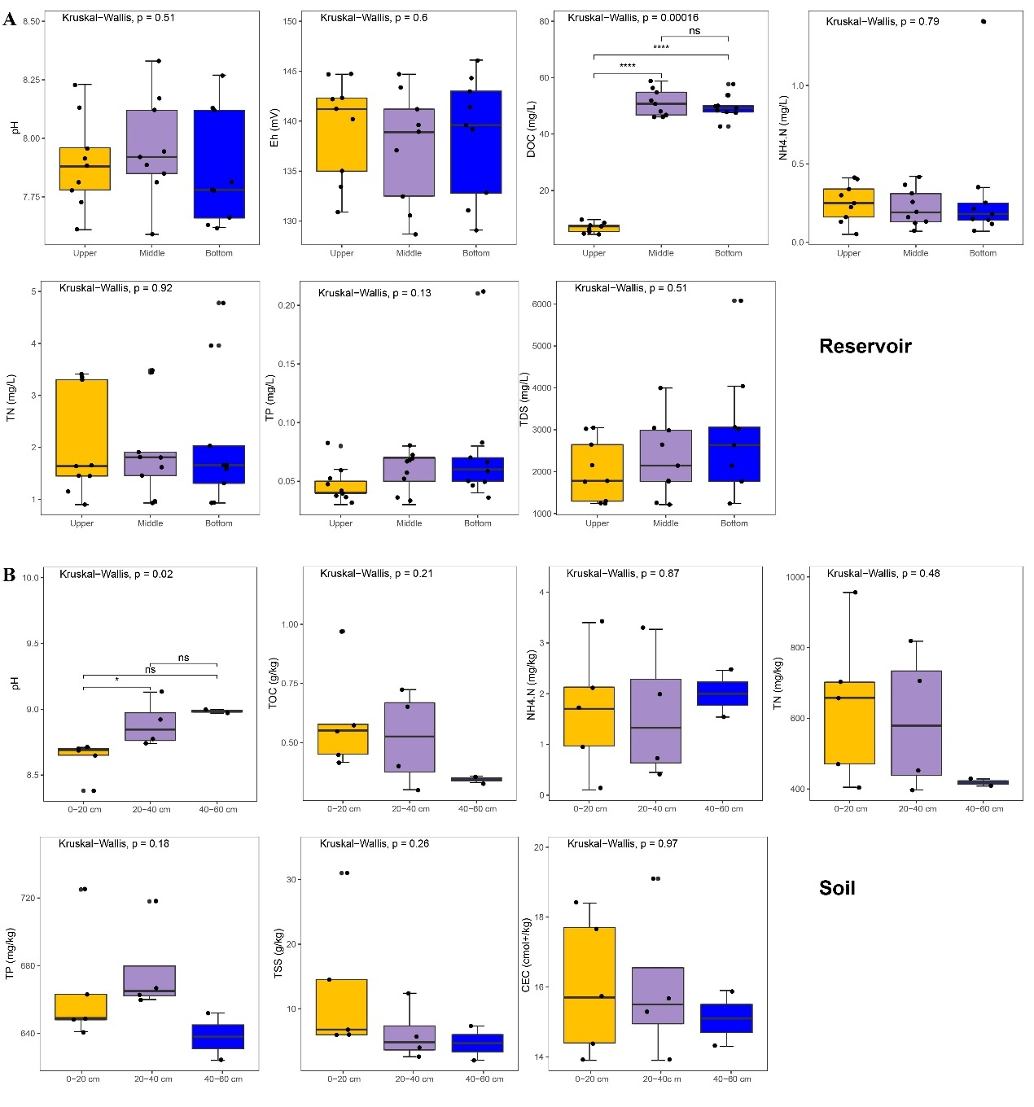

Figure S3. The vertical variation of environmental factors in the reservoir (A) and soil (B). The statistical differences were evaluated among layers utilizing the Kruskal–Wallis test and between layers, utilizing the Wilcoxon rank sum test (ns, not significant, p > 0.05, * p < 0.05, ** p < 0.01, *** p < 0.001, **** p < 0.0001). Eh: oxidation-reduction potential TDS: total dissolved solids; TN: total nitrogen; TP: total phosphorus; DOC: dissolved organic carbon; Eh, oxidation-reduction potential, TSS: total soluble salts, TOC: total organic carbon, CEC: cation exchange capacity.

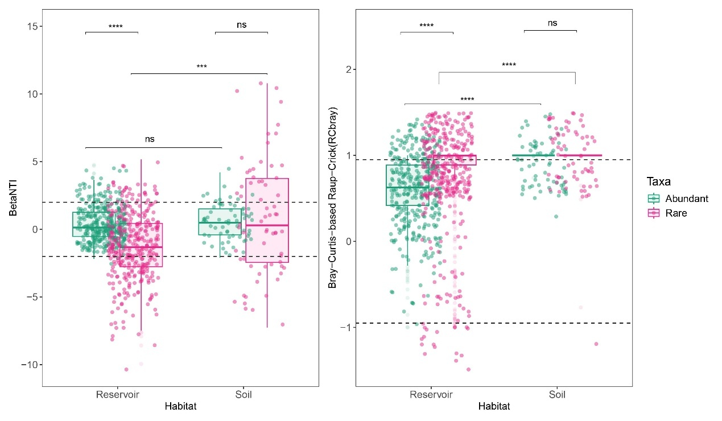
Figure S4. β-nearest taxon index (βNTI) and Bray-Curtis-based Raup-Crick (RCbray) analyses of abundant and rare taxa between reservoir water and soil. Comparisons between abundant and rare taxa, between reservoir and soil with Wilcoxon test (ns: not significant, p > 0.05, **p < 0.01, ***p < 0.001, ****p < 0.0001).

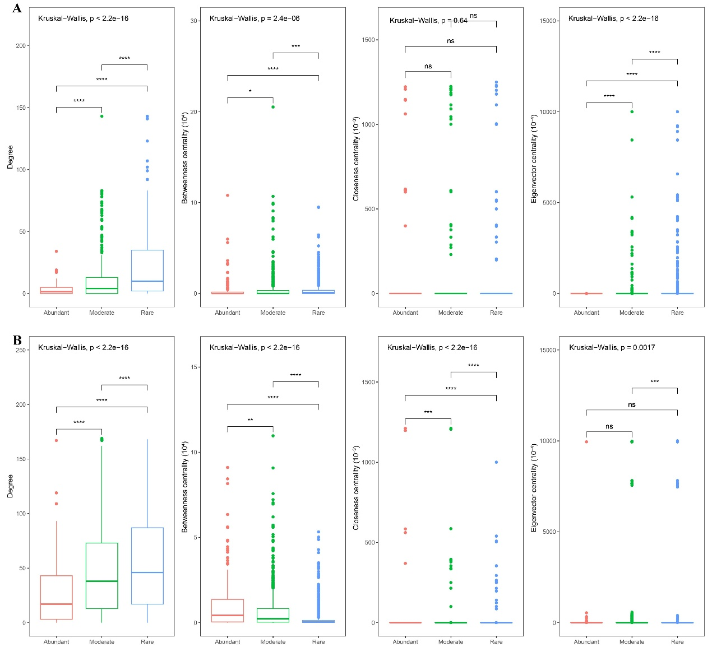
Figure S5. Comparison of non-normalized topological parameters (degree, betweenness centrality, closeness centrality, and eigenvector centrality) among abundant, moderate, and rare taxa in reservoir (A) and soil (B). Statistical differences were assessed using the Kruskal-Wallis’s test and Wilcoxon rank sum test (ns: not significant, p > 0.05, *p < 0.05, **p < 0.01, ***p < 0.001).

Supplementary Tables

Table S1 Identification and information of abundant, moderate, and rare bacterial taxa in different water layers. Description of bacterioplankton ASV datasets based on exact sequence variants.

Habitat | Taxa | ASV number (Percentage%) | Sequence number (Percentage%)
Reservoir | Abundant | 124 (2.40%) | 1,266,308 (75.81%)
Reservoir | Moderate | 597 (11.54%) | 290,317 (17.38%)
Reservoir | Rare | 4454 (86.07%) | 113,817 (6.81%)
Soil | Abundant | 162 (1.81%) | 294,128 (39.93%)
Soil | Moderate | 1459 (16.33%) | 303,550 (41.21%)
Soil | Rare | 7313 (81.86%) | 138,955 (18.86%)
Note: Abundant taxa were defined as the ASVs with average relative abundances greater than or equal to 0.1% in all samples; Rare taxa were defined as the ASVs with average relative abundances lass than or equal to 0.01% in all samples, the remaining ASVs were designated as moderate taxa.
The values in parentheses indicate the percentage of ASVs number or sequence of different taxa (abundant, moderate, rare) in the total bacterioplankton community.

Table S2 Results of PERMANOVA test for effects of habitat (reservoir vs. soil) and taxa abundance types (abundant vs. rare) on bacterial community structure based on Bray-Curtis dissimilarity. Statistical significance: ns, not significant (p > 0.05); * p < 0.05; ** p < 0.01; *** p < 0.001; **** p < 0.0001.

Term | Df | Sum of squares | R² | F | p value
Habitat | 1 | 2.890 | 0.084 | 8.919 | 0.001***
Taxa | 1 | 4.599 | 0.134 | 14.191 | 0.001***
Habitat*Taxa | 1 | 2.911 | 0.085 | 8.982 | 0.001***
Residual | 74 | 23.981 | 0.698
Total | 77 | 34.81

Table S3 Pairwise PERMANOVA comparisons of bacterial community structure among groups defined by habitat (reservoir, soil) and taxa abundance type (abundant, rare), based on the bray-Curtis dissimilarity. The p-values were adjusted for multiple comparisons using the Benjamini-Hochberg method. Statistical significance levels: ns, not significant (p > 0.05); * p < 0.05; ** p < 0.01; *** p < 0.001.

Group comparison | F | R² | p. adjusted | Significance
Reservoir Abundant vs Reservoir Rare | 0.471 | 0.009 | 1.000 | ns
Reservoir Abundant vs Soil Abundant | 3.512 | 0.087 | 0.003 | *
Reservoir Abundant vs Soil Rare | 3.509 | 0.087 | 0.003 | *
Reservoir Rare vs Soil Abundant | 3.417 | 0.085 | 0.003 | *
Reservoir Rare vs Soil Rare | 3.456 | 0.085 | 0.003 | *
Soil Abundant vs Soil Rare | 0.747 | 0.033 | 1.000 | ns

Table S4 Dissimilarity test of abundant and rare taxa in the reservoir water by ANOISM (analysis of similarity), and PERMANOVA (permutational multivariate analysis of variance) based on Bray-Curtis dissimilarity matrix between different water layers. *p < 0.05; **p < 0.01, *** p < 0.001.

Taxa | Water layer | ANOISM |  | PERMANOVA
Taxa | Water layer | r | p | F | p
Abundant | Upper vs. Middle | 0.293 | 0.003** | 3.851 | 0.015*
Abundant | Upper vs. Bottom | 0.255 | 0.008** | 3.515 | 0.009**
Abundant | Middle vs. Bottom | -0.099 | 1.000 | 0.226 | 0.986
Rare | Upper vs. Middle | 0.765 | 0.001*** | 2.127 | 0.002**
Rare | Upper vs. Bottom | 0.840 | 0.001*** | 2.071 | 0.002**
Rare | Middle vs. Bottom | -0.052 | 0.733 | 0.740 | 0.955

Table S5 Taxonomic information of shared ASVs between reservoir_abundant and soil_abundant, reservoir_abundant and soil_rare, reservoir_rare and soil_abundant.
ASV_ID | Phylum | Class | Order | Family | Genus
Shared between Reservoir_abundant and_Soil_abundant
ASV5 | Proteobacteria | Gammaproteobacteria | Burkholderiales | Burkholderiaceae | Limnobacter
Shared between Reservoir_rare and Soil_abundant
ASV32 | Proteobacteria | Gammaproteobacteria | Pseudomonadales | Pseudomonadaceae | Thioalkalispira-Sulfurivermis
ASV39 | Proteobacteria | Gammaproteobacteria | Ectothiorhodospirales | Thioalkalispiraceae | Pelagibius
ASV179 | Proteobacteria | Alphaproteobacteria | Kiloniellales | Kiloniellaceae | Salinimicrobium
ASV65 | Bacteroidota | Bacteroidia | Flavobacteriales | Flavobacteriaceae | Alcanivorax
ASV35 | Proteobacteria | Gammaproteobacteria | Oceanospirillales | Alcanivoracaceae1 | uncultured
ASV91 | Desulfobacterota | Desulfobulbia | Desulfobulbales | Desulfobulbaceae | uncultured
ASV96 | Proteobacteria | Alphaproteobacteria | uncultured | uncultured | uncultured
ASV353 | Actinobacteriota | Acidimicrobiia | Actinomarinales | uncultured
Shared between Reservoir_abundant and Soil_rare
ASV3 | Actinobacteriota | Actinobacteria | Frankiales | Sporichthyaceae | Perlucidibaca
ASV6 | Proteobacteria | Gammaproteobacteria | Pseudomonadales | Moraxellaceae | CL500-29_marine_group
ASV12 | Actinobacteriota | Acidimicrobiia | Microtrichales | Ilumatobacteraceae | hgcI_clade
ASV15 | Actinobacteriota | Actinobacteria | Frankiales | Sporichthyaceae | Limnohabitans
ASV17 | Proteobacteria | Gammaproteobacteria | Burkholderiales | Comamonadaceae | hgcI_clade
ASV23 | Actinobacteriota | Actinobacteria | Frankiales | Sporichthyaceae | Aquabacterium
ASV30 | Proteobacteria | Gammaproteobacteria | Burkholderiales | Comamonadaceae | Sphingorhabdus
ASV40 | Proteobacteria | Alphaproteobacteria | Sphingomonadales | Sphingomonadaceae | Algoriphagus
ASV53 | Bacteroidota | Bacteroidia | Cytophagales | Cyclobacteriaceae | Candidatus_Aquirestis
ASV54 | Bacteroidota | Bacteroidia | Chitinophagales | Saprospiraceae | Candidatus_Nitrotoga
ASV58 | Proteobacteria | Gammaproteobacteria | Burkholderiales | Gallionellaceae | hgcI_clade
ASV63 | Actinobacteriota | Actinobacteria | Frankiales | Sporichthyaceae | Hydrogenophaga
ASV75 | Proteobacteria | Gammaproteobacteria | Burkholderiales | Comamonadaceae | Flavobacterium
ASV66 | Bacteroidota | Bacteroidia | Flavobacteriales | Flavobacteriaceae | GKS98_freshwater_group
ASV76 | Proteobacteria | Gammaproteobacteria | Burkholderiales | Alcaligenaceae | Flavobacterium
ASV89 | Bacteroidota | Bacteroidia | Flavobacteriales | Flavobacteriaceae | Polaromonas
ASV100 | Proteobacteria | Gammaproteobacteria | Burkholderiales | Comamonadaceae | Paraperlucidibaca
ASV11 | Proteobacteria | Gammaproteobacteria | Pseudomonadales | Moraxellaceae | Reyranella
ASV115 | Proteobacteria | Alphaproteobacteria | Reyranellales | Reyranellaceae | Flavobacterium
ASV119 | Bacteroidota | Bacteroidia | Flavobacteriales | Flavobacteriaceae | Hydrogenophaga
ASV117 | Proteobacteria | Gammaproteobacteria | Burkholderiales | Comamonadaceae
ASV122 | Proteobacteria | Alphaproteobacteria | Rhodobacterales | Rhodobacteraceae | uncultured
ASV164 | Actinobacteriota | Acidimicrobiia | Microtrichales | uncultured | uncultured
ASV171 | Bacteroidota | Bacteroidia | Cytophagales | Cyclobacteriaceae | Nevskia
ASV191 | Proteobacteria | Gammaproteobacteria | Salinisphaerales | Solimonadaceae | Nitrosomonas
ASV209 | Proteobacteria | Gammaproteobacteria | Burkholderiales | Nitrosomonadaceae | Flavobacterium
ASV222 | Bacteroidota | Bacteroidia | Flavobacteriales | Flavobacteriaceae | Polaribacter
ASV218 | Bacteroidota | Bacteroidia | Flavobacteriales | Flavobacteriaceae | Hyphomonas
ASV134 | Proteobacteria | Alphaproteobacteria | Caulobacterales | Hyphomonadaceae | Nitrosomonas
ASV203 | Proteobacteria | Gammaproteobacteria | Burkholderiales | Nitrosomonadaceae | GKS98_freshwater_group
ASV247 | Proteobacteria | Gammaproteobacteria | Burkholderiales | Alcaligenaceae

Table S6 Environmental factors of three water layers (upper, middle, and bottom) in 27 samples, of three layers (0-20 cm, 20-40 cm, and 40-60 cm) of adjacent soil in 11samples, presented as mean ± standard deviation. Eh: oxidation-reduction potential, TDS: total dissolved solids; TN: total nitrogen; TP: total phosphorus; DOC: dissolved organic carbon; Eh, oxidation-reduction potential, TSS: total soluble salts, TOC: total organic carbon, CEC: cation exchange capacity.

Habitat | Layer | pH | Eh  (mV) | DOC  (mg/L) | NH₄⁺–N (mg/L) | TN  (mg/L) | TP  (mg/L) | TDS  (mg/L)
Reservoir | Upper | 7.89±0.18 | 139.40±4.76 | 6.82±1.64 | 0.25±0.12 | 2.04±0.96 | 0.05±0.01 | 2021.51±735.40
Reservoir | Middle | 7.96±0.21 | 137.41±5.34 | 51.05±4.48 | 0.23±0.12 | 1.94±0.88 | 0.06±0.02 | 2314.30±926.30
Reservoir | Bottom | 7.87±0.23 | 138.51±5.75 | 49.67±3.92 | 0.32±0.39 | 2.10±1.28 | 0.08+0.05 | 2861.22±1474.91
Habitat | Layer | pH | TOC  (g/kg) | NH₄⁺–N  (mg/kg) | TN  (mg/kg) | TP  (mg/kg) | TSS  (g/kg) | CEC  (cmol+/kg)
Soil | 0-20 cm | 8.63±0.14 | 0.59±0.22 | 1.66±1.24 | 638±216.68 | 665±34.37 | 12.84±10.77 | 16.02±1.98
Soil | 20-40 cm | 8.89±0.18 | 0.52±0.20 | 1.60±1.30 | 593±201.40 | 677±27.48 | 6.17±4.35 | 16.00±2.21
Soil | 40-60 cm | 8.99±0.02 | 0.34±0.02 | 2.00±0.65 | 418±14.14 | 638±19.80 | 4.68±3.75 | 15.10±1.13

Table S7 Comparison of topological properties for the empirical co-occurrence networks of bacterioplankton communities in the reservoir water and soil and their associated random networks.

 | Parameters | Reservoir | Soil
Empirical network | Nodes | 2143 | 2561
Empirical network | Abundant% | 5.79% | 6.29%
Empirical network | Moderate% | 27.30% | 46.66%
Empirical network | Rare% | 66.92% | 47.05%
Empirical network | Edges | 20,218 | 64,757
Empirical network | Positive edges | 20,195 | 64,149
Empirical network | Negative edges | 23 | 608
Empirical network | Average degree | 18.87 | 50.57
Empirical network | Average weight degree | 16.79 | 46.70
Empirical network | Average path length | 5.95 | 4.24
Empirical network | Network diameter | 15.38 | 13.59
Empirical network | Network density | 0.01 | 0.02
Empirical network | Clustering coefficient | 0.70 | 0.86
Empirical network | Betweenness centralization | 0.08 | 0.04
Empirical network | Centralization degree | 0.06 | 0.05
Empirical network | Network modularity | 0.69 | 0.74
Random network | Clustering coefficient | 0.0088 | 0.0198
Random network | Clustering coefficient | (SD = 0.0003) | (SD=0.0001)
Random network | Average path length | 2.889 | 2.341
Random network | Average path length | (SD = 0.0005) | (SD=0.0002)
Random network | Modularity | 0.1457 | 0.0723
Random network | Modularity | (SD = 0.0028) | (SD= 0.0011)
Random network | Network diameter | 4.041 | 3.00
Random network | Network diameter | (SD=0 .1985) | (SD=0.000)
Random network | Network density | 0.0088 | 0.00198
Random network | Network density | (SD = 0.0000) | (SD= 0.000)
Note: Number of ASVs with the correlation |r| > 0.8 and statistical significance (p< 0.05); In random network, the numbers in parentheses represent the standard deviation.

Table S8 Taxonomic information of keystone taxa from the networks in the reservoir water and soil.
ASV_ID | Taxa | Node roles | Phylum | Class | Order | Family | Genus
Reservoir water
ASV163 | Abundant | Module hubs | Proteobacteria | Gammaproteobacteria | Burkholderiales | Burkholderiaceae | Polynucleobacter
ASV187 | Abundant | Module hubs | Proteobacteria | Alphaproteobacteria | Rhizobiales | Rhizobiales_Incertae_Sedis | uncultured
ASV219 | Abundant | Connectors | Proteobacteria | Gammaproteobacteria | Xanthomonadales | Xanthomonadaceae | Arenimonas
ASV909 | Moderate | Module hubs | Proteobacteria | Alphaproteobacteria | Acetobacterales | Acetobacteraceae | Rhodovastum
ASV1729 | Moderate | Connectors | Proteobacteria | Gammaproteobacteria | Burkholderiales | TRA3-20 | TRA3-20
ASV1825 | Moderate | Connectors | Bacteroidota | Bacteroidia | Chitinophagales | uncultured | uncultured
ASV2525 | Rare | Connectors | Bacteroidota | Bacteroidia | Cytophagales | Microscillaceae | OLB12
ASV2933 | Rare | Connectors | Actinobacteriota | Actinobacteria | Propionibacteriales | Nocardioidaceae | Aeromicrobium
ASV3158 | Rare | Module hubs | Proteobacteria | Gammaproteobacteria | Burkholderiales | Rhodocyclaceae | Sulfuritalea
ASV3718 | Rare | Module hubs | Proteobacteria | Alphaproteobacteria | Rhodobacterales | Rhodobacteraceae | Tabrizicola
ASV3873 | Rare | Connectors | Gemmatimonadota | Gemmatimonadetes | Gemmatimonadales | Gemmatimonadaceae | uncultured
ASV2130 | Rare | Connectors | Acidobacteriota | Acidobacteriae | PAUC26f | PAUC26f | PAUC26f
ASV4065 | Rare | Connectors | Bacteroidota | Bacteroidia | Cytophagales | Microscillaceae | uncultured
ASV4068 | Rare | Connectors | Proteobacteria | Alphaproteobacteria | uncultured | uncultured | uncultured
ASV4199 | Rare | Module hubs | Proteobacteria | Gammaproteobacteria | Burkholderiales | Rhodocyclaceae | ssigned
ASV4372 | Rare | Module hubs | Proteobacteria | Gammaproteobacteria | Xanthomonadales | Rhodanobacteraceae | Ahniella
ASV4586 | Rare | Connectors | Proteobacteria | Alphaproteobacteria | Rhodobacterales | Rhodobacteraceae | ssigned
ASV6228 | Rare | Module hubs | Myxococcota | Myxococcia | Myxococcales | Myxococcaceae | P3OB-42
ASV7266 | Rare | Connectors | Gemmatimonadota | BD2-11_terrestrial_group | BD2-11_terrestrial_group | BD2-11_terrestrial_group | BD2-11_terrestrial_group
ASV7424 | Rare | Module hubs | NB1-j | NB1-j | NB1-j | NB1-j | NB1-j
ASV7451 | Rare | Connectors | Proteobacteria | Alphaproteobacteria | Rhizobiales | Xanthobacteraceae | Bradyrhizobium
ASV8705 | Rare | Connectors | Bdellovibrionota | Bdellovibrionia | Bdellovibrionales | Bdellovibrionaceae | Bdellovibrio
ASV7623 | Rare | Connectors | Proteobacteria | Gammaproteobacteria | Enterobacterales | Yersiniaceae | Serratia
Soil
ASV436 | Abundant | Connectors | Bacteroidota | Bacteroidia | Flavobacteriales | Flavobacteriaceae | Gramella
ASV3620 | Rare | Connectors | Proteobacteria | Alphaproteobacteria | Kiloniellales | Kiloniellaceae | uncultured
ASV3770 | Rare | Connectors | NB1-j | NB1-j | NB1-j | NB1-j | NB1-j
ASV4026 | Rare | Connectors | Latescibacterota | Latescibacterota | Latescibacterota | Latescibacterota | Latescibacterota
ASV4434 | Rare | Connectors | Gemmatimonadota | BD2-11_terrestrial_group | BD2-11_terrestrial_group | BD2-11_terrestrial_group | BD2-11_terrestrial_group
ASV7682 | Rare | Connectors | Acidobacteriota | Acidobacteriae | Bryobacterales | Bryobacteraceae | Bryobacter
ASV9355 | Rare | Connectors | Proteobacteria | Gammaproteobacteria | EPR3968-O8a-Bc78 | EPR3968-O8a-Bc78 | EPR3968-O8a-Bc78
ASV571 | Moderate | Connectors | Bacteroidota | Rhodothermia | Balneolales | Balneolaceae | Gracilimonas
ASV595 | Moderate | Connectors | Proteobacteria | Gammaproteobacteria | Nitrosococcales | Nitrosococcaceae | ssigned
ASV860 | Moderate | Connectors | Myxococcota | bacteriap25 | bacteriap25 | bacteriap25 | bacteriap25
ASV970 | Moderate | Connectors | Gemmatimonadota | BD2-11_terrestrial_group | BD2-11_terrestrial_group | BD2-11_terrestrial_group | BD2-11_terrestrial_group
ASV762 | Moderate | Connectors | Bacteroidota | Bacteroidia | Chitinophagales | Chitinophagaceae | Sediminibacterium
ASV1091 | Moderate | Connectors | Proteobacteria | Alphaproteobacteria | Defluviicoccales | uncultured | uncultured
ASV854 | Moderate | Connectors | Patescibacteria | Parcubacteria | ssigned | ssigned | ssigned
ASV1220 | Moderate | Connectors | Bacteroidota | Bacteroidia | Flavobacteriales | Flavobacteriaceae | Salinimicrobium
ASV1347 | Moderate | Connectors | Actinobacteriota | Acidimicrobiia | Actinomarinales | uncultured | uncultured
ASV1390 | Moderate | Connectors | Bacteroidota | Rhodothermia | Rhodothermales | Rhodothermaceae | uncultured
ASV1397 | Moderate | Connectors | Bacteroidota | Bacteroidia | Sphingobacteriales | NS11-12_marine_group | NS11-12_marine_group
ASV1889 | Moderate | Connectors | Proteobacteria | Gammaproteobacteria | Ectothiorhodospirales | Thioalkalispiraceae | Thioalkalispira-Sulfurivermis
ASV2367 | Moderate | Connectors | Bacteroidota | Rhodothermia | Balneolales | Balneolaceae | uncultured
ASV2207 | Moderate | Connectors | Proteobacteria | Alphaproteobacteria | Sphingomonadales | Sphingomonadaceae | Altererythrobacter
ASV2654 | Moderate | Connectors | Bacteroidota | Bacteroidia | Chitinophagales | uncultured | uncultured
ASV2683 | Moderate | Connectors | Proteobacteria | Alphaproteobacteria | ssigned | ssigned | ssigned
ASV2686 | Moderate | Connectors | Bacteroidota | Bacteroidia | Flavobacteriales | Cryomorphaceae | Vicingus
ASV2922 | Moderate | Module hubs | Gemmatimonadota | AKAU4049 | AKAU4049 | AKAU4049 | AKAU4049
ASV2996 | Moderate | Connectors | Desulfobacterota | Desulfuromonadia | Bradymonadales | Bradymonadales | Bradymonadales

Table S9 Node level topology characteristics of abundant, moderate, and rare taxa in the bacterial networks of reservoir and soil.

Node level topology characteristics | Reservoir |  |  | Soil
Node level topology characteristics | Abundant | Moderate | Rare | Abundant | Moderate | Rare
Nodes | 124 | 585 | 1434 | 161 | 1195 | 1205
Edges related to taxa | 352 | 5276 | 18787 | 4520 | 44819 | 47770
Edge/node ratio | 2.839 | 9.019 | 13.101 | 28.075 | 37.505 | 39.643
Average degree | 3.419 | 10.942 | 23.439 | 28.143 | 48.799 | 55.326
Average between centrality | 4551.597 | 4948.568 | 3423.583 | 11643.985 | 6221.679 | 2408.107
Average closeness centrality | 0.148 | 0.065 | 0.043 | 0.034 | 0.007 | 0.008
Average eigenvector centrality | 0.000 | 0.015 | 0.071 | 0.007 | 0.061 | 0.073
Average clustering coefficient | 0.210 | 0.321 | 0.525 | 0.397 | 0.636 | 0.850

