Supplementary Material
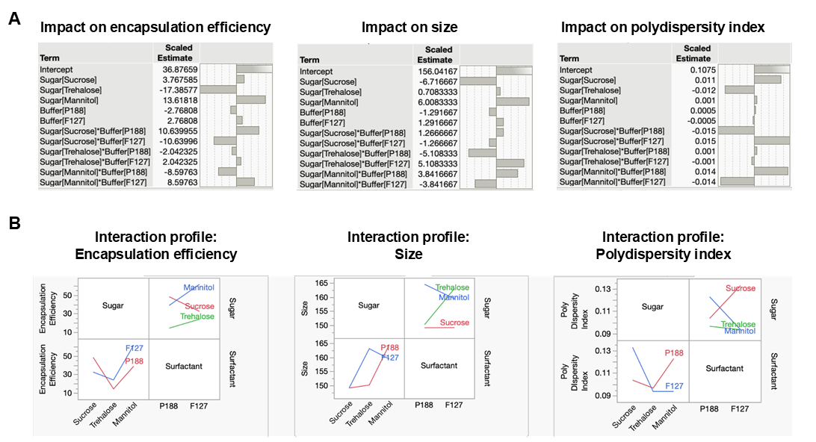
Supplementary Figure S1. A. The Scaled Estimates column of JMP’s regression output represents the standardized regression coefficients. B. Interaction profiles between different sugars and surfactants shows different responses. These were developed by the JMP application using the design of experiments (DOE) output of five times freeze thaw data of different formulations (Table 2). A total of five variables were used in this analysis: sucrose, trehalose, mannitol, P188 and F127.

A | B
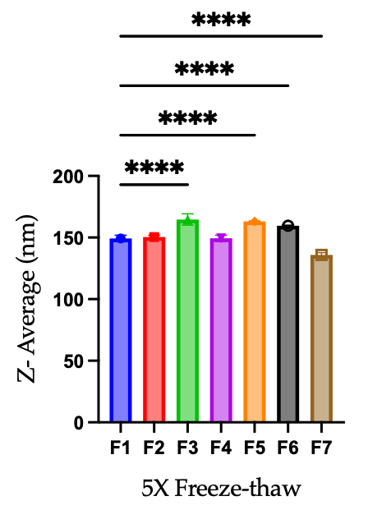 | 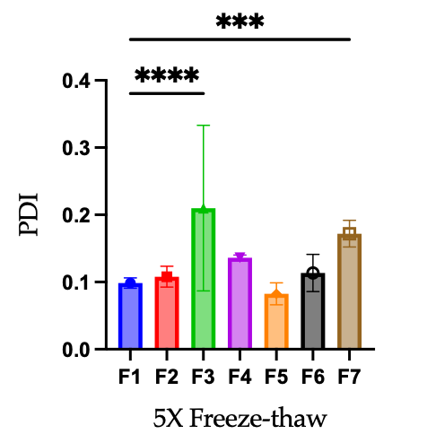
Supplementary Figure S2. Stability analysis of encapsulated mRNA to five cycles of freeze–thaw stress using different formulation F1 to F7 (Figure 2). Dynamic light scattering assay was used to measure the size and poly dispersity for all samples (N=14). Significant statistical differences between the control and test formulations were determined by one-way ANOVA analysis and are denoted through the asterisk (*) sign. Statistically significant differences were found at p < 0.05 (*** p< 0.001, ** p < 0.01; * p < 0.05).

A | B
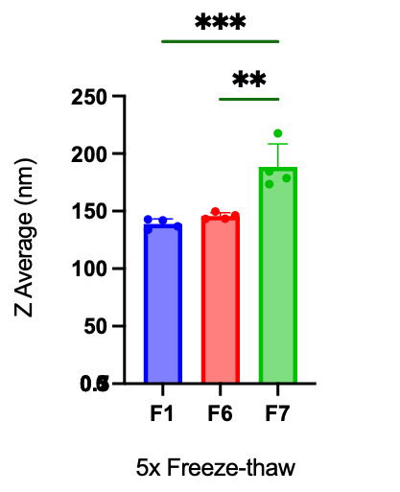 | 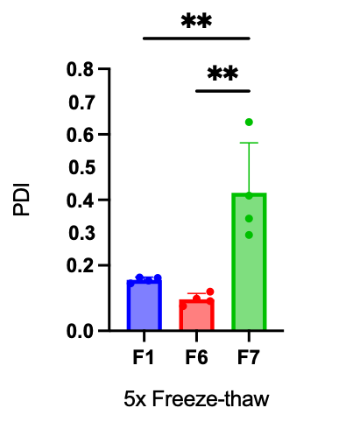
Supplementary Figure S3. Stability analysis of encapsulated mRNA to five cycles of freeze–thaw stress using different formulation F1, F6 and F7 (Figure 3). Dynamic light scattering assay was used to measure the size and poly dispersity for all samples (N=14). Significant statistical differences between the control and test formulations were determined by one-way ANOVA analysis and are denoted through the asterisk (*) sign. Statistically significant differences were found at p < 0.05 (*** p< 0.001, ** p < 0.01; * p < 0.05).

A | B
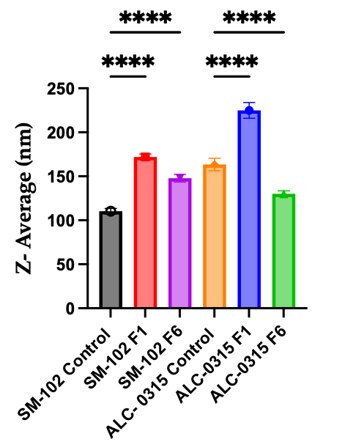 | 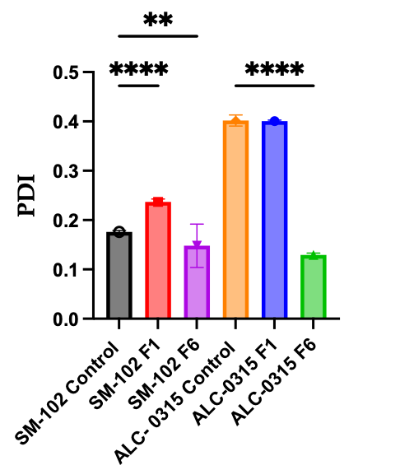
Supplementary Figure S4. Stability analysis of encapsulated mRNA using different formulations after 8 weeks at room temperature (Figure 4). Dynamic light scattering assay was used to measure the size and poly dispersity for all samples (N=14). Significant statistical differences between the control and test formulations were determined by one-way ANOVA analysis and are denoted through the asterisk (*) sign. Statistically significant differences were found at p < 0.05 (*** p< 0.001, ** p < 0.01; * p < 0.05).

A | B
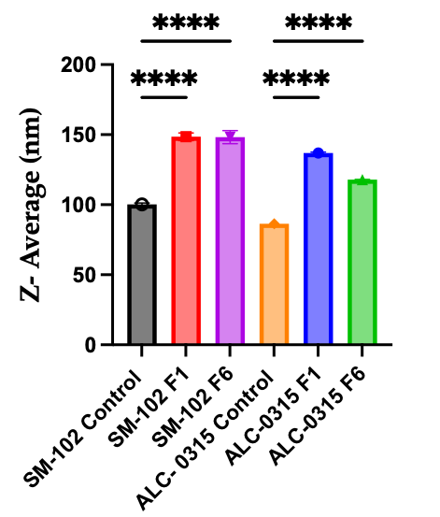 | 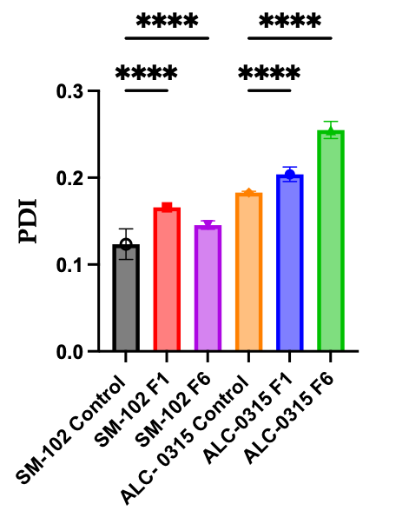
Supplementary Figure S5. Stability analysis of encapsulated mRNA using different formulations after 8 weeks at 4 °C (Figure 5). Dynamic light scattering assay was used to measure the size and poly dispersity for all samples (N=14). Significant statistical differences between the control and test formulations were determined by one-way ANOVA analysis and are denoted through the asterisk (*) sign. Statistically significant differences were found at p < 0.05 (*** p< 0.001, ** p < 0.01; * p < 0.05).

A | B
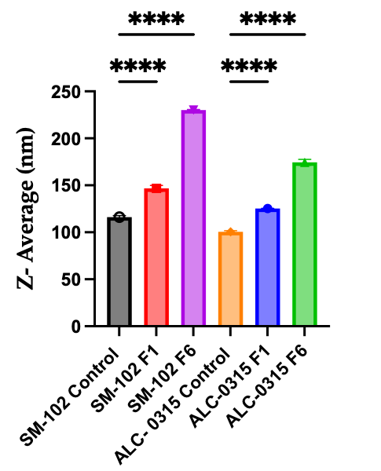 | 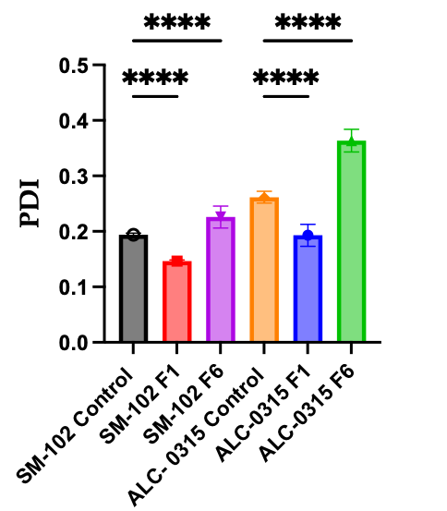
Supplementary Figure S6. Stability analysis of encapsulated mRNA using different formulations after 8 weeks at -20 °C (Figure 6). Dynamic light scattering assay was used to measure the size and poly dispersity for all samples (N=14). Significant statistical differences between the control and test formulations were determined by one-way ANOVA analysis and are denoted through the asterisk (*) sign. Statistically significant differences were found at p < 0.05 (*** p< 0.001, ** p < 0.01; * p < 0.05).

A | B
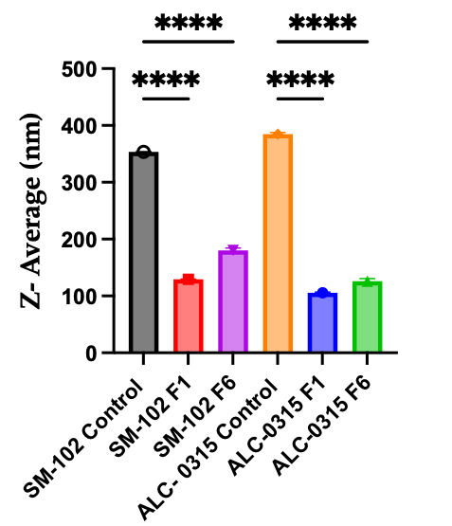 | 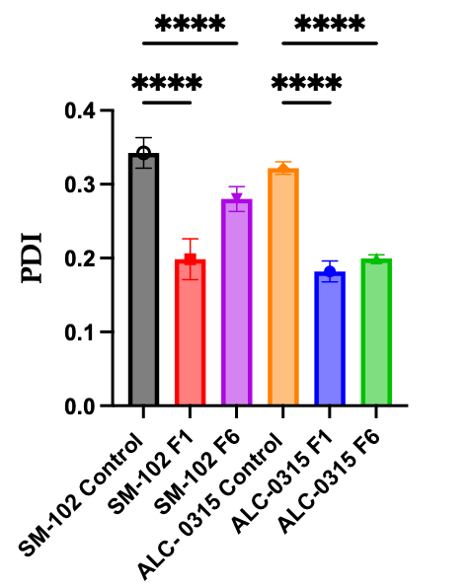
Supplementary Figure S7. Stability analysis of encapsulated mRNA using different formulations after 8 weeks at -80 °C (Figure 7). Dynamic light scattering assay was used to measure the size and poly dispersity for all samples (N=14). Significant statistical differences between the control and test formulations were determined by one-way ANOVA analysis and are denoted through the asterisk (*) sign. Statistically significant differences were found at p < 0.05 ((*** p< 0.001, ** p < 0.01; * p < 0.05).

