Supplementary Figures

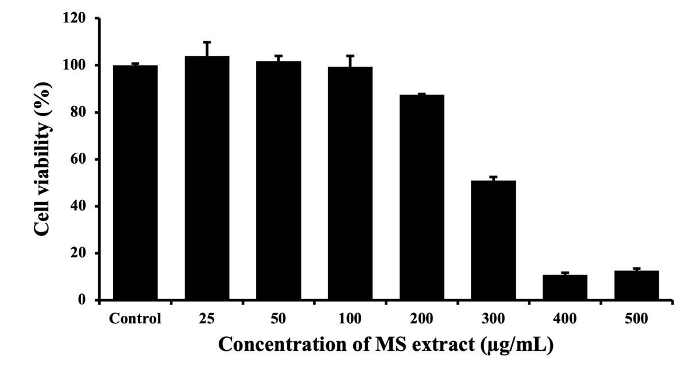
Figure S1. Effect of MS extract on cell viability in Vero cells by MTT assay. The cell lines were treated with various concentrations of MS extract for 24 h. The results were the mean values ± SD.

