Supplementary Materials
Sources and characteristics of dissolved organic matter (DOM) in winter season in the Hangzhou Bay: Insights from chromophoric DOM and fluorescent DOM
Chenshuai Wei ^{2,3}, Yanhong Xu ², Dewang Li ^{1,2,5,6}, Peisong Yu ^{2,5,6}, Qian Li ², Zhongqiang Ji ^{2,5,6}, Bin Wang ^{1,2,5,6}, Ying Luo ^{2,7}, Ningxiao Yu ^{2,7}, Lihong Chen ^{1,2} and Haiyan Jin ^{1,2,3,4,6,7*}
¹ Donghai Laboratory, Zhoushan 316000, China
² Key Laboratory of Marine Ecosystem Dynamics, Second Institute of Oceanography, Ministry of Natural Resources, Hangzhou 310012, China
³ Ocean College, Zhejiang University, Zhoushan 316021, China
⁴ State Key Laboratory of Satellite Ocean Environment Dynamics, Second Institute of Oceanography, Ministry of Natural Resources, Hangzhou 310012, China
⁵ Key Laboratory of Nearshore Engineering Environment and Ecological Security of Zhejiang Province, Hangzhou 310012, China
⁶ Observation and Research Station of Yangtze River Delta Marine Ecosystems, Ministry of Natural Resources, Zhoushan 316000, Zhejiang, China
⁷ School of Oceanography, Shanghai Jiaotong University, Shanghai 200230, China
* Correspondence: jinhaiyan@sio.org.cn

Contents of this file
Figure S1: Surface distributions of CDOM absorption coefficients in different wavelengths ranged from 254nm to 460 nm.
Figure S2: Pearson correlations analysis of DOC concentrations, CDOM absorptions at different wavelengths, and abundance of three FDOM components.
Figure S3: FDOM indexes ranged with salinity in HZB and adjacent seas in winter 2024. (a) F_{total}; (b) RFE; (c) HIX; (d) BIX.
Figure S4: FDOM indexes versus with component divided by PARAFAC
Figure S5: FDOM components of protein-like C2 along the salinity gradient in HZB and adjacent seas in winter.
Figure S6: Comparison of the Results of PARAFAC between 4-component model and 3-component model on Parameters, residuals, auxiliary and split-half test (a) 4-component model, EEMs of FDOM were divided into four characteristic components in this model; (b) 3-component model EEMs of FDOM were divided into three characteristic components in this model.

Introduction
There are six figures in this file.
Figure S1: In Hangzhou Bay and adjacent seas, the Napierian absorption coefficients ($a_{λ}$) of CDOM at different UV-vis wavelengths (240 – 500nm). The $a_{λ}$ was better fitted and representative in shorter wavelength than longer wavelength, and $a_{254}$ of all coefficients had the highest absorption values in Hangzhou Bay and adjacent seas in winter.
Figure S2: The $a_{λ}$ at different wavelengths have positive correlations with each other. The $a_{λ}$ is negatively correlated with C1 (p < 0.01), but positively correlated with C2 and C3 (p < 0.0001). Besides, C1 and C2 showed strong negative correlation, C3 and C2 showed strong positive correlation (both p < 0.0001). Water with salinity lower than 27.5 fits better than that at high-salinity.
Figure S3: In Hangzhou Bay and adjacent seas, different areas had different FDOM compositions and characteristics. F_{total}, HIX, BIX and RFE were significantly different in Qiantang River Estuary (QRE), Changjiang River Estuary (CRE) and Zhoushan Islands Region (ZIR) waters.
Figure S4: This figure showed the FDOM indexes versus with the components divided by PARAFAC. In winter HZB and adjacent seas, C1 was positively correlated with HIX (p < 0.0001), reflecting the degree of humification. C2 was positively correlated with BIX (p < 0.0001), reflecting the degree of autotrophic productivity.
Figure S5: It shows the variety of FDOM protein-like C2 component along the salinity gradient in HZB and adjacent seas in winter. Qiantang River Estuary (QRE) had the highest C2 abundance, while Changjiang River Estuary (CRE) and Zhoushan Islands Region (ZIR) had the lowest C2 values in winter. C2 as a protein-like component in FDOM accounted for 41.5% on average in HZB and 23.5% on average in ZIR, in late January 2024. Along the southern HZB section (including 16 samples of stations E1-E6, ZJD12014, ZJD12031), C2 abundance decreased seaward. On the northern HZB section (including 8 samples of stations E1, CE3, C1-2, C2-2), C2 abundance decreased more abruptly compared to the chang along the southern HZB section. .
Figure S6: The fluorescence excitation emission matrices (EEMs) data were analyzed using the parallel factor analysis (PARAFAC) with the Solo® Software (9.5R, with PLS_Toolbox, Eigenvector Research). FDOM of all samples were classified into several components. The n-component model (n = 2, 3, 4......) was validated by split-half, random initialization analysis and analysis of residuals. Figure. 1S-a. Four-component PARAFAC model has 97.226% of the data explained but the auxiliary of Core Consistency is only 17, with only 2.2% similarity measure of splits and overall model, which means the 4-component PARAFAC model is not available. Fig. 1S-b. Three–component PARAFAC model has 96.746% of the data explained and the auxiliary of Core Consistency is 87, with 87.2% similarity measure of splits and overall model. The 3-component PARAFAC model fits much better than the four-component PARAFAC model. Thus, in this study, we used the results of 3-component PARAFAC for further discussion.

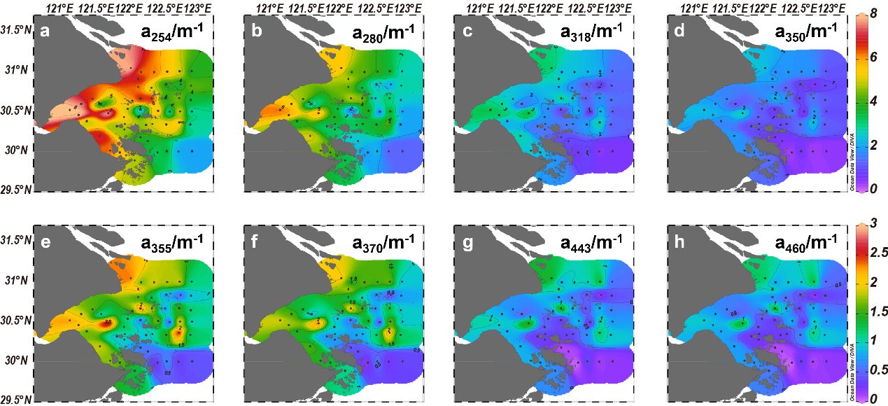
Figure S1. Surface distributions of CDOM absorption coefficients at different wavelengths ranged from 254nm to 460 nm. (a-d) matched color bar of 0 – 8 m⁻¹; (e-h) matched color bar of 0 – 3 m⁻¹.

Figure S2. Pearson correlations analysis of DOC concentrations, CDOM absorptions at different wavelengths, and abundance of three FDOM components.

Figure S3. FDOM indexes ranged with salinity in HZB and adjacent seas in winter 2024. (a) F_{total}; (b) RFE; (c) HIX; (d) BIX.

Figure S4. FDOM indexes versus with the components divided by PARAFAC. (a) The humification index (HIX) versus with C1; (b) The biological index (BIX) versus with C2. Correlation analysis is only for the samples in the HZB with salinity less than <27.5.

Figure S5. FDOM components of protein-like C2 along the salinity gradient in HZB and adjacent seas in winter 2024.

a. 4-component model
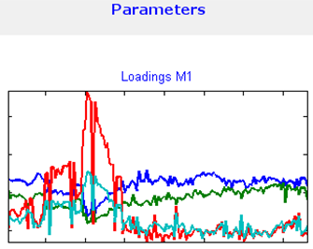 |  | 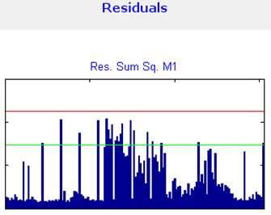 |  | 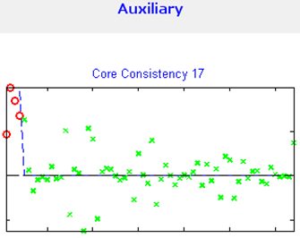
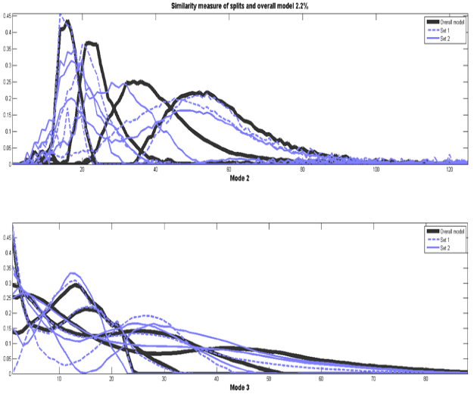
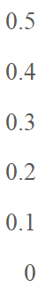
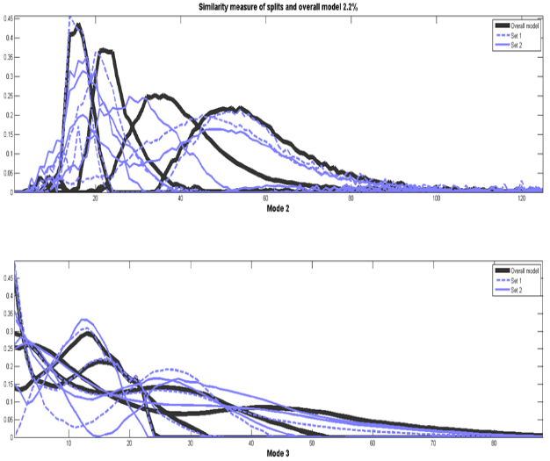
Mode 2 Mode3
b. 3-component model
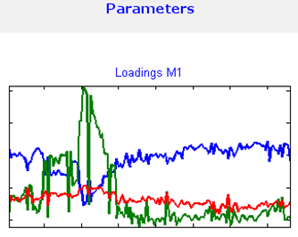 | 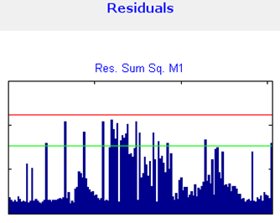 |  | 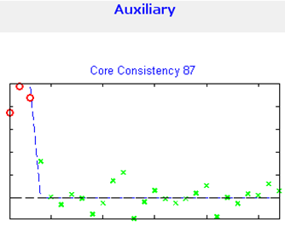
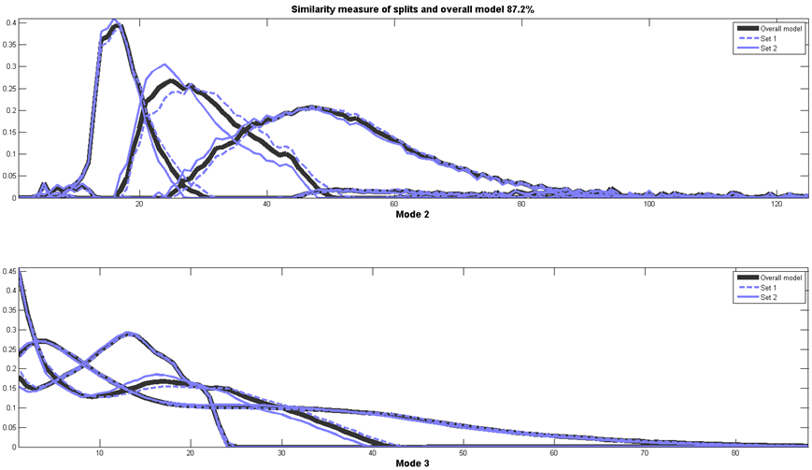
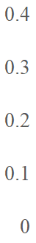

Mode 2 Mode3
Figure S6. Comparison of the Results of PARAFAC between 4-component model and 3-component model on Parameters, residuals, auxiliary and split-half test
(a) 4-component model, EEMs of FDOM were divided into four characteristic components in this model; (b) 3-component model EEMs of FDOM were divided into three characteristic components in this model.

