Electronic supporting information (ESI)

Hydrogenation of aromatic ethers and lactones: does the oxygen functionality really improve the thermodynamics of reversible hydrogen storage in the related LOHC systems?
Riko Siewert,^{a,b} Artemiy A. Samarov,^{c} Sergey V. Vostrikov,^{d} Karsten Müller,^{a,b} Peter Wasserscheid,^{e} Sergey P. Verevkin^{a,b,d,*}

ª Institute of Technical Thermodynamics, University of Rostock, 18059 Rostock, Germany
^{b} Competence Centre °CALOR at the Department Life, Light & Matter of the Faculty of Interdisciplinary Research at University of Rostock, 18059, Rostock, Germany
^{c} Department of Chemical Thermodynamics and Kinetics, Saint Petersburg State University, Peterhof, 198504 Saint Petersburg, Russia.
^{d} Engineering and Technology Department, Samara State Technical University, 443100 Samara, Russia
^{e} Institute of Chemical Reaction Engineering, Friedrich-Alexander-Universität Erlangen-Nürnberg, Egerlandstr. 3, 91058 Erlangen, Germany

General aspects of quantum-chemical calculations
The conformational analysis was performed with a computer code called CREST (conformer-rotamer ensemble sampling tool). The software package uses a metadynamics simulation-based screening procedure that is used to generate molecular conformations in the gas phase. A history-dependent bias potential is applied, where the collective variables for the metadynamics are the previous structures on the potential energy surface, expressed as the root-mean-square deviation of the atoms between them, which are calculated according to the quaternion algorithm. Conformations are generated at the GFNn-xTB level in the iMTD-GC workflow. More details are provided in the Ref. [1]. The obtained structures were optimised with the B3LYP/6-31g(d,p) method [2]. It turned out that the energetics of the conformers were quite close to each other within a few kJ·mol⁻¹. The most stable conformers for the aromatic compounds and their perhydrogenated products are shown in Fig. S1.

Front view | Side view
2,3-benzofuran [271-89-6]
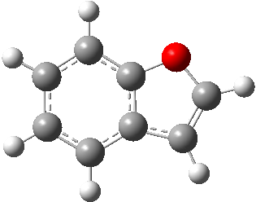 | 
2,3-dihydro-benzofuran [496-16-2]
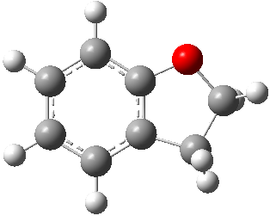 | 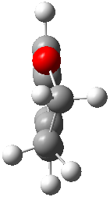
isobenzofuran [496-14-0] [270-75-7]
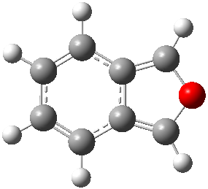 | 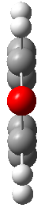
Phthalan [496-14-0]
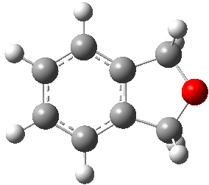 | 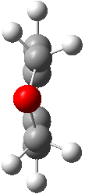
2-coumaranone [553-86-6]
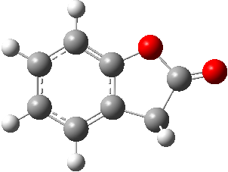 | 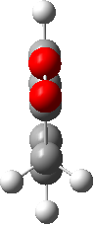
3-coumaranone [7169-34-8]
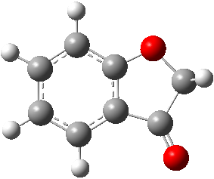 | 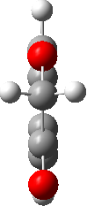
phthalide [87-41-2]
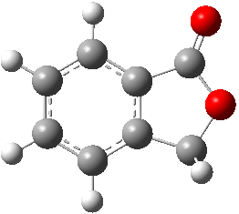 | 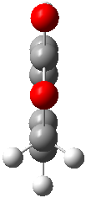
methoxy-cyclohexane [931-56-6]
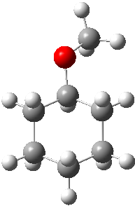 | 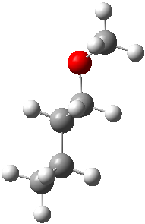
dicyclohexyl ether [4645-15-2]
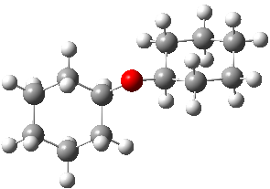 | 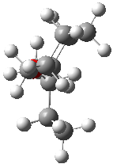
octahydro-benzofuran [13054-97-2]
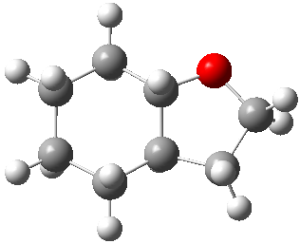 | 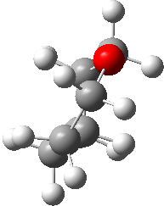
octahydro-isobenzofuran [4743-54-8]
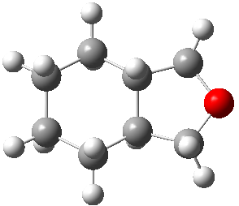 | 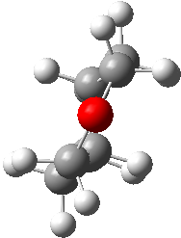
hexahydro-2-coumaranone [6051-03-2]
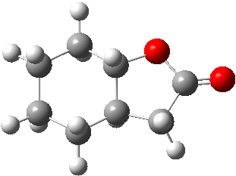 | 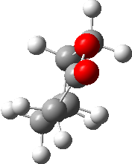
hexahydro-3-coumaronone [1206676-08-5]
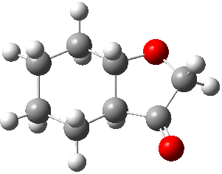 | 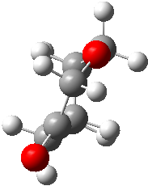
octahydro-benzofuran-2-ol [36871-99-5]
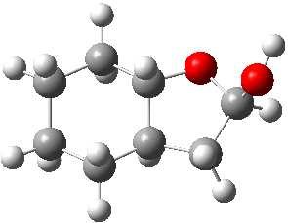 | 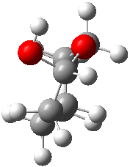
octahydro-benzofuran-3-ol [99769-38-7]
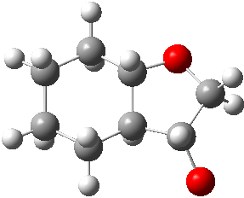 | 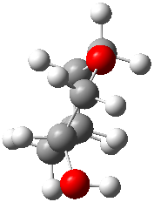
octahydro-isobenzofuran-1-ol [59901-42-7]
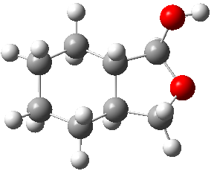 | 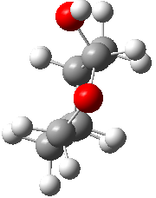

Fig. S1. Structures of the most stable conformers of aromatic ethers, lactones and their hydrogenated products.

The Gaussian 16 series software [3] was used for QC calculations. The total H₂₉₈-enthalpies and of the most stable conformers were calculated using the G3MP2 method [4]. The G3MP2 method was chosen as the optimal approach combining high accuracy of energy calculation with reasonable computational cost. This method has been systematically used in our laboratory for calculations of C-, H-, O-containing molecules, and in our experience G3MP2 provides the theoretical enthalpies of formation in very good agreement with the reliable experimental values. The H₂₉₈-values were finally converted to the theoretical $∆_{f}H_{\text{m}}^{\text{o}}$(g, 298.15 K)_{QC} values and discussed. The well-established assumption “rigid rotator-harmonic oscillator” was used for the quantum-chemical calculations. The $S_{\text{m}}^{\text{o}}$(g, 298.15 K)_{QC} values were calculated according to (Eq. 4) using H₂₉₈ and G₂₉₈ from the output file. The general details of the calculation procedure have been published elsewhere [5].

Table S1. Results of quantum-chemical calculations with G3MP2 method for aromatic ethers and lactones and their hydrogenated products (at T = 298.15 K, p° = 0.1 MPa, all data are in kJ·mol⁻¹).

CAS | Compound | $∆_{f}H_{\text{m}}^{\text{o}}$(g)_{AT}ª | $∆_{f}H_{\text{m}}^{\text{o}}$(g)_{exp} ^{b} | $∆_{f}H_{\text{m}}^{\text{o}}$(g)_{G3MP2} ^{c} | Δ ^{d}
271-89-6 | 2,3-benzofuran | 6.2 | 13.9±0.7 [Table 2] | 17.2 | -3.3
496-16-2 | 2,3-dihydrobenzofuran | -57.5 | -46.7±0.9 [Table 2] | -47.1 | 0.4
270-75-7 | isobenzofuran | 67.8 |  | 79.3
496-14-0 | 1,3-dihydro-isobenzofuran | -36.9 | -30.6±1.2 [Table 2] | -26.3 | -4.3
132-64-9 | dibenzofuran | 38.8 | 52.9±0.7 [Table 2] | 50.1 | 2.8
553-86-6 | 2-coumaranone | -231.5 | -210.8±4.0 [Table 2] | -222.7 | 11.9
7169-34-8 | 3-coumaranone | -175.6 | -168.8±2.4 [Table 2] | -166.3 | -2.5
87-41-2 | phthalide | -232.9 | -220.6±2.8 [Table 2] | -224.1 | 3.5
6351-10-6 | 1-indanol | -111.3 | -107.7±2.1 [6] | -101.4 | -6.3
4254-29-9 | 2-indanol | -114.9 | -109.5±2.8 [6] | -105.0 | -4.5
606-23-5 | 1,3-indandione | -174.9 | -165.0±2.6 [7] | -165.6 | 0.6
5111-70-6 | 5-methoxy-1-indanone | -230.1 | -215.6±4.1 [6] | -221.3 | 5.7
493-05-0 | isochromane | -78.2 | -63.1±1.1 [8] | -68.0 | 4.9
2216-69-5 | 1-methoxynaphthalene | -19.0 | -6.7±1.8 [9] | -8.3 | 1.6
93-04-9 | 2-methoxynaphthalene | -20.3 | -6.5±1.4 [9] | -9.6 | 3.1
529-34-0 | 1-tetralone | -102.8 | -95.3±0.8 [10] | -92.8 | -2.5
530-93-8 | 2-tetralone | -91.5 | -82.0±1.5 [10] | -81.4 | -0.6
493-08-3 | dihydrobenzopyran | -96.2 | -82.4±1.2 [8] | -86.2 | 3.8
91-64-5 | coumarin | -178.0 | -163.4±3.3 [11] | -168.7 | 5.3
491-38-3 | chromone | -138.1 | -126.1±2.4 [12] | -128.5 | 2.4
491-37-2 | chromanone | -213.3 | -204.5±2.3 [12] | -204.3 | -0.2
4385-35-7 | 3-isochromanone | -247.6 | -236.4±2.3 [12] | -239.0 | 2.6
119-84-6 | dihydrocoumarin | -259.8 | -247.9±2.3 [13] | -251.3 | 3.4
21720-89-8 | 1-methoxydecalin | -333.6 | -328.7±3.5 [9] | -325.7 | -3.0
55473-38-6 | 2-methoxydecalin | -334.6 | -329.5±3.5 [9] | -326.7 | -2.8
 |  |  |  | 10.9
101-84-8 | diphenyl ether | 38.6 | 50.9± 1.2 [14] | 49.9 | 1.0
946-80-5 | phenyl benzyl ether | 20.7 | 30.6±3.1 [15] | 31.8 | -1.2
118161-77-6 | cyclohexylmethoxy-cyclohexane | -377.0 | -372.0±4.1 [15] | -369.5 | -2.5
103-50-4 | dibenzyl ether | 15.0 | 28.5±3.0 [15] | 26.0 | 2.5
14315-63-0 | dicyclohexylmethyl ether | -391.5 | -386.5±4.1 [15] | -384.2 | -2.3
6072-57-7 | 3-Methyl-1-indanone | -97.8 | -92.9±3.5 [16] | -87.8 | -5.1
13336-31-7 | 4-Methoxy-1-indanone | -225.1 | -217.6±3.4 [16] | -216.2 | -1.4
13623-25-1 | 6-Methoxy-1-indanone | -224.1 | -216.0±3.4 [17] | -215.2 | -0.8
6093-68-1 | 6-Hydroxycoumarin | -347.1 | -339.8±3.4 [18] | -339.4 | -0.4
[13054-97-2] | octahydro-benzofuran | -243.0 |  | -234.3
[4743-54-8] | octahydro-isobenzofuran | -233.8 |  | -225.0
13054-98-3 | perhydro-benzofuran | -304.8 |  | -296.7
[6051-03-2] | hexahydro-2-coumaranone | -429.5 |  | -422.5
[1206676-08-5] | hexahydro-3-coumaronone | -346.0 |  | -338.2
[2611-01-0] | hexahydro-phthalide | -418.7 |  | -411.6
[36871-99-5] | octahydro-benzofuran-2-ol | -444.6 |  | -437.7
[99769-38-7] | octahydro-benzofuran-3-ol | -403.2 |  | -396.0
[59901-42-7] | octahydro-isobenzofuran-1-ol | -431.4 |  | -424.4
ª Calculated by G3MP2 and atomization reaction with the expanded uncertainties of ±4.1 kJ·mol⁻¹ [4].
^{b} The experimental data as compiled from the original literature (see references inside this table) and evaluated in Table 2 using the on-line data base [19]. Uncertainties in this table are expressed as two times the standard deviation.
^{c} Calculated according to equation:
$∆_{f}H_{\text{m}}^{\text{o}}$(g)_{G3MP2} / kJ·mol⁻¹ = $∆_{f}H_{\text{m}}^{\text{o}}$(g)_{AT}×1.0091 + 10.9 with R² = 0,9993,
derived from the correlations of the results given in columns 3 and 4 of this table.
^{d} Difference between column 4 and column 5.

Table S2. Results of quantum-chemical calculations with G3MP2/B3LYP method by Notario et al. [20] for aromatic ethers (at T = 298.15 K, p° = 0.1 MPa, all data are in kJ·mol⁻¹)

CAS | Compound | $∆_{f}H_{\text{m}}^{\text{o}}$(g)_{AT}^{b} | $∆_{f}H_{\text{m}}^{\text{o}}$(g)_{exp} ^{b} | $∆_{f}H_{\text{m}}^{\text{o}}$(g)_{QC} ^{b} | Δ
132-64-9 | dibenzofuran | 36.4 | 52.9±0.7 | 48.9 | 4.0
496-16-2 | 2,3-dihydro-dibenzofuran | -59.0 | -46.7±0.9 | -45.5 | -1.2
496-14-0 | 1,3-dihydro-isobenzofuran | -39.3 | -30.6±1.2 | -26.0 | -4.6
271-89-6 | 2,3-benzofuran | 3.8 | 13.9±0.7 | 16.6 | -2.7
493-08-3 | chroman | -97.1 | -82.4±1.2 | -83.2 | 0.8
493-05-0 | isochroman | -80.8 | -63.2±1.1 | -67.1 | 3.9
ª Calculated by G3MP2/B3LYP and atomization reaction with the expanded uncertainties of ±4.1 kJ·mol⁻¹ [4].
^{b} The experimental data from Table 2. Uncertainties in this table are expressed as two times the standard deviation.
^{c} Calculated according to equation:
$∆_{f}H_{\text{m}}^{\text{o}}$(g)_{G3MP2/B3LYP} / kJ·mol⁻¹ = $∆_{f}H_{\text{m}}^{\text{o}}$(g)_{AT}×0.9901 + 19.9 with R² = 0,9953,
derived from the correlation of the results given in columns 2 and 5 in ref. [20].
^{d} Difference between column 4 and column 5.

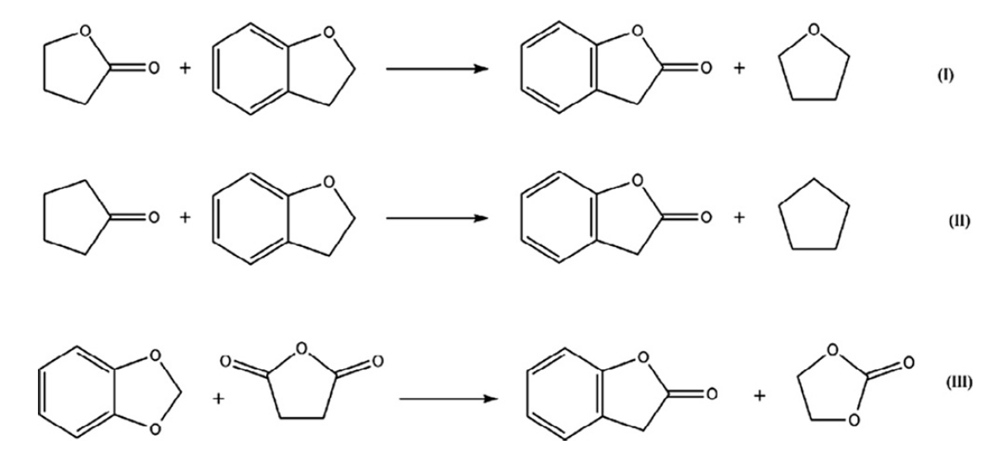
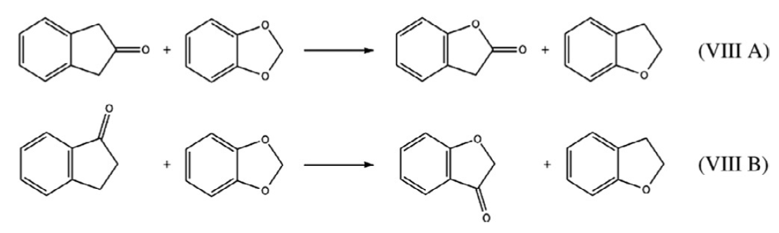
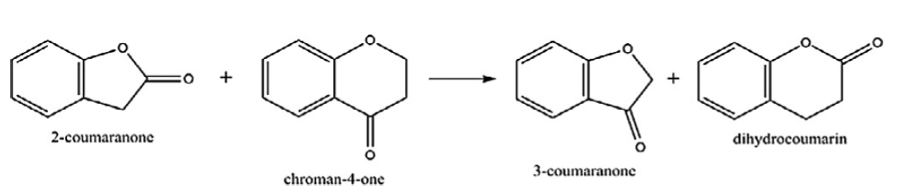
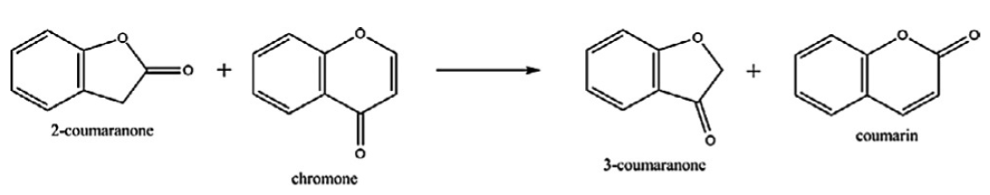
Fig. S2. Well balanced reaction used in ref. [21] for calculations of standard molar enthalpies of formation, $∆_{f}H_{\text{m}}^{\text{o}}$(g), from the G3MP2 and G3MP2/B3LYP methods.

Estimation of fusion enthalpies according to the Walden´s Rule

In 1908 Paul Walden found that the ratio according to Eq. (S12) can be considered as a constant (Walden´s Constant) [22] and [23]:
WC = $\frac{∆_{cr}^{l}H_{m}^{o} }{T_{fus}}$ = $∆_{cr}^{l}S_{m}^{o}$ = 56.5 J·K⁻¹·mol⁻¹ (S1)
This observation was supported by experimental results from 35 compounds (mostly substituted benzenes like nitrobenzene, aniline, dimethylaniline, diphenylmethane, diphenylamine, acetophenone, para-propenylanisole, but also aliphatic esters, anhydrides, etc.). The prerequisite for this constancy is that the compounds did not associate in the liquid state. Eq. (S1) is known as Walden's rule for thermochemistry [23].
From a practical point of view and based on our experience, Eq. S1 can be easily adapted for calculations within a range of similarly shaped molecules. We have already observed similarity of Walden´s Constants for R-acetanilides with R = alkyl, F, Cl, Br, NO₂, NH₂, OH, OCH₃ [24] and for the for R-substituted benzamides [24] and. [25]. We have found that for these series the WC for each series deviates from the “classic” value 56.5 J·K⁻¹·mol⁻¹ by about ± 10 J·K⁻¹·mol⁻¹. Such a “modified” Walden's Constant helps not only in evaluating the consistency of the experimental fusion data within a set of similarly structured compounds, but also the Walden's rule serves as a valuable tool for estimating missing fusion enthalpies of interesting compounds, provided that their fusion temperatures are available. Moreover, the “modified” Walden's Rule often helps to evaluate available phase transition data.

Table S3
Enthalpies of fusion ($∆_{\text{cr}}^{\text{l}}H_{\text{m}}^{\text{o}}$), vaporization ($∆_{\text{l}}^{\text{g}}H_{\text{m}}^{\text{o}}$) and sublimation ($∆_{\text{cr}}^{\text{g}}H_{\text{m}}^{\text{o}}$) of aromatic ethers and auxiliary compounds at melting points (T_{fus}) and 298 K (in kJ⋅mol⁻¹)ª
 | T_{fus} | $∆_{\text{cr}}^{\text{l}}H_{\text{m}}^{\text{o}}$(T_{fus}) ^{b} | $∆_{\text{cr}}^{\text{l}}H_{\text{m}}^{\text{o}}$(298 K)^{c} | $∆_{\text{cr}}^{\text{g}}H_{\text{m}}^{\text{o}}$(298 K) | $∆_{\text{l}}^{\text{g}}H_{\text{m}}^{\text{o}}$(298 K) ^{d}
Compound | K | kJ·mol⁻¹ | kJ·mol⁻¹ | kJ·mol⁻¹ | kJ·mol⁻¹
dibenzofuran [132-64-9] | 356 | 18.6±0.2 [26] | 15.8±0.8 | 82.0±0.3 [27] | 66.2±0.9
2-coumaranone [553-86-6] | 326 | 18.4±1.0 | 16.8±1.1 | 78.7±1.7 [21] | 61.9±2.0
phthalide [87-41-2] | 350 | 19.8±1.0 | 16.9±1.2 | 88.4±4.4 [28] | 71.5±4.6
3-coumaranone [7169-34-8] | 376 | 21.2±1.0 | 18.0±1.6 | 85.8±1.7 [21] | 67.8±2.3
2-indanone [615-13-4] | 330 | 16.9±0.2 [7] | 15.6±0.5 | 78.3±2.3 [7] | 62.7±2.4
ª Uncertainties are presented as expanded uncertainties (0.95 level of confidence with k=2).
^{b} Calculated using Eq. (S1) with the WC = 56.5 J·K⁻¹·mol⁻¹.
^{c} The $∆_{cr}^{l}H_{m}^{o}$ at T_{fus} were adjusted to 298.15 K using equation:
$∆_{\text{cr}}^{\text{l}}H_{\text{m}}^{\text{o}}$(298.15 K)/(J·mol⁻¹) = $∆_{\text{cr}}^{\text{l}}H_{\text{m}}^{\text{o}}$(T_{fus}/K) – ($∆_{\text{cr}}^{\text{g}}C_{\text{p}\text{,m}}^{\text{o}}$-$∆_{\text{l}}^{\text{g}}C_{\text{p}\text{,m}}^{\text{o}}$)×[(T_{fus}/K) – 298.15 K],
where $∆_{\text{cr}}^{\text{g}}C_{\text{p}\text{,}\text{m}}^{\text{o}}$ and $∆_{\text{l}}^{\text{g}}C_{\text{p}\text{,}\text{m}}^{\text{o}}$ were taken from Table S2-2. Uncertainties were estimated with 30 % of the total adjustment [29].
^{d} Difference of columns 5 and 4 in this table.

Table S4
The vapour pressures p, and standard vaporisation enthalpies and entropies obtained by the approximation of boiling points at different pressures available in the literature [30–32]
T/ª  K | p/  Pa | $∆_{l}^{g}H_{m}^{o}$/ª  kJ⋅mol⁻¹ | $∆_{l}^{g}S_{m}^{o}$/  J⋅K⁻¹⋅mol⁻¹
2,3-dihydro-benzofuran [496-16-2]
$∆_{l}^{g}H_{m}^{o}$(298.15 K) = (53.2±1.3) kJ.mol⁻¹
$∆_{l}^{g}S_{m}^{o}$(298.15 K) = (119.2±3.0) J⋅K⁻¹⋅mol⁻¹
$∆_{l}^{g}G_{m}^{o}$(298.15 K) = (17.7±0.3) kJ.mol⁻¹
$\text{ln} (p/p_{ref})=\frac{269.4}{R}-\frac{69452.4}{RT}-\frac{54.5}{R}ln\frac{T}{298.15}$ ; p_{ref} = 1 Pa
341 | 1067 | 50.9 | 111.7
343 | 1067 | 50.8 | 110.2
345 | 1600 | 50.6 | 112.4
346 | 1600 | 50.6 | 111.8
347 | 1733 | 50.5 | 111.9
348 | 1867 | 50.5 | 112.0
348 | 2000 | 50.5 | 112.5
348 | 1733 | 50.5 | 111.4
349 | 1867 | 50.4 | 111.4
350 | 1867 | 50.4 | 110.8
351 | 1600 | 50.3 | 109.0
351 | 1867 | 50.3 | 110.3
352 | 2266 | 50.3 | 111.3
355 | 2533 | 50.1 | 110.6
356 | 2533 | 50.1 | 110.0
357 | 2266 | 50.0 | 108.6
358 | 2133 | 49.9 | 107.5
359 | 2133 | 49.9 | 107.0
361 | 2400 | 49.8 | 106.9
363 | 2400 | 49.7 | 105.8
369 | 5066 | 49.3 | 108.9
377 | 6666 | 48.9 | 107.2
429 | 33331 | 46.1 | 98.3
431 | 33331 | 46.0 | 97.5
460 | 101325 | 44.4 | 96.6
461 | 101325 | 44.3 | 96.3
462 | 101325 | 44.3 | 95.9
463 | 101325 | 44.2 | 95.6
465 | 99325 | 44.1 | 94.9
phthalan (isobenzofuran) [496-14-0]
$∆_{l}^{g}H_{m}^{o}$(298.15 K) = (53.1±1.5) kJ.mol⁻¹
$∆_{l}^{g}S_{m}^{o}$(298.15 K) = (118.4±3.7) J⋅K⁻¹⋅mol⁻¹
$∆_{l}^{g}G_{m}^{o}$(298.15 K) = (17.8±0.3) kJ.mol⁻¹
$\text{ln} (p/p_{ref})=\frac{268.6}{R}-\frac{69336.6}{RT}-\frac{54.5}{R}ln\frac{T}{298.15}$ ; p_{ref} = 1 Pa
318 | 267 | 52.0 | 114.3
329 | 667 | 51.4 | 114.6
348 | 1333 | 50.4 | 108.8
351 | 2133 | 50.2 | 111.0
355 | 2400 | 50.0 | 109.8
356 | 2400 | 49.9 | 109.3
357 | 2666 | 49.9 | 109.6
358 | 2666 | 49.8 | 109.0
361 | 2666 | 49.7 | 107.4
378 | 5333 | 48.7 | 104.6
379 | 4800 | 48.7 | 103.2
379 | 4800 | 48.7 | 103.2
464 | 98658 | 44.0 | 94.8
465 | 101325 | 44.0 | 94.7
465 | 101325 | 44.0 | 94.7
octahydro-benzofuran [13054-97-2]
$∆_{l}^{g}H_{m}^{o}$(298.15 K) = (48.8±1.9) kJ.mol⁻¹
$∆_{l}^{g}S_{m}^{o}$(298.15 K) = (113.1±2.6) J⋅K⁻¹⋅mol⁻¹
$∆_{l}^{g}G_{m}^{o}$(298.15 K) = (15.0±0.2) kJ.mol⁻¹
$\text{ln} (p/p_{ref})=\frac{256.8}{R}-\frac{63068.9}{RT}-\frac{48.0}{R}ln\frac{T}{298.15}$ ; p_{ref} = 1 Pa
337 | 2000 | 46.9 | 106.6
339 | 2666 | 46.8 | 107.9
339 | 2000 | 46.8 | 105.5
341 | 2666 | 46.7 | 106.8
345 | 3333 | 46.5 | 106.5
345 | 3333 | 46.5 | 106.5
443 | 99992 | 41.8 | 94.4
445 | 99992 | 41.7 | 93.7
446 | 101325 | 41.7 | 93.5
octahydro-isobenzofuran [4743-54-8]
$∆_{l}^{g}H_{m}^{o}$(298.15 K) = (48.1±1.2) kJ.mol⁻¹
$∆_{l}^{g}S_{m}^{o}$(298.15 K) = (110.7±1.4) J⋅K⁻¹⋅mol⁻¹
$∆_{l}^{g}G_{m}^{o}$(298.15 K) = (15.1±0.2) kJ.mol⁻¹
$\text{ln} (p/p_{ref})=\frac{254.4}{R}-\frac{62405.5}{RT}-\frac{48.0}{R}ln\frac{T}{298.15}$ ; p_{ref} = 1 Pa
324 | 1067 | 46.9 | 106.9
325 | 1200 | 46.8 | 107.5
328 | 1333 | 46.7 | 106.4
335 | 2000 | 46.3 | 105.8
335 | 2000 | 46.3 | 105.8
337 | 2266 | 46.2 | 105.7
337 | 2400 | 46.2 | 106.2
337 | 2000 | 46.2 | 104.7
338 | 2000 | 46.2 | 104.1
340 | 2266 | 46.1 | 104.1
341 | 2266 | 46.1 | 103.8
343 | 2800 | 46.0 | 104.5
343 | 2266 | 45.9 | 102.5
343 | 2400 | 45.9 | 102.9
343 | 2666 | 45.9 | 103.8
347 | 3466 | 45.7 | 103.9
348 | 3333 | 45.7 | 103.0
349 | 3333 | 45.7 | 102.5
353 | 3733 | 45.5 | 101.4
353 | 4133 | 45.5 | 102.3
368 | 7506 | 44.7 | 100.1
443 | 97325 | 41.1 | 92.6
446 | 100125 | 41.0 | 92.1
446 | 100125 | 41.0 | 91.9
447 | 100125 | 40.9 | 91.6
448 | 97325 | 40.9 | 91.1
448 | 100125 | 40.9 | 91.3
451 | 101325 | 40.8 | 90.5
452 | 98658 | 40.7 | 90.0
453 | 101325 | 40.7 | 90.0
2-coumaranone [553-86-6]
$∆_{l}^{g}H_{m}^{o}$(298.15 K) = (65.3±2.4) kJ.mol⁻¹
$∆_{l}^{g}S_{m}^{o}$(298.15 K) = (132.4±3.0) J⋅K⁻¹⋅mol⁻¹
$∆_{l}^{g}G_{m}^{o}$(298.15 K) = (25.6±0.2) kJ.mol⁻¹
$\text{ln} (p/p_{ref})=\frac{280.7}{R}-\frac{80735.9}{RT}-\frac{52.6}{R}ln\frac{T}{298.15}$ ; p_{ref} = 1 Pa
384 | 1067 | 60.5 | 119.9
387 | 1067 | 60.4 | 118.3
397 | 1600 | 59.9 | 116.4
403 | 2666 | 59.5 | 117.6
405 | 2400 | 59.4 | 115.7
407 | 2400 | 59.3 | 114.8
419 | 5600 | 58.7 | 116.1
423 | 5333 | 58.5 | 113.9
512 | 101325 | 53.8 | 105.2
517 | 101325 | 53.5 | 103.7
518 | 101325 | 53.5 | 103.4
519 | 96792 | 53.4 | 102.7
520 | 101325 | 53.4 | 102.8
521 | 101325 | 53.3 | 102.5

3-coumaranone [7169-34-8]
$∆_{l}^{g}H_{m}^{o}$(298.15 K) = (68.8±2.3) kJ.mol⁻¹
$∆_{l}^{g}S_{m}^{o}$(298.15 K) = (132.2±5.1) J⋅K⁻¹⋅mol⁻¹
$∆_{l}^{g}G_{m}^{o}$(298.15 K) = (29.4±0.2) kJ.mol⁻¹
$\text{ln} (p/p_{ref})=\frac{274.1}{R}-\frac{82594.2}{RT}-\frac{46.2}{R}ln\frac{T}{298.15}$ ; p_{ref} = 1 Pa
425 | 15 | 2000 | 63.0 | 115.6
425 | 17 | 2266 | 63.0 | 116.7
427 | 17 | 2266 | 62.9 | 115.7
427 | 15 | 2000 | 62.9 | 114.7
551 | 760 | 101325 | 57.1 | 103.8
phthalide [87-41-2]
$∆_{l}^{g}H_{m}^{o}$(298.15 K) = (76.3±2.5) kJ.mol⁻¹
$∆_{l}^{g}S_{m}^{o}$(298.15 K) = (144.5±2.6) J⋅K⁻¹⋅mol⁻¹
$∆_{l}^{g}G_{m}^{o}$(298.15 K) = (33.3±0.5) kJ.mol⁻¹
$\text{ln} (p/p_{ref})=\frac{293.2}{R}-\frac{92132.4}{RT}-\frac{53.0}{R}ln\frac{T}{298.15}$ ; p_{ref} = 1 Pa
346 | 10 | 73.8 | 136.6
561 | 97325 | 62.4 | 111.0
563 | 101325 | 62.3 | 110.8
H6-2-coumaranone [6051-03-2]
$∆_{l}^{g}H_{m}^{o}$(298.15 K) = (64.3±2.3) kJ.mol⁻¹
$∆_{l}^{g}S_{m}^{o}$(298.15 K) = (127.6±5.6) J⋅K⁻¹⋅mol⁻¹
$∆_{l}^{g}G_{m}^{o}$(298.15 K) = (26.2±0.3) kJ.mol⁻¹
$\text{ln} (p/p_{ref})=\frac{279.4}{R}-\frac{80989.5}{RT}-\frac{56.1}{R}ln\frac{T}{298.15}$ ; p_{ref} = 1 Pa
377 | 400 | 59.8 | 112.8
378 | 467 | 59.8 | 113.5
383 | 667 | 59.5 | 113.7
383 | 667 | 59.5 | 113.7
385 | 800 | 59.4 | 114.1
385 | 800 | 59.4 | 114.1
393 | 1200 | 58.9 | 113.2
402 | 1733 | 58.4 | 111.6
403 | 1733 | 58.4 | 111.1
404 | 1600 | 58.3 | 110.0
408 | 2400 | 58.1 | 111.4
410 | 2000 | 58.0 | 108.9
411 | 2133 | 57.9 | 109.0
411 | 2000 | 57.9 | 108.4
412 | 2000 | 57.9 | 107.9
413 | 2133 | 57.8 | 108.0
413 | 3333 | 57.8 | 111.7
413 | 3333 | 57.8 | 111.7
418 | 3333 | 57.5 | 109.4
418 | 2666 | 57.5 | 107.5
418 | 3333 | 57.5 | 109.4
421 | 2666 | 57.4 | 106.1
425 | 3733 | 57.1 | 107.1
426 | 3733 | 57.1 | 106.7
537 | 101991 | 50.9 | 95.0

H6-3-coumaranone [1206676-08-5]
$∆_{l}^{g}H_{m}^{o}$(298.15 K) = (65.2±2.3) kJ.mol⁻¹
$∆_{l}^{g}S_{m}^{o}$(298.15 K) = (119.8±2.4) J⋅K⁻¹⋅mol⁻¹
$∆_{l}^{g}G_{m}^{o}$(298.15 K) = (29.5±0.2) kJ.mol⁻¹
$\text{ln} (p/p_{ref})=\frac{286.8}{R}-\frac{86456.8}{RT}-\frac{71.3}{R}ln\frac{T}{298.15}$ ; p_{ref} = 1 Pa
336 | 13 | 62.5 | 111.8
338 | 13 | 62.4 | 110.3
626 | 101325 | 41.8 | 66.9
H6-phthalide [2611-01-0]
$∆_{l}^{g}H_{m}^{o}$(298.15 K) = (77.6±1.3) kJ.mol⁻¹
$∆_{l}^{g}S_{m}^{o}$(298.15 K) = (162.5±2.9) J⋅K⁻¹⋅mol⁻¹
$∆_{l}^{g}G_{m}^{o}$(298.15 K) = (29.2±0.3) kJ.mol⁻¹
$\text{ln} (p/p_{ref})=\frac{314.3}{R}-\frac{94346.7}{RT}-\frac{56.1}{R}ln\frac{T}{298.15}$ ; p_{ref} = 1 Pa
347 | 67 | 74.9 | 155.0
347 | 53 | 74.9 | 153.1
353 | 93 | 74.5 | 153.2
353 | 107 | 74.5 | 154.3
355 | 93 | 74.4 | 151.7
359 | 120 | 74.2 | 150.8
360 | 120 | 74.2 | 150.1
361 | 160 | 74.1 | 151.7
363 | 160 | 74.0 | 150.3
363 | 200 | 74.0 | 152.1
366 | 200 | 73.8 | 150.0
394 | 1067 | 72.2 | 145.6
395 | 1200 | 72.2 | 146.0
395 | 1333 | 72.2 | 146.9
396 | 1600 | 72.2 | 148.1
396 | 1733 | 72.1 | 148.4
398 | 1733 | 72.0 | 147.2
404 | 2400 | 71.7 | 146.4
404 | 2400 | 71.7 | 146.4
405 | 2400 | 71.6 | 145.8
405 | 2400 | 71.6 | 145.8
406 | 2666 | 71.6 | 146.1
407 | 2666 | 71.5 | 145.6
411 | 3333 | 71.3 | 145.2
433 | 7999 | 70.1 | 140.8
438 | 9333 | 69.8 | 139.6
503 | 101325 | 66.1 | 131.6
octahydro-benzofuran-3-ol [99769-38-7]
$∆_{l}^{g}H_{m}^{o}$(298.15 K) = (73.2±1.6) kJ.mol⁻¹
$∆_{l}^{g}S_{m}^{o}$(298.15 K) = (151.9±5.5) J⋅K⁻¹⋅mol⁻¹
$∆_{l}^{g}G_{m}^{o}$(298.15 K) = (27.9±0.2) kJ.mol⁻¹
$\text{ln} (p/p_{ref})=\frac{321.8}{R}-\frac{95285.8}{RT}-\frac{74.1}{R}ln\frac{T}{298.15}$ ; p_{ref} = 1 Pa
354 | 133 | 69.1 | 140.0
357 | 133 | 68.8 | 137.8
513 | 101325 | 57.3 | 111.8
2-hydroxy-tetrahydrofuran [5371-52-8]
$∆_{l}^{g}H_{m}^{o}$(298.15 K) = (50.6±2.5) kJ.mol⁻¹
$∆_{l}^{g}S_{m}^{o}$(298.15 K) = (118.0±7.7) J⋅K⁻¹⋅mol⁻¹
$∆_{l}^{g}G_{m}^{o}$(298.15 K) = (15.4±0.4) kJ.mol⁻¹
$\text{ln} (p/p_{ref})=\frac{270.1}{R}-\frac{67418.2}{RT}-\frac{56.3}{R}ln\frac{T}{298.15}$ ; p_{ref} = 1 Pa
324 | 51 |  | 8 | 1067 | 82 | 49,2 | 114,0
333 | 60 |  | 13 | 1733 | 124 | 48,7 | 112,4
335 | 62 |  | 17 | 2266 | 479 | 48,6 | 113,5
336 | 63 |  | 15 | 2000 | 118 | 48,5 | 111,8
338 | 65 |  | 15 | 2000 | -86 | 48,4 | 110,6
338 | 65 |  | 20 | 2666 | 581 | 48,4 | 113,0
338 | 65 |  | 13 | 1733 | -352 | 48,4 | 109,4
340 | 67 |  | 14 | 1867 | -384 | 48,3 | 109,2
341 | 68 |  | 20 | 2666 | 241 | 48,2 | 111,3
357 | 84 |  | 40 | 5333 | 170 | 47,3 | 108,2
358 | 85 |  | 40 | 5333 | -65 | 47,3 | 107,6
361 | 88 |  | 35 | 4666 | -1491 | 47,1 | 105,0
362 | 89 |  | 35 | 4666 | -1764 | 47,0 | 104,5
437 | 164 |  | 760 | 101325 | 18272 | 42,8 | 98,2
±3-hydroxy-tetrahydrofuran [453-20-3]
$∆_{l}^{g}H_{m}^{o}$(298.15 K) = (56.9±1.4) kJ.mol⁻¹
$∆_{l}^{g}S_{m}^{o}$(298.15 K) = (128.6±3.6) J⋅K⁻¹⋅mol⁻¹
$∆_{l}^{g}G_{m}^{o}$(298.15 K) = (18.5±0.3) kJ.mol⁻¹
$\text{ln} (p/p_{ref})=\frac{280.7}{R}-\frac{73688.6}{RT}-\frac{56.3}{R}ln\frac{T}{298.15}$ ; p_{ref} = 1 Pa
319 | 267 | 55.7 | 125.4
321 | 333 | 55.6 | 125.8
323 | 400 | 55.5 | 125.9
333 | 667 | 54.9 | 123.3
334 | 667 | 54.9 | 123.0
334 | 667 | 54.9 | 122.7
335 | 667 | 54.8 | 122.0
353 | 2000 | 53.8 | 119.9
353 | 1467 | 53.8 | 117.3
354 | 1733 | 53.8 | 118.1
355 | 1733 | 53.7 | 117.6
357 | 2133 | 53.6 | 118.1
359 | 2133 | 53.5 | 117.0
361 | 2266 | 53.4 | 116.3
361 | 3200 | 53.4 | 119.2
361 | 3066 | 53.4 | 118.9
362 | 2266 | 53.3 | 115.8
363 | 2666 | 53.3 | 116.6
364 | 2666 | 53.2 | 116.0
383 | 7466 | 52.1 | 114.5
384 | 7999 | 52.1 | 114.6
385 | 7999 | 52.0 | 114.1
452 | 101325 | 48.2 | 106.8
454 | 101325 | 48.1 | 106.1
3-oxo-tetrahydrofuran [22929-52-8]
$∆_{l}^{g}H_{m}^{o}$(298.15 K) = (46.4±1.0) kJ.mol⁻¹
$∆_{l}^{g}S_{m}^{o}$(298.15 K) = (114.9±1.4) J⋅K⁻¹⋅mol⁻¹
$∆_{l}^{g}G_{m}^{o}$(298.15 K) = (12.1±0.2) kJ.mol⁻¹
$\text{ln} (p/p_{ref})=\frac{259.6}{R}-\frac{60999.5}{RT}-\frac{49.0}{R}ln\frac{T}{298.15}$ ; p_{ref} = 1 Pa
307 | 1200 | 46.0 | 112.9
308 | 1333 | 45.9 | 113.2
308 | 1333 | 45.9 | 113.2
308 | 1200 | 45.9 | 112.3
309 | 1467 | 45.9 | 113.3
309 | 1333 | 45.9 | 112.5
309 | 1333 | 45.9 | 112.5
311 | 1867 | 45.8 | 114.0
311 | 1467 | 45.8 | 112.0
311 | 1467 | 45.8 | 112.0
311 | 1867 | 45.8 | 114.0
312 | 1867 | 45.7 | 113.4
313 | 1867 | 45.7 | 112.8
313 | 1867 | 45.7 | 112.8
313 | 1867 | 45.7 | 112.8
339 | 8106 | 44.4 | 110.0
341 | 8106 | 44.3 | 109.0
345 | 9999 | 44.1 | 108.7
365 | 19998 | 43.1 | 104.7
367 | 19998 | 43.0 | 103.8
367 | 19998 | 43.0 | 103.8
409 | 98525 | 41.0 | 100.0
410 | 98525 | 40.9 | 99.8
412 | 101325 | 40.8 | 99.2
412 | 101325 | 40.8 | 99.0
413 | 101325 | 40.8 | 98.9
413 | 101325 | 40.8 | 98.8
413 | 101325 | 40.8 | 98.8
415 | 101325 | 40.7 | 98.1
2-methyl-2,3-benzofuran [4265-25-2]
$∆_{l}^{g}H_{m}^{o}$(298.15 K) = (52.8±1.1) kJ.mol⁻¹
$∆_{l}^{g}S_{m}^{o}$(298.15 K) = (117.5±1.1) J⋅K⁻¹⋅mol⁻¹
$∆_{l}^{g}G_{m}^{o}$(298.15 K) = (17.8±0.2) kJ.mol⁻¹
$\text{ln} (p/p_{ref})=\frac{267.5}{R}-\frac{68979.2}{RT}-\frac{54.3}{R}ln\frac{T}{298.15}$ ; p_{ref} = 1 Pa
304 | 133 | 52.5 | 117.6
306 | 133 | 52.4 | 116.1
319 | 267 | 51.7 | 112.7
323 | 400 | 51.4 | 113.3
325 | 467 | 51.3 | 113.3
325 | 400 | 51.3 | 112.0
327 | 467 | 51.2 | 112.0
334 | 667 | 50.8 | 110.6
341 | 1067 | 50.5 | 110.2
342 | 1333 | 50.4 | 111.5
343 | 1333 | 50.4 | 110.9
343 | 1067 | 50.4 | 109.1
344 | 1200 | 50.3 | 109.4
344 | 1200 | 50.3 | 109.4
346 | 1200 | 50.2 | 108.6
348 | 1600 | 50.1 | 109.5
348 | 1600 | 50.1 | 109.5
350 | 1867 | 50.0 | 109.7
350 | 1600 | 50.0 | 108.4
351 | 1867 | 49.9 | 109.1
352 | 1867 | 49.9 | 108.6
352 | 1867 | 49.9 | 108.6
353 | 1867 | 49.8 | 108.0
353 | 2000 | 49.8 | 108.6
354 | 1867 | 49.8 | 107.5
359 | 2666 | 49.5 | 108.0
360 | 2666 | 49.5 | 107.4
360 | 2666 | 49.4 | 107.2
361 | 2533 | 49.4 | 106.2
361 | 2666 | 49.4 | 106.6
378 | 5999 | 48.5 | 104.8
388 | 9466 | 47.9 | 103.9
391 | 9466 | 47.7 | 102.5
465 | 99192 | 43.7 | 94.0
465 | 99192 | 43.7 | 94.0
469 | 99458 | 43.5 | 92.7
469 | 98925 | 43.5 | 92.7
470 | 101325 | 43.5 | 92.6
470 | 98925 | 43.5 | 92.4
471 | 106658 | 43.4 | 92.8
471 | 101325 | 43.4 | 92.3
ª Uncertainties in this table are expressed as the expanded uncertainty (0.95 level of confidence. k = 2). Uncertainties of the vaporisation enthalpies include uncertainties from the fitting equation (Eq. S2) and uncertainties from temperature adjustment to T = 298.15 K. Uncertainties in the temperature adjustment of vaporisation enthalpies to the reference temperature T = 298.15 K are estimated to account with 20 % to the total adjustment.

Adjustment of vaporisation enthalpies to the reference temperature T = 298.15 K

The vapour pressure-temperature dependencies were fitted by the following equation [33,34]:
$R\ln{(p_{i}}{/p}_{ref})=a+ \frac{b}{T}+∆_{l}^{g}C_{p,m}^{o} ln\left(\frac{T}{T_{0}}\right)$ (S2),
where R = 8.314462 J.K⁻¹.mol⁻¹ is the molar gas constant, the reference pressure $p_{ref}=1 \text{Pa,}$ a and b are adjustable parameters, the arbitrary temperature T₀ applied in Eq. (S2) was chosen to be T₀ = 298.15 K and $∆_{l}^{g}C_{p,m}^{o}$ = $C_{\text{p}\text{,}\text{m}}^{\text{o}}$(g) – $C_{\text{p}\text{,}\text{m}}^{\text{o}}$(liq) is the difference between the molar heat capacities of the gaseous $C_{\text{p}\text{,}\text{m}}^{\text{o}}$(g) and the liquid phase $C_{\text{p}\text{,}\text{m}}^{\text{o}}$(liq), respectively. The $∆_{l}^{g}C_{p,m}^{o}$-values used in Eq. (S2) are given in Table S6.

The standard molar enthalpies of vaporization at temperatures T were derived from the temperature dependence of the vapor pressures, approximated by Eq. (S2) using the following equation:
$∆_{l, cr}^{g}H_{m}^{o}\left(T\right)=-b+∆_{l,cr}^{g}C_{p,m}^{o}×T$ (S3)
where b is one of the adjustable parameters of Eq. (S2).
The $∆_{l,cr}^{g}C_{p,m}^{o}$-values used in Eq. (S3) are usually derived according to empirical equations developed by Acree and Chickos [29]:
$∆_{l}^{g}C_{p,m}^{o}\left(\text{298.15}\text{ K}\right)=-0.26×C_{p,m}^{o}\left(\text{l}\text{iq}\text{, 298.15}\text{ K}\right)-10.58$ (S4)
$∆_{cr}^{g}C_{p,m}^{o}\left(\text{298.15}\text{ K}\right)=-0.15×C_{p,m}^{o}\left(\text{cr, 298.15}\text{ K}\right)-0.75$ (S5)
where $C_{p,m}^{o}$(cr, 298.15 K) or $C_{p,m}^{o}$(liq, 298.15 K) values are of experimental origin or they can be also estimated according to the group-additivity procedure by Chickos et al. [35]. The empirical coefficients in Eqs. (S4) and (S5) were originally derived from experimental data available for various organic compounds, but very few aromatic ethers participated in the parameterization of these equations.
It has turned out that the $∆_{l}^{g}C_{p,m}^{o}$–values calculated using the conventional method of Acree and Chickos [29] are systematically and significantly overestimated when the procedure is applied to aromatic and aliphatic ethers [15], or esters [36]. Therefore, the empirical coefficients in Eq. (S4) were re-evaluated [15] and [36] using the reliable vapor pressures from the literature and the specific for each family equations were derived:

for aromatic ethers:
$∆_{l}^{g}C_{p,m}^{o}\left(\text{298.15 K}\right)=-0.26×C_{p,m}^{o}\left(\text{liq, 298.15 K}\right)+2.0$ (S6),
for aliphatic ethers
$∆_{l}^{g}C_{p,m}^{o}\left(\text{298.15 K}\right)=-0.31×C_{p,m}^{o}\left(\text{liq, 298.15 K}\right)+17.4$ (S7),
for aliphatic and aromatic esters
$∆_{l}^{g}C_{p,m}^{o}\left(\text{298.15 K}\right)=-0.18×C_{p,m}^{o}\left(\text{liq, 298.15 K}\right)-16.4$ (S8),

for aromatic ketones [37] :
$∆_{l}^{g}C_{p,m}^{o}\left(\text{298.15 K}\right)=-0.26×C_{p,m}^{o}\left(\text{liq, 298.15 K}\right)+9.6$ (S9),
These equations were used in this work for the temperature adjustments of vaporization enthalpies of compounds to the reference temperature T = 298.15 K (see Table 3).
The standard molar vaporization entropies at temperatures T were also derived from the temperature dependences of the vapor pressures (approximated by Eq. S2) as follows:
$∆_{l,cr}^{g}S_{m}^{o}\left(T\right)={∆_{l,cr}^{g}H_{m}^{o}}/{T+R×ln\left({p_{i}}/{p^{o}}\right)}$ (S10)
with $p^{o}$ = 0.1 MPa.

Table S5-1
Compilation of data on molar heat capacities $C_{\text{p,m}}^{\text{o}}$(liq) and heat capacity differences $∆_{\text{l}}^{\text{g}}C_{\text{p,m}}^{\text{o}}$ (in J.K⁻¹.mol⁻¹) at T = 298.15 K
Compounds | $C_{\text{p,m}}^{\text{o}}(liq)$ ª | ${-∆}_{\text{l}}^{\text{g}}C_{\text{p,m}}^{\text{o}}$ ^{b}
2,3-benzofuran [271-89-6] | 186.6 [29] | 59.1
 | 178.7 [38] | 45.8±0.4^{c}
 | 178.7 [38] | 44.5 [Eq. S6]
2,3-dihydro-benzofuran [496-16-2] | 192.0 [29] | 60.5
 | 188.6 [38] | 53.2±0.7 ^{c}
 | 188.6 [38] | 47.0 [Eq. S6]
dibenzofuran [132-64-9] | 263.6 [29] | 79.1
 | 263.6 [29] | 66.5 [Eq. S6]
8H-benzofuran [13054-97-2] | 211.0 [29] | 65.4
 | 211.0 [29] | 48.0 [Eq. S7]
8H-isobenzofuran [4743-54-8] | 211.0 [29] | 65.4
 | 211.0 [29] | 48.0 [Eq. S7]
12H--dibenzofuran [13054-98-3] | 296.8 [29] | 87.7
 |  | 74.6 [Eq. S7]
phthalan [496-14-0] | 192.0 [29] | 60.5
 | 188.7 [38] | 54.5±0.6 ^{c}
 | 188.7 [38] | 47.0 [Eq. S6]
2-coumaranone [553-86-6] | 197.6 [29] | 62.0
 | 197.6 [29] | 52.6 [Eq. S8]
phthalide [87-41-2] | 197.6 [29] | 62.0
 | 197.6 [29] | 52.6 [Eq. S8]
3-coumaranone [7169-34-8] | 214.5 [29] | 66.4
 | 214.5 [29] | 46.2 [Eq. S9]
H6-2-coumaranone | 216.6 [29] | 66.9
[6051-03-2] | 216.6 [29] | 56.1 [Eq. S9]
H6-phthalide | 216.6 [29] | 66.9
[2611-01-1] | 216.6 [29] | 56.1 [Eq. S9]
H6-3-coumaranone | 233.5 [29] | 71.3
[1206676-08-5]
8H-benzofuran-2-ol [36871-99-5] | 244.2 [29] | 74.1
8H-benzofuran-3-ol [99769-38-7] | 244.2 [29] | 74.1
8H-isobenzofuran-1-ol [59901-42-7] | 244.2 [29] | 74.1
2-hydroxy-tetrahydrofuran [5371-52-8] | 175.8 [29] | 56.3
(±)-3-hydroxy-tetrahydrofuran [45320-3] | 175.8 [29] | 56.3
3-oxo-tetrahydrofuran [22929-52-8] | 147.7 [29] | 49.0
2-methyl-2,3-benzofuran [4265-25-2] | 216.4 [29] | 66.8
 | 216.4 [29] | 54.3 [Eq. S6]
furan [110-00-9] | 114.6 [39]
2,3-dihydro-furan [1191-99-7] | 129.8 [29] | 44.3
 | 122.1 [40] | 31.8±0.5 ^{c}
tetrahydrofuran [109-99-9] | 123.9 [41]
1,3-cyclopentadiene [542-92-7] | 115.3 [41]
cyclopentene [142-29-0] | 122.4 [42]
cyclopentane [287-92-3] | 126.8 [43]
indene [95-13-6] | 186.9 [44] | 59.2
indane [496-11-7] | 190.3 [44] | 60.1
trans-octahydro-1H-indene [3296-50-2] | 209.7 [45] | 65.1
fluorene [86-73-7] | 251.0 [46] | 75.8
dodecahydro-fluorene [5744-03-6] | 299.1 [29] | 88.3
ª Calculated according to the group-additivity procedure developed by Acree and Chickos [29] or taken from the literature.
^{b} Calculated according to Eq. (S4) or empirical equations modified in this work (see text above).
^{b} Calculated according to the Clarke and Glew equation [47]

$$R×ln\left({p_{\text{i}}}/{p^{o}}\right)=-\frac{∆_{l}^{g}G_{m}^{o}\left(θ\right)}{θ}+∆_{l}^{g}H_{m}^{o}\left(θ\right)\left(\frac{1}{θ}-\frac{1}{T}\right)+∆_{l}^{g}C_{p,m}^{o}\left(θ\right)\left[\left(\frac{θ}{T}\right)-1+ln\left(\frac{T}{θ}\right)\right]$$
where $p_{\text{i}}$ is the vapour pressure at the temperature T, $p^{o}$ is an arbitrary reference pressure (pº = 1 Pa in this work), θ is an arbitrary reference temperature (in this work we use θ = 298.15 K), R is the molar gas constant, $∆_{l}^{g}G_{m}^{o}\left(θ\right)$ is the difference in the standard molar Gibbs energy between the gaseous and the liquid phases, $∆_{l}^{g}H_{m}^{o}\left(θ\right)$ is the standard molar vaporization enthalpy, and ${\text{∆}}_{\text{l}}^{\text{g}}C_{p,m}^{o}\left(θ\right)$ is the difference in the molar heat capacity at constant pressure between the gaseous and the liquid phase.

Table S5-2
Compilation of data on molar heat capacities $C_{\text{p,m}}^{\text{o}}$(cr) and heat capacity differences $∆_{\text{cr}}^{\text{g}}C_{\text{p,m}}^{\text{o}}$ (in J.K⁻¹.mol⁻¹) at T = 298.15 K

Compounds | $C_{\text{p,m}}^{\text{o}}(cr)$ ª | ${-∆}_{\text{cr}}^{\text{g}}C_{\text{p,m}}^{\text{o}}$ ^{b}
2-coumaranone [553-86-6] | 153.8 [29] | 23.8
phthalide [87-41-2] | 153.8 [29] | 23.8
3-coumaranone [7169-34-8] | 164.6 [29] | 25.4
2-indanone [615-13-4] | 170.7 [29] | 26.4
dibenzofuran [132-64-9] | 199.0 [26] | 30.6
ª Calculated according to the group-additivity procedure developed by Acree and Chickos [29] or taken from the literature.
^{b} Calculated according to Eq. (S4).

Table S6
Thermochemical data at T = 298.15 K (p° = 0.1 MPa) for reference compounds (in kJ·mol⁻¹)

Compounds | $∆_{f}H_{\text{m}}^{\text{o}}$(liq) | $$∆_{\text{l}}^{\text{g}}H_{\text{m}}^{\text{o}}$$ | $∆_{f}H_{\text{m}}^{\text{o}}$(g)
benzene [71-43-2] [48] | 49.0±0.9 | 33.9±0.1 | 82.9±0.9
cyclohexane [110-82-7] [49] | -156.4±0.8 | 33.0±0.2 | -123.4±0.8
methoxy-benzene [100-66-3] [50] | -116.9±0.7 | 46.4±0.2 | -70.3±0.7
methoxy-cyclohexane [931-56-6] [51] | -270.7±4.1 | 43.0±0.5 | -313.7±3.5
diphenyl ether [101-84-8] [14] | -15.8±1.4 | 66.7±0.2 | 50.9±1.4
dicyclohexyl ether [4645-15-2] [15] | -356.1±4.1 | 68.2±1.3 | -424.3±4.3
indene [95-13-6] [49] | 110.6±1.6 | 52.8±1.4 | 163.4±2.1
indane [496-11-7] [49] | 11.5±1.6 | 49.0±0.5 | 60.5±1.7
trans-8H-octahydro-indene [3296-50-2] [49] | -176.2±1.8 | 44.8±1.3 | -131.4±2.2
furan [100-00-9] [49] | -62.3±0.7 | 27.4±0.2 | -34.9±0.7
2,3-dihydrofuran [1191-99-7] [40] | -103.0±0.4 | 30.8±0.1 | -72.3±0.4
tetrahydrofuran [109-99-9] [49] | -216.2±0.8 | 32.2±0.2 | -184.0±0.8
1,3-cyclopentadiene [542-92-7] [49] | 105.9±1.5 | 28.4±0.3 | 134.3±1.5
cyclopentene [142-29-0] [49] | 4.4±0.8 | 29.5±1.1 | 33.9±1.4
cyclopentane [287-92-3] [49] | -105.1±0.8 | 28.7±0.2 | -76.4±0.8

Table S6-1
Compilation of the standard molar enthalpies of vaporization for auxiliary compounds (in kJ⋅mol⁻¹)

Compounds | Methodª | T-range/  K | $$∆_{l}^{g}H_{m}^{o}$$  T_{av} | $$∆_{l}^{g}H_{m}^{o}$$  298.15 K^{b} | Ref.
2,3-dihydrofuran [1191-99-7] | E | 301.9-359.8 | 30.3±0.1 | 31.3±0.3 | [52]
 | J_{x} |  |  | 31.3±1.0 | Table S6-2
2-hydroxy-tetrahydrofuran [5371-52-8] | BP | 324-437 | 46.3±2.3 | 50.6±2.5 | Table S4
(±)-3-hydroxy-tetrahydrofuran [45320-3] | BP | 319-454 | 52.5±1.1 | 56.9±1.4 | Table S4
3-oxo-tetrahydrofuran [22929-52-8] | BP | 307-415 | 43.6±0.8 | 46.4±1.0 | Table S4
1-indanone [83-33-0] | T | 318.4-348.3 | 60.4±0.9 | 62.0±1.0 | [10]
2-indanone [615-13-4] | PhT | 298 |  | 62.7±2.6 | Table S3
6H-2-indanone [16484-17-6] | C | 298 |  | 56.1±0.3 | [53]
2-methyl-2,3-benzofuran [4265-25-2] | E | 366.7-479.5 | 46.7±0.7 | 53.3±1.5 | [54]
 | BP | 304-471 | 47.9±0.6 | 52.8±1.1 | Table S4
 |  |  |  | 53.0±0.9^{c} | average
 | J_{x} |  |  | 53.2±1.0 | Table S6-2
ª Methods: n/a = method is not available; E = ebulliometry; T = transpiration; PhT = from consistency of phase transitions (see Table S3); BP = estimated from boiling points at different pressures (see Table S4); J_{x} = calculated from correlation with the Kovats retention indices; C = calorimetry).
^{b} Vapour pressures available in the literature were treated using Eqs. (S2) and (S3) with help of heat capacity differences from Table S5 to calculate the enthalpies of vaporisation at 298.15 K. Uncertainties of the vaporisation enthalpies U($∆_{l}^{g}H_{m}^{o}$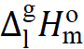) are the expanded uncertainties (0.95 level of confidence). They include uncertainties from the fitting equation and uncertainties from temperature adjustment to T = 298.15 K. Uncertainties in the temperature adjustment of vaporisation enthalpies to the reference temperature T= 298.15 K are estimated to account with 20% to the total adjustment.
^{c} Weighted mean value (uncertainties were taken as the weighting factor). Values given in bold are recommended for further thermochemical calculations.

Table 6-2
Correlation of vaporisation enthalpies, $∆_{\text{l}}^{\text{g}}H_{\text{m}}^{\text{o}}$(298.15 K)/ kJ.mol⁻¹ of auxiliary compounds with their Kovats indices (J_{x})

CAS | Compound | J_{x} ª | $∆_{l}^{g}H_{m}^{o}$(298.15 K)_{exp} ^{b} | $∆_{l}^{g}H_{m}^{o}$(298.15 K)_{calc} | Δ^{c}
 |  | SE-30
96-48-0 | γ-butyrolactone | 895 | 54.4±0.4 [55] | 53.4 ^{d} | 1.0
22929-52-8 | 3-oxo-tetrahydrofuran | 715 | 46.4±1.0 | 47.1 ^{d} | -0.7
553-86-6 | 2-coumaranone | 1250 | 65.3±2.4 | 65.7 ^{d} | -0.4
 |  | OV-101
96-48-0 | γ-butyrolactone | 866 | 54.4±0.4 [55] | 52.8 ^{e} | 1.6
22929-52-8 | 3-oxo-tetrahydrofuran | 694 | 46.4±1.0 | 47.5 ^{e} | -1.1
553-86-6 | 2-coumaranone | 1289 | 65.3±2.4 | 65.7 ^{e} | -0.4
ª Kovats indices on the non-polar columns SE-30 [56] and OV-101 [57] from the literature.
^{b} Experimental data evaluated in Table 3.
^{c} Difference between column 3 and 4 in this table.
^{d} Calculated using equation $∆_{l}^{g}H_{m}^{o}$(298.15 K) = 22.3 + 0.0347×J_{x} with R² = 0.9904,
with the assessed expanded uncertainty of ±1.5 kJ.mol⁻¹ (0.95 level of confidence, k = 2).
^{e} Calculated using equation $∆_{l}^{g}H_{m}^{o}$(298.15 K) = 26.3 + 0.0306×J_{x} with R² = 0.9775,
with the assessed expanded uncertainty of ±2.0 kJ.mol⁻¹ (0.95 level of confidence, k = 2).

Table S7
Group-additivity values Γ_{i} for calculation of enthalpies of vaporization, $∆_{l}^{g}H_{m}^{o}$(298.15 K) of alkanes, ethers, ketones, alcohols and esters at 298.15 K in kJ mol⁻¹

 | $∆_{l}^{g}H_{m}^{o}$(298.15 K)
 | Γ_{i} [58] [59]
Alkanes
СH₃-(С) | 5.65
СH₂-(С)₂ | 5.0
СH-(С)₃ | 3.0
С-(С)₄ | 0.0
5-ring: (СH₂)₅ | 5.74 ª
6-ring: (СH₂)₆ | 5.52 ª
Ethers
O-(C)₂ | 8.8
5-ring: (O)₅ | 11.5 ª
СH₂[O] | 4.6
СH[O] | 2.0
С[O] | -1.8
Ketones
C=O | 19.5
5-ring: (C=O)₅ | 25.3 ª
СH₂[C=O] | 3.0
СH[C=O] | 0.46
С[C=O] | -2.5
Alcohols
HO-(C) | 31.8
СH₂[OH] | 4.6
СH[OH] | 2.0
С[OH] | -1.8
Ester
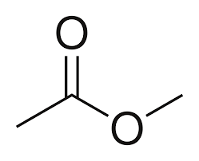 | 18.2
ª Developed in this work from vaporisation enthalpies of cyclopentane, cyclohexane, tetrahydrofuran, and cyclopentanone

Table S8
Correlation of the normal boiling temperatures, T_{b}, of furan derivatives with their J_{x} (Kovats retention indices)

CAS | Ether | T_{b}/K ª | J_{x}(exp) ^{b} | J_{x}(calc) ^{c} | Δ^{d}
1 | 2 | 3 | 4 | 5 | 6
109-99-9 | tetrahydrofuran | 339 | 612 | 611 | 1
110-00-9 | furan | 304.7 | 485 | 468 | 17
1191-99-7 | 2,3-dihydrofuran | 327.7 | 567 | 564 | 3
1708-29-8 | 2,5-dihydrofuran | 339.7 | 608 ^{e} | 614 | -6
534-22-5 | 2-methyl-furan | 337 | 613 | 603 | 10
625-86-5 | 2,5-dimethyl-furan | 367 | 715 | 729 | -14
3208-16-0 | 2-ethyl-furan | 365 | 720 | 720 | 0
271-89-6 | 2,3-benzofuran | 444.7 | 1013 | 1054 | -41
496-16-2 | 2,3-dihydrobenzofuran | 466.3 | 1188 | 1144 | 44
496-14-0 | phthalan | 465.8 |  | 1142
4265-25-2 | 2-methyl-benzofuran | 469.5 | 1131 | 1158 | -27
132-64-9 | dibenzofuran | 560 | 1526 | 1537 | -11
92-83-1 | xanthen | 584.2 | 1661 | 1638 | 23
ª Normal boiling temperatures are from Ref. [30–32].
^{b} Kovats indices, J_{x}, on the standard non-polar columns from [60].
^{c} Calculated using equation J_{x} = -808.3 + 4.1875×T_{b} with R² = 0.9968
^{d} Difference between column 4 and 5 in this table.
^{e} Calculated from the retention times given in ref. [61]

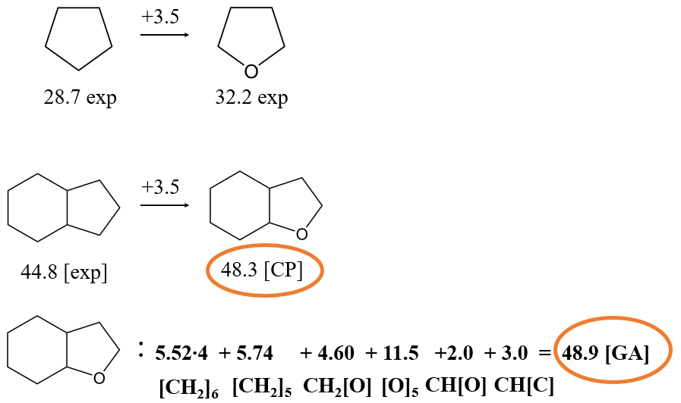

Fig. S3 Calculating the enthalpy of vaporization, $∆_{l}^{g}H_{m}^{o}$(298.15 K)/ kJ⋅mol⁻¹ of 8H-benzofuran using the “centerpiece approach” (CP) and using the GA method. The numerical values of enthalpies of vaporisation required for calculations are given in Table S6 and the group-contributions are given in Table S7.

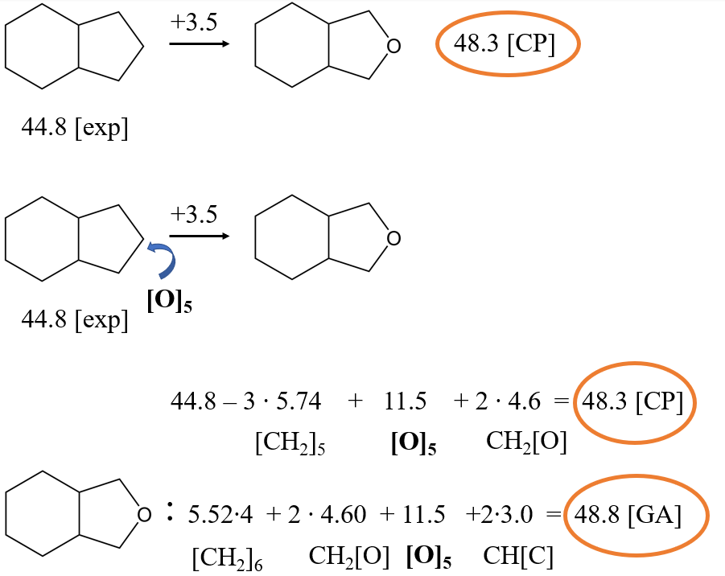
Fig. S4 Calculating the enthalpy of vaporization, $∆_{l}^{g}H_{m}^{o}$(298.15 K)/ kJ⋅mol⁻¹ of 8H-isobenzofuran using the “centerpiece approach” (CP) and using the GA method. The numerical values of enthalpies of vaporisation required for calculations are given in Table S6 and the group-contributions are given in Table S7.

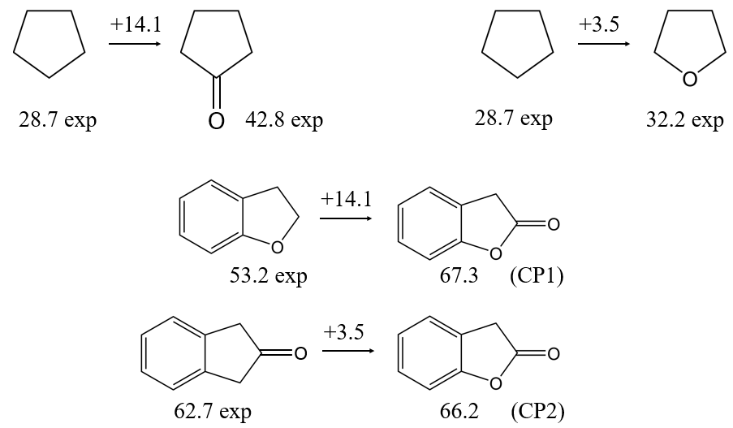
Fig. S5 Calculating the enthalpy of vaporization, $∆_{l}^{g}H_{m}^{o}$(298.15 K)/ kJ⋅mol⁻¹ of 2-coumaranone using the “centerpiece approach” (CP) and 2,3-dihydrobenzofuran or 2-indanone as the staring molecules. The numerical values of enthalpies of vaporisation required for calculations are given in Table 3 and Table S6.

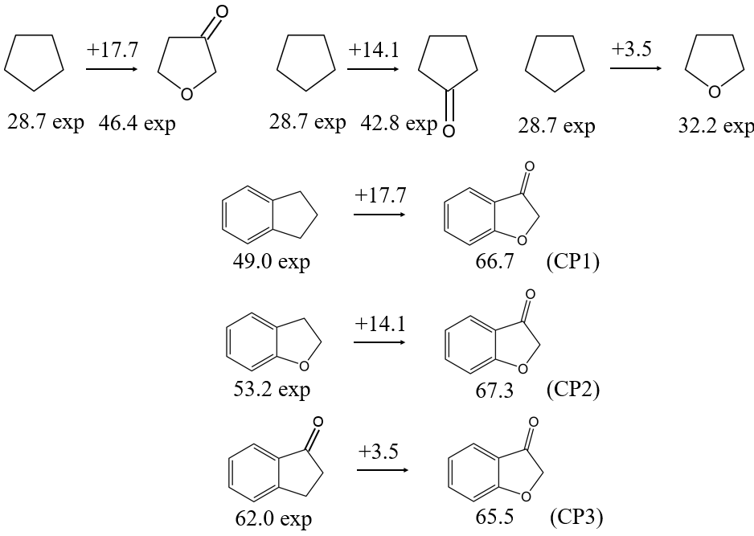
Fig. S6 Calculating the enthalpy of vaporization, $∆_{l}^{g}H_{m}^{o}$(298.15 K)/ kJ⋅mol⁻¹ of 3-coumaranone using the “centerpiece approach” (CP) and indane, 2,3-dihydrobenzofuran or 2-indanone as the staring molecules. The numerical values of enthalpies of vaporisation required for calculations are given in Table 3 and Table S6.

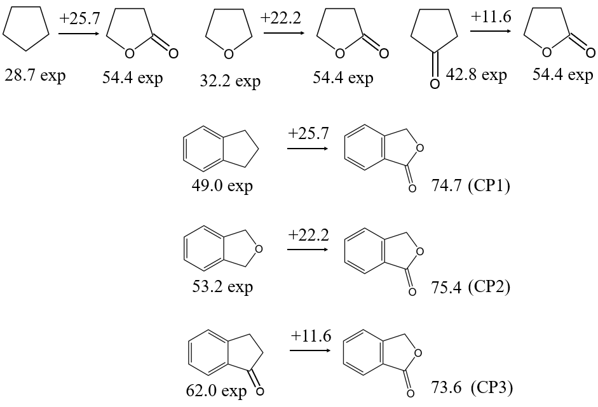
Fig. S7 Calculating the enthalpy of vaporization, $∆_{l}^{g}H_{m}^{o}$(298.15 K)/ kJ⋅mol⁻¹ of phthalide using the “centerpiece approach” (CP) and indane, phthalan or 1-indanone as the staring molecules. The numerical values of enthalpies of vaporisation required for calculations are given in Table 3 and Table S6.

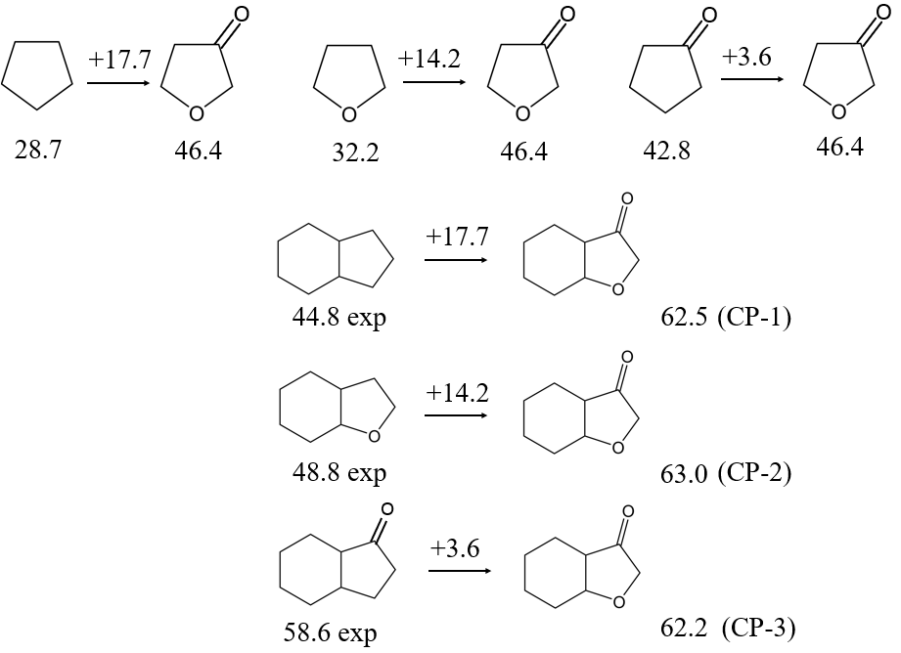
Fig. S8 Calculating the enthalpy of vaporization, $∆_{l}^{g}H_{m}^{o}$(298.15 K)/ kJ⋅mol⁻¹ of 6H-phthalide using the “centerpiece approach” (CP) and 8H-indene, 8H-benzofuran or 6H-1-indanone as the staring molecules. The numerical values of enthalpies of vaporisation required for calculations are given in Table 3 and Table S6.

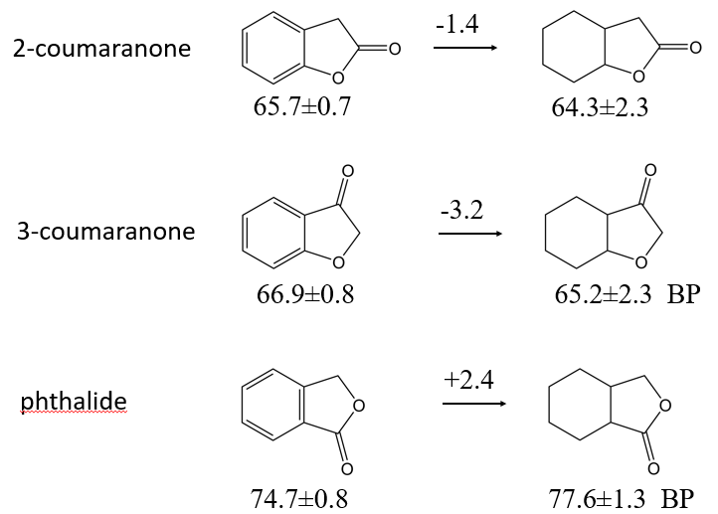
Fig. S9 Calculating the enthalpy of vaporization, $∆_{l}^{g}H_{m}^{o}$(298.15 K)/ kJ⋅mol⁻¹ of 6H-2-coumaranone, 3-coumaranon, and 6H-phthalide using the “centerpiece approach” (CP) and 2-coumaranone, 3-coumaranone, and phthalide as the staring molecules. The numerical values of enthalpies of vaporisation required for calculations are given in Table 3 and Table S6.

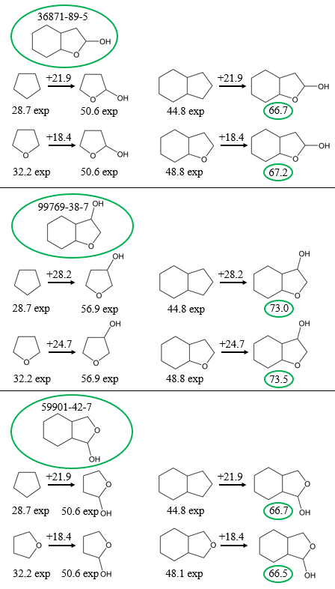

Fig. S10 Calculating the enthalpy of vaporization, $∆_{l}^{g}H_{m}^{o}$(298.15 K)/ kJ⋅mol⁻¹ of 8H-benzofuran-2-ol, 8H-benzofuran-3-ol, and 8H-benzofuran-1-ol using the “centerpiece approach” (CP) and 8H-indene, 8H-benzofuran or 8H-isobenzofuran as the staring molecules. The numerical values of enthalpies of vaporisation required for calculations are given in Table 3 and Table S6.

Table S9
Calculation of the liquid-phase enthalpies of formation, $∆_{f}H_{\text{m}}^{\text{o}}$(liq)_{theor}, at T = 298.15 K (p° = 0.1 MPa) for the hydrogen lean (HL) compounds (in kJ·mol⁻¹)

Compounds | $∆_{f}H_{\text{m}}^{\text{o}}$(g)_{QC} ª | $∆_{\text{l}}^{\text{g}}H_{\text{m}}^{\text{o}}$ ^{b} | $∆_{f}H_{\text{m}}^{\text{o}}$(liq)_{theor} ^{c}
dibenzofuran [132-64-9] | 49.5±2.9 | 66.3±0.6 [27] | -16.8±3.0
fluorene [86-73-7] | 176.0±1.4 | 70.9±0.3 [46] | 105.1±0.6
isobenzofuran [270-75-7] | 79.3±4.1 ^{d} | 48.8±2.0 ^{e} | 30.5±4.6
2-coumaranone [553-86-6] | -218.7±1.9 | 65.7±0.7 | -284.4±1.4
3-coumaranone [7169-34-8] | -162.9±1.9 | 66.9±0.8 | -229.8±2.1
phthalide [87-41-2] | -221.4±2.3 | 74.7±0.8 | -296.1±2.4
ª From Table 2.
^{b} From Table 3.
^{c} Difference between column 2 and 3.
^{d} From Table S1.
^{e} Assumed to be equal to the enthalpy of vaporisation of 2,3-benzofuran (see Table 3).

Table S10
Calculation of the liquid-phase enthalpies of formation, $∆_{f}H_{\text{m}}^{\text{o}}$(liq)_{theor}, at T = 298.15 K (p° = 0.1 MPa) for the hydrogen rich (HR) compounds (in kJ·mol⁻¹)

Compounds | $∆_{f}H_{\text{m}}^{\text{o}}$(g)_{QC} ª | $∆_{\text{l}}^{\text{g}}H_{\text{m}}^{\text{o}}$ ^{b} | $∆_{f}H_{\text{m}}^{\text{o}}$(liq)_{theor} ^{c}
8H-benzofuran [13054-97-2] | -234.3±4.1 | 48.8±1.2 | -283.1±4.3
8H-isobenzofuran [4743-54-8] | -225.0±4.1 | 48.8±0.9 | -273.8±4.2
12H-dibenzofuran [13054-98-3] | -296.7±4.1 | 63.8±2.7 | -360.5±4.9
12H-fluoren [5744-03-6] | -183.4±4.1 ^{d} | 65.7±2.5 [62] | -249.1±4.8
6H-2-coumaranone [6051-03-2] | -422.5±4.1 | 64.3±2.3 | -486.8±4.7
6H-3-coumaronone [1206676-08-5] | -338.2±4.1 | 62.9±0.8 | -401.1±4.2
6H-phthalide [2611-01-0] | -411.6±4.1 | 77.6±1.3 | -489.2±4.3
8H-benzofuran-2-ol [36871-99-5] | -437.7±4.1 | 66.9±1.4 | -504.6±4.3
8H-benzofuran-3-ol [99769-38-7] | -396.0±4.1 | 73.2±1.2 | -469.2±4.3
8H-isobenzofuran-1-ol [59901-42-7] | -424.4±4.1 | 66.6±1.4 | -491.0±4.3
ª The G3MP2 results from Table S1 (column 5).
^{b} The evaluated vaporisation enthalpies from Table 3.
^{c} The difference between column 2 and 3.
^{d} The G3MP2 result from Table S1 (column 2), corrected according to equation [63]:
$∆_{f}H_{\text{m}}^{\text{o}}$(g)_{QC}/ kJ.mol⁻¹ = 0.970 × $∆_{f}H_{\text{m}}^{\text{o}}$(g, AT)_{G3MP2} – 3.2 with R² = 0.9998

Table S11. Calculation of the liquid phase reaction enthalpies, $∆_{r}H_{\text{m}}^{\text{o}}$(liq), of the full hydrogenation reactions of aromatic ethers given in Fig. 2, at T = 298.15 K (p°=0.1 MPa, in kJ·mol⁻¹)

compound | $∆_{f}H_{\text{m}}^{\text{o}}$(liq)_{HL}ª | $∆_{f}H_{\text{m}}^{\text{o}}$(liq)_{HR}^{b} | $∆_{r}H_{\text{m}}^{\text{o}}$(liq)^{c} | $∆_{r}H_{\text{m}}^{\text{o}}$(liq)/H₂ ^{d}
(aliphatic)₅
1,3-cyclopentadiene | 105.9±1.5 | -105.1±0.8 | -211.0 | -105.5
furan | -62.3±0.7 | -216.2±0.8 | -153.9 | -77.0
(aromatic)₆ + (aliphatic)₅
indene | 110.6±1.6 | -176.2±1.8 | -286.8 | -71.7
2,3-benzofuran | -34.9±0.6 | -283.1±4.3 | -248.2 | -62.1
2,3-dihydrobenzofuran | -99.9±0.8 | -283.1±4.3 | -183.2 | -61.1
isobenzofuran | 30.5±4.6 | -273.8±4.2 | -304.3 | -76.1
1,3-dihydro-isobenzofuran | -83.8±0.9 | -273.8±4.2 | -190.0 | -63.3
(aromatic)₆ + (aliphatic)₅ | +(aromatic)₆
fluorene | 105.1±0.6 | -249.1±4.8 | -354.2 | -59.0
dibenzofuran | -16.8±3.0 | -360.5±4.9 | -343.7 | -57.3
(aromatic)₆ + (lactone)₅
indene | 110.6±1.6 | -176.2±1.8 | -286.8 | -71.7
2-coumaranone | -284.4±2.0 | -504.6±4.3 | -220.2 | -55.1
3-coumaranone | -229.8±2.1 | -469.2±4.3 | -239.4 | -59.9
phthalide | -296.1±2.4 | -491.0±4.3 | -194.9 | -48.7
open-chained ethers
benzene | 49.0±0.9 | -156.4±0.8 | -205.4 | -68.5
methoxy-benzene | -116.9±0.7 | -313.7±3.5 | -196.8 | -65.6
diphenyl ether | -15.8±1.4 | -424.3±4.3 | -408.5 | -68.1
ª Liquid-phase enthalpies of formation of of aromatic ethers and hydrocarbons (hydrogen-lean (HL) counterparts of the LOHC system) from Table S9.
^{b} Liquid-phase enthalpies of formation of perhydrogenated aromatic ethers and hydrocarbons (hydrogen-rich (HR) counterparts of the LOHC system) from Table S10.
^{c} Calculated according to the Hess´s Law applied to the reactions of aromatic ethers given in Fig. 2.
^{d} Reaction enthalpy per mole H₂.

Table S12. Calculation of the liquid phase reaction enthalpies, $∆_{r}H_{\text{m}}^{\text{o}}$(liq), of the partial hydrogenation of compounds shown in Fig. 2, at T = 298.15 K (p°=0.1 MPa, in kJ·mol⁻¹)

HL compound | $∆_{f}H_{\text{m}}^{\text{o}}$(liq)_{HL}ª | HR compound | $∆_{f}H_{\text{m}}^{\text{o}}$(liq)_{HR}^{b} | $∆_{r}H_{\text{m}}^{\text{o}}$(liq)^{c} | $∆_{r}H_{\text{m}}^{\text{o}}$(liq)/H₂ ^{d}
2,3-benzofuran | -34.9±0.6 | 2H-2,3-benzofuran | -99.9±0.8 | -65.0 | -65.0
isobenzofuran | 30.5±4.6 | phthalan | -83.8±0.9 | -114.3 | -114.3
2-coumaranone | -284.4±2.0 | 6H-2-coumaranone | -486.8±4.7 | -202.4 | 67.5
3-coumaranone | -229.8±2.1 | 6H-3-coumaranone | -401.1±4.2 | -171.3 | 57.1
phthalide | -296.1±2.4 | 6H-phthalide | -489.2±4.3 | -193.1 | 64.4
ª Liquid-phase enthalpies of formation of of aromatic ethers or hydrogen-lean (HL) counterparts of the LOHC system from Table S9.
^{b} Liquid-phase enthalpies of formation of perhydrogenated aromatic ethers or hydrogen-rich (HR) counterparts of the LOHC system from Table S10.
^{c} Calculated according to the Hess´s Law applied to the hydrogenation of compounds shown in Fig. 2.
^{d} Reaction enthalpy per mole H₂.

Table S13. Liquid phase thermodynamic properties of the hydrogenation of the hydrogen-lean LOHC counterparts

reactants | $∆_{f}H_{\text{m}}^{\text{o}}$ª  (298 K) | $S_{\text{m}}^{\text{o}}$^{b}  (298 K) | $C_{\text{p}\text{.}\text{m}}^{\text{o}}$^{c}  (298 K) | $∆_{r}H_{\text{m}}^{\text{o}}$^{d}  (298 K) | $∆_{r}S_{\text{m}}^{\text{o}}$^{e}  (298 K) | $∆_{r}C_{\text{p}\text{.m}}^{\text{o}}$^{f}  (298 K) | $∆_{r}G_{\text{m}}^{\text{o}}$^{g}  (298 K) | $∆_{r}G_{\text{m}}^{\text{o}}$ ^{h}  (500 K) | $T_{eq}$^{i,j}
benzene | 49.0 | 173.3 | 136.4
cyclohexane | -156.4 | 204.3 | 156.3
 |  |  |  | -205.4 | -360.9 | -66.5 | -97.8 | -21.1 | 569
 |  |  |  | -68.5 | -120.3 |  | -32.6 | -7.0
methoxy-benzene | -116.9 | 234.8 | 199.0
methoxy-cyclohexane | -313.7 | 270.1 | 203.0
 |  |  |  | -196.8 | -356.8 | -82.4 | -90.4 | -13.7 | 552
 |  |  |  | -65.6 | -118.9 |  | -30.1 | -4.6
diphenyl-ether | -15.8 | 305.3 | 267.5
dicyclohexyl ether | -424.3 | 332.2 | 313.0
 |  |  |  | -408.5 | -757.3 | -127.3 | -182.7 | -22.6 | 539
 |  |  |  | -68.1 | -126.2 |  | -30.5 | -3.8
furan | -62.3 | 176.7 | 114.6
2.3-dihydrofuran | -103.0 | 198.9 | 122.1
 |  |  |  | -40.7 | -108.5 | -21.3 | -8.4 | 14.8 | 375
2.3-dihydrofuran | -103.0 | 198.9 | 122.1
tetrahydrofuran | -216.2 | 203.9 | 123.9
 |  |  |  | -113.2 | -125.7 | -27.0 | -75.7 | -48.8 | 901
furan | -103.0 | 198.9 | 122.1
tetrahydrofuran | -216.2 | 203.9 | 123.9
 |  |  |  | -153.9 | -234.2 | -48.3 | -84.1 | -34.0 | 657
 |  |  |  | -77.0 | -117.1 |  | -42.0 | -17.0
2.3-benzofuran | -34.9 | 215.6 | 178.7
2.3-dihydrobenzofuran | -99.9 | 226.4 | 188.6
 |  |  |  | -65.0 | -119.9 | -18.9 | -29.3 | -4.0 | 542
2.3-dihydrobenzofuran | -99.9 | 226.4 | 188.6
6H-benzofuran | -283.1 | 252.4 | 211
 |  |  |  | -183.2 | -366.1 | -64.0 | -74.0 | 3.5 | 500
 |  |  |  | -61.1 | -122.0 |  | -24.7 | 1.2
2.3-benzofuran | -34.9 | 215.6 | 178.7
6H-benzofuran | -283.1 | 252.4 | 211
 |  |  |  | -248.2 | -486 | -82.9 | -103.3 | -0.5 | 511
 |  |  |  | -62.1 | -121.5 |  | -25.8 | -0.1
isobenzofuran | 30.5 | 228.3 | 178.7
1.3-dihydro-isobenzofuran | -83.8 | 238.3 | 188.7
 |  |  |  | -114.3 | -120.7 | 38.8 | -78.3 | -56.2 | 947
1.3-dihydro-isobenzofuran | -83.8 | 238.3 | 188.7
6H-isobenzofuran | -273.8 | 253.5 | 211.0
 |  |  |  | -190.0 | -376.9 | 108.7 | -77.6 | -7.7 | 504
 |  |  |  | -63.3 | -125.6 |  | -25.9 | -2.6
isobenzofuran | 30.5 | 228.3 | 178.7
6H-isobenzofuran | -273.8 | 253.5 | 211.0
 |  |  |  | -304.3 | -497.6 | 147.5 | -155.9 | -63.9 | 612
 |  |  |  | -76.1 | -124.4 |  | -39.0 | -16.0
dibenzofuran | -16.8 | 255.6 | 263.6
12-H-dibenzofuran | -232.9 | 295.2 | 296.8
 |  |  |  | -343.7 | -744.6 | -139.6 | -121.7 | 36.6 | 462
 |  |  |  | -57.3 | -124.1 |  | -20.3 | 6.1
2-coumaranone | -284.4 | 221.4 | 197.6
6H-2-coumaranone | -486.8 | 246.3 | 216.6
 |  |  |  | -202.4 | -367.2 | -67.4 | -92.9 | -15.0 | 551
 |  |  |  | -67.5 | -122.4 |  | -31.0 | -5.0
6H-2-coumaranone | -486.8 | 246.3 | 216.6
8H-benzofuran-2-ol | -504.6 | 233.9 | 244.2
 |  |  |  | -17.8 | -143.1 | -1.2 | 24.9 | 53.8 | 124
2-coumaranone | -284.4 | 221.4 | 197.6
8H-benzofuran-2-ol | -504.6 | 233.9 | 244.2
 |  |  |  | -220.2 | -510.3 | -68.6 | -68.1 | 38.9 | 432
 |  |  |  | -55.1 | -127.6 |  | -17.0 | 9.7
3-coumaranone | -229.8 | 223.6 | 214.5
6H-3-coumaranone | -401.1 | 258.1 | 233.5
 |  |  |  | -171.3 | -357.6 | -67.4 | -64.7 | 11.3 | 479
 |  |  |  | -57.1 | -119.2 |  | -21.6 | 3.8
6H-3-coumaranone | -401.1 | 258.1 | 233.5
8H-benzofuran-3-ol | -469.2 | 238.4 | 244.2
 |  |  |  | -68.1 | -150.4 | -18.1 | -23.3 | 8.1 | 453
3-coumaranone | -229.8 | 223.6 | 214.5
8H-benzofuran-3-ol | -469.2 | 238.4 | 244.2
 |  |  |  | -239.4 | -508 | -85.5 | -87.9 | 19.5 | 471
 |  |  |  | -59.9 | -127.0 |  | -22.0 | 4.9
phthalide [87-41-2] | -296.1 | 209.1 | 197.6
6H-phthalide [2611-01-0] | -489.2 | 211.6 | 216.6
 |  |  |  | -193.1 | -389.6 | -67.4 | -76.9 | 5.5 | 496
 |  |  |  | -64.4 | -129.9 |  | -25.6 | 1.8
6H-phthalide [2611-01-0] | -489.2 | 211.6 | 216.6
8H-benzofuran-2-ol | -491.0 | 215.8 | 244.2
[59901-42-7] |  |  |  | -1.8 | -126.5 | -1.2 | 35.9 | 61.5
phthalide [87-41-2] | -296.1 | 209.1 | 197.6
8H-isobenzofuran-1-ol | -491.0 | 215.8 | 244.2
[59901-42-7] |  |  |  | -194.9 | -516.1 | -68.6 | -41.0 | 67.1 | 378
 |  |  |  | -48.7 | -129.0 |  | -10.3 | 16.8
1.3-cyclo-pentadiene | 105.9 | 182.7 | 115.3
cyclopentene | 4.4 | 201.3 | 122.4
 |  |  |  | -101.5 | -112.1 | -21.7 | -68.1 | -44.2 | 905
cyclopentene | 4.4 | 201.3 | 122.4
cyclopentane | -105.1 | 204.1 | 126.8
 |  |  |  | -109.5 | -127.9 | -24.4 | -71.4 | -44.2 | 856
1.3-cyclo-pentadiene | 109.5 | 182.7 | 115.3
cyclopentane | -105.1 | 204.1 | 126.8
 |  |  |  | -211 | -240 | -46.1 | -139.4 | -88.4 | 879
 |  |  |  | -105.5 | -120.0 |  | -69.7 | -44.2
indene | 110.6 | 214.2 | 186.9
indane | 11.5 | 234.4 | 190.3
 |  |  |  | -99.1 | -110.5 | -25.4 | -66.2 | -42.4 | 897
indane | 11.5 | 234.4 | 190.3
8H-indene | -176.2 | 258.9 | 209.7
 |  |  |  | -187.7 | -367.6 | -67 | -78.1 | -0.1 | 511
 |  |  |  | -62.6 | -122.5 |  | -26.0 | 0.0
indene | 110.6 | 214.2 | 186.9
8H-indene | -176.2 | 258.9 | 209.7
 |  |  |  | -286.8 | -478.1 | -92.4 | -144.3 | -42.5 | 600
 |  |  |  | -71.7 | -119.5 |  | -72.1 | -10.6
fluorene | 105.1 | 257.8 | 251
12H-fluorene | -249.1 | 295.2 | 299.1
 |  |  |  | -354.2 | -743.3 | -124.7 | -132.6 | 24.6 | 477
 |  |  |  | -59.0 | -123.9 |  | -22.1 | 4.1
ª From Tables S9 and S10.
^{b} From Table 5 (main text).
^{c} From Table S5-1.
^{d} Calculated according to Eq. (9) from standard molar enthalpies of formation of reactants from column 2.
^{e} Calculated according to Eq. (10) from standard molar entropies of reactants from column 3.
^{f} The difference in the standard molar heat capacities of reactants calculated from data given in column 4.
^{g} Calculated according to Eq. (4) from results given in column 5 and 6 and referenced to 298 K.
^{h} Calculated according to Eq. (4) from results given in column 5 and 6 and adjusted to 500 K.
^{i} Calculated according to Eq. (1).
^{j} Comparison of the hydrogen storage capacity values of LOHC candidates is given in Table S14.

Table S14
Comparison of the hydrogen storage capacity values of LOHC candidates in different common units

 | % mass | gH₂/l | mol H₂/l | MJ/l | kWh/kg | kWh/l
benzene | 7.19 | 0.0560 | 0.0278 | 6.2 | 2219.2 | 1728.8
benzene, methoxy- | 5.30 | 0.0455 | 0.0263 | 5.9 | 1635.7 | 1406.7
cyclopentadiene | 5.75 | 0.0429 | 0.0285 | 6.4 | 1775.4 | 1323.9
furan | 5.59 | 0.0497 | 0.0277 | 6.2 | 1726.8 | 1535.5
indene | 6.49 | 0.0589 | 0.0322 | 7.2 | 2004.7 | 1818.9
indane | 4.87 | 0.0442 | 0.0242 | 5.4 | 1503.5 | 1364.1
2,3-benzofuran | 6.39 | 0.0616 | 0.0317 | 7.1 | 1973.3 | 1901.5
2,3-dihydrobenzofuran | 4.79 | 0.0462 | 0.0238 | 5.3 | 1480.0 | 1426.1
1,3-dihydro-isobenzofuran | 4.79 | 0.0466 | 0.0238 | 5.3 | 1480.0 | 1439.6
fluorene | 6.78 | 0.0624 | 0.0337 | 7.5 | 2094.8 | 1927.2
dibenzofuran | 6.71 | 0.0658 | 0.0333 | 7.5 | 2071.9 | 2032.5
2-coumaranone | 4.31 | 0.0472 | 0.0214 | 4.8 | 1332.4 | 1456.3
3-coumaranone | 4.31 | 0.0472 | 0.0214 | 4.8 | 1332.4 | 1456.3
phthalide | 4.31 | 0.0472 | 0.0214 | 4.8 | 1332.4 | 1456.3

References

1. Pracht, P.; Bohle, F.; Grimme, S. Automated Exploration of the Low-Energy Chemical Space with Fast Quantum Chemical Methods. Phys. Chem. Chem. Phys. 2020, 22, 7169–7192, doi:10.1039/C9CP06869D.
2. Petersson, G.A.; Bennett, A.; Tensfeldt, T.G.; Al‐Laham, M.A.; Shirley, W.A.; Mantzaris, J. A Complete Basis Set Model Chemistry. I. The Total Energies of Closed‐shell Atoms and Hydrides of the First‐row Elements. J. Chem. Phys. 1988, 89, 2193–2218, doi:10.1063/1.455064.
3. Frisch, M.J.; Trucks, G.W.; Schlegel, H.B.; Scuseria, G.E.; Robb, M.A.; Cheeseman, J.R.; Scalmani, G.; Barone, V.; Petersson, G.A.; Nakatsuji, H.; et al. Gaussian 16, Revision C.01 Gaussian, Inc., Wallingford CT. 2016.
4. Curtiss, L.A.; Raghavachari, K.; Redfern, P.C.; Pople, J.A. Gaussian-3 Theory Using Scaled Energies. J. Chem. Phys. 2000, 112, 1125–1132, doi:10.1063/1.480668.
5. Verevkin, S.P.; Emel’yanenko, V.N.; Notario, R.; Roux, M.V.; Chickos, J.S.; Liebman, J.F. Rediscovering the Wheel. Thermochemical Analysis of Energetics of the Aromatic Diazines. J. Phys. Chem. Lett. 2012, 3, 3454–3459, doi:10.1021/jz301524c.
6. Silva, A.L.R.; Gama, P.M.V.; Ribeiro da Silva, M.D.M.C. Influence of the Functional Groups −NH 2 , −OCH 3 , and −OH on the Thermochemistry of Indanes. Can. J. Chem. 2019, 97, 788–794, doi:10.1139/cjc-2019-0257.
7. Matos, M.A.R.; Miranda, M.S.; Pereira, S.M.M.; Morais, V.M.F.; Liebman, J.F. The Experimental and Calculational Thermochemistry of 1,2,4,5-Benzenetetracarboxylic Dianhydride: Is This 10 π Multiring Species Aromatic? J. Phys. Chem. A 2007, 111, 7181–7188, doi:10.1021/jp071625n.
8. Chirico, R..; Archer, D..; Hossenlopp, I..; Nguyen, A.; Steele, W..; Gammon, B.. The Thermodynamic Properties of Chroman and Isochroman. J. Chem. Thermodyn. 1990, 22, 665–682, doi:10.1016/0021-9614(90)90020-Q.
9. Verevkin, S.P.; Samarov, A.A.; Vostrikov, S. V Thermodynamics of Reversible Hydrogen Storage: Does Alkoxy-Substitution of Naphthalene Yield Functional Advantages for LOHC Systems? J. Chem. Phys. 2024, 160, 154709, doi:10.1063/5.0200047.
10. Verevkin, S.P. Thermochemistry of Aromatic Ketones. Experimental Enthalpies of Formation and Structural Effects. Thermochim. Acta 1998, 310, 229–235, doi:10.1016/s0040-6031(97)00231-1.
11. Matos, M.A.R.; Sousa, C.C.S.; Miranda, M.S.; Morais, V.M.F.; Liebman, J.F. Energetics of Coumarin and Chromone. J. Phys. Chem. B 2009, 113, 11216–11221, doi:10.1021/jp9026942.
12. Matos, M.A.R.; Sousa, C.C.S.; Morais, V.M.F. Experimental and Computational Thermochemistry of the Isomers: Chromanone, 3-Isochromanone, and Dihydrocoumarin. J. Chem. Thermodyn. 2009, 41, 308–314, doi:10.1016/j.jct.2008.08.012.
13. Matos, M.A.R.; Sousa, C.C.S.; Morais, V.M.F. Thermochemical Study of Some Methoxytetralones. J. Chem. Thermodyn. 2009, 41, 69–73, doi:10.1016/j.jct.2008.07.021.
14. Emel’yanenko, V.N.; Zaitsau, D.H.; Pimerzin, A.A.; Verevkin, S.P. Benchmark Properties of Diphenyl Oxide as a Potential Liquid Organic Hydrogen Carrier: Evaluation of Thermochemical Data with Complementary Experimental and Computational Methods. J. Chem. Thermodyn. 2018, 125, 149–158, doi:10.1016/j.jct.2018.05.021.
15. Verevkin, S.P.; Samarov, A.A.; Vostrikov, S. V. Does the Oxygen Functionality Really Improve the Thermodynamics of Reversible Hydrogen Storage with Liquid Organic Hydrogen Carriers? Oxygen 2024, 4, 266–284, doi:10.3390/oxygen4030015.
16. Silva, A.L.R.; León, G.P.; Ribeiro da Silva, M.D.M.C. Energetic Effects in Methyl- and Methoxy-Substituted Indanones: A Synergistic Experimental and Computational Study. Appl. Sci. 2023, 13, 10262, doi:10.3390/app131810262.
17. Silva, A.L.R.; Lima, A.C.M.O.; Ribeiro da Silva, M.D.M.C. Energetic Characterization of Indanone Derivatives Involved in Biomass Degradation. J. Therm. Anal. Calorim. 2018, 134, 1267–1276, doi:10.1007/s10973-018-7533-z.
18. Silva, A.L.R.; C. M. O. Lima, A.; Agostinha R. Matos, M.; Morais, V.M.F. Thermochemical Study of the Antioxidant Activity of Some Hydroxycoumarins. J. Chem. Thermodyn. 2023, 180, 107006, doi:10.1016/j.jct.2023.107006.
19. Database Quantum Chemical Calculations. Available Online: Https://Http://Gaussdb.Samgtu.Ru:8000/Homepage/ (Accessed on 15.06.2025).
20. Notario, R.; Victoria Roux, M.; Castaño, O. The Enthalpy of Formation of Dibenzofuran and Some Related Oxygen-Containing Heterocycles in the Gas Phase. A GAUSSIAN-3 Theoretical Study. Phys. Chem. Chem. Phys. 2001, 3, 3717–3721, doi:10.1039/b101136g.
21. Sousa, C.C.S.; Matos, M.A.R.; Santos, L.M.N.B.F.; Morais, V.M.F. Reprint of: Energetics of 2- and 3-Coumaranone Isomers: A Combined Calorimetric and Computational Study. J. Chem. Thermodyn. 2014, 73, 283–289, doi:10.1016/j.jct.2014.03.017.
22. Walden, P. Über Die Schmelzwärme, Spezifische Kohäsion Und Molekulargrösse Bei Der Schmelztemperatur. Zeitschrift für Elektrotechnik und Elektrochemie 1908, 14, 713–724, doi:10.1002/bbpc.19080144302.
23. Abdelaziz, A.; Zaitsau, D.H.; Kuratieva, N. V.; Verevkin, S.P.; Schick, C. Melting of Nucleobases. Getting the Cutting Edge of “Walden’s Rule.” Phys. Chem. Chem. Phys. 2019, 21, 12787–12797, doi:10.1039/C9CP00716D.
24. Verevkin, S.P.; Emel’yanenko, V.N.; Nagrimanov, R.N. Nearest-Neighbor and Non-Nearest-Neighbor Interactions between Substituents in the Benzene Ring. Experimental and Theoretical Study of Functionally Substituted Benzamides. J. Phys. Chem. A 2016, 120, 9867–9877, doi:10.1021/acs.jpca.6b10332.
25. Nagrimanov, R.N.; Ziganshin, M.A.; Solomonov, B.N.; Verevkin, S.P. Thermochemistry of Drugs: Experimental and Theoretical Study of Analgesics. Struct. Chem. 2019, 30, 247–261, doi:10.1007/s11224-018-1188-z.
26. Chirico, R..; Gammon, B..; Knipmeyer, S..; Nguyen, A.; Strube, M..; Tsonopoulos, C.; Steele, W.. The Thermodynamic Properties of Dibenzofuran. J. Chem. Thermodyn. 1990, 22, 1075–1096, doi:10.1016/0021-9614(90)90157-L.
27. Verevkin, S.P. Enthalpy of Sublimation of Dibenzofuran: A Redetermination. Phys. Chem. Chem. Phys. 2003, 5, 710–712, doi:10.1039/b208228d.
28. Freitas, V.L.S.; Santos, C.P.F.; Ribeiro da Silva, M.D.M.C.; Ribeiro da Silva, M.A.V. The Effect of Ketone Groups on the Energetic Properties of Phthalan Derivatives. J. Chem. Thermodyn. 2016, 96, 74–81, doi:10.1016/j.jct.2015.12.018.
29. Acree, W.; Chickos, J.S. Phase Transition Enthalpy Measurements of Organic and Organometallic Compounds and Ionic Liquids. Sublimation, Vaporization, and Fusion Enthalpies from 1880 to 2015. Part 2. C11-C192. J. Phys. Chem. Ref. Data 2017, 46, 013104, doi:10.1063/1.4970519.
30. SciFinder - Chemical Abstracts Service Available Online: Http://Scifinder.Cas.Org/ (Accessed on 20.04.2025).
31. Reaxys Available Online: Https://Www.Reaxys.Com/ (Accessed on 20.04.2025).
32. Guidechem Chemical Network. Available Online: Https://Www.Guidechem.Com (Accessed on 20.04.2025).
33. Kulikov, D.; Verevkin, S.P.; Heintz, A. Determination of Vapor Pressures and Vaporization Enthalpies of the Aliphatic Branched C 5 and C 6 Alcohols. J. Chem. Eng. Data 2001, 46, 1593–1600, doi:10.1021/je010187p.
34. Verevkin, S.P.; Emel’yanenko, V.N. Transpiration Method: Vapor Pressures and Enthalpies of Vaporization of Some Low-Boiling Esters. Fluid Phase Equilib. 2008, 266, 64–75, doi:10.1016/j.fluid.2008.02.001.
35. Chickos, J.S.; Hosseini, S.; Hesse, D.G.; Liebman, J.F. Heat Capacity Corrections to a Standard State: A Comparison of New and Some Literature Methods for Organic Liquids and Solids. Struct. Chem. 1993, 4, 271–278, doi:10.1007/BF00673701.
36. Zaitsau, D.H.; Pimerzin, A.A.; Verevkin, S.P. Fatty Acids Methyl Esters: Complementary Measurements and Comprehensive Analysis of Vaporization Thermodynamics. J. Chem. Thermodyn. 2019, 132, 322–340, doi:10.1016/j.jct.2019.01.007.
37. Steele, W. V; Chirico, R.D.; Knipmeyer, S.E.; Nguyen, A. Vapor Pressure of Acetophenone, (±)-1,2-Butanediol, (±)-1,3-Butanediol, Diethylene Glycol Monopropyl Ether, 1,3-Dimethyladamantane, 2-Ethoxyethyl Acetate, Ethyl Octyl Sulfide, and Pentyl Acetate. J. Chem. Eng. Data 1996, 41, 1255–1268, doi:10.1021/je9601117.
38. Chirico, R.D.; Nguyen, A.; Steele, W.V.; Strube, M.M.; Hossenlopp, I.A.; Gammon, B.E. Thermochemical and Thermophysical Properties of Organic Compounds Derived from Fossil Substances. Chemical Thermodynamic Properties of Organic Oxygen Compounds Found in Fossil Materials. NIPER Rep. 1986, 135, 42.
39. Guthrie, G.B.; Scott, D.W.; Hubbard, W.N.; Katz, C.; McCullough, J.P.; Gross, M.E.; Williamson, K.D.; Waddington, G. Thermodynamic Properties of Furan. J. Am. Chem. Soc. 1952, 74, 4662–4669, doi:10.1021/ja01138a063.
40. Steele, W. V.; Chirico, R.D.; Nguyen, A.; Hossenlopp, I.A.; Smith, N.K. Determination of Some Pure Compound Ideal-Gas Enthalpies of Formation. AIChE Symp. Ser. 1989, 85, 140–162, doi:10.2172/6020818.
41. Lebedev, B.V.; Lityagov, V.Y. Calorimetric Study of Tetrahydrofuran and Its Polymerization in the Temperature Range 0–400°K. Vysok. Soedin. 1977, A19, 2283–2290.
42. Huffman, H.M.; Eaton, M.; Oliver, G.D. The Heat Capacities, Heats of Transition, Heats of Fusion and Entropies of Cyclopentene and Cyclohexene. J. Am. Chem. Soc. 1948, 70, 2911–2914, doi:10.1021/ja01189a025.
43. Douslin, D.R.; Huffman, H.M. The Heat Capacities, Heats of Transition, Heats of Fusion and Entropies of Cyclopentane, Methylcyclopentane and Methylcyclohexane 1. J. Am. Chem. Soc. 1946, 68, 173–176, doi:10.1021/ja01206a004.
44. Stull, D.R.; Sinke, G.C.; McDonald, R.A.; Hatton, W.E.; Hildebrand, D.L. Thermodynamic Properties of Indane and Indene. Pure Appl. Chem. 1961, 2, 315–322, doi:10.1351/pac196102010315.
45. Finke, H..; McCullough, J..; Messerly, J..; Osborn, A.; Douslin, D.. Cis- and Trans-Hexahydroindan. Chemical Thermodynamic Properties and Isomerization Equilibrium. J. Chem. Thermodyn. 1972, 4, 477–494, doi:10.1016/0021-9614(72)90032-8.
46. Verevkin, S.P. Vapor Pressure Measurements on Fluorene and Methyl-Fluorenes. Fluid Phase Equilib. 2004, 225, 145–152, doi:10.1016/j.fluid.2004.08.037.
47. Clarke, E.C.W.; Glew, D.N. Evaluation of Thermodynamic Functions from Equilibrium Constants. Trans. Faraday Soc. 1966, 62, 539, doi:10.1039/tf9666200539.
48. Roux, M.V.; Temprado, M.; Chickos, J.S.; Nagano, Y. Critically Evaluated Thermochemical Properties of Polycyclic Aromatic Hydrocarbons. J. Phys. Chem. Ref. Data 2008, 37, 1855–1996, doi:10.1063/1.2955570.
49. Pedley, J.B.; Naylor, R.D.; Kirby, S.P. Thermochemical Data of Organic Compounds, Chapman and Hall, New York. 1986, 1–792.
50. Verevkin, S.P. Weaving a Web of Reliable Thermochemistry around Lignin Building Blocks: Phenol, Benzaldehyde, and Anisole. J. Therm. Anal. Calorim. 2022, 147, 6073–6085, doi:10.1007/s10973-021-10924-x.
51. Verevkin, S.P.; Samarov, A.A.; Vostrikov, S. V. Thermodynamics of Reversible Hydrogen Storage: Are Methoxy-Substituted Biphenyls Better through Oxygen Functionality? Hydrogen 2023, 4, 862–880, doi:10.3390/hydrogen4040052.
52. Steele, W. V.; Chirico, R.D.; Knipmeyer, S.E.; Nguyen, A. Measurements of Vapor Pressure, Heat Capacity, and Density along the Saturation Line for Cyclopropane Carboxylic Acid, N , N -Diethylethanolamine, 2,3-Dihydrofuran, 5-Hexen-2-One, Perfluorobutanoic Acid, and 2-Phenylpropionaldehyde. J. Chem. Eng. Data 2002, 47, 715–724, doi:10.1021/je010087j.
53. Sellers, P.; Holm, J.L.; Welch, B.J.; Prelesnik, A.; Zupancic, I.; Ehrenberg, L. Enthalpies of Formation of Cis- and Trans-2-Hydrindanone. Acta Chem. Scand. 1971, 25, 2189–2193, doi:10.3891/acta.chem.scand.25-2189.
54. Daubert, T.E. Vapor Pressure of 13 Pure Industrial Chemicals. DIPPR Data Ser. 1991, 1, 80–95.
55. Leitão, M.L.P.; Pilcher, G.; Meng-Yan, Y.; Brown, J.M.; Conn, A.D. Enthalpies of Combustion of γ-Butyrolactone, γ-Valerolactone, and δ-Valerolactone. J. Chem. Thermodyn. 1990, 22, 885–891, doi:10.1016/0021-9614(90)90176-Q.
56. Viani, R.; Müggler‐Chavan, F.; Reymond, D.; Egli, R.H. Sur La Composition de l’arôme de Café [1]. Helv. Chim. Acta 1965, 48, 1809–1815, doi:10.1002/hlca.19650480743.
57. Ohnishi, S.; Shibamoto, T. Volatile Compounds from Heated Beef Fat and Beef Fat with Glycine. J. Agric. Food Chem. 1984, 32, 987–992, doi:10.1021/jf00125a008.
58. Ducros, M.; Gruson, J.F.; Sannier, H. Estimation Des Enthalpies de Vaporisation Des Composes Organiques Liquides. Partie 1. Applications Aux Alcanes, Cycloalcanes, Alcenes, Hydrocarbures Benzeniques, Alcools, Alcanes Thiols, Chloro et Bromoalcanes, Nitriles, Esters, Acides et Aldehydes. Thermochim. Acta 1980, 36, 39–65, doi:10.1016/0040-6031(80)80109-2.
59. Ducros, M.; Gruson, J.F.; Sannier, H.; Velasco, I. Estimation Des Enthalpies de Vaporisation Des Composes Organiques Liquides. Partie 2. Applications Aux Ethersoxydes, Thioalcanes, Cetones et Amines. Thermochim. Acta 1981, 44, 131–140, doi:10.1016/0040-6031(81)80035-4.
60. NIST Chemistry WebBook. Available Online: Https://Webbook.Nist.Gov/Chemistry/ (Accessed on 15.06.2025).
61. Wang, C.; Zhang, W.; Li, H.; Mao, J.; Guo, C.; Ding, R.; Wang, Y.; Fang, L.; Chen, Z.; Yang, G. Analysis of Volatile Compounds in Pears by HS-SPME-GC×GC-TOFMS. Molecules 2019, 24, 1795, doi:10.3390/molecules24091795.
62. Stephenson, R.M.; Malanowski, S. Handbook of the Thermodynamics of Organic Compounds; Springer Netherlands: Dordrecht, 1987; ISBN 978-94-010-7923-5.
63. Verevkin, S.P.; Samarov, A.A.; Vostrikov, S. V.; Wasserscheid, P.; Müller, K. Comprehensive Thermodynamic Study of Alkyl-Cyclohexanes as Liquid Organic Hydrogen Carriers Motifs. Hydrogen 2023, 4, 42–59, doi:10.3390/hydrogen4010004.

