Supplementary material to
Stressed lysosome: theoretical model of late endosomal and lysosomal pH regulation applied to single and mixed stress conditions

Sofia F. Nazarova¹⁺, Vadim А. Alekhin¹⁺, Vladislav V. Pavlov¹, Yury S. Semenov¹, Siarhei M. Bukhalovich¹, Fedor M. Tsybrov¹, Diljara R. Gizatullina¹, Andrey O. Bogorodskiy¹, Diana F. Bagaeva¹, Olga V. Moiseeva^{1,2}, Anastasiya D. Vlasova¹, Anatolii E. Mikhailov¹, Andrey V. Rogachev¹, Semen V. Nesterov¹, Valentin I. Borshchevskiy¹, Piotr D. Bregestovski^{1,3}, Valentin I. Gordeliy⁴ and Nikolay S. Ilyinsky¹*

¹Moscow Center for Advanced Studies, Moscow 123592, Russia
²G.K. Skryabin Institute of Biochemistry and Physiology of Microorganisms, Pushchino Center for Biological Research of the Russian Academy of Sciences, 142290, Pushchino, Russia
³Department of Physiology, Institute of Neuroscience, Kazan State Medical University, 420012 Kazan, Russia
⁴Univ. Grenoble Alpes, CEA, CNRS, Institut de Biologie Structurale (IBS), 38000, Grenoble, France

⁺Equal contribution

*To whom correspondence should be addressed:
Nikolay S. Ilyinsky: nikolay.ilyinsky@gmail.com.

Supplementary Note 1. Comparison of current and previous lysosomal ion homeostasis models
A critical comparison of the key elements of lysosomal pH model performance shows advantages and disadvantages of current and previous model implementations (Table S1).
Table S1. Comparison of current and previous lysosomal ion homeostasis models
Question/model |  | this work | R. Astaburuaga et al., 2019 [1] | Y. Ishida et al., 2013 [2]
pH_{L} ≈ 4.7 ? |  | + 4.74 | + | +  BUT  with permeabilities for K⁺, Na⁺, Cl⁻ ions set to zero, not to the table values.
[K⁺]_{L} ≈ 60mM?  [3] |  | + 66mM | +  initial [K⁺] = 5mM → steady state 50mM | +  initial 5mM →  steady state 50mM
[Na⁺]_{L} ≈ 20mM?  [3] |  | + 22mM | - [Na⁺] = 3-12 mM | -  [Na⁺] = 145mM → 5mM (too little) with permeabilities for K⁺, Na⁺, Cl⁻ ions set to the table values.
[Cl⁻]_{L} ≈ 100mM?  [4], [5] |  | + 92mM | + [Cl⁻] = 20-170 mM | -  110mM → 20mM (little) with leaks permeabilities for K⁺, Na⁺, Cl⁻ ions set to the table values.
no ClC7  pH_{L} ≈ 4.7?  [3] |  | +  N_{ClC7}=50 | +  pH_{L} = 4.7,  N_{ClC7}=300 | -  pH_{L} = 7.4 without ClC7, initial N_{ClC7}=5000
Lysosomal ions concentrations, pH_{L}, R, Δ$ψ$ are stable to variation of | [Cl⁻]_{L init}? | + (Fig S3)  Also, [Cl⁻]_{L} from initial 50-140mM → 92mM (Fig S2) | + stable to ±10% change of [Cl⁻]_{L init} | - [Cl⁻]_{L} is unstable  200 mM → 190 mM,  110 mM → 20 mM,  20 mM → 14 mM
 | pH_{С} ? | +, except [Ca⁺]_{L}, [H⁺]_{L} | - unstable to ±10% variation of pH_{С} | -
Stability of [H+]_{L} to variation of constants, essential for lysosome¹ |  | - | + | ± [H⁺] 30% change pH ±10% to R
Stability of pH_{L} to variation of constants, essential for lysosome¹ |  | + | + | +
Convenient lysosomal values are given in Table S2, index L - lysosomal value, init - initial, C - cytosolic value.
¹ Constants, essential for lysosome:
initial cytosolic chloride, calcium, sodium, potassium, pH;
initial lysosomal chloride, calcium, sodium, potassium, pH, proton concentrations, radius;
number of CAX, ClC, vATPase, NKA proteins and power constant on TRPML1;
lysosomal membrane permeabilities for chloride, calcium, sodium, potassium, protons, water;
difference between external and internal membrane potential ψ_{out} - ψ_{in}.

Supplementary Note 2. Lysosome pH regulation model equations
1. Lysosomal membrane potential and ion concentrations
The model considers the concentrations of sodium, potassium, chloride, hydrogen, and calcium ions in the lysosomal lumen and in the cytosol. Ion concentrations are assumed to be constant in the cytosol and variable in the lumen.
The change in the concentration of ions in the lumen is determined by the derivatives of the number of ions in the lysosome, while the number of particles and the concentration are calculated by the following relationship:
$N_{ion}= {\left[ion\right]}_{L} ×V ×NA,$ (S1)
where N_{ion} is the number of ions in a lumen, [ion]_{L} is the concentration of an ion in a lumen, V is the volume of a lysosome, NA is Avogadro's constant (6.02214076×10²³ particles/mol). The equation is valid for all ions.
To account for the influence of the membrane potential, the concentrations of all ions have been modified by the Boltzmann factor:
${[ion]}_{i}={[ion]}_{L}×exp⁡(\frac{{- q_{ion∙}ψ}_{in}∙F}{R∙T})$ , (S2)
${[ion]}_{e}={[ion]}_{C}×exp\left(\frac{{- q_{ion∙}ψ}_{out}∙F}{R∙T}\right),$ (S3)
for pH:
${pH}_{i}={pH}_{L}+\frac{ψ_{in}∙F}{2.3∙R∙T}$, (S4)
${pH}_{e}={pH}_{C}+\frac{ψ_{out}∙F}{2.3∙R∙T}$, (S5)
where the indices C and L are introduced to denote the cytosolic and lysosomal concentrations, respectively, the indices i and e denote the modified internal (lysosomal) and external (cytosolic) concentrations. F is the Faraday constant, R is the gas constant, temperature T = 298K, RT/F = 25.69 mV, $q_{ion}$ is the ionic charge, $ψ_{in}$ is the internal membrane potential, $ψ_{out}$ is the external membrane potential.
The total potential ${Δψ}_{T}$ is determined by three quantities:
${Δψ}_{T}= Δψ+(ψ_{out}- ψ_{in})$, (S6)
where $ψ_{in}$ is the internal membrane potential and is equal to 0mV,${ ψ}_{out}$ is the external membrane potential (-50mV),$Δψ$ is the potential, determined by the concentrations of ions inside the lysosome:
$Δψ= \frac{F∙V}{C∙S}(\sum{{(\left[ion\right]}_{L}×q_{ion} )-B)}$, (S7)
where B is the concentration of Donnan particles, chosen so that the total potential is zero at the beginning of the simulation, C is the lysosome membrane capacitance per unit area, S is the membrane area.

2. Change of quantities over time
The change in pH is determined by the change in the number of protons and the buffer capacity of the lumen (β):
$\frac{d{pH}_{L}}{dt}=- \frac{1}{β}×(\frac{d{NH}^{+}}{dt}× \frac{1}{V∙NA})$ (S8)
The change in the number of protons is determined by the following equation:
$\frac{{dNH}^{+}}{dt}=J_{H^{+}}+J_{vATPase}-n_{clc-7}^{H+}∙J_{clc-7}-n_{CAX}^{H+}∙J_{CAX}$, (S9)
where $J_{vATPase}$– vATPase operating flux, $J_{clc-7}$ – ClC7 operating flux, $J_{CAX}$– CAX flux, $n_{chanel}^{ion}$– stoichiometry of a specific channel operating for a specific ion.

The change in the number of chloride ions is determined as:
$\frac{{dNCl}^{-}}{dt}=J_{{Cl}^{-}}+n_{clc-7}^{Cl-}∙J_{clc-7}$ (S10)
The change in the amount of calcium ions is determined as:
$\frac{{dNСa}^{2+}}{dt}=J_{Ca2+}+n_{CAX}^{Ca2+}∙J_{CAX}+J_{TRPML1}$, (S11)
where $J_{TRPML1}$– calcium flux of TRPML1.
The change in the amount of sodium and potassium ions is determined as:
$\frac{{dNNa}^{+}}{dt}=J_{{Na}^{+}}$+$J_{NKA}^{Na+}{×N}_{NKA}×A_{NKA}$ (S12)
$\frac{{dNK}^{+}}{dt}=J_{K^{+}}{+J}_{NKA}^{K+}{×N}_{NKA}×A_{NKA}$, (S13)
where $J_{NKA}^{Na+}$ – Na⁺ flux of Na⁺/K⁺-ATPase (NKA) (positive), $J_{NKA}^{K+}$ – K⁺ flux of NKA (negative). $A_{NKA}$ - activity coefficient of NKA, $N_{NKA}$ – number of NKAs.
For all ions the parameter $J_{ion}$ is determined by passive leak-like channels (Goldman-Hodgkin-Kanz current equation [6]):
$J_{ion}=P_{ion}×S×\frac{U}{1-e^{-U}}×({\left[ion\right]}_{e}×e^{-U}-{\left[ion\right]}_{i})×\frac{NA}{{10}^{3}}$, (S14)
where U is the reduced membrane potential, $U=(Δψ∙F)/(R∙T).$
In all cases, P_{ion} is the permeability for a specific ion.

3. Functions for ion transporters
The equation describing the operation of vATPase is created based on the numerical surface [7] and fitted by the following function:
$J_{vATPase}=(tanh\left(a×{pH}_{l} + b\right)×c-d)×N_{vATPase}$, (S15)
where a, b, c, d are polynomials of the quantity $Δψ$: (S16)
$$a(x)= 3.37 × {10}^{-14}× x^{10}- 1.73 × {10}^{-20}× x^{9}- 1.88 × {10}^{-18}× x^{8}+ 1.84 × {10}^{-15}× x^{7}+ 1.15 × {10}^{-14}× x^{6}- 7.86 × {10}^{-11}× x^{5}+ 8.74 × {10}^{-10}× x^{4}+ 1.39 × {10}^{-06}× x^{3}+ 4.03 × {10}^{-05}× x^{2}- 0.000922 × x + 0.893$$
$b(x) = -0.012 × x - 1.74$
$$c\left(x\right)= 1.98 × {10}^{-16}× x^{8}- 8.11 × {10}^{-14}× x^{7}- 1.41 × {10}^{-11}× x^{6}+ 7.37 × {10}^{-9}× x^{5}+ 2.69 × {10}^{-7}× x^{4}- 1.48 × {10}^{-04}× x^{3}- 0.00188 × x^{2}+ 0.0294 × x + 122$$
$$d\left(x\right)= 3.33 × {10}^{-12}× x^{6}- 3.43 × {10}^{-10}× x^{5}- 5.77 × {10}^{-07}× x^{4}+ 7.90 × {10}^{-05}× x^{3}+ 0.00138 × x^{2}+ 0.120 × x + 1.51$$
The equation describing the operation of the ClC7 is:
$J_{CLC}= N_{ClC7}× A_{eff}× μ_{ClC7}$, (S17)
where $μ_{CLC}$ is the driving force of the ClC7:
$$μ_{CLC}= \left(n_{ClC7}^{H+}+ n_{ClC7}^{Cl-}\right)× Δψ + RTF ×$$
$\left(n_{ClC7}^{H+}× 2.3 × ΔpH+ n_{ClC7}^{Cl-}× \log\left(\frac{Cl_{e}}{Cl_{i}}\right)\right)$; (S18)
$\frac{dA_{eff}}{dt}=\frac{1}{τ}×\left(A - A_{eff}\right)$; (S19)
$A = 0.3×x + 1.5×{10}^{-5}×\left(1-x\right)×μ_{ClC7}^{2}$; (S20)
$x = 0.5 + 0.5×\tanh\left(\frac{μ_{ClC7}+ 250}{75}\right);$ (S21)
where A is the channel activity, $A_{eff}$is the effective channel activity, $τ$ is the activation/deactivation time of the ClC7 transporter.
The equation describing the function of CAX is:
$J_{CAX}= N_{CAX}×μ_{CAX}$, (S22)
where $μ_{CAX}$ is CAX driving force:
$$μ_{CAX}= \left(n_{CAX}^{H+}- 2×n_{CAX}^{Ca+}\right)×Δψ +$$
$RTF×\left(n_{CAX}^{H+}×2.3×ΔpH+\frac{n_{CAX}^{Ca+}}{2}×\log\left(\frac{[C{a^{2+}]}_{i}}{[C{a^{2+}]}_{e}}\right)\right)$ (S23)
The equations that describe the operation of TRPLM1 are:
$y = 0.5 - 0.5×\tanh\left(Δψ + 40\right)$; (S24)
$P_{trpml1}= 3.88∙{10}^{-12}×\left(y×\left|Δψ\right|+ \left(1-y\right)×\frac{{\left|Δψ + 40\right|}^{3}}{pH_{L}^{2.2}}\right)$; (S25)
$J_{Ca_{trpml1}}= -P_{trpml1}×S×\left([C{a^{2+}]}_{e}×e^{-2U}-[C{a^{2+}]}_{i}\right)*\frac{2U}{1-e^{-2U}}*\frac{NA}{1000}$. (S26)
In all the above equations, $N_{transporter }$is the number of corresponding transporters.
The flux of the Na⁺/K⁺-ATPase is calculated numerically using a system of differential equations. The data is taken from numerical surfaces [7] and approximated.

4. Change in lysosomal volume
The volume of the lysosome is determined by the initial value and changes as a function of the magnitude of the water flux
$\frac{dV}{dt}= J_{w}×S$, (S27)
The water flux rate $J_{w}$is determined by the osmotic pressure; when ions enter the lumen of the lysosome, water also enters the lysosome to equalise the osmotic pressure (similarly, when ions exit, there is a water efflux from the lysosome):
$J_{w}=P_{w}× \sum{O_{ion}}×{\left[ion\right]}_{L}- Φ_{C}$, (S28)
where $P_{w}$ is the permeability of water, $O_{ion}$ is the osmotic coefficient of the corresponding ion and $Φ_{C}$ is the osmolar parameter, regulated in such a way that the model is launched from the initial osmotic equilibrium.
5. The initial values of the model parameters are given in Table S2.
Table S2. Initial model values [2], [1].
Symbol | Value | Units | Description | Name in code
$$R_{0}$$ | 0,34 | microns | Initial organelle radius | init_R
$$pH_{0}$$ | 4,7ª |  | Initial lysosome pH | init_pH
$$n_{CAX}^{Ca2+}$$ | 1 |  | Calcium stoichiometry of CAX | CAX_Ca
$$n_{CAX}^{H+}$$ | 3 |  | Proton stoichiometry of CAX | CAX_H
$$n_{ClC7}^{H+}$$ | 1 |  | Chloride stoichiometry of ClC7 | CLC_Cl
$$n_{ClC7}^{Cl-}$$ | 2 |  | Proton stoichiometry of ClC7 | CLC_H
$$A_{eff_{0}}$$ | 0,3 |  | Initial effective activity of ClC7 | init_Aeff
$$N_{CAX}$$ | 16 |  | Number of CAX | N_CAX
$$p$$ | $$3.88∙{10}^{-12}$$ |  | Power constant on TRPML1 | p
$$N_{CLC}$$ | 50 |  | Number of ClC7 | N_CLC
$$N_{vATPase}$$ | 350 |  | Number of vATPase | N_VATP
$$A_{NKA}$$ | 100 |  | Activity coefficient of Na⁺,K⁺-ATPase | A_NKA
$$N_{NKA}$$ | 130 |  | Number of Na⁺,K⁺-ATPase | N_NKA
$${\left[Ca^{2+}\right]}_{C}$$ | 0,0000001 | M | Cytosolic calcium concentration | Ca_C
$${\left[Cl^{-}\right]}_{C}$$ | 0,05 | M | Cytosolic chloride concentration | Cl_C
$${\left[Na^{+}\right]}_{C}$$ | 0,015 | M | Cytosolic sodium concentration | Na_C
$${\left[K^{+}\right]}_{C}$$ | 0,145 | M | Cytosolic potassium concentration | K_C
$$F$$ | 96485 | C | Faraday constant | F
$$NA$$ | 6,02E+23 |  | Avogadro constant | NA
$$P_{Ca^{2+}}$$ | 0,00000015 | ion*cm/s | Calcium permeability | P_Ca
$$P_{{Cl}^{-}}$$ | 0,000012 | ion*cm/s | Chloride permeability | P_Cl
$$P_{H^{+}}$$ | 0,00006 | ion*cm/s | Proton permeability | P_H
$$P_{K^{+}}$$ | 0,00000071 | ion*cm/s | Potassium permeability | P_K
$$P_{{Na}^{+}}$$ | 0,00000096 | ion*cm/s | Sodium permeability | P_Na
$$RTF$$ | 25,69 | mV | RT/F | RTF
$$β$$ | 0,04 | M/pH | Proton buffering capacity | beta_pH
$$С$$ | 1,45268E-14 | Farad/cm² | Capacity per area unit | Cap
$${\left[Ca^{2+}\right]}_{L}$$ | 0,0005 | M | Initial concetration of free calcium | init_Ca_F
$${\left[Ca^{2+}\right]}_{LT}$$ | 0,005 | M | Initial concetration of total calcium | init_Ca_T
$$r$$ | 0,1 |  | Free to total calcium ratio | r
$${\left[Cl^{-}\right]}_{L0}$$ | 0,10ª | M | Initial luminal chloride concentration | init_Cl
$${\left[K^{+}\right]}_{L0}$$ | 0,06ª | M | Initial luminal potassium concentration | init_K
$${\left[{Na}^{+}\right]}_{L0}$$ | 0,02ª | M | Initial luminal sodium concentration | init_Na
$$ψ_{in}$$ | 0 | mV | Inside leaflet potential | psi_in
$$ψ_{out}$$ | -50 | mV | Outside leaflet potentia | psi_out
$$B$$ | 0,024285124 | M | Donnan particles concentration | B
$$pH_{C}$$ | 7,2 |  | Cytosolic pH | pH_C
$$P_{w}$$ | 0,00054 | cm/s | Water permeability | Pw
$$O_{c}$$ | 0,291 | M | Cytoplasmic osmolyte concentration | Oc
$$O_{H}$$ | 0,73 |  | Osmotic coefficient of protons | oh
$$O_{K}$$ | 0,73 |  | Osmotic coefficient of potassium | ok
$$O_{Na}$$ | 0,73 |  | Osmotic coefficient of sodium | ona
$$O_{Cl}$$ | 0,73 |  | Osmotic coefficient of chloride | ocl
$$k_{fus}$$ | 1000 | 1/(M*s) | Constant of the sponge protonation rate | k_fus
$$k_{fis}$$ | 0,01 | 1/s | Constant of the sponge deprotonation rate | k_fis
$${\left[Sp\right]}_{0}$$ | 0,1^{b} | M | Initial luminal nonprotonated sponges concentration | init_Sp
$${\left[HSp\right]}_{0}$$ | 0 | M | Initial luminal protonated sponges concentration | init_HSp

- $pH_{0}= 5.8, {\left[Cl^{-}\right]}_{L0}=0.06M, {\left[K^{+}\right]}_{L0}= 0.40M , {\left[{Na}^{+}\right]}_{L0}=0.50M$in the maturation simulation;
- ${\left[Sp\right]}_{0}=0$ in all simulation without proton sponges.

Supplementary Figure to the section Materials and Methods
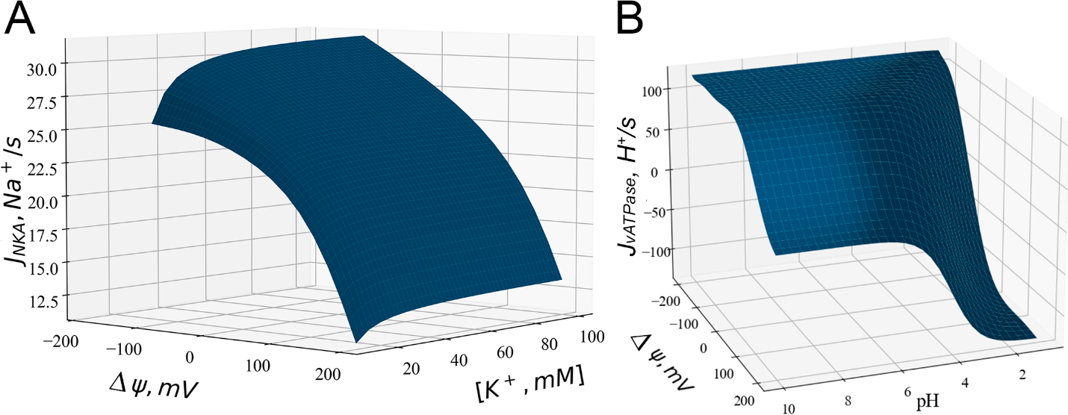
Fig. S1. Performance surfaces of Na⁺/K⁺-ATPase (NKA) and vATPase. A. The pumping rate for a single NKA plotted as a function of lumenal potassium concentration and membrane potential at fixed sodium concentration. B. The proton pumping rate [H⁺/s] for a single V-ATPase is plotted as a function of lumenal pH and membrane potential across the bilayer based on a mechanochemical model [7].

Supplementary Note 3. Model in norm: stability to changes in initial parameters
The model was tested by simulating deviations of organelle parameters from the norm. This, firstly, gives an understanding of the stability of the model after short term perturbations the system relaxes to a normal steady state. Secondly, it shows the possibility of using the model for subsequent simulations of physiological stresses.
Fig. S2 shows the transition of the main parameters of lysosomal homeostasis (vATPase activity, potential, volume, ion concentrations) to steady-state values ​​from initial values taken different from equilibrium. For pH, the initial values were in the near physiological range of 4 - 7.5 units. For [K⁺], [Na⁺], [Cl⁻] we also chose physiological values 10 – 140 mM, 10 – 140 mM, 50 – 140 mM, respectively.
vATPase activity, membrane potential, lysosomal radius, after starting the simulation from different physiological initial pH values, stabilised to near-conventional values with discrepancies of 7, 18 and 3%, respectively (Fig. S2A-C). Concentrations of potassium, sodium and chloride ions, after changing their own initial values, stabilised to the conventional values without discrepancy (Fig. S2D-F).
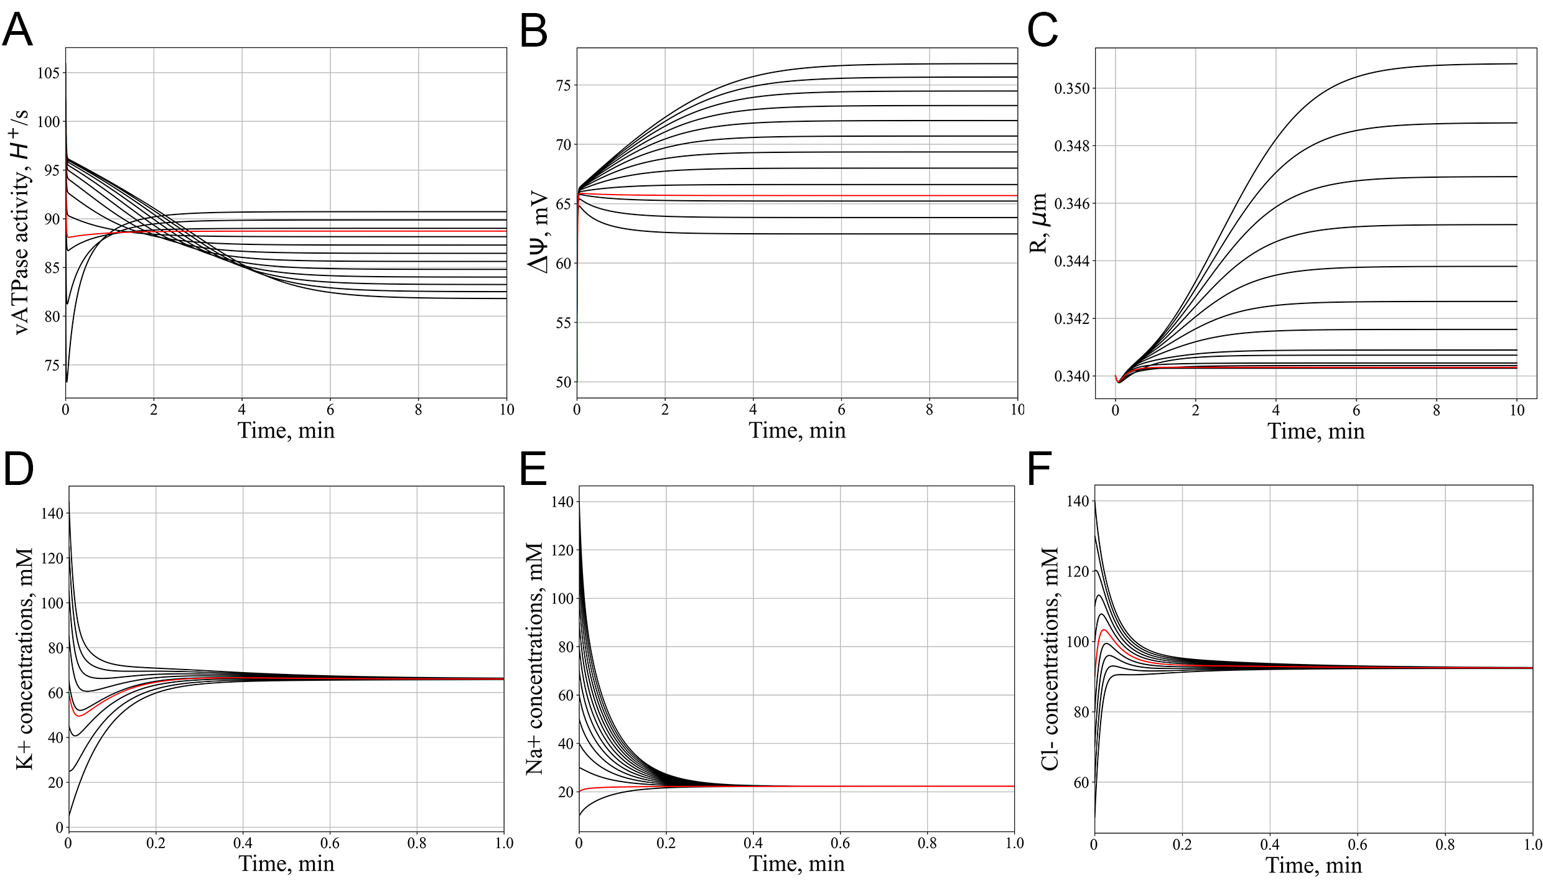
Fig. S2. Stability check of the model.
Relaxation kinetics of the main parameters of lysosome homeostasis to steady-state values ​​from the initial values that differ from convenient ones.
A. vATPase activity. B. Lysosomal membrane potential. C. Lysosomal radius.
Ions concentrations D. [K⁺]. E. [Na⁺]. F. [Cl⁻].
Red lines correspond to cases starting from normal lysosomal conditions.

The model passed the stability check for [H⁺], pH, [K⁺], [Na⁺], [Cl⁻], [Ca2⁺], lysosomal radius and transmembrane potential after ±10% changes in other key model parameters (Fig. S3).
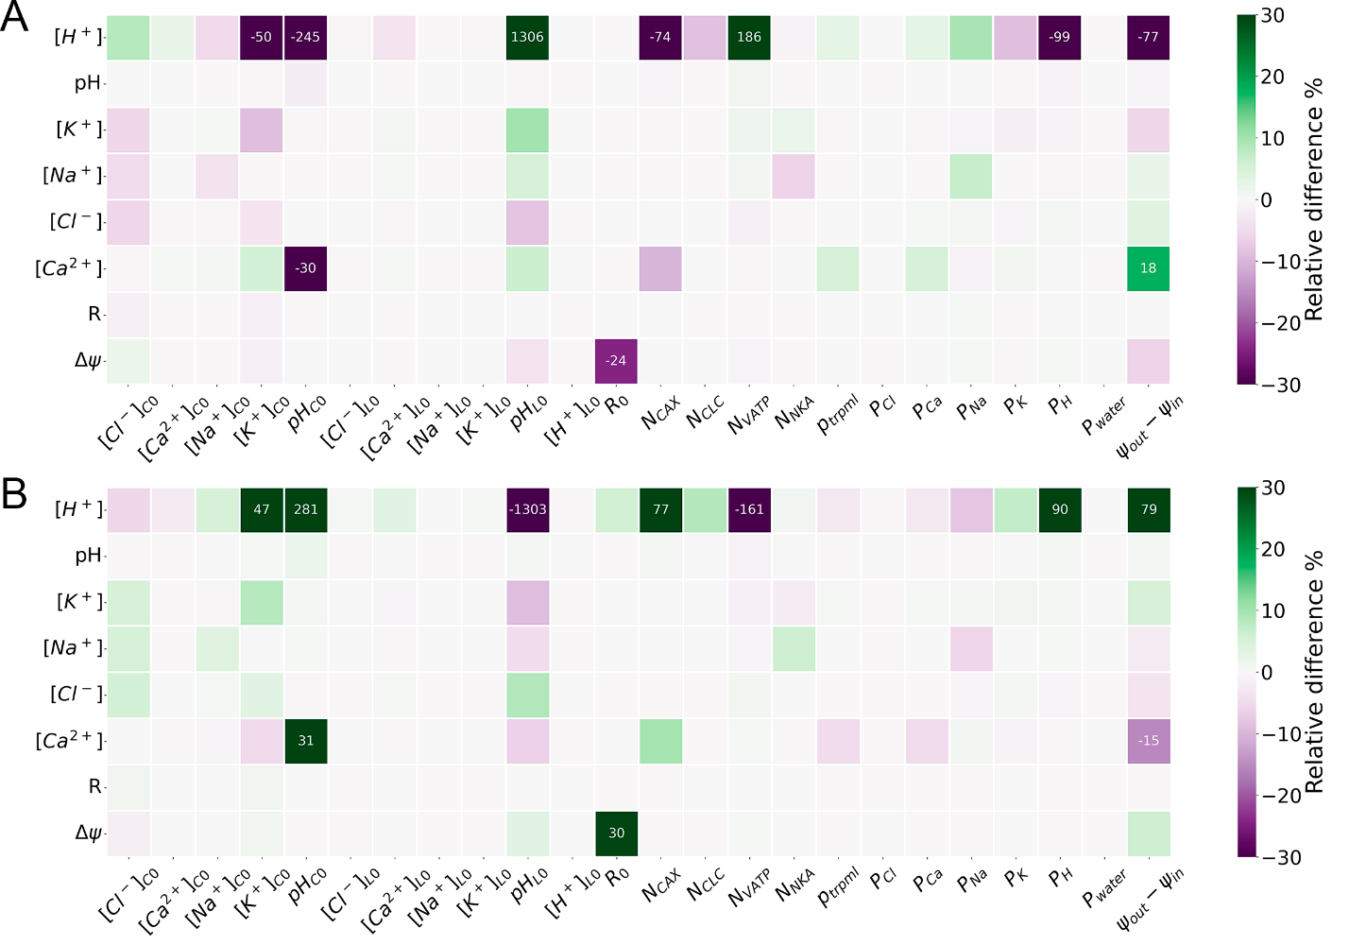
Fig. S3. Model stability matrix.
Variation of the initial values of the parameters, specified in horizontal line, to minus 10% (A) or plus 10% (B) from conventional lysosomal and cytosolic values. Consequence of such variation to [H⁺], pH, [K⁺], [Na⁺], [Cl⁻], [Ca²⁺], R, Δψ after 20000s relaxation of the system shown in numbers and heat map manner. Numbers shown for relative differences more than 10%.

Supplementary Figure to the section 2. Lysosome Membrane Permeabilization (LMP)
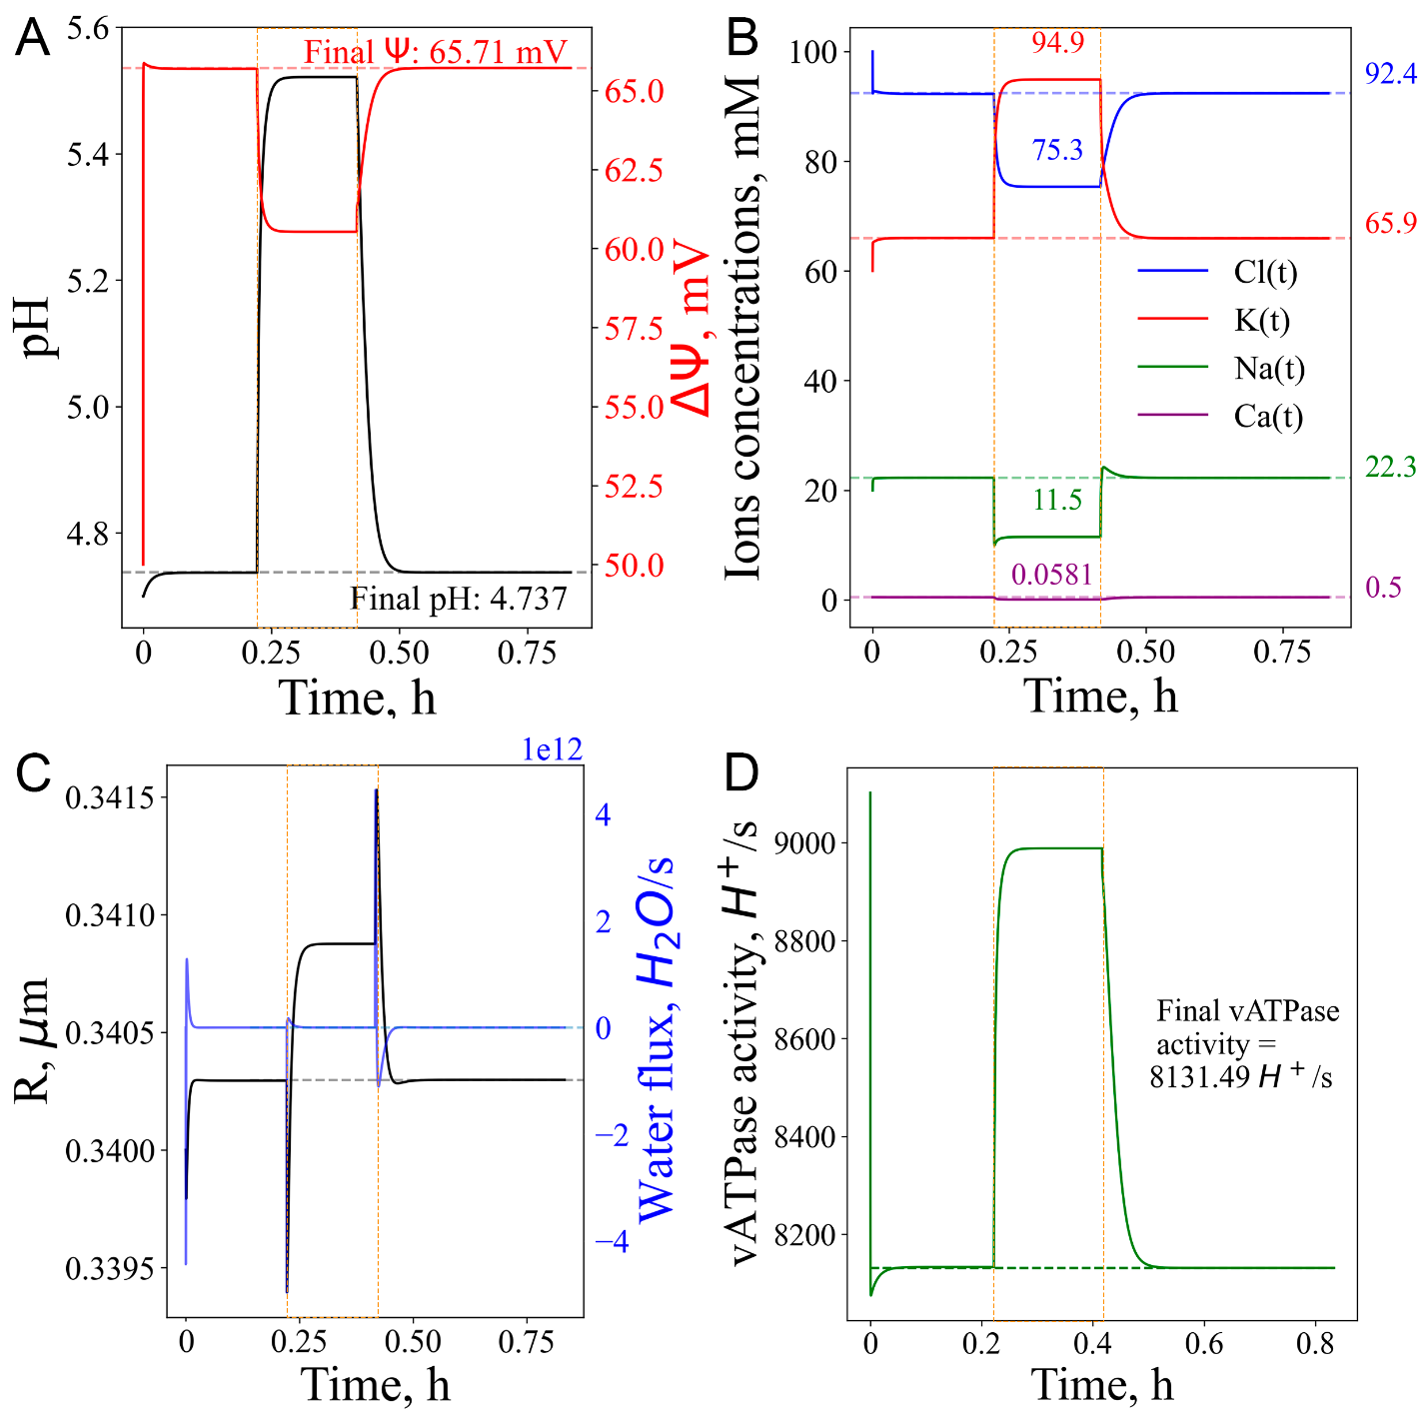
Fig. S4. Consequences of the transient LMP modelled as a 10-fold increase in permeabilities. A. Increase in pH, decrease in potential, B. Adjustment of K⁺, Na⁺, Cl⁻ ions concentrations. C. Increase in radius and water uptake. D. vATPase activity increases, resulting in a return to the initial state.
Orange dashed rectangles mark the period of stress application.

Supplementary Figure to the section 3. Short-term vATPase “knockout” or lysosome enlargement stresses
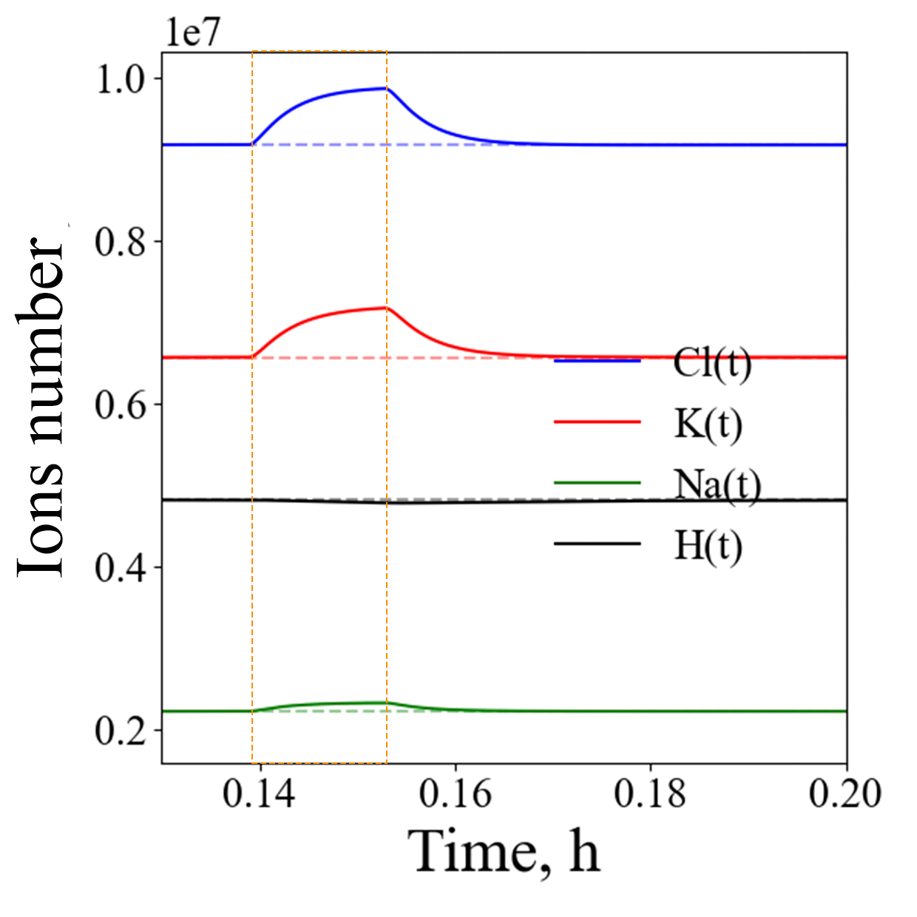Fig. S5. Change in ions number under conditions of increased water influx. Influx of Cl⁻, Na⁺, K⁺, efflux of protons.
The orange dashed rectangle marks the time periods of stress application.

Supplement references

[1] R. Astaburuaga, O.D.Q. Haro, T. Stauber, A. Relógio, A mathematical model of lysosomal ion homeostasis points to differential effects of Cl− transport in Ca2+ dynamics, Cells 8 (2019). https://doi.org/10.3390/cells8101263.
[2] Y. Ishida, S. Nayak, J.A. Mindell, M. Grabe, A model of lysosomal pH regulation, J. Gen. Physiol. 141 (2013) 705–720. https://doi.org/10.1085/jgp.201210930.
[3] B.E. Steinberg, K.K. Huynh, A. Brodovitch, S. Jabs, T. Stauber, T.J. Jentsch, S. Grinstein, A cation counterflux supports lysosomal acidification, J. Cell Biol. 189 (2010) 1171–1186. https://doi.org/10.1083/jcb.200911083.
[4] S. Saha, V. Prakash, S. Halder, K. Chakraborty, Y. Krishnan, A pH-independent DNA nanodevice for quantifying chloride transport in organelles of living cells, Nat. Nanotechnol. 10 (2015) 645–651. https://doi.org/10.1038/nnano.2015.130.
[5] E. Riederer, C. Cang, D. Ren, Lysosomal Ion Channels: What Are They Good For and Are They Druggable Targets?, Annu. Rev. Pharmacol. Toxicol. 63 (2023) 19–41. https://doi.org/10.1146/annurev-pharmtox-051921-013755.
[6] B. Hille, Ionic channels of excitable membranes, 2nd ed., Sinauer Associates, Inc., Sunderland, MA, 1992. https://doi.org/10.1016/0306-3623(85)90172-7.
[7] M. Grabe, G. Oster, Regulation of organelle acidity, J. Gen. Physiol. 117 (2001) 329–343. https://doi.org/10.1085/jgp.117.4.329.

