Supplementary information
Acidic oxidative depolymerization towards functionalized low molecular weight lignin and high value-added aliphatic monomers: operating conditions, scale-up, and cross-linking
Marta C. Lourenço, Talita Nascimento, Pedro José Sanches Filho, Ana C. Marques and Marta Ramos-Andrés

Figure S1. ¹H NMR spectrum of LB.

Figure S2. ¹H NMR spectrum of LB-pH1-50°C (7 h).

Figure S3. ¹H NMR spectrum of LB-pH1-60°C (3 h).

Figure S4. ¹H NMR spectrum of LB-pH1-70°C (2 h).

Figure S5. ¹H NMR spectrum of LB-pH1-0rpm-60°C (3 h).

Figure S6. ¹H NMR spectrum of LB-pH10-60°C (3 h).

Figure S7. ¹H NMR spectrum of KL.

Figure S8. ¹H NMR spectrum of KL-pH1-60°C (3 h).

Figure S9. ¹H NMR spectrum of LB-pH1-60°C-×25.

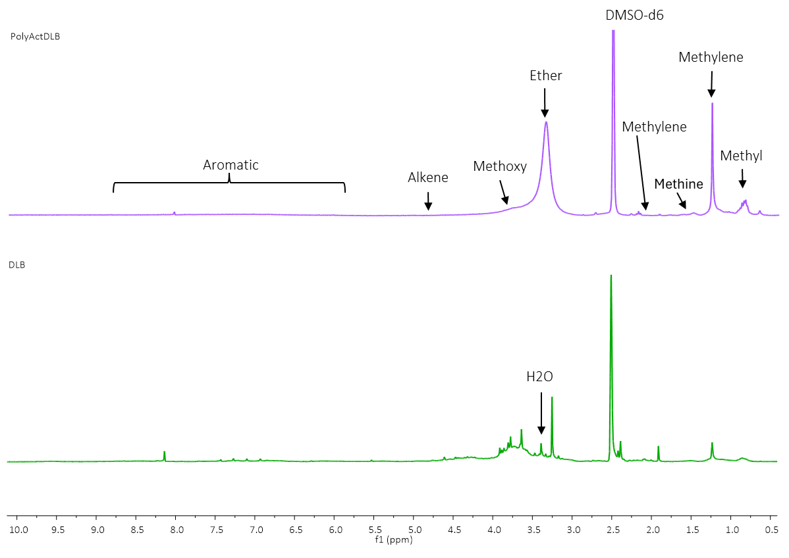

Figure S10. ¹H NMR spectrum of PolyActDLB and DLB.

Figure S11. ³¹P NMR spectrum of LB.

Figure S12. ³¹P NMR spectrum of LB-pH1-50°C (7 h).

Figure S13. ³¹P NMR spectrum of LB-pH1-60°C (3 h).

Figure S14. ³¹P NMR spectrum of LB-pH1-70°C (2 h).

Figure S15. ³¹P NMR spectrum of LB-pH1-0rpm-60°C (3 h).

Figure S16. ³¹P NMR spectrum of LB-pH10-60°C (3 h).

Figure S17. ³¹P NMR spectrum of KL.

Figure S18. ³¹P NMR spectrum of KL-pH1-60°C (3 h).

Figure S19. ³¹P NMR spectrum of LB-pH1-60°C-×25.

Figure S20. ³¹P NMR spectrum of PolyActDLB.

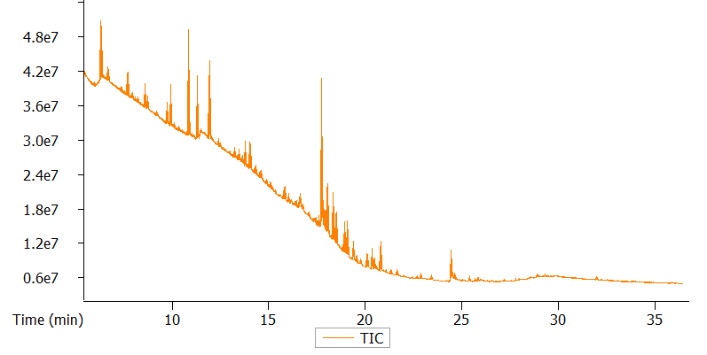

Figure S21. GC-FID-(TOF-MS) chromatogram of spectrum of LB-pH1-50°C (7 h).

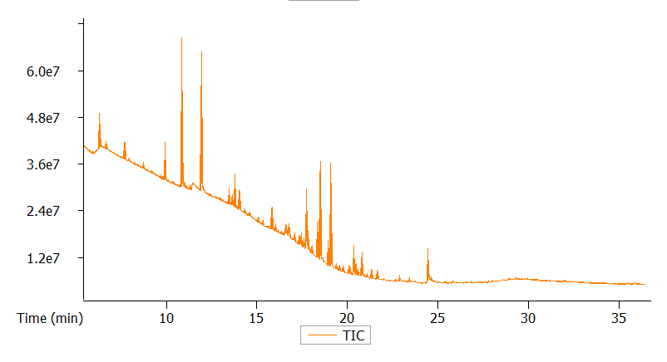

Figure S22. GC-FID-(TOF-MS) chromatogram of spectrum of LB-pH1-60°C (3 h).

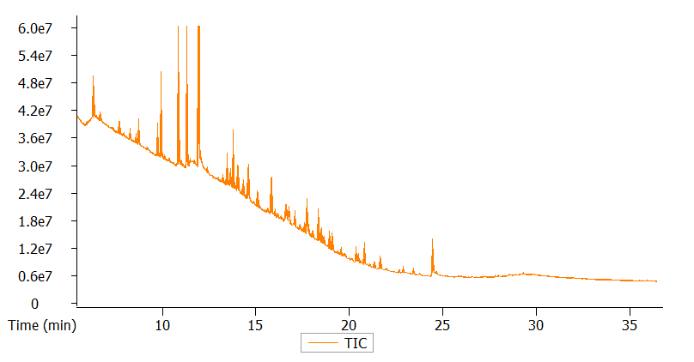

Figure S23. GC-FID-(TOF-MS) chromatogram of spectrum of LB-pH1-70°C (2 h).
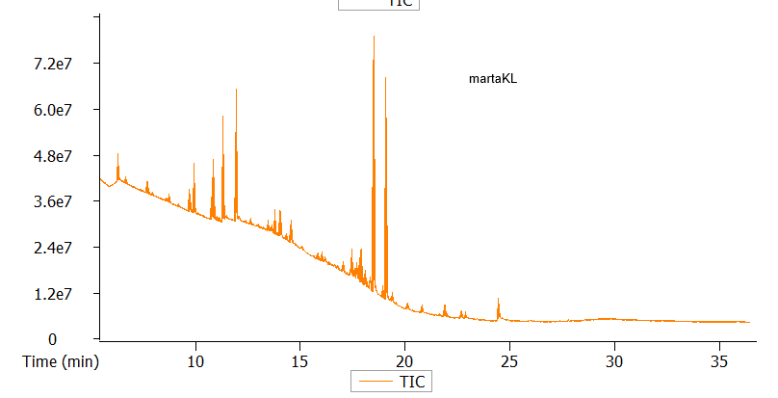

Figure S24. GC-FID-(TOF-MS) chromatogram of spectrum of KL-pH1-60°C (3 h).

