Supplementary Materials
DERA-Catalyzed Chemoenzymatic Access to Nucleobase-Substituted Candidate Statin Precursors
Romina Fernández Varela, Eman Abdelraheem, Lautaro Giaimo, Luciano Cortész, Leticia Lafuente, Ana Valino, Peter-Leon Hagedoorn, Ulf Hanefeld, Adolfo Iribarren and Elizabeth Lewkowicz

Table of Contents
- Pectobacterium atrosepticum complete genome
- ¹H and ¹³C-NMR data
- Instrumental
- Spectra
- GC data
- Instrumental
- Chromatograms
- HPLC-MS data
- Instrumental
- Chromatograms
- TLC data
- Materials
- Supplementary tables (S1-3)

- DNA sequence of Pectobacterium_atrosepticum DERA
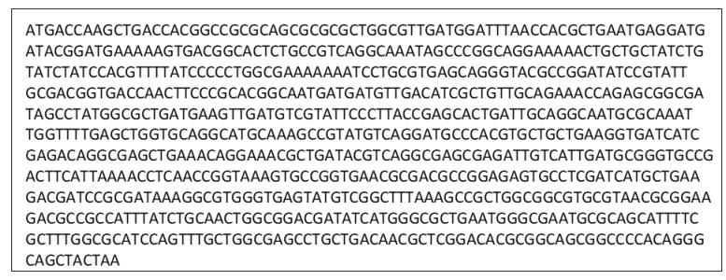
Figure S1: DNA sequence of Pectobacterium_atrosepticum DERA.

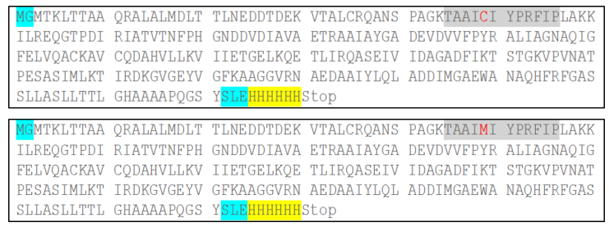
Figure S2: Amino acid sequences of PaDERA and PaDERA C49M.

- ¹H and ¹³C-NMR data

- Instrumental

¹H and ¹³C NMR spectra were recorded on a Bruker Avance II 500 spectrometer (Madison, WI, USA) at 500 MHz and 125 MHz, respectively, or on a Bruker Avance III 600 spectrometer (Madison, WI, USA) at 600 MHz, using CDCl₃ and DMSO-d₆ as solvents.

- Spectra

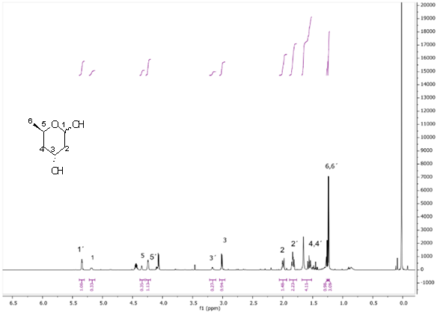
Figure S3: ¹H NMR analysis of 2a: 2,4,6-trideoxy-d-erythro-hexapyranose obtained with DERA as biocatalyst.
¹H NMR (600 MHz, CDCl₃): δ (ppm) 5.34 (t, J = 4.7 Hz, 1H, H-1 α), 5.22 – 5.12 (m, 1H, H-2 β), 4.35 (q, J = 3.1, Hz, 1H, H-5 α), 4.24 (dt, J = 6.4, 3.1 Hz, 1H, H-5 β), 3.17 (d, J = 6.1 Hz, 1H, H-3 β), 3.01 (d, J = 6.5 Hz, 1H, H-3 α), 2.05 – 1.95 (m, 2H, H-2 α/β), 1.83 (tq, J= 12.1, 3.1 Hz, 2H, H-2 α/β), 1.68 - 1.52 (m, 4H,H-4 α/β), 1.26 (d, J = 6.3 Hz, 3H, H-6 β), 1.24 (d, J = 6.3 Hz, 3H, H-6 α).
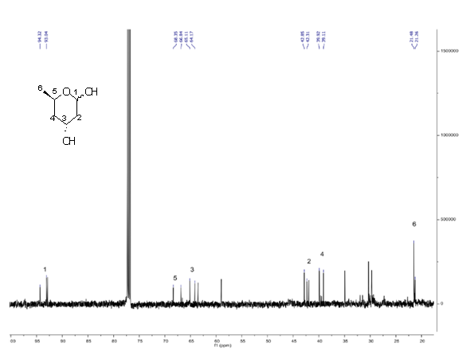
Figure S4: ¹³C NMR analysis of 2a: 2,4,6-trideoxy-d-erythro-hexapyranose obtained with DERA as biocatalyst.
¹³C NMR (126 MHz, CDCl₃) δ (ppm): 94.32 (CHOH, C-1), 93.04 (CHOH, C-1 ́), 68.35 (CH, C-5), 66.84 (CH, C-5 ́), 65.11 (CHOH, C-3), 64.17 (CHOH, C-3 ́), 42.85 (CH₂, C-2), 42.31 (CH₂, C-2 ́), 39.92 (CH₂, C-4), 39.11 (CH₂, C-4 ́), 21.48 (CH₃, C-6), 21.26 (CH₃, C-6 ́).
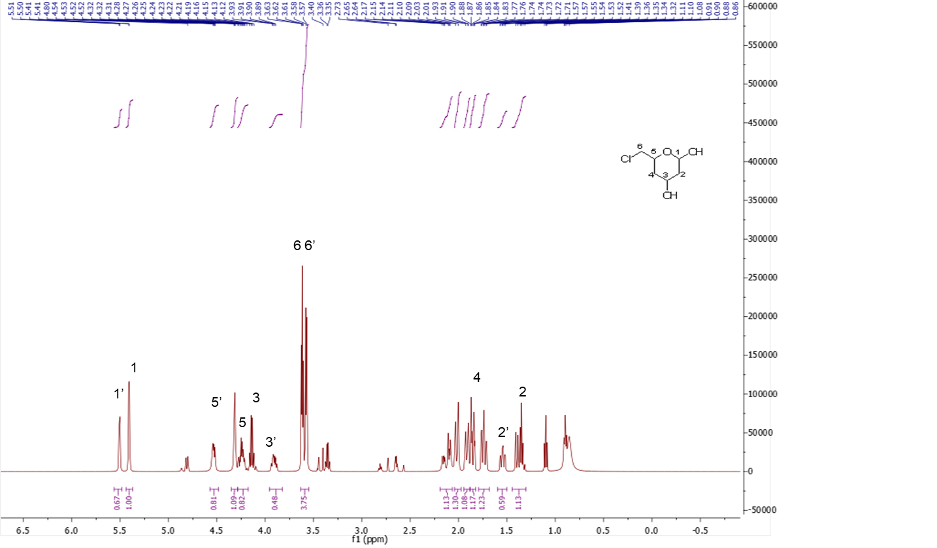

Figure S5: ¹H NMR analysis of 2b: 6-chloro-2,4,6-trideoxy-d-erythro-hexapyranose obtained with DERA as biocatalyst.
¹H NMR (500 MHz, CDCl₃): δ (ppm) 5.51 (d, J = 3.5 Hz, 1H, β), 5.41 (d, J = 3.6 Hz, 1H, α), 4.53 (dd, J = 9.0, 4.2 Hz, 1H, H-5), 4.32 (m, 1H, H-5), 4.28 – 4.18 (m, 1H, H-3), 3.91 (dq, J = 11.7, 6.2 Hz, 1H, H-3), 3.63 – 3.55 (m, 4H, H’s-6), 2.22 – 1.96 (m, 3H, H-4), 1.98 – 1.77 (m, 2H, H-2), 1.74 (ddd, J = 14.0, 11.9, 2.7 Hz, 1H, H-4), 1.55 (td, J = 12.0, 3.6 Hz, 1H, H-2), 1.47 – 1.28 (m, 1H, H-2).

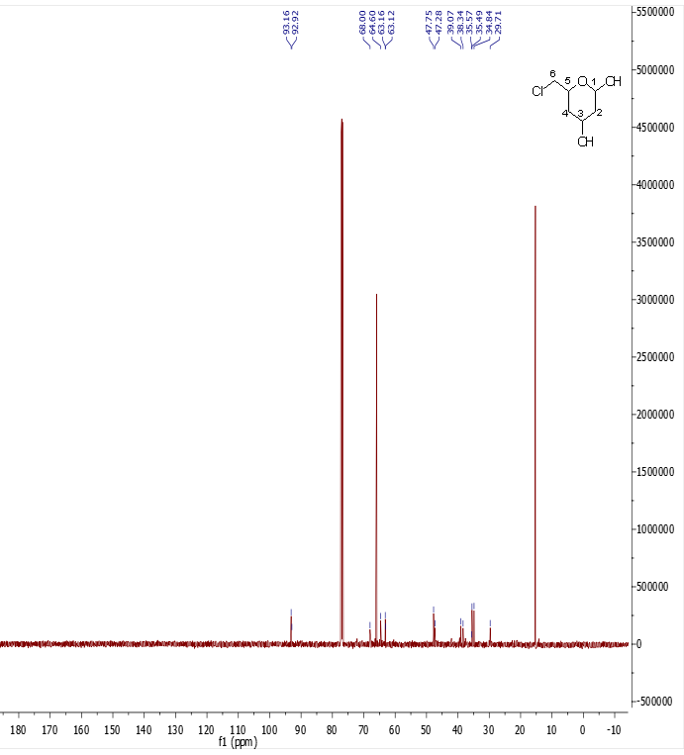
Figure S6: ¹³C NMR analysis of 2b: 6-chloro-2,4,6-trideoxy-d-erythro-hexapyranose obtained with DERA as biocatalyst.
¹³C NMR (126 MHz, CDCl₃) δ (ppm): 93.16 (CHOH, C-1), 92.92 (CHOH, C-1´), 68.00 (CH, C-5), 64.60 (CH, C5´), 63.16 (CHOH, C-3), 63.12 (CHOH, C-3´), 47.75 (CH₂, C-6), 47.28 (CH₂, C-6´), 39.07 (CH₂, C-2), 38.34 (CH2, C-2´), 35.49 (CH₂, C-4), 34.84 (CH₂, C-4´).

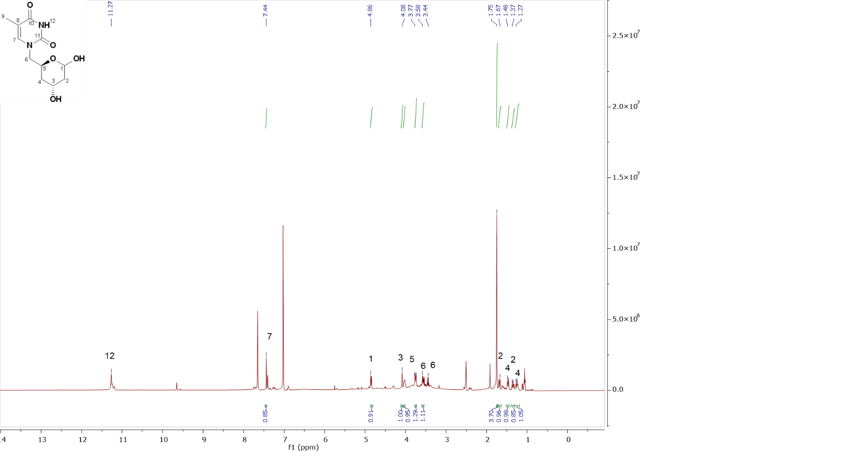
Figure S7: ¹H NMR analysis of 6i: 6-thyminyl-2,4,6-trideoxy-d-erythro-hexopyranose obtained with DERA as biocatalyst.
¹H NMR (500 MHz, DMSO-d₆): δ (ppm) 11.25 (d, J = 12.5 Hz, 1H, NH), 7.44 (s, 1H, H-7), 4.85 (d, J = 9.1 Hz, 1H, H-1), 4.08 (s, 1H, H-3), 4.03 (d, J = 8.6 Hz, 1H, H-5), 3.74 (d, J = 3.5 Hz, 1H, H-6a), 3.58 (d, J = 8.4 Hz, 1H, H-6b), 1.75 (s, 3H, H-9), 1.68 (d, J = 14.0 Hz, 1H, H-2b), 1.47 (d, J = 12.7 Hz, 1H, H-4a), 1.34 (t, J = 11.6 Hz, 1H, H-2a), 1.26 (d, J = 11.6 Hz, 1H, H-4b).

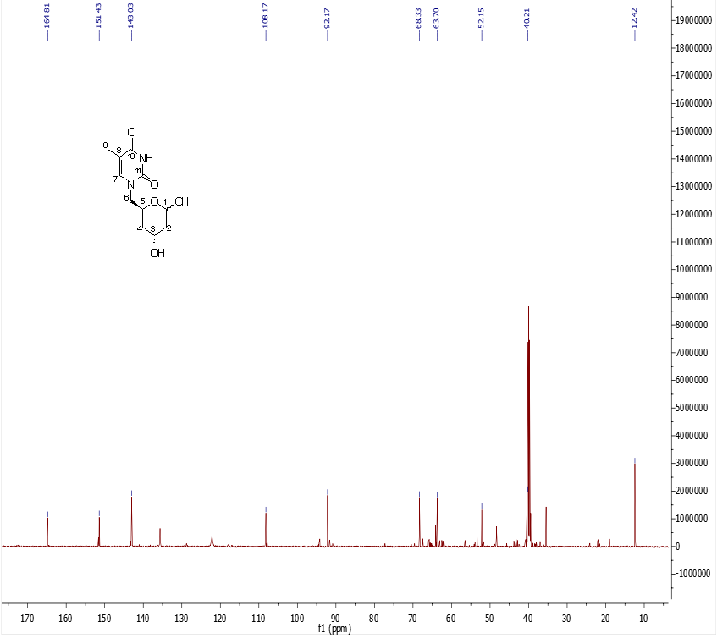
Figure S8: ¹³C NMR analysis of 6i: 6-thyminyl-2,4,6-trideoxy-d-erythro-hexopyranose obtained with DERA as biocatalyst.
¹³C NMR (126 MHz, DMSO-d₆): δ (ppm): 164.81 (CO, C-11), 151.43 (CO, C-10), 143.03 (CH, C-7), 108.17 (CH, C-8), 92.17 (CHOH, C-1), 68.33 (CH, C-5), 63.70 (CHOH, C-3), 52.15 (CH₂, C-6), 40.21 (CH₂, C-2), 35.45 (CH₂, C-4), 12.42 (CH₃, C-9).
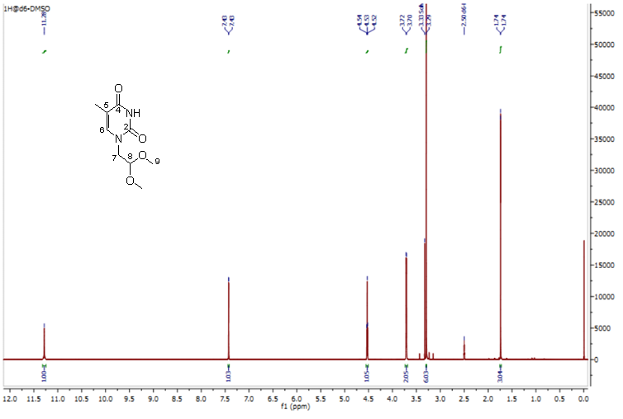
Figure S9: ¹H NMR analysis of 4i: N-1-(2,2-dimethoxyethyl) thymine obtained by chemical synthesis.
¹H NMR (500MHz, DMSO-d₆) δ (ppm) 11.28 (s, 1H, NH), 7.43 (d, 1H, J=1.21 Hz, H6), 4.53(t, 1H, J=5.37 Hz, H8), 3.71 (d, 2H, J=5.37 Hz, H7), 3.29 (s, 6H, H9), 1.74 (d, 3H, J=1.16 Hz, CH₃ exocyclic).

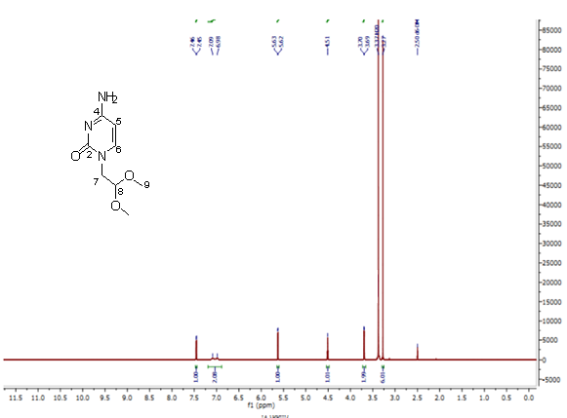
Figure S10: ¹H NMR analysis of 4ii: N-1-(2,2-dimethoxyethyl) cytosine obtained by chemical synthesis.
¹H NMR (500 MHz, DMSO-d₆) δ (ppm) 7.45 (d, 1H, J=7.2 Hz, H6), 7.09 (d, 2H, J=5.52 Hz, NH₂ exocyclic), 5.63 (d, 1H, J=7.2 Hz, H5), 4.51 (t, 1H, J=5.4 Hz, H8), 3.69 (d, 2H, J=5.4 Hz, H7), 3.27 (s, 6H, H9).
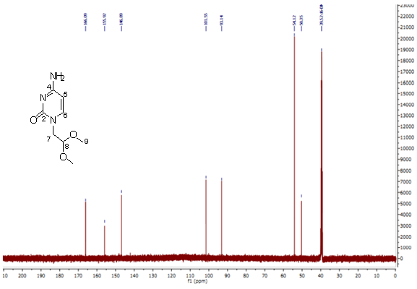
Figure S11: ¹³C NMR analysis of 4ii: N-1-(2,2-dimethoxyethyl) cytosine obtained by chemical synthesis.
¹³C NMR (125 MHz, DMSO-d₆) δ (ppm): 166.1 (CO, C-2), 155.9 (CNH2, C-4), 145.9 (CH, C-6), 101.5 (CH, C-8), 93.1 (CH, C-5), 54.1 (CH3, C-9), 50.3 (CH2, C-7).

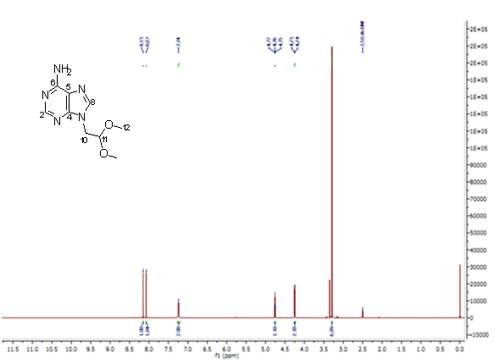
Figure S12: ¹H NMR analysis of 4iii: N-9-(2,2-dimethoxyethyl) adenine obtained by chemical synthesis.
¹H NMR (500 MHz, DMSO-d6) δ (ppm) 8.15 (s, 1H, H2), 8.07 (s, 1H, H8), 7.24 (s, 2H, NH₂ exocyclic), 4.76 (t, 1H, J=5.38 Hz, H11), 4.25 (d, 2H, J= 5.38 Hz, H10), 3.29(s, 6H, H12).
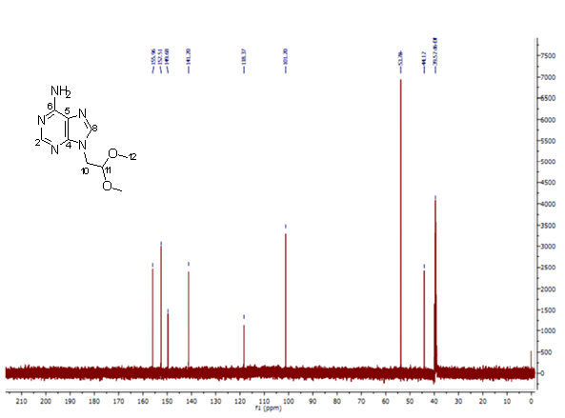
Figure S13: ¹³C NMR analysis of 4iii: N-9-(2,2-dimethoxyethyl) adenine obtained by chemical synthesis.
¹³C NMR (125 MHz, DMSO-d6) δ (ppm): 155.9 (C, C-4), 152.5 (CH, C-2), 149.7 (CNH2, C-6), 141.2 (CH, C-8), 116.7 (C, C-5), 101.2 (CH, C-11), 53.8 (CH3, C-12), 44.1 (CH2, C-10).

- GC data

- Instrumental

Quantitative analysis was performed by GC using He as gas carrier (1 mL/min) and injector temperature 200 °C. The oven temperature was set at 50 °C (5 min), increased to 250 °C (10 °C/min) and maintained at the final temperature for 5 min.

- Chromatograms
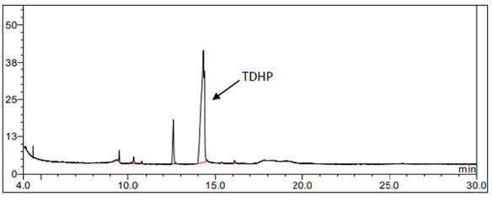
Figure S14: GC analysis of 2a: 2,4,6-trideoxy-d-erythro-hexapyranose (TDHP). Rt: 13.9 minutes.
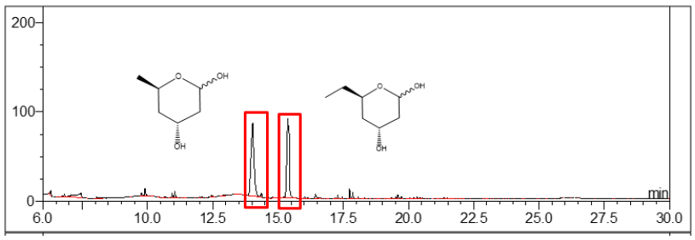
Figure S15: GC analysis of 2c: 6-methyl-2,4,6-trideoxy-d-erythro-hexapyranose. Rt: 15.3 minutes.
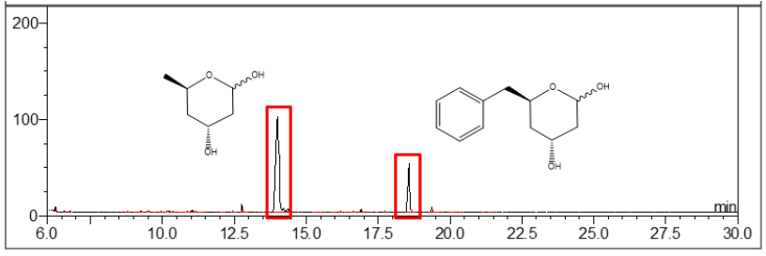
Figure S16: GC analysis of 2d: 6-phenyl-2,4,6-trideoxy-d-erythro-hexapyranose. Rt: 18.7 minutes.

- HPLC-MS data

- Instrumental
LC-ESI-MS analysis: Mass spectrometric analysis as carried out using an ACQUITY UPLC system (Waters, UK) coupled online to a high-resolution Orbitrap mass spectrometer (Q-Exactive Focus, Thermo Fisher Scientific, Germany). Chromatographic separation was achieved on a reverse-phase ACQUITY UPLC BEH C18 column (1.0 × 100 mm, 1.7 μm; Waters, UK) operated at room temperature. The mobile phases consisted of water containing 0.1% formic acid (A) and acetonitrile containing 0.1% formic acid (B). A gradient was maintained at 50 μL/min at 5% B over 15 minutes. Solvent B was then increased to 75% over 22 minutes, before equilibrating back to the starting conditions. The mass spectrometer was operated alternating in full scan and PRM mode. Full scan was acquired from 50–750 m/z in ESI positive mode at a resolution of 70 K. Raw data were analyzed using XCalibur 4.1 (Thermo Fisher Scientific, Germany). The mass spectrometer was calibrated using the Pierce™ LTQ ESI positive ion calibration solution (Thermo Fisher Scientific, Germany).
- Chromatograms
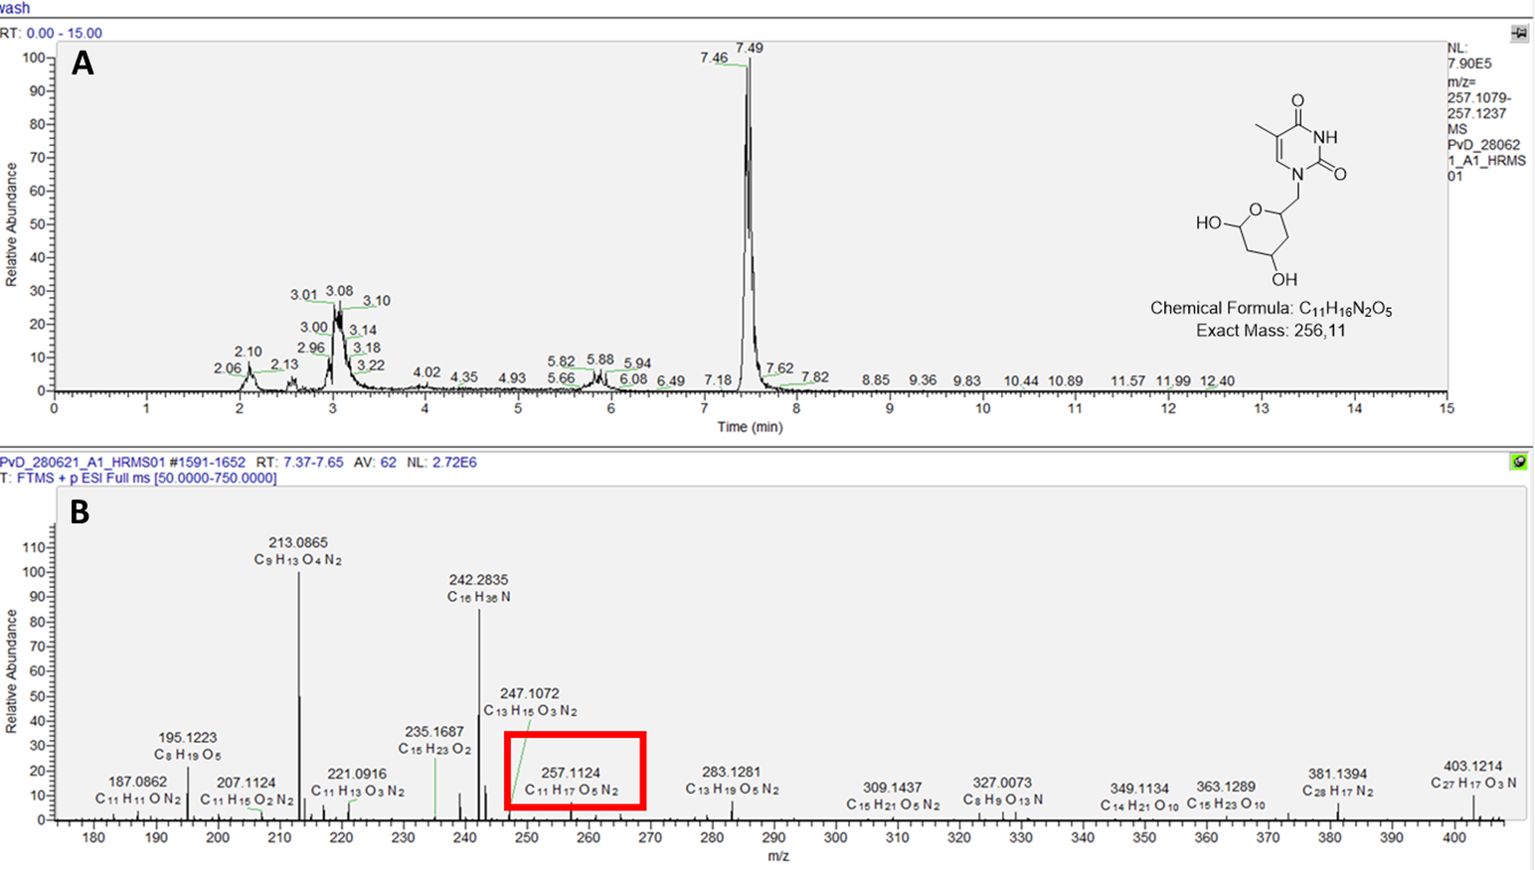
Figure S17: LC-ESI-MS analysis for 6i: 6-thyminyl-2,4,6-trideoxy-D-erythro-hexapyranose (256 m/z). A) total ion chromatogram in the positive mode for compound 6i at Rt 7.49 mins. B) mass spectra found as [M+H⁺] corresponding to the product [C₁₁H₁₇N₂O₅]⁺: 257.1124).
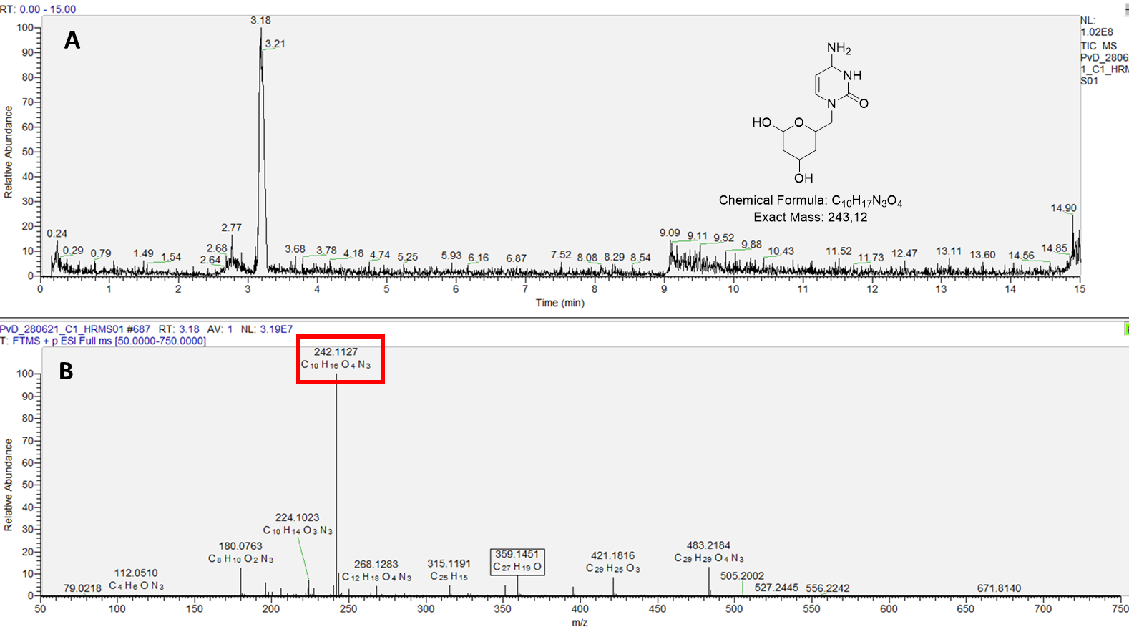
Figure S18: LC-ESI-MS analysis for 6ii: 6-cytosyl-2,4,6-trideoxy-D-erythro-hexapyranose (243 m/z). A) total ion chromatogram in the positive mode for compound 6ii at Rt 3.19 mins. B) mass spectra found as [M-H⁺] corresponding to the product [C₁₀H₁₆N₃O₄]⁻: 242.1127).
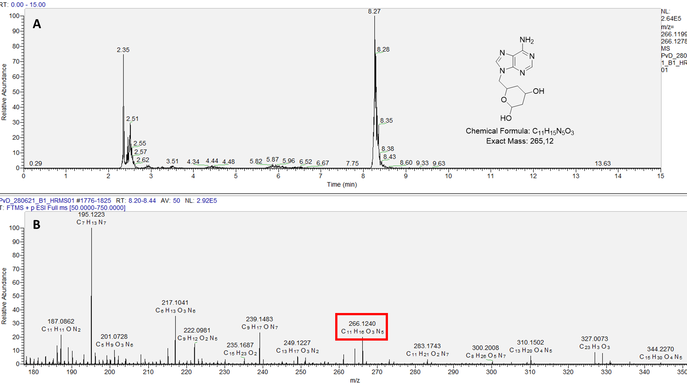
Figure S19: LC-ESI-MS analysis for 6iii: 6-adenyl-2,4,6-trideoxy-d-erythro-hexapyranose (265 m/z). A) total ion chromatogram in the positive mode for compound 6iii at Rt 8.27 mins. B) mass spectra found as [M+H⁺] corresponding to the product [C₁₁H₁₆N₅O₃]⁺: 266.1240).

- TLC analysis

- Materials

Thin-layer chromatography (TLC) was performed on Merck silica gel 60 GF₂₅₄ plates (0.25 mm). Visualization was achieved under UV light or by heating after spraying with a 5% (v/v) H₂SO₄ solution in ethanol.

- Supplementary tables (S1-3)

Table S1: The qualitative analysis of whole-cell biotransformations (2a-d) were performed by TLC using acetonitrile:ethylether 1:1 (v/v) as a solvent and the spots were visualized by heating after spraying with 5 % v/v H₂SO₄ in ethanol.

Acceptor aldehyde | Lactol product | Rf
Acetaldehyde | 2,4,6-trideoxy-d-erythro-hexapyranose (2a) | 0.5
chloroacetaldehyde | 6-chloro-2,4,6-trideoxy-d-erythro-hexapyranose (2b) | 0.6
propanaldehyde | 6-methyl-2,4,6-trideoxy-d-erythro-hexapyranose (2c) | 0.75
phenylacetaldehyde | 6-phenyl-2,4,6-trideoxy-d-erythro-hexapyranose (2d) | 0.85

Table S2: The qualitative analysis of free-enzyme biotransformations were performed by TLC using dichloromethane:methanol 9:1 (v/v) as solvent and the spots were visualized by UV light.
Acceptor aldehyde | Lactol product | Rf
N-1-(2-oxoethyl) thymine | 6-thyminyl-2,4,6-trideoxy-d-erythro-hexapyranose (6i) | 0.17
N-1-(2-oxoethyl) cytosine | 6-citosyl-2,4,6-trideoxy-d-erythro-hexapyranose (6ii) | 0.8
N-9-(2-oxoethyl) adenine | 6-adenyl-2,4,6-trideoxy-d-erythro-hexapyranose (6iii) | 0.38

Table S3: The qualitative analysis of substrate synthesis was performed by TLC using dichloromethane:methanol 9:1 (v/v) as solvent and the spots were visualized by UV light.
Base | N-oxoalkyl product | Rf
Adenine | N-9-(2-oxoethyl) adenine | 0.2
Cytosine | N-1-(2-oxoethyl) cytosine | 0.44
Thymine | N-1-(2-oxoethyl) thymine | 0.3

