A New Frame Work of Thermodynamics
The Second law of thermodynamics is a law of Energy Circulation
Xinyong Fu* & Zitao Fu Shanghai Jiao Tong University xyfu@sjtu.edu.cna
June 18, 2025
Keywords：traditional thermodynamics; artificial demon; thermal electrons in a magnetic field; a closed universe; black holes are natural demons; the 3K heat ocean; big cycle of matter and energy; big band and big assembling
Abstract This new frame work of thermodynamics contains three parts. （1）The traditional thermodynamics: relating to all the ordinary thermodynamical processes we meet in our life，work, and ordinary research, covering an immense scope. They are all irreversible. Entropy tends to increase, never decreases. (2）Thermodynamics of thermal electrons in a magnetic field: There are some experiments of thermal electrons emitted from two identical and parallel Ag-O-Cs emitters (work function 0.8eV) in a vacuum tube. The tube is applied by a static magnetic field that bends the trajectories of the electrons, resulting in a weak asymmetry of their motions, and the tube can output an electric current and power. The magnetic field here is an artificial demon, resulting in a tiny cycle of energy. （3）Cosmos thermodynamics: The universe is closed. There is an extraordinary immense heat ocean at a temperature of about 3K in the central part of the closed universe. A big band and a big assembling constitute a big cycle, all the matter and energy in the closed universe are involved in the big cycles. Entropy can either increase or decrease, and match each other. Black holes are natural demons in the universe.
A nice video of an experiment of the thermal electrons in a magnetic field, an artificial entropy-reducing process is attached in the supplement file of this article.
(I) Traditional Thermodynamics
At present time，we spend electric energy every day. One joule electric energy, as we use it, converts to one joule waste heat. There are numerous similar processes, for examples, by friction, work converts to heat, a stone falls down to the ground, air leakage of a car tire, and so on, covering an extremely immense scope.
Energy is conserved. That is the first law of thermodynamics. One joule electric energy converts to one joule waste heat, exactly.
Electric energy is useful energy, that means, it can be used to do work. Waste heat is useless energy, that means, it can never be used to do work again.
All the energy source are useful energy that the nature grants us. Every piece of energy source we derived from the nature, can be used to do work once only.
That is the second law of thermodynamics. According to this law, all the practical thermodynamical processes is irreversible, resulting in the monotonical increase of the entropy in the universe.
The second law of thermodynamics is so far always valid for almost all the artificial and natural processes known by mankind. The final fate of the universe, as described by Clausius, is all the energy in the universe changes to waste heat and be radiated to the infinitive vast cosmic space, leading to the Heat Death.⁽¹⁾⁽²⁾⁽³⁾⁽⁴⁾

(II) Thermodynamics of thermal electrons in a magnetic field
However, in the history of physics, there were a few outstanding peoples who doubted sharply and profoundly the absolute single-direction of all the physical processes described by the second law of thermodynamics. Among them, James Clerk Maxwell was the most genius and brave one.
From 1866 to 1871, Maxwell immersed himself in the searching for a way of converting waste energy back to useful energy again.
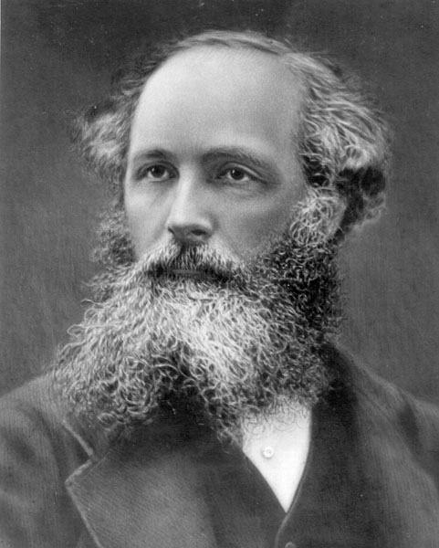
James Clerk Maxwell 1831-1879
Limited by the historic level of science and technology of his time, he had not successfully designed and performed such an experiment. However，he wrote down his thoughts and experiences of his exploration into his famous textbook Theory of Heat published in 1871. He hoped that in some future days this cherished wish of
mankind would be realized by some inheritors. ⁽⁵⁾
In his exploration, Maxwell thought to use a closed container filled up with air molecules. The container is divided by a separator into two parts, A and B, as shown in Fig.1. At the middle on the separator, there is a small door, which is controlled by an intellectual being. (Kelvin called the “intellectual being” jokingly a demon.)
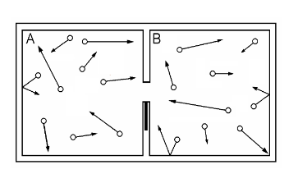
Fig.1 An air container of two parts, A and B. There is a small door at the middle of
the separator, which is controlled by a small intellectual being.
At the beginning, the air in the container is at a thermal equilibrium state. The temperature and pressure of the air are uniform everywhere in the container.
The demon has two work modes, described respectively as follows.
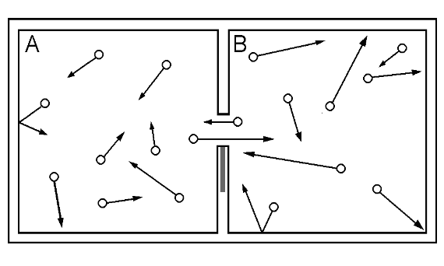
Fig.2 A temperature demon.
In the first work mode, the demon permits the faster molecules to pass the door from A to B, and the slower molecules to pass the door from B to A, as shown in Fig. 2. Gradually, the temperature in A drops down and the temperature in B rises up. A temperature difference between A and B emerges, enabling a part of the internal energy of the air in the container to be used to do work.
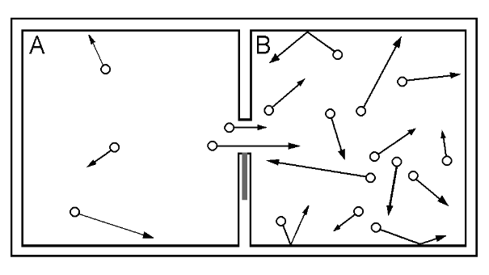
Fig. 3 A pressure demon.
In the second work mode, the demon permits only the molecules of A to pass the door to B, and does not permit the molecules of B to pass the door to A, as shown in Fig. 3. Gradually, the pressure in A drops down and the pressure in B rises up. A pressure difference between A and B emerges, also enabling a part of the internal energy of the air in the container to be used to do work.
In the past one and a half centuries, many physicists and inventors, have made numerous efforts to design and execute various experiments, hoping to find such a demon. However, all their efforts failed.
The two authors of this paper, in the past several decades (one since 1960, the other since 2000), following Maxwell’s steps, insisted on searching such an entropy reducing experiment. They replaced Maxwell’s gas molecules in the container by thermal electrons in a vacuum tube, which contains two electrodes. Fig.4 (1) shows one of the electron tubes, FX8-24. There are two identical and paralelll Ag-O-Cs thermal electron surfaces A and B in the vacuum tube. The work function of Ag-O-Cs surface is only 0.8 eV, ⁽⁶⁾⁽⁷⁾⁽⁸⁾⁽⁹⁾ ⁽¹⁰⁾ ⁽¹¹⁾ the least one among all known thermal electron emitters. It can eject thermal electrons ceaselessly at room temperature, the so called “dark current” as in the photomultipliers or the night vision instruments. Our experiment relied on the thermal electrons of the “dark current”. Hence, the experiment can be performed with the whole closed circuit at a same room temperater. That is a great advantage.
When no magnetic field is applied on the tube, there is no output current, as shown in Fig.4 (2).

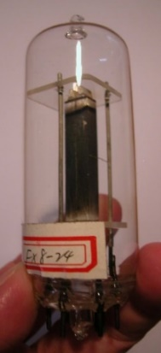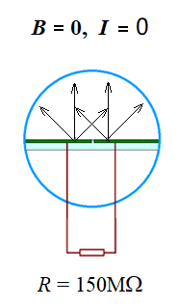
(1) electron tube FX8-24 （2）
Fig.4 Two identical and paralelll Ag-O-Cs thermal electron
surfaces A and B are settled in a vacuum tube.
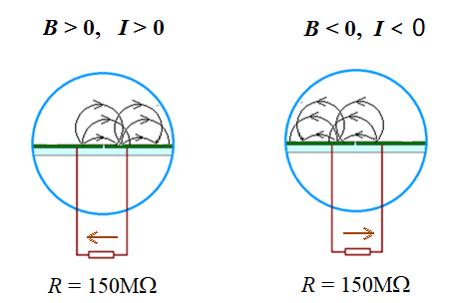
(1) （2）
Fig.5, (1) If the directionof magnetic field is positive, then the output current is positive.
(2) If the direction of the magnetic field is negative, the output current is ngative.
That is an electric potential demon.
If a uniform and static magnetic field (provided by one or a pair of permanent magnets) in the direction, firstly, pointing into the paper to bend the trajectories of the emitted thermal electrons, resulting in a slight asymmetry in their thermal motion within the tube. Thus, the number of electrons emitted from emitter A and fall down into emitter B in each second is slightly greater than the number of the electrons move from B and fall into A, as shown in Fig.5 (1). A net electron transfer from A to B happens. Emiter A losing some net electrons continuously, is charged positively, and emitter B, receiving some net electrons continuously, is charged negatively. A potential difference between A and B emerges, enabling the electron tube to output a current and an electric power to an exterior load, e.g., a resistor (or, a storage battery).
If the direction of the static magnetic field is opposite, pointing out from this paper, the direction of the output current is also opposite, as shown in Fig.5 (2).
If the magnetic field keeps constant for a long duration (just keep the permanent magnet stationary), the electron tube can output a stable electric current and a stable electric power in the whole duration. For examples, 30 seconds, 3 minutes, 1 hours, 3 hours, and so on, as long as the performers wish. ⁽¹²⁾ ⁽¹³⁾ ⁽¹⁴⁾
As the electron tube ceaselessly outputs electric energy to do work on the exterior resistor with a power (P = I² R), the internal energy of the tube tends to decrease, though very slightly. And the temperature of the tube follows to drop down, also very slightly.
Thus, the tube can spontaneously attract the waste heat from the ambient air to compensate its energy loss due to the output of electric energy.
The experiment verifies that 1 joule waste heat is possible to convert back to 1 joule electric energy, without producing any other changes, violating the Kelvin- Planck statement of the second law of thermodynamics. ⁽¹⁵⁾ ⁽¹⁶⁾ ⁽¹⁷⁾ ⁽¹⁸⁾
The following is an experiment video of our electron tube FX8-24 (for100 seconds):
In this experiment，the whole closed circuit is desired to be kept at the same room temperature, say, t = 20ºC. However, the room we used to perform the experiment is not a thermostatic laboratory. It is just a common dwelling room. There are usually some 3ºC ∼ 7ºC changes in temperature every day (in 24 hours). The temperature of the room is always changing very slowly. There are inevitably temperature differences distributed along the closed circuit, of the magnitude of several 0.1º C. The temperatures at all the connections of two different metals along the closed circuit are usually not exactly equal each other. The general Peltier-Seeback effect along the whole closed circuit is usually not zero, but very small, fluctuating ceaselessly, results in a background fluctuating current in the circuit.
The whole video presents here last 100 seconds.
(1) From t = 0 to t = 10 seconds
No magnetic field is applied to the vacuum tube in this duration. So, no real output current exists in the circuit. Only a small fluctuating background current as shown in the video below,
I_{o} ≈ (-7 ~ -15) ⅹ10⁻¹⁶ A = (-0.7 ~ -1.5)fA.
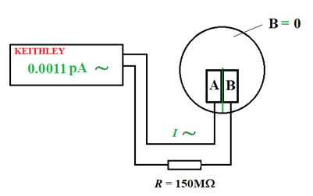
(2) From t = 10 to t = 40 seconds
Move in a permanent magnet of 2 kg at t = 10 seconds, as shown in the video. There appears a fundamental output current in the circuit,
I ≈ (-150 ~ -190) ⅹ10⁻¹⁶ A = (-15.0 ~ -19.0) fA,
fluctuating slightly.
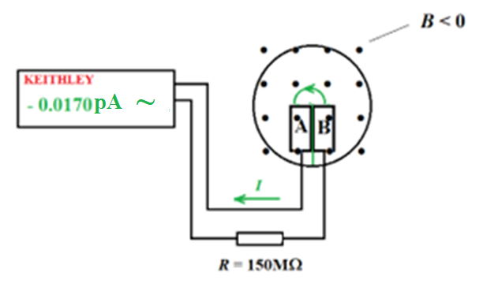
(3) From t = 40 to t = 70 seconds
Reverse the direction of the magnetic field at t = 40 seconds, as shown in the video. The direction of the output current also reverses, the output current becomes
I ≈ (+200 ~ +230) ⅹ10⁻¹⁶ A = (+20.0 ~ +23.0) fA,
also fluctuating slightly.
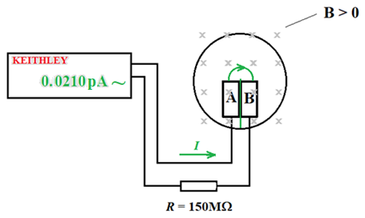
And so on.
Two clear photoes of the set up of the experiment
(1) The set up of the experiment

Keithley 6514（10⁻¹⁶A） copper shielding box magnet

(2) The interior of the copper shielding box

An electron vacuum tube, a resistor R = 150 MΩ, some connection lines, etc.

(III) Cosmos Thermodynamics
Most astrophysicists today believe that the present universe was produced in a big bang. ⁽¹⁹⁾⁻⁽²²⁾ This article explores the big cycle of matter and energy in the universe: a big bang and a big assembling constitute a big cycle.
It is essentially a thermodynamic exploration.
The authors approve of the idea that the space of the universe is closed, and all the matter and radiations are impossible to fly off the closed universe.
Within the closed universe，naturally，there is an intrinsic immense heat ocean. We believe, it is just the 3K microwave background radiation discovered in 1965. ⁽²³⁾⁻⁽²⁶⁾ It is not produced by the big bang.
The big bang drove the matter of more than 2×10¹² galaxies to the remote space, with their potential energy getting higher and higher. They are flying farther and farther at present, until reaching their individual far-most positions. Then they will return back one after another, and fly back to the central region of the universe. They are impossible to restore directly to the original state of the primitive atom (Lemaitre’s word). They will fly through the central region with different tremendous kinetic energies to their individual far-most positions on the other sides of the central region. Due to the gravitational attraction, they will slow down, and finally return back to the central region again. In such a way, they will keep shuttling through the central region ceaselessly.
From the big bang to the big expansion, to the generations of numerous galaxies, to the even more numerous stars with most stars release tremendous amounts of light and heat due to their internal nuclear fusion, and so on, all these different processes are irreversible, producing immense amount of entropy. Meanwhile, actually, all these processes scatter tremendous amount of light and heat (i.e., energy) into the cosmic space. These light and heat also keep shuttling within the closed universe with tremendously greater amplitudes, and, after an extremely long, long relaxation time, mingle into the 3K heat ocean. The heat ocean plays a role of immense heat reservoir (called alternatively, an energy reservoir) in the closed universe.
In every galaxy, there are numerous stars and many black holes. Every black hole, since its birth, attracts all the matter and radiations that approach it, and gets larger. A black hole can annex any other celestial body that it encountered, including annexes another black hole.
By the shuttling, the numerous galaxies are passing through the central region repeatedly in the various directions in the 4π solid angle. Hence, they have many chances to meet each other in the central region. And the even more numerous stars and black holes in these galaxies also have numerous chances to meet each other. Annexation happens whenever a black hole encounters any other celestial body in the shuttling.
The core black hole of any galaxy is tremendously greater than a black hole of the star grade. Its chances of annexation with other celestial bodies are also tremendously greater.
The processes of shuttling and annexations carry on and on. After an extremely long, long period, the total number of all the celestial bodies（stars, black holes, galaxy cores, and so on）in the closed universe will finally begin to decrease. The survived black holes become larger and larger by the annexations, and meanwhile their shuttling amplitudes become shorter and shorter. Due to these two factors, the general annexation processes in the universe will become faster and faster. After an extremely long, long period, finally, all the matter in the universe will inevitably assemble together to form a single and extraordinarily immense central black hole.
The central black hole has an astonishingly huge Schwarzschild sphere, absorbing the thermal radiation from the extremely immense 3K heat ocean ceaselessly in all the directions at the speed of light. Its internal energy will increase extremely rapid and monotonically. That means, the general repelling factor within the core of the central black hole increases extremely rapidly and monotonically. When some threshold value of the repelling factor in the core of the central black hole is reached and exceeded, a new big bang breaks out.
Black holes are natural Maxwell’s demons in the universe.
1. Assembling of all the matter that scattered into the cosmic space by the big band
The authors, like most of today’s astrophysicists, approve of the theory of the
big bang established by Lemaitre ⁽¹⁹⁾, Hubble ⁽²⁰⁾, Gamow ⁽²¹⁾, et al.
However, there is a major deficiency in the present cosmology theory: Where did the primitive atom of the big bang, i.e., the primitive egg of the universe，come from?
Many people just avoid this problem totally.
The authors assert that this problem is a crucial one in cosmology. It should not be avoided, absolutely.
This article tries to answer this problem by a thermodynamical way.
The authors approve of that the universe is closed. All the matter and all the electromagnetic radiations in the closed universe are involved in an extremely immense cycle in the closed universe.
For the first step, let us look back the current theory about the fundamental characteristics of the cosmic space.
According to the cosmology principle, adopt the Robertson Walker metric, Einstein’s equation, the state equation, etc., one can finally derive the relation between the cosmos scale factor R and time t, R = R(t), as shown by equation (1) and Fig. 1.
(1)
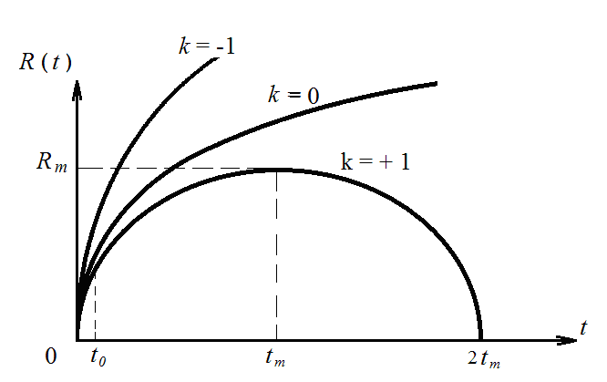
Fig.1 Different space curve sign k result in different R = R(t): k = +1, the space is closed, k = 0, the space is flat; k= -1, the space is open. The authors prefer to k = +1.

R = R(t) has three different situations, relies on the value of the space curve sign k:
(1) k = + 1，the cosmic space is closed.
In this situation, all the matter and radiation that scattered into the cosmic space by a big bang, may fly outward, getting farther and father, however, after reaching their individual far-most positions, all of them will fly back one after another towards the central region of the closed universe.
(2) k = 0，the cosmic space is flat.
(3) k = -1，the cosmic space is open.
In these two later situations, all the matter and radiations that scattered into the
cosmic space by the big bang just fly outward to the infinitely remote space. They can never return back.
The above discussion of equation (1) and Fig.1 are extremely correct, strict and profound. However, they are rather abstract and difficult to understand. The authors think that this extremely mysterious theory might be enriched by a brief and intuitional explanation as follows.
Whether the universe is closed is determined by two factors:
(1) The total amount of the mass of the universe. That is the attracting factor. The mass mentioned here, consists of common visible matter, dark matter, various electromagnetic radiations, and some other strange matter totally unknown to mankind today. At present, the dark matter seems very important, as is well known, it is about 5 times of the visible common matter.
(2) The total amount of the energy of the big bang. That is the repelling factor.
If the first factor prevails over the second one, the universe is closed.
If the two factors are “equivalent” or “balanced”, the universe is flat.
If the second factor prevails over the first one, the universe is open.
As have mentioned above, the authors approve of the first situation, k = + 1.
The authors also believe that in the middle of the closed universe, naturally, there is an extremely immense intrinsic heat ocean, an ocean of equilibrium thermal radiation at a stable temperature. The microwave background radiation discovered in 1965 should just be this extremely immense heat ocean.
More than 2 × 10 ¹² galaxies produced by the big bang are now flying fiercely outward. Their individual immense kinetic energies derived from the big bang are converting to their individual potential energies. When the galaxies reach their individual far-most positions in the closed universe, they will return back one after another, and fly towards the central region of the universe with different tremendous kinetic energies. It is of course impossible for them to return back to the start point of the big bang at a same time. It is also impossible for them to restore directly to their initial state before the big bang, as so much entropy has been produced in the big bang and numerous subsequent processes. All these galaxies will rush through the central region with different tremendous kinetic energies and fly towards their individual far-most positions on the other sides of the central region. Because of the gravitational attraction, they will slow down, and finally return back one after another to the central region again. In such a way, they will keep shuttling through the central region of the universe ceaselessly.
The directions of the shuttling of the numerous galaxies are various in the 4π solid angle. Hence, the ceaseless shuttling offers numerous opportunities for the 2 ×10¹² galaxies to meet each other in the central region. And, the numerous and numerous various celestial bodies in all these galaxies (about 2×10²³ stars and so on) will also have numerous and numerous chances to approach even meet each other. There are numerous black holes of various sizes among all these celestial bodies. Annexation occurs whenever a black hole meets another celestial body in the shuttling. Especially, the black holes of all the galaxy cores are extremely greater than the black holes of the star grade, they are extremely important in the general annexation processes in the universe.
After an extremely long period of shuttling and annexations, finally, the total number of the black holes and other celestial bodies in the universe will begin to decrease. The masses of the survived black holes become larger and larger, meanwhile, their shuttling amplitudes become shorter and shorter. These two factors will greatly increase the chances of the survived black holes to encounter with other celestial bodies. The general annexation processes in the whole universe will become faster and faster. After an extremely long, long duration, eventually, all the matter within the closed universe will inevitably be assembled together to form an extraordinary immense central black hole.
In this assembling process, most of the kinetic and potential energy of all the celestial bodies in the 2 ×10¹² galaxies are eventually assembled into the central black hole, preserving directly a great amount of precious energy for the next big bang.
At that time, the picture of the universe will become very simple: In the central part of the closed universe, there is an extraordinary immense and very dilute heat ocean at a temperature of about 3K; and at the center of the heat ocean, there is an extraordinary massive central black hole, having an even more massive central core containing all the real matter of the universe.
The whole geometric picture of the universe at that time is rather similar to the one of a hydrogen atom.
The formation of the central black hole accomplishes the first preparation for the next big bang: the reassembling of all the real matter.
Next, how to overcome the deadly obstruction of the second law of thermodynamics to collect and assemble again the great amount of energy that has scattered in to the vast 3K heat ocean due to all the irreversible processes of the big bang and all its subsequent processes to accomplish the second necessary preparation for the next big bang: The re-assembling of the energy (the light and thermal radiation) scattered into the immense 3k heat ocean by the big bang and all its subsequent processes. In other words, the reduction of the entropy that was produced during the big bang and all its subsequent processes.
Fortunately, the black holes also have a second important assembling function: they can collect and assemble spontaneously an extraordinary immense amount of energy in the form of thermal radiation from the extremely immense 3K heat ocean. How much energy in the form of light and thermal radiation a big bang and all its subsequent processes have scattered into the vast 3K heat ocean, how much energy in the form of thermal radiation will all the black holes, especially the extremely immense central black hole, collect and assemble back from the heat ocean again，leading to a new big bang.
2．The 3K background radiation is an extremely immense heat ocean, an intrinsic existence in the closed universe. It is not produced by the big bang.
(1) The 3K background radiation is not the afterglow of the decoupled fire ball as some researchers claimed
As is well known, in 1965, Penzias and Wilson unexpectedly discovered the 3K microwave background radiation coming from the remote space in all the direction. The microwave background radiation shows two fundamental characteristics: (1) an ideal isotropic, (2) its spectrum coincides with Planck’s formula for the black body radiation at a temperature of about 3K. They are actually the same fundamental characteristics of the equilibrium thermal radiation in the space of a cavity within a solid at a same temperature. Accordingly, the authors regard, what Penzias and Wilson discovered is an extremely immense and stable ocean of equilibrium thermal radiation at a temperature of about 3K, briefly, a heat ocean at 3K, an intrinsic existence in the central part of the closed universe.
The existence of the stable ocean of 3K background radiation is a credible proof that the cosmos space is closed. If the space of the universe were not closed, the thermal radiation would have flied off, and mankind should be impossible to observe it keeping undecayed for so long a duration.
The 3K microwave radiation is an equilibrium thermal radiation, so it is impossible to measure its depth by any direct astronomic observation. We cannot determine the size of the heat ocean this way.
The authors just believe deeply that the 3K heat ocean is an intrinsic existence in the central part of the closed universe, it is not produced by the big bang.
As is well accepted by most researchers, 380,000 years after the big bang, when the interior temperature of the expanding primitive fire ball dropped down to 3000K, the electrons and protons in the plasma in the expanding primitive fire ball combined to become neutral hydrogen atoms. The neutral hydrogen atoms do not exchanged heat with the thermal radiation. That means, the fireball was decoupled, the interior of the fireball became transparent for the thermal radiation. All the thermal radiation within the expanding fire ball got free, and started immediately to fly off at light speed and traveled straight forward in all the directions into the extremely vast space.
That is a free ejection.
However, there are a part of the researchers who regarded that, after flied off the decoupled fire ball, the thermal radiation kept “expanding adiabatically” for an extremely long time, and changed finally to the 3K background equilibrium thermal radiation of today. They alleged further that the 3K background radiation is a credible proof of the big bang.
They speak of an “adiabatic expansion”. What do they mean by this terminology here?
The initial state of the “adiabatic expansion” of the thermal radiation is an equilibrium thermal radiation at 3000K, and the final state of it is an equilibrium thermal radiation at 3K. Then, how about the numerous intermediate states? Were they also a series of thermal equilibrium states of the thermal radiation at a descending temperature?
If all the intermediate states were not equilibrium ones, how could the final state of the “adiabatic expansion” became an equilibrium one at a temperature of 3K?
Such an assumption of “adiabatic expansion” is obviously irrational, totally impossible to be true.
The authors claim here again，the 3K microwave background radiation is just an extraordinarily immense heat ocean. It is an intrinsic existence in the central part of the closed cosmic space. It is not the afterglow of the decoupled fire ball that emerged 380,000 years after the big bang. More generally, it is not the afterglow of the big bang.
As soon as the fireball decoupled, all its internal thermal radiations got free, and immediately started to eject in various directions in the 4π solid angle at the speed of light to leave off the decoupled fire ball and traveled straight forward to the extremely vast space. The process was a free ejection, similar to the free ejection of the light and thermal radiation from the sun or any other star.
For example, the radiation of the light and thermal radiation of a star 10 million light years away from our earth are free ejection. When its light and thermal radiation reach our earth (obviously this process is not an “adiabatic expansion”, just a free ejection), the energy intensity of the bunch of the light and thermal radiation is already extremely weak. However, the bunch would not have changed to be an extremely low temperature equilibrium thermal radiation. Its spectrum is still the same spectrum as it just left the surface of its mother star, consistent with Planck’s formular, and the temperature of the spectrum still corresponds to the very high temperature at the surface of its mother star. This fact is a common knowledge in the astronomy and astrophysics circle.
A similar thing happened to the decoupled thermal radiation. The ejection of the 3000K radiation of the decoupled fire ball was also a free ejection. Once decoupled, all the decoupled thermal radiation in the fireball flied off directly in all the directions to the exterior, and travelled straight forward at light speed to the farther vast space. The energy density of the bunch of the thermal radiation from the decoupled fire ball was weakened and weakened as the bunch got farther and farther (for a far observer, the decoupled fire ball can be regarded as a point source of thermal radiation), but the bunch would not convert to an equilibrium thermal radiation at a lower and lower temperature. The bunch kept its spectrum unchanged, consistent with Planck’s formula, always keeping consistent to the original decoupled temperature of 3000K.
We come to the conclusion that the 3K background radiation is not the afterglow of the decoupled fire ball. Accordingly, it is not the afterglow of the thermal radiation of the big bang.
As we have mentioned above again and again, the 3K background radiation itself is an intrinsic existence in the closed universe, an extremely immense and stable heat ocean. It existed before the big bang. It exists now. It will exit in the future.
(For more details about this topic, read the appendix of this article, please.)
(2) The extraordinarily immense 3 K heat ocean itself
Now, let us surmise briefly the structure and picture of the 3K heat ocean itself.
As a preparation, let us make a calculation of the mass density of the 3K equilibrium thermal radiation.
From Stefan-Boltzmann’s law, the radiation intensity from the surface of a black body (the energy emitted in unit time from unit area of the black body surface at a given temperature) at T = 2.73K is
. (2)
As is well known, the relation between the radiation intensity from the surface of a black body j and the energy density of the equilibrium thermal radiation in a solid cavity at the same temperature u is
(3)
hence, at T = 2.73K, the energy density of the immense heat ocean is
. (4)
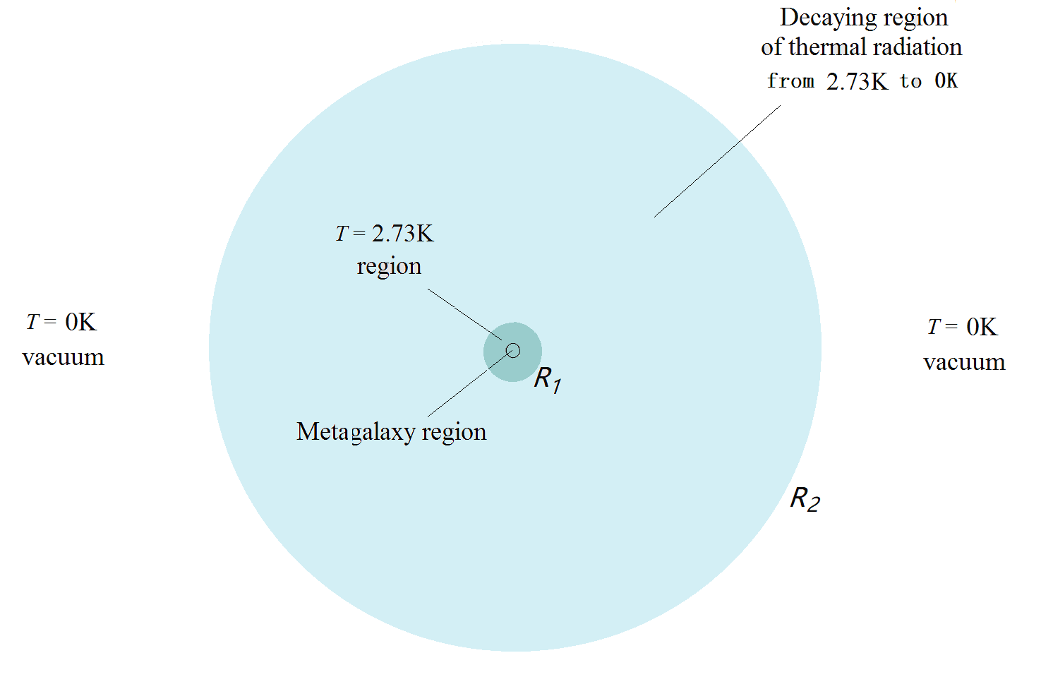
Fig.2 A heat ocean model. The central small circle is the metagalaxy region. The bigger blue circle with a radius R₁ is the 2.73 K region. Then the thermal radiation decaying region, from R₁ to R₂, with the temperature drops down from 3K to 0K. Out of R₂, is the infinitively vast cosmic vacuum, T = 0, ρ =0.

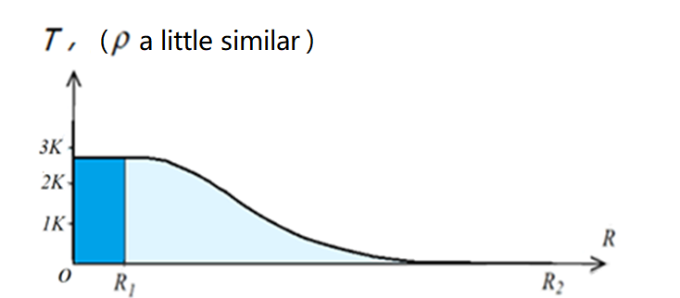
Fig. 3 We suppose the central part of the heat ocean is a spherical region of radius R₁, filled up with 2.73K thermal radiation. Stretched outward from R₁, the temperature of the thermal radiation decreases gradually from 2.73K to 0K, while the density of the thermal radiation also decreases gradually to zero Beyond R₂ is the infinitively vast cosmic empty space.
And，the mass density of the thermal radiation in the heat ocean is， (5)
Let us have a look at the picture of the 3K heat ocean.
The whole heat ocean should be a very large sphere, as shown in Fig.2.
The metagalactic region is located at the central part of the vast heat ocean, represented by a very small circle.
Containing the metagalactic region and within the radius of R₁, is the T = 2.73K
region, as shown by the blue part in Fig.2.
Then, from R₁ to R₂, is the thermal radiation decaying region, as simply and briefly shown by the light-blue part in Fig.2, with the temperature falls down gradually from 2.73K to 0K,
$T=T(R)$ (6)
which corresponding to a somehow similar decaying mass density,
$ρ=ρ\left(R\right),$ (7)
as shown in Fig.3.
Finally, out of R₂, is the infinitively vast cosmic space, the absolute vacuum.
In the 2.73K region, and, also in the thermal radiation decaying region, all the outward flying photons undergo red shift. Strictly to say, few of the outward flying photon is precisely along the radius of the closed heat ocean. So, guided by their tangential kinetic energy (mostly extremely tiny), all the out flying photons will eventually turn back and fly towards the central part of the heat ocean again, undergoing blue shift.
Passing through the central region, the blue shifted photons will fly to their individual far most sites on the other side of the central region, undergoing red shift again.
In such a way, all the photons will keep shuttling ceaselessly in the various directions in the 4π solid angle, all with extremely great amplitudes, and the whole closed heat ocean keeps fundamentally stable and equilibrium.
The heat ocean is extraordinary immense, and its mass may be extraordinary great, which might also contribute considerably to the gravitational close of the universe.
(3) The big bang and its subsequent processes are all extraordinarily great
irreversible processes, resulting in immense increase of entropy in the universe. Meanwhile, they deliver immense amounts of energy (light and heat) into the 3K heat ocean, a heat reservoir (also an energy reservioir).
（a）The big band is a tremendously great explosion. It is of course an irreversible process, resulting in extremely large amount increase of entropy in the universe. Meanwhile，it scattered tremendous amount of energy (light and heat) into the heat ocean, an energy reservoir.
These scattered light and heat also cannot fly off the closed universe. They also keep shuttling in the closed universe ceaselessly with extremely greater amplitudes. After an extremely long relaxation time, finally, by interchange heat with some atoms, molecules, cosmic dusts and cosmic rocks in the metagalaxy region, all completely mingle into the 3K heat ocean.
（b）As have mentioned above, about 380,000 years after the big bang, the interior temperature of the expanding primitive fire ball dropped down to about 3000K. The whole fire ball was decoupled, became transparent. All the thermal radiations in the decoupled fire ball (it is certainly of an extraordinary immense amount) got free, started immediately to fly off at the speed of light in all the directions, and scattered into the farther vast space. They also keep shuttling in the closed universe, and finally mingle into the 3K heat ocean.
(c) In the further expansion, all the real matter (mainly hydrogen and helium) within the primitive expanding ball changed into numerous nebulae, into galaxies, and developed into even more numerous stars and other celestial bodies. All these processes are also irreversible, producing immense entropy, sending immense energy (light and heat) into the heat ocean.
(d) Then in a very long period, there formed early or late, extremely numerous and numerous stars in all the galaxies. Like the sun, most of these stars have averagely a lifetime of about 10¹⁰ years, ejecting ceaselessly light and heat into the vast space due to the energy produced in their internal nuclear fusions of hydrogen and helium. All these processes produce immense entropy. And all these processes scatter immense energy (light and heat) into the heat ocean, too.
And so on.
All the processes described in the above paragraphs increase the entropy in the closed universe tremendously. In the same time, they finally deliver immense amount of energy (light and heat) into the heat ocean, an immense heat reservoir (i.e., an immense energy reservoir) in the universe.
Although the 3 K heat ocean is very thin and diluted, its volume and total mass might be both extraordinary great. Hence, we guess (may be incorrect), all the above discussed large amount of energy of the light and heat that scattered into the heat ocean, just raise the temperature of the heat ocean very slowly and slightly. Mostly, the temperature of the heat ocean is essentially stable.
3. The collection and assembling of energy from the heat ocean by the black holes, leading to a new big bang
In the heat ocean, the 2.73K thermal equilibrium radiation travels everywhere randomly and ceaselessly at the speed of light. Every black hole in the metagalaxy region is immersed in the 2.73K vast heat ocean, hence it takes in the 2.73K thermal radiation at the speed of light from all the directions since its birth and throughout its extremely long lifetime. Meanwhile, any black hole does not deliver any thermal radiation to its exterior. Such a process is distinctly a single way collection of the thermal energy from the extremely cold 2.73K heat ocean to the black hole that contains a huge amount of internal energy, at an extremely high latent temperature. The process apparently violates the Clausius’s statement of the second law of thermodynamics.
Let us see 3 typical examples of black holes of different grades.
1. A black hole with a mass 10 times of the sun.
As shown in Fig.4 (a)，its mass is
M₁ = 10 M = 10×(2×10³⁰ )= 2×10³¹ kg. (8)
Its Schwarzschild radius is
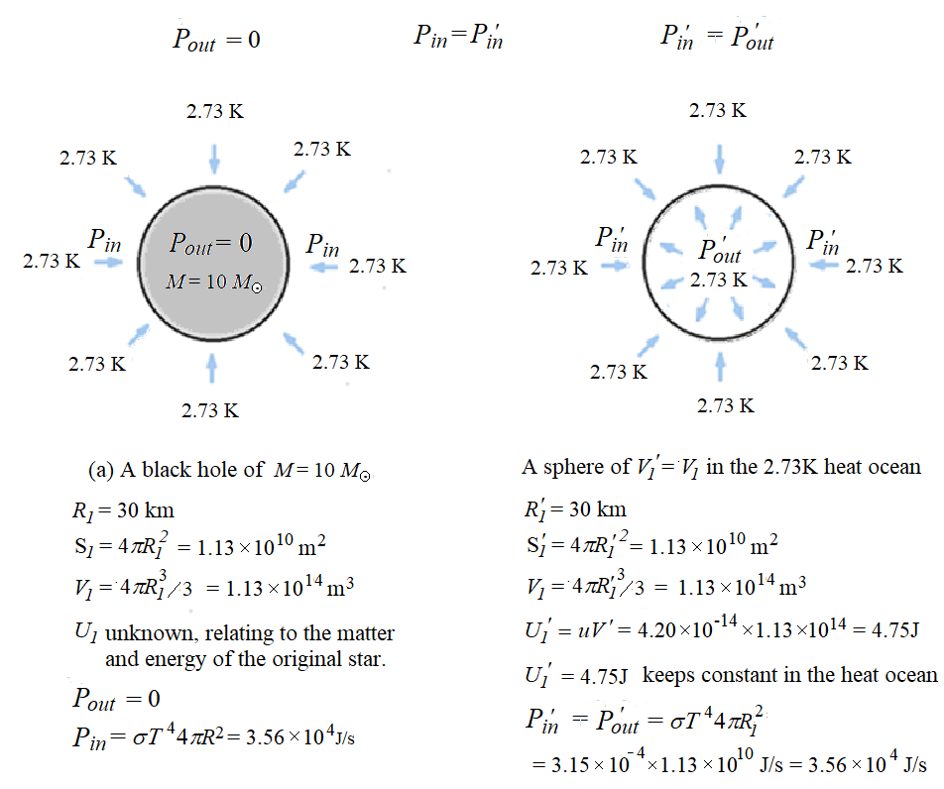
Fig.4 (a) A black hole of M = 10M, R₁ = 30km, V₁ = 1.13×10¹⁴m³, its internal energy is considerably great; (b) In the heat ocean, in a same volume V₁′= V₁ , the energy of the 2.73K thermal radiation is only U₁′= 4.75J
(9)
When this M₁ = 10 M black hole was formed, most of the matter and energy of its original star was collapsed down into the new formed black hole. The great amount of the gravitational potential energy of the matter of the original star first converts to kinetic energy step by step, and concentrates into the small new formed black hole. So, there is a great amount of internal energy in the black hole, witch now highly concentrated in a very small volume. Hence, the newly formed black hole can be regarded to be equivalent at some extremely high temperature, see Fig.4 (a).
(A common bomb contains a great amount of chemical energy. From the viewpoint of the second law of thermodynamics, it is equivalent to be at a latent extremely high temperature.)
Let us make some calculation. The volume and surface area of the black hole of the M₁ = 10 M are
V₁ = (4π/3)R₁³ = 1.13×10¹⁴m³, (10)
S₁ = 4πR₁² = 1.13×10¹⁰m² (11)
respectively.
For comparison（to compare their temperature）, imagine a sphere in the heat ocean of a same volume and a same surface area as shown in Fig.4 (b),
V₁′ (= V₁ ) = 1.13×10¹⁴m³ , (12)
S′ (= S₁) = 4πR₁² = 1.13×10¹⁰m², (13)
The internal energy of this 2.73K thermal radiation sphere with the volume V₁′ is
U₁′= u V₁′= 4.20×10⁻¹⁴×1.13×10¹⁴ = 4.75J. (14)
The (latent) temperature of the M₁ = 10 M black hole (V₁) is extremely high. But it does not emit thermal radiation to the surrounding extremely cold 2.73K heat ocean. Contrarily, it just takes in thermal radiation at the speed of light from the extremely cold 2.73K heat ocean ceaselessly. From Fig.4 (a), we can see, the M₁ = 10 M black hole takes in the 3K thermal radiation from the heat ocean in all the directions with a power
P₁ = σT⁴4πR₁² = 3.15×10⁻⁶×1.13×10¹⁰ = 3.56×10⁴J/s. (15)
In each second, suppose the M₁ = 10 M black hole takes in the 2.73K thermal radiation of a volume N₁V₁′ from the heat ocean, the number N₁ should be
N₁ = P₁ / U₁′ = 3.56×10⁴ ÷4.75 = 7494 ≈ 7500. (16)
In one day, the corresponding number of the energy U₁′ collected from the heat ocean by the M₁ = 10 M black hole is
N_{day} = 86400×7500 =6.5×10⁸. (17)
In one year, the corresponding number is
N_{year} =365×6.5×10⁸ = 2.37×10¹¹. (18)
In one million years, it is
N ₁₀⁶ _{years} = 2.37×10¹¹×10⁶ = 2.37×10¹⁷. (19)
One million years is a twinkle of an eye in the long, long lifetime of a black hole.
We conclude that, the 2.73K thermal radiation pouring ceaselessly at the speed of light from all the directions into the M₁ = 10 M black hole is a typical process of spontaneous heat transfer from an extremely low temperature region (3K) to an extremely high temperature (latent temperature) region.
So, black holes are Maxwell’s demons in the Nature. ⁽⁷⁾⁽⁸⁾⁽⁹⁾⁽¹⁰⁾⁽¹¹⁾
Numerous and various such black holes of the star grade in all the millions over millions of galaxies ceaselessly absorb a very great amount of thermal radiation from the vast heat ocean throughout their individual extremely long, long lifetimes. That is a great process of energy collection.
(2) the central black hole of a galaxy
Such a black hole usually has approximately a mass of about 10¹⁰ times of M₁, i.e.,
M₂ ≈ 10¹⁰×M₁ = 10¹⁰×10 M , (20)
The radius of its Schwarzschild sphere is
R₂ ≈ 10¹⁰×R₁ = 10¹⁰×30km (21)
and its spherical surface S₂ is 10²⁰ times of S₁. It absorbs the 2.73K thermal radiation from the heat ocean at a much greater power,
P₂ = σT⁴4πR₂² = (3.15×10⁻⁶×1.13×10¹⁰ )×10²⁰ = 3.56×10²⁴ J/s. (22)
If we still take U₁′= u V₁′= 4.75J as an energy counting unit, the corresponding number N₂ of the absorbed energy by M₂ in each second is
N₂ = P₂/ U₁′= 3.56×10²⁴÷4.75 = 7494×10²⁰ ≈ 7500×10²⁰. (23)
The absorption rate of the thermal radiation from the heat ocean by the M₂ black hole is extremely higher than the M₁ = 10 M black hole. The process reduces a huge amount of entropy in the universe in each second.
The total rate of assembling of energy from the heat ocean by all the numerous black holes of galaxy cores in the metagalaxy region is of course even more tremendously great, and the corresponding decrease of entropy of the universe is extraordinarily large.
As all these two kinds of black holes unite step by step (together with all the other celestial bodies in the galaxies) through shuttling and annexations to form eventually the central black hole, they will carry all the energy that they have collected from the heat ocean in their individual long, long lifetimes together into the central black hole.
（3）The central black hole of the universe
The central black hole contains all the real matter of the whole universe, having an extraordinarily immense amount of mass. Its radius is proportional to its mass. The area of its Schwarzschild sphere is proportional to the square of its radius. Hence, it has an extremely immense spherical area (an extraordinary immense event horizon.) It will also absorb the 2.73K thermal radiation from the extremely vast 3K heat ocean ceaselessly in all the directions at the speed of light. Hence, the power of its absorption of the thermal radiation from the vast heat ocean will be extraordinarily immense. The internal energy of the central black hole rises extraordinarily fast, and, monotonically.
Notice please, at that time, all the real matter in the universe has already been concentrated into the central black hole. There will be no longer any new mass of real matter fall into the central black hole. The average energy possessed by per unit mass of the real matter in the central black hole just rises and rises, very quickly and monotonically. The interior matter should undergo a series of endothermic reactions. By the end of all these endothermic reactions, the energy possessed by per unit mass of the interior matter of the central black hole reaches an extremely high level. The authors assert that the matter in such an extreme state is closely identical to the “primitive matter” or “ylem” described by Gamow et al in their theory of the thermal big bang.
Nevertheless, the central black hole continues to absorb energy extremely fast from the heat ocean. Its total internal energy continues to increase. That means, its internal repulsive factor continues to increase, extremely fast. Such a unidirectional process should not go on and on without an end, when a threshold value of the repulsive factor is reached and exceeded, a new big bang breaks out!
So far, we have accomplished the description of an extraordinarily big cycle of matter and energy in the universe.
A big bang and a big assembling constitute a big cycle.
The cycles go on and on, without an end.
(IV) The New Second Law of Thermodynamics
In the above discussions, we have described and demonstrated by an experiment video of a special test of thermal electrons in a magnetic field, an artificial entropy reducing process. It is very interesting, very enlightening.
We also discussed the extraordinarily immense big cycle of matter and energy in the closed universe. A big bang and a big assembling constitute a big cycle. Entropy can either increase, or decrease, both in an extraordinarily immense scale。In general, the increase and decrease of entropy in a big cycle match each other.
The entropy of the universe would never reach a Maximum value, Clausius’s “Heat Death” is an excessive anxiety.
Hence, the traditional second law of thermodynamics needs to be reformed. We put forward a new theoretical system for thermodynamics as follows.
（The first law keeps unchanged. The second law changes considerably.）
1. The first law of thermodynamics is energy conservation.
Energy is conserved, wherever and whenever. It is a law of the universe.
The total amount of energy of the universe keeps constant (Clausius’s word).
And so on.
2. The second law of thermodynamics is energy circulation.
For all the matter in the closed universe, together with an extraordinary immense amount of energy, a big bang and a big assembling constitute a big cycle. Entropy can either increase, or decrease. In general, the increase and decrease match each other.
The black holes are natural demons in the universe.
The new theoretical system is greatly different from the traditional one.
Nevertheless, the traditional second law of thermodynamics should not thus be
discarded. It is still valid in almost all of the numerous ordinary thermodynamical processes that we meet in our life, work, and ordinary research.
The situation is rather similar to the one in mechanics.
Einstein’s special relativity shows profoundly that Newton’s mechanics is not accurate in some special cases. However, for almost all the practical mechanical problems we meet in our life, work and ordinary research, Newton’s mechanics is still accurate to an extreme extent, it is still perfect and valid.
Similarly, for all the numerous ordinary thermodynamical processes we meet in our life, work and ordinary research, the traditional second law of thermodynamics is still correct covering an extremely wide scope, with an extreme accuracy.
More ever, entropy is also a real physical quantity. It has many different forms, for examples, heat temperature quotient entropy, volume expanding entropy, phase change entropy, chemical entropy, and so on.
Entropy is conserved in all reversible processes. This theorem provides a way to find the accurate and credible equivalent relations between the different forms of entropy.
Nevertheless, unlike energy, entropy tends to increase spontaneously in numerous and numerous ordinary processes that we meet almost every day and everywhere.
Fortunately, entropy can also decrease in the extraordinary immense cycle of matter and energy in the closed universe. We need not to worry about the Heat Death predicted by Clausius.
The special artificial processes，the experiment of thermal electrons in a magnetic field results in some very tiny decrease of entropy. Although it is a very tiny process, its output current is already a macroscopic direct current (DC). Such an interesting experiment shakes profoundly the traditional thermodynamics.
Some ending word
(1) The universe is extraordinary immense and mysterious. There are so many, many things in the universe still keep unknown and totally mysterious to mankind. This article is just a primary thermodynamical exploration of the cycle of the matter and energy in the closed universe. Mistakes and deficiencies are of course inevitable in such an exploration. ⁽²⁷⁾ ⁽²⁸⁾ ⁽²⁹⁾ ⁽³⁰⁾ Any criticism or suggestion to this article is warmly welcome.
(2) In our discussion, we claimed that the black holes are natural Maxwell’s demon in the universe. A black hole just takes in the 3K thermal radiation in all the directions at the speed of light, reducing the entropy of the heat ocean, reducing the entropy of the universe, ceaselessly.
Some people might argue that, according to Bekenstein, the “area entropy” of the event horizon of the black hole should increase in such a process, and the total change of entropy for the process is still an increasing one, and so on. ⁽²⁷⁾⁽²⁸⁾⁽²⁹⁾⁽³⁰⁾
The authors claim here that Bekenstein’s “area entropy” of a black hole is an incorrect idea. Actually, there are several major mistakes in Bekenstein and Hawking’s “black hole thermodynamics”. Limited by space, we do not discuss these problems in this article. We have another article On Bekenstein and Hawking’s Black Hole Thermodynamics, attached to the supplementary file of preprints-162206-manuscript (2024-06-03).
Because the pdf file cannot demonstrate our experiment video of tube FX8-24, we intend to attach our experimental video as a supplementary file to the present article.

Appendix
How did the thermal radiation of the decoupled fire ball fly off and eject freely into the vast cosmic space, and their final destination
As mentioned above, in our opinion, the 3K background radiation is an immense heat ocean, a natural and intrinsic existence in the closed universe.
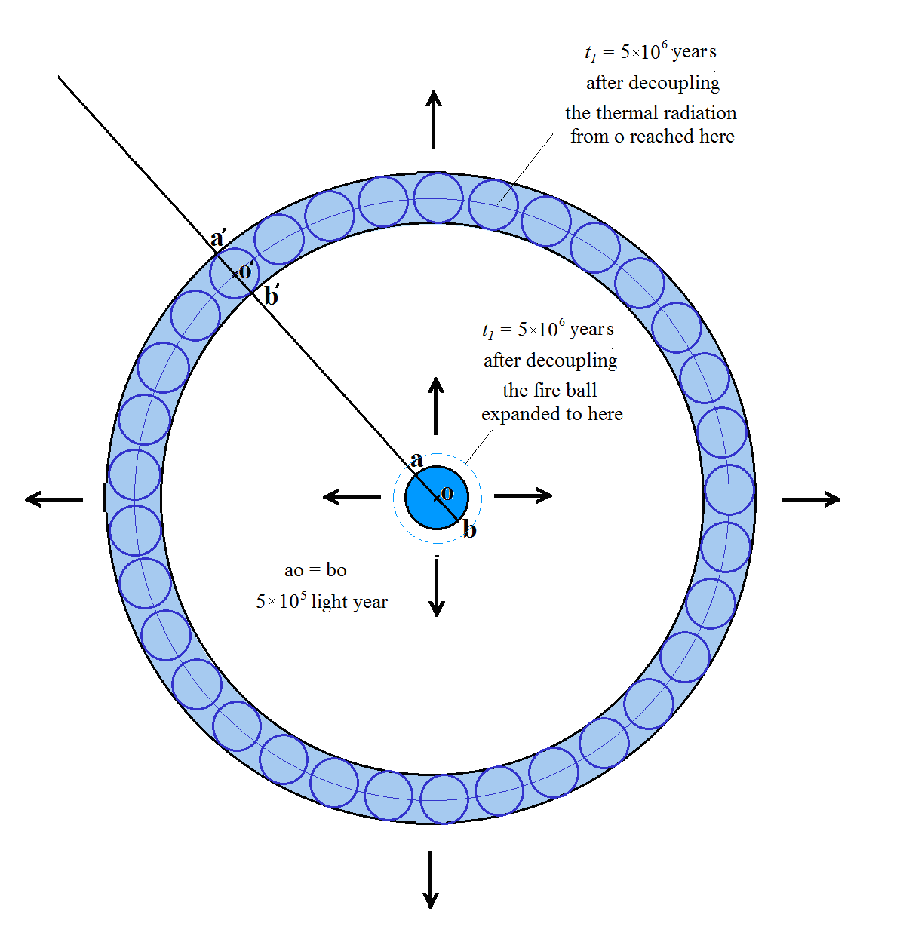
Fig.1 The radius of the decoupled fire ball was about ao = ob ≈ 5×10⁵ light years, at 380,000 years after the big bang. All the thermal radiation within the whole decoupled fire ball aob began to fly off to leave it in all the directions. 5×10⁶ years later, in the direction of oo′, the thermal radiation from point o reached a new point o′, (oo′ = 10 oa = 5×10⁶ light years.) The radiations in the direction of oo′ from the whole sphere aob reached a new place of a sphere a′o′b′, within the spherical layer a′b′. And all the thermal radiation from all the points of the small ball aob, the decoupled fire ball, in all the other directions within the 4π solid angle all reached the spherical layer a′b′ = 10⁶ light years (the big blue spherical layer in Fig.1).
Some researchers’ opinions are different from ours. They believe that the 3K background radiation is the product of the big bang, especially, it is the afterglow of the thermal radiation in the decoupled fire ball, 380,000 years after the big bang, after passing a long, long “adiabatic expansion”.
We have pointed out in our above discussion that their idea of the “adiabatic expansion” is not correct, the actual process should be a free ejection. Now, let us show how the remnant 3,000K thermal radiation in the decoupled fire ball ejected freely to the exterior vast cosmic space, and, their final destination.
First, as shown in Fig.1, the small ball with the diameter ab in the central part of the figure represents the decoupled fireball, 380,000 years after the big bang. Its radius is approximately oa = ob ≈ 10 ²² m = 5×10⁵ light years（for convenience of discussion, we make up a round number for the radius here, oa ≈ 5×10⁵ light years, and its diameter is ab =10⁶ light years. ）
As the decouple happened, the fire ball became transparent. All the thermal radiation in the fireball started to fly off in all the directions at the speed of light into the exterior cosmic space, and travels straight forward farther and farther.
Obviously, it is just a free ejection, not an “adiabatic expansion”.
5×10⁶ years later, the thermal radiation from point o, in the direction of oo', reached point o' (oo' = 10 oa = 5×10⁶ light years), as shown in Fig.1. In the direction of oo′, the decoupled radiation from the small ball aob reached a new small ball a′o′b′: the thermal radiation from point a reached a′, the thermal radiation from point o reached o′, the thermal radiation from point b reached b′, and all the thermal radiations from all the different points of the small ball aob, actually, the whole decoupled thermal radiation in this direction, now all reached the corresponding points of a new small ball a′o′b′, witch lay in a spherical layer a′b′ = 10⁶ light years.
And all the thermal radiations ejected from all the different points of the original decoupled fire ball aob in all the different directions in the 4π solid angle now all reached points within the spherical layer a′b′, as shown in Fig.1. The width of the spherical layer a′b′ equals the diameter of the small ball a′o′b′, it also equals the diameter of the decoupled fire ball ab.
a′b′ = ab = 10⁶ light years. （1）
5 ×10⁷ years after the decouple, all the thermal radiation from point o arrived at the spherical surface of the radius of oo'' = 5 ×10⁷ light years (oo'' = 100 oa), as shown in Fig.2. In the direction of oo'', the thermal radiation from point a reached point a'', the thermal 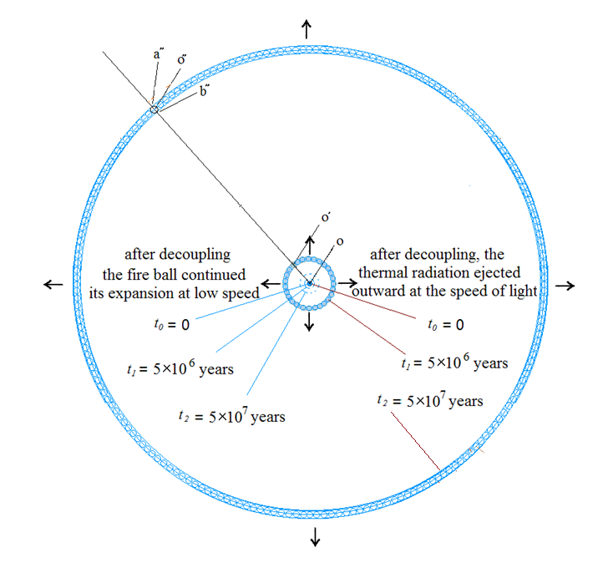
Fig.2 5 ×10⁷ years after the decoupling, in the direction of oo'', the radiation from o reached point o'',and the radiation from a reached a'',the radiation from b reached b''. The radiation from all the points of the decoupling ball aob reached the corresponding points of ball a''o''b''. And, the radiation from all the points of ball aob in all the directions in the 4π solid angle reached the spherical layer ab'', a''b'' = a′b′ = ab =10⁶ light years.

radiation from point o reached point o'', the thermal radiation from point b reached point b''. All the thermal radiations in the direction of oo'' from all the points of the decoupled fire ball (i.e., the ball aob, the whole decoupled fire ball at t = 380,000 years) now reached the corresponding points of a small ball a''o''b'', which lay in the spherical layer a''b'', and obviously a''b'' = ab = 10⁶ light years.
And, all the radiations from all the points of the small ball aob (i.e., the whole decoupled ball) and in all the different directions in the 4π solid angle now all reached the points within the whole spherical layer a'' b''. Obviously,
a'' b'' = a′b′ = ab = 10⁶ light years （2）
5 ×10⁸ years later，all the radiations from all the points of the small ball aob (i.e., the whole decoupled fire ball at t = 380,000 years) and in all the different directions in the 4π solid angle, all reached the correspondent points within the whole spherical layer a'''b'''. Obviously,
a'''b''' = a'' b'' = a′b′ = ab = 10⁶ light years （3）
And, 5 ×10⁹ years later, 5 ×10¹⁰ years later，and so on, as the thermal radiation ejected freely from the decoupled fireball aob, flied outward continuously at the speed of light, it always keeps within a spherical layer with a thickness of 10⁶ light years.
… = a''''b''''= a'''b''' = a''b'' = a'b' = ab = 10⁶ light years （4）
The expanding of this spherical layer of the thermal radiation of a thickness of 10⁶ light years, (ab), a′b′, a''b'', a'''b''', a''''b'''', ……, and so on, should not go on and on at the light speed to the farther and farther space without an end. Because the space of the universe is closed, when some utmost possible position is reached, the thermal radiation layer of the 10⁶ light years will no longer fly away further. It will return back to the central region of the universe, and passing through the central region, then, travel to their other side far most positions of the central region. In such away, it keeps shuttling in the closed universe ceaselessly, meanwhile, getting more and more dispersive.
Finally, after an extremely long relaxation time, by interactions (exchange heat) with the atoms, molecules, cosmic dusts, cosmic rocks and so on in the metagalaxy region, it will eventually mingle into the 3K heat ocean, their final destination.
So, the authors behold that, the 3K background radiation discovered by Penzias and Wilson is not the afterglow of the decoupled fire ball. It is not produced by the big bang. It itself is just an extremely immense intrinsic 3K vast heat ocean in the closed universe. It existed before the big bang, it exists now, and it will exist in the future, may be, forever.
In the above discussion, for the sake of concise, we postponed a detail about the process of light and heat ejected from the surface of the expanding fireball from the time of the big bang to the decouple time, i.e., from t₁= 0 to t₂= 380,000 years. Now we make it up as follows.
Please have a look at Fig.3.

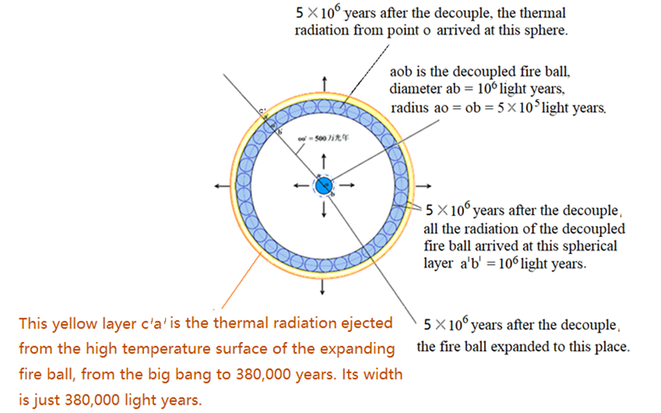
Fig 3 Another spherical layer with a width of c'a' = 380,000 light years (shown as a “yellow” one in the figure) just out the spherical layer of 10⁶ light years (the “blue” ones a′b′, a''b'', a'''b''', ……).
After the big bang happened, the interior of the expanding fireball was first at an extremely high temperature. It descended step by step very rapidly. In this process, the whole interior
was very high temperature plasma, which was totally opaque for the interior thermal radiation. So, the thermal radiation within the expanding fireball could not eject outward to leave the fireball. However, in the same duration, the surface of the expanding fire ball was also plasma at a rather lower and also descending temperature, but its temperature was still extremely high. This surface of the expanding fire ball should eject thermal radiation ceaselessly.
Let us have a compare, as is well known, the temperature at the central part of the sun is about 15000K, and the temperature at the surface of the sun is about 6000K. The interior thermal radiation of the sun cannot fly off the sun, because the interior plasma is totally opaque for the thermal radiation. Only the surface of the sun, exposed to the exterior space, would eject light and heat ceaselessly, and the temperature of the ejected light and heat is about 6000K.
Similarly, the descending temperature at the surface of the expanding fire ball in the duration from the big bang to the decouple time was also still be extremely high. The surface kept being plasma, still kept at extremely high temperature. It is exposed to the vast exterior space. Like the surface of the sun, the surface of the expanding primitive fire ball should eject thermal radiation continuously. Hence, just out the expanding spherical layer with a width of 10⁶ light years (the “blue” one spherical layer), as shown in Fig1 and Fig 2,
…… a''''b'''' = = a'''b''' = a'' b'' = a′b′ = ab = 10⁶ light years. （4）
there is another spherical layer of a width of 380,000 light years (the “yellow” one spherical layer in Fig.3).
…… c''''a'''' = c'''a''' = c''a'' = c′a′= 380,000 light years （5）
The two layers ejected outward at light speed, one after the other. After reaching their far-most positions in the closed universe, they will both return back, still one after the other. Then they will keep shuttering in the closed universe, becoming more and more dispersive. After a long, long relaxation time, finally, both the “blue” and “yellow” thermal radiations should mingle into the stable immense 3K heat ocean.
References
1. R. Clausius, Uber den zweiten Hauptsatz der mechanischen Warmetheorie (1867)
2. lord Kelvin, On the Dynamical Theory of Heat, etc., Transactions of the Royal Society of Edingburg (1851)
3. Max Planck, Forlesungen Uber Thermodynamik (Erste auflage,1897); (Siebente auflage, 1922), §116 & §136.
English Version: Treatise On Thermodynamics, §116 & §136, Dover Publications Inc. (1926),
4. J. C. Maxwell, Theory of Heat 328 (1871)
5. W. Ehrenberg, Maxwell’s Demon. Scientific American 103-110 (1967)
6. Richardson and Brown, Phil. Mag. 16, 353 (1908)
7. Richardson, Phil. Mag. 16, 890 (1908); 18, 681 (1909)
8. Schottky, Ann. der Phys. 44, 1011 (1914)
9. L.H Germer, THE DISTRIBUTION OF INITIAL VELOCITIES AMONG THERMIONIC ELECTRONS (1925)
10. John E. Davey, Thermionic and Semiconducting Properties of〔Ag〕- Cs2O3, Ag, Cs, Journal of Applied Physics, Volume 28, Number 9, p.1031 (1957)
11. A. H. Sommer PHOTOEMISSIVE MATERIALS Preparation, Properties, and Uses John Wiley & Sons (1968) Section 10.7.1, Chapter 10.
12. X. Y. Fu, An Approach to Realize Maxwell’s Hypothesis，Energy Conversion and Management (1982)
13. X. Y. Fu and Z. T. Fu, The Realization of Maxwell’s Hypothesis. arxiv /physics /0311104v1-v3 (2003-2016); MDPI preprints.org/manuscript/201607.0028/v1-v5 (2016-2018)
14. X. Y. Fu and Z. T. Fu, A graphical survey on the electron’s trajectories in Fu & Fu’s experiment, preprints.org/manuscript/201607.0028/v4
15. 16. Harvey S. Leff & Rex F. Andrew, Maxwell’s Demon, Entropy, Information, Computing (1990)
16. Harvey S. Leff & Rex F. Andrew, Maxwell’s Demon 2, Entropy, Classical and Quantum Information, Computing (2003)
17. Harvey S. Leff, Energy and Entropy: A Dynamic Duo. CRC Press Taylor & Francis Group (2020)
18. Kamarul Aizat Abdul Khalid, Thye Jien Leong, and Khairudin Mohamed, Review on Thermionic Energy Converters IEEE TRANSACTIONS ON ELECTRON DEVICES, VOL. 63, NO. 6, JUNE 2016
19. G. Lemaitre，On the Evolution of the Universe and the Hypothesis of the
Primitive Atom (1927)
20. E. Hubble，Distance and radial velocity among extra-galactic nebulae. Proc. Nat.
Acad. Sci. 15, 168 – 173 (1929)
21. G．Gamow，The Creation of the Universe. New York Viking Press (1952)
22. R. M. Wald，Space, Time and Gravitation, the Theories of the Big Bang and Black Holes, Chicargo University Press（1977）
23. A. Penzias and R. Wilson, A Measurement of Excess Antenna Temperature. Astrophysics J. 142, 419 – 421 (1965)
24. E. H. Avrett and Herbert Gursky, Frontiers of Astrophysics. Harvard University Press 157 - 158 (1976)
25. X. Y. Fu, and Z. T. Fu, The Origin of Energy for the Big Bang. arxiv.org/astrophysics
/v1-v3 (2003), (Note: This is the original manuscript of the present article of the authors)
26. M. Umair Shahzad, Muhammad Imran Asjad*, Sana Nafees, Hamood-Ur-Rehman, Study of thermodynamical geometries of conformal gravity black hole, European Physical Journal C (2022) 82: 1044
27. Liu Liao, Zhao Zheng, General Relativity广义相对论，高等教育出版社 (2004)
28. Zhao Zheng, Thermal Properties of Black Holes and Singularity of Time and Space 黑洞的热性质和时空奇异性，Beijing Normal University Press (1999)
29. Wang Yong Jiu, Physics of Black Holes, 黑洞物理学，Hunan Normal University Press (2000)
30. 方励之，R. Ruffini, 《相对论天体物理的基本概念》，上海科学技术出版社（1981）

