Supplementary Materials
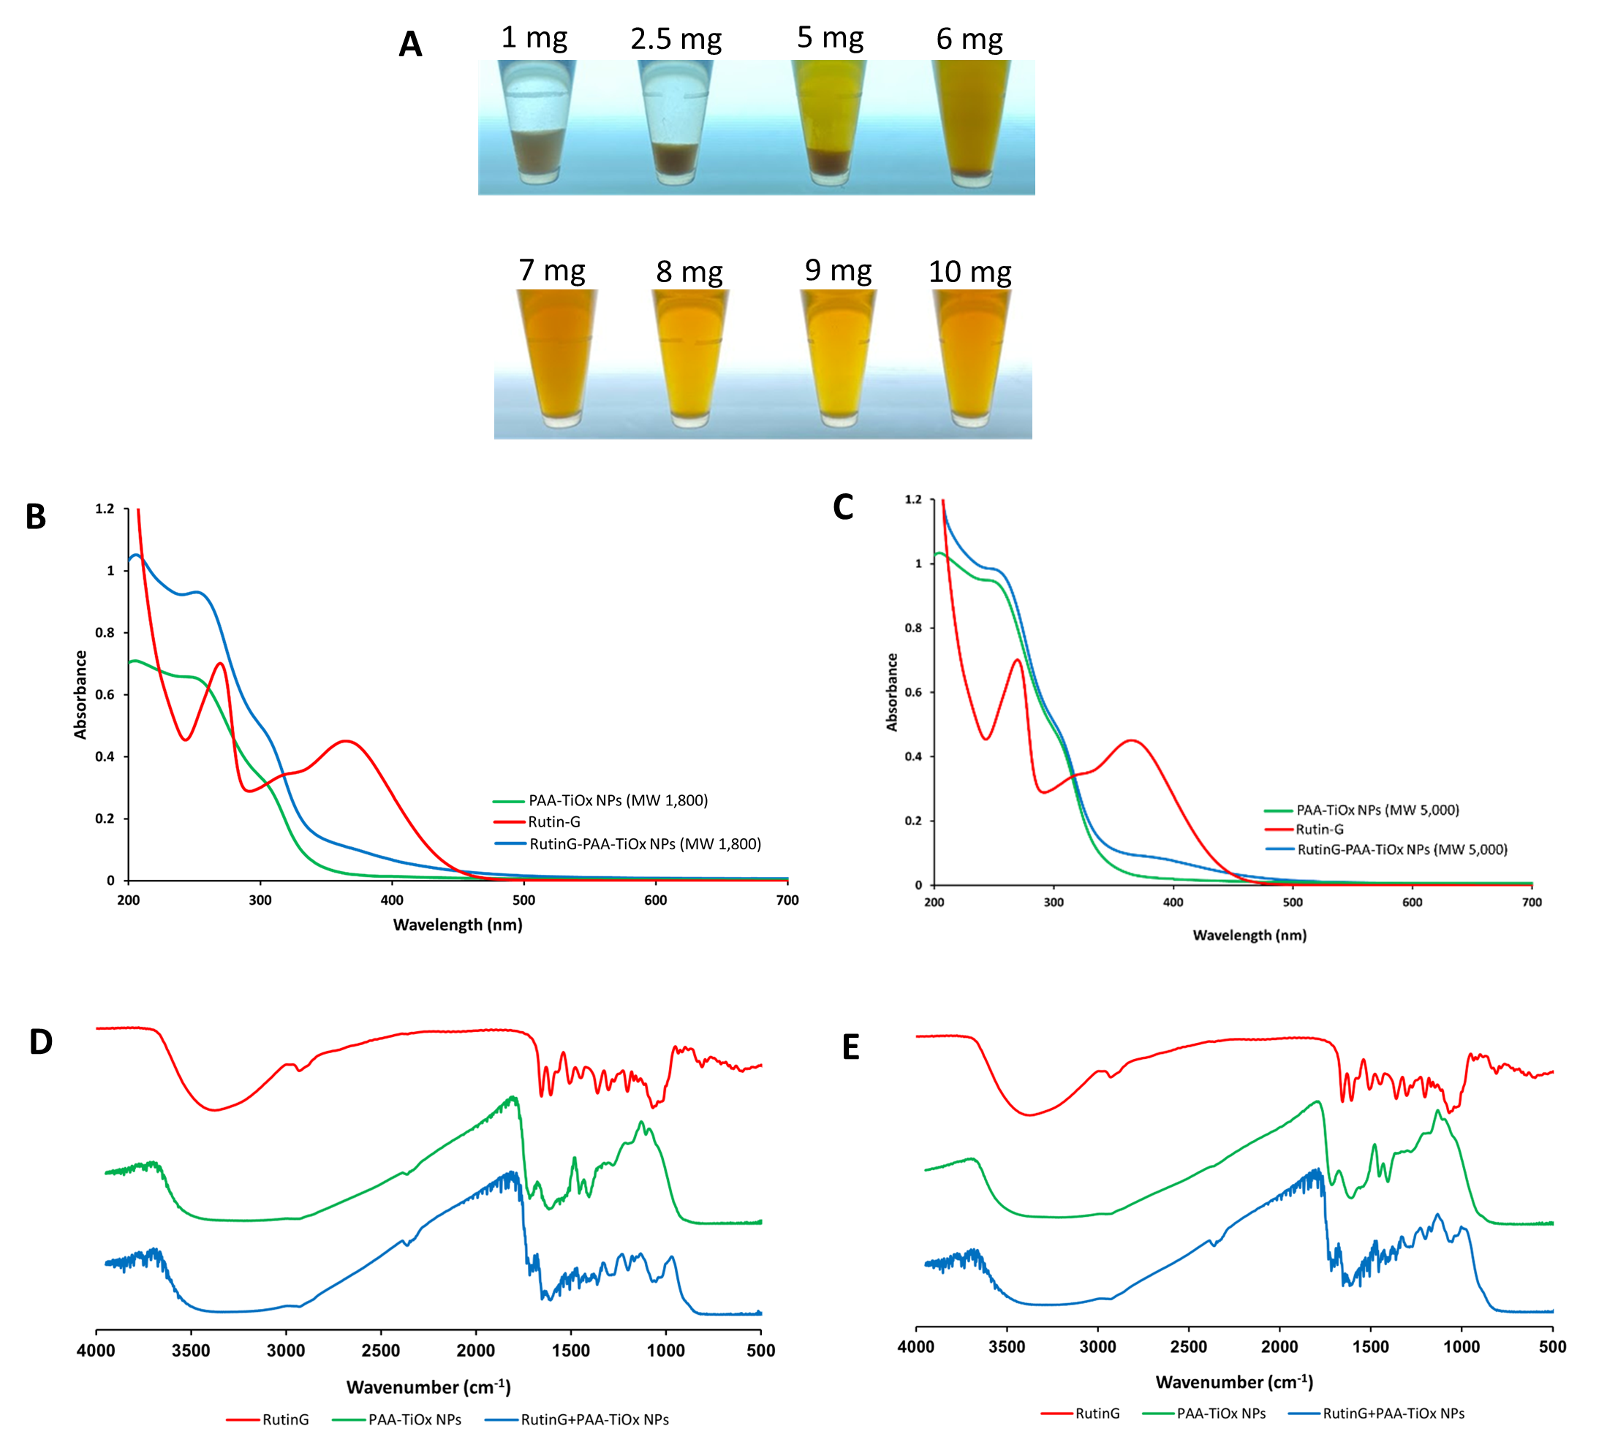
Figure S1. Characterization of modified NPs. (A) Physical appearance of TiO₂ NPs (10 mg) mixed with several concentration of Rutin-G; (B – C)UV-Vis absorbance spectra of (B) RutinG-PAA-TiOx NPs (MW 1,800) and (C) RutinG-PAA-TiOx NPs (MW 5,000); (D – E) FTIR spectra of (D) RutinG-PAA-TiOx NPs (MW 1,800) and (E) RutinG-PAA-TiOx NPs (MW 5,000).

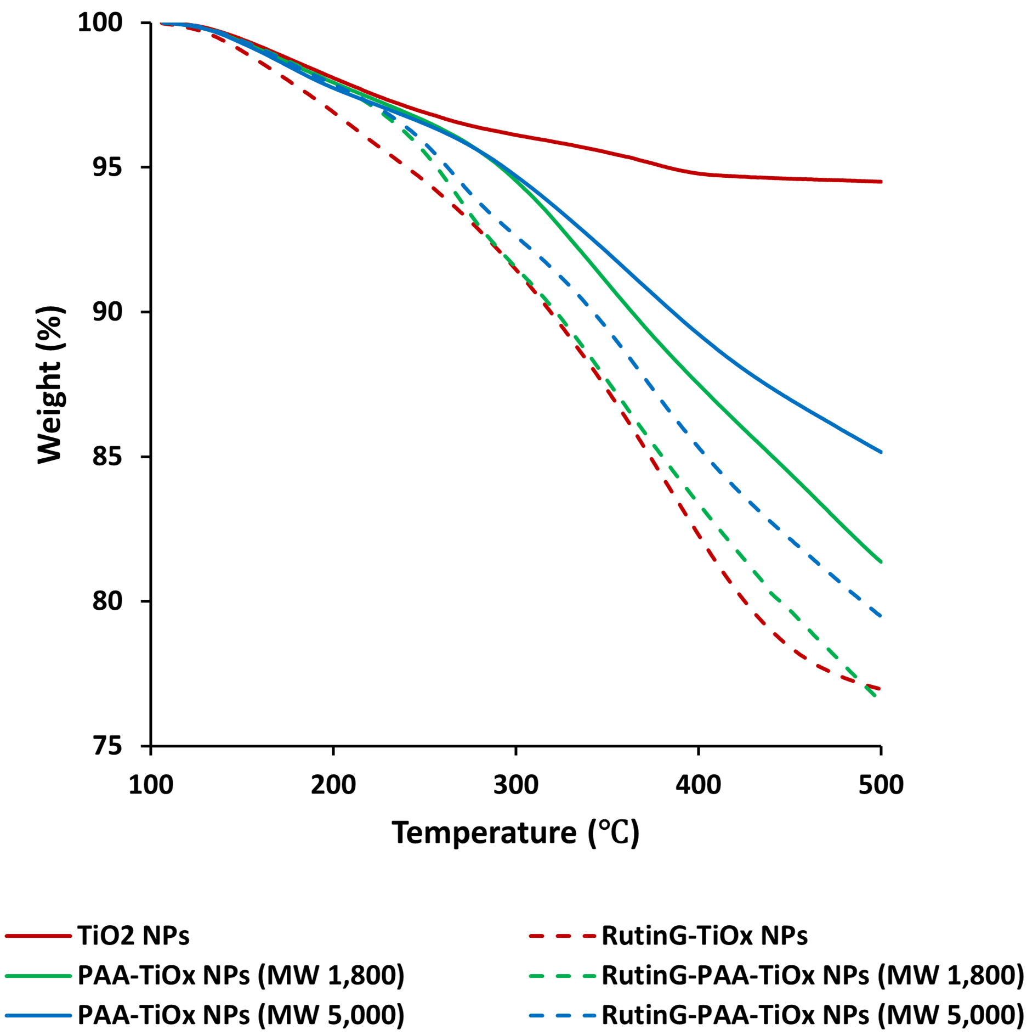
Figure S2. Thermograph of TiO₂ NPs and modified NPs.

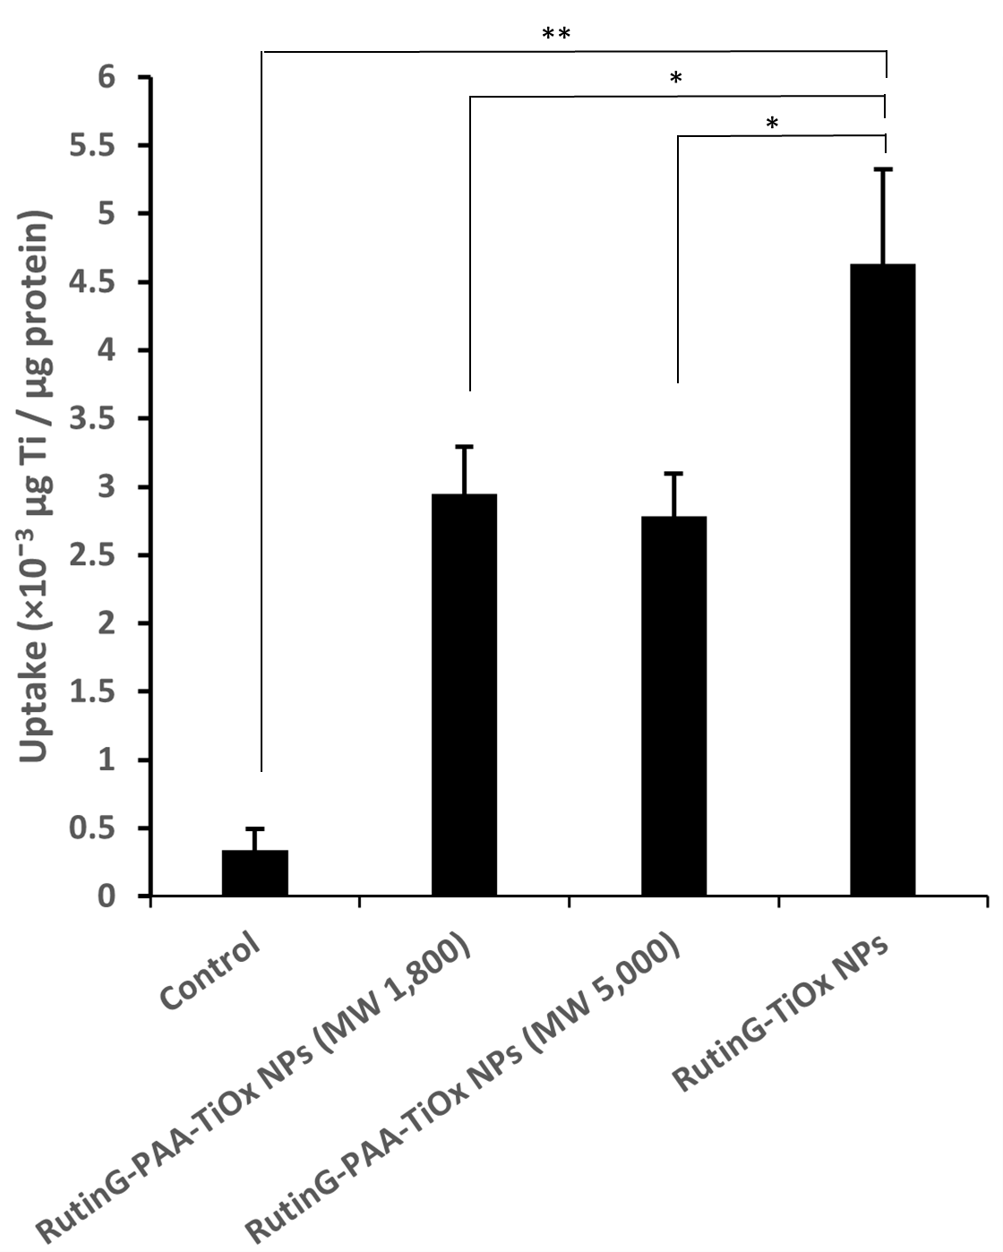
Figure S3. Cellular uptake of modified NPs indicated by titanium amount in cell lysate of MDA-MB-231 cells. Data represent the mean ± standard deviations from three replicates, *p ≤ 0.05, ** p ≤ 0.01.

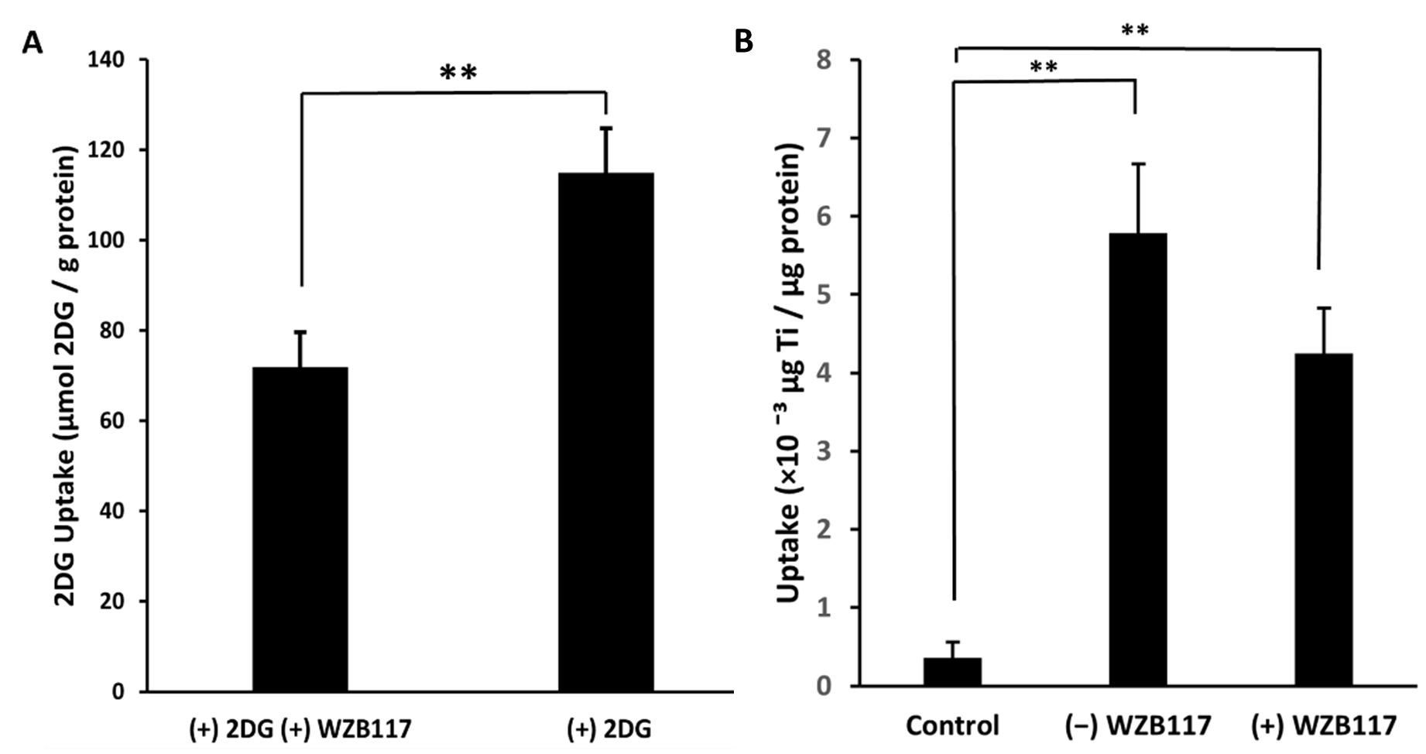
Figure S4. Confirmation of Glut1 targeting ability of Rutin-G. (A) 2DG uptake assay to confirm the effect of WZB117 in inhibiting Glut1 in MDA-MB-231 cells; (B) Cellular uptake of RutinG-TiOx NPs by MDA-MB-231 cells with and without WZB117 treatment. (+) 2DG represents the cells treated with 2DG. (+) WZB117 represents the cells with WZB117 treatment. (-) WZB117 represents the cells without WZB117 treatment. Data represent the mean ± standard deviations from three replicates, ** p ≤ 0.01.

Table S1. Hydrodynamic size and zeta potential of modified NPs
Nanoparticles | Water |  | DMEM + 10% FBS |  | Zeta Potential (mV)
Nanoparticles | Average size (nm) | PdI | Average size (nm) | PdI | Zeta Potential (mV)
RutinG-TiOx | 73.8 ± 0.6 | 0.1 ± 0.01 | 182.1 ± 1.6 | 0.2 ± 0.01 | −34.9 ± 1.3
RutinG-PAA-TiOx (MW 1,800) | 91.5 ± 0.5 | 0.1 ± 0.01 | 99.2 ± 0.4 | 0.1 ± 0.01 | −28.2 ± 0.7
RutinG-PAA-TiOx (MW 5,000) | 88.4 ± 0.3 | 0.2 ± 0.01 | 87.4 ± 0.7 | 0.1 ± 0.01 | −38.3 ± 0.7

Table S2. Relative amount of Rutin-G based on thermogravimetric weight loss.
Nanoparticles | Weight (%) Remaining at Different Temperatures |  |  |  |  | Rutin-G Amount (%)
Nanoparticles | 100°C | 200°C | 300°C | 400°C | 500°C | Rutin-G Amount (%)
TiO₂ | 100 | 98.1 | 96.1 | 94.8 | 94.5 | -
RutinG-TiOx | 100 | 96.9 | 91.5 | 82.3 | 77.0 | 22.8
PAA-TiOx (MW 1,800) | 100 | 97.9 | 94.5 | 87.5 | 81.4 | -
RutinG-PAA-TiOx (MW 1,800) | 100 | 97.9 | 91.5 | 83.4 | 76.5 | 7.3
PAA-TiOx (MW 5,000) | 100 | 97.7 | 94.7 | 89.2 | 85.2 | -
RutinG-PAA-TiOx (MW 5,000) | 100 | 97.9 | 92.6 | 85.3 | 79.5 | 7.9

Weight (%) (Wt%) loss was calculated as the difference between Wt% at 100°C and at 500°C.
Wt% remaining was Wt% remaining at 500°C.

- Weight loss ratio of TiO₂ NPs (R_{TiO2})
$$R_{TiO2}= \frac{{Wt\% loss}_{TiO2}}{{Wt\% remaining}_{TiO2}}$$

- Rutin-G weight (%) on RutinG-TiOx NPs (R/T_{RutinG-TiOx}(%))
$${R/T}_{RutinG-TiOx}(\%)= \frac{{100-Wt\% remaining}_{RutinG-TiOx}(1+R_{TiO2})}{{Wt\% remaining}_{RutinG-TiOx}(1+R_{TiO2})}×100$$

- PAA weight (%) on PAA-TiOx NPs (P/T_{PAA-TiOx}(%))
$${P/T}_{PAA-TiOx}(\%)= \frac{{100-Wt\% remaining}_{PAA-TiOx}(1+R_{TiO2})}{{Wt\% remaining}_{PAA-TiOx}(1+R_{TiO2})}×100$$

- Rutin-G weight (%) on RutinG-PAA-TiOx NPs (R/T_{RutinG-PAA-TiOx}(%))
$${R/T}_{RutinG-PAA-TiOx}(\%)= \frac{{100-Wt\% remaining}_{RutinG-PAA-TiOx}(1-R_{TiO2}+(1+R_{TiO2})×\frac{{P/T}_{PAA-TiOx}}{100}}{{Wt\% remaining}_{RutinG-PAA-TiOx}(1+R_{TiO2})}×100$$

