Supplementary File

Table S1. Selected hyperparameters for top-performing classifiers.
Classifiers | Hyperparameter
ET | n_estimators=232  max_features =3  min_sample_split =3  criterion=gini  class_weight=balance  random_state=123
CB | Iteration=143  learning_rate=0.1  depth=6  random_state=123
XGB | n_estimators = 481  eta=0.5  max_depth=10  random_state=123
*ET: ExtraTrees
*CB: CatBoost
*XGB: ExtremeGradientBoosting

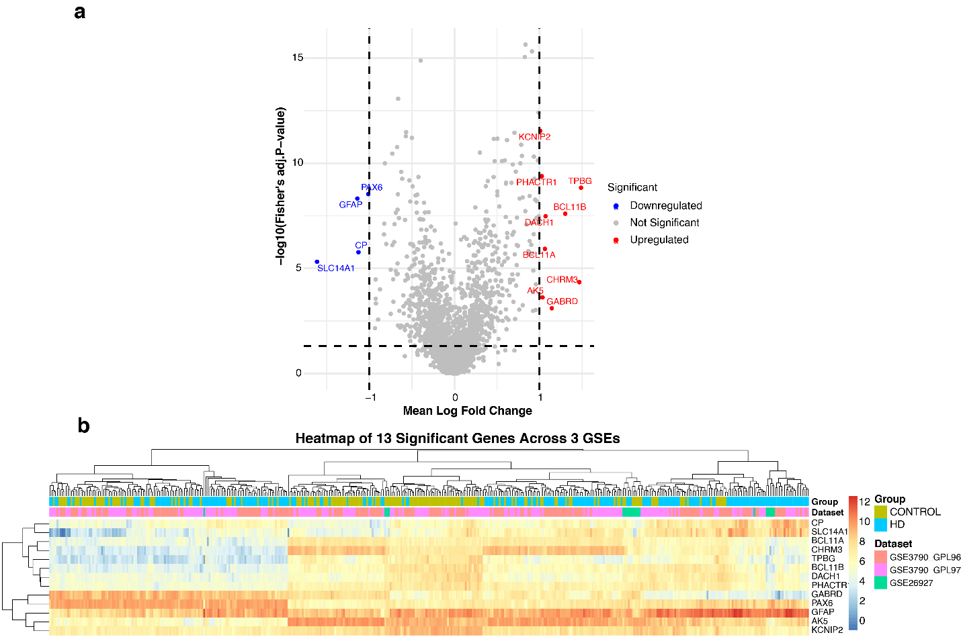
Figure S1. Identification of differentially expressed genes (DEGs) from GSE3790_GPL96, GSE3790_GPL97, and GSE26927 using meta-analysis following stringent criteria.

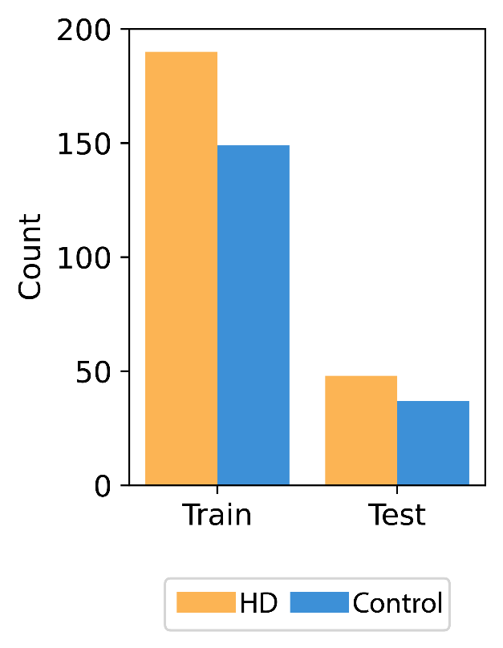
Figure S2. Distribution of HD and Control Samples in Training and Test Sets.

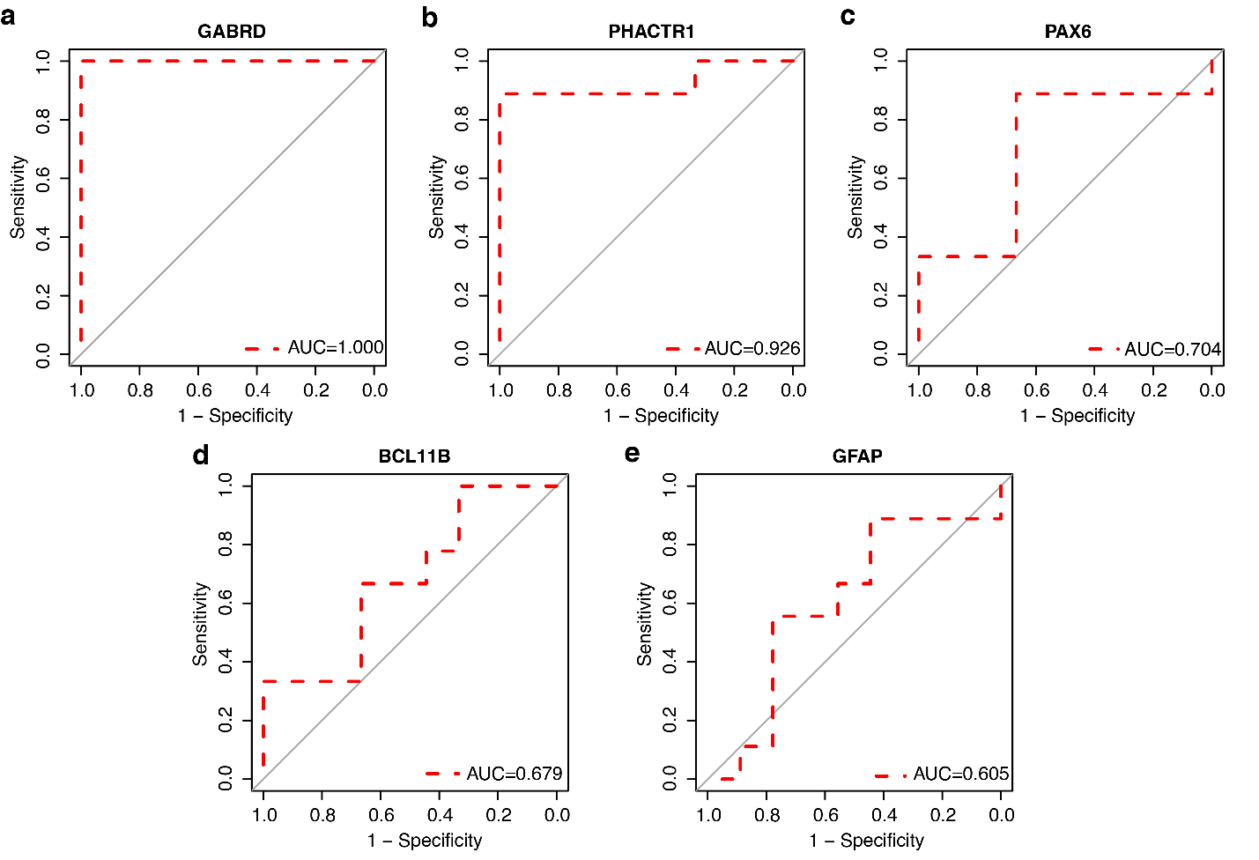
Figure S3. ROC curve analysis of five robust genes (a) GABRD, (b) PHACTR1, (c) PAX6, (d) BCL11B, and (e) GFAP, for diagnostic performance.

