Supplementary material
Table S1. Summary of studies employing the ISSR method applied to cycads based on searches performed in Web of Science Core collection and Google Scholar using the search terms “Cycad* AND "ISSR" OR “intersimple sequence repeat*”.
Species | Region | Main aims | Key findings | Reference
Ceratozamia fuscoviridis D.Moore (Zamiaceae) | Mexico | Effect of anthropogenic disturbance of species diversity using microsatellites and ISSR | Clustering of taxa corresponded to level of disturbance instead of geographic distance  Negative relationship between level of genetic diversity and degree of disturbance | (García-Montes et al., 2020)
Encephalartos woodii hort.(Zamaiceae) | South Africa | Comparing specimens using 15 RAPD and 5 ISSR primers | E. woodii collections of Ngoye and Krantzkloof types found to not be genetically identical, suggesting different parents | (Prakash et al., 2008)
Cycas debaoensis Y.C.Zhong & C.J.Chen (Cycadaceae) | South China | Determine genetic differentiation | Phenetic analysis reveals two clusters of grouped populations showing relative similarity of all populations to one another.  Genetic diversity among populations was high | (Jianguang et al., 2005)
Cycas diannanensis Z.T.Guan & G.D.Tao (= Cycas parvula) and Cycas balansae Warb. (Cycadaceae) | South China | Examine level and distribution of genetic variation in two species | Populations of C. diannanensis with lower spatial separation had low expected heterozygosity and very low genetic differentiation compared to the more widely distributed C. balansae | (Xiao et al., 2005)
Encephalartos Lehm. species (Zamiaceae) | African continent | Phylogenetic relationships between 52 Encephalartos species using ISSRs,  ITS and rbcLa sequences, and morphological and geographical characters | ISSRs were unable to provide sufficient resolution to resolve phylogenetic relationships of taxa  Morphological, geographical and nuclear DNA characters provided more insight and resolution of phylogenetic relationships | (Treutlein et al., 2005) *
Cycas guizhouensis K.M.Lan & R.F.Zou (Cycadaceae) | South China | Genetic diversity | Low genetic diversity within populations and high differentiation among populations  Evidence of potential drift and inbreeding | (Long‐Qian et al., 2004)
Cycas fairylakea D.Yue Wang (Cycadaceae) | South China | Genetic diversity | Species clustered into two groups with UPGMA and Principal components analysis in agreement | (Wang et al., 2006)
Dioon spinulosum Dyer ex Eichler  (Zamiaceae) | Egypt | Species identification using ISSR and Start Codon Translation (SCoT) markers | SCoT markers more informative with more polymorphic bands than ISSR markers  More ScoT markers were suitable for identifying D. spinulosum than ISSR markers | (Marwa et al., 2020)
Cycas taitungensis C.F.Shen, K.D.Hill, C.H.Tsou & C.J.Chen (Cycadaceae) | Taiwan | Genetic diversity using microsatellites and ISSRs  Identifying genetic units for conservation | Bayesian MCMC analysis revealed presence of inbreeding in populations and decline in genetic variability.  Management units for conservation were identified  Distinct genetic units were found in in situ and ex situ populations  Genetic variability estimates were much lower with ISSR markers than microsatellites | (Liao et al., 2018)
Cycas beddomei Dyer (Cycadaceae) | India | Genetic diversity | 15 out of 20 ISSR primers produced unambiguous bands  Phenetic analysis clusters species in two groups corresponding to different sampling locations | (Rout, G.R., Jadhao, K.R., Swain, D. and Panda, 2014)
Cycas balansae Warb complex (Cycadaceae) | South China | Taxonomy of Cycas balansae complex | ISSRs revealed low genetic diversity  Phenetic analysis with UPGMA reveals five distinct clusters corresponding to species | (Xiao et al., 2006)
Dioon caputoi De Luca, Sabato & Vázq.Torres  Dioon planifolium Salas-Mor., Chemnick & T.J.Greg  (Zamiaceae) | Mexico | Fine scale genetic variation at different spatial separation | Genetic variation correlated to spatial separation, but in a species-specific manner  Data supplements the study of population demographics of species | (Cabrera-Toledo et al., 2019)
Zamia inermis Vovides, J.D.Rees & Vázq.Torres  (Zamiaceae) | Mexico | Sex identification using ISSRs | Located a marker associated with the expression of female traits  Tendency found for separate clustering of male and females with Principal coordinates analysis | (Iglesias-Andreu and Favian-Vega, 2021)
Zamia furfuracea L.f  (Zamiaceae) | Mexico | Population demographics and fine scale genetic structure of species | Identified three gene neighbourhoods  Genetic composition of age groups and between populations was determined and substantial loss of genetic variability in juveniles discovered  Provided useful insights supplementing demographic data and aiding conservation  Demystifies population and spatial dynamics and the influence of external factors like dispersal and pollination | (Octavio-Aguilar et al., 2017)
Cycas circinalis L. | India | Sex determination in commercially important plants using RAPD and ISSR | Identified a male specific RAPD marker in C. circinalis  No male or female sex-specific ISSR markers were found | (Gangopadhyay et al., 2007)
Ceratozamia  mexicana Brongn. (Zamiaceae) | Mexico | Sex determination and SCAR marker development from ISSRs | ISSRs used as precursors to developing SCAR markers associated with male plants  Needly gene associated with sexual expression | (Sánchez-Coello et al., 2018)
Ceratozamia mexicana Brongn.  (Zamiaceae) | Mexico | Optimised DNA isolation and ISSR-PCR protocol for species | Modified CTAB method used for fresh, young cycad material  Included a pre-soak in 5 M NaCL solution | (Guadalupe Sánchez-Coello et al., 2012)

Table S2. Cophenetic correlation values (r) and t -values showing the extent to which UPGMA trees derived from distance matrices of respective similarity coefficients, fit the datasets. Data are arranged by minimum band intensity (relative fluorescence units, rfu) and from highest r-value. Trees produced from standardised Euclidean and Manhattan distances are also shown.
Distance coefficient | Tree type | RFU cut-off value
 |  | 50rfu |  | 100rfu |  | 200rfu
 |  | r | t | r | t | r | t
DICE – DICE (1945) | UPGMA | 0.8094 | 11.7986 | 0.69475 | 15.5792 | 0.71523 | 12.6501
J – Jaccard (1908) | UPGMA | 0.81149 | 13.1634 | 0.72079 | 18.478 | 0.73528 | 14.9337
K1 – Kulcznski (1927) coef. 1 | UPGMA | 0.75491 | 13.6306 | 0.84352 | 36.5891 | 0.83691 | 30.7461
K2 – Kulcznski (1927) coef. 2 | UPGMA | 0.73371 | 14.4069 | 0.70329 | 15.6134 | 0.71218 | 12.6602
O – Ochiai (1957) | UPGMA | 0.80731 | 11.7822 | 0.6988 | 15.6277 | 0.71096 | 12.6282
PHI – phi | UPGMA | 0.79508 | 12.1712 | 0.70696 | 16.1855 | 0.69869 | 13.1679
RR – Russel and Rao (1940) | UPGMA | 0.88238 | 10.5089 | 0.81662 | 11.2702 | 0.81367 | 11.4547
Euclidean distance | UPGMA | 0.79887 | 13.3991 | 0.736 | 17.7936 | 0.71845 | 15.1323
Manhattan distance | UPGMA | 0.69813 | 15.6775 | 0.67458 | 21.5935 | 0.65628 | 15.2665
SM – Simple Matching | UPGMA | 0.70461 | 12.9729 | 0.66026 | 18.2035 | 0.63741 | 13.1314
UN1 – “unnamed” coef. 1 | UPGMA | 0.66961 | 12.4717 | 0.65027 | 18.1519 | 0.62853 | 12.7104
UN2 – “unnamed” coef. 2 | UPGMA | 0.81546 | 14.8146 | 0.75244 | 21.4056 | 0.75533 | 17.7002
UN3 – “unnamed” coef. 3 | UPGMA | 0.78531 | 20.9135 | 0.86157 | 37.3712 | 0.81065 | 28.7192
UN5 – “unnamed” coef. 5 | UPGMA | 0.80153 | 12.1907 | 0.69732 | 16.0344 | 0.71417 | 13.4151
Y – Yule (1911) | UPGMA | 0.7859 | 9.9835 | 0.55659 | 9.8533 | 0.64114 | 9.5787
DICE – DICE (1945) | NJ | -0.47017 | -8.0962 | -0.29193 | -6.1135 | -0.52836 | -9.6449
J – Jaccard (1908) | NJ | -0.55374 | -9.3346 | -0.36788 | -9.3598 | -0.51923 | -9.7077
K1 – Kulcznski (1927) coef. 1 | NJ | -0.69221 | -14.8578 | -0.4351 | -13.7926 | -0.58122 | -16.0262
K2 – Kulcznski (1927) coef. 2 | NJ | -0.49912 | -7.9988 | -0.3862 | -8.4618 | -0.38373 | -6.4997
O – Ochiai (1957) | NJ | -0.51031 | -9.0625 | -0.3764 | -7.6594 | -0.37952 | -6.1808
PHI – Phi | NJ | -0.51479 | -9.0697 | -0.2089 | -3.65 | -0.41201 | -7.0555
RR – Russel and Rao (1940) | NJ | -0.26776 | -4.7001 | -0.11976 | -3.1332 | -0.16614 | -4.7405
Euclidean distance | NJ | 0.53859 | 10.3391 | 0.24643 | 4.6292 | 0.5636 | 11.1529
Manhattan distance | NJ | 0.44849 | 8.4883 | 0.44553 | 10.573 | 0.42152 | 12.4922
SM – Simple Matching | NJ | -0.50293 | -10.5151 | -0.43859 | -14.6196 | -0.31934 | -10.311
UN1 – “unnamed” coef. 1 | NJ | -0.36636 | -6.1756 | -0.43197 | -14.2131 | -0.42653 | -11.011
UN2 – “unnamed” coef. 2 | NJ | -0.62535 | -11.3851 | -0.54452 | -15.9192 | -0.47702 | -9.1826
UN3 – “unnamed” coef. 3 | NJ | -0.5929 | -23.1388 | -0.56111 | -29.1071 | -0.58183 | -20.7647
UN5 – “unnamed” coef. 5 | NJ | -0.46182 | -7.8936 | -0.37989 | -7.8434 | -0.4368 | -7.5074
Y – Yule (1911) | NJ | -0.50894 | -7.6932 | -0.3069 | -5.0216 | -0.34696 | -5.4206

Table S3. List of all plants sampled in this study.
Final ID | Extraction ID | Batch | Species | Locality/phenotype | Source
cup1 | 142ECUP002R | 2 | E. cupidus |  | Ridgemere
cup10 | 155ECUP019R | 2 | E. cupidus | Ohrigstad River | Ridgemere
cup11 | 156ECUP030R | 2 | E. cupidus | Bourkes Luck | Ridgemere
cup12 | 157ECUP031R | 2 | E. cupidus | Bourkes Luck | Ridgemere
cup13 | 158ECUP032R | 2 | E. cupidus | Swadini | Ridgemere
cup14 | 159ECUP035R | 2 | E. cupidus | Swadini | Ridgemere
cup15 | 161ECUP057R | 2 | E. cupidus | Strydom Tunnel | Ridgemere
cup16 | 164ECUP060R | 2 | E. cupidus | Above Tunnel | Ridgemere
cup17 | 165ECUP061R | 2 | E. cupidus | Above Tunnel | Ridgemere
cup18 | 166CUP1L | 2 | E. cupidus | Steenveld Farm: Blyde River canyon Nature Reserve | Lowveld BG
cup19 | 169CUP38L | 2 | E. cupidus |  | Lowveld BG
cup2 | 143ECUP004R | 2 | E. cupidus |  | Ridgemere
cup20 | 170CUP9L | 2 | E. cupidus | Bambi Area Helvetia section | Lowveld BG
cup21 | 171CUP47L | 2 | E. cupidus |  | Lowveld BG
cup22 | 174CUP58L | 2 | E. cupidus |  | Lowveld BG
cup23 | 175CUPn/n#2L | 2 | E. cupidus |  | Lowveld BG
cup24 | 52ECUP015R | 1 | E. cupidus | Ohrigstad River | Ridgemere
cup25 | 53ECUP016R | 1 | E. cupidus | Ohrigstad River | Ridgemere
cup3d1 | 145ECUP006R | 2 | E. cupidus | Brett Tunnel | Ridgemere
cup3d2 | 50ECUP006R | 1 | E. cupidus | Brett Tunnel | Ridgemere
cup4T | 147ECUP008R | 2 | E. cupidus | Type Locality | Ridgemere
cup5T | 148ECUP009R | 2 | E. cupidus | Type Locality | Ridgemere
cup6T | 150ECUP011R | 2 | E. cupidus | Type Locality | Ridgemere
cup7T | 151ECUP013R | 2 | E. cupidus | Type Locality | Ridgemere
cup8 | 152ECUP014R | 2 | E. cupidus | Ohrigstad River | Ridgemere
cup9 | 1554ECUP018R | 2 | E. cupidus | Ohrigstad River | Ridgemere
dol1 | 186EDOL001R | 2 | E. dolomiticius |  | Ridgemere
dol2 | 187EDOL007R | 2 | E. dolomiticius |  | Ridgemere
dol3 | 74EDOL002R | 1 | E. dolomiticius |  | Ridgemere
dol4 | 75EDOL003R | 1 | E. dolomiticius |  | Ridgemere
dol5 | 77EDOL005R | 1 | E. dolomiticius |  | Ridgemere
dol6 | 78EDOL006R | 1 | E. dolomiticius | Downs | Ridgemere
dol7 | 80DOL2L | 1 | E. dolomiticius |  | Lowveld BG
dol9 | 83DOLnn2L | 1 | E. dolomiticius |  | Lowveld BG
dye1 | 188EDYE003R | 2 | E. dyerianus |  | Ridgemere
dye10d1 | 199DYE30L | 2 | E. dyerianus |  | Lowveld BG
dye10d2 | 91DYE30L | 1 | E. dyerianus |  | Lowveld BG
dye11 | 200DYE82L | 2 | E. dyerianus |  | Lowveld BG
dye11Lb | 85dyelebuvu | 1 | E. dyerianus
dye12d1 | 201DYE90L | 2 | E. dyerianus |  | Lowveld BG
dye12d2 | 94DYE90L | 1 | E. dyerianus |  | Lowveld BG
dye16 | 93DYE97L | 1 | E. dyerianus |  | Lowveld BG
dye2 | 189EDYE004R | 2 | E. dyerianus |  | Ridgemere
dye3d1 | 190EDYE006R | 2 | E. dyerianus |  | Ridgemere
dye3d2 | 87EDYE006R | 1 | E. dyerianus |  | Ridgemere
dye4d1 | 191EDYE010R | 2 | E. dyerianus |  | Ridgemere
dye4d2 | 89EDYE010R | 1 | E. dyerianus |  | Ridgemere
dye5 | 192EDYE009R | 2 | E. dyerianus |  | Ridgemere
dye6Lb | 193EDYE013R | 2 | E. dyerianus | levubuensis | Ridgemere
dye7 | 194DYE8L | 2 | E. dyerianus |  | Lowveld BG
dye8 | 196DYE87L | 2 | E. dyerianus |  | Lowveld BG
dye9 | 198DYE15L | 2 | E. dyerianus |  | Lowveld BG
eug1 | 10EEUG013R | 1 | E. eugene-maraisii | Geelhoutkloof type | Ridgemere
eug10 | 20EEUG025R | 1 | E. eugene-maraisii | Umkomaas Waterberg | Ridgemere
eug11 | 22eug2UP | 1 | E. eugene-maraisii | Palala (male) | UP
eug12 | 23eug3UP | 1 | E. eugene-maraisii | Marakele | UP
eug13 | 24eug4UP | 1 | E. eugene-maraisii | Marakele | UP
eug14 | 25eug5UP | 1 | E. eugene-maraisii | likely Kransberg | UP
eug15W | 26EUG8L | 1 | E. eugene-maraisii | Waterberg | UP
16Lb | 27euglebuvuA | 1 | unknown | levubuensis?
eug17 | 28EUG13L | 1 | E. eugene-maraisii |  | Lowveld BG
eug18 | 29EUG14L | 1 | E. eugene-maraisii |  | Lowveld BG
eug19 | 32EUG28L | 1 | E. eugene-maraisii |  | Lowveld BG
eug2 | 11EEUG014R | 1 | E. eugene-maraisii | Thabazimbi | Ridgemere
eug20 | 33EUG32L | 1 | E. eugene-maraisii |  | Lowveld BG
eug21 | 3EEUG004R | 1 | E. eugene-maraisii | Sterkspruit Potgietersrus | Ridgemere
eug22P | Palala | 1 | E. eugene-maraisii |  | Ridgemere
eug23P | 8EEUG010R | 1 | E. eugene-maraisii | Palala | Ridgemere
eug24 | 9EEUG012R | 1 | E. eugene-maraisii | Bokpoort | Ridgemere
eug3 | 12EEUG016R | 1 | E. eugene-maraisii | Palala Plato | Ridgemere
eug4 | 13EEUG018R | 1 | E. eugene-maraisii | Palala | Ridgemere
eug5 | 16EEUG021R | 1 | E. eugene-maraisii | Kransberg | Ridgemere
eug6 | 17EEUG022R | 1 | E. eugene-maraisii | Kransberg | Ridgemere
eug7 | 18EEUG023R | 1 | E. eugene-maraisii | Kransberg | Ridgemere
eug8P | 19EEUG024R | 1 | E. eugene-maraisii | Palala | Ridgemere
eug9W | 1EEUG002R | 1 | E. eugene-maraisii | Waterberg | Ridgemere
his1 | 34EHIS009R | 1 | E. hirsutus |  | Ridgemere
his2 | 35his2A | 1 | E. hirsutus
mid1 | 176EMID006R | 2 | E. middelburgensis |  | Ridgemere
mid2d1Av | 177EMID003R | 2 | E. middelburgensis | Avontuur | Ridgemere
mid2d2Av | 63EMID003R | 1 | E. middelburgensis | Avontuur | Ridgemere
mid3 | 178MID2L | 2 | E. middelburgensis | Nelspruit | Lowveld BG
mid4 | 181MID59L | 2 | E. middelburgensis |  | Lowveld BG
mid5 | 185MID87L | 2 | E. middelburgensis |  | Lowveld BG
mid6 | 62EMID002R | 1 | E. middelburgensis |  | Ridgemere
mid8 | 64EMID004R | 1 | E. middelburgensis |  | Ridgemere
nub10Bt | 116ENUB020R | 2 | E. nubimontanus | Strydom Tunnel/Big tooth | Ridgemere
nub11Sp | 117ENUB023R | 2 | E. nubimontanus | Strydom Tunnel/Small pinna | Ridgemere
nub12Bt | 118ENUB024R | 2 | E. nubimontanus | Strydom Tunnel/Big tooth | Ridgemere
nub13Fi | 119ENUB025R | 2 | E. nubimontanus | Fine | Ridgemere
nub14Fi | 120ENUB026R | 2 | E. nubimontanus | Strydom Tunnel gorge/Fine | Ridgemere
nub15D | 121ENUB027R | 2 | E. nubimontanus | Dolomitica | Ridgemere
nub16R | 122ENUB032R | 2 | E. nubimontanus | Mafefe/Robusta | Ridgemere
nub17D | 123ENUB036R | 2 | E. nubimontanus | W of Trichards Dal/Dolomitica | Ridgemere
nub18 | 124ENUB040R | 2 | E. nubimontanus | NE of Penge | Ridgemere
nub19 | 125ENUB041R | 2 | E. nubimontanus | NE of Penge | Ridgemere
nub1Tw | 107ENUB008R | 2 | E. nubimontanus | Kromellenboog/Twisted rachis | Ridgemere
nub20 | 126ENUB042R | 2 | E. nubimontanus | NW of Penge | Ridgemere
nub21M | 128ENUB044R | 2 | E. nubimontanus | Near Strydom Tunnel/Miniature | Ridgemere
nub22Ft | 129ENUB057R | 2 | E. nubimontanus | Fishtail | Ridgemere
nub23 | 131NUB1L | 2 | E. nubimontanus | Thabagolo-Confiscated | Lowveld BG
nub24 | 133NUB4L | 2 | E. nubimontanus |  | Lowveld BG
nub25 | 134NUB6L | 2 | E. nubimontanus |  | Lowveld BG
nub26 | 135NUB14L | 2 | E. nubimontanus |  | Lowveld BG
nub28 | 137NUB18L | 2 | E. nubimontanus |  | Lowveld BG
nub29 | 138NUB20L | 2 | E. nubimontanus |  | Lowveld BG
nub2Gr | 108ENUB010R | 2 | E. nubimontanus | E of Kromellenboog Mine/Green | Ridgemere
nub30 | 139NUB22L | 2 | E. nubimontanus |  | Lowveld BG
nub31 | 141NUB28L | 2 | E. nubimontanus |  | Lowveld BG
nub32 | 39ENUB022R | 1 | E. nubimontanus | MH Big tooth near Strydom Tunnel | Ridgemere
nub33 | 41ENUB030R | 1 | E. nubimontanus | MH Dolomitica Giant near Downs | Ridgemere
nub34 | 43ENUB033R | 1 | E. nubimontanus | MH Mafefe Robusta Fishtail near Strydom Tunnel | Ridgemere
nub35 | 48NUB3L | 1 | E. nubimontanus |  | Lowveld BG
nub37 | 136NUB17L | 2 | E. nubimontanus |  | Lowveld BG
nub3Gr | 109ENUB011R | 2 | E. nubimontanus | E of Kromellenboog Mine/Green | Ridgemere
nub4Gr | 110ENUB012R | 2 | E. nubimontanus | E of Kromellenboog Mine/Green | Ridgemere
nub5DG | 111ENUB013R | 2 | E. nubimontanus | Downs/Dolomitica Giant | Ridgemere
nub6D | 112ENUB014R | 2 | E. nubimontanus | Downs/Dolomitica | Ridgemere
nub7DB | 113ENUB015R | 2 | E. nubimontanus | Downs/Blue Dolomitica | Ridgemere
nub8D | 114ENUB016R | 2 | E. nubimontanus | Downs/Dolomitica | Ridgemere
nub9Bt | 115ENUB019R | 2 | E. nubimontanus | Strydom Tunnel/Big tooth | Ridgemere
Excluded | CUP9L | 1 | E. cupidus | Mpumulanga -Bambi Area, Helvetia section | Lowveld BG
Excluded | CUP34L | 2 | E. cupidus |  | Lowveld BG
Excluded | CUP35L | 2 | E. cupidus |  | Lowveld BG
Excluded | CUP53L | 2 | E. cupidus |  | Lowveld BG
Excluded | CUP54L | 2 | E. cupidus |  | Lowveld BG
Excluded | CUPn/n#1L | 1 | E. cupidus | Broader leaflets | Lowveld BG
Excluded | ECUP005R | 1 | E. cupidus | Tunnel | Ridgemere
Excluded | ECUP005R | 2 | E. cupidus | Tunnel | Ridgemere
Excluded | ECUP007R | 2 | E. cupidus | Type Locality | Ridgemere
Excluded | ECUP010R | 2 | E. cupidus | Type Locality | Ridgemere
Excluded | ECUP013R | 1 | E. cupidus | Type Locality | Ridgemere
Excluded | ECUP028R | 1 | E. cupidus | Bourkes Luck | Ridgemere
Excluded | ECUP029R | 1 | E. cupidus | Bourkes Luck | Ridgemere
Excluded | ECUP033R | 1 | E. cupidus | Swadini | Ridgemere
Excluded | ECUP034R | 1 | E. cupidus | Swadini | Ridgemere
Excluded | ECUP036R | 2 | E. cupidus | Swadini | Ridgemere
Excluded | ECUP053R | 1 | E. cupidus | Giant Cupidus | Ridgemere
Excluded | ECUP058R | 2 | E. cupidus | Strydom Tunnel | Ridgemere
Excluded | ECUP059R | 2 | E. cupidus | Above Tunnel | Ridgemere
Excluded | DOL3L | 1 | E. dolomiticius |  | Lowveld BG
Excluded | DOLn/n#1L | 1 | E. dolomiticius |  | Lowveld BG
Excluded | DOLn/n#3L | 1 | E. dolomiticius |  | Lowveld BG
Excluded | E.dolA | 1 | E. dolomiticius |  | abel
Excluded | EDOL004R | 1 | E. dolomiticius |  | Ridgemere
Excluded | DYE101L | 2 | E. dyerianus |  | Lowveld BG
Excluded | DYE15L | 1 | E. dyerianus |  | Lowveld BG
Excluded | DYE45L | 1 | E. dyerianus |  | Lowveld BG
Excluded | DYE72L | 2 | E. dyerianus |  | Lowveld BG
Excluded | DYE82L | 1 | E. dyerianus |  | Lowveld BG
Excluded | DYE97L | 2 | E. dyerianus |  | Lowveld BG
Excluded | DYEn/n#1L | 1 | E. dyerianus | Finer leaf, Long leaflet | Lowveld BG
Excluded | EDYE009R | 1 | E. dyerianus |  | Ridgemere
Excluded | EDYE013R | 1 | E. dyerianus | levubuensis | Ridgemere
Excluded | EEUG003R | 1 | E. eugene-maraisii | Waterberg | Ridgemere
Excluded | EEUG005R | 1 | E. eugene-maraisii | Kransberg | Ridgemere
Excluded | EEUG007R | 1 | E. eugene-maraisii | Kransberg | Ridgemere
Excluded | EEUG009R | 1 | E. eugene-maraisii | Palala | Ridgemere
Excluded | EEUG019R | 1 | E. eugene-maraisii | Kransberg | Ridgemere
Excluded | EEUG020R | 1 | E. eugene-maraisii | Kransberg | Ridgemere
Excluded | eug kransH | 1 | E. eugene-maraisii | Kranskop | Hannes
Excluded | EUG15L | 1 | E. eugene-maraisii |  | Lowveld BG
Excluded | EUG18L | 1 | E. eugene-maraisii |  | Lowveld BG
Excluded | eug1UP | 1 | E. eugene-maraisii |  | UP
Excluded | mid avontA | 1 | E. middelburgensis |  | Abel
Excluded | MID12L | 1 | E. middelburgensis | Loskop Dam Nature Reserve | Lowveld BG
Excluded | MID13L | 1 | E. middelburgensis | Mpumulanga | Lowveld BG
Excluded | MID29L | 1 | E. middelburgensis | Lammerkop | Lowveld BG
Excluded | MID32L | 2 | E. middelburgensis |  | Lowveld BG
Excluded | MID43L | 2 | E. middelburgensis |  | Lowveld BG
Excluded | MID5L | 1 | E. middelburgensis | TPA_Garden Genebank | Lowveld BG
Excluded | MID61L | 2 | E. middelburgensis |  | Lowveld BG
Excluded | MID69L | 2 | E. middelburgensis |  | Lowveld BG
Excluded | MID75L | 2 | E. middelburgensis |  | Lowveld BG
Excluded | EMID001R | 1 | E. middelburgensis | RH | Ridgemere
Excluded | EMID005R | 1 | E. middelburgensis | Theunis Bester/ ex Ferguson | Ridgemere
Excluded | EMID006R | 1 | E. middelburgensis |  | Ridgemere
Excluded | EMID014R | 1 | E. middelburgensis | RH Avontuur | Ridgemere
Excluded | EMID019R | 1 | E. middelburgensis | MH Doringkop | Ridgemere
Excluded | NUB25L | 2 | E. nubimontanus |  | Lowveld BG
Excluded | ENUB009R | 1 | E. nubimontanus | N of Kromellenboog Mine/Twister robust cupidus | Ridgemere
Excluded | ENUB017R | 1 | E. nubimontanus | Tunnel/Munchii | Ridgemere
Excluded | ENUB018R | 1 | E. nubimontanus | Tunnel/Munchii | Ridgemere
Excluded | ENUB021R | 1 | E. nubimontanus | Strydom Tunnel/cupidus form | Ridgemere
Excluded | ENUB029R | 1 | E. nubimontanus | S of Downs/Dolomitica | Ridgemere
Excluded | ENUB037R | 1 | E. nubimontanus | W of Trichards Dal/Dolomitica | Ridgemere
Excluded | ENUB038R | 1 | E. nubimontanus | E of Penge | Ridgemere
Excluded | ENUB039R | 1 | E. nubimontanus | NE of Penge | Ridgemere
Excluded | ENUB059R | 2 | E. nubimontanus | Robusta | Ridgemere
Excluded | ENUB062 | 1 | E. nubimontanus | Penge | Ridgemere

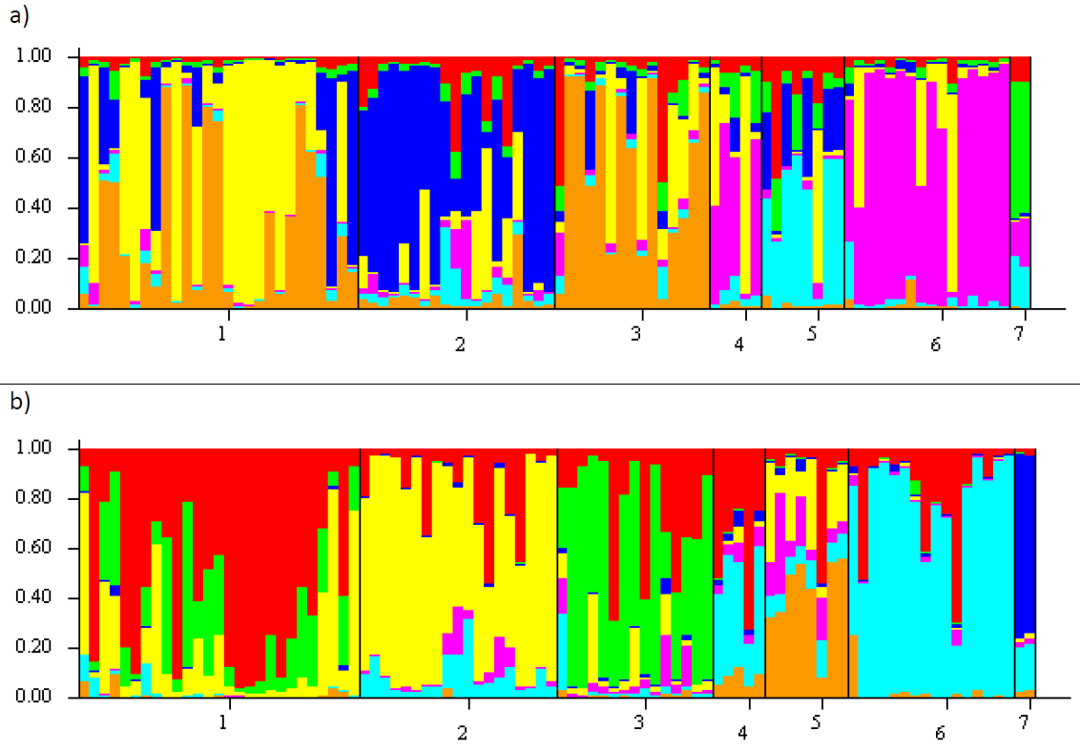
Figure S1. STRUCTURE barplots showing the proportion of membership of samples assigned to K = 7 clusters within the Encephalartos eugene-maraisii complex. Results are based on ISSR fragments scored at a 100 relative fluorescence unit (rfu) cut-off value. The dataset was tested using the Standard STRUCTURE model (a) and the LOCPRIOR model (b) that accounts for known locality data prior to the run. Colours represent each of the predefined clusters to which each sample is assigned. Species are numbered 1 – 7 on the x-axis, from left to right: E. nubimontanus, E. eugene-maraisii, E. cupidus, E. middelburgensis, E. dolomiticus, E. dyerianus, E. hirsutus.

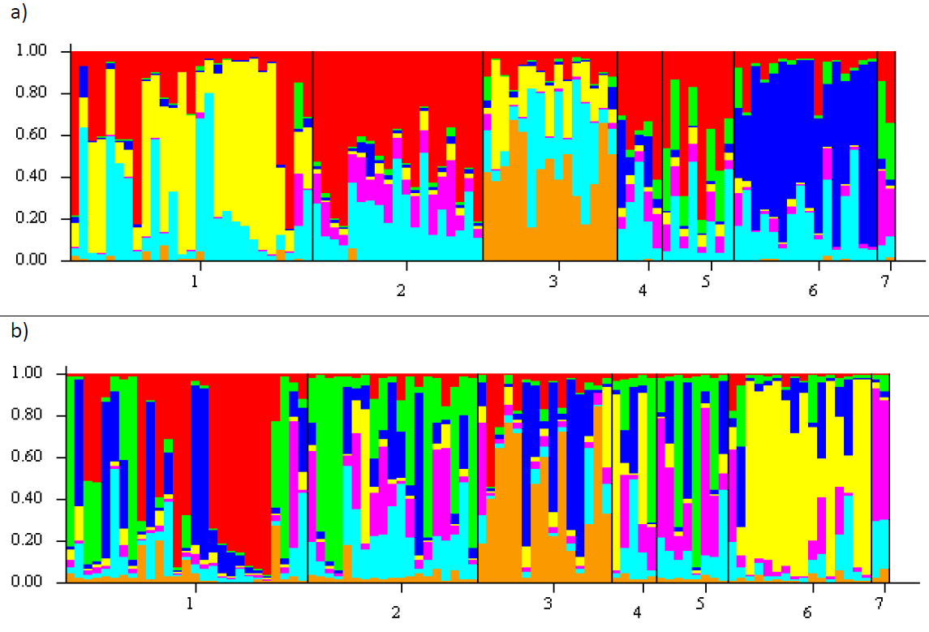
Figure S2. STRUCTURE barplots showing the proportion of membership of samples assigned to K = 7 clusters within the Encephalartos eugene-maraisii complex. Results are based on ISSR fragments scored at a 200 relative fluorescence unit (rfu) cut-off value. The dataset was tested using the Standard STRUCTURE model (a) and the LOCPRIOR model (b) that accounts for known locality data prior to the run. Colours represent each of the predefined clusters to which each sample is assigned. Species are numbered 1 – 7 on the x-axis, from left to right: E. nubimontanus, E. eugene-maraisii, E. cupidus, E. middelburgensis, E. dolomiticus, E. dyerianus, E. hirsutus.

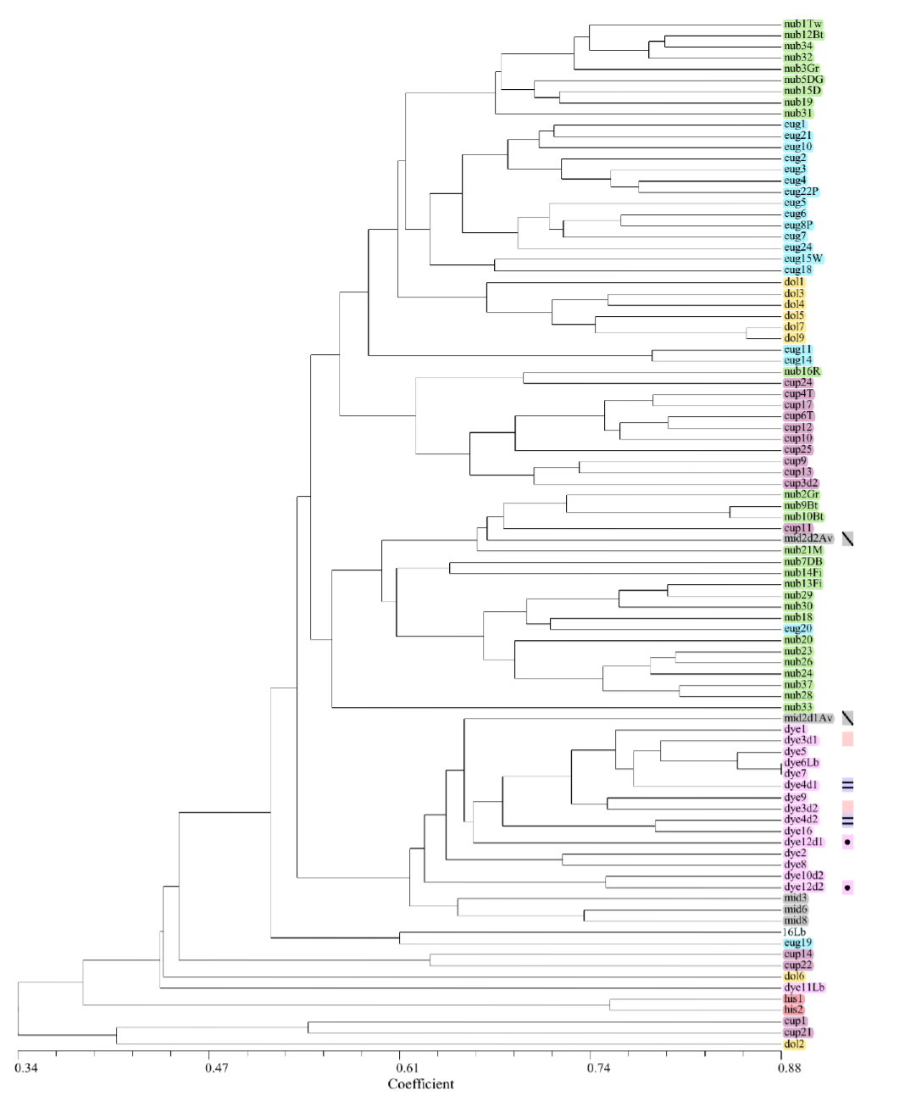
Figure S3. UPGMA dendrogram of the Encephalartos eugene-maraisii complex based on ISSR markers at a relative fluorescence unit (rfu) cut-off of 50rfu. Band presence and absence was used to compute genetic distances using the DICE coefficient. Colour shading indicates each species group, and specimen names are represented by the first three letters of their species epithet, corresponding to Table S5. Sample duplicates, representing material obtained from the same plant, but extracted in a different DNA extraction batch, are indicated by the coloured rectangles.

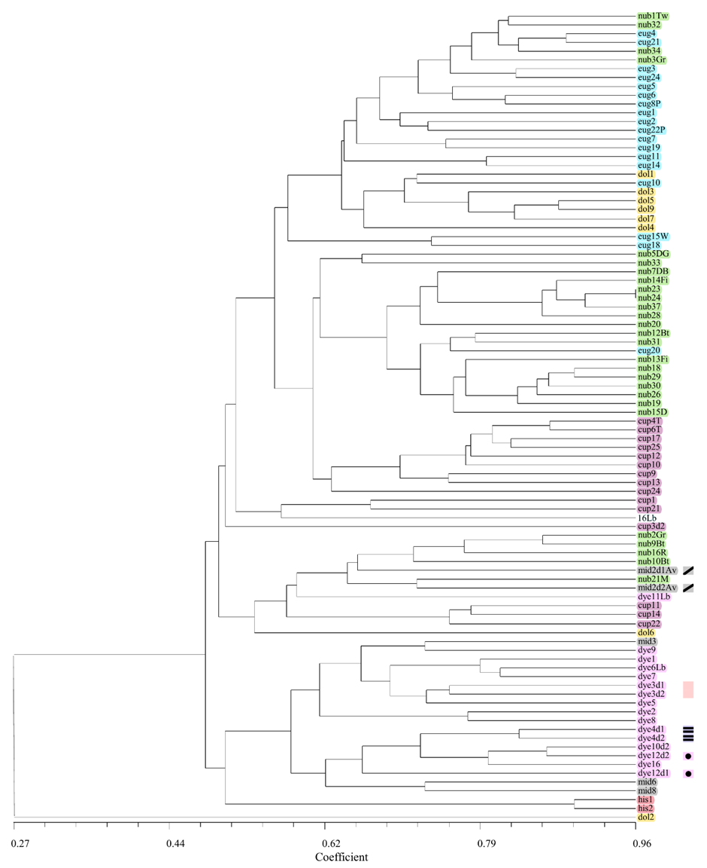
Figure S4. UPGMA dendrogram of the Encephalartos eugene-maraisii complex based on ISSR markers with a minimum band intensity of 100 relative fluorescence units (rfu). Band presence and absence was used to compute genetic distances using the DICE coefficient. Colour shading indicates each species group, and specimen names are represented by the first three letters of their species epithet, corresponding to Table S5. Sample duplicates, representing material obtained from the same plant, but extracted in a different DNA extraction batch, are indicated by the coloured rectangles.

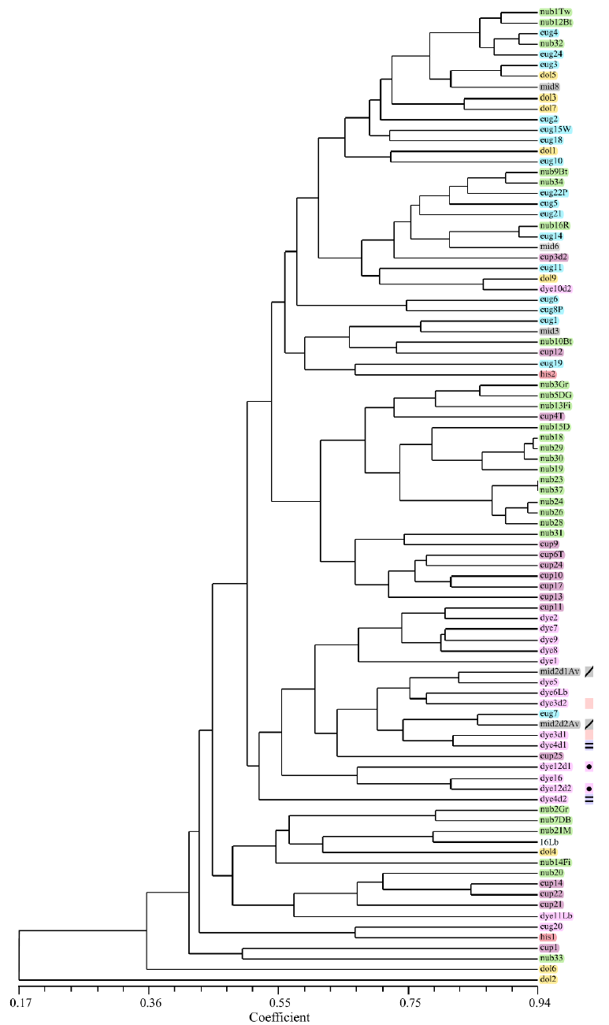
Figure S5. UPGMA dendrogram of the Encephalartos eugene-maraisii complex based on ISSR markers at a relative fluorescence unit (rfu) cut-off of 200rfu. Band presence and absence was used to compute genetic distances using the DICE coefficient. Colour shading indicates each species group, and specimen names are represented by the first three letters of their species epithet, corresponding to Table S5. Sample duplicates, representing material obtained from the same plant, but extracted in a different DNA extraction batch, are indicated by the coloured rectangles.

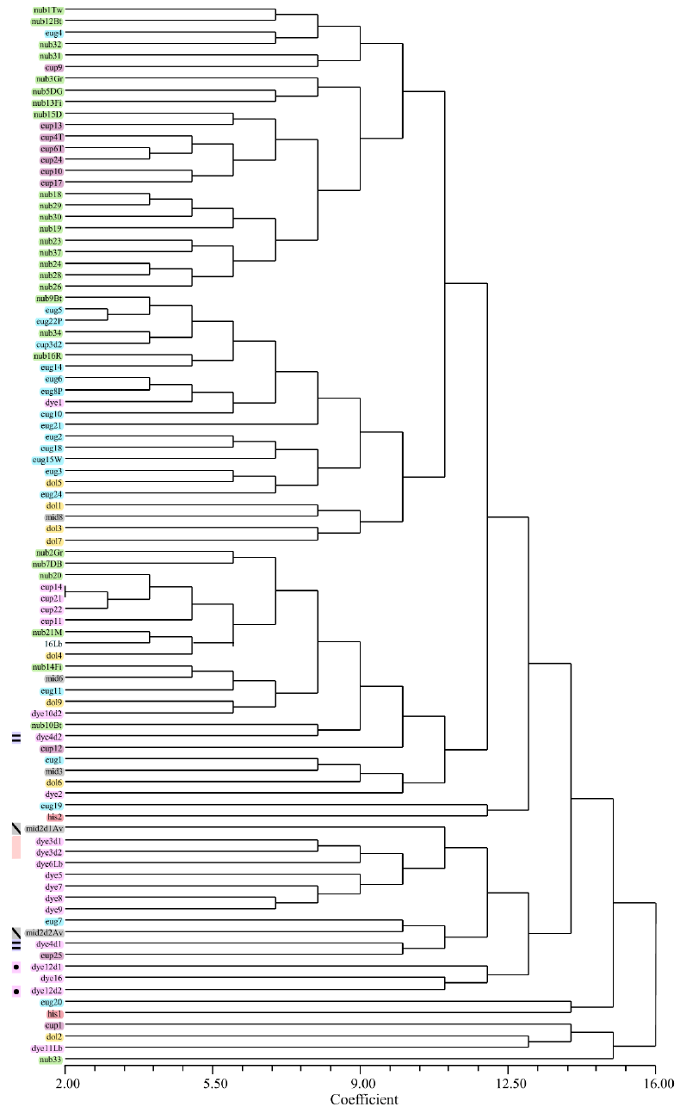
Figure S6. Neighbor Joining dendrogram of the Encephalartos eugene-maraisii complex based on ISSR markers at a relative fluorescence unit (rfu) cut-off of 200rfu. Band presence and absence was used to compute genetic distances using the DICE coefficient. Colour shading indicates each species group, and specimen names are represented by the first three letters of their species epithet, corresponding to Table S5. Sample duplicates, representing material obtained from the same plant, but extracted in a different DNA extraction batch, are indicated by the coloured rectangles.

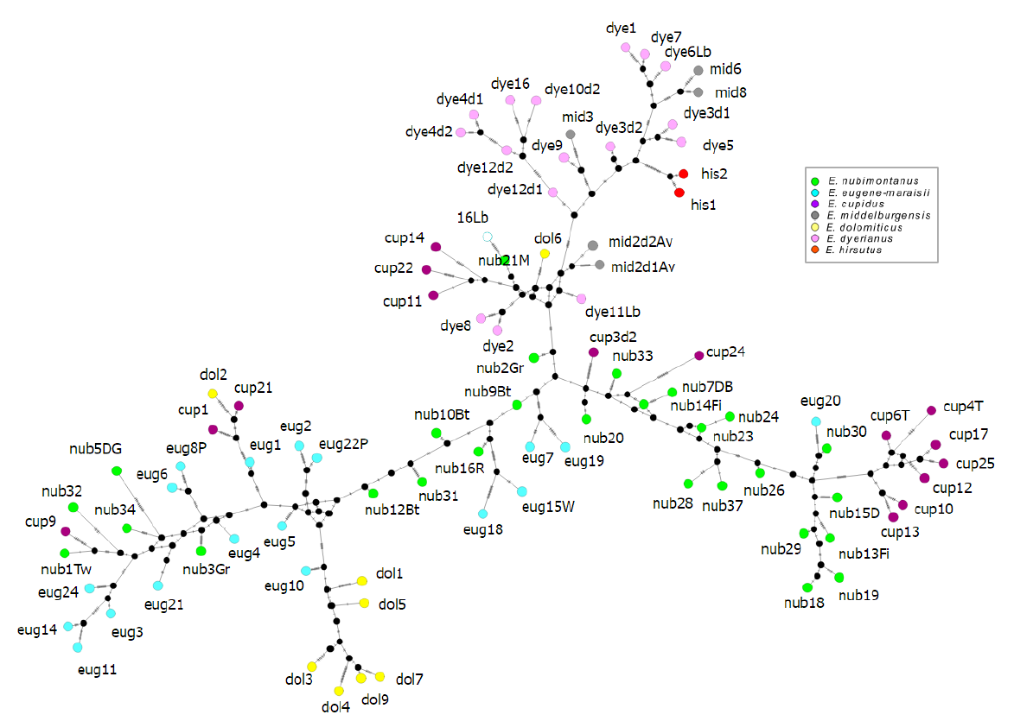
Figure S7. Median joining networks of the Encephalartos eugene-maraisii complex based on ISSR markers with a minimum band intensity of 100 relative fluorescent units (rfu). Colours denote the species of each sample in this study.

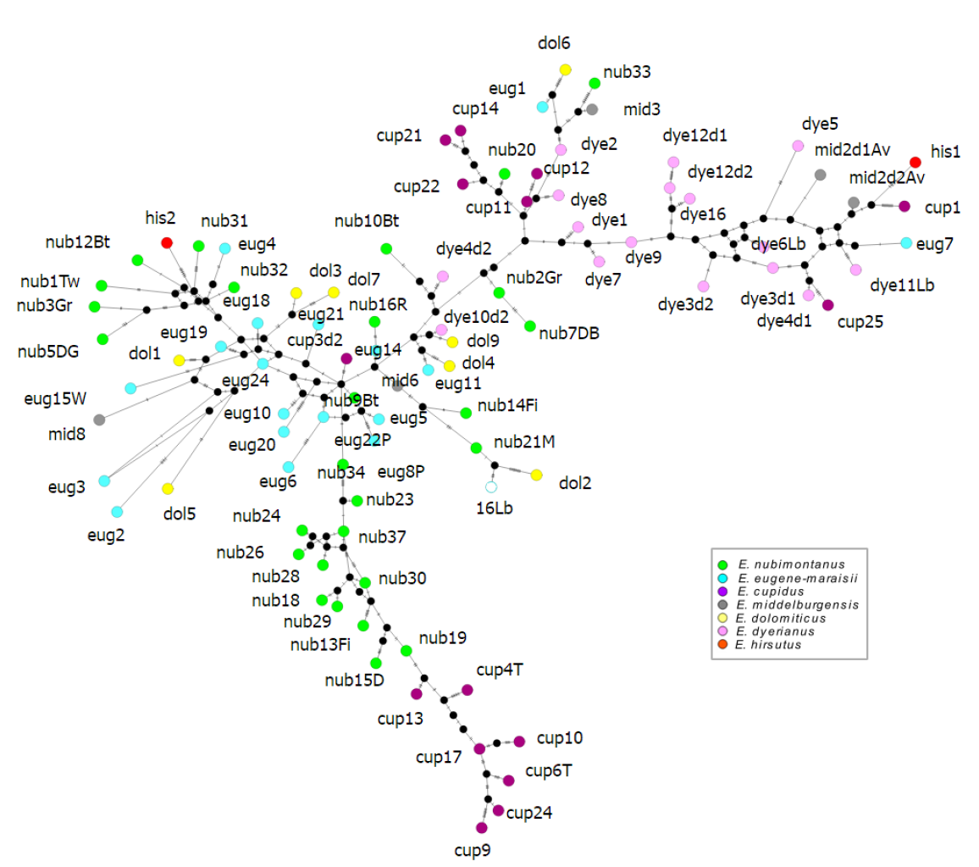
Figure S8. Median joining network of the Encephalartos eugene-maraisii complex based on ISSR markers with a minimum band intensity of 200 relative fluorescent units (rfu). Colours denote the species of each sample in this study.

