Beta-cyclodextrin Molecules (β‐CD) modified PVDF Membranes to remove multi-ionic Dye solutions using steric, inclusion, and dielectric-exclusion.
Wadha Alrashedi^{1,2}, Hafedh Kochkar^{1,2*} ,Ismail Ercan³

¹ Department of Chemistry, College of Science, Imam Abdulrahman Bin Faisal University, P.O. Box 1982, 31441, Dammam, Saudi Arabia.
² Basic & Applied Scientific Research Center, Imam Abdulrahman Bin Faisal University, P.O. Box 1982, 31441, Dammam, Saudi Arabia.
³Department of Electrical and Electronics Engineering, Faculty of Engineering, Düzce University, 81010, Turkey.

*Corresponding author. E-mail address: hbkochkar@iau.edu.sa (H. Kochkar)

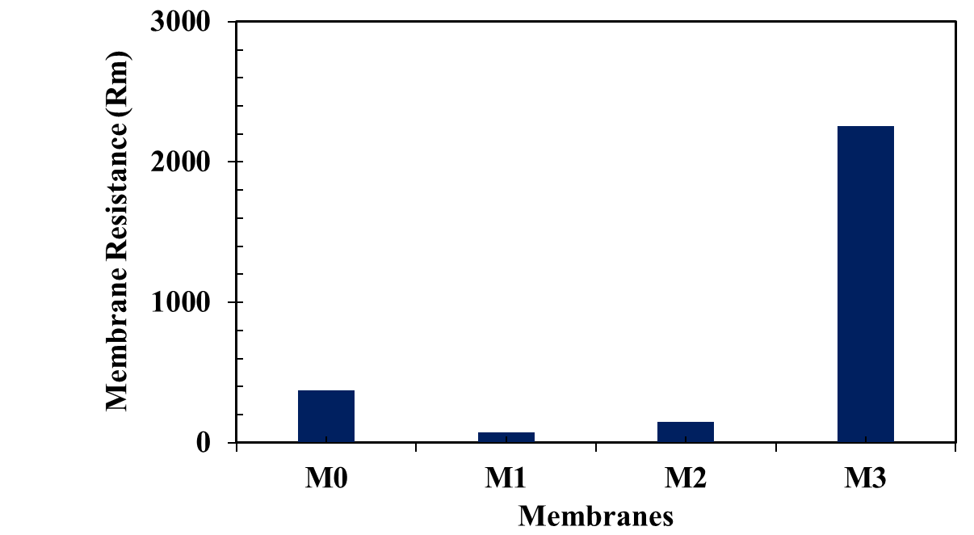

Figure S1: Membrane resistance of PVDF-PVP_{(1-x)}- β- CD_{(x)} membranes: M₀ (x=0), M₁ (x=0.25), M₂ (x=0.50), M₃ (x=0.75) and M₄ (x=1.0).

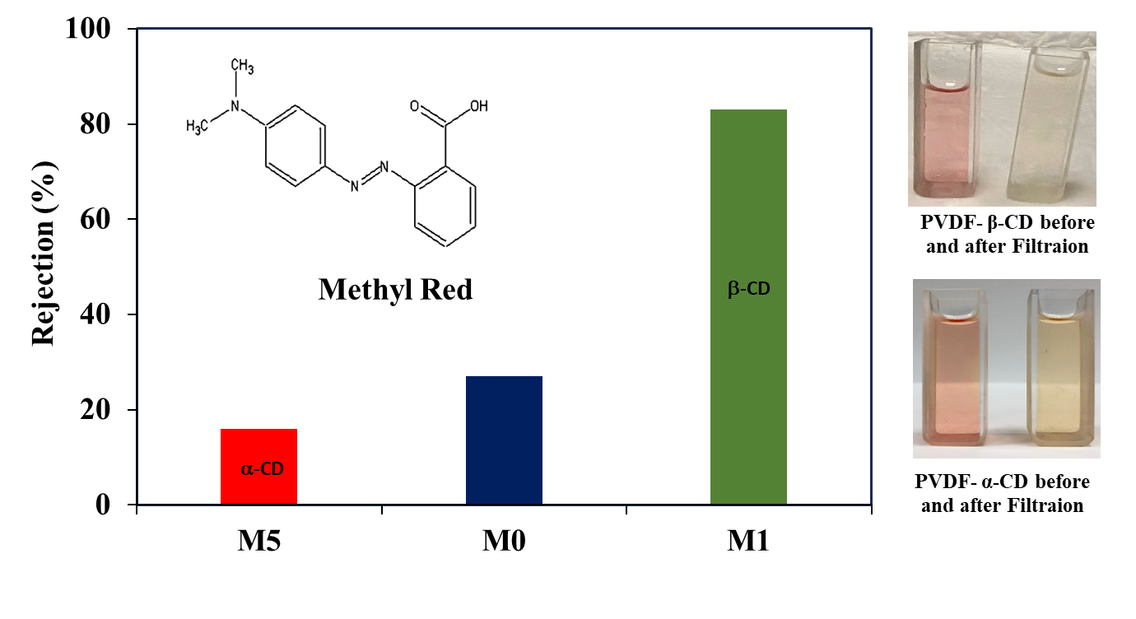

Figure S2. Methyl Red (MR) rejection with different membranes: M₅ (PVDF-PVP _{(0.75)-} α−CD_{(0.25)}), M₀ ( PVDF-PVP), and M₁ (PVDF-PVP _{(0.75)-} βCD_{(0.25)}).

