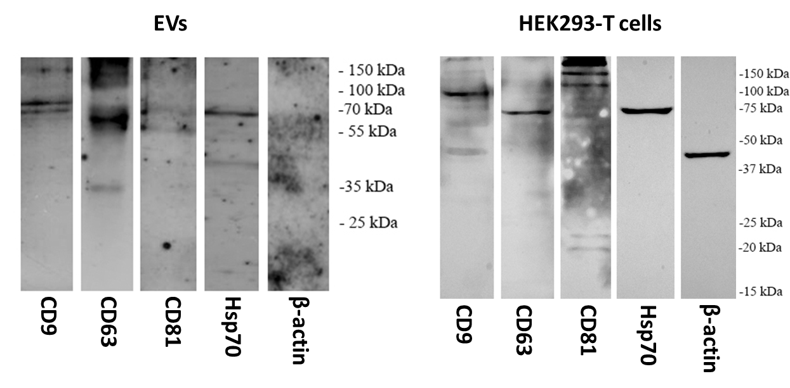
Figure S1. Protein expression analysis. Analysis of EVs-specific protein biomarkers (CD9, CD63, CD81, Hsp70) and β-actin as housekeeping control in isolated EVs and HEK293-T cells.

