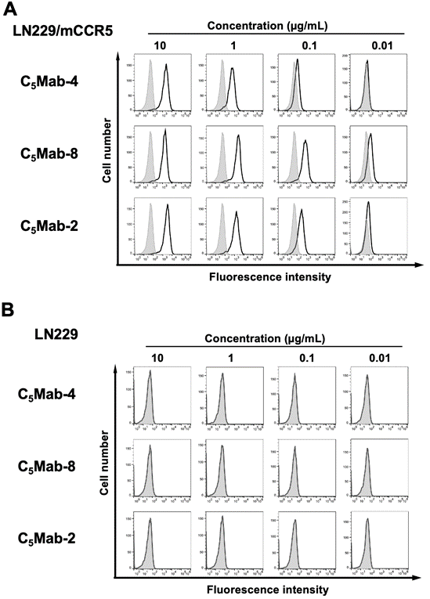
Scheme 1. Flow cytometry of mCCR5-overexpressed LN229 cells using anti-mCCR5 mAbs. LN229/mCCR5 (A) and LN229 (B) cells were treated with 0.01–10 µg/mL of C₅Mab-4, C₅Mab-8, or C₅Mab-2 (black line). The mAbs-treated cells were further incubated with anti-rat IgG conjugated with Alexa Fluor 488. The filled gray represents the negative control (blocking buffer).

