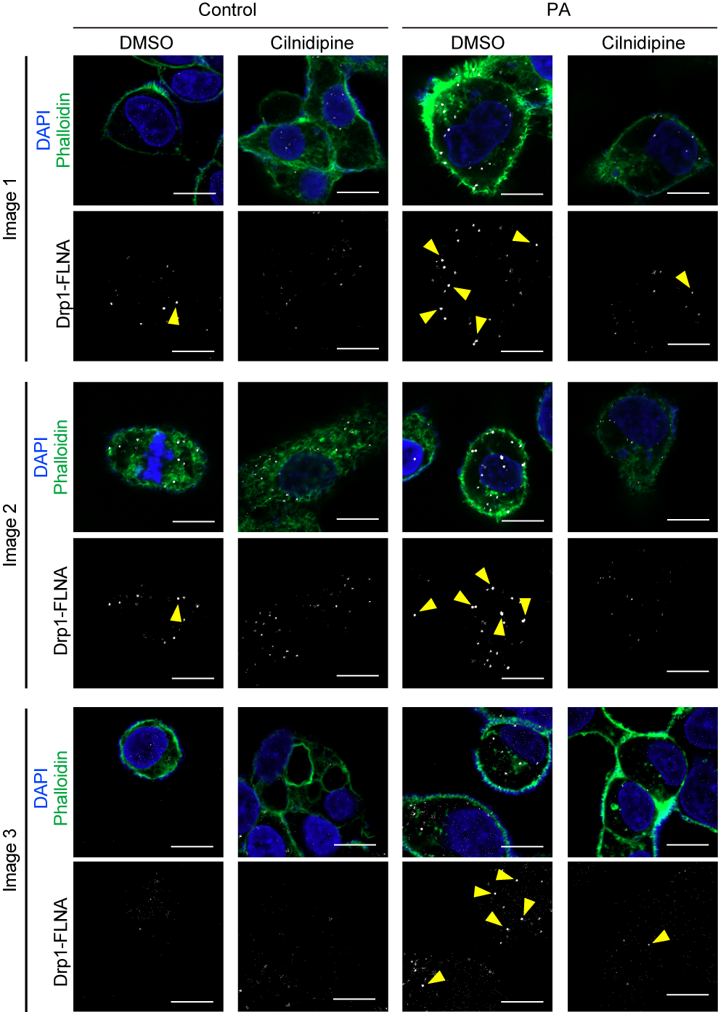
Supplemental figure 1. Effect of cilnidipine on the PA-induced Drp1-FLNA complex formation in HepG2. Supplemental images of PLA between Drp1 and FLNA. PLA signals are shown as white spots counterstained with phalloidin (green) and DAPI (blue). HepG2 cells were treated with 30 μM of PA with or without cilnidipine. Scale bars: 10 μm.
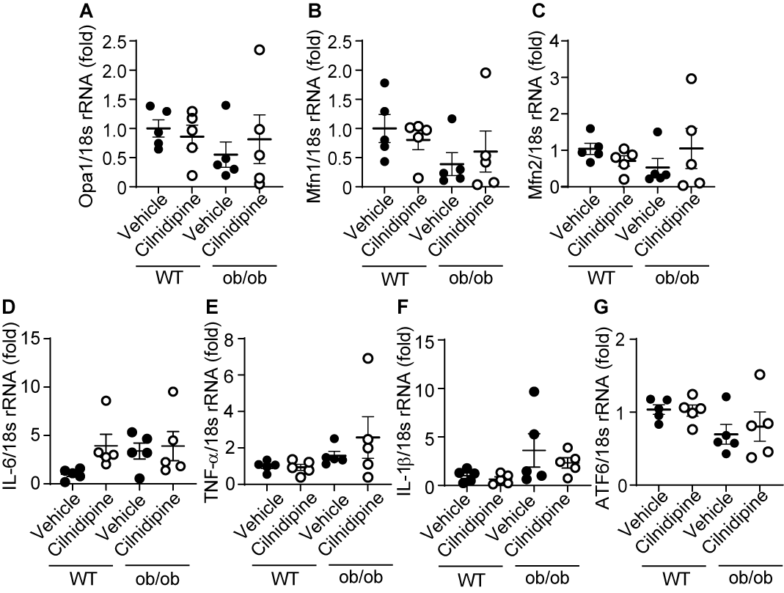
Supplemental figure 2. Changes in mRNA expression levels related to mitochondria fusion, inflammation, and ER stress in ob/ob mice. (A-C) Gene expression of mitochondrial fusion-related proteins. The expression of Opa1 (A), Mfn1 (B), and Mfn2 (C). (D-F) Gene expression of inflammation-related proteins. The expression of IL-6 (D), TNF-α (E), and IL-1β (F). (G) The expression level of ATF6 gene. Data are means ± SEM (n=5 mice in each group). Significance was determined using one-way ANOVA followed by Tukey’s comparison test.
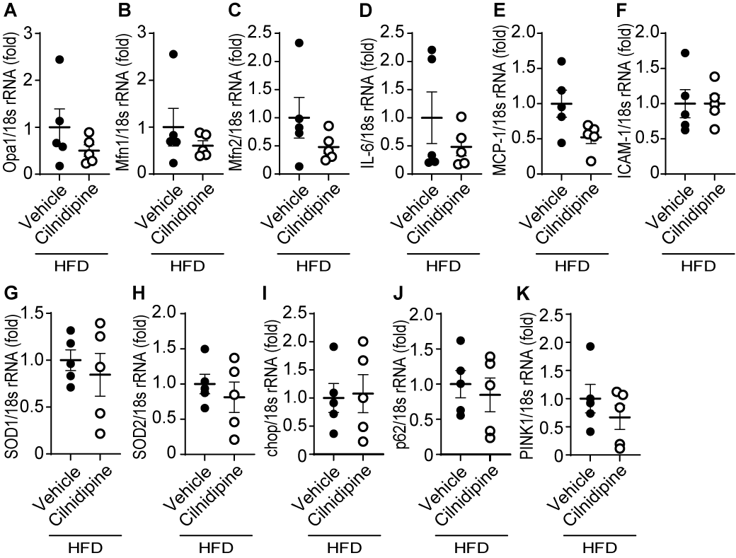
Supplemental figure 3. Changes in mRNA expression levels related to mitochondria fusion, inflammation, and ER stress in WT mice fed HFD. (A-C) Gene expression of mitochondrial fusion-related proteins. The expression of Opa1 (A), Mfn1 (B), and Mfn2 (C). (D-F) Gene expression of inflammation-related proteins. The expression of IL-6 (D), MCP-1 (E), and ICAM-1 (F). (G, H) Gene expression of ROS-related proteins. The expression of SOD1 (G), and SOD2 (H). (I, J) Gene expression of ER stress-related proteins. The expression of chop (I), and p62 (J). (K) mRNA expression of PINK1. Data are means ± SEM (n=5 mice in each group). Significance was determined using one-way ANOVA followed by Tukey’s comparison test.
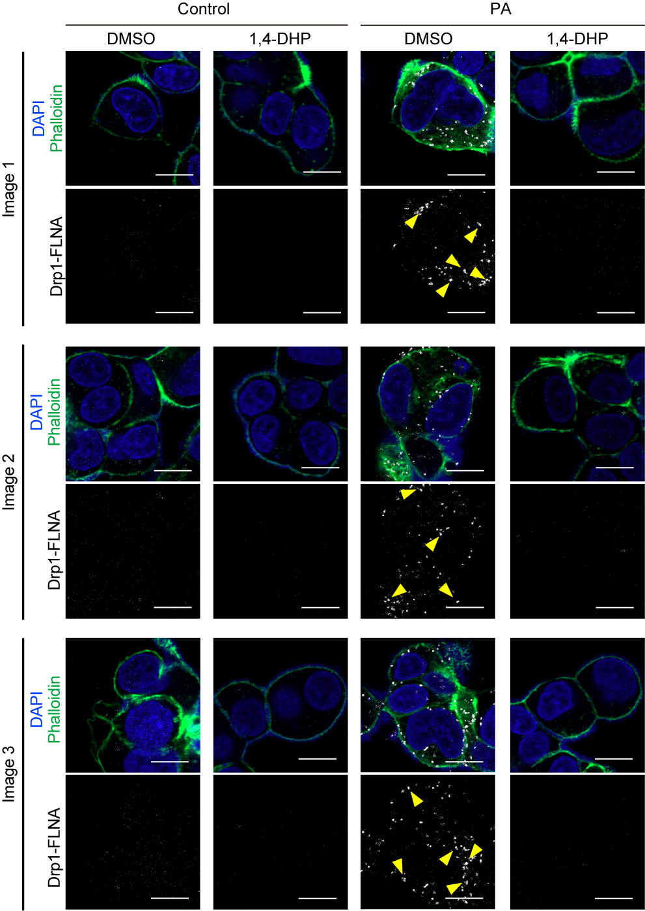
Supplemental figure 4. Effect of 1,4-DHP on the PA-induced Drp1-FLNA complex formation in HepG2. Representative images of PLA between Drp1 and FLNA. PLA signals are shown as white spots counterstained with phalloidin (green) and DAPI (blue). HepG2 cells were treated with 30 μM of PA with or without 1,4-DHP. Scale bars: 10 μm.
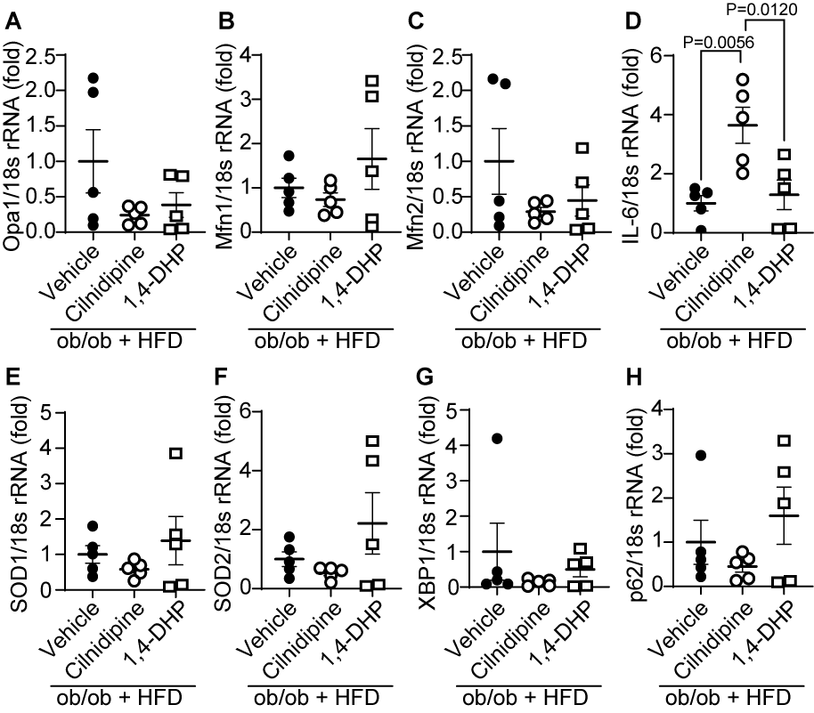
Supplemental figure 5. Changes in mRNA expression levels related to mitochondria fusion, inflammation, and ER stress in ob/ob mice fed HFD. (A-C) Gene expression of mitochondrial fusion-related proteins. The expression of Opa1 (A), Mfn1 (B), and Mfn2 (C). (D) The expression of IL-6. (E, F) Gene expression of ROS. The expression of SOD1 (E), and SOD2 (F). (G, H) Gene expression of ER stress. The expression of XBP1 (G), and p62 (H). Data are means ± SEM (n=5 mice in each group). Significance was determined using one-way ANOVA followed by Tukey’s comparison test.
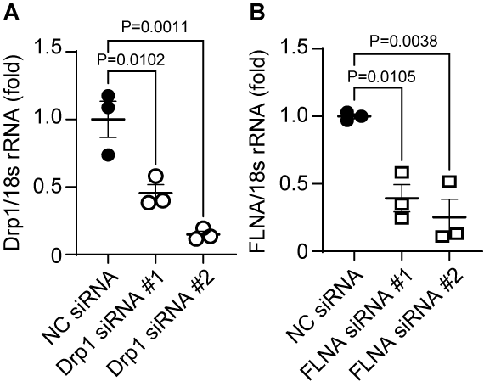
Supplemental figure 6. Knockdown efficiencies of siRNAs for Drp1 and FLNA in HepG2. (A, B) mRNA expression levels of Drp1 (A), and FLNA (B) in HepG2 cells. Data are means ± SEM (n=3 in each group). Significance was determined using two-way ANOVA followed by Tukey’s comparison test.

Supplementary Table 1 Primer list
No. | Gene |  | Primer Sequence (5’ - 3’)
1 | Drp1 | Forward | GATGCCATAGTTGAAGTGGTGAC
 |  | Reverse | CCACAAGCATCAGCAAAGTCTGG
2 | FLNA | Forward | CTTATCGCGCTGTTGGAGGT
 |  | Reverse | GCCACCGACACGTTCTCAA
3 | Opa1 | Forward | TGGAAAATGGTTCGAGAGTCAG
 |  | Reverse | CATTCCGTCTCTAGGTTAAAGCG
4 | Mfn1 | Forward | ATGGCAGAAACGGTATCTCCA
 |  | Reverse | CTCGGATGCTATTCGATCAAGTT
5 | Mfn2 | Forward | GTGGAATACGCCAGTGAGAAGC
 |  | Reverse | CAACTTGCTGGCACAGATGAGC
6 | IL-6 | Forward | AAGGGCCAGGGATCTGTAAG
 |  | Reverse | TCTCTTGTTGCTCCCCAAAG
7 | TNF-alpha | Forward | ATGAGCACAGAAAGCATGATCCGC
 |  | Reverse | CCAAAGTAGACCTGCCCGGACTC
8 | IL-1 beta | Forward | ATGGCAACTGTTCCTGAACTCAACT
 |  | Reverse | CAGGACAGGTATAGATTCTTTCCTTT
9 | MCP-1 | Forward | TTAAAAACCTGGATCGGAACCAA
 |  | Reverse | GCATTAGCTTCAGATTTACGGGT
10 | ICAM1 | Forward | GTGTGCCATGCCTTTAGCTC
 |  | Reverse | CTGATCTTTCTCTGGCGGTT
11 | SOD1 | Forward | AACCAGTTGTGTTGTCAGGAC
 |  | Reverse | CCACCATGTTTCTTAGAGTGAGG
12 | SOD2 | Forward | CAGACCTGCCTTACGACTATGG
 |  | Reverse | CTCGGTGGCGTTGAGATTGTT
13 | ATF6 | Forward | TCGCCTTTTAGTCCGGTTCTT
 |  | Reverse | GGCTCCATAGGTCTGACTCC
14 | XBP1 | Forward | CTGAGTCCGAATCAGGTGCAG
 |  | Reverse | GTCCATGGGAAGATGTTCTGG
15 | p62 | Forward | GCTGCCCTATACCCACATCT
 |  | Reverse | CGCCTTCATCCGAGAAAC
16 | chop | Forward | CACCACACCTGAAAGCAGAA
 |  | Reverse | CGTTTCCTGGGGATGAGATA
17 | PINK1 | Forward | CTTATAGGAAAGGGCCCGGATGTCG
 |  | Reverse | GATGATGTTAGGGTGTGGGGCAAGC
18 | 18srRNA | Forward | ATTAATCAAGAACGAAAGTCGCAGGT
 |  | Reverse | TTTAAGTTTCAGCTTTGCAACCATACT
19 | Human 18srRNA | Forward | CTACCACATCCAAGGAAGCA
 |  | Reverse | TTTTTCGTCACTACCTCCCCG

