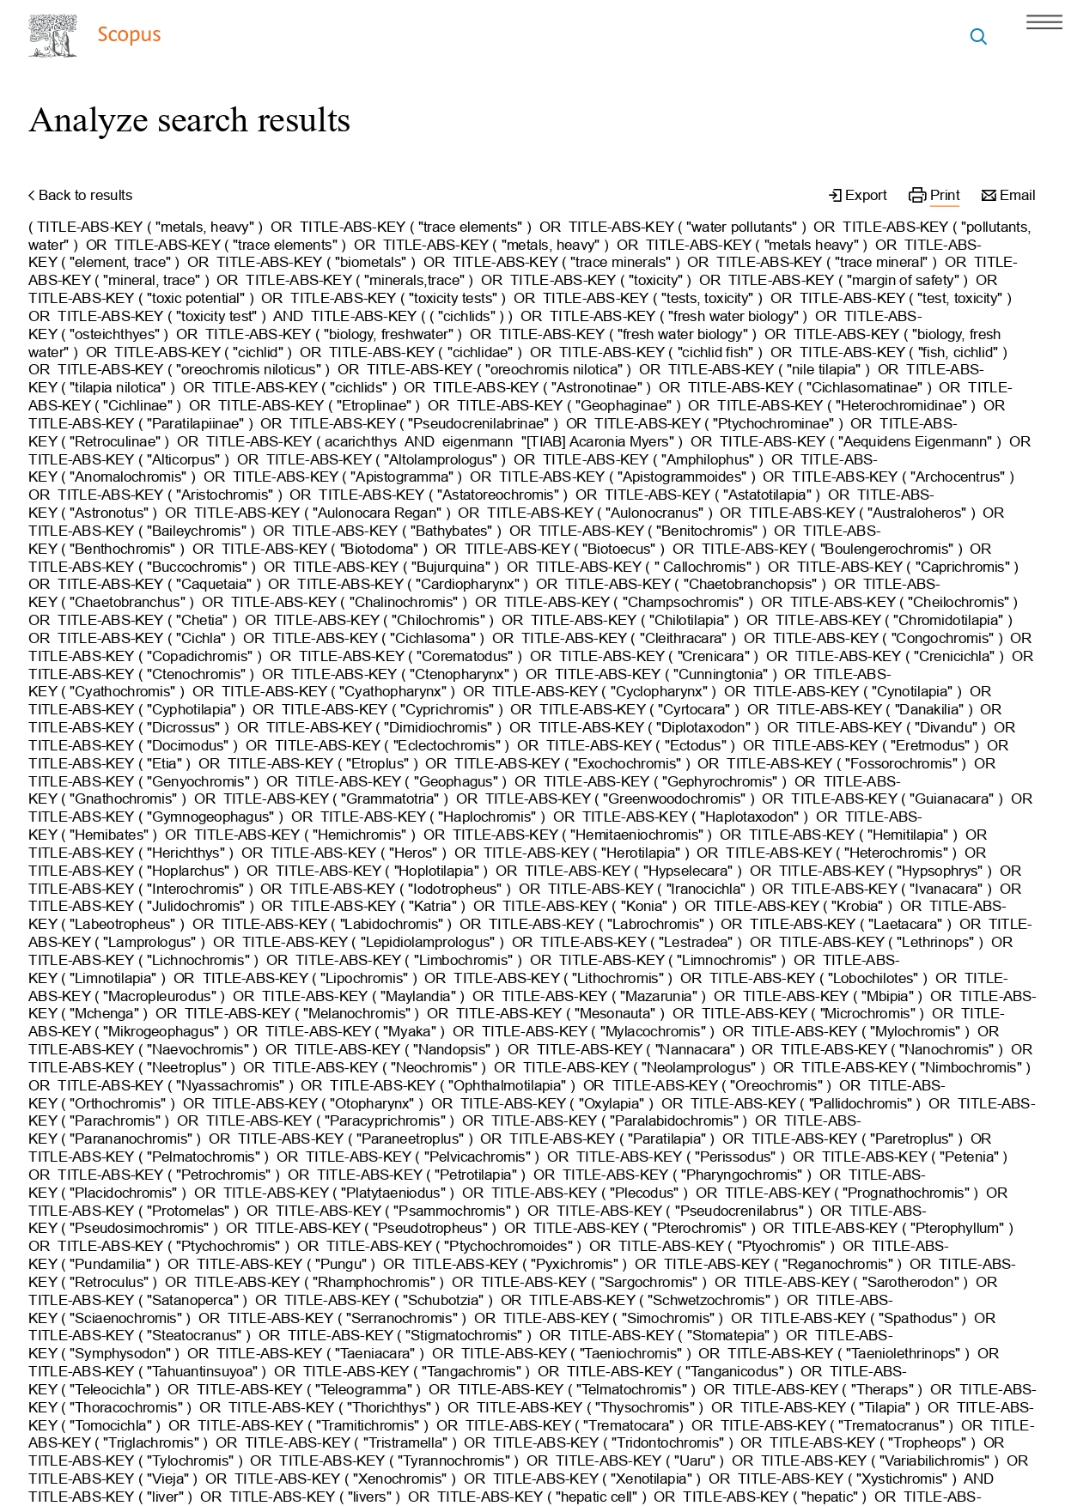

Descriptors used in search platforms Scopus

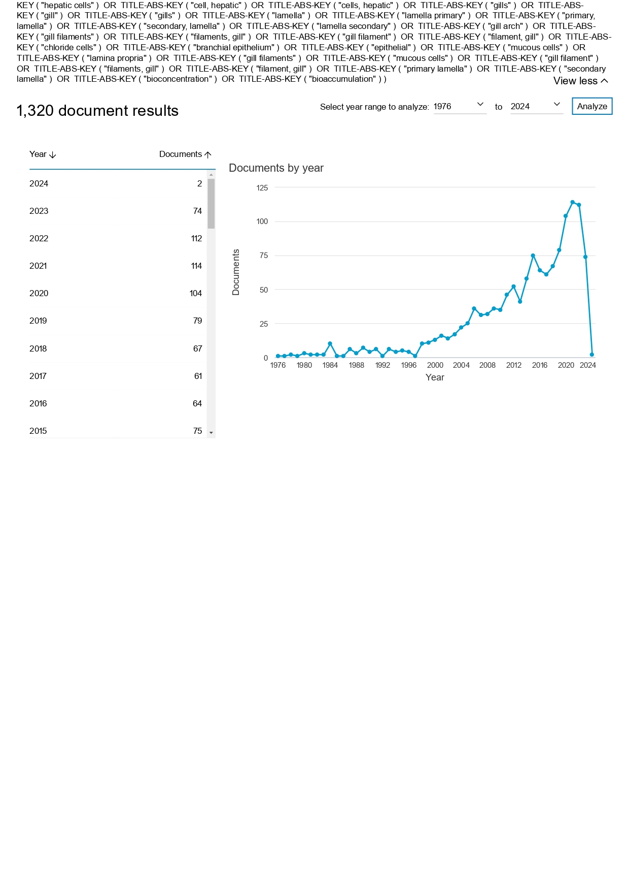

Table 1. – Características dos estudos que analisaram os efeitos da exposição à metais pesados em fígado e brânquias de ciclídeos coletados no ambiente.
References | Country | Species | Weight (g)/ Size (cm) | Number of animals | Groups of animals | Collection Period/ Station | |Analysis | Metals | Tissues
El-Demerdash and Elagamy, 1999  [30] | Egypt | Tilapia nilótica  (Oreochromis nilótica) | 200-250/ 15-20 | 20 | Test + Control | Yes/ ? | Metals in tissues and water, oxidative status, biochemical markers | Cd, Hg | Liver, Brain
Rashed, 2001(a)  [31] | Egypt | Tilapia nilótica  (Oreochromis nilótica) | 440-1020/ ? | 50 | Tests (animal ages) | ? | Metals in tissues, water, sediment and aquatic plant | Co, Cr, Cu, Fe, Mn, Ni, Sr, Zn | Liver, Gills, Muscle, Stomach, Intestine, Vertebral Column, Scales
Rashed, 2001(b)  [18] | Egypt | Tilapia nilótica  (Oreochromis nilótica) | 440-1020/ ? | 50 | Tests (animal ages) + Control | ? | Metals in tissues, water, sediment and aquatic plant | Pb, Cd | Liver, Gills, Muscle, Stomach, Intestine, Vertebral Column, Scales
Elghobashy et al, 2001  [32] | Egypt | Oreochromis niloticus | 150 ± 5/ ? | 30 | Tests (collection sites) + Control | Yes/ Summer | Metals in tissues, metals and physical-chemical parameters in water, oxidative status, biochemical markers | Fe, Cu, Zn, Pb, Cd | Liver, Gills, Kidney, Muscle
Adham et al, 2001  [33] | Egypt | Oreochromis niloticus | 150 ± 16,0/ 14,00 ± 1,4 | 200 | Tests (collection sites) + Control | Yes/ Fall-Winter, Spring-Summer | Metals and physical-chemical parameters in water, histopathology, biochemical markers | Pb, Cu, Mn, Zn, Fe, Ni, Hg | Liver, Gills, Blood
Youssef et al, 2004  [34] | Egypt | Oreochromis spp/ Sarotherodon galilaues | O. niloticus: 60-431/ 14,5-27  S. galilaeus: 3,6-37,5/ 8,0-11,5  O. oreus: 21-151,8/ 10.5-20 | ? | Tests (animal species) | ? | Metals in tissues | Cu, Zn, Fe, Mn, Cd | Liver, Gills, Kidney, Muscle, Brain, Gonad
Al-Kahtani, 2009  [35] | Arabia | Oreochromis niloticus | 40-60/ 12-19 | ? | Tests (collection stations) | Yes/ Fall, Winter, Spring, Summer | Metals in tissues, metals and physical-chemical parameters in water | Fe, Zn, Cu, Pb, Mn, Cd | Liver, Muscle
Abdel-Baki et al, 2011  [36] | Saudi Arabia | Tilapia nilótica  (Oreochromis nilótica) | ?/ ? | 10 | Test | Yes/ Summer | Metals in tissues and water | Pb, Cd, Hg, Cu, Cr | Liver, Kidney, Intestine, Gills, Muscle
Muisa et al, 2011  [37] | Zimbabwe | Oreochromis niloticus | ?/ ? | ? | Tests (collection periods and sites) | Yes/ 2 periods | Metals in tissues, water and sediment | Al | Liver, Gills, Muscle, Kidney
Abdel-Moneim et al, 2012(a)  [38] | Egypt | Oreochromis niloticus | 85-150/ 18-25 | 108 | Tests (collection sites) + Control | Yes/ ? | Metals in water, histopathology, oxidative status | Cd, Cu, Fe, Mn, Pb, Zn, Cr, Hg, Co, Ni | Gills
Abdel-Moneim et al, 2012(b)  [39] | Saudi Arabia | Oreochromis niloticus | 90-130/ 18-22 | 120 | Tests (collection sites) | Yes/ ? | Metals and physical-chemical parameters in water, histopathology | Fe, Mn, Zn, Cu, Ni, Cd, Pb, Cr, Co, Hg | Liver, Gills
Cyrille et al, 2012  [40] | Ivory Coast | Sarotherodon melanotheron | Juvenile: 15,1-15,8/ ? Adult: 19,5-25,0/ ? | 15 | Tests (juvenile and adult animals) | Yes/ Dry, Rainy, Swelling | Metals in tissues, water physical-chemical parameters | Cd | Liver, Gills, Muscle
Carvalho et al, 2012  [41] | Brazil | Oreochromis niloticus | 90-200/ 15-20 | 32 | Tests (collection stations) + Control | Yes/ Fall, Winter, Spring, Summer | Metals and physical-chemical parameters in water, oxidative status, biochemical markers | Cr, Cd, Cu, Zn, Mn, Fe | Liver, Gills, Muscle
Coulibaly et al, 2012  [42] | Ivory Coast | Sarotherodon melanotheron | ?/ ? | 60 | Tests (collection stations) | Yes/ Dry, Rainy, Swelling | Metals in tissues, water and sediment | Cd, Cu, Pb, Hg, Zn | Liver, Kidney, Muscle, Brain
Abdel-Moneim et al, 2013a  [43] | Egypt | Oreochromis niloticus | 125-210/ 20-26 | 120 | Test + Control | Yes/ ? | Metals in tissues and water, oxidative status, histopathology | Cd, Cu, Fe, Pb, Zn, Mn | Liver
Abdel-Moneim, 2013b  [44] | Saudi Arabia | Oreochromis niloticus | 75-152/ 15-21 | ? | Tests (collection sites) + Control | Yes/ ? | Metals in water, histopathology | Ni, Fe, Zn, Co, Ba, Pb, Cu, Cd | Liver
Jinadasa and Edirisinghe, 2014  [45] | Sri Lanka | Tilapia sp | 216.6 ± 162,1/ 21,1 ± 4,0 | 80 | Tests (collection sites) | ? | Metals in tissues | Cd, Pb, Hg | Liver, Gills, Muscle
Mohamed and Osman, 2014  [46] | Sudan | Oreochromis niloticus | ?/ ~13 | ? | Tests (collection sites) | ? | Metals in tissues and water | Cd, Cr, Ni, Pb, Cu, Zn, Fe, Sr | Muscle, Gills
Voigt et al, 2014  [47] | Brazil | Geophagus brasiliensis | Male: 59,5-278,0/ 145-250  Female: 64,6-145,4/ 150-190 | Male:38  Female:17 | Tests (gender, weight and size of animals) | Yes/ Summer | Metals in tissues, water and sediment | Cu, Mn, Zn, Fe, Co, Cd, Cr, Ag, Ni | Liver, Gills, Muscle
Abdel-Khalek, 2014  [48] | Egypt | Oreochromis niloticus | 160-180/ 18,5-24,8 | 36 | Tests (collection sites) + Contol | Yes/ Summer | Metals in tissues and water, histopathology | Cu, Zn, Pb, Fe, Mn, Cd | Liver, Gills, Kidney, Muscle
Abdel-Khalek, 2015  [49] | Egypt | Oreochromis niloticus | 160-180/ 18,5-24,8 | 36 | Tests (collection sites) + Control | Yes/ Summer | Metals and physical-chemical parameters in water, oxidative status | Cu, Zn, Pb, Fe, Mn, Cd | Liver, Gills, Blood
Ajima et al, 2015  [50] | Nigeria | Pelmatochromis guentheri/  Pelmatochromis pulcher | 35 ± 0,05/ ? | 18 | Tests (animal species) | ? | Metals in tissues, water and sediment | Pb, Zn, Cd, Cu, Fe | Gills, Muscle, Intestine
Ruelas-Inzunza et al, 2015  [51] | Mexico | Oreochromis aureus | Rainy station: 506,8 ± 100,5/ 30,9±2,4 Dry station: 563,4 ± 93,9/ 31,0±2,8 | 80 | Tests (collection stations) | Yes/ Dry,  Rainy | Metals in tissues | Hg | Liver, Muscle, Kidney
Kumar et al, 2016  [52] | India | Oreochromis mossambicus | ? | 54 | Tests (collection sites) | Yes/ ? | Metals in muscle, histopathology, oxidative status, biochemical markers | Cr, Mn, Co, Ni, Cu, Zn, As, Se, Cd, Hg, Pb | Liver, Gills, Kidney, Muscle, Brain, Gonad
Mbewe et al, 2016  [53] | Zambia | Tilapia andersonii/  T. rendalli/  Oreochromis niloticus | T.rendalli: 170-250/ ?  O.niloticus: 150-300/ ?  T.andersonii: 390/ ? | 3/ 4/ 3 | Tests (animal species and collection sites) | Yes/ ? | Metals in tissues and sediment | Cu, Cd, Pb, Mn, Cr, Ni, Fe | Liver, Gonads, Muscle, Intestines, Head.
Doria et al, 2017  [54] | Brazil | Geophagus brasiliensis | 148,8 ± 8,89/ 19,97 ± 2,87 | 55 | Tests (collection sites) | Yes/ Summer | Metals in tissues, histopathology, oxidative status, biochemical markers | Cu, Mn, Zn, Co, Cd, Cr, Ag, Pb, Ni, Al, As | Liver, Gills, Blood, Muscle, Brain
Kumar et al, 2017  [55] | India | Oreochromis mossambicus | ?/ ? | ? | Tests (collection sites) | Yes/ ? | Metals in tissues, water and sediment, oxidative status, biochemical markers | Cr, Mn, Co, Ni, Cu, Zn, As, Se, Cd, Hg, Pb | Liver, Gills, Kidney, Muscle, Brain, Gonad
Muñoz-Nájera et al, 2018  [56] | Mexico | Oreochromis niloticus | ?/ ? | 150 | Tests (collection periods) | Yes/ 5 periods | Metals in tissues, metals and physical-chemical parameters in water, biochemical markers | Cd, Cr, Cu, Pb | Liver, Muscle
Pettamanna; Raghav; Nair, 2020  [57] | Índia | Etroplus suratensis | 65,7-83,1/11-14,5 | 15 | Test + Control | Yes/Winter | Metals and physical-chemical parameters in water, histopathology, biochemical markers | Cu, Fe | Liver
Martínez-Durazo et al, 2020  [58] | Mexico | Tilapia nilótica  (Oreochromis niloticus)  Largemouth bass  (Micropterus  salmoides) | 461,8-619,6/26,98-34,51  45,1-1.182,0/30,17-40,10 | 21-30  21-30 | Tests (animal species) | Yes/Dry and Rainy | Metals in tissues. | Cr, Cu, Fe, Mn, Ni,Zn | Liver, gills, stomach, gonads and muscle
Salem et al, 2021  [59] | Egypt | Tilapia nilótica  (Oreochromis nilótica) | 80±5/17±2 | 16 males | Tests (collection sites) | Yesyear all | Metals in tissues, metals and physical-chemical in water, quantitative, biochemical markers Real-Time PCR. | Cd, Fe, Mn, Co e Pb | Liver
Ngo et al, 2022  [01] | Vietname | common Carp (Cyprinus carpio),  silver Carp (Hypothalmic molitrix),  Tilapia nilótica (Oreochromis niloticus) | ? | 240/240/240 | Tests (animal species) | Yes/four seasons | Metals in tissues and wate, oxidative status, biochemical markers. | Zn, Cu, Pb, Cd | Livers, kidneys, gills
Páez-Osuna et al, 2022  [60] | Mexico | Oreochromis aureus | 200-840/22.2-41.3 | 15 | Tests (collection periods) | Yes/spring | Metals in tissues, sediments, metals and physical-chemical parameters in water and risk assessment. | As, Cd, Cu, Hg, Se, Zn | Liver, muscle, and guts
Vieira et al, 2023  [61] | Brazil | Tucunare (Cichla sp).  Piraíba (Braquiplatystoma filamentosum)  Jaraqui (Semaprochilodus sp) | ? | 10/10/10 | Tests (animal species) | ? | Metals in tissues, oxidative status, biochemical markers and bioinformatic. | Hg | Liver, muscle
Martínez-Durazo et al, 2023  [6] | Mexico | Tilapia nilótica  (Oreochromis niloticus)  Largemouth bass  (Micropterus  salmoides | ? | 20/20/20 | Tests (animal species) + control | Yes/Dry and Rainy | Metals in tissues, histopathology. | Cr, Cu, Fe, Mn Ni, Zn, As, Hg, Se. | Liver, gills, muscle, gonads
Páez-Osuna, et al, 2023  [62] | Mexico | Carpa mon  (Cyprinus carpio)  Tilápia azul  (Oreochromis aureus)  Robalo  (Micropterus  salmoides) | C.carpio  36,5-47/625/1.725  O. aureus  21-34/165-670  M. salmoides  24-38/170/740 | 7/22/16 | Tests (animal species) | ? | Metals in tissues, risk assessment. | As, Cd, Cu, Zn | Liver, gills, muscle, guts
Table 1. Legenda: Ag: Silver; Al: aluminum; As: Arsênico; Ba: Barium; Ni Cd: Cadmium; Co: Cobalt; Cr: Chrome; Cu: Copper; Se: Selenium; Fe: Iron; Hg: Mercury; Mn: Manganese; Mo: Molybdenum; Nickel; Pb: Lead; Se: Selênio; Sr: Strontium; Zn: Zinc; ?: uninformed.

Table 2 – Resultados primários dos estudos sobre efeitos de metais pesados na histologia e no status oxidativo branquial e hepática de peixes ciclídeos em ambientes contaminados.
Metais pesados |  | Órgãos | Danos histológicos | Estresse Oxidativo
Cd |  | Fígado  (n=5) | ↑necrose, esteatose, lipidose, hiperemia, hemorragia, congestão, neoplasia, diferenciação celular, vacuolização citoplasmática e nuclear, degeneração citoplasmática e nuclear, núcleo picnótico, eosinófilos e infiltrados leucocitários. | MDA:↑  SOD: ↓  GSH:↑  GST:↑  GPx: ↓  CAT: ↓  LPO:↑  PCO: ↑
 |  | Brânquia  (n=3) | ↑ hiperplasia, hipertrofia, dilatação vascular, levantamento do epitélio, fusão lamelar, desorganização lamelar, congestão, aneurisma, fusão lamelar e ruptura das células de cloreto. | MDA: ↑  SOD: ↑  GSH: ↑  GST: ↑  GR: ↓  GPx: ↓  CAT: ↓  LPO: ↑  G6PD:↓
Cu |  | Fígado  (n=8) | ↑ necrose, esteatose, lipidose, hiperemia, hemorragia, congestão, neoplasia, diferenciação tecidual, vacuolização citoplasmática e nuclear, degeneração citoplasmática e nuclear, núcleo picnótico, eosinófilos e infiltrados leucocitários. | MDA:↑  SOD: ↓  GSH:↑  GST:↑  GPx: ↓  CAT: ↓  LPO:↑  PCO: ↑
 |  | Brânquia  (n=5) | ↑ Hiperplasia, hipertrofia, dilatação vascular, levantamento do epitélio, fusão lamelar, desorganização lamelar, congestão, aneurisma, fusão lamelar e ruptura das células de cloreto. | MDA: ↑  SOD: ↑  GSH: ↑  GST: ↑  GR: ↓  GPx: ↓  CAT: ↓  LPO: ↑  G6PD:↓
Pb |  | Fígado  (n=6) | ↑ necrose, esteatose, lipidose, hiperemia, hemorragia, congestão, neoplasia, diferenciação tecidual, vacuolização citoplasmática e nuclear, degeneração citoplasmática e nuclear, núcleo picnótico.  ↑ Eosinófilos e infiltrados leucocitários. | MDA:↑  SOD: ↓  GSH:↑  GST:↑  GPx: ↓  CAT: ↓  LPO:↑  PCO: ↑
 |  | Brânquia  (n=4) | ↑ Hiperplasia, hipertrofia, dilatação vascular, levantamento do epitélio, fusão lamelar, desorganização lamelar, congestão, aneurisma, fusão lamelar e ruptura das células de cloreto. | MDA: ↑  SOD: ↑  GSH: ↑  GST: ↑  GR: ↓  GPx: ↓  CAT: ↓  LPO: ↑  G6PD:↓
Zn |  | Fígado  (n=7) | ↑ necrose, esteatose, lipidose, hiperemia, hemorragia, congestão, neoplasia, diferenciação tecidual, vacuolização citoplasmática e nuclear, degeneração citoplasmática e nuclear, núcleo picnótico.  ↑ Eosinófilos e infiltrados leucocitários. | MDA:↑  SOD: ↓  GSH:↑  GST:↑  GPx: ↓  CAT: ↓  LPO:↑  PCO: ↑
 |  | Brânquia  (n=5) | ↑ Hiperplasia, hipertrofia, dilatação vascular, levantamento do epitélio, fusão lamelar, desorganização lamelar, congestão, aneurisma, fusão lamelar e ruptura das células de cloreto. | MDA: ↑  SOD: ↑  GSH: ↑  GST: ↓  GR: ↓  GPx: ↓  CAT: ↓  LPO: ↑  G6PD:↓
Mn |  | Fígado  (n=7) | ↑ necrose, esteatose, lipidose, hiperemia, hemorragia, congestão, neoplasia, diferenciação tecidual, vacuolização citoplasmática e nuclear, degeneração citoplasmática e nuclear, núcleo picnótico.  ↑ Eosinófilos e infiltrados leucocitários. | MDA:↑  SOD: ↓  GSH:↑  GST:↑  GPx: ↓  CAT: ↓  LPO:↑  PCO: ↑
 |  | Brânquia  (n=5) | ↑ Hiperplasia, hipertrofia, dilatação vascular, levantamento do epitélio, fusão lamelar, desorganização lamelar, congestão, aneurisma, fusão lamelar e ruptura das células de cloreto. | MDA: ↑  SOD: ↑  GSH: ↑  GST: ↑  GR: ↓  GPx: ↓  CAT: ↓  LPO: ↑  G6PD:↓
Fe |  | Fígado  (n=6) | ↑ necrose, esteatose, lipidose, hiperemia, hemorragia, congestão, neoplasia, diferenciação tecidual, vacuolização citoplasmática e nuclear, degeneração citoplasmática e nuclear, núcleo picnótico.  ↑ Eosinófilos e infiltrados leucocitários. | MDA:↑  SOD: ↓  GSH:↑  GST:↑  GPx: ↓  CAT: ↓  LPO:↑  PCO: ↑
 |  | Brânquia  (n=3) | ↑ Hiperplasia, hipertrofia, dilatação vascular, levantamento do epitélio, fusão lamelar, desorganização lamelar, congestão, aneurisma, fusão lamelar e ruptura das células de cloreto. | MDA: ↑  SOD: ↑  GSH: ↑  GST: ↑  GR: ↓  GPx: ↓  CAT: ↓  LPO: ↑  G6PD:↓
Cr |  | Fígado  (n=5) | ↑ necrose, esteatose, lipidose, hiperemia, hemorragia, congestão, neoplasia, diferenciação tecidual, vacuolização citoplasmática e nuclear, degeneração citoplasmática e nuclear, núcleo picnótico.  ↑ Eosinófilos e infiltrados leucocitários. | MDA:↑  SOD: ↓  GSH:↑  GST:↑  GPx: ↓  CAT: ↓  LPO:↑  PCO: ↑
 |  | Brânquia  (n=3) | ↑ Hiperplasia, hipertrofia, dilatação vascular, levantamento do epitélio, fusão lamelar, desorganização lamelar, congestão, aneurisma, fusão lamelar e ruptura das células de cloreto. | MDA: ↑  SOD: ↑  GSH: ↑  GST: ↑  GR: ↓  GPx: ↓  CAT: ↓  LPO: ↑  G6PD:↓
Hg |  | Fígado  (n=5) | ↑ necrose, esteatose, lipidose, hiperemia, hemorragia, congestão, neoplasia, diferenciação tecidual, vacuolização citoplasmática e nuclear, degeneração citoplasmática e nuclear, núcleo picnótico.  ↑ Eosinófilos e infiltrados leucocitários. | MDA:↑  SOD: ↓  GSH:↑  GST:↑  GPx: ↓  CAT: ↓  LPO:↑  PCO: ↑
 |  | Brânquia  (n=3) | ↑ Hiperplasia, hipertrofia, dilatação vascular, levantamento do epitélio, fusão lamelar, desorganização lamelar, congestão, aneurisma, fusão lamelar e ruptura das células de cloreto. | MDA: ↑  SOD: ↑  GSH: ↑  GST: ↑  GR: ↓  GPx: ↓  CAT: ↓  LPO: ↑  G6PD:↓
Ni |  | Fígado  (n=6) | ↑ necrose, esteatose, lipidose, hiperemia, hemorragia, congestão, neoplasia, diferenciação tecidual, vacuolização citoplasmática e nuclear, degeneração citoplasmática e nuclear, núcleo picnótico.  ↑ Eosinófilos e infiltrados leucocitários. | MDA:↑  SOD: ↓  GSH:↑  GST:↑  GPx: ↓  CAT: ↓  LPO:↑  PCO: ↑
 |  | Brânquia  (n=4) | ↑ Hiperplasia, hipertrofia, dilatação vascular, levantamento do epitélio, fusão lamelar, desorganização lamelar, congestão, aneurisma, fusão lamelar e ruptura das células de cloreto. | MDA: ↑  SOD: ↑  GSH: ↑  GST: ↑  GR: ↓  GPx: ↓  CAT: ↓  LPO: ↑  G6PD:↓
Co |  | Fígado  (n=4) | ↑ necrose, esteatose, lipidose, hiperemia, hemorragia, congestão, neoplasia, diferenciação tecidual, vacuolização citoplasmática e nuclear, degeneração citoplasmática e nuclear, núcleo picnótico.  ↑ Eosinófilos e infiltrados leucocitários. | MDA:↑  SOD: ↓  GSH:↑  GST:↑  GPx: ↓  CAT: ↓  LPO:↑  PCO: ↑
 |  | Brânquia  (n=2) | ↑ Hiperplasia, hipertrofia, dilatação vascular, levantamento do epitélio, fusão lamelar, desorganização lamelar, congestão, aneurisma, fusão lamelar e ruptura das células de cloreto. | MDA: ↑  SOD: ↑  GSH: ↑  GST: ↑  GR: ↓  GPx: ↓  CAT: ↓  LPO: ↑  G6PD:↓
Ag |  | Fígado  (n=1) | ↑ necrose, esteatose, hemorragia, congestão, diferenciação tecidual.  . | -
 |  | Brânquia  (n=1) | ↑ Hiperplasia, fusão lamelar, aneurisma, parasita, descamação epitelial e necrose. | -
As |  | Fígado  (n=3) | ↑ necrose, esteatose, hemorragia, congestão, diferenciação tecidual, vacuolização, núcleo picnótico, degeneração citoplasmática e hiperemia.  . | SOD e CAT: ↓  PCO e LPO: ↑
 |  | Brânquia  (n=3) | ↑ Hiperplasia, fusão lamelar, aneurisma, parasita, descamação epitelial e necrose. | -
Al |  | Fígado  (n=1) | ↑ necrose, esteatose, hemorragia, congestão, diferenciação tecidual.  . | SOD e CAT: ↓  PCO e LPO: ↑
 |  | Brânquia  (n=1) | ↑ Hiperplasia, fusão lamelar, aneurisma, parasita, descamação epitelial e necrose. | -
Se |  | Fígado  (n=2) | - |  | MDA:↑  SOD: ↓  GSH:↑  GST:↑  GPx: ↓  CAT: ↓  LPO:↑  PCO: ↑
 |  | Brânquia  (n=2) | -

Table 3: Descriptors used in search platforms Pubmed
PUBMED
Heavy Metals | Fish | Liver and Gill
("metals, heavy"[MeSH Terms] OR "trace elements"[MeSH Terms] OR "water pollutants"[MeSH Terms] OR "pollutants, water"[TIAB] OR "water pollutants"[TIAB] OR "trace elements"[TIAB] OR "metals, heavy"[ TIAB] OR "metals heavy"[TIAB] OR "metal heavy"[TIAB] OR "element, trace"[TIAB] OR "elements, trace"[TIAB] OR "biometals"[TIAB] OR "biometal"[TIAB] OR "trace minerals"[TIAB] OR "trace mineral"[TIAB] OR "mineral, trace" [TIAB] OR "minerals,trace"[TIAB] OR "toxicity"[TIAB] OR "toxicity"[MeSH Terms] OR "margin of safety"[TIAB] OR "toxic potential"[TIAB] OR "toxicity tests"[MeSH Terms] OR "tests, toxicity"[TIAB] OR "test, toxicity"[TIAB] OR "toxicity test"[TIAB]) | ("cichlids"[MeSH Terms] OR "fresh water biology"[MeSH Terms] OR "osteichthyes" [TIAB] OR "Biology, Freshwater"[TIAB] OR "Fresh Water Biology"[TIAB] OR "Biology, Fresh Water"[TIAB] OR "cichlid"[TIAB] OR "cichlidae"[TIAB] OR "cichlid fish"[TIAB] OR "fish, cichlid"[TIAB] OR "Oreochromis niloticus"[TIAB] OR "Oreochromis nilotica"[TIAB] OR "nile tilapia"[TIAB] OR "tilapia nilotica"[TIAB] OR "cichlids"[TIAB] OR "Astronotinae"[TIAB] OR "Cichlasomatinae"[TIAB] OR "Cichlinae"[TIAB] OR "Etroplinae"[TIAB] OR "Geophaginae"[TIAB] OR "Heterochromidinae"[TIAB] OR "Paratilapiinae"[TIAB] OR "Pseudocrenilabrinae"[TIAB] OR "Ptychochrominae"[TIAB] OR "Retroculinae"[TIAB] OR Acarichthys Eigenmann"[TIAB] Acaronia Myers"[TIAB] OR "Aequidens Eigenmann"[TIAB] OR "Alticorpus"[TIAB] OR "Altolamprologus"[TIAB] OR "Amphilophus"[TIAB] OR "Anomalochromis"[TIAB] OR "Apistogramma"[TIAB] OR "Apistogrammoides"[TIAB] OR "Archocentrus"[TIAB] OR "Aristochromis"[TIAB] OR "Astatoreochromis"[TIAB] OR "Astatotilapia"[TIAB] OR "Astronotus"[TIAB] OR "Aulonocara Regan"[TIAB] OR "Aulonocranus"[TIAB] OR "Australoheros"[TIAB] OR "Baileychromis"[TIAB] OR "Bathybates"[TIAB] OR "Benitochromis"[TIAB] OR "Benthochromis"[TIAB] OR "Biotodoma"[TIAB] OR "Biotoecus"[TIAB] OR "Boulengerochromis"[TIAB] OR "Buccochromis"[TIAB] OR "Bujurquina"[TIAB] OR " Callochromis"[TIAB] OR "Caprichromis"[TIAB] OR "Caquetaia"[TIAB] OR "Cardiopharynx"[TIAB] OR "Chaetobranchopsis"[TIAB] OR "Chaetobranchus"[TIAB] OR "Chalinochromis"[TIAB] OR "Champsochromis"[TIAB] OR "Cheilochromis"[TIAB] OR "Chetia"[TIAB] OR "Chilochromis"[TIAB] OR "Chilotilapia"[TIAB] OR "Chromidotilapia"[TIAB] OR "Cichla"[TIAB] OR "Cichlasoma"[TIAB] OR "Cleithracara"[TIAB] OR "Congochromis"[TIAB] OR "Copadichromis"[TIAB] OR "Corematodus"[TIAB] OR "Crenicara"[TIAB] OR "Crenicichla"[TIAB] OR "Ctenochromis"[TIAB] OR "Ctenopharynx"[TIAB] OR "Cunningtonia"[TIAB] OR "Cyathochromis"[TIAB] OR "Cyathopharynx"[TIAB] OR "Cyclopharynx"[TIAB] OR "Cynotilapia"[TIAB] OR "Cyphotilapia"[TIAB] OR "Cyprichromis"[TIAB] OR "Cyrtocara"[TIAB] OR "Danakilia"[TIAB] OR "Dicrossus"[TIAB] OR "Dimidiochromis"[TIAB] OR "Diplotaxodon"[TIAB] OR "Divandu"[TIAB] OR "Docimodus"[TIAB] OR "Eclectochromis"[TIAB] OR "Ectodus"[TIAB] OR "Eretmodus"[TIAB] OR "Etia"[TIAB] OR "Etroplus"[TIAB] OR "Exochochromis"[TIAB] OR "Fossorochromis"[TIAB] OR "Genyochromis"[TIAB] OR "Geophagus"[TIAB] OR "Gephyrochromis"[TIAB] OR "Gnathochromis"[TIAB] OR "Grammatotria"[TIAB] OR "Greenwoodochromis"[TIAB] OR "Guianacara"[TIAB] OR "Gymnogeophagus"[TIAB] OR "Haplochromis"[TIAB] OR "Haplotaxodon"[TIAB] OR "Hemibates"[TIAB] OR "Hemichromis"[TIAB] OR "  Hemitaeniochromis"[TIAB] OR "Hemitilapia"[TIAB] OR "Herichthys"[TIAB] OR "Heros"[TIAB] OR "Herotilapia"[TIAB] OR "Heterochromis"[TIAB] OR "Hoplarchus"[TIAB] OR "Hoplotilapia"[TIAB] OR "Hypselecara"[TIAB] OR "Hypsophrys"[TIAB] OR "Interochromis"[TIAB] OR "Iodotropheus"[TIAB] OR "Iranocichla"[TIAB] OR "Ivanacara"[TIAB] OR "Julidochromis"[TIAB] OR "Katria"[TIAB] OR "Konia"[TIAB] OR "Krobia"[TIAB] OR "Labeotropheus"[TIAB] OR "Labidochromis"[TIAB] OR "Labrochromis"[TIAB] OR "Laetacara"[TIAB] OR "Lamprologus"[TIAB] OR "Lepidiolamprologus"[TIAB] OR "Lestradea"[TIAB] OR "Lethrinops"[TIAB] OR "Lichnochromis"[TIAB] OR "Limbochromis"[TIAB] OR "Limnochromis"[TIAB] OR "Limnotilapia"[TIAB] OR "Lipochromis"[TIAB] OR "Lithochromis"[TIAB] OR "Lobochilotes"[TIAB] OR "Macropleurodus"[TIAB] OR "Maylandia"[TIAB] OR "Mazarunia"[TIAB] OR "Mbipia"[TIAB] OR "Mchenga"[TIAB] OR "Melanochromis"[TIAB] OR "Mesonauta"[TIAB] OR "Microchromis"[TIAB] OR "Mikrogeophagus"[TIAB] OR "Myaka"[TIAB] OR "Mylacochromis"[TIAB] OR "Mylochromis"[TIAB] OR "Naevochromis"[TIAB] OR "Nandopsis"[TIAB] OR "Nannacara"[TIAB] OR "Nanochromis"[TIAB] OR "Neetroplus"[TIAB] OR "Neochromis"[TIAB] OR "Neolamprologus"[TIAB] OR "Nimbochromis"[TIAB] OR "Nyassachromis"[TIAB] OR "Ophthalmotilapia"[TIAB] OR "Oreochromis"[TIAB] OR "Orthochromis"[TIAB] OR "Otopharynx"[TIAB] OR "Oxylapia"[TIAB] OR "Pallidochromis"[TIAB] OR "Parachromis"[TIAB] OR "Paracyprichromis"[TIAB] OR "Paralabidochromis"[TIAB] OR "Parananochromis"[TIAB] OR "Paraneetroplus"[TIAB] OR "Paratilapia"[TIAB] OR "Paretroplus"[TIAB] OR "Pelmatochromis"[TIAB] OR "Pelvicachromis"[TIAB] OR "Perissodus"[TIAB] OR "Petenia"[TIAB] OR "Petrochromis"[TIAB] OR "Petrotilapia"[TIAB] OR "Pharyngochromis"[TIAB] OR "Placidochromis"[TIAB] OR "Platytaeniodus"[TIAB] OR "Plecodus"[TIAB] OR "Prognathochromis"[TIAB] OR "Protomelas"[TIAB] OR "Psammochromis"[TIAB] OR "Pseudocrenilabrus"[TIAB] OR "Pseudosimochromis"[TIAB] OR "Pseudotropheus"[TIAB] OR "Pterochromis"[TIAB] OR "Pterophyllum"[TIAB] OR "Ptychochromis"[TIAB] OR "Ptychochromoides"[TIAB] OR "Ptyochromis"[TIAB] OR "Pundamilia"[TIAB] OR "Pungu"[TIAB] OR "Pyxichromis"[TIAB] OR "Reganochromis"[TIAB] OR "Retroculus"[TIAB] OR "Rhamphochromis"[TIAB] OR "Sargochromis"[TIAB] OR "Sarotherodon"[TIAB] OR "Satanoperca"[TIAB] OR "Schubotzia"[TIAB] OR "Schwetzochromis"[TIAB] OR "Sciaenochromis"[TIAB] OR "Serranochromis"[TIAB] OR "Simochromis"[TIAB] OR "Spathodus"[TIAB] OR "Steatocranus"[TIAB] OR "Stigmatochromis"[TIAB] OR "Stomatepia"[TIAB] OR "Symphysodon"[TIAB] OR "Taeniacara"[TIAB] OR "Taeniochromis"[TIAB] OR "Taeniolethrinops"[TIAB] OR "Tahuantinsuyoa"[TIAB] OR "Tangachromis"[TIAB] OR "Tanganicodus"[TIAB] OR "Teleocichla"[TIAB] OR "Teleogramma"[TIAB] OR "Telmatochromis"[TIAB] OR "Theraps"[TIAB] OR "Thoracochromis"[TIAB] OR "Thorichthys"[TIAB] OR "Thysochromis"[TIAB] OR "Tilapia"[TIAB] OR "Tomocichla"[TIAB] OR "Tramitichromis"[TIAB] OR "Trematocara"[TIAB] OR "Trematocranus"[TIAB] OR "Triglachromis"[TIAB] OR "Tristramella"[TIAB] OR "Tridontochromis"[TIAB] OR "Tropheops"[TIAB] OR "Tropheus"[TIAB] OR "Tylochromis"[TIAB] OR "Tyrannochromis"[TIAB] OR "Uaru"[TIAB] OR "Variabilichromis"[TIAB] OR "Vieja"[TIAB] OR "Xenochromis"[TIAB] OR "Xenotilapia"[TIAB] OR "Xystichromis"[TIAB]) | ("liver"[MeSH Terms] OR "liver"[TIAB] OR "livers"[TIAB] OR "hepatic cell"[TIAB] OR "hepatic"[TIAB] OR "hepatic cells"[TIAB] OR "cell, hepatic"[TIAB] OR "cells, hepatic"[TIAB] OR "gills"[MeSH Terms] OR "gill"[TIAB] OR "gills"[TIAB] OR "lamella"[TIAB] OR "lamella primary"[TIAB] OR "primary, lamella"[TIAB] OR "secondary, lamella"[TIAB] OR "lamella secondary"[TIAB] OR "gill arch"[TIAB] OR "gill filaments"[TIAB] OR "filaments, gill"[TIAB] OR "gill filament"[TIAB] OR "filament, gill"[TIAB] OR "chloride cells"[TIAB] OR "branchial epithelium"[TIAB] OR "epithelial"[TIAB] OR "mucous cells"[TIAB] OR "lamina propria"[TIAB] OR "gill filaments"[TIAB] OR "foregut"[TIAB] OR "hingut"[TIAB] OR "mucous cells" [TIAB] OR "gill filament"[TIAB] OR "filaments, gill"[TIAB] OR "filament, gill"[TIAB] OR "primary lamella"[TIAB] OR "secondary lamella"[TIAB] OR "bioconcentration"[TIAB] OR "bioaccumulation"[TIAB])

