Supporting Information
Oxygen defects containing TiN films for the hydrogen evolution reaction: a robust thin film electrocatalyst with outstanding performance
Ayoub Laghrissi and Mohammed Es-Souni *
A. Laghrissi¹
¹Currently with the Technical Faculty, Mads Clausen
Institute, University of Southern Denmark, 6400 Sønderborg
Prof. Dr. habil. M. Es-Souni
Institute for Materials & Surface Technology,
Honorary Member, Kiel University of Applied Sciences
Sokrates Platz 1, D-24149 Kiel, Germany
E-mail: mohammed.es-souni@fh-kiel.de

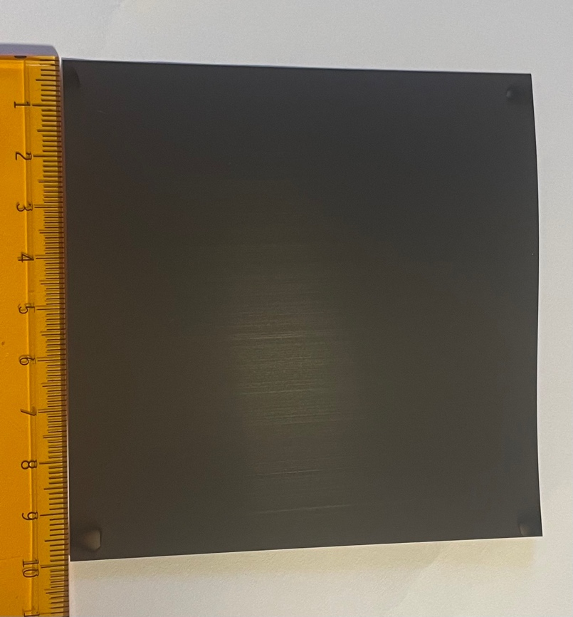

Figure S1: a photograph of a large area TiNO film deposited on a Ti sheet.

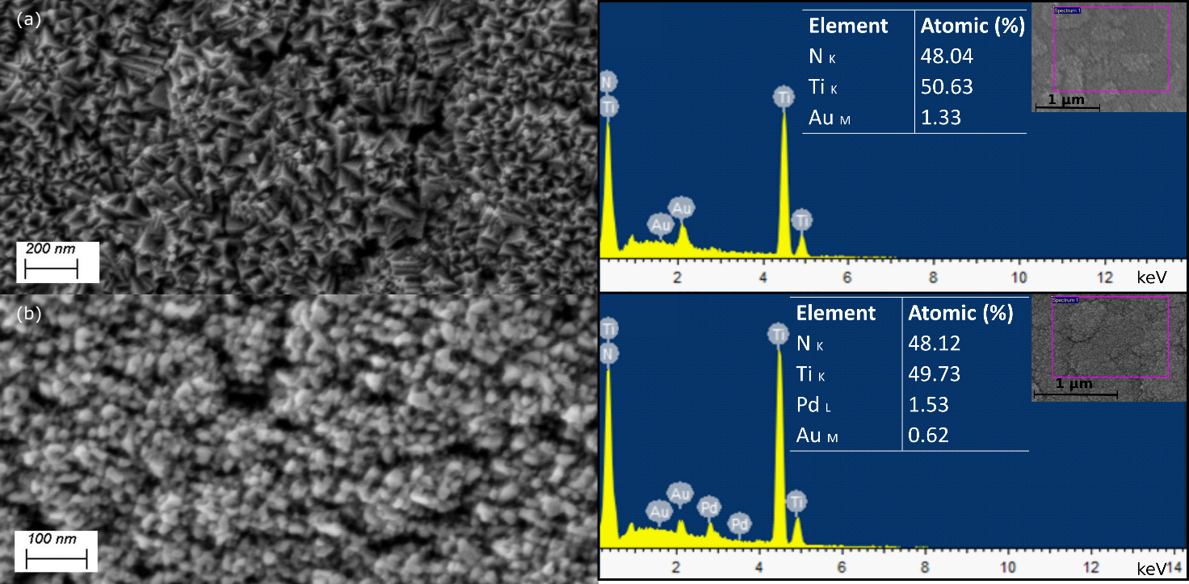
Figure S2: Top view secondary electron (SE) micrographs of TiN (a) and TiN-PdNPs (b) together with their EDS analysis after HER studies.

