Supporting Information

A Non-isothermal Curing Kinetic Studies of Novolac type Phenol-Formaldehyde resin for 3D Printing of Sustainable Building design
Archana Bansode†, ‡, Iris Beatriz Vega Erramuspe§, Lorena Alexandra Portilla Villarreal§, Braden Hahn‡, Brian K. Via§, Allan David‡, Nicole Labbé¶, Maria L. Auad*, †, ‡

†Center for Polymers and Advanced Composites, Gavin Engineering Research Laboratory, Auburn University, 311 West Magnolia Avenue, Auburn, Alabama 36849, United States
‡Department of Chemical Engineering, Ross Hall, Auburn University, 222 Foy Union Circle, Auburn, Alabama 36849, United States
§Forest Products Development Center, College of Forestry, Wildlife and Environment, Auburn University, 520 Devall Drive, Auburn, Alabama 36849, United States
¶Center for Renewable Carbon, University of Tennessee, 2506 Jacob Drive, Knoxville, TN, 37996, United States of America

*Corresponding Authors
Dr. Iris Beatriz Vega Erramuspe
520 Devall Dr, Auburn University,
Auburn, AL, 36849-5418, United States of America
Tel: +1334-5246076
Email Address: beatriz.vega@auburn.edu

Dr. Maria L. Auad
1301 Shelby Center, Auburn University,
Auburn, AL, 36849-5330, United States of America
Tel: +1334-8445459
Email Address: auad@auburn.edu

Number of Pages: 6
Number of Figures: 3
Number of Tables: 1

Compound | Source | Initial Purity | Purification Method | Final Purity | Purity Basic | Explanation
Phenol crystals | VWR International | 99% | - | 99% | Mass | The compound was obtained from the supplier with an initial purity of 99% and used as such, with no further purification.
Formalin solution (37% formaldehyde in water) | VWR International | 37% | - | 37% | Mass | The compound was obtained from the supplier with an initial purity of 37% and used as such, with no further purification.
Acetone | VWR International | 99.5% | - | 99.5% | Mass | The compound was obtained from the supplier with an initial purity of 99.5% and used as such, with no further purification.
Oxalic acid (anhydrous crystal) | Spectrum Chemical Mfg. Corp | 98.0% | - | 98.0% | Mass | The compound was obtained from the supplier with an initial purity of 98.0% and used as such, with no further purification.
Bio-oil | Received from the Center for Renewable Carbon Laboratory, University of Tennessee | N/A | - | - | Mass | It is a mixture of compounds isolated from the organic phase of bio-oil, with 11.5 % of water.
Table S1: Compound Purity Information

Figures S1: The reaction mechanism of bionovolac phenol-formaldehyde resin (BNPF)

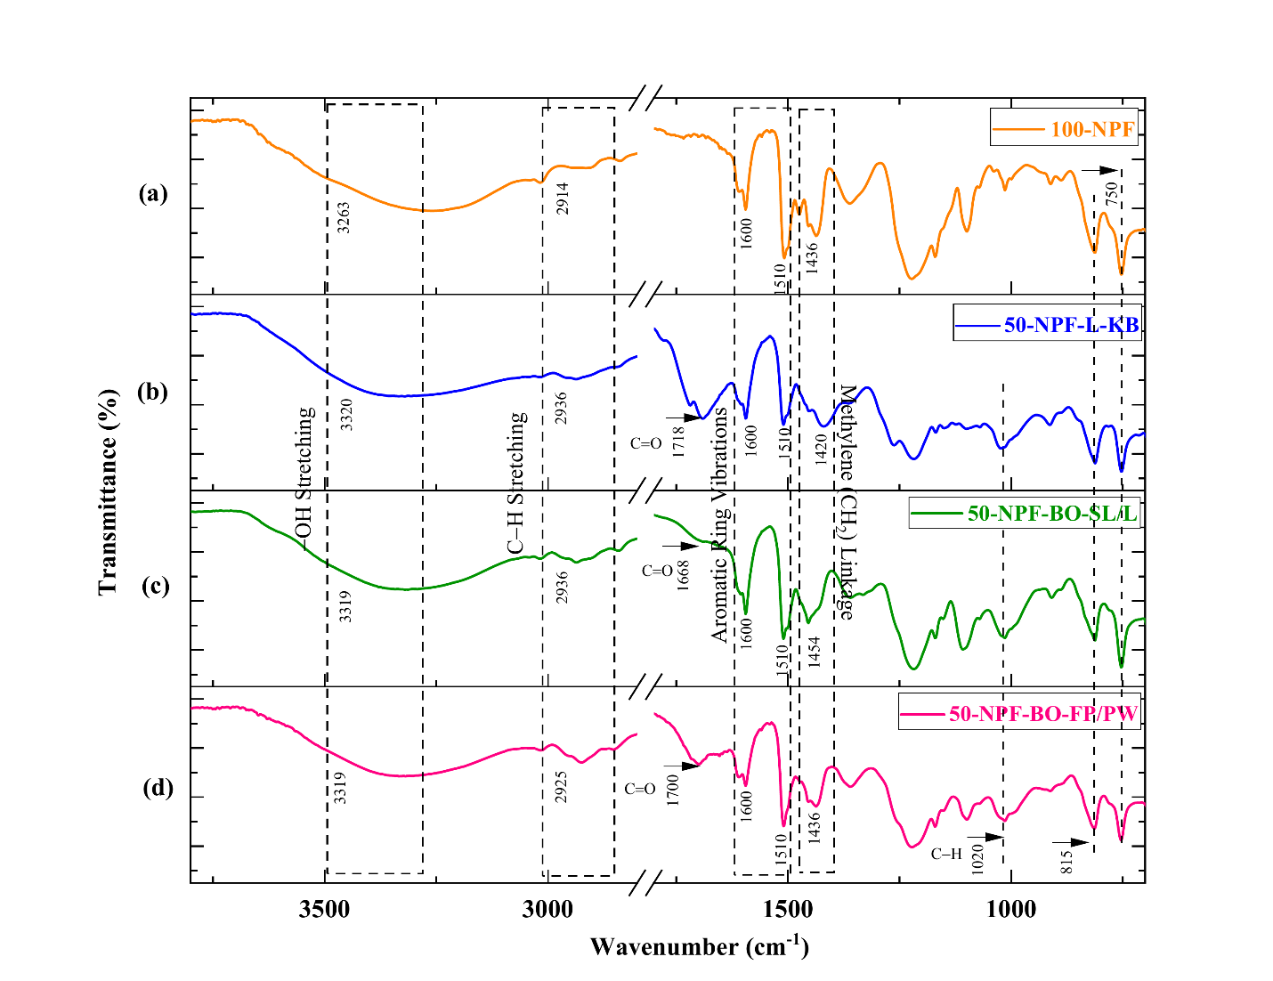
Figure S2 Resin characterization by FTIR (a) Novolac phenol-formaldehyde resin and, (d) biobased novolac phenol-formaldehyde resin [Adapted from our previous publication: Synthesis of Biobased Novolac Phenol–Formaldehyde Wood Adhesives from Biorefinery-Derived Lignocellulosic Biomass (2021) ACS Sustainable Chemistry & Engineering, 9 (33), 10990–11002.]
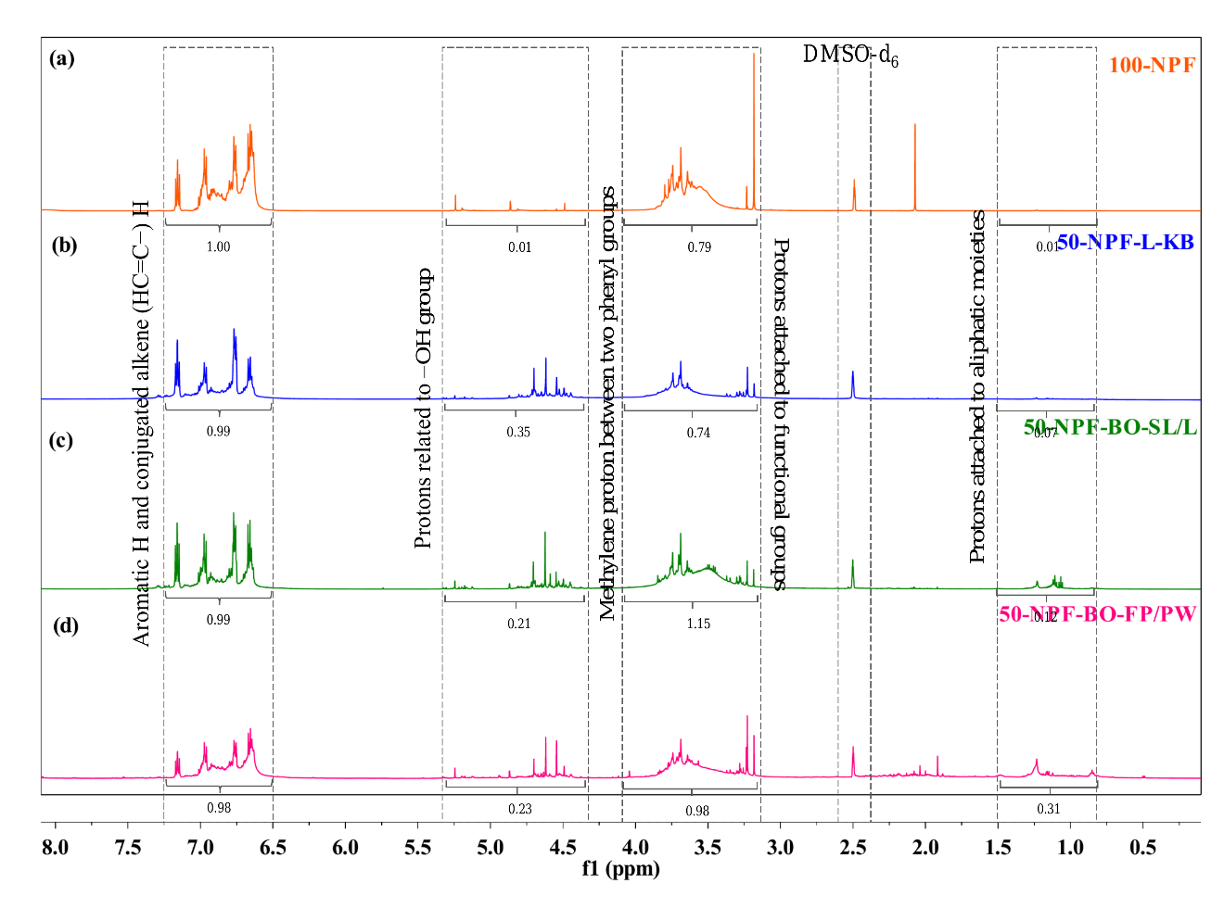
Figure S3 Resin characterization by ¹H NMR (a) Novolac phenol-formaldehyde resin and, (d) bionovolac phenol-formaldehyde resin [Adapted from our previous publication: Synthesis of Biobased Novolac Phenol–Formaldehyde Wood Adhesives from Biorefinery-Derived Lignocellulosic Biomass (2021) ACS Sustainable Chemistry & Engineering, 9 (33), 10990–11002.]

