Supplementary Figures

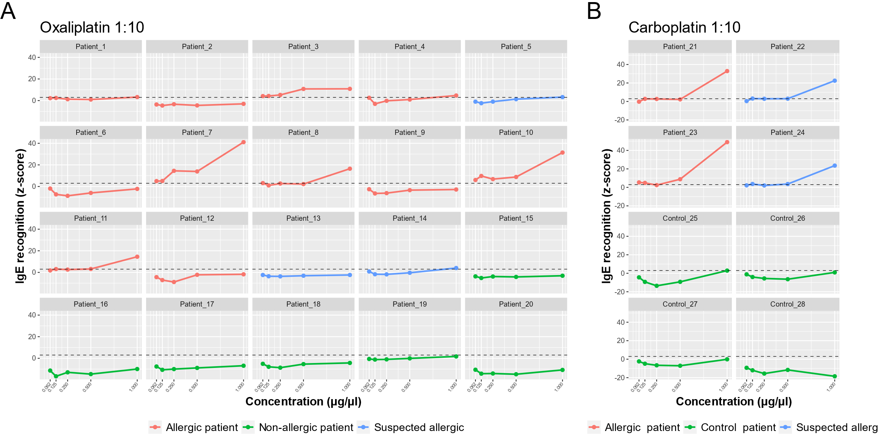

SUPPLEMENTARY FIGURE 1 sIgE microarrays immunoassay. The y-axis shows the average IgE binding represented as average Z-scores. The x-axis shows the drug concentration: oxaliplatin (A) and carboplatin (B) 1:10 molar ratio. The standardized fluorescence intensity represented as the average Z-score was considered positive if it exceeded 3 (dotted line).

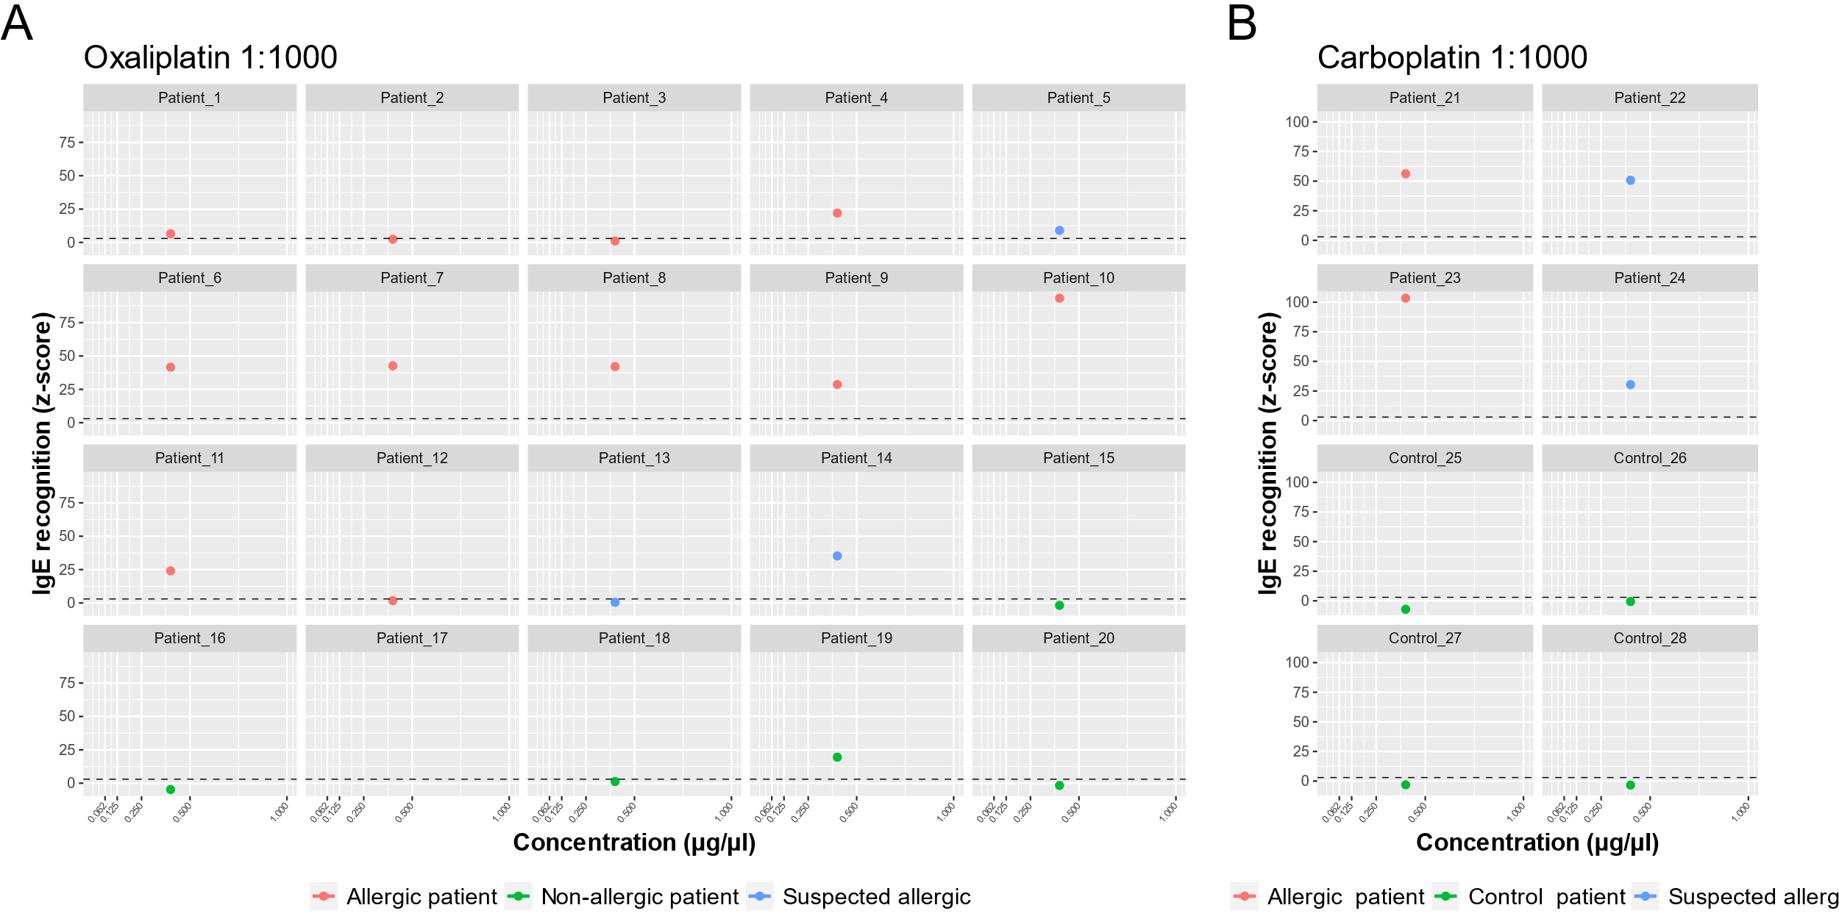
SUPPLEMENTARY FIGURE 2 sIgE microarrays immunoassay. The y-axis shows the average IgE binding represented as average Z-scores. The x-axis shows the drug concentration: oxaliplatin (A) and carboplatin (B) 1:1000 molar ratio. The standardized fluorescence intensity represented as the average Z-score was considered positive if it exceeded 3 (dotted line).

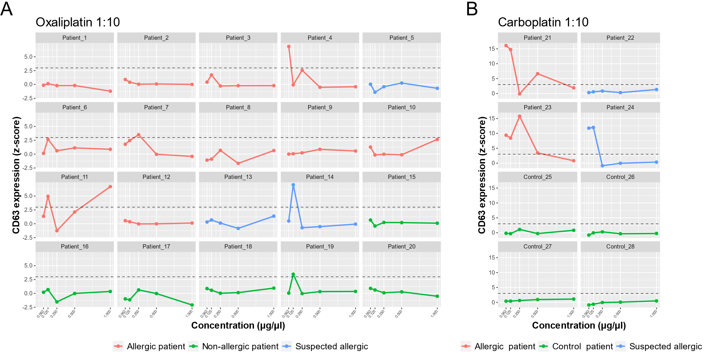

SUPPLEMENTARY FIGURE 3 BAT-microarray immunoassay. The y-axis shows the average CD63 expression represented as average Z-scores. The x-axis shows the drug concentration: oxaliplatin (A) and carboplatin (B) 1:10 molar ratio. The standardized fluorescence intensity represented as the average Z-score was considered positive if it exceeded 3 (dotted line).

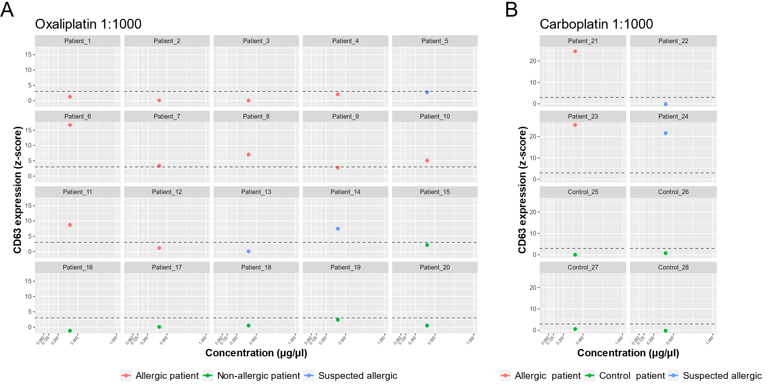
SUPPLEMENTARY FIGURE 4 BAT-microarray immunoassay. The y-axis shows the average CD63 expression represented as average Z-scores. The x-axis shows the drug concentration: oxaliplatin (A) and carboplatin (B) 1:1000 molar ratio. The standardized fluorescence intensity represented as the average Z-score was considered positive if it exceeded 3 (dotted line).

