Table S1. List of independent socioeconomic, demographic, and environmental variables for Ibagué.
Variable | Description | Source | Range
 |  |  | Comunas | Sectores | Secciones | Manzanas
Area | Area of the structure [km²] | DANE | 1.24 – 10.78 | 0.07 – 8.25 | 0.01– 1.86 | 5.83E-05 – 0.84
Population | Count of people | DANE | 14,903 – 71,226 | 94 – 25,062 | 0 – 6345 | 0 – 2,946
Density | Population density [ppl/km²] | DANE | 5,983 – 23,584 | 569 – 36,759 | 0 – 66,160 | 0 – 378,700
Houses | Count of houses | DANE | 6,241 – 26,895 | 34 – 12,178 | 0 – 3,116 | 0 – 1,075
Homes | Count of populated houses | DANE | 5,221 – 24,464 | 31 – 8,640 | 0 – 2,205 | 0 – 1,071
Electricity | Percentage of houses with electricity | DANE | 0.77 – 0.95 | 0.64 – 0.98 | 0 – 1 | 0 – 1
Aqueduct | Percentage of houses connected to the aqueduct | DANE | 0.76 – 0.92 | 0.64 – 0.97 | 0 – 1 | 0 – 1
Sewage | Percentage of houses connected to the sewage | DANE | 0.76 – 0.94 | 0.03 – 0.97 | 0 – 1 | 0 – 1
Gas | Percentage of houses connected to the gas network | DANE | 0.69 – 0.90 | 0.49 – 0.94 | 0 – 0.96 | 0 – 1
Garbage | Percentage of houses with garbage pickup service | DANE | 0.76 – 0.94 | 0.63 – 0.99 | 0 – 1 | 0 – 1
Internet | Percentage of houses with internet connection | DANE | 0.28 – 0.67 | 0.09 – 0.75 | 0 – 0.84 | 0 – 1
Strata | Average strata | DANE | 1 – 3 | 1 – 3 | 0 – 3 | 0 – 5
Higher Ed. | Percentage of people with a higher education degree (after high school) | DANE | 0.12 – 0.40 | 0.06 – 0.58 | 0 – 0.61 | 0 – 0.86
No Ed. | Percentage of people without any education | DANE | 0.02 – 0.04 | 0 – 0.06 | 0 – 0.08 | 0 – 0.48
Kids | Percentage of people under 19 years old | DANE | 0.23 – 0.34 | 0.15 – 0.37 | 0 – 0.41 | 0 – 0.58
Adults | Percentage of people over 19 years old | DANE | 0.66 – 0.77 | 0.63 – 0.85 | 0 – 0.88 | 0 – 1
Men | Percentage of people identifying as man | DANE | 0.46 – 0.48 | 0.44 – 0.52 | 0 – 0.62 | 0 – 0.93
Women | Percentage of people identifying as woman | DANE | 0.51 – 0.54 | 0.48 – 0.56 | 0 – 0.62 | 0 – 0.81
Total Prec. | Total precipitation [mm/month] | CHIRPS | 0.81 – 118 | 0.05 – 89.78 | 0.01 – 20.36 | 0 – 9.25
Mean Temp. | Mean temperature during each month [°C] | MODIS | 22.96 – 38.77 | 21.98 – 39.62 | 21.03 – 39.75 | 20.51 – 39.75
Wet Days | Count of raining days each month | - | 2 – 20 | 2 – 20 | 2 – 20 | 2- 20
Days ov. 32 | Count of days when the maximum temperature exceeded 32°C each month | - | 0 – 29 | 0 – 29 | 0 – 29 | 0 – 29
NDVI | Normalized Vegetation Index per month | MODIS | 0.23 – 0.71 | 0.16 – 0.80 | 0.19 – 0.87 | 0.14 – 0.90

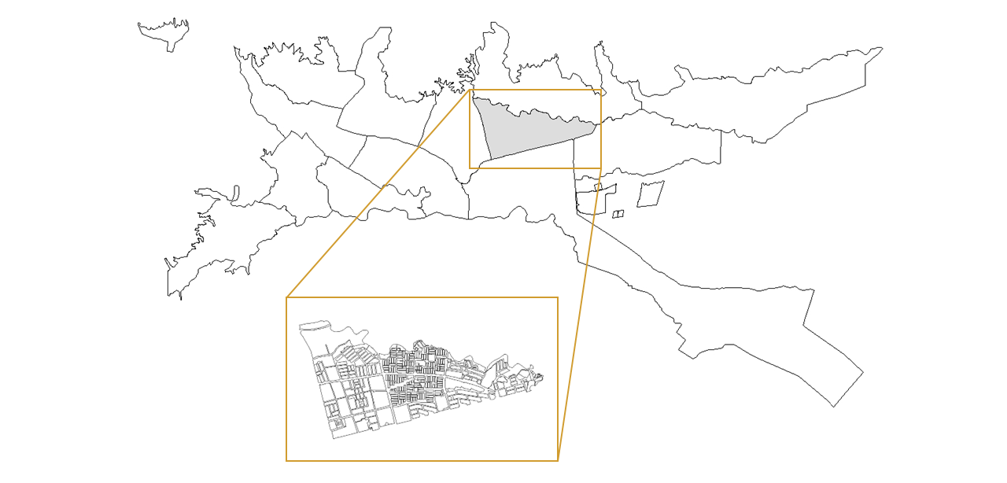
Figure S1. Ibagué’s spatial division, from which aggregation levels are obtained. Comunas are the biggest group, each composed of multiple manzanas as shown in the figure. Smaller groups of manzanas build secciones and sectores.

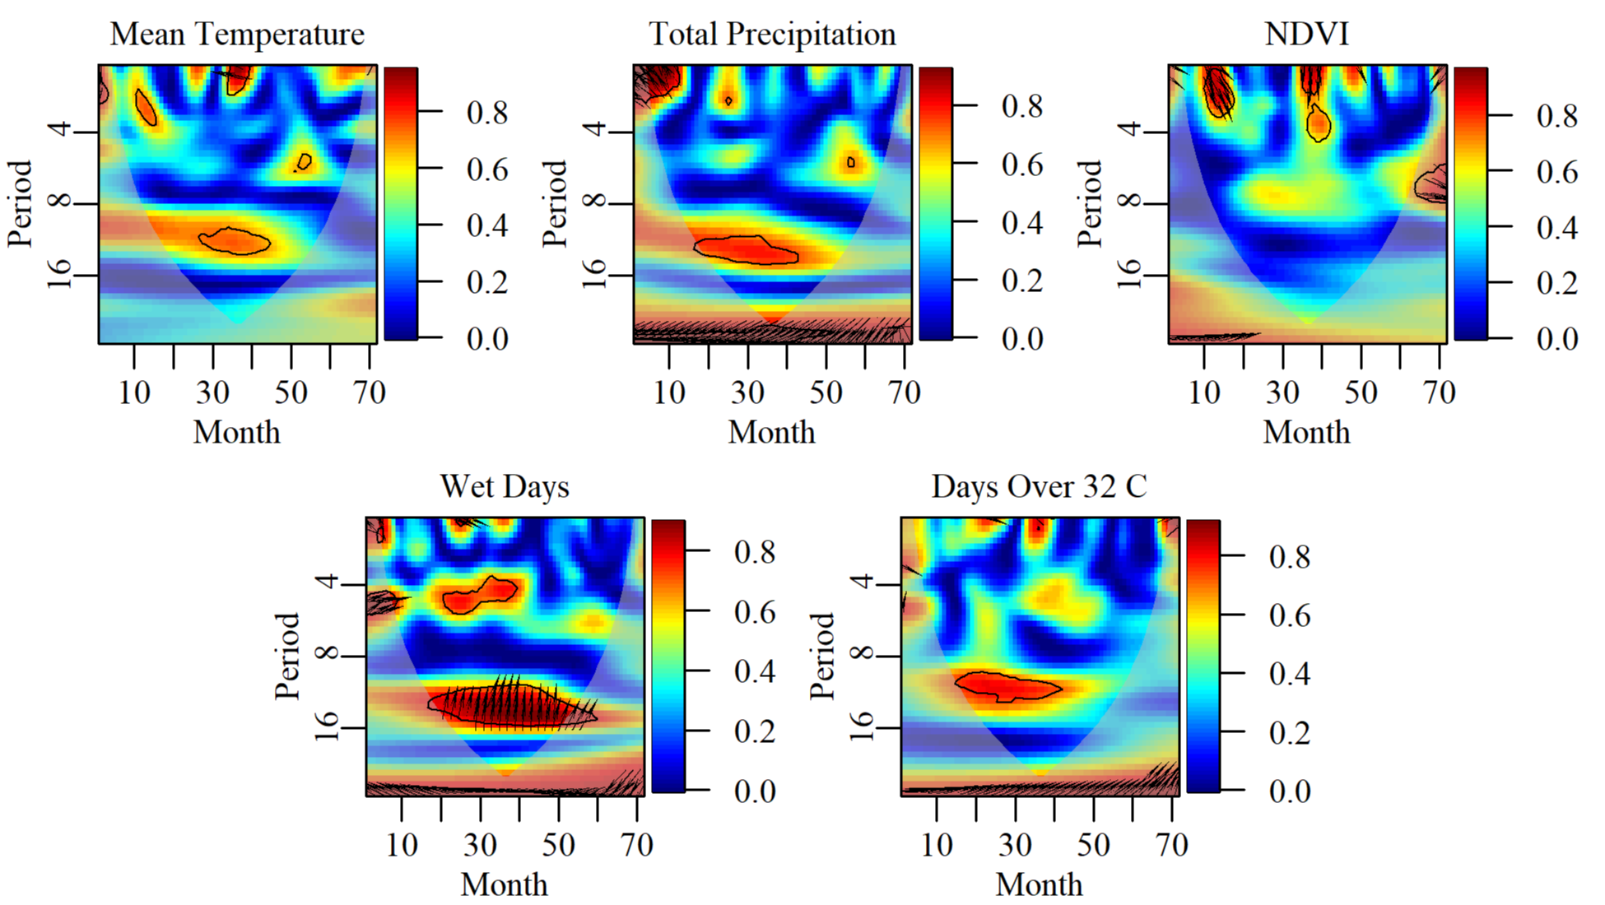

Figure S2. Wavelet coherence analysis for environmental variables. Each plot shows the coherence between the environmental variables and DENV cases. High-significance (0.05) regions are plotted as bounded areas. A cone of influence is included to discard any significant regions outside it. Arrows indicate the relationship of the two series included in each plot.

