Supplementary material
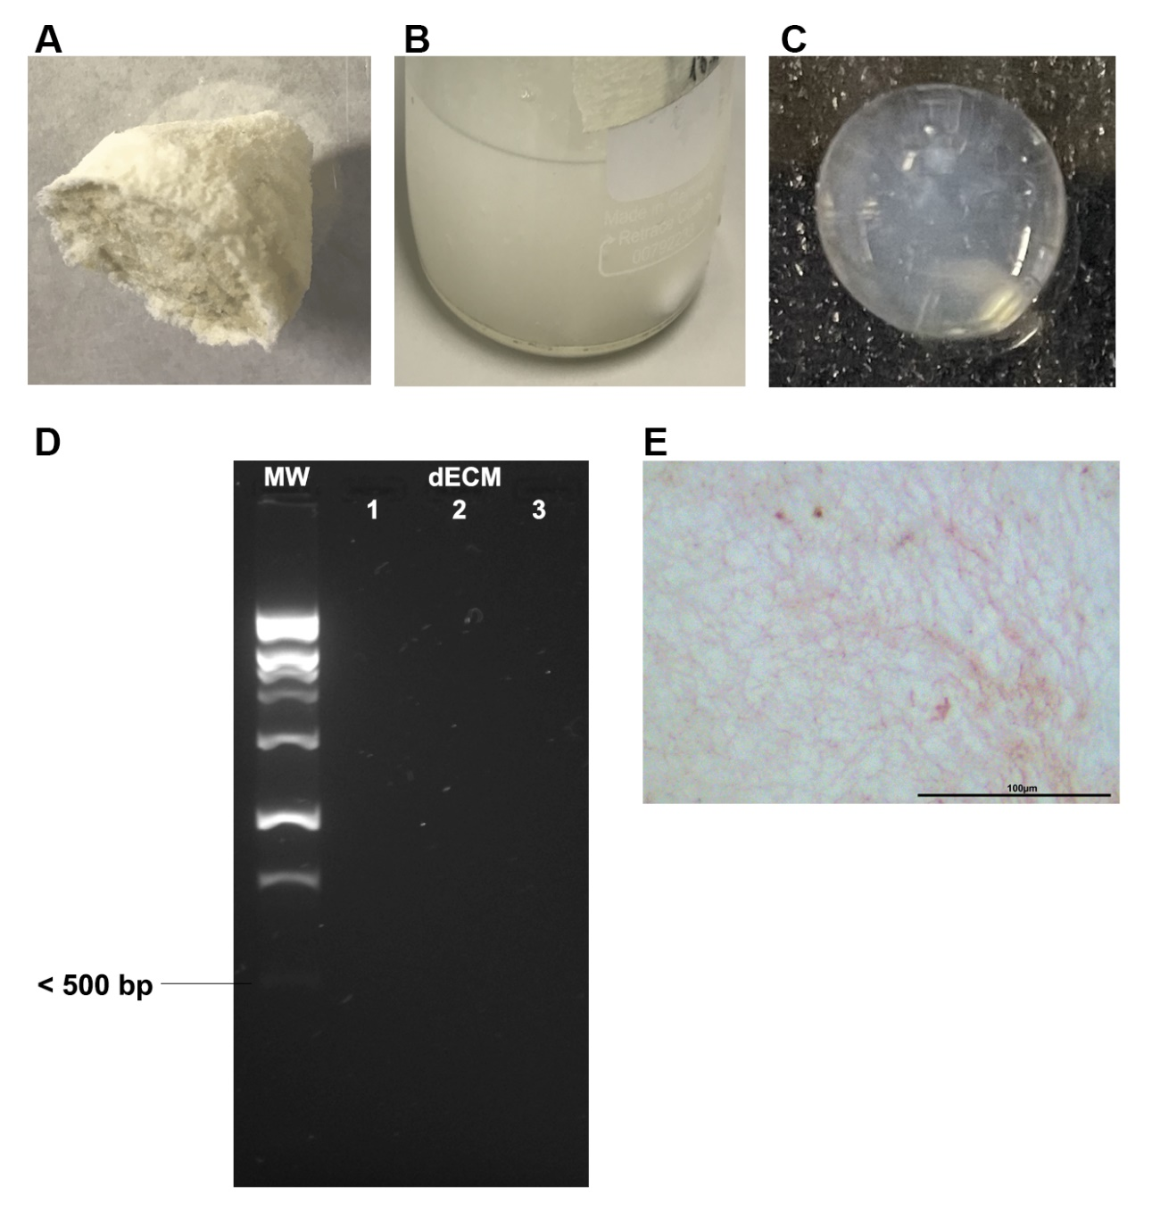
Figure S1. (A) Lyophilized skin after extraction with sponge-like morphology, (B) human dECM solution after pepsin digestion and (C) human dECM hydrogel at 4 mg/mL. (D) 2% agarose gel electrophoresis showing absence of residual DNA content and (E) haematoxylin-eosin stain showing the lack of cellular nuclei in human dECM.
Figure S2. (A) Amplitude sweep of human dECM hydrogel. (B) Negative control of immunofluorescence for collagen type I, type III, type IV and fibronectin, and (C) immunofluorescence of collagen type IV. (D) Collagen hydrogel shrinkage by dermal fibroblast and lack of contraction in dECM hydrogels. (E) Keratinocytes (yellow) on top of collagen type I hydrogels and fibroblast embedded in collagen type I hydrogel (blue) tracking overtime within a skin-on-chip device. (F) Analysis of cell migration quantifying the fluorescence intensity of fibroblasts (blue) embedded in collagen type I hydrogel and keratinocytes on top of hydrogel (orange) over time within skin on chip deviceNote: Immunofluorescence scale bar: 50 µm. CAM-PI: Live/Dead staining.

Table S1. Protein identification by liquid chromatography mass spectrometry from three independent human hydrogel dECM.
dECM 1
Accesion number | Gene name | Seq count | EMPAI | Description
Collagens
P02452 | COL1A1 | 218 | 1.93 | Collagen alpha-1(I) chain OS=Homo sapiens OX=9606 GN=COL1A1 PE=1 SV=6
P08123 | COL1A2 | 172 | 1.71 | Collagen alpha-2(I) chain OS=Homo sapiens OX=9606 GN=COL1A2 PE=1 SV=7
P02461 | COL3A1 | 80 | 0.54 | Collagen alpha-1(III) chain OS=Homo sapiens OX=9606 GN=COL3A1 PE=1 SV=4
P02458 | COL2A1 | 53 | 0.32 | Collagen alpha-1(II) chain OS=Homo sapiens OX=9606 GN=COL2A1 PE=1 SV=3
P05997 | COL5A2 | 13 | 0.17 | Collagen alpha-2(V) chain OS=Homo sapiens OX=9606 GN=COL5A2 PE=1 SV=3
P20908 | COL5A1 | 20 | 0.16 | Collagen alpha-1(V) chain OS=Homo sapiens OX=9606 GN=COL5A1 PE=1 SV=3
P12111 | COL6A3 | 12 | 0.12 | Collagen alpha-3(VI) chain OS=Homo sapiens OX=9606 GN=COL6A3 PE=1 SV=5
Keratins
P04264 | KRT1 | 36 | 0.85 | Keratin, type II cytoskeletal 1 OS=Homo sapiens OX=9606 GN=KRT1 PE=1 SV=6
P04259 | KRT6B | 12 | 0.31 | Keratin, type II cytoskeletal 6B OS=Homo sapiens OX=9606 GN=KRT6B PE=1 SV=5
Q5XKE5 | KRT79 | 11 | 0.28 | Keratin, type II cytoskeletal 79 OS=Homo sapiens OX=9606 GN=KRT79 PE=1 SV=2
Q14CN4 | KRT72 | 8 | 0.21 | Keratin, type II cytoskeletal 72 OS=Homo sapiens OX=9606 GN=KRT72 PE=1 SV=2
O95678 | KRT75 | 13 | 0.21 | Keratin, type II cytoskeletal 75 OS=Homo sapiens OX=9606 GN=KRT75 PE=1 SV=2
P08729 | KRT7 | 7 | 0.19 | Keratin, type II cytoskeletal 7 OS=Homo sapiens OX=9606 GN=KRT7 PE=1 SV=5
Q86Y46 | KRT73 | 4 | 0.17 | Keratin, type II cytoskeletal 73 OS=Homo sapiens OX=9606 GN=KRT73 PE=1 SV=1
Q7Z794 | KRT77 | 7 | 0.15 | Keratin, type II cytoskeletal 1b OS=Homo sapiens OX=9606 GN=KRT77 PE=1 SV=3
Q3SY84 | KRT71 | 7 | 0.14 | Keratin, type II cytoskeletal 71 OS=Homo sapiens OX=9606 GN=KRT71 PE=1 SV=3
Q7RTS7 | KRT74 | 4 | 0.13 | Keratin, type II cytoskeletal 74 OS=Homo sapiens OX=9606 GN=KRT74 PE=1 SV=2
Other components of the dECM
P60709  P63261 | ACTB  ACTG1 | 14 | 0.57  0.57 | Actin, cytoplasmic 1 OS=Homo sapiens OX=9606 GN=ACTB PE=1 SV=1  Actin, cytoplasmic 2 OS=Homo sapiens OX=9606 GN=ACTG1 PE=1 SV=1
Q07507 | DPT | 9 | 0.36 | Dermatopontin OS=Homo sapiens OX=9606 GN=DPT PE=1 SV=2
P15502 | ELN | 6 | 0.11 | Elastin OS=Homo sapiens OX=9606 GN=ELN PE=1 SV=4
P35555 | FBN1 | 15 | 0.09 | Fibrillin-1 OS=Homo sapiens OX=9606 GN=FBN1 PE=1 SV=4
dECM 2
Accesion number | Gene name | Seq count | EMPAI | Description
Collagens
P02452 | COL1A1 | 232 | 1.90 | Collagen alpha-1(I) chain OS=Homo sapiens OX=9606 GN=COL1A1 PE=1 SV=6
P08123 | COL1A2 | 178 | 1.70 | Collagen alpha-2(I) chain OS=Homo sapiens OX=9606 GN=COL1A2 PE=1 SV=7
P02461 | COL3A1 | 75 | 0.54 | Collagen alpha-1(III) chain OS=Homo sapiens OX=9606 GN=COL3A1 PE=1 SV=4
P02458 | COL2A1 | 56 | 0.46 | Collagen alpha-1(II) chain OS=Homo sapiens OX=9606 GN=COL2A1 PE=1 SV=3
P12109 | COL6A1 | 14 | 0.29 | Collagen alpha-1(VI) chain OS=Homo sapiens OX=9606 GN=COL6A1 PE=1 SV=3
P20908 | COL5A1 | 23 | 0.26 | Collagen alpha-1(V) chain OS=Homo sapiens OX=9606 GN=COL5A1 PE=1 SV=3
P25940 | COL5A3 | 13 | 0.24 | Collagen alpha-3(V) chain OS=Homo sapiens OX=9606 GN=COL5A3 PE=1 SV=3
P12111 | COL6A3 | 24 | 0.15 | Collagen alpha-3(VI) chain OS=Homo sapiens OX=9606 GN=COL6A3 PE=1 SV=5
P05997 | COL5A2 | 14 | 0.13 | Collagen alpha-2(V) chain OS=Homo sapiens OX=9606 GN=COL5A2 PE=1 SV=3
P12110 | COL6A2 | 5 | 0.10 | Collagen alpha-2(VI) chain OS=Homo sapiens OX=9606 GN=COL6A2 PE=1 SV=4
Keratins
P04264 | KRT1 | 40 | 0.77 | Keratin, type II cytoskeletal 1 OS=Homo sapiens OX=9606 GN=KRT1 PE=1 SV=6
P04259 | KRT6B | 14 | 0.61 | Keratin, type II cytoskeletal 6B OS=Homo sapiens OX=9606 GN=KRT6B PE=1 SV=5
Q5XKE5 | KRT79 | 14 | 0.46 | Keratin, type II cytoskeletal 79 OS=Homo sapiens OX=9606 GN=KRT79 PE=1 SV=2
O95678 | KRT75 | 12 | 0.18 | Keratin, type II cytoskeletal 75 OS=Homo sapiens OX=9606 GN=KRT75 PE=1 SV=2
Other components of the dECM
P35555 | FBN1 | 13 | 0.07 | Fibrillin-1 OS=Homo sapiens OX=9606 GN=FBN1 PE=1 SV=4
dECM 3
Accesion number | Gene name | Seq count | EMPAI | Description
Collagens
P02452 | COL1A1 | 248 | 2.10 | Collagen alpha-1(I) chain OS=Homo sapiens OX=9606 GN=COL1A1 PE=1 SV=6
P08123 | COL1A2 | 184 | 1.76; | Collagen alpha-2(I) chain OS=Homo sapiens OX=9606 GN=COL1A2 PE=1 SV=7
P02461 | COL3A1 | 87 | 0.56 | Collagen alpha-1(III) chain OS=Homo sapiens OX=9606 GN=COL3A1 PE=1 SV=4
P02458 | COL2A1 | 52 | 0.34 | Collagen alpha-1(II) chain OS=Homo sapiens OX=9606 GN=COL2A1 PE=1 SV=3
P12109 | COL6A1 | 10 | 0.25 | Collagen alpha-1(VI) chain OS=Homo sapiens OX=9606 GN=COL6A1 PE=1 SV=3
P05997 | COL5A2 | 14 | 0.18 | Collagen alpha-2(V) chain OS=Homo sapiens OX=9606 GN=COL5A2 PE=1 SV=3
P12111 | COL6A3 | 30 | 0.16 | Collagen alpha-3(VI) chain OS=Homo sapiens OX=9606 GN=COL6A3 PE=1 SV=5
P20908 | COL5A1 | 22 | 0.16 | Collagen alpha-1(V) chain OS=Homo sapiens OX=9606 GN=COL5A1 PE=1 SV=3
P25940 | COL5A3 | 8 | 0.11 | Collagen alpha-3(V) chain OS=Homo sapiens OX=9606 GN=COL5A3 PE=1 SV=3
Keratins
Q7Z794 | KRT77 | 9 | 0.41 | Keratin, type II cytoskeletal 1b OS=Homo sapiens OX=9606 GN=KRT77 PE=1 SV=3
Q5XKE5 | KRT79 | 11 | 0.36 | Keratin, type II cytoskeletal 79 OS=Homo sapiens OX=9606 GN=KRT79 PE=1 SV=2
P04264 | KRT1 | 14 | 0.31 | Keratin, type II cytoskeletal 1 OS=Homo sapiens OX=9606 GN=KRT1 PE=1 SV=6
Q6KB66 | KRT80 | 6 | 0.30 | Keratin, type II cytoskeletal 80 OS=Homo sapiens OX=9606 GN=KRT80 PE=1 SV=2
O95678 | KRT75 | 12 | 0.28 | Keratin, type II cytoskeletal 75 OS=Homo sapiens OX=9606 GN=KRT75 PE=1 SV=2
P04259 | KRT6B | 10 | 0.24 | Keratin, type II cytoskeletal 6B OS=Homo sapiens OX=9606 GN=KRT6B PE=1 SV=5
Q9NSB2 | KRT84 | 4 | 0.19 | Keratin, type II cuticular Hb4 OS=Homo sapiens OX=9606 GN=KRT84 PE=2 SV=2
Q86Y46 | KRT73 | 3 | 0.16 | Keratin, type II cytoskeletal 73 OS=Homo sapiens OX=9606 GN=KRT73 PE=1 SV=1
Q14CN4 | KRT72 | 4 | 0.15 | Keratin, type II cytoskeletal 72 OS=Homo sapiens OX=9606 GN=KRT72 PE=1 SV=2
Q3SY84 | KRT71 | 5 | 0.13 | Keratin, type II cytoskeletal 71 OS=Homo sapiens OX=9606 GN=KRT71 PE=1 SV=3
Other components of the dECM
P07585 | DCN | 5 | 0.39 | Decorin OS=Homo sapiens OX=9606 GN=DCN PE=1 SV=1
P15502 | ELN | 16 | 0.21 | Elastin OS=Homo sapiens OX=9606 GN=ELN PE=1 SV=4

