SUPPLEMENTAL MATERIAL

The figures and tables provided below gives additional details regarding the sorting activities as well as the methods and strategies used for sampling. Please note that
-----

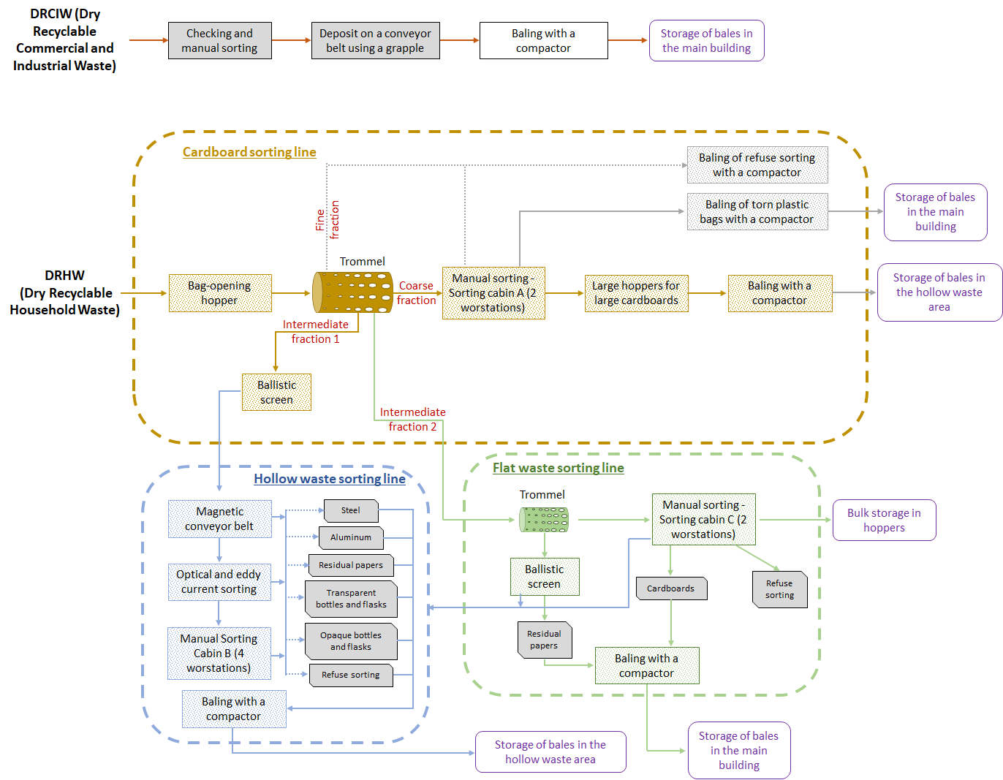

Figure S1: Schematic representation of the workflow for waste sorting in the WSP. Hollow waste: cardboard boxes for packaging, steel and aluminium metal packaging (metal beverage cans and tins), plastic bottles and flasks as well as food bricks; Flat waste: paper, magazines, newspapers and other flat waste (flattened paper and small cardboard packaging).

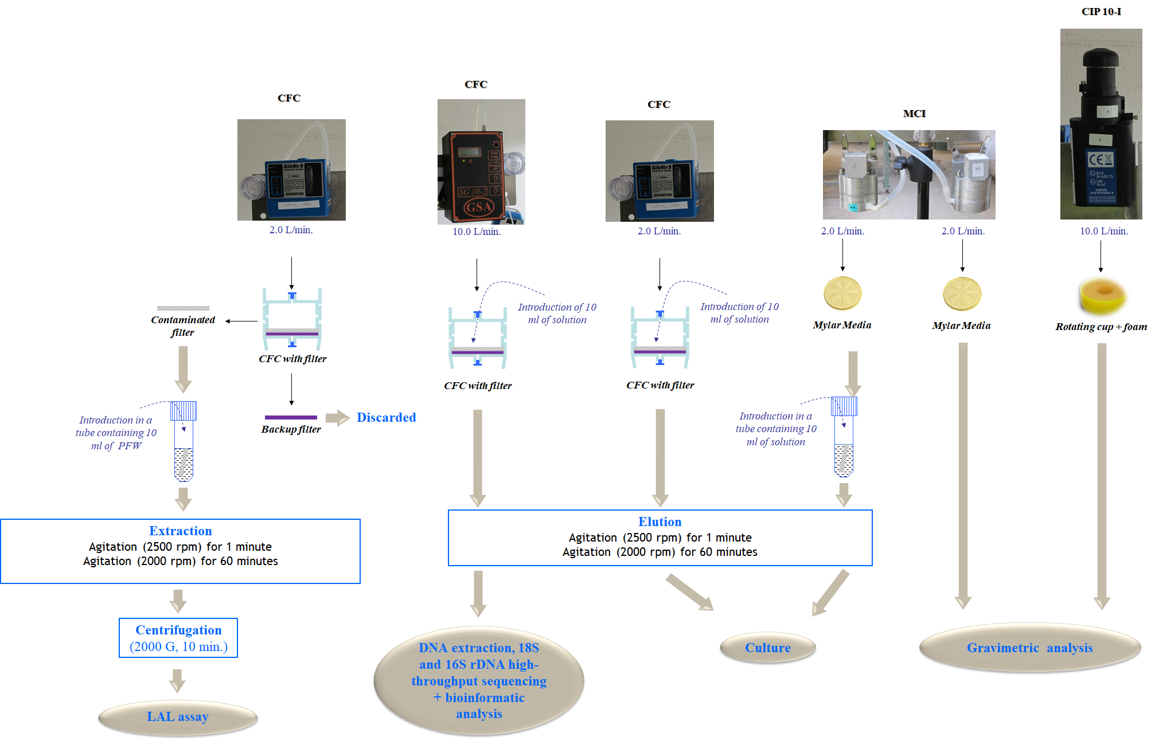
Figure S2: Schematic representation of the off-line measurement process used for assessing the concentration levels of airborne culturable bacteria and fungi, endotoxins, inhalable dust as well as the biodiversity of microbial communities in bioaerosols and the size distribution of airborne microorganisms and dust in the WSP. CFC: Closed-Face Cassette; MCI: MARPLE Cascade Impactor.

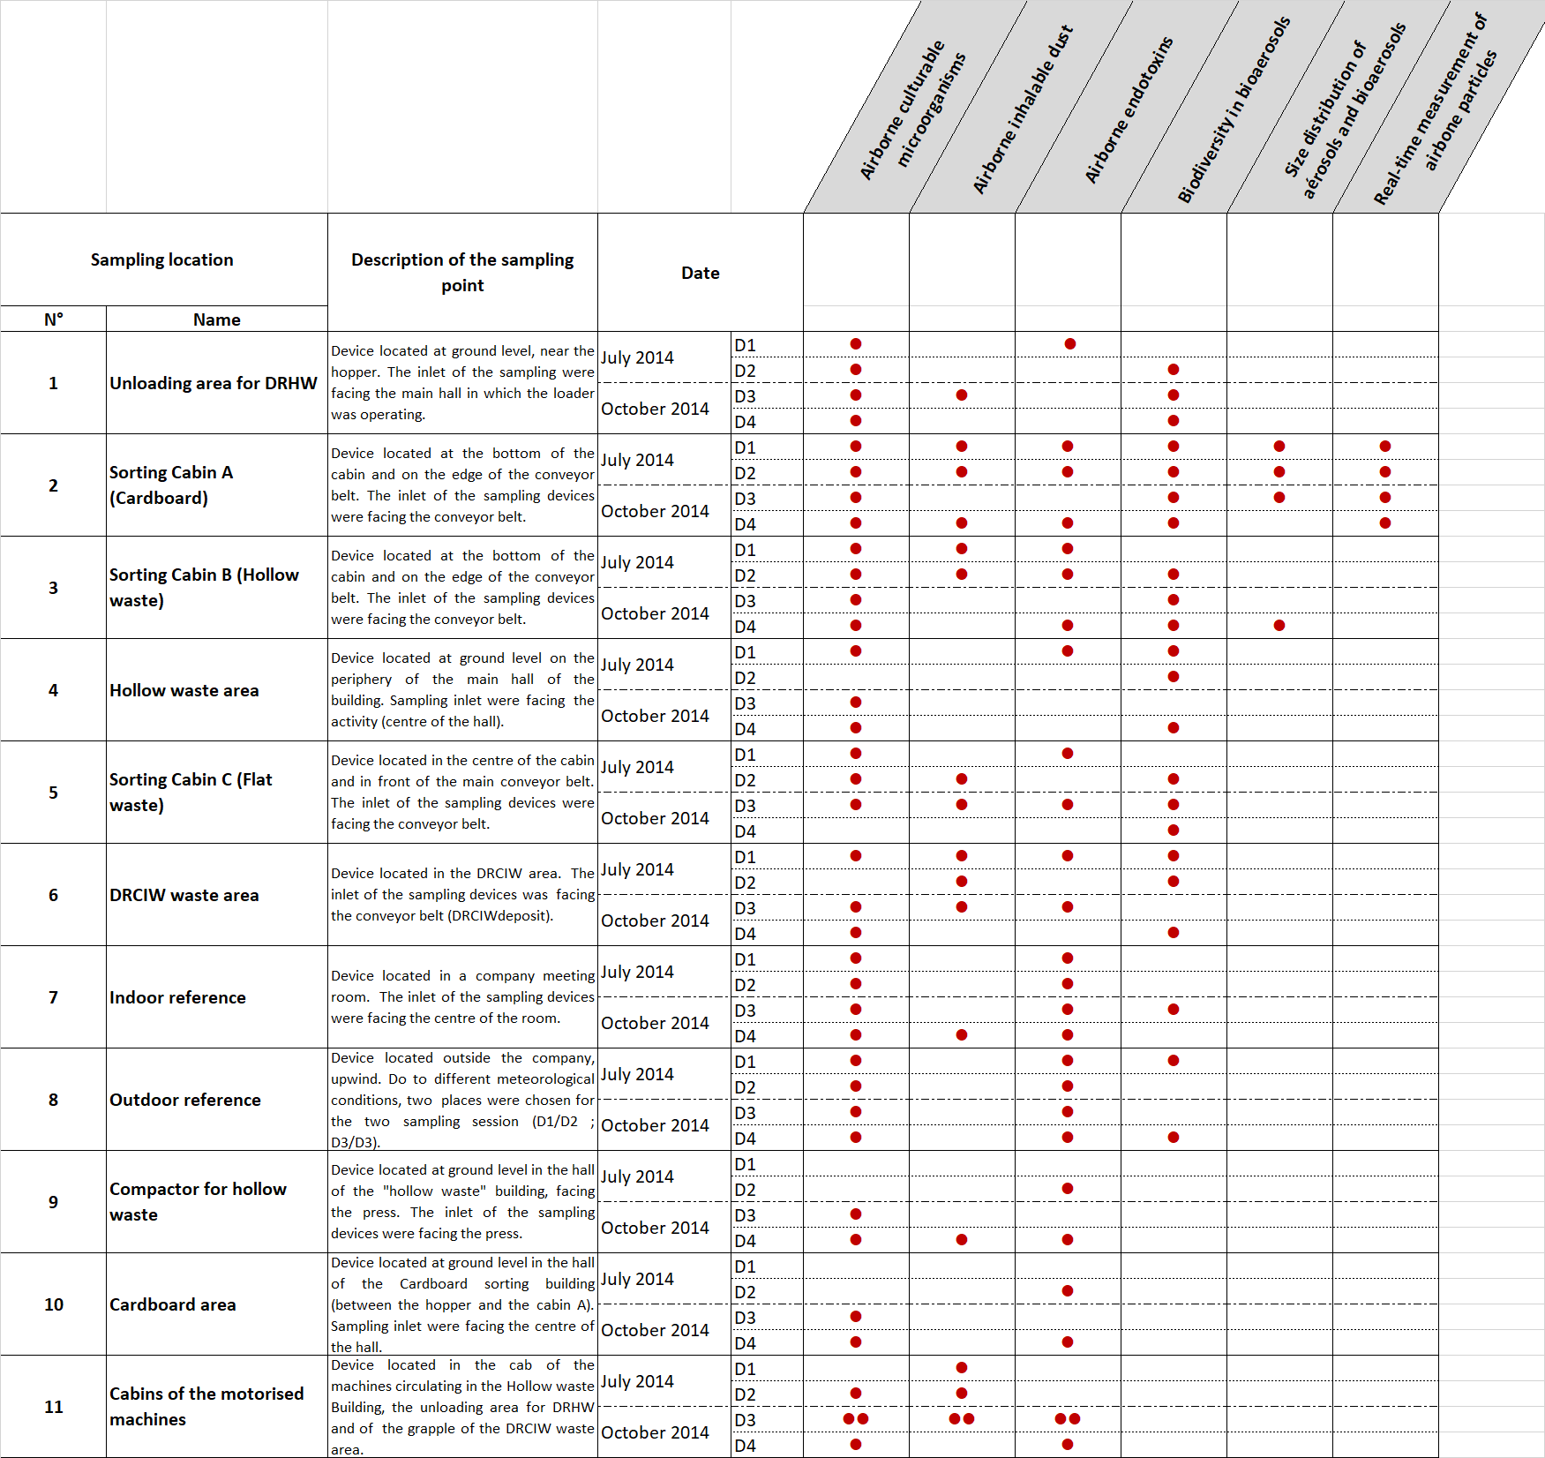

Table S1: Details of the sampling plan designed for the stationary assessment of bioaerosols and airborne dust in the investigated WSP. DRHW: Dry Recyclable Household Waste; DRCIW: Dry Recyclable Commercial and Industrial Waste; Hollow waste: cardboard boxes for packaging, steel and aluminium metal packaging (metals beverage can and tins), plastic bottles and flasks as well as food bricks; Flat waste: paper, magazines, newspapers and others (flattened paper and small cardboard packaging).

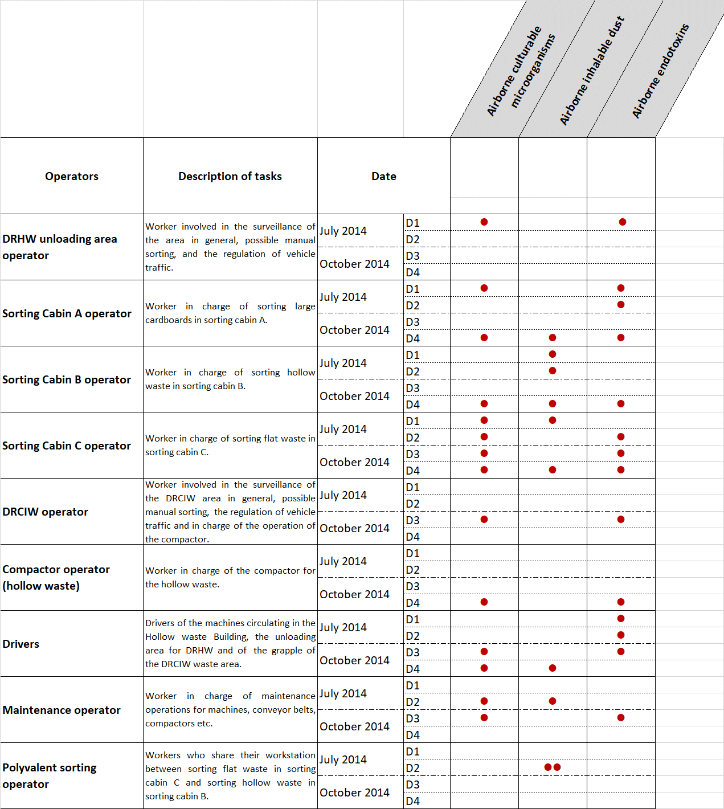
Table S2: Details of the sampling plan designed for the assessment of personal exposure to bioaerosols and airborne dust in the investigated WSP. DRHW: Dry Recyclable Household Waste; DRCIW: Dry Recyclable Commercial and Industrial Waste; Hollow waste: cardboard boxes for packaging, steel and aluminium metal packaging (metals beverage can and tins), plastic bottles and flasks as well as food bricks; Flat waste: paper, magazines, newspapers and others (flattened paper and small cardboard packaging).

 |  | July D1 - End |  |  | July D2 - Beginning |  |  | July D2 - End |  |  | October D3 - Half |  |  | October D4 - Half
 | Sampling point | T (°C) | RH (%) |  | T (°C) | RH (%) |  | T (°C) | RH (%) |  | T (°C) | RH (%) |  | T (°C) | RH (%)
1 | Unloading area DHRW | 30.2 | 40.2 |  | 26.1 | 49.1 |  | 28.2 | 44.0 |  | 21.5 | 57.6 |  | / | /
2 | Sorting cabin A (cardboard) | 26.0 | 53.6 |  | 24.9 | 56.2 |  | 26.4 | 52.4 |  | / | / |  | 24.9 | 64.7
3 | Sorting cabin B (hollow waste) | 28.3 | 44.0 |  | 26.9 | 47.8 |  | 28.1 | 45.5 |  | / | / |  | 23.2 | 65.0
4 | Hollow waste area | 27.0 | 47.8 |  | 26.5 | 51.2 |  | 28.3 | 46.3 |  | / | / |  | 22.8 | 62.6
5 | Sorting cabin C (flat waste) | 30.5 | 43.0 |  | 24.0 | 48.0 |  | 26.6 | 45.3 |  | 21.6 | 59.8 |  | 22.9 | 66.0
6 | DRCIW waste area | 29.0 | 46.0 |  | 26.7 | 48.8 |  | 31.3 | 38.0 |  | 22.7 | 54.0 |  | / | /
7 | Indoor reference | 29.8 | 43.3 |  | 26.8 | 48.1 |  | 31.7 | 40.0 |  | 24.6 | 50.5 |  | / | /
8 | Outdoor reference | 30.0 | 43.4 |  | 27.9 | 49.3 |  | 32.2 | 33.5 |  | 20.2 | 62.5 |  | 21.6 | 67.2
9 | Compactor for hollow waste | 27.1 | 46.5 |  | 26.5 | 50.4 |  | 28.7 | 44.7 |  | / | / |  | / | /
10 | Cardboard area | / | / |  | 25.6 | 51.5 |  | 27.6 | 49.4 |  | / | / |  | 24.2 | 62.3
 | City local weather station* | 28.3 | 56.0 |  | 26.0 | 48.0 |  | 28.8 | 41.0 |  | 20.8 | 61.0 |  | 21.4 | 64.0

Table S3: Data of temperature and relative humidity of air at the sampling points in the investigated WSP. * https://www.infoclimat.fr

