Supplement 1: Time and the phenomenon of "duration"
For the ancient Egyptians, time was represented by two deities. They had a god, NEHE, who stood for periodic return and a goddess, DJET, who symbolised duration. Both were equally fundamental to them. An ideal, periodic process can serve as a measure of time, but what about duration?
Arguments keep popping up on the internet that try (unsuccessfully) to prove that the special theory of relativity is wrong. A particularly amusing one concerns the twin paradox: "If you move faster, time passes more slowly, the distance in the direction of movement shortens and the mass increases. When the twin returns from his almost light-fast journey, he is younger than the other, which remained behind at the starting point". "Why," is the subsequent question (and it is never wrong to ask a question), "is he not also compressed or heavier when he returns?"
The question is very easy to answer and the answer is also instructive. The theory of relativity says something about measures (standards), in the case of time this is an ideal, periodic process, such as an oscillation (like a pendulum) or a rotation. When the twin returns from his journey through space and the two meet, they will realise by comparison that all the measures of the two twins match again. Ideal oscillators oscillate at the same speed, the distance measures match and so do the mass measures, just as the theory predicts. But apparently, in addition to the time measure, there is another fundamental characteristic of time, a counter (Figure 1.1), which we can call "duration" and which integrates over time. This is not the same as getting older, but getting older requires duration. Our photons also have duration, but without getting older. It is undoubtedly an important characteristic of time, but one that special relativity does not deal with. The questioner has therefore confused NEHE and DJET. Only the measures have to match when the twins meet, but not their age, their duration.
Figure 1.1. Periodic process (rotation or oscillation) as a measure of time (bottom), represented by a clock face with a hand. Duration as an integral over time (or as a sum in the discrete example), represented by a strip that always moves in the same direction and in which a hole is punched when the hand passes the 12 o'clock position during its ideal rotation.
The fact that we only observe the integration over time, but not over space, may have something to do with the fact that we cannot move freely along the time axis, but only in one direction, which is why the strip in Figure 1.1 only ever moves in one direction. This is not the case in space; the strip would move both to the left and to the right (if we only consider one spatial dimension).
It is interesting that, as with interference, we also come across a counter here. So perhaps there is a spatio-temporal counter after all and perhaps it is even responsible for the strange phenomena we observed at the detector. But that is pure speculation.
Incidentally, in his works of 1905 and 1907, A. Einstein did not clearly separate the two phenomena of "measure of time" and "duration" when describing his clock, which obviously caused problems of understanding later on (his clock, like a real clock, is a hybrid that also determines the duration up to a certain period of time).
Supplement 2: Replicator dynamics and the interaction of light and matter.
From the point of view of replicator dynamics, the world - or everything that is of importance in it - consists of copiers and information (messages, also referred to as replicators in this context). We define information as an immaterial "something" that can be stored in physically very different storage media (such as a sheet of paper or a polynucleotide ...), that can be transferred from one medium to another, that can be copied and overwritten (and thus deleted). A material object can be transformed, but not deleted. In this respect, this ability cannot be taken for granted. Information can also have the ability to change the probability of a transformation, which is particularly important in the following.
We imagine a molecule as a copier and a photon as the carrier of a message (Figure 2.1).
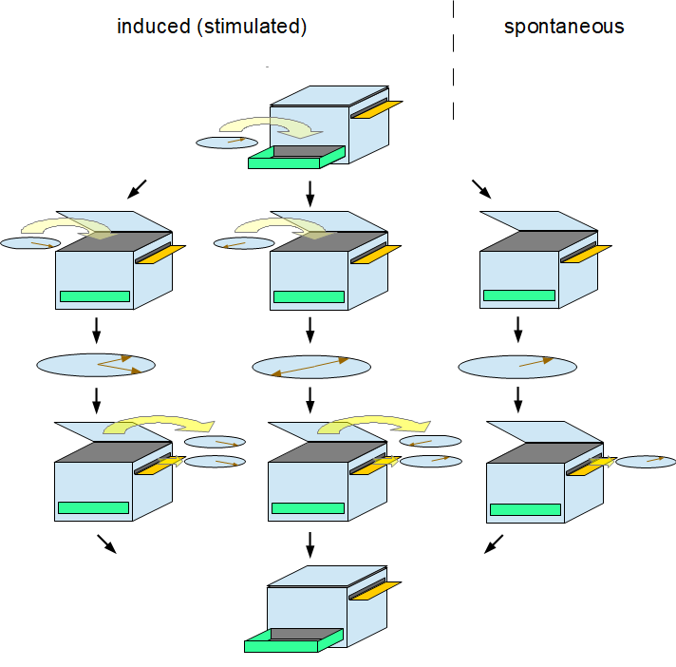
Figure 2.1. Induced and spontaneous emission from the perspective of replicator dynamics. The molecule is shown as a copier, the photons as discs with a hand.
In its initial state, the copier's paper drawer is open and the lid is closed. The copier is located in a small room, the door of which is sometimes open, sometimes closed. Occasionally, a person may enter and bring a spinning disc with her. As soon as it is placed in the paper drawer, the disc stops spinning. The paper drawer closes and the lid opens. The copier is in an excited state now. After some time, with the same probability as before, another person can enter the room with a spinning disc and place it on the copier, whereupon it stops spinning. This disc is the copy template. The copier is in a doubly excited state and now compares the pointer positions of the two discs and the more similar they are, the more likely it is that the pointer position of the copy template will be copied to the other disc. In any case, the two discs leave the copier immediately, either with the initial pointer positions or both discs have those of the copy template. They start to rotate (induced emission). The cover closes, the paper drawer opens and the copier returns to its initial state. This happens after a certain time even if no copy template has been placed on the copier (spontaneous emission).
In 1981, H. Haken surprisingly realised (Refs. 12 & 13) that the equations describing the autocatalytic propagation of biomolecules according to M. Eigen (Ref. 2) correspond in the original version with those that deal with the amplification of light waves or photons in his laser model. In both cases, a selection process obviously takes place and in the case of photons it must be a positive density-dependent selection whose target is the phase of the light quanta. A good example from biology of density-dependent selection is a species of snail that was found on the island of Moorea until it was wiped out and which in some valleys had shells that curled to the left and in others to the right. As it turned out, the mating of snails with the same shell coils is more successful, which means that a snail with a left-coiled shell has an advantage over a right-coiled shell in a population of predominantly left-coiled snails, but a disadvantage in a population of right-coiled snails. Ultimately, therefore, one of the two shell types will prevail in each valley, which one depends on the initial abundance (Ref. 22).
Analogously, a photon in a "population" of light quanta with a similar phase can also have a selection advantage if the probability of being copied in the induced emission depends on the phase difference, e.g. according to Equation 4 (i.e. becomes greater with greater similarity) and a disadvantage if the phase difference to the "population mean" is large. If, on the other hand, the phase of the copy template would always be copied in the induced emission without difference, there would be no selection. One of the phases could still "prevail", but as a result of random migration and not as a result of a selection process (which would of course affect the descriptive equation). Therefore, there must be two alternatives of induced emission, as assumed in Figure 2.1, namely with and without copying.
The replicator equation is
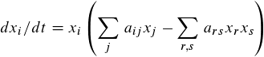
2.1

where i,j,r,s=1...n. x stands for the relative frequency of the replicators and a for the interaction coefficient, which describes the interaction between two replicators. The replicator is the photon phase. n is the number of different replicators. In order to apply Equation (2.1), n discrete phase classes must be assumed, which do not exist in nature. x_{i} would then be the frequency of photons of phase class i. It can be recognised that interactions always occur in pairs. We must thus assume a pair interaction between the photons. a_{ij} in Equation (2.1) could correspond to p_{ij} in Equation (4).
The following equation combines replicator dynamics and quantum theory: Ω=A²+1, where Ω stands for the mean fitness (Σ(arsxrxs) in Equation (2.1)).

Supplement 3: Proof of the equivalence of Equations (1) and (2). It has already been presented previously in preprints by the author (one of the advantages of preprints is that the reader can be spared unnecessary searching in the literature).
From
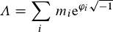
3.1

follows:
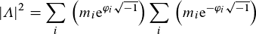

If one chooses α_{ij}=φ_{i}-φ_{j} this can be written as follows:
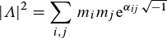
where

We define:
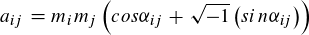

from which it follows that A²=Σa_{ij}. Furthermore a_{ii}=m_{i}², because cos0=1 and sin0=0. Now we calculate the sum
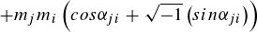

because sin(-α)=-sinα it follows

From this one can ultimately conclude

We have claimed that
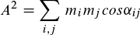
3.2

We now define

so that A²=Σb_{ij}. Now we calculate the sum

Because of cos -α = cos α follows

and because of cos 0 =1 also b_{ii}=m_{i}² results. But from this follows altogether that

and

and from this in turn it follows that Equation (3.2) must be correct if Equation (3.1) holds and hence |Λ|² = A².

