Supplementary material

Table S1. Possible functional groups/ bonds originated from stretching/ bending vibrations frequencies useful in discriminating wild adlay flours.
Peak (s) at cm⁻¹ animated | Origin hailing to peak (s) | possible functional group (s) reached out | wild Adlay flours
 |  |  | PRP 2863/ 1885 cm⁻¹ upto | YLW 2279/ 2281 cm⁻¹ to | OWT 2279/ 2281 cm⁻¹ to | BLK 2279/ 2281 cm⁻¹ to |  | GRY 2279/22 81 cm¹ upto |  | GRN 2863/1865 cm⁻¹ upto |  | BRN 2158/ 21 59; 2176 cm⁻¹ upto
 |  |  | OOP (out of plane) region
 |  |  | Frequencies 419 to 2863/1865 originating functional group (s)
2863/  3865 to 1865 | Shoulder peak just to right of R- C–H stretch | H-C=O nor- mally at 27 60; a known window | peak 2865 is aldehy dic H | No peak appearance (NIL)  Normally aldehydic peak originate at 2760 Cm⁻¹ |  |  |  |  |  | 2865 peak aldehydic H |  | NIL
2279/  2281 | -CN (2240-22 80)/ or R- CN⁺-O⁻ (2280-2305); or R-N⁺ N (~2260) | aliphatic Nitrile/Oxid e/diazonium salt/Cyanid | Thiocyanate (2240-2260/1180-1190) accompanied with absorbance (2158/2159 |  |  |  |  |  |  | Absent |  | associated to 2158 -2159; 2176
2225  Cm⁻¹ | Ar-CN or R-N⁺N⁻(Diazonium salt) ~2260-2150 (-C C) | Ar– amide / or nitrile (2220-224 0) OR –C C– stretch | Absent | Absent | Absent | Absent |  | ArC≡N or Nitrile is present |  | absent |  | Absent
2176 | Ar-CN or R-N⁺N⁻(Diazonium salt) ~2260-2150 (-C C-) stretch | Ar– anide / or nitrile (2220-224 0) OR –C ≡C–stretch | absent | Absent | absent | absent |  | Absent |  | absent |  | Thio/isothio cyanate
2157 to  2159 |  |  | Single peak at 2158-59 (2140-2175) indicate thiocyanate (-SCN
2176 | Cyanide/thiocyanate /cyanate /RS-C N or -SCN- or –C=N-S stretch (2000-2200) | CN⁻/SCN/ OCN⁻ iso thiocyan ates or Ar-substitut ed upper or alkyl at lower end of Isothio cyanate | Absent | Absent | Absent | Absent |  | Absent |  | absent |  | Thio/isothio cyanate
2157 to  2159 |  |  | Single peak at 2158-59 (2140-2175) indicate thiocyanate (-SCN)
2149 | Cyanide/thiocya nate/ cyanate / RS-C N or -SCN- or –C=N-S stretch (2000-2200) | CN⁻ or SC≡N⁻ or  OC ≡N⁻Thiocyan ates OR Ar- substi tuted at upper or lower R- at lower end of Iso thio- cyanate | absent | absent | -SCN (2140-2175) also C= C only ~600 OOP | Absent |  | Absent |  | absent |  | absent
2143 |  |  | Absent | absent | absent | -SCN |  | -SCN |  | -SCN |  | absent
2046/47 |  |  | present | absent | singlet | absent |  | Absent |  | singlet |  | absent
33/35-23 |  |  | Present | Present | absent | absent |  | Absent |  | absent |  | absent
2012 |  |  | present | absent | absent | absent |  | Absent |  | absent |  | absent
2005/06 |  |  | Absent | absent | singlet | singlet |  | Present |  | present |  | singlet
1993[94 |  |  | Absent | absent | absent | absent |  | Present |  | absent |  | absent
1975/76 |  |  | Absent | absent | WNB | WNB |  | Present |  | present |  | present
1961/62 |  |  | Absent | absent | as above |  |  | Absent |  | present |  | present
1832 Cm⁻¹ | acid -CO-X) or Aryl carbonate/ open chain acid anhyd (1800-1850/ 1740 to 1790 / 5-member ring anh or cyclic ketone 5-member ring/Ar- & α, ß usd ketone s/ C=O /5- member ring C=O or –CO OC- or SD 4-members ring C=O/ Lactone at 1870 -1820/ 1750-1800 | Aryl carbonate (1775-1820) | Absent | Absent | peaks 1832 & 1775 show acid anhydride or 5-member ring anhydrid |  | absent | Absent |  | Aryl  carbon  ate |  | absent
1765/  1775  cm ⁻¹ |  | 1,2-diketon e (s)- cis, 5- members ring (at Ʋ 1750-1800) or Aryl carbonate (1775 - 1820) | only at u 1765 or upward implicate α, α/ - di chloro and or α, α^{/--}dibromo | Separate peaks at Ʋ 1765, 1777 >1, 2-diketon es(S) Cis, 5-member ring ahd or Ar-car bonate Separate peaks at Ʋ 1765, 1777 >> 1,2-di keton es(S) Cis, 5 members ring ahd/Ar-carbonat |  |  | only at Ʋ 1765 >> α, α/ -dichloro or α α/ -dibromo ketones |  |  | absent |  | absent
1753 |  | α, α/-di chloro or α α/- dlbromo ketones / 5-membrs ketones or lactone ring | Absent | Absent | Absent |  | Absent | Absent |  | alkyl car bonate or Aryl ketones |  | alkyl carb onate or Aryl ketones
1736/37 | C=O (735-7 50 (S) plus Ʋ 715 -730 (s) / Aryl comb bands (1500/1660-2000) several peaks due to Ar-CG C=C stretch / over tones /open chain imino (RC= N-) or amide | 6-membr Lactone or aliphatic C=O stretch (s or RCOOH /or Ketone / ester | a single band alone at Ʋ 1727 or 1720/ 1725 indicate aliphatic RC=O stretch OR Carboxylic acid (1700-1725) or triglycerides (ester) are present |  |  |  | Singlet (S) at Ʋ 1737 indicate Ar-C =O; Separate bands at Ʋ 1720/ 1737 accompanied strong band at 1066 1134-1144 >>>> six members lactone or Aryl-C=O stretch (S) and OR α, ß-US C=O stretch, plus C-O stretch band at (Ʋ1310 -1050 (S), well known window OR Carboxylic acid (1700-1725) or triglycerides (ester) are present
1727 |  | Ar- C=O stretch (S) and α ß US C=O stretch | Absent | absent | absent |  | Absent | Absent | absent |  | absent
1719/21 |  |  | absent | Present | present |  | absent | Absent | Present |  | present
1690  Cm⁻¹ | C=O (735-750 (s) and 715-730 (s) or Ar-CB (1 600-2000) several peaks due to over tones or Ar- CGD C =C stretch or open chain imino (RC =N-)/ amide | enol esters / enol ROR & enol en amines weaker than C=O (1640-1590 (s)/C=C NCG with Aryl ring (1625)/ amide (16 30-1680)/ RC =N -(16 90-1590/ dienes/ tri enes/sat ROH (1600-1725) | absent | Enol esters/ enol R-O-R or enol enamines weaker than C=O (1640-1590(s) |  |  |  | Absent | absent |  | absent
1678 | same as above |  | Absent | NCG C=C stretch due to 1620 -1680 or saturated ROH | NCG- C=C; amide |  | NCG- C=C; amide | Non conjugated (NCG) - C=C; amide | NCG C= C stretch  due to 162 0/1680/ CJ-Ar. censure when Ʋ at 1625 |  | NCG C=C. or  amide
1656 |  |  | Absent |  | absent |  | absent | Absent |  |  | absent
1677 |  |  | Absent | Absent | present |  | present | NCG C=C | present |  | present
1577 | open chain azo OR aliphatic Nitro compounds or well-known NB R~ 1600; ~1580 and ~1500 due to Ar- ring stretch (NBR associated with OOP) | N=N -163 0-1575/ C=C–CAr. ring in pla ne stretch accompanied with OOP & in plane bending at 1000-1280 as well as several pe aks at 1660 -2000 due to overtone | Absent | Absent | absent |  | absent | Absent | present |  | absent
1574 |  |  | present | Absent | absent |  | absent | Absent | absent |  | absent
1560/61 |  |  | absent | Present | absent |  | present | Present | present |  | present
1523/25 |  |  | absent | Present | absent |  | present | Present | present |  | present
1491/94 |  |  | present | Absent | Absent |  | present | Absent | present |  | absent
1484 |  |  | present | Absent | Absent |  | absent | Absent | present |  | present
1441 | aliphatic symm. scissor/ bend CH | Basics skeleton o | present | absent | absent |  | absent | absent | absent |  | absent
1391/92 |  |  | Present | present | present |  | present | present | present |  | present
1348/ 1351 | Pri. /sec. OH (1350-12 60) /aliphatic Nitro cmpds/ organic P=O stretch | OH, in plane bend for simple P -Oxy/ hetro- Oxy bond | present | absent | absent |  | present | present | present |  | present
1291/  1284 | C=C-C-H (in-ring) plane bend |  | Present | Present | absent |  | present | Absent | present |  | present
1215/ | ArC-O stretch / C-N/-OCN+ /COCN stretch; or Cyclic ether large ring C-O stretch/ C-O-C in Acid anhydride and OR Ar-C-O sym- stretch or Pri. / Sec. ROH C-O stretch or R-substituted ether C-O stretch OR C-O and C-C- stretch of carbon and ring vibration mainly from carbohydrate | C-O-/C-O & or Sec amine C-N stretch | Absent | present | absent |  | absent | Absent | absent |  | present
1190/88 |  | Cyanate due to Ʋ 1180-1190 /2240-2260 cm⁻¹ | Sec. /Ter. amine CN stretch (1130-1190 or 1150-1210; OR N-H bending of amide (mainly from AAs) |  |  |  | probably Cyanassociate Ʋ 2225 | Sec./ Ter. amine C-N stretch (1130-1190 or 1150-1210; OR N-H bending of amide (mainly from AAs)
1134/40 |  | large ring or R-sub- stituted ether CO-C | C-C stretch of carbohydrate (Anomeric Ring vibration (mainly from Carbohydrates) 1. mono substituted due to Ʋ at 738 and 687cm⁻¹; 2.- ortho at 738 and 3.- 1,3,5-tri substituted due to Ʋ at 687cm⁻¹ and 720 and 878 cm⁻¹
1066/69 |  | Ar-OH or R-substit uted ether or ArO-gr /ArO-H or ahd or R-OH/C-O-C or Carboh
Peak animated | Origin hailing to peak (s) | Functional group (s) reached out | “OOP” (Out of plane) region 905- 632 cm⁻¹
905  875/ 880 | well known OOP inter mingle with FPR =C-H OOP bend ing several peaks are present at Ʋ 631/ 632-943 / 945 witness ing mono/di/ tri/ tetra sub stituted at O-; & or m-, & or p- or ali-phatic C-Cl stretch Ʋ at 827 may also be due to (cy clic ketone) sat 5-memb er ring C=O (820 -870) associated with 1750-1800 or per oxide C-O-O-C stretch (820 -890) or anomeric region of carb. & ring vibrations (mainly from carbo- hydrate | since mono substitution Ʋ at (730-7 70 & 68 0-720)/ ortho at (735-77 0); meta (685-720, 750-810); para (800-860/ tri substituted Ʋ at 1, 2,3 (685-720, 750 -81 0); for 1,2,4 (800-810, 820-900) /1, 3, 5 (685-720, 820-90 0); for tetra substitutions due to Ʋ at 1,2,3,4 (800-840); for 1,2, 3,5 as well as for 1, 2, 4, 5 (same at 840-880) while penta substituted due to Ʋ at 8 60-900 cm⁻¹ & last but not least hexa substituted due to Ʋ at (385 -415)/or otherwise R-C -Cl(700-800cm⁻ | 1. ortho substituted due to Ʋ at 747.  2.-para due to Ʋ at at 878.  3.- 1,2,3 ,4- tetra & or 1, 2,3,5- & or 1,2, 4,5-tetra substituted due to Ʋ at 878.  4.- penta substituted due to Ʋ at 878 cm⁻¹ | 1.-ortho substituted due to 745; 2.-para 846; 3.- 1,2,4-tri substituted due to Ʋ at 846 & 876  3. 1,2, 3, 4-tetra & or1,2,4,5-tetra & or 1,2,3,5-tetra substitute due to Ʋ at 846 & 8764.- penta due to Ʋ at 876 Cm⁻¹ | 1.- para substituted 845; 2.- 1,2, 4-tri-subsituted 845 & 876; 3.-1,2,3, 4- tetra & or 1,2, 4,5-tetra & or 1,2, 4,5-tetra at 845 & 877.  4.-penta at 8777; while hexa substituted due to Ʋ at 419 cm⁻¹ | 1.- para (Ʋ 849); 2: 1,2,4-tri-substited due to Ʋ at 849 & 905.  3. penta due to Ʋ at 905 & hexa substituted due to Ʋ at 410, and 419  Cm⁻¹ | 1. 1,2, 3 5- & 1,2,3,4- & 1.3.4. 5-tetra substituted ted haling to Ʋ at 878 & OR otherwise penta substitution in preview of same Ʋ 878 Cm⁻¹ | 1.ortho substituted at Ʋ 744cm⁻¹  2: p-substituted at Ʋ 828cm⁻¹  3. 1,2,3 5-tetra & or 1,2,4,5-tetra substitution at Ʋ 880 Cm⁻¹  While 4. Penta substitution at Ʋ 880 Cm⁻¹ | 1. mono substituted due to Ʋ at 738 and at 687 Cm⁻¹  2.ortho-due to Ʋ at 738 cm⁻¹  3. 1,3,5-tri- substituted due to Ʋ at 687 & 720 & 878 cm⁻¹
845/ 849
827
738 |  |  |  |  |  | present | present | present | present
663/  64 | aliphatic bromo (due to C-Br stretch & or -SH & thio substituted | ROH bend (-OH OOP)/ aliphatic Halides (RC-X) or CH-S-C-S stretch) | Present | Absent | present | present | present | present | present
640/ 645 |  |  | Absent | present | absent | present | present | present | present
631/ 632 |  |  | Absent | Absent | absent | present  present | present | present | present
 |  |  |  | Absent | Absent |  | absent | absent | absent
Abbreviations NCG for non-conjugated; CG for conjugated; US for unsaturated, Sat for saturated. Abs means absent and pre means present while Ʋ stands for frequency number (cm⁻¹); WNB for week narrow band; NBR for narrow band region (Ʋ 1391/1392 cm⁻¹ – 1560/1561cm⁻¹); OOP for out of plane (Ʋ at 650 cm⁻¹ – 943cm⁻¹) or FPR for fingerprint region (631/632cm-1 — 943/945cm-1; 905 cm-1); ahd for anhydride

Supplementary Figures

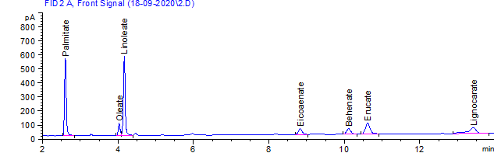
Figure S1 GC Chromatogram of fatty acids of oil obtained from purple adlay seed

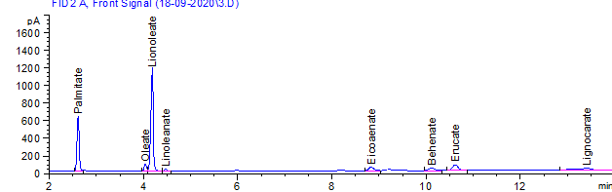
Figure SII GC Chromatogram of fatty acids of oil obtained from black adlay seed

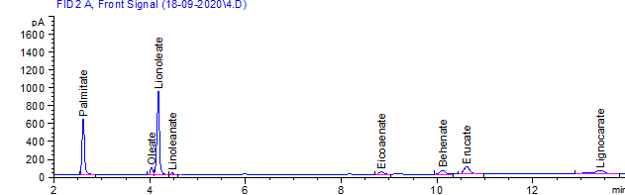
Figure SIII GC Chromatogram of fatty acids of oil obtained from brown adlay seed

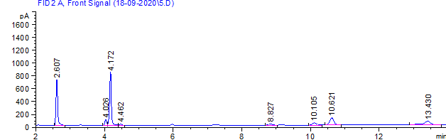
Figure SIV GCFID Chromatogram of Green grains Triglyceride characteristics

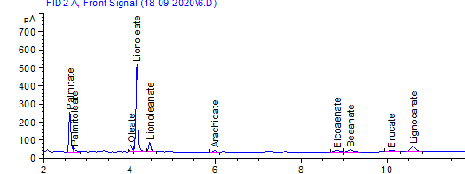
Figure SV GC Chromatogram of fatty acids of oil obtained from yellow adlay seed

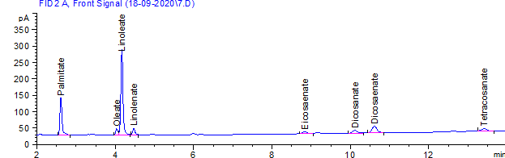
Figure SVI GC Chromatogram of fatty acids of oil obtained from grey adlay seed

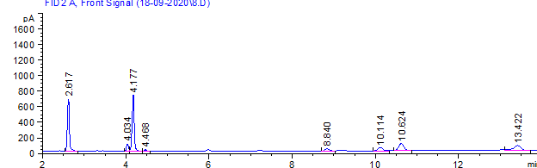
Figure SVII GC Chromatogram of fatty acids of oil obtained from Off -White adlay seed

