Supplementary materials of the manuscript
“Prolonged oral administration of ethyl alcohol leads to histopathology of the epididymis and seminal vesicle and changes of metabolite composition in the tissue lumen”
by
Chayakorn Taoto, Nareelak Tangsrisakda,
Wipawee Thukhammee, Sitthichai Iamsaard, Nongnuj Tanphaichitr

Supplementary Figures
Supplementary Figure S1. Hematoxylin/eosin-stained sections of the cauda epididymis from EtOH rats revealed marked disorientation and collapse of the epithelium with no discernment of the basement membrane in 10% of the total epithelium. Tissue fragments were also observed in the epididymal lumen of this highly deformed epithelium. The scale bar in the inset is 20 μm.

Supplementary Figure S2. Immunoblotting of the cauda epididymis and seminal vesicle with anti-caspase 9 antibody and anti-GAPDH antibody. The blot containing electrophoresed proteins from the cauda epididymis and seminal vesicle was cut between the MW of ~60,000 and 30,000, and this blot segment was used to probe with anti-caspase 9 and then reprobed with GADPH. This was to minimize the amount of antibodies needed for immunoblotting. The pro-caspase 9 band and cleaved-caspase 9 band as well as the GAPDH band in the first and second lanes were selected for presentation in Figure 5B. Similarly, for the presentation in Figure 6B, the pro-caspase 9 band and cleaved-caspase 9 band as well as the GAPDH band in lanes five and six were selected.

Supplementary Figure S3. Immunoblotting of the cauda epididymis and seminal vesicle with anti-caspase 3 antibody and anti-GAPDH antibody. The blot containing electrophoresed proteins from the cauda epididymis and seminal vesicle was cut between the MW of ~10,000 and ~35,000, and between the MW of ~35,000 and ~40,000. The first blot segment was used to probe with anti-caspase 3, whereas the second one was probed with GADPH. This was to minimize the amount of antibodies needed for immunoblotting. The pro-caspase 3 band and cleaved-caspase 3 band as well as the GAPDH band in the first and second lanes were selected for presentation in Figure 5C. Similarly, for the presentation in Figure 6C, the pro-caspase 3 band and cleaved-caspase 3 band as well as the GAPDH band in lanes five and six were selected.

Supplementary Tables
Supplementary Table S1. Identification of metabolites in the caudal epididymal fluid (CEF) based on their chemical shift values (ppm) from the website, https://hmdb.ca.

Supplementary Table S2. Identification of metabolites in the seminal vesicle fluid (SVF) based on their chemical shift values (ppm) from the website, https://hmdb.ca.

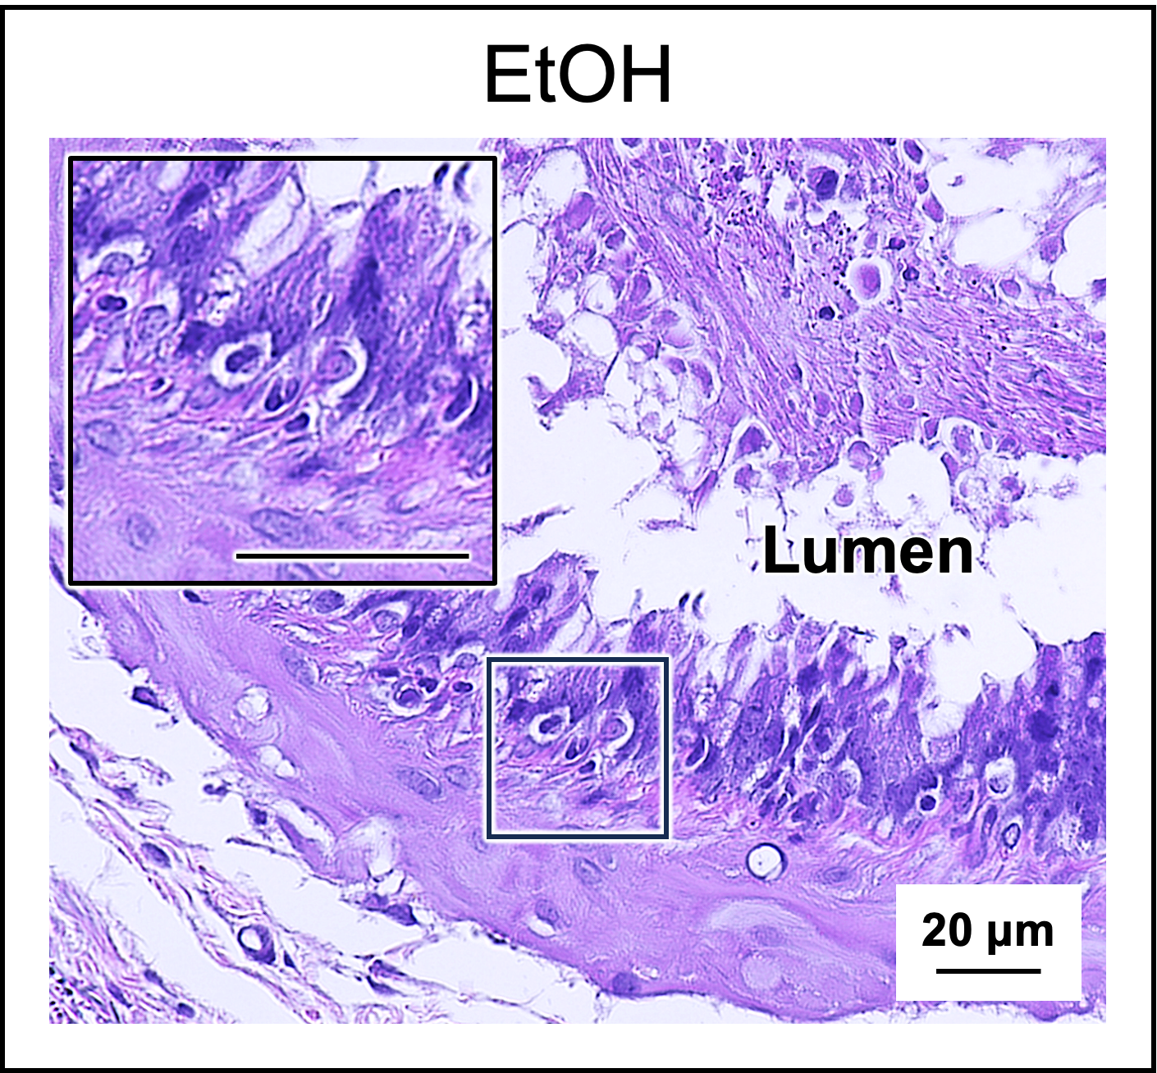
Supplementary Figure S1. Hematoxylin/eosin-stained sections of the cauda epididymis from EtOH rats revealed marked disorientation and collapse of the epithelium with no discernment of the basement membrane in 10% of the total epithelium. Tissue fragments were also observed in the epididymal lumen of this highly deformed epithelium. The scale bar in the inset is 20 μm.

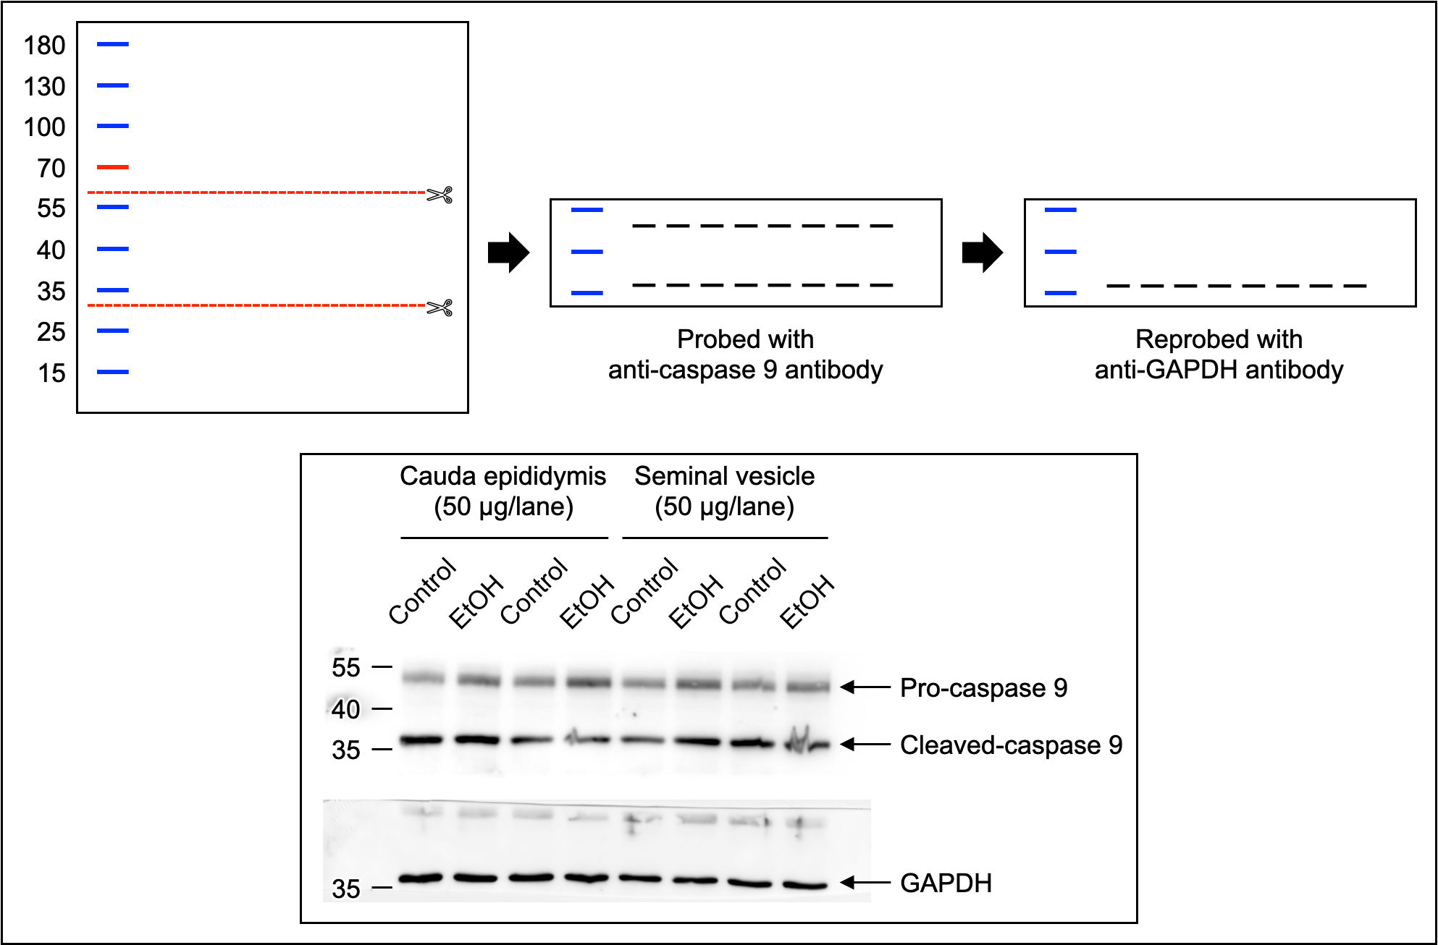
Supplementary Figure S2. Immunoblotting of the cauda epididymis and seminal vesicle with anti-caspase 9 antibody and anti-GAPDH antibody. The blot containing electrophoresed proteins from the cauda epididymis and seminal vesicle was cut between the MW of ~60,000 and 30,000, and this blot segment was used to probe with anti-caspase 9 and then reprobed with GADPH. This was to minimize the amount of antibodies needed for immunoblotting. The pro-caspase 9 band and cleaved-caspase 9 band as well as the GAPDH band in the first and second lanes were selected for presentation in Figure 5B. Similarly, for the presentation in Figure 6B, the pro-caspase 9 band and cleaved-caspase 9 band as well as the GAPDH band in lanes five and six were selected.

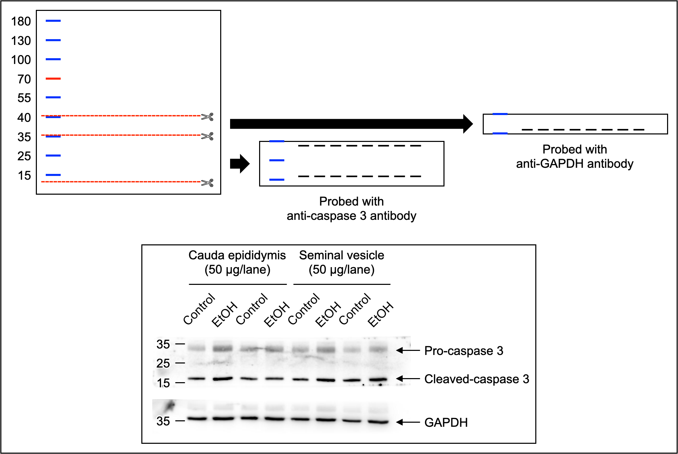
Supplementary Figure S3. Immunoblotting of the cauda epididymis and seminal vesicle with anti-caspase 3 antibody and anti-GAPDH antibody. The blot containing electrophoresed proteins from the cauda epididymis and seminal vesicle was cut between the MW of ~10,000 and ~35,000, and between the MW of ~35,000 and ~40,000. The first blot segment was used to probe with anti-caspase 3, whereas the second one was probed with GADPH. This was to minimize the amount of antibodies needed for immunoblotting. The pro-caspase 3 band and cleaved-caspase 3 band as well as the GAPDH band in the first and second lanes were selected for presentation in Figure 5C. Similarly, for the presentation in Figure 6C, the pro-caspase 3 band and cleaved-caspase 3 band as well as the GAPDH band in lanes five and six were selected.

Supplementary Table S1. Identification of metabolites in the caudal epididymal fluid (CEF) based on their chemical shift values (ppm) from the website, https://hmdb.ca.
No. | Chemical shift  (ppm) | Multiplicity | STOCSY | Metabolite
1 | 1.32374 | d* | 1.32374 (d), 4.09023 (q) | Lactate
2 | 1.47547 | d | 1.47547 (d), 3.73798 (q) | Alanine
3 | 1.92124 | s* | 1.92124 (s) | Acetate
4 | 2.07701 | s | 2.07701 (s), 2.52312 (dd), 2.62405 (dd), 3.20709 (s), 3.60610 (d), 3.86852 (dd) | Acetylcarnitine
5 | 2.14699 | s | 2.14699 (s), 2.63414 (t), 3.86852 (t) | Methionine
6 | 2.42993 | dd* | 2.42993 (dd), 3.23333 (s), 3.42779 (m) | Carnitine
7 | 3.04156 | s | 3.04156 (s), 3.93412 (s) | Creatine
8 | 3.20709 | s | 3.20709 (s), 3.47960 (m), 4.06129 (m) | Choline
9 | 3.23333 | s | 3.23333 (s), 3.59634 (m), 3.86852 (m), 4.30621 (m) | Glycerophosphocholine
10 | 3.23333 | s | 3.23333 (s), 3.90586 (s) | Betaine
11 | 3.26126 | s | 3.26126 (s) | Trimethylamine N-oxide
12 | 3.28413 | t* | 3.28413 (t), 3.52199 (dd), 3.60610 (t), 4.06129 (t) | Myo-inositol
13 | 3.56337 | d | 3.56337 (d), 3.58692 (d), 3.65387 (m), 3.99367 (m) | Fructose
14 | 3.65387 | q* | 3.65387 (q), 3.90586 (m), 4.05120 (s) | Fructose 2,6-bisphosphate
15 | 8.19706 | s | 8.19706 (s), 8.21623 (s) | Adenine
16 | 8.46082 | s | 8.46082 (s) | Formate
s: singlet; d: doublet; t: triplet; q: quartet; dd: doublet of doublet.

Supplementary Table S2. Identification of metabolites in the seminal vesicle fluid (SVF) based on their chemical shift values (ppm) from the website, https://hmdb.ca.
No. | Chemical shift  (ppm) | Multiplicity | STOCSY | Metabolite
1 | 0.89176 | m* | 0.89176 (m), 1.62586 (m), 3.70905 (t) | Leucine
2 | 0.92540 | t* | 0.92540 (t), 0.97318 (d), 1.21675 (m), 1.36613 (m), 2.18198 (m), 3.67271 (d) | Isoleucine
3 | 1.32374 | d* | 1.32374 (d), 4.08316 (q) | Lactate
4 | 2.09753 | s* | 2.09753 (s), 2.94366 (dd), 4.37283 (m) | Acetylcysteine
5 | 2.52279 | d | 2.52279 (d), 2.68130 (d) | Citrate
6 | 3.04123 | s | 3.04123 (s), 3.93412 (s) | Creatine
7 | 3.23333 | s | 3.23333 (s), 3.59601 (m), 3.85573 (m), 4.30554 (m) | Glycerophosphocholine
8 | 3.23333 | s | 3.23333 (s), 3.90586 (s) | Betaine
9 | 3.26092 | t | 3.26092 (t), 3.52266 (dd), 3.60610 (t), 4.06096 (t) | Myo-inositol
10 | 3.59601 | d | 3.59601 (d), 3.64008 (d), 3.80829 (d), 4.02294 (m), 4.06386 (m) | Fructose
11 | 3.70905 | dd* | 3.70905 (dd), 3.80829 (dd) | Glycerate
12 | 7.83538 | s | 7.83538 (s) | Xanthine
s: singlet; d: doublet; t: triplet; m: multiplet; dd: doublet of doublet.

