Scheme 1. Shows vibriocidal geometric mean antibody titres to Ogawa in participants with high (positive) or lower (negative) baseline IgG antibodies across treatment arms.>.

Scheme 2. Shows vibriocidal geometric mean antibody titres to Inaba in participants with high (positive) or lower (negative) baseline IgG antibodies across treatment arms.>.

Scheme 3. Shows vibriocidal geometric mean antibody titres to Ogawa in participants with high (positive) or lower (negative) baseline IgA antibodies across treatment arms.>.
Scheme 4. Shows vibriocidal geometric mean antibody titres to Inaba in participants with high (positive) or lower (negative) baseline IgA antibodies across treatment arms.>.

Scheme 5. Shows vibriocidal geometric mean antibody titres to serotype Inaba in participants with high (positive) or lower (negative) baseline IgM antibodies across treatment arms.>.
Scheme 6. Shows vibriocidal geometric mean antibody titres to Ogawa in participants with high (positive) or lower (negative) baseline IgM antibodies across treatment arms.>.

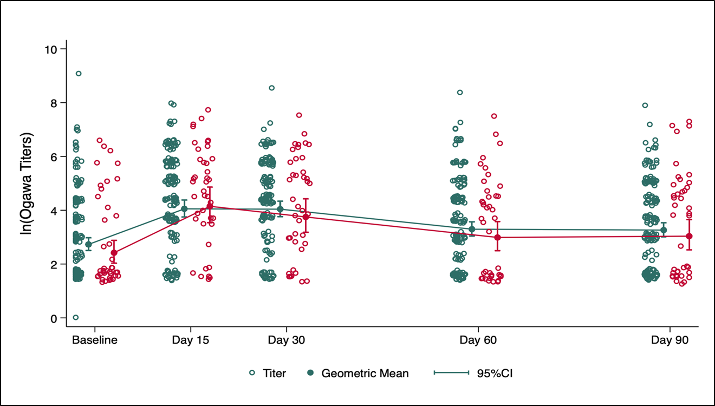
Scheme 7. Ogawa titers kinetics by HIV status. Emerald (HIV-), Red (HIV+).
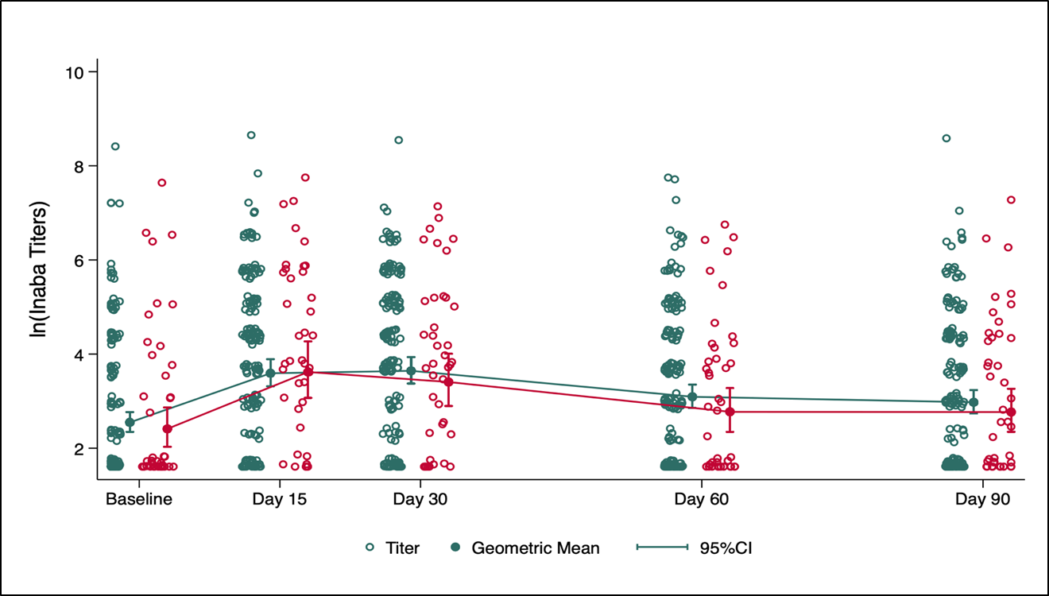
Scheme 8. Inaba titers kinetics by HIV status. Emerald (HIV-), Red (HIV+)>.

